National Road Transport Technology

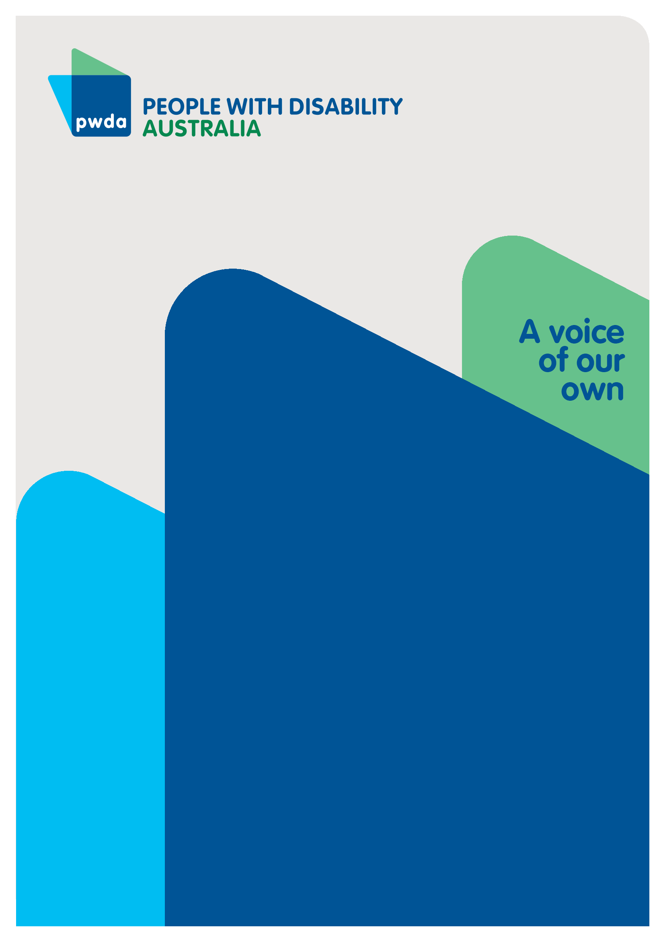
Submission to the Infrastructure and Transport Ministers review of the draft National Road Transport Technology Strategy and the National Connected and Automated Vehicle (CAV) Action Plan
DEC
2023

Copyright information
National Road Transport Technology– Submission to the Infrastructure and Transport Ministers’ Meeting Review of the draft National Road Transport Technology Strategy and the National Connected and Automated Vehicle (CAV) Action Plan

First published in 2023 by People with Disability Australia Ltd.
Level 8, 418a Elizabeth Street, Surry Hills, New South Wales, Australia 2010
Head office also in Sydney
Email: pwd@pwd.org.au
Phone: +61 2 9370 3100 Fax: +61 2 9318 1372
URL: www.pwd.org.au

Typeset in Arial 12 and 14 pt and VAG Rounded 26 pt

© People with Disability Australia Ltd. 2023

The moral rights of the authors have been asserted

National Library of Australia Cataloguing-in-Publication data:

Creator(s): | Bastien Wallace
Title: | National Road Transport Technology – Submission to the Infrastructure and Transport Ministers’ Meeting Review of the draft National Road Transport Technology Strategy and the National Connected and Automated Vehicle (CAV) Action Plan

All rights reserved. Except as permitted with the Australian Copyright Act 1968 (for example, a fair dealing for the purposes of study, research, criticism or review), no part of this book may be reproduced, stored in a retrieval system, communication or transmitted in any form or by any means without prior written permission. All inquiries should be made to the publisher at the address above.

Suggested citation:

Wallace, B., National Road Transport Technology– Submission to the Infrastructure and Transport Ministers’ Meeting Review of the draft National Road Transport Technology Strategy and the National Connected and Automated Vehicle (CAV) Action Plan, 6 December 2023, People with Disability Australia, Sydney.

ISBN: 978-0-6459325-5-3

About PWDA
People with Disability Australia (PWDA) is a national disability rights and advocacy organisation made up of, and led by, people with disability.
We have a vision of a socially just, accessible and inclusive community in which the contribution, potential and diversity of people with disability are not only recognised and respected but also celebrated.
PWDA was established in 1981, during the International Year of Disabled Persons.
We are a peak, non-profit, non-government organisation that represents the interests of people with all kinds of disability.
We also represent people with disability at the United Nations, particularly in relation to the United Nations Convention on the Rights of Persons with Disabilities (CRPD).
Our work is grounded in a human rights framework that recognises the CRPD and related mechanisms as fundamental tools for advancing the rights of people with disability.
PWDA is a member of Disabled People’s Organisations Australia (DPO Australia), along with the First People’s Disability Network, National Ethnic Disability Alliance and Women with Disabilities Australia.
DPOs collectively form a disability rights movement that places people with disability at the centre of decision-making in all aspects of our lives.
‘Nothing About Us, Without Us’ is the motto of Disabled Peoples’ International.

Table of Contents
Introduction 5
Summary of Recommendations 6
National Transport Strategy 7
Vehicle Automation 9
Vehicle connectivity 13
Vehicle convoys 15
Safety by design 16
Cross-cutting actions supporting Connected Autonomous Vehicles 17
Conclusion 20

Introduction
People with Disability Australia (PWDA) welcomes the opportunity to provide feedback on the development of the National Road Safety Action Plan 2023–2025 and the National Road Safety Strategy 2021-30.
If deployed appropriately, the evolution of transport technologies has the potential to increase the independence, inclusion, transport access and safety of people with disability. The development of the National Road Safety Action Plan 2023–2025 and the National Road Safety Strategy 2021-30 is part of:
- setting clear Australian Standards for manufacturers developing vehicles and operating systems, to ensure they meet the needs of people with disability
- ensuring that vehicle designs are accessible, safe and standardised for people with disability
- creating a nationally consistent operating framework for new transport technologies; and
- developing transport technology and supporting infrastructure, such as roads, in ways that avoid obstructing, excluding, or creating unintended hazards for people with disability.
Historic road safety models have been developed based on human beings making all decisions. These models must evolve to reflect the replacement of human decision making by machines. However, it is imperative that technology operations and decision making be independently scrutinised to ensure safe operations that do not endanger people with disability due to omissions or ableist assumptions.
To maximise the benefits, avoid harms and unintended consequences, people with disability need to be consulted on the design of vehicles, transport infrastructure, the operation of technologies, strategies and standards as transport technology evolves.

Summary of Recommendations
Recommendation 1 – A new road safety model must be developed to reflect that the social model, which depends on all decisions being made by humans, must evolve to reflect a system where autonomous vehicles, computers and human beings make decisions.

Recommendation 2 – The operating systems for Autonomous and Connected Autonomous Vehicles must be independently tested to ensure that they detect and respond safely to people with disability using assistance animals and mobility assistance devices.

Recommendation 3 – Vehicle designs for connected vehicles providing ‘mobility as a service’ must be accessible for people with disability to use independently.

Recommendation 4 – Booking systems, controls, safety restraints and transport communications about Connected Autonomous Vehicles must be accessible and nationally standardised.
Recommendation 5 – Connected heavy vehicles should be confined to dedicated separated corridors.
Recommendation 6 – Any road feature introduced to support connected automatic vehicles must not create hazards or obstructions for people with disability.

Recommendation 7 – People with disability must be consulted on the design of vehicles, infrastructure and standards for Autonomous and Connected Autonomous Vehicles, and their needs included in standard settings, for infrastructure and vehicle design.

National Transport Strategy
To evaluate the draft National Road Transport Technology Strategy and 2024–27 National Connected and Automated Vehicle (CAV) Action Plan, it is critical to understand the existing governance of Australian transport, as well as the legal, policy and planning considerations that underpin it.
The National Road Safety Action Plan 2023–2025, is designed to deliver on the road safety priorities in the National Road Safety Strategy 2021-30.
Transport systems and plans (road, public and active transport) must:
- conform to the Safe Systems approach
- conform with the Disability Standards for Accessible Public Transport; and
- deploy technology in conformity with the Convention on the Rights of Persons with Disabilities (CRPD)
The Safe Systems approach originated in Sweden and is a philosophy focused on reducing fatal crashes to zero through the efforts of all stakeholders in the transport system. The four core principles of the Safe System approach are that:
- ‘humans are fallible, but no mistake should lead to death or serious injury
- the road system should be designed around the capacity of the human body to tolerate external forces
- the responsibility for road safety should be shared by all parties, including road users and system designers; and
- all parts of the system must be strengthened to multiply their effects.’
The Safe System approach combined with the Disability Standards for Accessible Public Transport, requires road designs to engineer in safety for all transport users, without ableist assumptions.
Article 4 of the CRPD requires all policies to protect and promote the human rights of people with disability, and public authorities and institutions to refrain from acting in a manner inconsistent with the Convention. It requires States Parties to undertake or promote research and the development of goods, services and technologies that meet the needs of people with disability.
PWDA notes that the results of the National Review of Transport Standards are due to be published later this year. However all of Australia's public transport networks and associated infrastructure were required to be fully accessible under these Standards by the end of 2022 (except for trains and trams, which have until the end of 2032).
The Transport Standards are supported by the Disability Standards for Accessible Public Transport Guidelines that focus on human-centered design. This means any new form of transport technology must focus on the human beings it is designed to serve.
The current Transport Standards are also supported by The Whole Journey Guide, which assists operators and providers with planning, designing, implementing and delivering accessibility and non-discriminatory public transport services. Together these guidelines help maximise transport accessibility without the need for specialised or adapted features, or retro-fitting to eliminate barriers, which increases efficient use. They place users’ perspectives and needs at the centre of the design process.
The current National Road Safety Strategy commits to the Safe System approach and to strengthening ‘Safe roads, Safe vehicles and Safe road use.’ The Strategy adopts a social model approach to road safety, which makes everyone responsible for road safety.
This includes vehicle operators, pedestrians, road and infrastructure engineers – not just governments. However, if new technologies are designed so that vehicles communicate with each other, computers, and not human beings, the ‘social model’ applied to safe road use will necessarily be disrupted. The applicability of the social model approach to road safety needs to be reconsidered if computers will replace humans for some of the decision making.
Recommendation 1 – A new road safety model must be developed to reflect that the social model, which depends on all decisions being made by humans, must evolve to reflect a system where autonomous vehicles, computers and human beings make decisions.

Vehicle Automation
This section discusses the opportunities and challenges that automated features and functioning of vehicles can present. Its recommendation is designed to maximise the benefits of these new technologies for people with disability, while avoiding unintended consequences or hazards created through insufficient independent verification. A fully autonomous vehicle is one where the vehicle completes the entire driving task once the human operator selects the destination for the journey.
PWDA appreciates the benefits already offered by evolving automation in the motor vehicle sector. Some vehicle driving functions are already automated and they improve road safety. This includes autonomous emergency braking, steering and lane centring systems already help to make driving safer.
It is anticipated that in future, fully automated vehicles will improve safety by eliminating human error from the driving task. Fully automated vehicles could also enable people with disability, who are unable to drive currently, to own and operate a motor vehicle, or to use automated shared vehicles independently.
For vehicle automation to work well, vehicle designs need to incorporate and develop on the accessibility standards set in the ‘Imove’ Connected and automated vehicles: barriers and opportunities for people with disability. As spelled out in that research, many people with disability find current public transport inaccessible, and in Australia many rural, regional and outer urban communities have no public transport available.
However, vehicle automation needs to be implemented carefully. Media reports have noted that autonomous vehicle driving systems have previously failed to detect a pedestrian pushing a bicycle across the street, and two people riding motorcycles, with fatal consequences in all three cases.
Therefore, vehicle automation systems need to be developed to ensure that they detect and respond safely to all road users, including pedestrians, wheelchair users, bicycle riders, motorcycle riders and animals, not just larger motor vehicles.
People with disability may use wheelchairs or other mobility assistance devices that alter their height, how they are perceived by vehicle automation systems, or the speed and pattern of travel compared with other pedestrians. Assistance animals may also precede a person with disability as they navigate crossing a road.
PWDA calls for the 2024-2027 National Connected Automatic Vehicle Action Plan to require the testing and certification of vehicle automation systems to ensure that they detect and respond safely to people with disability using assistance animals and mobility assistance devices.
Passengers entrusting their safety to automated vehicles must be able rely on them operating safely, especially in cases where a person with disability is unable to verify how the vehicle is operating. Manufacturer claims must be independently tested to ensure that they are accurate, and that vehicle automation systems will operate safely in Australia, where different road conditions and variable internet connectivity are likely to impact systems designed for the USA and Europe.
Disability is a risk factor for pedestrian road injury, and vehicle and infrastructure design has a critical role to play to reduce and eradicate exclusion, inequity and harm. Many automated vehicles are also electric, and operate more quietly than vehicles with internal combustion engines. This is an example of design whose unintended consequence is that it makes detecting vehicles more difficult for some people with disability.
PWDA has previously raised the issue of quiet electric vehicles being difficult to detect, and we have endorsed the submission from Blind Citizens Australia (BCA) to the Department of Infrastructure, Transport, Regional Development, Communications and the Arts’ proposal to mandate Acoustic Vehicle Alerting Systems (AVAS) for new electric, hydrogen fuel cell and hybrid vehicles in Australia. However we have yet to see regulations that respond to this. To ensure safer and more inclusive transport systems, people with disability must be consulted, and their needs included in standard settings, for infrastructure and vehicle design.
Vehicle automation means that for some, or all, of the driving task, computers or algorithms will make decisions, not human beings. Vehicles may communicate with each other, Intelligent Transport Systems, or satellites, and make decisions without a human participating in the process. This overturns the social model of road safety, as personal decision making and influence over behaviour will be replaced, to the extent that the driving task is automated.
It is critical that the draft National Road Transport Technology Strategy, the 2024–2027 National Connected and Automated Vehicle (CAV) Action Plan, and vehicle automation systems permitted under them be designed to make safe decisions that consider the needs of people with disability, as the behaviour of a human driver may not be able to override the decisions of machines.
Purchasers of private automated vehicles are likely to prefer automation systems that prioritise the safety of occupants, over that of pedestrians and other road users, in situations where the needs of both are in conflict. It is also possible the human owners of automated vehicles will be able to avoid legal responsibility for the crashes they cause. This highlights the need for policy, regulation, independent verification and legislation requiring automated vehicle systems to operate safely and in accordance with inclusive design principles that prioritise the needs of people with disability.
Recommendation 2 – The operating systems for Autonomous and Connected Autonomous Vehicles must be independently tested to ensure that they detect and respond safely to people with disability using assistance animals and mobility assistance devices.

Vehicle connectivity
This section discusses ‘connected vehicles’, vehicle convoys and connected autonomous vehicles, the safety issues and cross-cutting actions to support them.
Connected vehicles are where individual vehicles may be connected to a central control computer or operator, and they may be electronically connected to other vehicles. These vehicles could provide ‘mobility as a service’ (MaaS) enabling passengers to book individual driverless journeys similar to current taxis.
This could also help address unreliability and increasing shortages people with disability have identified with wheelchair accessible taxis in Queensland, Victoria, Tasmania, New South Wales, and South Australia.
Alternatively, connected vehicles could provide shuttle services along prescribe routes making large precincts accessible, or they may operate as a ‘last mile’ solution connecting passengers to key destinations or public transport hubs. Provided vehicles, booking services and infrastructure are designed to be inclusive, this could offer greater transport choice for people with disability. Therefore, it is important that:
- the physical design of vehicles enables independent access
- verbal, in-person and on-line bookings are possible
- controls, seating design, safety restraints and signage are nationally consistent and easy to understand
- communication about the service is produced in easy read and accessible formats; and
- safety is monitored.
Recommendation 3 – Vehicle designs for connected vehicles providing ‘mobility as a service’ must be accessible for people with disability to use independently.

Recommendation 4 – Booking systems, controls, safety restraints and transport communications about Connected Autonomous Vehicles must be accessible and nationally standardised.

Vehicle convoys
Vehicles can be connected together to improve the efficiency of freight and passenger operations by reducing the need for drivers. They can be connected in series to form a convoy of linked vehicles and they are used as ‘rail-less trams’ overseas.
Vehicle convoys are cheaper and faster to set up than standard light rail and fit more passengers than conventional busses. These types of connected vehicles may operate on ordinary roads amongst traffic, or in separated lanes. However, it will generally be clear that they are connected to each other. This makes it easier for people with disability, and their assistance animals, to identify that vehicles are connected and avoid crossing between the connected vehicles.
Connected heavy vehicles on dedicated corridors could also provide more efficient inter-city or regional freight services. However, it is usually unclear to the observer that these vehicles are connected, or how many are in the convoy, or that a driver is not present in each vehicle. This can pose safety issues if they are allowed to travel mixed with other traffic in the ordinary road related environment.
People with disability who need to cross the road, especially those with assistance animals, may mistake these vehicles as separate and try to cross between them. A convoy of connected vehicles in motion could also be misunderstood as separate vehicles, endangering other road users trying to change lanes, merge onto the road, collect a passenger, or stop in an emergency.
In order to maximise the benefits and reduce the risk to people with disability, connected heavy vehicle use should be restricted to separated corridors.
Recommendation 5 – Connected heavy vehicles should be confined to dedicated separated corridors.

Safety by design
It is important that any physical road feature, sign, or system introduced to support connected automatic vehicles under section 3.5 of the Connected Automatic Vehicle Action Plan does not create hazards or obstructions for people with disability.
Developing autonomous, and connected autonomous vehicles, in line with the Safe Systems approach also aligns with the requirements of Article 4 of the CRPD to promote the use of new technologies suitable for people with disability. PWDA recommends that people with disability be consulted, their needs designed for, and feedback sought, in order to optimise the benefits and reduce the hazards of connected automatic vehicle use. This should include an evaluation of vehicle standards, operating rules, the transport environment, and the interactions between people and vehicles.
Recommendation 6 – Any road feature introduced to support connected automatic vehicles must not create hazards or obstructions for people with disability.

Cross-cutting actions supporting Connected Autonomous Vehicles
The road related environment in Australia is complicated by differences in laws and rules between Federal, State, Territory and local Government.
Public transport vehicles, transport information, booking and payment systems are often not inter-operable within a state where transitions between operators and modes occur. At the time of writing, travelling between states and territories requires using different state-based booking and ticketing services, that operate in different ways. This makes using these systems, and travelling, more confusing and difficult to use for people with disability.
Evolving transport technology so that it is inclusive by design and nationally consistent offers an excellent opportunity to increase independence and choice for people with disability.
In order to ’…take a nationally consistent approach to technology deployment where this is needed to achieve the Strategy’s vision’ PWDA supports Action 3.1 ‘[to] consider and develop an approach for looking holistically at the treatment of CAVs under Commonwealth, state and territory law.’
A nationally consistent framework that regulates the types of vehicles allowed to operate in Australia:
- provides the best chance of ensuring that vehicles and supporting infrastructure is inclusive by design
- provides the best opportunity to ensure information and safety standards are legible and follow the same approach, so people with disability do not have to re-learn new systems as they travel between states and territories
- helps reduce the accessibility barrier of having to learn new systems when people travel across state borders
- enables inter-operability of vehicles between states and territories
- increases employment opportunities for people operating, supporting or servicing vehicles, even if they need to relocate; and
- makes it easier for manufacturers to understand and comply with a single system.
In learning from other jurisdictions such as the USA and EU to develop a national road rating system for Australia, PWDA also calls for lessons to be learned from the UK as detailed previously on ‘smart motorways’. Road features introduced to support connected automatic vehicles must not endanger or exclude people with disability from using transport.
Therefore, we recommend using a combination of the imove research and evaluation by people with disability, to develop:
- a national rating system for roads and infrastructure for connected autonomous vehicles
- standardised set of tools, including icons, braille, tactiles, easy read and meaningful images to communicate transport information, services, safety information and wayfinding
- a set of national standards to train transport workers, in order to improve inclusion; and
- standards for the disability accessibility of connected autonomous vehicles
PWDA supports national work to identify and plan for the needs of a connected autonomous vehicle workforce. This should include consideration of the skills and education requirements to ensure the workforce is trained to provide inclusive transport services, and to include people with disability as workers.
In the past, Australian transport systems have suffered from a lack of interoperability. This inconsistency is confusing for everyone and makes it difficult for people with disability to use the transport system. PWDA calls for national coordination of ‘mobility as a service’ to improve consistency, accessibility and coherent operation nationwide.
Recommendation 7 – People with disability must be consulted on the design of vehicles, infrastructure and standards for Autonomous and Connected Autonomous Vehicles, and their needs included in standard settings, for infrastructure and vehicle design.

Conclusion
The Infrastructure and Transport Ministers must ensure that vehicle designs are accessible, safe and standardised for people with disability.
Our road safety model must evolve to reflect the increasing replacement of human decision making by machines. But the programming of the machines making decisions must avoid ableism, reflecting and accommodating the needs of people with disability.
Vehicle designs, booking systems, and safety restraints should evolve to enable safe, independent use by people with disability to maximise our ability to travel where we need to go. Road features to support connected autonomous vehicles must not introduce hazards for people with disability and connected heavy vehicles should be confined to separate corridors.
Engaging people with disability on vehicle and transport system designs that focuses on safety and accessibility, will ensure that evolving transport technologies maximise social benefit and inclusion and reduce hazards for everyone.

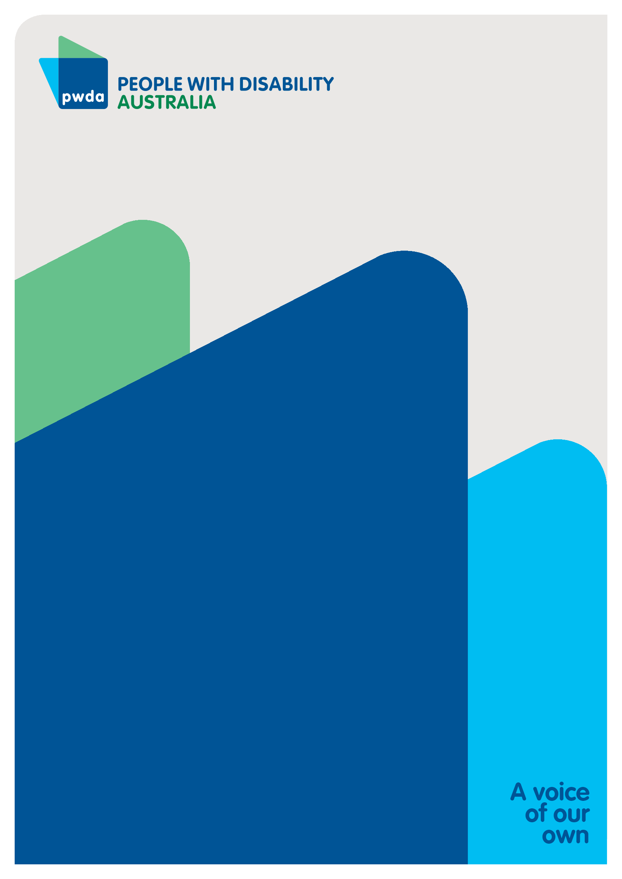
People with Disability Australia (PWDA) is a national disability rights and advocacy organisation made up of, and led by, people with disability.
For individual advocacy support contact PWDA between 9 am and 5 pm (AEST/AEDT) Monday to Friday via phone (toll free) on 1800 843 929 or via email at pwd@pwd.org.au
Submission contact
Giancarlo de Vera
Senior Manager of Policy
E: policy@pwd.org.au

Infrastructure and Transport Ministers, National Road Safety Strategy 2021-30, National Road Safety Action Plan, last accessed 7 November 2023, https://www.roadsafety.gov.au/action-plan/national-road-safety-action-plan-2023-25
Infrastructure and Transport Ministers, National Road Safety Strategy 2021-30, National Road Safety Action Plan, last accessed 7 November 2023, https://www.roadsafety.gov.au/nrss
Infrastructure and Transport Ministers, National Road Safety Strategy 2021-30, last accessed 6 November 2023, https://www.roadsafety.gov.au/sites/default/files/documents/National-Road-Safety-Strategy-2021-30.pdf
Australian Government, Disability Standards for Accessible Public Transport 2002, updated 1 May 2011, last accessed 6 November 2023, https://www.legislation.gov.au/Details/F2011C00213
United Nations, Convention on the Rights of Persons with Disabilities, 12 December 2006. Last accessed 6 November 2023, https://www.ohchr.org/en/instruments-mechanisms/instruments/convention-rights-persons-disabilities
Signor, K., Kumfer, W., LaJeunesse, S., Carter, D., UNC Highway Safety Research Centre, University of North Carolina at Chapel Hill, 28 June 2018, p1, last accessed 24 November 2023, https://www.roadsafety.unc.edu/wp-content/uploads/2018/08/SafeSystemsSynthesis-FinalReport_3.pdf
Signor, K., Kumfer, W., LaJeunesse, S., Carter, D., UNC Highway Safety Research Centre, University of North Carolina at Chapel Hill, 28 June 2018, p3, last accessed 24 November 2023, https://www.roadsafety.unc.edu/wp-content/uploads/2018/08/SafeSystemsSynthesis-FinalReport_3.pdf
Australian Government, Disability Standards for Accessible Public Transport 2002, updated 1 May 2011, last accessed 6 November 2023, https://www.legislation.gov.au/Details/F2011C00213
Infrastructure and Transport Ministers, National Road Safety Strategy 2021-30, last accessed 6 November 2023, https://www.roadsafety.gov.au/sites/default/files/documents/National-Road-Safety-Strategy-2021-30.pdf
United Nations, Convention on the Rights of Persons with Disabilities, 12 December 2006. Last accessed 6 November 2023, https://www.ohchr.org/en/instruments-mechanisms/instruments/convention-rights-persons-disabilities
Australian Government, Department of Infrastructure, transport, Regional Development, Communication and the Arts, 2022 Review of the Transport Standards, last accessed 6 November 2023, https://www.infrastructure.gov.au/infrastructure-transport-vehicles/transport-accessibility/reviews-disability-standards-accessible-public-transport-2002-transport-standards/2022-review-transport-standards
Australian Government, Disability Standards for Accessible Public Transport Guidelines 2004, last accessed 6 November 2023, https://www.legislation.gov.au/Details/F2005B01059/Supporting%20Material%203/Text
Australian Government, Department of Infrastructure and Regional Development, The Whole Journey: A guide for thinking beyond compliance to create accessible public transport journeys, p 50, last accessed 6 November 2023, https://www.infrastructure.gov.au/sites/default/files/migrated/transport/disabilities/whole-journey/files/whole_of_journey_guide.pdf
Australian Government, Department of Infrastructure and Regional Development, The Whole Journey: A guide for thinking beyond compliance to create accessible public transport journeys, p 50, last accessed 6 November 2023, https://www.infrastructure.gov.au/sites/default/files/migrated/transport/disabilities/whole-journey/files/whole_of_journey_guide.pdf
Australian Government, Department of Infrastructure and Regional Development, The Whole Journey: A guide for thinking beyond compliance to create accessible public transport journeys, p 50, last accessed 6 November 2023, https://www.infrastructure.gov.au/sites/default/files/migrated/transport/disabilities/whole-journey/files/whole_of_journey_guide.pdf
Infrastructure and Transport Ministers, National Road Safety Strategy 2021-30, last accessed 6 November 2023, https://www.roadsafety.gov.au/sites/default/files/documents/National-Road-Safety-Strategy-2021-30.pdf
Australian Government, Department of Infrastructure Transport, Regional Development, Communications and the Arts, National Road Safety Strategy 2021-31, last accessed 6 November 2023, https://www.roadsafety.gov.au/nrss/fact-sheets/social-model-approach https://www.roadsafety.gov.au/nrss
Australian Government, Department of Infrastructure, Transport, Regional Development, Communications and the Arts, National Road Transport Technology Strategy—draft for public consultation, 25 October 2023, last accessed 9 November 2023, page 8 https://www.infrastructure.gov.au/sites/default/files/documents/national-road-transport-technology-strategy-draft-for-public-consultation-october2023.docx Monash University, Vehicle safety research group, The Contribution of Vehicle Safety Improvement to Road Trauma Trends and the Potential Benefits of New Safety Technologies for Light and Heavy Vehicles, last accessed 9 November 2023, https://www.monash.edu/__data/assets/pdf_file/0019/1045216/Contribution-of-vehicle-safety-improvement-to-road-trauma-trends.pdf
Lja Nastjuk, Bernd Herrenkind, Mauricio Marrone, Alfred Benedikt Brendel, Lutz M. Kolbe, What drives the acceptance of autonomous driving? An investigation of acceptance factors from an end-user's perspective, Technological Forecasting and Social Change, v 161, 2020, last accessed 9 November 2023, https://doi.org/10.1016/j.techfore.2020.120319.
Australian Government, Department of Infrastructure, Transport, Regional Development, Communications and the Arts, National Road Transport Technology Strategy—draft for public consultation, 25 October 2023, last accessed 9 November 2023, page 8 https://www.infrastructure.gov.au/sites/default/files/documents/national-road-transport-technology-strategy-draft-for-public-consultation-october2023.docx
Imove CRC, Australian Government, Department of Infrastructure, Transport, Regional Development and Communications, Connected and automated vehicles: barriers and opportunities for people with disability, last accessed 9 November 2023, https://imoveaustralia.com/wp-content/uploads/2021/12/DSAPT-CAV-and-PWD-barriers-and-opportunities.pdf
Imove CRC, Australian Government, Department of Infrastructure, Transport, Regional Development and Communications, Connected and automated vehicles: barriers and opportunities for people with disability, p 5, last accessed 9 November 2023, https://imoveaustralia.com/wp-content/uploads/2021/12/DSAPT-CAV-and-PWD-barriers-and-opportunities.pdf
ABC, Uber fatal self driving crash entirely avoidable backup driver watching The Voice, US transport agency says , last accessed 8 November 2023, https://www.abc.net.au/news/2019-11-20/uber-fatal-self-driving-crash-entirelyavoidable-backup-driver/11720818
Drive, Jordan Mulach, US road safety authority probes Tesla Autopilot after two fatal crashes involving motorcycles, 11 August 2022, Last accessed 8 November 2023, https://www.drive.com.au/news/us-tesla-autopilot-fatal-motorcycle-crashes/
Schwartz,N., Buliung,R., Daniel, A., Rothman, L., Disability and pedestrian road traffic injury: A scoping review, Health & Place, Volume 77, 2022, last accessed 8 November 2023, https://www.sciencedirect.com/science/article/pii/S1353829222001575
Crawford, C., Blind Citizens Australia, Response to the Consultation Impact Analysis for Improving Pedestrian Safety- Acoustic Vehicle Alerting Systems for Electric Vehicles, 26 May 2023, last accessed 24 November 2023 https://pwd.org.au/wp-content/uploads/2023/05/PWDA-BCA-EV-Consultation.docx
Australian Government, Department of Infrastructure, Transport, Regional Development, Communications and the Arts, National Road Transport Technology Strategy—draft for public consultation, 25 October 2023, last accessed 9 November 2023, page 8 https://www.infrastructure.gov.au/sites/default/files/documents/national-road-transport-technology-strategy-draft-for-public-consultation-october2023.docx
Australian Government, Department of Infrastructure Transport, Regional Development, Communications and the Arts, National Road Safety Strategy 2021-31, last accessed 6 November 2023, https://www.roadsafety.gov.au/nrss/fact-sheets/social-model-approach https://www.roadsafety.gov.au/nrss
Australian Government, Department of Infrastructure, Transport, Regional Development, Communications and the Arts, National Road Transport Technology Strategy—draft for public consultation, 25 October 2023, last accessed 9 November 2023, https://www.infrastructure.gov.au/sites/default/files/documents/national-road-transport-technology-strategy-draft-for-public-consultation-october2023.docx
Australian Government, Department of Infrastructure, Transport, Regional Development, Communications and the Arts, 2024–27 National Connected and Automated Vehicle (CAV) Action Plan—draft for public consultation, 25 October 2023, last accessed 9 November 2023, https://www.infrastructure.gov.au/sites/default/files/documents/2024-27-national-connected-and-automated-vehicle-cav-action-plan-draft-for-public-consultation-october2023.docx
Australian Government, Department of Infrastructure, Transport, Regional Development, Communications and the Arts, 2024–27 National Connected and Automated Vehicle (CAV) Action Plan—draft for public consultation, 25 October 2023, p 8, last accessed 9 November 2023, https://www.infrastructure.gov.au/sites/default/files/documents/2024-27-national-connected-and-automated-vehicle-cav-action-plan-draft-for-public-consultation-october2023.docx
‘Mobility as a service’ is a technical term and denotes types of transport that can be hired, shared or booked, whether car, bus, bike, e-scooter or other type
ABC, Sarah Richards, Shortage of wheelchair accessible taxis reaching ‘crisis point’ as ministr set to review taxi licensing framework q6 April, 2023 last accessed 24 November 2023 https://www.abc.net.au/news/2023-04-16/qld-wheelchair-accessible-taxi-licence-transport-forum/102171750
ABC, Claudia Forsberg, Wheelchair-accessible taxi shortage leaves people stranded, and socially isolated, 20 August 2022, last accessed 24 November 2023, https://www.abc.net.au/news/2022-08-20/wheelchair-accessible-taxis-disability-transport-in-short-supply/101303804
ABC, Lachlan Bennett, Northern Tasmania's accessible taxi shortage leaves wheelchair users stranded, 13 October 2022, last accessed 24 November 2023, https://www.abc.net.au/news/2022-10-12/wheelchair-taxi-shortage-northern-tasmania/101527928
The Guardian, Clare McCabe, ‘I had to stay in the house’: in regional NSW, it’s getting harder to find a wheelchair taxi, 19 August 2023, last accessed 24 November 2023, https://www.theguardian.com/australia-news/2023/aug/19/i-had-to-stay-in-the-house-in-regional-nsw-its-getting-harder-to-find-a-wheelchair-taxi
Nine news, Sarah Swain, Call for action over lack of accessible taxis in South Australia, 13 August 2023, last accessed 24 November 2023, https://www.9news.com.au/national/adelaide-taxi-call-for-action-over-lack-of-accessible-taxis/89f76eac-7d5a-4383-80fe-67dfc4ed2ec9
Imove CRC, Australian Government, Department of Infrastructure, Transport, Regional Development and Communications, Connected and automated vehicles: barriers and opportunities for people with disability, last accessed 9 November 2023, https://imoveaustralia.com/wp-content/uploads/2021/12/DSAPT-CAV-and-PWD-barriers-and-opportunities.pdf
Imove CRC, Australian Government, Department of Infrastructure, Transport, Regional Development and Communications, Connected and automated vehicles: barriers and opportunities for people with disability, last accessed 9 November 2023, https://imoveaustralia.com/wp-content/uploads/2021/12/DSAPT-CAV-and-PWD-barriers-and-opportunities.pdf
Urban Transport Magazine, Erik Buch, ART: Another rail-less tramway in China, last accessed 8 November 2023, https://www.urban-transport-magazine.com/en/art-another-rail-less-tramway-china-2/
Sustainable Urban Transport Project, Are Chinese trackless trams the nest new thing to hit the road in your city? Last accessed 8 November 2023, https://sutp.org/are-chinese-trackless-trams-the-best-new-thing-to-hit-the-road-in-your-city
The Conversation, Peter Newman, Driverless Vehicles and Pedestrians Don’t Mix: so how do we rearrange our cities, last accessed 9 November 2023, https://bit.ly/3oVR27W
Australian Government, Department of Infrastructure, Transport, Regional Development, Communications and the Arts, 2024–27 National Connected and Automated Vehicle (CAV) Action Plan—draft for public consultation, 25 October 2023, p 16, last accessed 9 November 2023, https://www.infrastructure.gov.au/sites/default/files/documents/2024-27-national-connected-and-automated-vehicle-cav-action-plan-draft-for-public-consultation-october2023.docx
United Nations, Convention on the Rights of Persons with Disabilities, 12 December 2006. Last accessed 6 November 2023, https://www.ohchr.org/en/instruments-mechanisms/instruments/convention-rights-persons-disabilities
Australian Government, Department of Infrastructure, Transport, Regional Development, Communications and the Arts, National Road Transport Technology Strategy—draft for public consultation, 25 October 2023, last accessed 9 November 2023, page 4 https://www.infrastructure.gov.au/sites/default/files/documents/national-road-transport-technology-strategy-draft-for-public-consultation-october2023.docx
Australian Government, Department of Infrastructure, Transport, Regional Development, Communications and the Arts, 2024–27 National Connected and Automated Vehicle (CAV) Action Plan—draft for public consultation, 25 October 2023, p 14, last accessed 9 November 2023, https://www.infrastructure.gov.au/sites/default/files/documents/2024-27-national-connected-and-automated-vehicle-cav-action-plan-draft-for-public-consultation-october2023.docx
Australian Government, Department of Infrastructure, Transport, Regional Development, Communications and the Arts, 2024–27 National Connected and Automated Vehicle (CAV) Action Plan—draft for public consultation, 25 October 2023, p 15, last accessed 9 November 2023, https://www.infrastructure.gov.au/sites/default/files/documents/2024-27-national-connected-and-automated-vehicle-cav-action-plan-draft-for-public-consultation-october2023.docx
Sky News, Megan Baynes, New smart motorways to be banned after safety concerns - find out which ones have been scrapped, last accessed 8 November 2023, https://news.sky.com/story/rishi-sunak-to-ban-new-smart-motorways-following-concerns-about-safety-and-cost-12858118
Imove CRC, Australian Government, Department of Infrastructure, Transport, Regional Development and Communications, Connected and automated vehicles: barriers and opportunities for people with disability, last accessed 9 November 2023, https://imoveaustralia.com/wp-content/uploads/2021/12/DSAPT-CAV-and-PWD-barriers-and-opportunities.pdf
Australian Government, Department of Infrastructure, Transport, Regional Development, Communications and the Arts, 2024–27 National Connected and Automated Vehicle (CAV) Action Plan—draft for public consultation, 25 October 2023, p 18, last accessed 9 November 2023, https://www.infrastructure.gov.au/sites/default/files/documents/2024-27-national-connected-and-automated-vehicle-cav-action-plan-draft-for-public-consultation-october2023.docx

