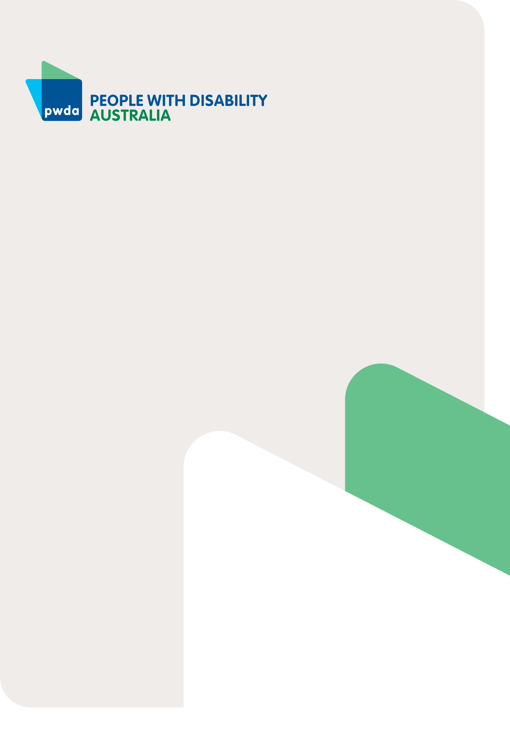

PWDA Disability Royal

Commission Policy Positions
January 2024

A voice
of our own

About PWDA

People with Disability Australia (PWDA) is a national Disability Representative Organisation made up of, and led by, people with disability. Our Board is 100% comprised of people with disability, many of whom are respected disability leaders, with many of our staff members including leadership, also being people with disability. PWDA has a national membership, and we represent the cross-disability interests of the 1 in 6 Australians with disability.

Our response to key Disability Royal Commission recommendations

222 recommendations were made by the Disability Royal Commission in its Final Report which was first published on 29 September 2023. Following extensive consultation with our national membership, PWDA has developed
19 positions on key recommendations.

Governance and Rights Protections
- We support proposals for stronger human rights protections through legislation
and would like a Disability Rights Act enacted first followed by a Human Rights Act, with both requiring close consultation with people with disability.
- We support an appropriately resourced National Disability Commission being created to ensure our rights are being protected, with its oversight and development directed by people
with disability.
- We support the strengthening of disability discrimination laws, including creating a duty to prevent discrimination and making sure migration laws are not discriminatory.
- We support a Minister for Disability Inclusion, who must demonstrate leadership across governments, and have a supporting department with widespread disability representation.
- We support the review of Australia’s Disability Strategy and state/territory plans, as well as creating a National Disability Agreement that does not conflict with our human rights.
- To strengthen human rights protections, we also urge the Australian Government to remove its interpretative declaration on Articles 12, 17 and 18 of the United Nations Convention on the Rights of Persons with Disabilities (CRPD).

Housing
We need governments to act immediately to end segregated housing, by investing in increased supply of and access to options
that promote our right to live independently in the community.

Education and Employment
- We need immediate action to end segregation in education and employment.
- We urge governments to provide adequate resourcing and funding to support the transition to, and better equip mainstream schools to provide, inclusive education within 5–10 years.
- We call for investment in, and the implementation of, a structural and industry-wide transition plan away from segregated employment, to promote open employment.
- We call for all people with disability to be paid the minimum wage immediately.
- We support more ambitious public sector disability employment targets, including at executive levels.
- We support all public services updating their procurement policies and rules to give preference to organisations
that pay people with disability the minimum wage, are disability inclusive and have accessible Information and Communications Technology (ICT).

Safeguarding and redress
- We need a supported decision-making framework that allows people with disability to make decisions about their lives and respects individual will and preferences.
- We seek a commitment from governments to eliminate the traumatic use of restrictive practices. Until restrictive practices are eliminated, we need clear public reporting on when they are used, accountability for when they are misused, and strategies developed to reduce the use of restrictive practices.
- We need nationally consistent and sufficiently resourced Community Visitor Schemes (CVS) to safeguard against harm to people with disability in closed settings. CVS could also potentially play a role in preventing torture and other cruel, inhumane, or degrading treatment or punishment.
- We need a regulator that is appropriately resourced to conduct monitoring, compliance, and enforcement activities effectively.
- We need accessible complaint mechanisms, and we support a ‘one- stop-shop’ complaint reporting and referral mechanism with a dedicated national complaints helpline.
- We call for a national redress scheme to support all people with disability who have experienced violence, abuse, neglect and exploitation.
Read our full Response to the Disability Royal Commission Final Report for more detail on why these policy positions are important to people with disability.

Now is the time to support Australians with disability

The Disability Royal Commission recommendations alongside recommendations from the Independent NDIS Review Final Report released on 7 December 2023, outline
a significant reform agenda for governments. It is time to get behind Australians with disability, to ensure this golden opportunity for change is not wasted.

Disability-led reform is crucial
People with disability must be at the forefront of every decision, policy and action moving forward. A formal
mechanism must be created for people with disability and their representative organisations to lead the prioritisation, sequencing, implementation, and monitoring of reform measures.

To ensure forthcoming reform is disability- led PWDA calls for:
- Formal mechanisms that recognise people with disability as equal partners, and account for the diversity and intersectionality of the disability community.
- Adequately resourcing representation organisations to provide the level
of engagement and representation required to meet the expectations of the disability community and governments, to effectively co-design and co-deliver reform measures and solutions.

People with Disability Australia (PWDA) is a national disability rights and advocacy organisation made up of, and led by, people with disability.
For individual advocacy support contact PWDA between 9 am and 5 pm (AEST/AEDT) Monday to Friday via phone (toll free) on 1800 843 929 or via email at pwd@pwd.org.au

Report contact
Giancarlo de Vera
Senior Manager of Policy E: policy@pwd.org.au

