Budget Measures to Support Long Lasting Reform for the Disability Community
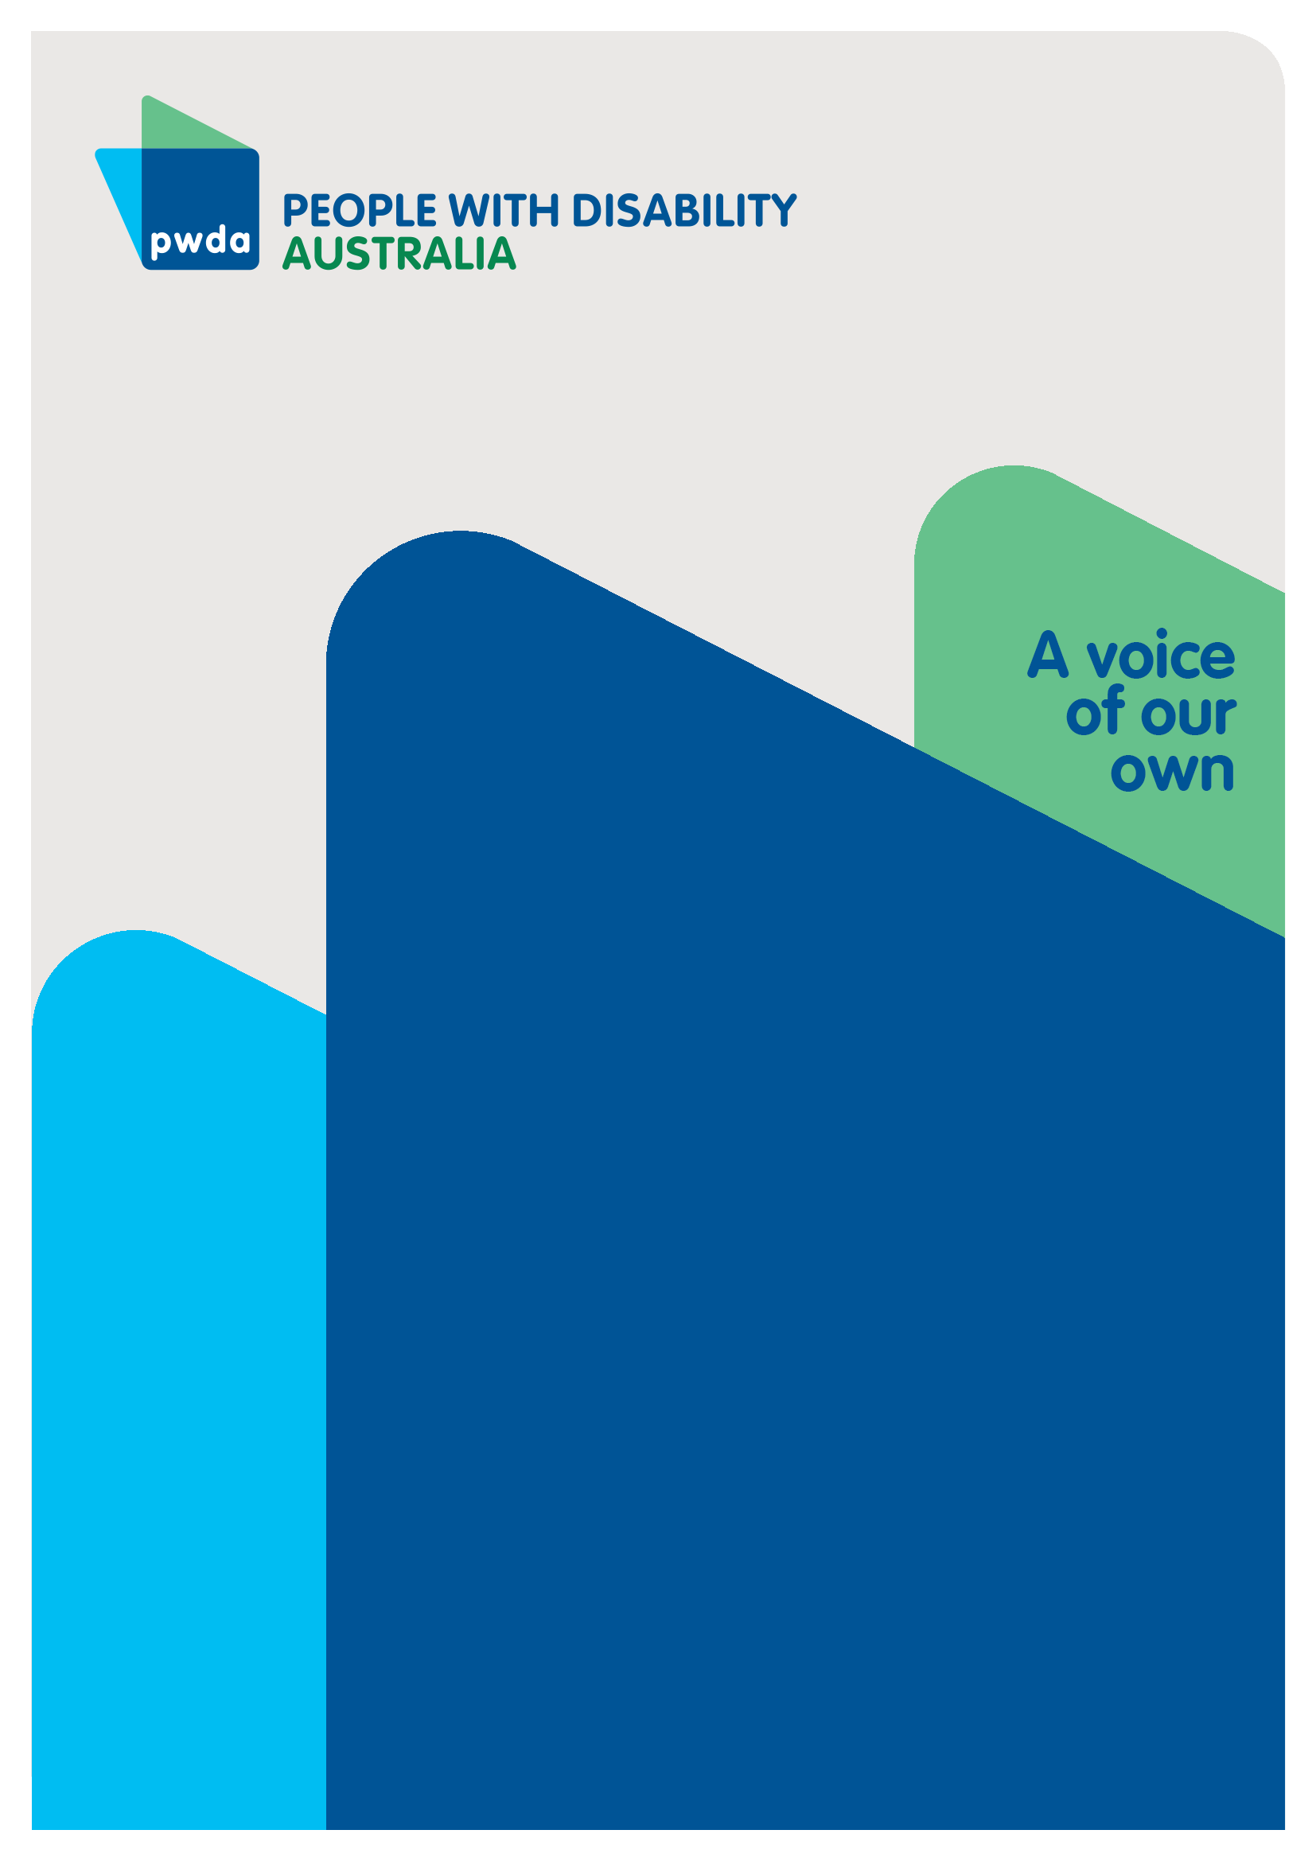
Pre-Budget Submission to the Australian Treasury

JAN
2024

Copyright information
Budget measures to support long lasting reform for the disability community: Pre-Budget Submission to the Australian Treasury

First published in 2024 by People with Disability Australia Ltd.
Level 8, 418a Elizabeth Street, Surry Hills, New South Wales, Australia 2010
Head office also in Sydney
Email: pwd@pwd.org.au
Phone: +61 2 9370 3100 Fax: +61 2 9318 1372
URL: www.pwd.org.au

Typeset in Arial 12 pt and VAG Rounded 26 and 16 pt

© People with Disability Australia Ltd. 2024

The moral rights of the authors have been asserted.

National Library of Australia Cataloguing-in-Publication data:

Creator(s): | Lisa Ira and Giancarlo de Vera
Title: | Budget measures to support long lasting reform for the disability community: Pre-Budget Submission to the Australian Treasury

All rights reserved. Except as permitted with the Australian Copyright Act 1968 (for example, a fair dealing for the purposes of study, research, criticism or review), no part of this book may be reproduced, stored in a retrieval system, communication or transmitted in any form or by any means without prior written permission. All inquiries should be made to the publisher at the address above.

Suggested citation:

Ira, L. and de Vera, G. (2024) Budget measures to support long lasting reform for the disability community: Pre-Budget Submission to the Australian Treasury, Sydney.

ISBN 978-0-6459325-6-0
Table of Contents

Introduction 5
Ensuring a seat at the table 6
Embedding a robust governance mechanism 6
Adequately resourcing Disability Representative Organisations 7
Having our basic needs met 8
Economic security 9
Housing security 9
Ensuring safety in disability supports 11
Conclusion 12

About PWDA
People with Disability Australia (PWDA) is a national disability rights and advocacy organisation made up of, and led by, people with disability.
We have a vision of a socially just, accessible and inclusive community in which the contribution, potential and diversity of people with disability are not only recognised and respected but also celebrated.
PWDA was established in 1981, during the International Year of Disabled Persons.
We are a peak, non-profit, non-government organisation that represents the interests
of people with all kinds of disability.
We also represent people with disability at the United Nations, particularly in relation to the Convention on the Rights of Persons with Disabilities (CRPD).
Our work is grounded in a human rights framework that recognises the CRPD and related mechanisms as fundamental tools for advancing the rights of people with disability.
PWDA is a member of Disabled People’s Organisations Australia (DPO Australia), along with the First People’s Disability Network, National Ethnic Disability Alliance and Women with Disabilities Australia.
DPOs collectively form a disability rights movement that places people with disability at the centre of decision-making in all aspects of their lives. Nothing About Us, Without Us is the motto of members of the international disability community, and it’s our ethos too.

Introduction
The past 12 months have been significant for people with disability. The National Disability Insurance Scheme Review (NDIS Review) and the Royal Commission into Violence, Abuse, Neglect and Exploitation of People with Disability (Disability Royal Commission) both concluded and released their final recommendations.
As we enter the 2024-2025 financial year, significant disability reform will need to commence with the Australian Government as well as state and territory governments, implementing agreed recommendations from both reform processes. Implementing recommendations will take years, and if done ‘right’, these reforms will have a lasting positive impact on people with disability, their families, friends and communities. However, this is no simple task, and it will take time and resources.
To set people with disability up for success and to ensure recommendations are implemented effectively, and the disability community needs are met while recommendations are implemented, we need the next Federal Budget to:
- ensure people with disability have a ‘seat at the table’, through a formal engagement mechanism to influence the reform agenda and implementation
- ensure that Disability Representative Organisations (DROs) are adequately resourced to engage in reform processes
- adequately fund individual advocacy support for people with disability
- ensure our basic needs are met as we face a dire cost-of-living crisis, including through increased JobSeeker payments
- increase our access to housing through an increase to the Commonwealth Rent Assistance rate, funding for home modifications and developing a Targeted Housing Action Plan under Australia’s Disability Strategy and an associated Congregate Housing Transition Plan
- ensure the NDIS Review’s recommendation for expanding the remit of the NDIS Quality and Safeguards Commission is enabled by the provision of appropriate budget allocations.

Ensuring a seat at the table
Article 4(3) of the Convention on the Rights of Persons with Disabilities (CRPD) requires Australia to closely consult with and actively involve people with disability through our representative organisations in developing and implementing legislation and policies that affect us. However, we are still being left out of many conversations and important decision-making processes. We are experts in our own lives and need a ‘seat at the table’ when the Government makes decisions that affect us.

Embedding a robust governance mechanism
In December 2023, People with Disability Australia and 65 other organisations made a statement calling on the Government to immediately establish a Disability Reform Implementation Council to oversee how the NDIS Review and the Disability Royal Commission recommendations are realised. The Council envisioned must have strong representation from people with disability, Disability Representative Organisations and different levels of government.
The NDIS Review Final Report recognises this and called for a committee to be created as part of a governance infrastructure to support the implementation of reforms (see Recommendation 24). In addition, the Disability Royal Commission recognised the importance of consulting people with disability (including their representative organisations) in making major change (Recommendation 4.11).
Over the coming years, the Government will be responding to and implementing the NDIS Review and Disability Royal Commission recommendations. It has never been more important to ensure we have a ‘seat at the table’ to make sure we are involved in decisions that will directly affect us.
Recommendation 1 – The Government urgently funds the establishment and ongoing costs of a Disability Reform Implementation Council to oversee the NDIS Review and the Disability Royal Commission recommendations, led by people with disability and our representative organisations (budget impact not available).

Adequately resourcing Disability Representative Organisations
Disability Representative Organisations (DROs) provide a crucial service for people with disability though their systemic and with some organisations, individual advocacy work. However, DROs are chronically underfunded, while being expected to do more and more. Given reform processes will commence in the 2024-2025 financial year, the next Federal Budget will be the only opportunity to ensure DROs are adequately funded from the very beginning. The disability community cannot play catch up once reform processes start.

Systemic advocacy
DROs require further funding to effectively represent people with disability in various systemic reform processes. This is especially as DROs will be expected to be heavily involved by both Government and the broader disability community to engage with governments’ response to and implementation of both the NDIS Review and Disability Royal Commission’s recommendations in by the 2024-2025 financial year.
Recommendation 2 – Urgently invest in at least each Disability Representative Organisation funded by the Department of Social Services’ Disability Representative Organisations Program, to ensure capacity to be involved in Government’s response to and implementation of recommendations from the NDIS Review and Disability Royal Commission (Cost: at least an additional $500,000 per year for each currently funded Disability Representative Organisation)

Individual advocacy
Likewise, individual advocacy services funded by the Department of Social Services National Disability Advocacy Program (NDAP) are struggling to meet need. As highlighted in Disability Advocacy Network Australia’s (DANA) 2023 Pre-Budget Submission, approximately 1 in 2 people with disability are unable to access advocacy supports when required. We support the following recommendations that were made in DANA’s pre-budget submission, and we reiterate them below:
- Recommendation 3 – Provide urgent additional funding for National Disability Advocacy Program organisations to meet existing advocacy demand until mid-2025 (budget impact: $43 million)
- Recommendation 4 – Create a new grant round for non-National Disability Advocacy Program (NDAP) organisations in urgent need of funding (budget impact: $25 million)
- Recommendation 5 – Deliver a targeted funding boost for independent disability advocates operating in rural, remote and very remote areas (budget impact: $20 million)
- Recommendation 6 – Further sector capacity building: invest in disaster support, First Nations cultural safety training, resources and pilot projects and awareness of supported decision-making (budget impact: $5.225 million)

Having our basic needs met
In our 2023 Pre-Budget Submission we called for a host of budget measures to improve our economic security and housing security. While we note and welcome modest measures were made in the last Federal Budget, these did not go far enough. As a result, many people with disability continue to live in poverty and face major barriers in accessing appropriate housing.
The below targeted economic and housing security measures will ensure the basic cost-of-living and housing needs are met for people with disability. The targeted measures below will support the most socially and economically disadvantaged people with disability, and it is important that those most marginalised are not left further behind.

Economic security
Last year there was a very modest increase of $40 a fortnight to JobSeeker and other related payments. While an improvement, it is not enough to meet our basic living needs given the high cost of living. We reiterate similar recommendations from our 2023 Pre-Budget Submission, and note the below is also consistent with the Australian Council of Social Services (ACOSS) recommendations contained in their 2024-25 Budget Priorities Statement currently before the Treasury:
- Recommendation 7 – Increase JobSeeker payments to the same rate as the Disability Support Pension, inclusive of pension supplements (budget impact not available).
- Recommendation 8 – Introduce a $65 a week disability and illness supplement for people with disability on the JobSeeker payment and the Disability Support Pension to meet additional living costs (budget impact not available).
- Recommendation 9 – Provide lifelong access to the Centrelink Disability Support Pension, and improve access to the Disability Support Pension by permitting people to achieve the 20 points requirements across multiple tables (budget impact not available, but the cost would be negligible if all income support payments were lifted to the same level as the pension)

Housing security
While the delivery of housing is largely the responsibility of state and territory governments, the Australian Government has an important role in improving housing outcomes for people with disability by expanding access to housing for people with disability.
In terms of access to renting, we note that the $31 per fortnight increase to Commonwealth Rent Assistance in the last Federal Budget is welcome but modest and does not match the sky-rocketing rental costs in Australia. As recommended in our 2023 Pre-Budget Submission, and consistent with ACOSS’ 2024-25 Budget Priorities Statement currently before the Treasury, we call on the Government to:
Recommendation 10 – Increase Commonwealth Rent Assistance by 60% (budget impact not available).
As highlighted in our 2023 Pre-Budget Submission, the Government can also take steps to increase access to much needed housing modifications. We recommend that the Government:
Recommendation 11 - Establishes a program to fund necessary modifications of existing housing to (a) meet Livable Housing Australia Silver-level design guidelines, and (b) rationalise existing home-modification assistance programs under one Commonwealth program.
In addition, our recent submission to the National Housing and Homelessness Plan Issues Paper, we highlighted that Australia’s Disability Strategy 2021-2031 does not include any targeted action plans for housing despite a 2022 Productivity Commission recommendation for Commonwealth, state and territory governments to ‘commission a housing Targeted Action Plan under Australia’s Disability Strategy’.
As governments continue to consider the Australia-wide housing crisis, the next Federal Budget will be a key, if not the only, opportunity to budget for the development of a Targeted Action Plan, before a National Housing and Homelessness Agreement is struck between all Australian governments.
Therefore, we call on the Australian Government to create a Targeted Housing Action Plan for People with Disability under the forthcoming National Housing and Homelessness Plan, to set out actions that address issues of housing supply, affordability, accessibility and safety for people with disability.
We also call for a Congregate Housing Transition Plan that would be embedded within the Targeted Housing Action Plan for People with Disability, to better facilitate the Disability Royal Commission’s recommendation to phase out group homes (Recommendation 7.41).
We call on the Government to:
Recommendation 12 – Fund the development, implementation and ongoing review of a Targeted Housing Action Plan for People with Disability and an associated Congregate Housing Transition Plan (budget impact not available).

Ensuring safety in disability supports
The recently released NDIS Review report recommended that the Government establishes and appropriately resources a ‘quality function’ in a proposed National Disability Supports Quality and Safeguards Commission. We note that the last Federal Budget committed $142.6 million over two years to support the NDIS Quality and Safeguards Commission carry out its safeguarding role. However, with the proposed creation of a National Disability Supports Quality and Safeguards Commission, the expanded scope and role of the proposed Commission means the Commission needs to be adequately resourced through appropriate budget allocation in this year’s Budget.
Recommendation 13 – Provide additional resourcing to the proposed National Disability Supports Quality and Safeguards Commission to carry out its proposed expanded scope and role under the NDIS Review (budget impact not available).

Conclusion
With the conclusion of the NDIS Review and Disability Royal Commission, we now face crossroads in realising the rights of people with disability in Australia.
This once in a generation opportunity to deliver much needed positive change for the 1 in 6 Australians with disability, and this golden opportunity must be seized to ensure the next generation of Australians with disability thrive on an equal basis as those without disability.
As reform processes commence and continue into the 2024-2025 financial year, we must ensure that they are accompanied by sufficient budget allocations to support people with disability to engage in this once in a generation opportunity to make lasting change.
The disability community fought for decades to advocate for our rights at the NDIS Review and Disability Royal Commission, and now it is time to make sure this translates into reality.
To do so, it is crucial that people with disability have a ‘seat at the table’ through a formal engagement mechanism that can support the NDIS Review and Disability Royal Commission reform agendas and responses. This will enrich outcomes not only for people with disability, but for the Government and the rest of the community.
At the same time, we must ensure that Disability Representative Organisations are adequately resourced to engage in reform processes and can provide individual advocacy support for people who require it.
In the context of a cost-of-living and housing crisis, the budget must provide measures that ensure our financial and housing security. We need increases to JobSeeker and Commonwealth Rent Assistance and funding for home modifications. We also need an adequately funded Targeting Housing Action Plan and associated Congregate Living Plan to help realise the Disability Royal Commission’s recommendations.
Finally, the NDIS Review’s recommended expansion of the NDIS Quality and Safeguards Commission’s scope and functions must be matched by appropriate resources.
It has never been more important to get this year’s budget right for people with disability.

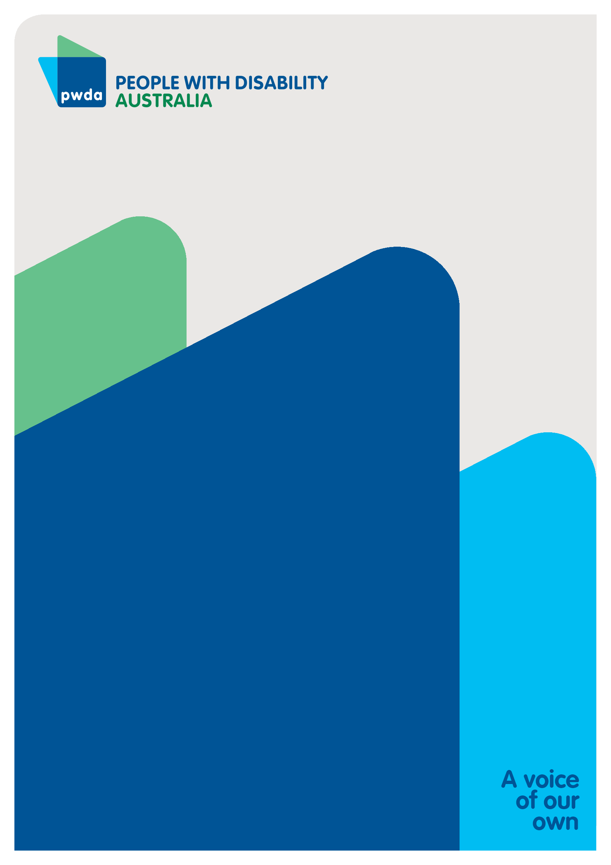
People with Disability Australia (PWDA) is a national disability rights and advocacy organisation made up of, and led by, people with disability.
For individual advocacy support contact PWDA between 9 am and 5 pm (AEST/AEDT) Monday to Friday via phone (toll free) on 1800 843 929 or via email at pwd@pwd.org.au
Submission contact
Giancarlo de Vera
Senior Manager of Policy
E: policy@pwd.org.au

Disability Advocacy Network Australia (2023) NDIS change must be led by people with disability: Joint media statement, accessed 17 January 2023.
Disability Advocacy Network Australia (2023) A strong, sustainable future: addressing capacity shortfalls for a strengthened disability advocacy sector, accessed 16 January 2023.
Productivity Commission (2022) In need of repair: The National Housing and Homelessness Agreement Review, p.16, accessed 17 January 2024
Commonwealth of Australia (2023) Working together to deliver the NDIS: Independent review into the National Disability Insurance Scheme, Final report, accessed 17 January 2023, p. 11.

