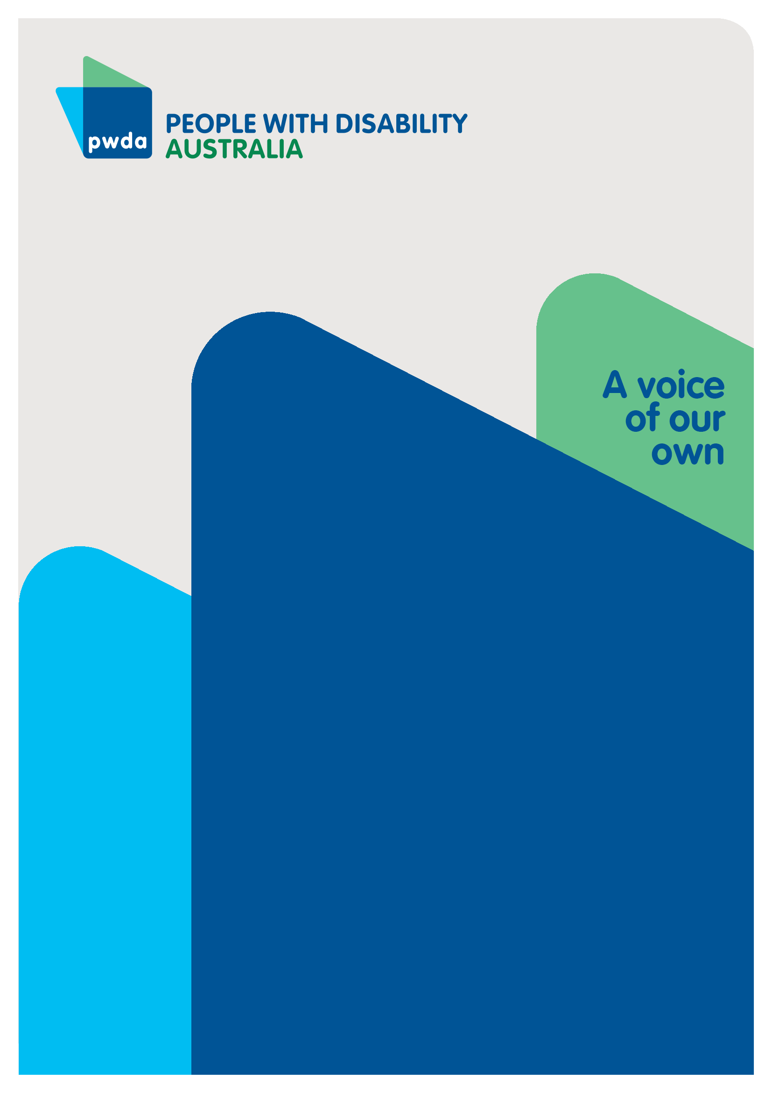
Administration of the 2023 NSW state election
Submission to the NSW Parliament Joint Standing Committee on Electoral Matters.
February 2024

Copyright information
Administration of the 2023 NSW state election: Submission to the NSW Parliament Joint Standing Committee on Electoral Matters.
Copyright © People with Disability Australia Ltd. 2024
First published 2024
Published by People with Disability Australia
Level 8, 418a Elizabeth Street, Surry Hills, Sydney, New South Wales, Australia 2010
Email: pwda@pwd.org.au
Phone: +61 2 9370 3100 Fax: +61 2 9318 1372
URL: www.pwd.org.au
All rights reserved. Without limiting the rights under copyright reserved above, no part of this publication may be reproduced, stored in or introduced into a database and retrieval system or transmitted in any form or any means (electronic, mechanical, photocopying, recording or otherwise) without the prior written permission of both the owner of copyright and the above publishers.
Printed by People with Disability Australia

Table of Contents
About PWDA iv
Introduction v
Our Submission vi
Recommendations xi
Conclusion xii

About PWDA
People with Disability Australia (PWDA) is a national disability rights and advocacy organisation made up of, and led by, people with disability.
We have a vision of a socially just, accessible and inclusive community in which the contribution, potential and diversity of people with disability are not only recognised and respected but also celebrated.
PWDA was established in 1981, during the International Year of Disabled Persons.
We are a peak, non-profit, non-government organisation that represents the interests
of people with all kinds of disability.
We also represent people with disability at the United Nations, particularly in relation to the Convention on the Rights of Persons with Disabilities (CRPD).
Our work is grounded in a human rights framework that recognises the CRPD and related mechanisms as fundamental tools for advancing the rights of people with disability.
PWDA is a member of Disabled People’s Organisations Australia (DPO Australia), along with the First People’s Disability Network, National Ethnic Disability Alliance and Women with Disabilities Australia.
DPOs collectively form a disability rights movement that places people with disability at the centre of decision-making in all aspects of our lives.
‘Nothing About Us, Without Us’ is the motto of Disabled Peoples’ International (DPI).

Introduction
People with Disability Australia has drafted this submission to help inform changes to the conduct of the 2027 NSW State Election, so that all people with disability are able to exercise their rights, unimpeded, to vote.
The abolition of the iVote system in particular disadvantaged people with vision impairment. People with Disability Australia 9PWDA) and our members were disappointed that the system was not re-commissioned in time for the 2023 election. We have since then participated in the NSW Electoral Commission's review of technology assisted voting. We participated in that review with our colleagues Blind Citizens Australia, ACCAN (Australian Communications Consumer Action Network), and Guide Dogs Australia. We attach our joint submission to that review for your additional information and commend its recommendations to you.
Put simply, PWDA does not consider it acceptable that our members be forced to participate in another election without the NSW Government and the NSW Electoral Commission investing in reasonable adjustment to allow all voters to participate equally.
PWDA supports the submission made to this inquiry by our colleagues, Blind Citizens Australia.

Our Submission
Since the 2019 NSW state election, PWDA has participated in NSW Electoral Commission consultations about accessibility issues, notably on technology-assisted voting. This has been on a replacement for iVote, which, following its failure at the 2021 local government elections, was not available for the 2023 NSW state election. This was a considerable failure to efficiently ensure people with disability could fairly and equally participate in the 2023 NSW state election.
This paper raises issues relating to participation in the 2023 NSW election of people with vision impairment and extends this to an in-principle discussion about the rights of people with disability to vote and participate fulsomely in our democratic processes.
For example, there are currently more than 500,000 people who are blind or vision impaired in Australia with estimates that this will rise to 564,000 by 2030.
Australians who are blind or vision impaired live rich and active lives and make meaningful contributions to their communities: working, volunteering, raising families and engaging in sports and other recreational activities.
The extent to which people can actively and independently participate in community life does, however, rely on facilities, services and systems that are available to the public and which are designed to be inclusive of the needs of all citizens.
PWDA reconfirms recommendations made to the NSW Electoral Commission’s review of technology assisted voting to provide equal access to all voters who are blind or vision impaired, and to improve the electoral participation of people with disability in future elections: These are:
- the NSW Electoral Commission commits to the development of a technology assisted voting system that provides multiple options for voters who are blind, or vision impaired to vote independently, secretly and verifiably; to be made available for future NSW elections.
- any technology assisted voting system implemented in NSW provides a voting platform that can accommodate different accessibility requirements at the same time as ensuring security and performance.
- people who are blind or vision impaired, and the broader disability community, is consulted and involved in the development and implementation of any such system to ensure it is fit for purpose.
PWDA notes the inquiry by the Joint Standing Committee on Electoral Matters on the administration of the 2019 NSW State Election, its report and findings, and the Government response. Whilst PWDA cannot judge the status of the implementation of the recommendations made in that report and the Government's response, it remains the case that the accessibility of polling places and the processes to support people with disability to vote, could be further improved.
For example, the Government accepted recommendation 13, that the NSW Electoral Commission conduct a review of the number and location of early voting centres in NSW prior to the 2023 State election to ensure an appropriate level of accessibility, stating that “[t]he NSW Electoral Commission supports the recommendation and notes that accessibility is one its main priorities when selecting any voting centre".
At the 2019 State election, 66% of districts had at least one “accessible” voting centre and 90% of those districts had at least one voting centre that was “fully accessible””. This meant that 61 of the 92 NSW electorates had a voting centre which was accessible, with 55 of those 61 electorates with a single voting centre which was fully accessible.
And, what lies behind the statistics is important. Not all electorates (electoral districts) are the same geographical size, as boundaries are determined by population size. If a person with disability resides in the electorate of Murray, for example, they might live in Hay, Balranald, Griffith or Deniliquin, and only one of those townships might be the polling place that is the accessible voting centre. People with disability should not be required to travel hours and cover hundreds of kilometres (and in areas underserved by public transport), simply to cast their vote.
Recommendation 17, that the NSW Electoral Commission facilitate a thorough review, upgrade and testing of the iVote system well in advance of the 2023 NSW State election, in consultation with all relevant stakeholders to ensure optimal security, reliability and accessibility was accepted. However, the iVote system was not available at the 2023 election.
Since then, PWDA has, along with colleague organisations in the disability sector, engaged with the NSW Electoral Commission in the redesign of a suitable system to support vision impaired voters in time for the 2027 election. However, community concern about the preparedness of the NSW Electoral Commission to reintroduce technology assisted voting is reflected in media reports, which suggest that the legislation necessary could be more complex than first thought. It would be useful for the Joint Committee on Electoral Matters to understand from the NSW Electoral Commission what this complexity entails and why it was not envisaged earlier. How it intends to involve the disability community in the design of any new system should also be clarified because the disability sector should be an equal partner at every stage of design, development, testing and implementation of a new technology assisted voting platform. Whatever the reasoning and the complexity, work on drafting the relevant amendments to ensure the 2027 NSW state election should begin immediately. No voter should be discouraged from casting a verifiable vote at the 2027 NSW state election.
PWDA notes that the a Request for Information (RFI) has been issued, and will be used by the NSW Electoral Commission to inform planning for the potential re-introduction of online voting, with the Commission’s RFI stating it “is seeking to engage with industry to undertake strategic dialogue with the market to ascertain the availability, suitability and viability of a potential internet voting solution for use by electors who are blind or have low vision at the NSW State General Election in 2027”.
Respectfully, PWDA anticipates that the NSW Electoral Commission will also engage with the disability community to assess the viability, suitability and usability of any proposed technology assisted voting system. We believe it is imperative that any technology provider or developer engages, as an equal partner, with the disability community at the commencement of planning, building and testing to ensure that any system proposed to be developed is accessible, appropriate and deemed fit for purpose by people with disability, centering the people it is designed to support within the design and development process..
While PWDA understands that the RFI is seeking information about how technology assisted voting can be used by voters who are not blind or vision impaired, we should remain cognisant of the fact that it was first designed to support people with disability and this community of voters should remain the focus for its re-introduction.
PWDA anticipates that the NSW Electoral Commission would not proceed to tender unless the developer was able to demonstrate a collaborative arrangement with the disability community in the design, user testing and implementation of any technology assisted voting system.
Other recommendations made by the Committee in its 2020 report, relate to the systems and other support provided to voters with disability. These included the publication and distribution of how-to-vote cards, and the training of staff to assist the filling out of, and submitting, a completed ballot paper in a manner that promotes integrity and upholds the secrecy and choice of the person voting. These issues should continue to be the subject of ongoing consultation and discussion between the Government, the NSW Electoral Commission and the disability community, in accordance with good governance and as prescribed by the NSWEC Disability Inclusion Plan.

Recommendations
- Recommendation 1. The NSW Electoral Commission commits to the development of a technology assisted voting system that provides multiple options for voters who are blind or vision impaired to vote independently, secretly and verifiably; to be made available for the 2027 NSW state election and all elections thereafter.
- Recommendation 2. Any technology assisted voting system implemented in NSW provides a voting platform that can accommodate accessibility requirements at the same time as ensuring security and performance.
- Recommendation 3. Voters who are blind or vision impaired, and People with Disability Australia (PWDA) are engaged by the successful provider of both the Request for Information and the Request for Tender, in the development of technology assisted voting systems, to ensure these are fit for purpose.
- Recommendation 4. Increase the number of accessible voting centres in all electoral districts, and list these in advance of the opening of pre-polling centres and all voting centres on the NSW Electoral Commission website.
- Recommendation 5. NSW Electoral Commission continues to include the disability community in the design and implementation of technology assisted voting and that this be implemented in time for the 2027 NSW state election.
- Recommendation 6. The Government and the NSW Electoral Commission continue to include the disability community in the design and implementation of all other supports for voters with disability.

Conclusion
PWDA wishes to thank the Joint Standing Committee on Electoral Matters for seeking our views on the administration of the 2023 NSW State election. The processes by which elections are managed are important to upholding both international covenants and national laws that protect the right of citizens to vote. Inclusive practices that allow a voter with disability to vote, including the location of accessible voting places, technology assisted voting, person assisted voting, or the physical assets of a voting place like the design of booths, the size, height, colour and depth of booths, the pencil or other writing materials offered to voters, all impact on a person’s ability to exercise their right to vote.
PWDA has made some recommendations to inform the administration of the next NSW State election and looks forward to ongoing engagement with both Government and the NSW Electoral Commission on improvements that facilitate more accessible participation of voters with disability in elections.

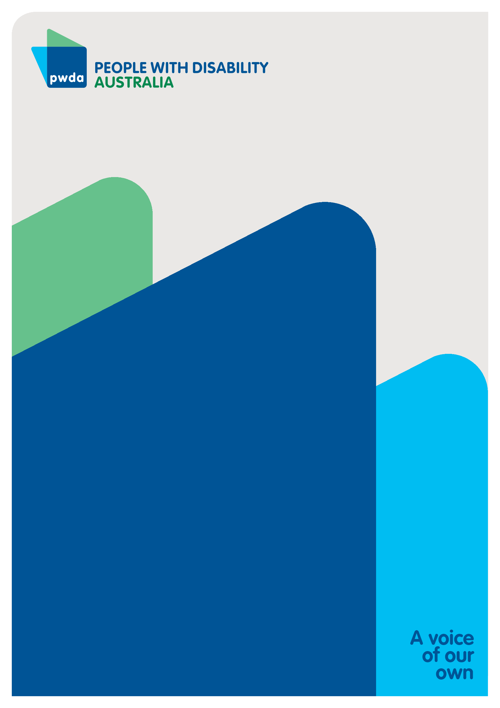
People with Disability Australia (PWDA) is a
national disability rights and advocacy organisation
made up of, and led by, people with disability.
PWDA submission contact:
Joanne Yates
NSW Policy Lead
policy@pwd.org.au

Please see the joint submission of PWDA, BCA, ACCAN and Blind Dogs Australia to the NSW Electoral Commission's review, attached.
https://www.parliament.nsw.gov.au/committees/inquiries/Pages/inquiry-details.aspx?pk=2549
https://www.parliament.nsw.gov.au/ladocs/inquiries/2549/Government%20Response%20-%20Administration%20of%20the%202019%20NSW%20State%20election.pdf
https://www.parliament.nsw.gov.au/ladocs/inquiries/2549/Government%20Response%20-%20Administration%20of%20the%202019%20NSW%20State%20election.pdf, page 8
https://www.parliament.nsw.gov.au/ladocs/inquiries/2549/Government%20Response%20-%20Administration%20of%20the%202019%20NSW%20State%20election.pdf, page 9
NSW internet voting revival needs even more legal changes - Software - iTnews, 4
https://elections.nsw.gov.au/getmedia/32e75622-e0d2-49df-9ffa-751fef5fedda/tav-review-final-report.pdf
NSW takes first steps at restarting internet voting strategy - Strategy - Software - iTnews,.
https://www.tenders.nsw.gov.au/?event=public.rft.showClosed&RFTUUID=D7018DD5-9815-4027-C56D9F95280073B5
https://www.innovationaus.com/online-voting-nsw-gets-the-ball-rolling-on-ivote-2-0/
https://www.parliament.nsw.gov.au/ladocs/inquiries/2549/Final%20Report%20-%20Administration%20of%20the%202019%20NSW%20State%20Election.PDF

