About our Privacy Policy

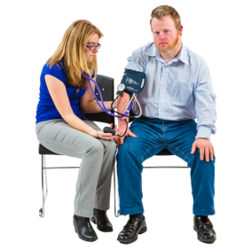  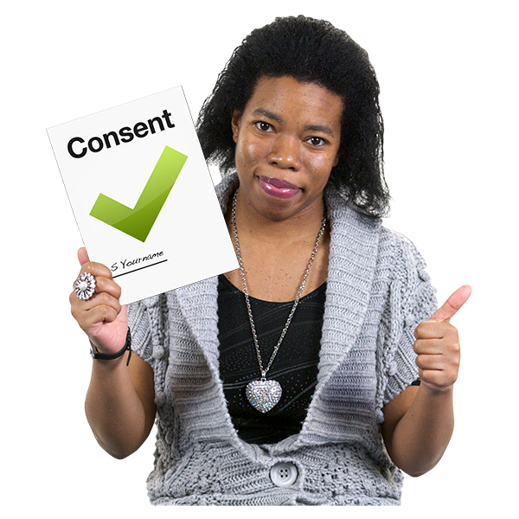  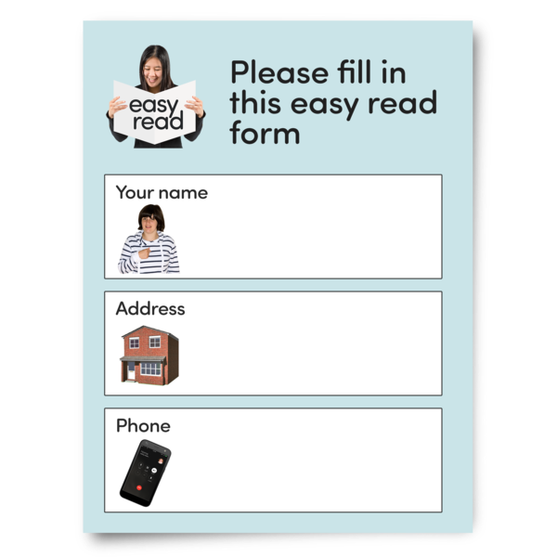  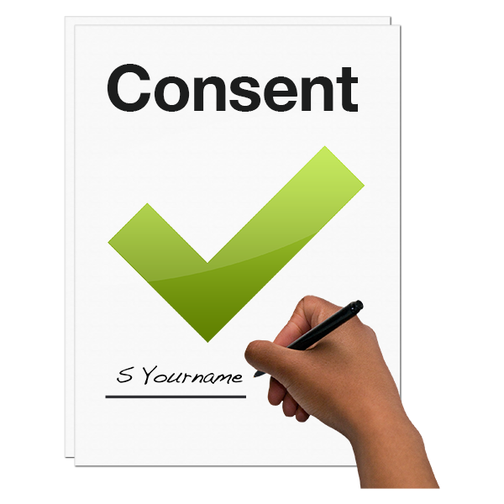  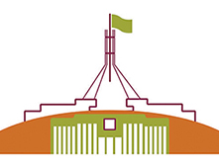  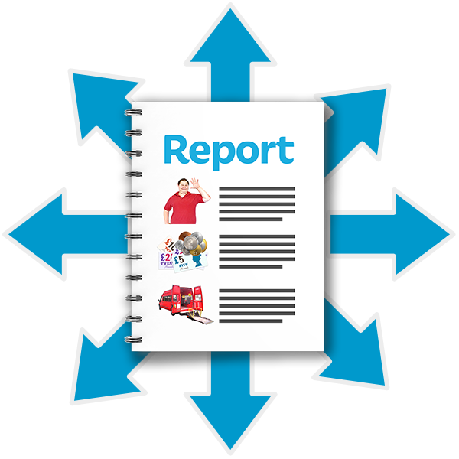  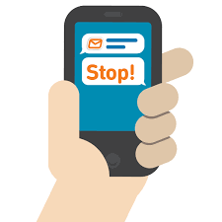  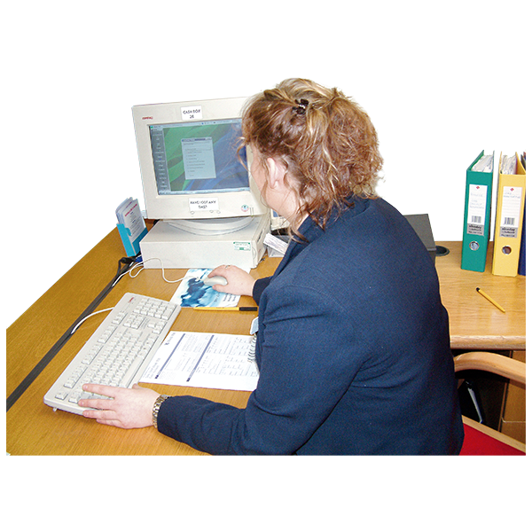  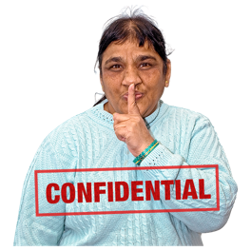  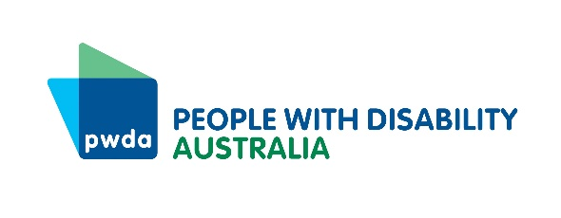  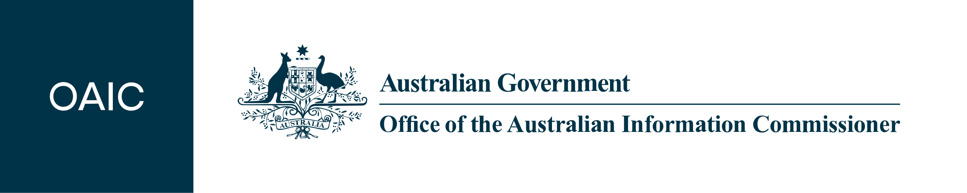 | This is Easy Read information about PWDA’s Privacy Policy.  The Privacy Policy is PWDA’s rules about how we use people’s personal information and keep it private.  You can ask us for a copy of the full policy or click here to look at it.  Please tell us if you would like some help to read the information.  Everyone has a right to privacy  The law that says people have the right to have their personal information kept private.  PWDA follows the law to keep your information safe.  What is Personal Information?  PWDA sometimes collects people’s personal information. Your personal information is things like:  Your name  Where you live and how to contact you, such as your email address and phone number  How old you are  The kind of work you do  It can also be other information about you or that people know is about you.  The law says we have to keep some kinds of personal information even more private. This is called sensitive information.  Sensitive information about you could be:  Information about your health or disability,  If you are in the NDIS  Your race – such as Aboriginal or African  A criminal record – if you broke a law and got into trouble  We only collect your sensitive information if we need it to do our work. We must always get your consent for us to have your sensitive information. This means you say it is OK. You can choose to say it is not OK.  How do we collect your personal information?  We usually get your personal information directly from you. This could be when you:  - Fill in a membership form or apply for a Qantas Concession Card  - Donate some money to PWDA  - Ask us for information  - Use our services  - Fill in one of our surveys  - Tell us about your experiences  - Take part in a PWDA event or activity  - Contact us in any way.  If you use PWDA services, other people or organisations, such as your health care provider, might give us information about you.  We need your consent to get your information from other people. Or if you have told someone else they can contact PWDA about you. This could be your family, guardian or another organisation helping you to get services or information from PWDA.  Our website  Our website is set up with ‘cookies’. Cookies collect some of your information when you use the website. This makes it easier for you if you use the website more than once.  It also helps PWDA to see why people use our website so we can improve our online information and services.  You can set your computer or other device to stop cookies so our website doesn’t collect your information. But this will mean you can’t see or use some of the things on our website.  If you use links on our website to go to other websites, they won’t follow our Privacy Policy. They will have their own privacy policies.  What happens if we can’t collect your personal information?  It is usually best if we have your name and contact information. But sometimes you might not want to give it to us.  If we don’t have your personal information, we might not be able to provide the service or information you want. Or the service or information might not be as good or useful to you.  But sometimes we can help you without your details. For example if you want general information and we can answer it straight away.  Why do we collect and use your personal information?  There are different reasons why we collect people’s information.  The kind of information depends on why you are in touch with us.  We need people’s personal information to help us do our work.  This includes making sure people get the services and help they need.  Speaking up to government for the rights of people with disability.  Writing reports about the work we do.  Getting money to help us do our work.  Making sure we follow the law about how we have to work.  Helping us to put things right if you have a complaint about PWDA.  Direct Marketing  This is when we send you information about things we think you will be interested in such as our services, the work we are doing and other news.  We might send it in different ways such as email, mail or SMS (text message).  You can choose not to get direct marketing from us. This is called ‘opting out’. You can opt out on the email or SMS, or you can phone or email us to tell us you don’t want to get our direct marketing.  We never give your personal information to other organisations so they can do direct marketing to you.  Who can we give your information to?  We only give your personal information to people who need it to do their work. This is our staff and other people who do work for PWDA.  We make sure all of these people know they have to keep your information private.  Sometimes we may need to give your information to government or other organisations. We will always get your consent to share your information like this.  Sometimes we might use information people tell us about their experiences to help us in our work. We always ask for your consent or we don’t use your details to make sure people can’t tell it is your story.  Can I see my personal information at PWDA and make sure it is correct?  You can ask for a copy of the information we have about you. We can usually show it to you.  We might not be able to let you see it if it includes other people’s personal information. We will let you know if this is why you can’t see it.  You can ask PWDA to change any information about you that is wrong. If we think it doesn’t need changing, we will add a note to say you don’t agree with it.  We won’t charge you any money to ask to see your information or to make any changes to it.  We will always do our best to communicate with you in the way that works best for you.  How do we keep your information safe?  We always follow the law and our Privacy Policy to keep your personal information safe.  We do as much as we can to keep your personal information safe – whether it is on paper or on the computer.  We do this in different ways such as with passwords, and locked filing cabinets. We make sure people can only see your information if they need it to do their job for PWDA.  Contacting Us and Making a Complaint  Please get in touch with us if you have any questions about privacy at PWDA.  Please tell us if you have a problem with how we look after the privacy of your information. You have the right to make a complaint.  We will get in touch with you to help you sort it out. We will do it as soon as we can.  PWDA can organise support to make a complaint if you need it. Let us know what you need.  We will keep your questions or complaints private.  If you want to make a complaint or find out more about Privacy at PWDA, contact our Governance and Compliance Coordinator at:  People with Disability Australia  PO Box 666  Strawberry Hills NSW 2012  Free Call: 1800 422 015  Phone: 02 8365 0400  Email: pwd@pwd.org.au  If you aren’t happy with how we work on your complaint you can take it to the office of the Australian Information Commissioner.  Phone: 1300 363 992  Email: enquiries@oaic.gov.au  Changes to the Privacy Policy  If we change the PWDA Privacy Policy we will put information about the changes on our website.  The last time we updated our Privacy Policy was on 13 January 2022.

