Getting help with my NDIS plan
An NDIS plan says what support and services a person with disability will get.
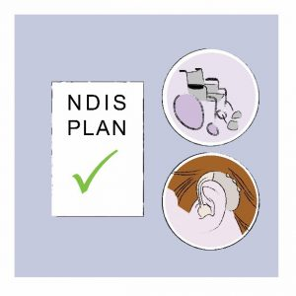
Your NDIS plan can help you with:
- Mobility aids
- Communication devices
- Personal care
- Transport costs.
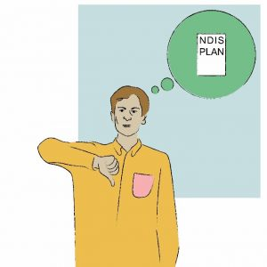
Are you unhappy with your NDIS plan?
You or someone you trust can ask for help from an advocate.
An advocate can:
- Listen to you and find out what you want to make that happen.
- Support you to make phone calls and go to the meetings.
- Help you say what you need.
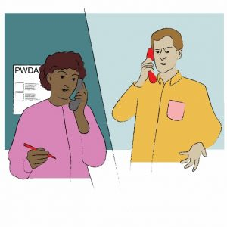
People with Disability Australia can find an advocate to help you.
You or someone you trust can call us.
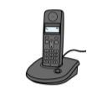
Call us on the phone for free: 1800 422 015
Or visit the PWDA website here.

