How To Make a Complaint About Your Advocate

To make a complaint about your advocate to People with Disability Australia, you can contact us in any of these ways:
Free call from home
1800 422 015
or
Telephone
(02) 8365 0400
or
Email
pwd@pwd.org.au

If you don’t want to tell People with Disability Australia about being unhappy with your advocate, you can call the Complaints Resolution and Referral Service (CRRS):
Telephone
1800 880 052

Making a complaint about your advocate
I am not happy with my advocate.
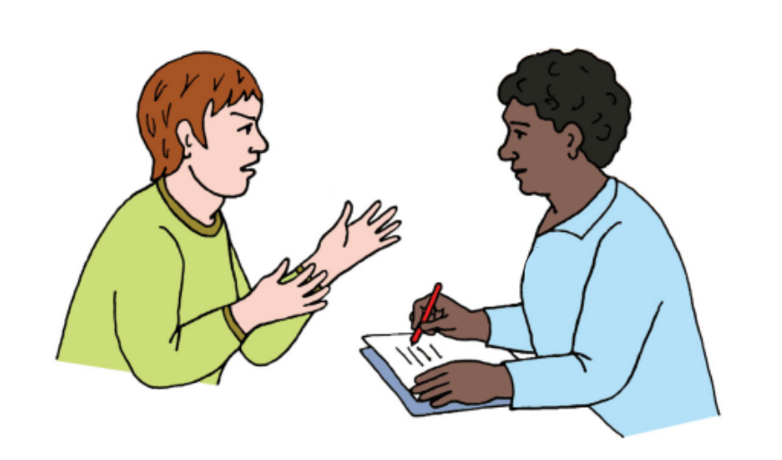
I can talk to someone else at People with Disability Australia.
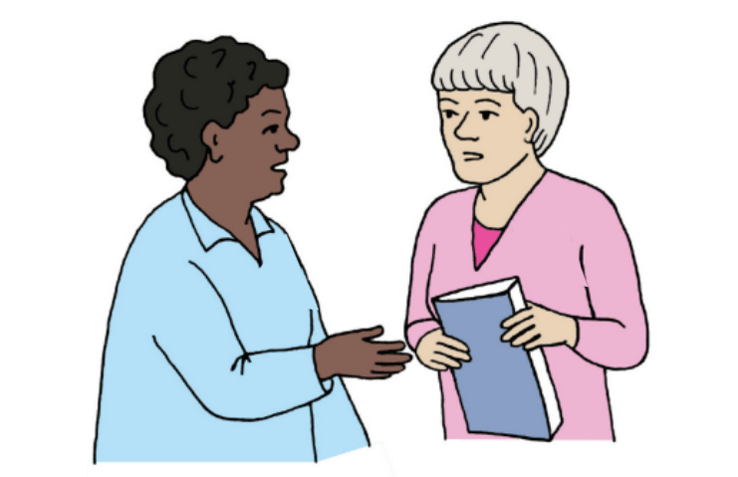
People with Disability Australia will try to find out what happened.
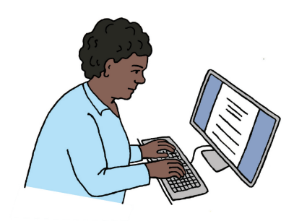
People with Disability Australia will try to fix the problem.
They will tell me what they have done.
They will ask me if I am happy now.

