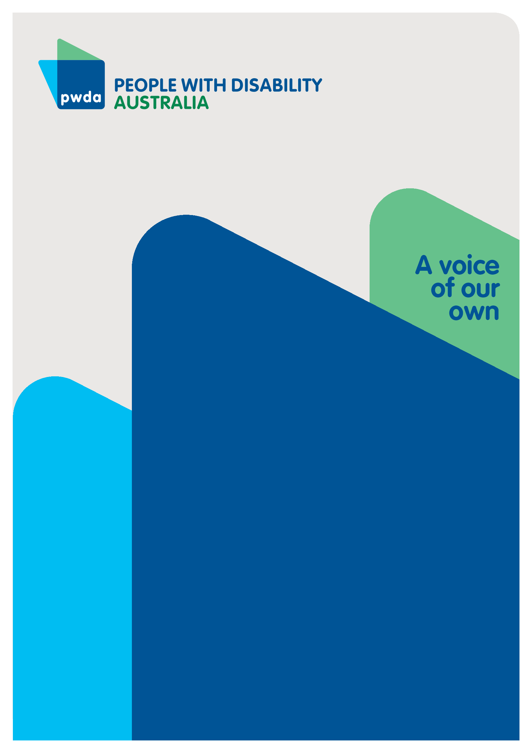
Here to Stay

Working to future proof the NDIS
Submission to the Senate Community Affairs Legislation Committee’s Inquiry into the NDIS Amendment (Getting the NDIS Back on Track No. 1) Bill 2024
MAY
2024

Copyright information
Here to Stay – Working to future proof the NDIS

First published in 2024 by People with Disability Australia
Suite 10.01, Level 10, Centennial Plaza, 300 Elizabeth St, Surry Hills, NSW 2010
Head office also in Sydney
Email: pwd@pwd.org.au
Phone: +61 2 9370 3100 Fax: +61 2 9318 1372
URL: www.pwd.org.au

Typeset in Arial 12 and 14 pt and VAG Rounded 16, 22 and 26 pt

© People with Disability Australia 2024

The moral rights of the authors have been asserted

National Library of Australia Cataloguing-in-Publication data:

Creator(s): | People with Disability Australia
Title: | Here to Stay – Working to future proof the NDIS

All rights reserved. Except as permitted with the Australian Copyright Act 1968 (for example, a fair dealing for the purposes of study, research, criticism or review), no part of this book may be reproduced, stored in a retrieval system, communication or transmitted in any form or by any means without prior written permission. All inquiries should be made to the publisher at the address above.

People with Disability Australia, Here to Stay – Working to future proof the NDIS, 17 May 2024, People with Disability Australia, Sydney
ISBN: 978-0-6459325-8-4

About PWDA
People with Disability Australia (PWDA) is a national disability rights and advocacy organisation made up of, and led by, people with disability.
We have a vision of a socially just, accessible and inclusive community in which the contribution, potential and diversity of people with disability are not only recognised and respected but also celebrated.
PWDA was established in 1981, during the International Year of Disabled Persons.
We are a peak, non-profit, non-government organisation that represents the interests of people with all kinds of disability.
We also represent people with disability at the United Nations, particularly in relation to the United Nations Convention on the Rights of Persons with Disabilities (CRPD).
Our work is grounded in a human rights framework that recognises the CRPD and related mechanisms as fundamental tools for advancing the rights of people with disability.
PWDA is a member of Disabled People’s Organisations Australia (DPO Australia), along with the First People’s Disability Network, National Ethnic Disability Alliance and Women with Disabilities Australia.
DPOs collectively form a disability rights movement that places people with disability at the centre of decision-making in all aspects of our lives.
‘Nothing About Us, Without Us’ is the motto of Disabled Peoples’ International.

Contents

Introduction 5
Summary of Recommendations 7
About the Bill 10
PWDA response 13
General comments 13
Statement to participants and NDIS Rules 16
New reasonable and necessary budget framework 18
New framework plans 21
New definition of ‘NDIS supports’ 24
Measures to protect participants 25
New quality and safeguard amendments 27
Conclusion 28
Appendix 1 29

Introduction
PWDA welcomes the opportunity to provide feedback to the Senate Community Affairs Legislation Committee Inquiry into the Exposure Draft of the National Disability Insurance Scheme Amendment (Getting the NDIS Back on Track No.1) Bill 2024 (referred to as the NDIS Amendment Bill).

PWDA extensively engaged with its national membership to help shape our response to the NDIS Amendment Bill. We surveyed our membership and received 259 responses, and through two dedicated membership consultations we also consulted with 61 people from the disability community.

Our submission proudly reflects their views and is firmly rooted in a rights-based approach. To know what our members said on a range of topics related to this Bill please see Appendix 1.

During our consultations with our members, we heard recurring concerns about the NDIS Amendment Bill. PWDA, who advocates for exceptionally marginalised groups, has significant concerns about the future support for people with a disability under this legislation.

This legislation is not universally welcomed by members, who have reservations about the implementation of this legislation, including the view that its introduction may be premature. For example, the Government has yet to table its formal response to the NDIS Review Report. Other concerns include potential upcoming reforms to the workplace and the timing of this undertaking.

State and territory governments are to start delivering foundational supports to people with a disability by mid-2025; this is an ambitious deadline. The strategy to deliver on this ambition, including design, planning, commissioning, and implementation, is not yet agreed, leaving foundational supports undefined, unknown, and unfunded.

PWDA urges the Government to listen to the voices of the many people with disability who have contributed to the NDIS Review and to this Amendment Bill. The proposed reforms have created great anxiety within the disability community. Their voices must be heard and respected.

PWDA recommends a delay in the commencement of the NDIS Amendment Bill until the foundational support strategy is clearly defined, agreed upon, and when support is solidly in place. This delay will ensure that all people with a disability, including the most marginalised, can access the supports we need to live active, engaged, and healthy lives.

Any reform to the NDIS should be built upon the agreed recommendations from the Final Report of the Independent Review into the NDIS and the Final Report of the Royal Commission into Violence, Abuse, Neglect, and Exploitation of People with a Disability. Both reports relied heavily on the input of people with a disability. The Government must table its formal responses to these significant pieces of work before commencing any other reforms.

PWDA recommends that, at each step in the reform agenda, the Government commits to co-designing with people with a disability. People with a disability must be at the heart of government efforts.

PWDA encourages the Government to keep our international obligations in mind, as a signatory under the UNCRPD.

PWDA believes that the NDIS has been a lifesaving, innovative system. Like other Australians, we want it to continue, growing and providing the same safety net Medicare provides for other Australians. Our community seeks an NDIS that is enduring, sustainable, and which truly serves the needs of the people it was designed to support.

PWDA is committed to supporting people with disability as we continue to discuss disability reform in Australia. The NDIS should continue to be an example of what a fair and compassionate society can achieve.

Summary of Recommendations
Recommendation 1 – The right to appeal
The proposed eligibility reassessment process must be clarified by providing more details on its use, timing, when it will be conducted, by whom, and who will be subject to an eligibility reassessment.

Recommendation 2 – Genuine co-design involvement
The Minister for the NDIS must be committed to genuine co-design. Co-design should be clear, prioritised, and implemented according to an agreed process. It must be meaningful, timely, fair, and authentic. It must contain diverse voices.

Recommendation 3 – Continuous co-design in implementation processes
To improve NDIS plans, any changes to how needs, supports, and budgets are identified must be co-designed with people with a disability throughout the development stages, not just consulted on before implementation. Feedback must be genuinely included.

Recommendation 4 – Comprehensive needs assessment
Any proposed Needs Assessment must look at all the needs of the person with a disability, not just their impairments. It should include supports from the NDIS and other agencies. Clear guidelines must ensure assessments are consistent.

Recommendation 5 – Identifying and addressing all needs
The NDIS must broadly consider all impairments, regardless of disability requirements, in order to identify and address all the needs described by the participant during their Needs Assessment. These needs should be properly acknowledged and met.

Recommendation 6 – Participant discussions before finalisation
The NDIS Amendment Bill must require thorough discussions with the participant, not just their provider, before finalising the Needs Assessment to make sure all support needs are considered. This process must be detailed during the co-design phase and overseen.

Recommendation 7 – Clear review and appeal processes
The Needs Assessment process must include clear information on how and when outcomes can be reviewed, and how participants can appeal decisions. The review and appeal processes must be simple, accessible, easy to navigate, and must be reviewable decisions.

Recommendation 8 – Transparent budget calculation methods
The government must develop and publish detailed, clear methods for calculating budgets based on NDIS participants’ needs assessment outcomes. These methods should be created with input from people with a disability and be made publicly available alongside the Bill to ensure transparency and accountability.

Recommendation 9 – Evidence-based, participant-centred tools
Any processes or tools developed for the purpose of assessing people with disability tools should be evidence-based, participant-centred, and developed via a genuine co-design process with the disability community to ensure they meet the needs of all participants effectively.

Recommendation 10 – Supported decision-making consideration
NDIS rules must ensure that the need for supported decision-making is considered throughout any decision-making process, including during participants’ Needs Assessments. In addition, supported decision-making must be funded by the Agency.

Recommendation 11 – Safeguards against hardship
The NDIS Amendment Bill must protect participants from any negative impacts during changes. Measures should be in place to ensure participants do not face service interruptions or reduced support during the transition to new assessment and funding methods.

Recommendation 12 – Fair approach to spending breaches
The NDIS must address breaches of spending rules in a fair way, considering individual circumstances and focusing on education and support, rather than harsh penalties.

Recommendation 13 – Evidence-based changes to plan management
Any changes by the NDIA to a participant’s chosen plan management type must be rare and based on clear, strong evidence of actual or potential wrongdoing, with strict oversight and clearly communicated justification.

Recommendation 14 – Presumption of participant plan management choice
The NDIS should respect the plan management type chosen by the participant. Regular checks should ensure it remains the best option for their needs.

About the Bill
National Disability Insurance Scheme Amendment (Getting the NDIS Back on Track No. 1) Bill 2024

This Bill amends the NDIS (National Disability Insurance Scheme) Act 2013 to do the following:

- Statement to participants and NDIS rules
  - Require the National Insurance Disability Agency (NDIA) to give participants a clear statement on the basis they entered the NDIS, either by meeting disability requirements, the early intervention requirements, or both.
  - Clarify and expand the NDIS rules about access, including decisions about entry criteria and what to consider and what not to consider when making these decisions.

- New reasonable and necessary budget framework
  - Create the new reasonable and necessary budget framework for participants’ NDIS plans. Participants will receive funding based on whether they accessed the NDIS with impairments that met the disability requirements or the early intervention requirements, or both.

- Specify in the legislative instruments and the NDIS rules for new framework plans:
  - The process for the Needs Assessment and
  - The method for calculating the total amount of both the participant’s flexible funding and their stated supports, stating that these are to be developed in consultation with people with disability, the disability community, health and allied health professionals, and with all States and Territories.

- New definition for ‘NDIS supports’
  - Provide a clear definition for all participants of the authorised supports that will be funded by the NDIS and those that will not.

- Measures to protect participants
  - The NDIS CEO will specify in the statement of participant supports the total funding for reasonable and necessary supports and the funding for each support or class of supports up to a specified amount.
  - Participants may only spend funding for NDIS supports in accordance with their plan. Participants should spend up to the limits in their plan unless their needs significantly change and spend on supports needed as a result of their impairment.
  - The NDIA may change the plan management type as well as impose shorter funding periods to safeguard participants where others may seek to exploit or coerce the participant to spend in ways that are not in their best interests.

- New quality and safeguard amendments
  - Impose conditions that approve quality auditors may not employ or engage people who have banning orders.
  - Enable greater delegation of the Commissioner’s compliance and enforcement powers to specified positions.

- The Bill sets out schedules for amendments covering:
  - Clarifies the process for reassessment of participant status.
  - Provides for participants to transition to a new framework plan.
  - New framework plans to have a flexible budget and a budget for stated supports.
  - Old framework plans to have a total budget.
  - Updates the circumstances where the NDIA will manage funds.
  - Specification that participants may spend money only on NDIS supports in their plan.
  - Exemptions for NDIS rules from sunsetting.
  - Conditions for approval of quality auditors in relation to the employment of someone with a banning order.
  - Expanded compliance and enforcement delegation powers.

- Other Important purposes:
  - The NDIS Amendment Bill is designed to give effect to several recommendations in the NDIS Review.
  - The term ‘reasonable and necessary supports’ will be replaced by ‘supports’ or ‘NDIS supports’, and the concept of reasonable and necessary for participants will apply instead to a participant’s ‘reasonable and necessary budget’.
  - National Cabinet is expected to moderate cost growth of the NDIS in the medium to long term towards a sustainability target of eight per cent.

PWDA response

General comments

Corrections to the NDIS Amendment Bill Explanatory Memorandum
In reviewing the NDIS Amendment Bill and associated documents, PWDA observed several typographical and format errors in the NDIS Amendment Bill Explanatory Memorandum. Consequently, the Department of Social Services (DSS) uploaded a corrected version of the NDIS Amendment Bill Explanatory Memorandum to its website on 14 May 2024.

DSS advised that the Correction to the Explanatory Memorandum would be tabled in Parliament on 14 May 2024. However, the deadline for submissions remained the 17 May 2024. This did not allow sufficient time for most people with disability and our representative organisations to review the corrected version of the Explanatory Memorandum to assess it for any material differences.

Summary of changes and implications in the Amendment Bill

- Expanded Definitions and Clarifications:
  - Change: The memorandum provides more detailed definitions of terms such as "disability supports" and "reasonable and necessary budgets."
  - Implication: While these definitions aim to clarify, they could also lead to narrower interpretations, potentially excluding supports that participants previously relied on. This could result in reduced access to necessary services.

- Enhanced Needs Assessment Process:
  - Change: Introduction of a comprehensive needs assessment process that evaluates all aspects of a participant’s needs, not just their impairments.
  - Implication: Although intended to be holistic, the lack of a review mechanism means participants have no recourse if they disagree with their assessment. This could leave them stuck with inadequate or inappropriate support plans.

- New Financial Sustainability Framework:
  - Change: Implementation of a framework to ensure the financial sustainability of the NDIS, including mechanisms for adjusting budgets based on broader economic factors.
  - Implication: This framework prioritises financial constraints over participant needs, potentially leading to budget cuts and reduced support. Participants might face increased uncertainty and instability in their care.

- Flexible Funding Options:
  - Change: Introduction of more flexible funding arrangements, allowing participants greater control over how they use their allocated budgets.
  - Implication: While flexibility is touted, it could mask reductions in overall funding. Participants may have to make difficult choices between essential supports, leading to gaps in care.

- Strengthened Quality and Safeguards:
  - Change: Enhanced powers for the NDIA CEO to implement quality and safeguard measures quickly.
  - Implication: Increased powers for the CEO may lead to arbitrary decisions without sufficient oversight. This could undermine trust and transparency in the system, with participants facing sudden changes in their support without adequate justification.

- Clear Pathways for Eligibility and Transitions:
  - Change: Detailed procedures for transitioning participants from old to new systems, including clearer eligibility criteria.
  - Implication: While clearer pathways are intended to help, they could also tighten eligibility, excluding individuals who previously qualified for support. The transition process might result in service disruptions and confusion, particularly for vulnerable participants.

Eligibility reassessment process
The DSS Questions and Answers webpage covering the NDIS Amendment Bill explains that one immediate impact on participants of it will be: “Participants need to provide information to the NDIA, if asked, as part of an eligibility reassessment process.”

There appears to be no further detail on any proposed eligibility reassessment process, its timing, or who it applies to. To ensure participant confidence, it is essential that any impacts on existing participants are fully explained, along with the provision of comprehensive details.

Under a proposed eligibility reassessment process, should there be the possibility that an existing NDIS participant may become ineligible for the NDIS, or their eligibility is reduced, it is essential to describe for that participant their rights of appeal and potential access to other related supports, including both mainstream and Foundational Supports.

While not covered in the NDIS Amendment Bill, the plans for the development, funding, and provision of Foundational Supports to people with disability not eligible to access the NDIS must be explained as part of the general disability system referred to in the NDIS.

Co-design with people with disability
The NDIS Amendment Bill provides scant detail on processes and tools for assessment, budget development, and implementation of the amendments. PWDA understands that these will be developed and made public after a series of co-design and consultation phases.

PWDA urges the Minister and the NDIS to use co-design as the preferred method at all stages during the development of these processes and tools. Co-design will ensure that NDIS acquires the best possible advice, information, and outcomes for improved and effective processes and tools.

If necessary, consultations can be used as a final checkpoint before finalising processes and tools.
The must be and enable genuine co-design involving people with disability, Disability Representative Organisations (DROs), and people with expertise in the design and implementation of Needs Assessment tools.

Purposes of the NDIS Amendment Bill
PWDA has structured further comments in our submission to the NDIS Amendment Bill using the six main purposes of the amendments as summarised in the Explanatory Memorandum.

Statement to participants and NDIS Rules

Statement to participants
PWDA welcomes the provision of a clear statement to participants about the basis on which they have been approved entry to the NDIS, or equally the basis on which they were not approved NDIS entry.

PWDA members have long been concerned about the lack of clarity and transparency of decisions with and by the NDIA in relation to:

- Their access to NDIS Plans
- Extended timeframes for advising decisions
- How to proceed with managing their NDIS plans
- When and how to challenge or appeal previously unexplained decisions
- Where to access support with all of the above.

PWDA recognises that this statement to participants is intended to provide improved clarity to participants for some of these concerns.

On their own terms
The Minister for the NDIS, the Hon Bill Shorten MP in his speech to Parliament on 27 March 2024 said: "The NDIS unlocks the great potential of Australians with disability and their families. It enables them to participate in the life of our country on their own terms."
In using ‘on their own terms’, Minister Shorten has reinforced that people with disability in the NDIS should make their own decisions and that NDIS supports should centre on the person’s choices.

However, there appears to be a fundamental discord between the intent of the amendments and the wording/detail of the amendments. The intent of the NDIS Amendment Bill is plainly laid out in the Explanatory Memorandum, Minister Shorten’s second reading speech, and on the DSS questions and answers webpage.

This discord between the intent and the wording in the Bill is evident in, for example, the use of ‘authorised supports’, which appears to relate either to supports for stated impairments in the Needs Assessment or to ‘protections’ that place value judgments by the NDIA on what supports are allowable for that participant in their NDIS plan.

Consequently, PWDA is concerned that the amendments require that supports will be determined according to a prescribed checklist rather than tailored to the needs, choices, and aspirations of the person with disability.

NDIS rules
One of the purposes of the NDIS Amendment Bill is fairer, more consistent decisions for participants. The Minister, the Hon Bill Shorten, MP said: "However, all the changes to budget setting aim to provide participants with greater clarity and transparency and with fairer and more consistent decision-making and will improve participant satisfaction."

Several of the measures in the NDIS Amendment Bill describe changes to the way people with disability engage with the NDIA in the development of their plans and subsequent support budget.

However, fairer, more consistent decisions in relation to budget setting do not depend on a standard checklist of disability or standardised service models. Fairer, more consistent decisions depend on NDIS decision-makers having competent skill levels and clear consistent guidelines on how to make decisions, what to take into account, and how it relates to the participant as a whole.
The focus must be on NDIS staff to improve decisions and processes, not on participants to manage their approaches to the NDIS.

Minister Shorten was very clear: "Flexible budgets and a whole-of-person approach will increase the ability of participants to exercise real, true choice and control and to best realise their full social and economic participation in Australian society."

New reasonable and necessary budget framework
PWDA acknowledges the need for clarity and integrity on how decisions about all the factors in developing a person’s NDIS plan relate to each other, namely a person’s disability, their needs, their requested supports, calculating funding for approved supports, and total funding amounts.

PWDA would support a new budget framework that addresses clarity for these factors, as long as the basic and intrinsic principles of the NDIS are upheld. Primary amongst these is the choice and control of the person with disability in identifying what they need, what they consider is reasonable and necessary to live a life reflective of others in the community, what supports will meet their needs, and how they want to use and receive those supports.

Reasonable and necessary supports
Since the start of the NDIS, the principle of reasonable and necessary has applied to the customized supports that people with disability have identified in their NDIS Plans. Reasonable and necessary supports were intended to enable people with disability to choose the supports they require to strive for an ordinary life in the community.

Removing the term reasonable and necessary as the descriptor of supports and applying it to individual budgets indicates a fundamental shift away from the focus on tailored responsive individualised supports for the participant. This shift of focus could result in a return to the standardisation of service delivery, where people with the same or similar sets of disabilities or impairments receive the same services, with little consideration of their individual and distinct circumstances or needs for support.

NDIA must recognize that a person’s needs for support depend on more than their identified eligible impairments, especially for people with multiple and complex disability where the cumulative impact of their disabilities is significantly greater than the sum of each separate impairment.

Equally, other factors will inevitably affect a person’s needs for supports, including first nations peoples, location, specific language and/or cultural requirements, methods of communication, complex personal histories, and circumstances. The total experience of the participant must be taken into consideration.

History has repeatedly shown that standardised models of service provision have been ineffective, expensive, and unresponsive for many people with disability, in that people were either coerced into using services that they didn’t want or that did not meet their needs, or they simply received no services whatsoever. The demonstrated adverse consequences of standardised service types for people with disability have included avoidable health conditions, unnecessary and often rapid decline in independence, a premature escalation of needs, and societal exclusion.

Further, there is danger in adopting standardised definitions of supports needs and models of service for the person with disability. Minister Shorten said: "A whole-of-person approach will increase the ability of participants to exercise real, true choice and control and to best realise their full social and economic participation in Australian society."

PWDA contends that limiting the assessment of support needs to the eligible impairments will lead to the old-fashioned deficit approach to service provision. As Minister Shorten explained, the NDIS was intended to enable participants to participate fully in society. A deficit service approach only compensates the perceived deficits of a person, thereby not enabling any progress or improvements in the person’s life.

The NDIS was designed not only to address these harmful consequences but also to increase the inclusion of people with disability in the community and society in general.

Reasonable and necessary budgets
PWDA recognizes that NDIS costs should be managed effectively and efficiently in order to maintain the focus on responding to the person and increasing their inclusion.

PWDA is concerned that the change to reasonable and necessary budgets will result in adverse outcomes for both people with disability in the short term and for the entire system in the medium to long term. Applying the term reasonable and necessary to a participant’s budget rather than their supports represents a shift in focus from person-centred planning to budget-centred planning.

There is danger that this shift in focus will lead to standardised budgets for people with disability with similar impairments instead of individualised budgets customised to the person’s support needs.

PWDA advises that people identifying similar impairments can have very different needs for support, depending on their personal history, their location, their specific language and/or cultural requirements, their diverse communication needs, their significant relationships, their private resources, and if there are complex personal circumstances.

Just as people can be differently impacted by the same health condition, so too can people with the same disability have differing support needs, requiring higher or lower levels of support involving differing costs.

For all the above reasons and more, it would be unsafe or hazardous for both the person with disability and the disability sector if the driver of service supports is the budget rather than the person’s identified needs.

To achieve real and lasting improvement in the responsiveness, fairness, and equity of NDIS plans, any changes to the implementation processes for identifying needs, NDIS supports, and budgets must be co-designed with people with disability prior to and during the development stage, not just at consultation before implementation.

New framework plans

The process for Needs Assessments
The dangers of using the deficit approach when setting funding budgets according to the Needs Assessments are immediately relevant here and explained earlier. The NDIS must guard against a slide towards the deficit approach as explained earlier.

The Needs Assessment must be a holistic assessment of all the needs identified by the person with disability, to ascertain information about the supports that can be provided by the NDIS and/or other agencies.

The NDIS must be required to identify and consider all the needs described by the participant during their Needs Assessment.

The Needs Assessment must not be conducted solely with respect to the person’s impairments that meet the disability requirements or early intervention pathway as this will limit the access to supports and opportunities for the participant.

Developing planning documents with the participant
On its Questions and Answers webpage for the NDIS Amendment Bill, DSS explains that: "It is expected that discussions with the participant will occur before the needs assessment report is finalised, to confirm that all the information on a person’s support needs has been taken into account. How this works will be part of the work done during co-design."

Preliminary discussions with participants before finalising their plan documents has been an important and long-requested missing feature of the planning process since the inception of the NDIS. However, DSS describes this feature merely as an expectation. Further, it is difficult to find any mention of this expectation or requirement in the NDIS Amendment Bill.

PWDA asserts that the NDIA and planners must be required to check draft planning documents with the participant before they are finalised and prior to decisions about approval and/or budgets.
The NDIS Amendment Bill explicitly requires that discussions with the participant will occur before the Needs Assessment is finalised, to confirm that all the information about a person’s support needs has been taken into account. The process for these discussions must be co-design phase and finalised prior to the Bill’s commencement.

Assessment outcomes
Assessment outcomes must be conveyed to participants in a timely way and in a manner that addresses their individual communication requirements. However, the process for reviewing an assessment outcome is unclear under the NDIS Amendment Bill, as is how participants can challenge decisions about outcomes.

The Needs Assessment process must include explicit information on how and when assessment outcomes can be reviewed and how participants can appeal outcome decisions.

Calculating the reasonable and necessary budget
PWDA understands that the method for converting the Needs Assessment outcomes into a reasonable and necessary budget and details on who conducts the assessment will be determined as part of the co-design process.

While we cannot comment on methods yet to be determined, PWDA contends that budget calculation methods must be responsive and consistent for participants, as well as transparent and accountable.

Clear detail about the method that will be used to calculate a budget based on an NDIS participant’s Needs Assessment outcome must be provided alongside the NDIS Amendment Bill.

Needs Assessment process and tools
The NDIS Review Panel provided clear direction on developing the process for the assessment of needs and the tools to be used as part of that assessment. The NDIA must follow the NDIS Review proposals that existing functional capacity assessments are transparently tested for diagnostic groups for which they already exist. For diagnostic groups that do not currently have functional capacity assessments, the Panel proposed that new assessments are designed and tested for validation prior to implementation.

PWDA understands that decisions about a participant’s support needs will be taken at the time of completion of the assessment. It is important to recognise that, in addition to other impacts, a participant’s stated impairments can variously and significantly affect the support needs of the person at different times and in different circumstances.

In developing the process and assessment tools to be used for the Needs Assessment, the NDIA must follow the direction of the NDIS Review in that:

- Existing functional capacity assessments are transparently tested for diagnostic groups for which they already exist, and
- Capacity assessments are co-designed with people with disability and people with expertise, and
- Any new capacity assessments are developed to be fit for purpose for diagnostic groups without existing assessments.

Supports for participant decision-making
Recommendations from both the NDIS Review (Action 5.3) and the Disability Royal Commission (Recommendations 6.5 and 6.6) have stated the necessity for supports for decision-making for people with disability where necessary or requested.

Supported decision-making is required by State Parties under the Convention on the Rights of Persons with Disabilities (CRPD) Article 12(3), Equal recognition before the law. Further, General Comment no.1 stipulates that this allows both formal and informal support.

Decision-making supports enable and facilitate people with disability, where needed, to make their own independent decisions. PWDA has long advocated for the availability of supports for decision-making for people with disability to assist in determining and expressing their choices, goals, and aspirations.

Where needed, decision supports must be considered as part of a reasonable and necessary budget when a person wants it or needs it. The proposed Needs Assessment must always assess whether supports for decision-making should be included in the participant’s budget for those who require it.

The NDIS Review noted that many nominees appointed by participants ‘act according to best decision practices to supported decision making’. However, ‘the design of the nominee provision leaves it open to misuse and the potential for abuse of participants’ (p.111). The NDIS Review Panel proposed that ‘the NDIA should embed a best practice, rights-based approach to supported decision making’ (p.112).

The NDIS rules must require that the need for supported decision-making is considered at the time of the development of every participant’s Needs Assessment. The NDIS rules must further require that processes for supported decision-making involve a best practice, rights-based approach.

New definition of ‘NDIS supports’
In addition to previous comments, PWDA strongly advises that an amended definition of NDIS supports must be as broad and as flexible as possible to account for the individual needs and circumstances of all persons with disability.

The amendments explain that the CEO may not consider supports that are more appropriately provided by another service system.

The NDIS Amendment Bill seeks to clarify the definition and meaning of an NDIS support, specifically stipulating that it is not an NDIS support if it can be provided by other parties. ‘Other parties’ refers to agencies and organisations which are not part of the NDIS system.

The success of this clause for participants depends entirely on other parties being quickly and capably responsive to approaches from people with disability, which has not been something that people with disability could rely on in the past.
In referring participants to other parties, the NDIS has a responsibility for ensuring that people with disability can receive appropriate engagement and timely responses from other agencies and service systems. This will involve the NDIS:

- Entering into formal agreements with other parties regarding people with disability, particularly where agencies have not previously reliably dealt with participants. These formal agreements should cover not only who will do what and when but should also set out the requirement to engage with people with disability and to provide suitable responses.

- Providing other parties with expert training, advice, and information to improve their understanding of people with disability as well as respectful and effective strategies to engage with people with disability. This must include at least the following elements:
  - Information on obligations under the CRPD and other legislative instruments
  - General awareness and strategies to engage with people with disability and their representatives, and effective responses.
  - Other parties should consider the appointment of disability specialists where appropriate.

The NDIS must take responsibility for ensuring that other parties, including government service systems, can appropriately respond to approaches by people with disability.

Measures to protect participants

No harm or disadvantage
In implementing its broad range of numerous changes, the NDIS must be explicitly and actively aware of any unintended or adverse consequences to participants arising from unanticipated impacts among the various amendment actions.

Clarity in funding
PWDA welcomes the requirement for the CEO to provide participants with a statement of supports that contains total funding amounts and funding components for each support up to specified amounts.

Spending according to an approved plan
PWDA acknowledges that participants are required to spend their funding according to their approved NDIS plan. However, PWDA recognizes that there are many and differing reasons for participants to unintentionally spend their funding on the non-NDIS supports they need. The NDIA must take a proportional approach to addressing where spending has been misguided and provide appropriate advice and information to the participants to enable them to stay on track with their funding and to acquire other supports they might require.

A proportionate approach to breaches of spending NDIS funding by participants, in determining any resultant consequences must be applied. Appropriate information and assistance should be offered to participants who have unintentionally used funding for non-NDIS supports to stay on track with their funding and to enable participants to acquire other supports they might require.

Types of plan management
The NDIS currently provides that participants can choose how they would like to manage any and/or all supports in their approved NDIS plan. There are three distinct management types: i. Agency managed (by the NDIA), ii. plan managed (by an identified provider), iii. self-managed (directly by the participant or their nominee.)

The NDIS Amendment Bill enables the NDIA CEO to change a participant’s plan management type under certain prescribed conditions, including if there is any risk of harm to the participant, or a risk of financial exploitation or mismanagement of funding in the participant’s plan.

PWDA asserts that any proposed change by the NDIA to a participant’s plan management type must be based on clear and strong evidence of actual or potential wrong-doing. And, as far as is practicable and safe to do so, this must be undertaken with appropriate communication and appeals rights.

Further, NDIA should commence all NDIS approved plans with the general assumption that the management type chosen by the participant and/or their nominee will be initially acceptable, except where evidence to the contrary already exists.
The NDIS must retain the initial and automatic presumption capacity for the plan management type chosen by the participant. PWDA is concerned that general presumptions of the incapacity of certain participants or ‘classes of’ participants will disallow their plan management choice in the absence of existing evidence before participants have had the opportunity to succeed.

Any changes made by the NDIA to a participant’s chosen plan management type must be exceptional and be based on clear and strong evidence of actual or potential wrong-doing. Further, the initial and automatic presumption capacity for the plan management type chosen by the participant.

New quality and safeguard amendments

Approved quality auditors
PWDA agrees that people subject to banning orders must be specifically excluded from employment or engagement with approved quality auditors. PWDA anticipates that closer scrutiny of people subject to banning orders will be the result of these amendments.

Delegation of powers
PWDA expects that enabling the CEO to delegate certain powers will result in increased capacity by the NDIS Quality and Safeguards Commission to respond to and deal with matters involving compliance and enforcement actions. This is welcome if the consequences for wrong-doing can be swiftly completed and made public for the safety and protection of people with disability.

Conclusion
The reform of the National Disability Insurance Scheme is likely to remain a part of the disability agenda for the next five years, as detailed in the NDIS Amendment (Getting the NDIS Back on Track) Bill 2024.

It is crucial therefore, that people with disability remain central and involved in genuinely co-designing the second decade of the NDIS and beyond.

Appendix 1
Below are direct and de-identified quotes from PWDA members on a range of topics related to the NDIS Amendment Bill.

General comments
"This legislation should be defeated."
"We are impacted by all the changes which will impact all people with disability. And then we are also being subjected to clear policy segregation which is a form of discrimination."
"Do you have any insight into why the bill is being pushed so hard so quick? This adversarial stuff isn't and grow and harvest the client climate of fear of doing something wrong rather than encouragement to do the right thing."
"We need to advocate to have this Bill thrown in the bin!"
"This bill is nothing less than terrifying. It's not fixing the NDIS, it's eviscerating it. The minister engages in double speak; he talks all the 'right' words, but walks in completely opposite direction."
"Go [name redacted]. Yes, this is WORSE than the proposals from the previous government. Instead of consultant OTs, you will get jaded bureaucrats."
"VALUE For MONEY but how much is MY VALUE of LIFE when I actually born into this cruel world in the first place without being asked & I also had no control over it either."
"Yes, people will die from this if it goes through!"

Genuine co-design
"The Minister for the NDIS must require and enable genuine codesign involving people with disability, Disability Representative Organisations (DROs), and people with expertise in the design and implementation of Needs Assessment tools."
"To achieve real and lasting improvement in the responsiveness, fairness, and equity of NDIS plans, any changes to the implementation processes for identifying needs, NDIS supports, and budgets must be co-designed with people with disability prior to and during the development stage, not just at consultation before implementation."

Need assessment
"Needs assessment quite literally equals independent assessments 2.0."
"In developing the process and assessment tools to be used for the Needs Assessment, the NDIA must follow the direction of the NDIS Review."
"Needs-based assessments can be restrictive and fail to capture the holistic requirements of participants leading to inadequate support plans."
"The Needs Assessment must be a holistic assessment of all the needs identified by the person with disability, to ascertain information about the supports that can be provided by the NDIS and/or other agencies."
"The proposed eligibility reassessment process must be clarified by providing more details on its use, timing, when it will be conducted, by whom, and who will be subject to an eligibility reassessment."
"The NDIS be required to identify and consider all the needs as described by the participant during their Needs Assessment."
"Mandatory assessments create significant stress and power imbalances, particularly for those with psychosocial disabilities."
"The Needs Assessment must not be conducted solely with respect to the person’s impairments that meet the disability requirements or early intervention pathway as this will limit the access to supports and opportunities for the participant."
"The NDIS Amendment Bill explicitly requires that discussions with the participant will occur before the Needs Assessment is finalised, to confirm that all the information about a person’s support needs has been taken into account. The process for these discussions must be developed during the co-design phase."
"The Needs Assessment process must include explicit information on how and when assessment outcomes can be reviewed and how participants can appeal outcome decisions."
"The NDIS rules must require that the need for supported decision making is considered at the time of the development of every participant’s Needs Assessment. The NDIS rules must further require that processes for supported decision making involve a best practice, rights-based approach."

Clear review and appeal processes
"By moving to a 'top down' planning model it makes it almost impossible to appeal a planning decision. As you would be able to justify your entire plan and not just a single support - almost no chance getting it through AAT."

Participant-centred tools
"The current tools do not capture the needs of participants with psychosocial disabilities accurately. Our treating team knows our needs better than an external assessor."

The reasonable and necessary budget
"The Commonwealth Government must provide clear detail about the method that will be used to calculate a budget based on an NDIS participant’s Needs Assessment outcome; this must be tabled alongside the Bill."
"The proposed changes could make support packages too rigid, limiting participants' ability to tailor supports to their specific needs."
"Participants should have the flexibility to use their funds for various supports, including community activities and assistive technology."
"Flexibility in how we use our funds is crucial. We should be able to allocate funds to areas that best meet our needs."
"Participants should not be punished and have choice and control removed because the safeguards commission has not done its job."

Transitional arrangements
"The NDIS Amendment Bill must guard against changes that lead to hardship or disadvantage to people with disability who rely on the NDIS."
"All references to APTOS in the NDIS Amendment Bill should be replaced by proposals to develop a multilateral schedule under a new Disability Intergovernmental Agreement with clear timeframes for transition."
"The segregation I suffer from is the travel allowance does not cover costs which I used to have before my disability."
"Has anyone noticed that the proposed changes mean all participants to be removed from the scheme once over 65 because of the reassessment for each plan? This is a major change and means disabled over 65 are simply thrown into the Aged Care system with max funding of what? $12k? It’s not enough."
"I really support what [named redacted] has said. My understanding is that the govt is also prescriptive about what can be purchased under Aged Care packages."
"NDIS has no idea why people with disability have transport challenges that means they need proper funding for their circumstances."
"I live in a rural area with no public transport, my travel allowance wouldn't even get me halfway to my workplace."
"Exactly, thank you for raising that. I cannot use a bus or train or cross a busy road, and people will say, but you can walk okay. We are not a homogenised group nor do our disabilities act the same every day."
"Exactly and they do not understand. I am tired of defending myself when people say, just catch the bus, there is a ramp. It doesn't take into account the fact that drivers may drive off mid ramp, not accept a walker, or stop suddenly, and not stop for people with hearing and vision impairments. It is terrifying to navigate busy roads and transport."

New quality and safeguards amendments
"There are not enough protections for participants. Too much power to NDIA and the Minister, and too much is being left to rules that we don't yet have. It's very rushed, too many risks to participants, and not enough protections. We need to retain choice and control."
[responding to expanded powers for quality and safeguard measures] “This change is extremely problematic. The Government wants to bring in a 'white list' and a 'black list' of what we can and can't claim. For example, there are people who use acrylic nails which fits under cosmetics, but are reasonable and necessary because of peripheral nerve pain. Acrylic nails mean they can type and thus work. There are people who need assistive apps, noise-canceling headphones, a robot vacuum, etc. - all things which are reasonable and necessary for their disability but likely to be blacklisted. This change in the legislation is extremely risky to participants. It must not pass."
"Strongly disagree - participants should not be punished and have choice and control removed because the safeguards commission has never done its job, or NDIS has allowed people to engage non-registered providers who should not be self or plan managed due to vulnerable state."
"Advocacy services are essential for helping us navigate the NDIS and ensure our rights are protected."
"I live in a rural area, there are very limited registered providers for some services, where registered providers are located 3-8 hours drive from my location. I am self-managed and use many non-registered providers who are very reliable and open to negotiation of fees etc. I understand the need for accountability etc however, all of my negative experiences have been with registered providers."
"Do you know how the registration process and auditing will be different for the different registration groups?"

Spending according to an approved plan
"The NDIS uses a proportionate approach to breaches of spending NDIS funding by participants, in determining any resultant consequences."
"The NDIS Amendment Bill must provide appropriate information and assistance to participants who have unintentionally used funding for non-NDIS supports to stay on track with their funding and to enable participants to acquire other supports they might require."

Changes to plan management
"That any changes made by the NDIA to a participant’s chosen plan management type must be exceptional and be based on clear and strong evidence of actual or potential wrong-doing."
"The NDIS must retain the initial and automatic presumption capacity for the plan management type chosen by the participant."

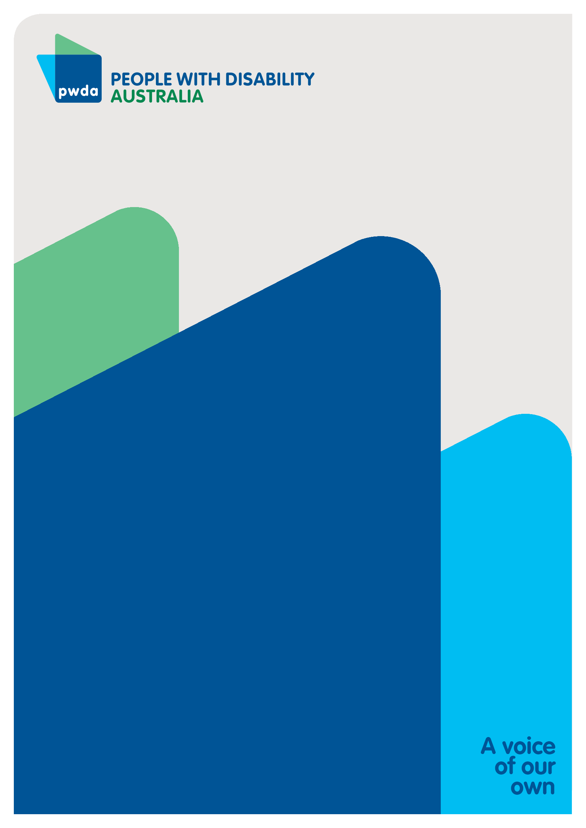
People with Disability Australia (PWDA) is a national disability rights and advocacy organisation made up of, and led by, people with disability.
For individual advocacy support contact PWDA between 9 am and 5 pm (AEST/AEDT) Monday to Friday via phone (toll free) on 1800 843 929 or via email at pwd@pwd.org.au
Submission contact
Giancarlo de Vera
Senior Manager of Policy
E: policy@pwd.org.au

