Response to the NDIS Provider and Worker Registration Taskforce

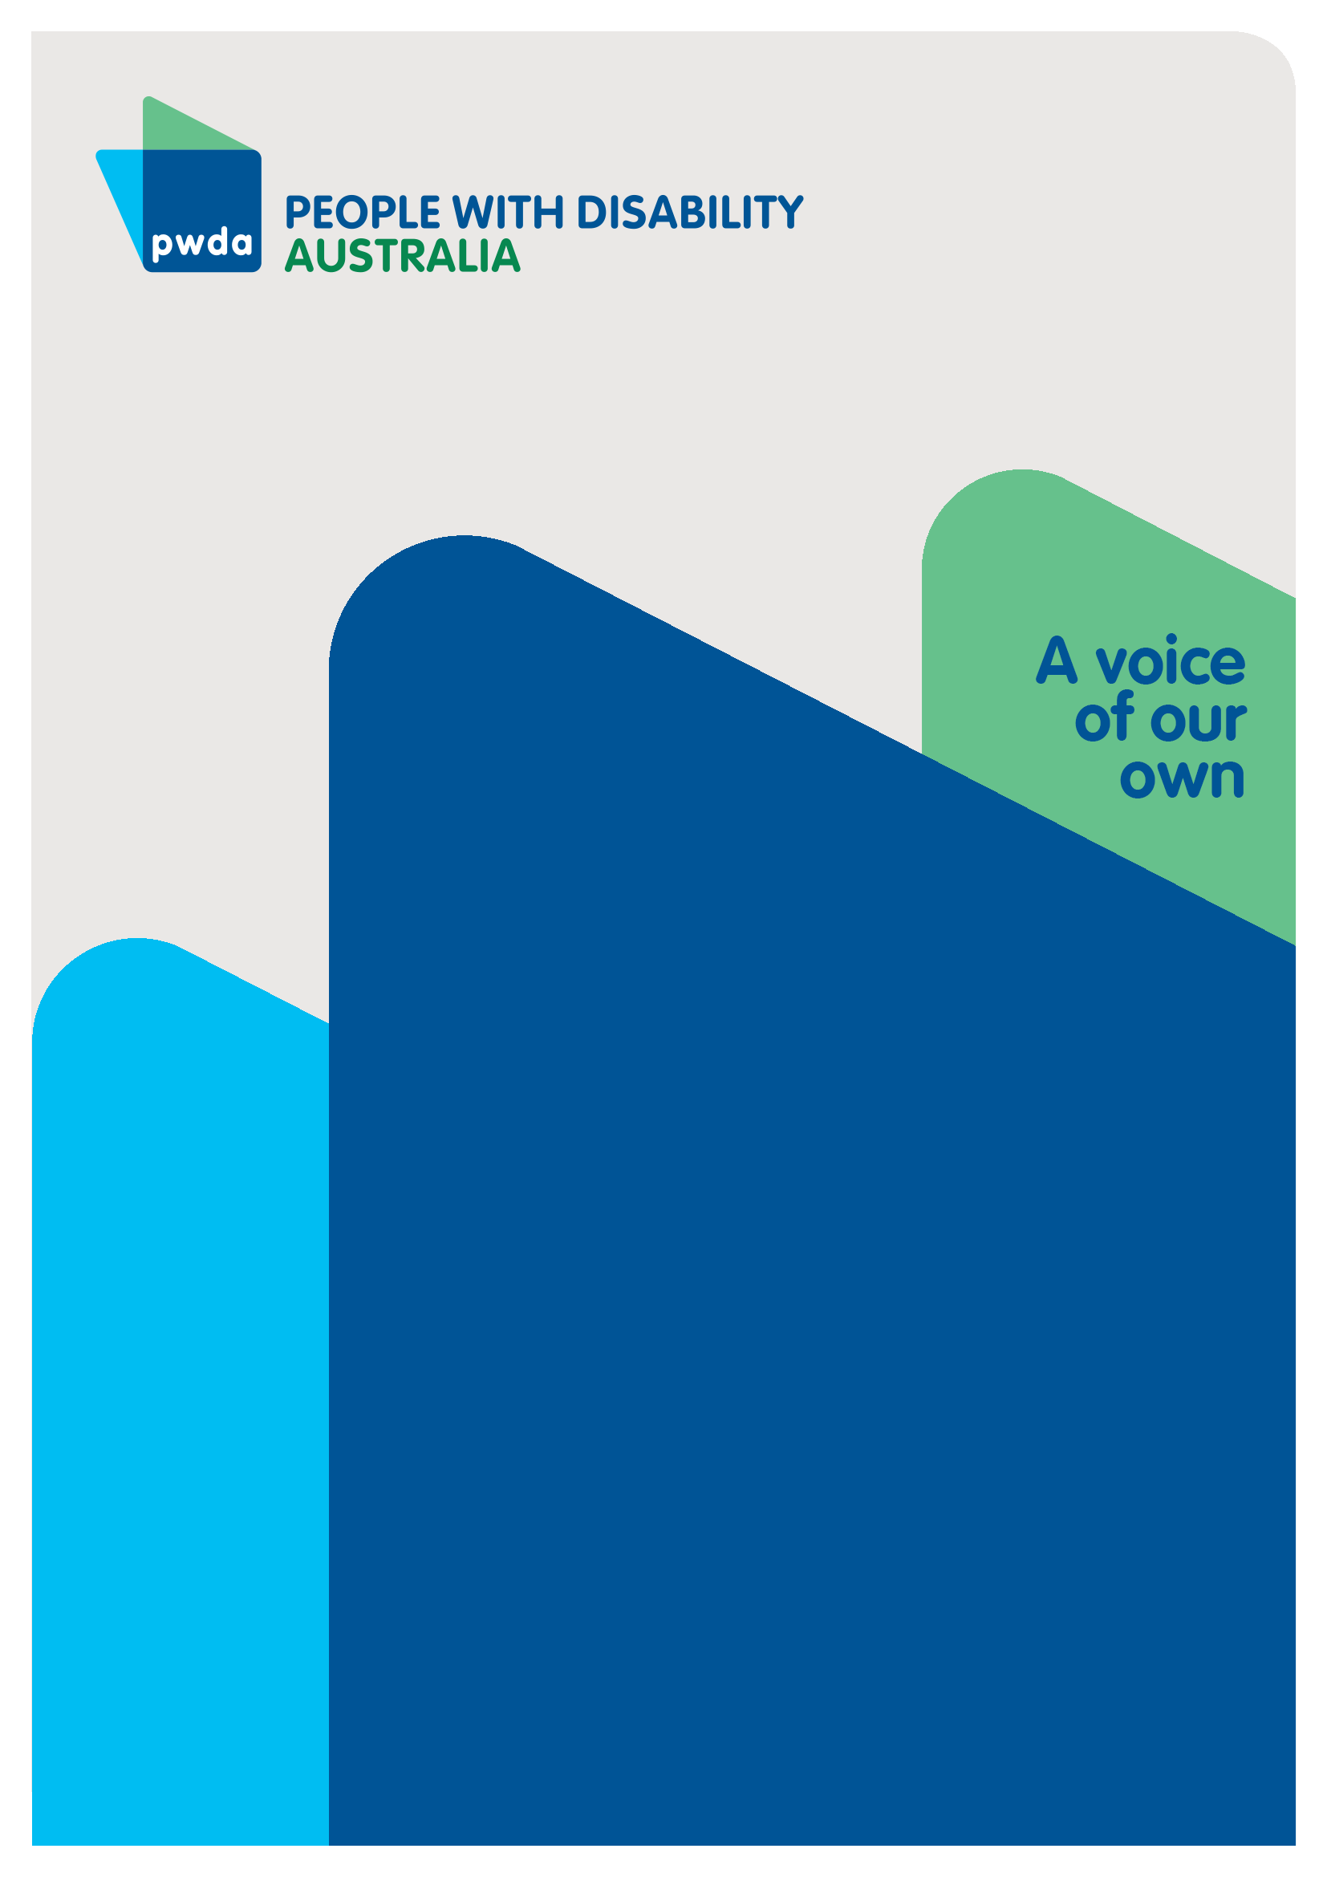
Recommendation 17 of the Independent Review of the National Disability Insurance Scheme
APRIL
2024

Copyright information
Response to NDIS Provider and Worker Registration Taskforce: Recommendation 17 of the Independent Review of the National Disability Insurance Scheme
First published in 2024 by People with Disability Australia Ltd.
Level 8, 418a Elizabeth Street, Surry Hills, New South Wales, Australia 2010
Head office also in Sydney
Email: pwda@pwd.org.au
Phone: +61 2 9370 3100 Fax: +61 2 9318 1372
URL: www.pwd.org.au

Typeset in Arial 12 and 14 pt and VAG Rounded 26 pt.

© People with Disability Australia Ltd. 2024

The moral rights of the authors have been asserted.

National Library of Australia Cataloguing-in-Publication data:

Creator(s): | Jane Britt
Title: | Response to NDIS Provider and Worker Registration Taskforce: Recommendation 17 of the Independent Review of the National Disability Insurance Scheme

All rights reserved. Except as permitted with the Australian Copyright Act 1968 (for example, a fair dealing for the purposes of study, research, criticism or review), no part of this book may be reproduced, stored in a retrieval system, communication or transmitted in any form or by any means without prior written permission. All inquiries should be made to the publisher at the address above.

Suggested citation:

Britt, J., Response to the NDIS Provider and Worker Registration Taskforce: Recommendation 17 of the Independent Review of the National Disability Insurance Scheme (26 April 2024), People with Disability Australia, Sydney.

ISBN 978-0-6459325-7-7

About PWDA
People with Disability Australia (PWDA) is a national disability rights and advocacy organisation made up of, and led by, people with disability.
We have a vision of a socially just, accessible and inclusive community in which the contribution, potential and diversity of people with disability are not only recognised and respected but also celebrated.
PWDA was established in 1981, during the International Year of Disabled Persons.
We are a peak, non-profit, non-government organisation that represents the interests of people with all kinds of disability.
We also represent people with disability at the United Nations, particularly in relation to the Convention on the Rights of Persons with Disabilities (CRPD).
Our work is grounded in a human rights framework that recognises the CRPD and related mechanisms as fundamental tools for advancing the rights of people with disability.
PWDA is a member of Disabled People’s Organisations Australia (DPO Australia), along with the First People’s Disability Network, National Ethnic Disability Alliance, and Women with Disabilities Australia.
DPOs collectively form a disability rights movement that places people with disability at the centre of decision making in all aspects of our lives.
‘Nothing About Us, Without Us’ is the motto of Disabled Peoples’ International (DPI).
Table of Contents
Response to the NDIS Provider and Worker Registration Taskforce 1
Copyright information 1
About PWDA 2
Executive Summary 4
Summary of Recommendations 6
PWDA’s response to the Taskforce 7
Introduction 7
What informed our response? 8
Consequences and unintended consequences of a Registration Scheme 9
Intended consequences for visibility of unregistered provider market 9
Unintended consequences to participants' choice and control 9
Safeguarding approaches outside registration 11
Supported decision making and plan management assessments 11
Regulatory oversight and uplift of the NDIS Commission 13
Tracking unregistered providers through alternate mechanisms 13
Conclusion 14

Executive Summary
The Independent Review into the National Disability Insurance Scheme (NDIS Review) handed down its final report in December 2023, making (amongst others) a recommendation for a risk-proportionate model for the visibility and regulation of all providers and workers of NDIS delivered support services (Recommendation 17). This led to the formation of the NDIS Provider and Worker Registration Taskforce in February 2024, to examine issues related to a registration scheme proposed by Recommendation 17 and its actions 17.1, 17.2 and 17.3.
People with Disability Australia (PWDA) provides our response primarily based on extensive member consultation through the NDIS Review.
This submission addresses PWDA's concerns relating to the design and implementation of a registration scheme for all workers and providers. We suggest that the risks that are hoped to be addressed through a registration scheme need to be weighed against any unintended consequences of diminishing participants' choice and control in accessing NDIS services and supports. Finally, we express concern that the registration scheme should not be overly administratively or financially burdensome to ensure a range of service providers remain in the market.
PWDA presents recommendations for alternate solutions to participant safeguarding. These include:
- a new codesigned plan management assessment,
- providing appropriate resourcing for the NDIS Quality and Safeguards Commission National Disability Supports Quality and Safeguards Commission or NDIS Commission) through investment to help with oversight for a proposed registration scheme in addition to other proposed functions by the NDIS Review and Disability Royal Commission,
- disability leadership embedded into the governance and leadership structure of the NDIS Commission,
- an alternative method to track financial transactions of a provider, to be considered by the Fraud Fusion Taskforce.

Summary of Recommendations
PWDA makes the following recommendations.
- Recommendation 1: The NDIA commits to a codesign process to redesign and implement a plan management assessment that better assesses whether a participant might require supported decision making or can make their own decisions when choosing their service providers. The assessment must apply supported decision making principles when the assessment outcome is considered. The need for supported decision making principles to be used to guide decisions about how a participant manages their plan needs to be included in the National Disability Insurance Scheme Act 2013, and the NDIS rules. This new process would also be captured in the NDIS Supported Decision Making Policy and Implementation Plan. PWDA strongly recommends that the plan management assessment process is subject to ongoing review and feedback from people with disability, their representative organisations, and people with expertise in an appropriate assessment tool plus supported decision making.
- Recommendation 2: The Australian government commits to resourcing the NDIS Commission to meet its expanded responsibilities.
- Recommendation 3: The Australian government provides clarity around the governance and leadership structure of the NDIS Commission.
- Recommendation 4: The Australian Government commits to establishing a NDIS Commission leadership team that includes people with disability, and/or people with deep engagement and understanding of the issues facing the community of people with disability.
- Recommendation 5: The Australian Government investigates and implements, through the Fraud Fusion Taskforce, an alternative method to track financial transactions made to, or by, unregistered service providers.

PWDA’s response to the Taskforce

Introduction
People with Disability Australia (PWDA) welcomes the opportunity to provide our feedback to the NDIS Provider and Registration Taskforce (the Taskforce).
Specifically, PWDA welcomes the opportunity to comment on the Terms of Reference for the Taskforce, relating to Recommendation 17 and Actions 17.1, 17.2 and 17.3 made in the Independent Review of the National Disability Insurance Scheme (NDIS Review) Final Report, Working Together to Deliver the NDIS, released on 7 December 2023.
- Recommendation 17: Develop and deliver a risk-proportionate model for the visibility and regulation of all providers and workers and strengthen the regulatory response to long-standing and emerging quality and safeguard issues.
- Action 17.1: The Department of Social Services and the new National Disability Supports Quality and Safeguards Commission should design and implement a graduated risk-proportionate regulatory model for the whole provider market.
- Action 17.2: The Department of Social Services and the new National Disability Supports Quality and Safeguards Commission should develop a staged implementation approach to transition to the new graduated risk-proportionate regulatory model.
- Action 17.3: The Australian Government should amend the National Disability Insurance Scheme Act 2013 to remove the link between a participant’s financial management of their plan and the regulatory status of their support providers.

What informed our response?
PWDA's response to the Taskforce is based on extensive feedback received from PWDA members and the broader community of people with disability throughout the NDIS Review, and the PWDA Board, which is comprised of people with disability and deep connection with the disability community.
Between March and July 2023, PWDA consulted with people with disability on their experiences of the NDIS This involved several member focus groups and two online surveys (including one easy read version) which received 441 valid responses. We followed up with a specific survey relating to NDIS housing, which received 76 responses, and two further consultations held in July 2023 about NDIS housing, and non-NDIS participants.
PWDA members shared their experiences of the NDIS across the surveys and focus groups, providing evidence for PWDA's six submissions to the NDIS Review
PWDA is undertaking an additional survey of members on the issues raised by the Taskforce's terms of reference. Given the timeframe for making submissions, this survey is not yet complete. Our findings will be submitted as an addendum to this paper.

Consequences and unintended consequences of a Registration Scheme

Intended consequences for visibility of unregistered provider market
Regulation and oversight ought to provide greater visibility of the entire NDIS market and ought to assure people with disability that they can access safe, quality NDIS supports. The Disability Royal Commission held four public hearings concluding with Public Hearing 32 on the role of service providers in responding to, and preventing violence, abuse, neglect, and exploitation against people with disability within services, providing evidence that stronger safeguarding and oversight of the NDIS service provider market is needed.
While it is evident that stronger safeguarding approaches are needed, this must be balanced with any unintended consequences of introducing a registration scheme. Registration itself cannot not guarantee the delivery of safe supports to people with disability. The scheme must contain elements that in unison reach this objective, plus the role and function of the NDIS Quality and Safeguards Commission require careful consideration.

Unintended consequences to participants' choice and control
It is unclear how the proposed registration scheme will affect access to NDIS service providers. There is concern that changes may create a lengthy and costly registration process, in turn leading to some providers to exit the NDIS market altogether. This would cause a reduction in the overall pool of available providers, impacting NDIS participants’ choice and control.
It has already been flagged in the Inquiry to the NDIS Quality and Safeguards Commission that some providers operate in areas where other regulatory systems operate e.g. Australian Health Practitioners Regulation Agency (AHRPA). These regulatory systems require significant paperwork, which is both burdensome and time-consuming. Any additional administrative burden created by a proposed NDIS registration scheme, should be avoided.
Improved regulation, and the requirement for worker and provider registration ought not be attended by onerous red tape or other administrative burdens, especially on smaller providers and sole operators. An optimal supplier network that is comprised of both smaller and niche providers as well as larger, corporate providers enhances the choice of NDIS participants and allows people to receive support they wish to receive at a cost able to be met by their plan.
Further, NDIS participants in rural, remote, and regional areas, who have traditionally struggled to find appropriate and affordable service providers because of thin markets in those areas, should not be adversely affected. The Inquiry to the NDIS Quality and Safeguards Commission states that:
“The committee heard that the burden and cost of registration was a disincentive to smaller providers obtaining registration with the Commission, and that this contributes to the problem of thin markets, especially in rural, regional and remote areas” (p.88).
Finally, there is a question about whether registration will apply to mainstream retailers who may sell consumables e.g. aids or equipment used by a person with disability such as continence or mobility aids. This requires clarification. PWDA has concerns that this could drive up the cost of items people with disability need and could add to the so-called “NDIS tax” that many participants are forced to pay when accessing mainstream services. This could impact participants' choice and control, and affect the efficiency of a NDIS plan.
In ensuring that there are no unintended consequences in introducing a registration scheme, there may be alternate solutions providing opportunities to address safeguarding and regulatory oversight without impacting participants' choice and control. Unless participants' choice and control can be preserved within a registration scheme, it should not proceed.
In this submission, we have focussed attention on alternative safeguarding mechanisms including supported decision making and plan management assessments, uplift of the NDIS Commission, and tracking unregistered providers through other mechanisms for alternative approaches to the NDIS market.

Safeguarding approaches outside registration

Supported decision making and plan management assessments
In considering how to ensure participant safety, safeguarding measures could include adjustment to the current assessment used to assess whether a participant can self-manage or plan-manage their NDIS plan.
There is an issue in the way that participants are currently assessed to determine whether they can self-manage or plan-manage their NDIS plan. The NDIS Review Supporting Analysis states that:
“Current assessments that determine whether participants can self-manage or plan-manage their plans – and therefore whether they can access unregistered providers – are focused on considering the participant’s capacity to manage the funding in their plan, and do not sufficiently consider varying capacity to manage complex risks in the delivery of supports” (p.915).
If the process for plan management was adjusted through redesign and implementation of a more appropriate assessment tool to assess plan management risk, then the NDIS Supported Decision Making Policy could be used for a decision supporter or plan nominee (both defined in the Policy) to be identified to support a participant make decisions about their service provider. The assessment redesign should be codesigned with people with expertise in the assessment tool development, and supported decision making, people with disability, and Disability Representative Organisations (DROs). This should then be implemented through an updated NDIS Supported Decision Making Implementation Plan. This is supported by NDIS Review Action 5.3, which proposes to ‘include an assessment of participants’ need for independent decision-making support as part of budget setting.’
The changes proposed by sections 43 and 44 in the National Disability Insurance Scheme (Getting the NDIS Back on Track No.1) Bill with subsequent changes to the NDIS rules should also provide clarification about ensuring appropriate supported decision making for NDIS participants.
Recommendation 1: The NDIA commits to a codesign process to redesign and implement a plan management assessment that better assesses whether a participant might require supported decision making or can make their own decisions when choosing their service providers. The assessment must apply supported decision making principles when the assessment outcome is considered. The need for supported decision making principles to be used to guide decisions about how a participant manages their plan needs to be included in the National Disability Insurance Scheme Act 2013, and the NDIS rules. This new process must be captured in the NDIS Supported Decision Making Policy and Implementation Plan. We strongly recommend that the plan management assessment process is subject to ongoing review and feedback from people with disability, their representative organisations, and people with expertise in an appropriate assessment tool plus supported decision making.

Regulatory oversight and uplift of the NDIS Commission
Under Recommendation 17, Action 17.1, the NDIS Quality and Safeguards Commission (referred to as a 'new' National Disability Supports Quality and Safeguards Commission) is proposed to have regulatory oversight of the registration scheme. The NDIS Quality and Safeguards Commission should be appropriately resourced to undertake this task.
Further, substantive detail is required around governance and executive management of the Commission. PWDA proposes that people with disability, and /or people with deep engagement and understanding of the issues facing people with disability be appointed to decision making roles of the Commission.
PWDA recommends that the Australian Government commit to ongoing consultation with people with disability and their representative organisations across all stages of the Review's implementation.
Recommendation 2: The Australian government commits to resourcing the NDIS Commission to meet its expanded responsibilities.
Recommendation 3: The Australian government provides clarity around the governance and leadership structure of the Commission.
Recommendation 4: The NDIS Commission commits to a leadership team, that includes people with disability, and/or people with deep engagement and understanding of the issues facing the community of people with disability.

Tracking unregistered providers through alternate mechanisms
Due to the requirement for an Australian Business Number (ABN) placing businesses on the Australian Business Register (ABR), there may be other mechanisms that could be explored for tracking financial transactions. The Fraud Fusion Taskforce established in November 2022 could develop of an alternate mechanism to protect against financial fraud. Unscrupulous service delivery behaviour that falls outside financial fraud, e.g. using prohibited restricted practices, should be covered by the strengthened NDIS Commission.
Recommendation 5: That the Australian Government investigates and implements, through the Fraud Fusion Taskforce, an alternative method to track financial transactions made to, or by, unregistered service providers.

Conclusion
The Taskforce needs to weigh up safeguarding measures, for example, visibility of the unregistered provider market, against concerns about loss of choice and control in accessing NDIS services. Lengthy or costly registration process should be avoided to ensure smaller and /or niche providers remain in the market, contributing to healthy competition, and to uphold the choice and control of participants.
There may be untapped safeguarding mechanisms including new codesigned plan management assessments, better regulatory oversight and uplift of the NDIS Commission, supported through proper investment. Finally, alternative methods to capturing financial transactions should be explored by the Fraud Fusion Taskforce.
People with Disability Australia (PWDA) is a national disability rights and advocacy organisation made up of, and led by, people with disability.
For individual advocacy support contact PWDA between 9 am and 5 pm (AEST/AEDT) Monday to Friday via phone (toll free) on 1800 843 929 or via email at pwd@pwd.org.au
Submission contact
PWDA Policy
E: policy@pwd.org.au

Australian Government department of Prime Minister and Cabinet (2023). About the NDIS Review, PM&C, accessed 26 April 2024.
Australian Government Department of Social Services (11 April 2024). NDIS Provider and Registration Taskforce, DSS, accessed 15 April 2024.
Commonwealth of Australia, Department of the Prime Minister and Cabinet (2023). Working to deliver the NDIS: Independent review into the National Disability Insurance Scheme final report, PM&C, accessed 12 April 2024.
The graduated risk-proportionate regulatory model is a model that explains the level of registration required for each provider based on the level of risk posed by their activities, for people with disability. It has four levels of registration: enrolment for lowest-risk supports, basic registration for lower-risk supports, general registration for medium-risk supports, and advanced registration for all high-risk supports. For more information see PWDA's blog post, Proposed changes to regulation and oversight of the NDIS workforce.
Royal Commission into Violence, Abuse, Neglect and Exploitation of People with Disability (2022). Public hearing 32: Service providers revisited, DRC, accessed 12 April 2024.
Commonwealth of Australia (2021). Joint Standing Committee into the National Disability Insurance Scheme: NDIS Quality and Safeguards Commission, Commonwealth of Australia, accessed 12 April 2024.
Ibid.
Commonwealth of Australia (2023). Working together to deliver the NDIS: Independent Review of the National Disability Insurance Scheme final report - Supporting analysis, Commonwealth of Australia, accessed 12 April 2024.
National Disability Insurance Agency (April 2023). NDIS Supported Decision Making Policy, NDIA, accessed 12 April 2024.
National Disability Insurance Agency (April 2023). NDIS Supported Decision Making Implementation Plan, NDIA, accessed 12 April 2024.
National Disability Insurance Agency (24 November 2023). Fraud Fusion Taskforce, NDIA, accessed 15 April 2024.

