Digital Inclusion Strategy

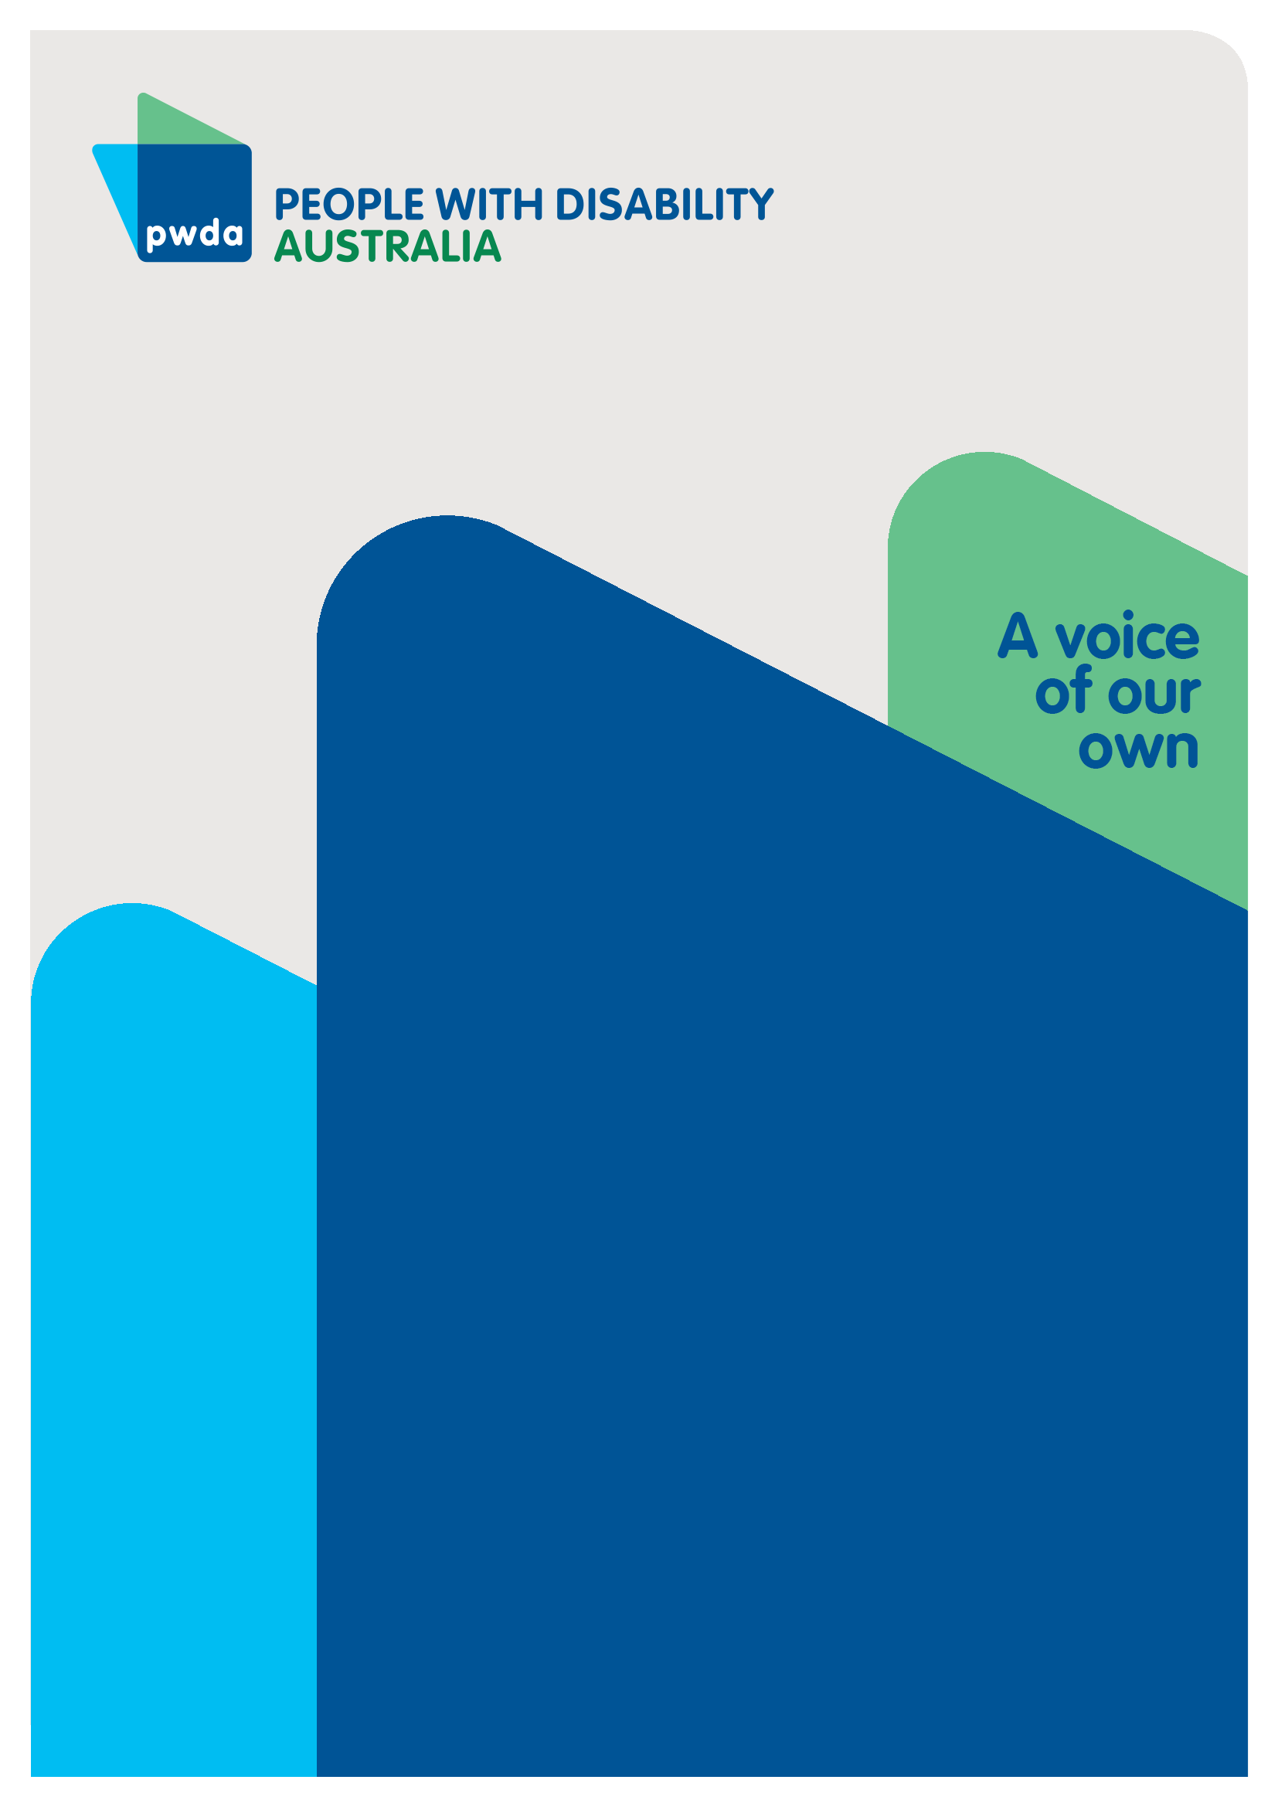
Response to the NSW Government discussion paper
June
2024

Copyright information
Digital Inclusion Strategy– Response to the NSW Government Discussion Paper

First published in 2024 by People with Disability Australia Ltd.
Suite 10.01, Centennial Plaza, 10/300 Elizabeth Street, Surry Hills, New South Wales, Australia 2010
Head office also in Sydney
Email: pwd@pwd.org.au
Phone: +61 2 9370 3100 Fax: +61 2 9318 1372
URL: www.pwd.org.au

Typeset in Arial 12 and 14 pt and VAG Rounded 26 pt

© People with Disability Australia Ltd. 2024

The moral rights of the authors have been asserted

National Library of Australia Cataloguing-in-Publication data:

Creator(s): | Bastien Wallace
Title: | Digital Inclusion Strategy– Response to the NSW Government Discussion Paper.

All rights reserved. Except as permitted with the Australian Copyright Act 1968 (for example, a fair dealing for the purposes of study, research, criticism or review), no part of this book may be reproduced, stored in a retrieval system, communication or transmitted in any form or by any means without prior written permission. All inquiries should be made to the publisher at the address above.

Suggested citation: EXAMPLE BELOW

Wallace, B., Digital Inclusion Strategy Review– Response to the NSW Government Discussion Paper, 19 July 2024, People with Disability Australia, Sydney.

About PWDA

People with Disability Australia (PWDA) is a national disability rights and advocacy organisation made up of, and led by, people with disability.
We have a vision of a socially just, accessible and inclusive community in which the contribution, potential and diversity of people with disability are not only recognised and respected but also celebrated.
PWDA was established in 1981, during the International Year of Disabled Persons.
We are a peak, non-profit, non-government organisation that represents the interests of people with all kinds of disability.
We also represent people with disability at the United Nations, particularly in relation to the United Nations Convention on the Rights of Persons with Disabilities (CRPD).
Our work is grounded in a human rights framework that recognises the CRPD and related mechanisms as fundamental tools for advancing the rights of people with disability.
PWDA is a member of Disabled People’s Organisations Australia (DPO Australia), along with the First People’s Disability Network, National Ethnic Disability Alliance, and Women with Disabilities Australia.
DPOs collectively form a disability rights movement that places people with disability at the centre of decision-making in all aspects of our lives.
The work of PWDA embraces the ‘Nothing About Us, Without Us’ motto of the international disability community and Disabled Peoples’ International, the international organisation representing national organisations of people with disability in over 130 countries.

Table of Contents
Digital Inclusion Strategy 1
Response to the NSW Government discussion paper 1
Copyright information 2
About PWDA 3
Introduction 5
The experience of PWDA individual advocates 6
Submission structure 8
Summary of Recommendations 9
Chapter 2 – Addressing the consultation questions 9
Part 1 Submission Background 10
Digital Inclusion Strategy Design 11
Part 2 Addressing the consultation questions 13
Conclusion 21

Introduction
PWDA welcomes the opportunity to provide preliminary comments on the development of the NSW Digital Inclusion Strategy.
PWDA is Australia’s peak cross-disability Disability Representative Organisation. Nationally 4.4 million Australians have a disability, around 17.7% of the population.
When compared with people without disability, people with disability continue to experience discrimination and poorer life outcomes across all life domains. It is estimated that 22% of people aged over 15 with disability in Australia have experienced some form of discrimination compared with 15% of those without disability. Disability discrimination is the largest ground of complaint to Anti-Discrimination NSW (ADNSW) and the Australian Human Rights Commission (AHRC). Discrimination against people with disability appears deeply entrenched across systems.
Governments have an obligation to respect, protect and fulfil human rights. Disability Rights are Human Rights.

The experience of PWDA individual advocates
PWDA has been consulted on the development of Digital ID and digital voting technology. We are funded by the NSW Department of Communities and Justice’s Disability Advocacy Futures Program to provide individual advocacy. As part of this work we have provided the following case studies.
Case Study 1
In one case a Grandmother residing in social housing with her daughter who has disability, needed to add her daughter’s 9 month old baby to as an additional occupant of the home. This was part of a change of circumstances application for this family who were waiting on the housing transfer list, and it needed to be completed online.
In order to lodge the application, 7 forms had to be completed and submitted, all of which were only available in PDF format. This is not an accessible format and could not be filled out on a mobile phone- the only digital device available.
The application process required supporting evidence. This included a birth certificate for the baby, which had not been able to be obtained due to the $65 fee. The baby required proof of identity documents to be attached, which did not exist in the baby’s name. The additional occupant form also required the signature of that person, who as a 9-month-old infant was unable to sign.
In order to apply for a rent subsidy each person had to attach proof of all income. The payroll and timesheet management system used by the daughter’s workplace would not allow the daughter to email pay-slips to herself to attach as supporting information, if the system was accessed via a mobile phone. This was the only way the daughter was able to access this system.
In addition, the daughter was required to have her boss complete an income assessment letter on company letterhead, and she was too embarrassed to request this and identify herself as living in social housing at work.
The application forms required attachments to support proof of: disability, citizenship, and aboriginality and these could not be obtained. Without all of these forms completed and supporting documentation, the application could not be lodged.
Case Study 1 illustrates barriers to digital inclusion across multiple domains, that have the effect of excluding a person from being able to access the appropriate level of government housing support. Process design has failed to:
- select a format for forms that: is inclusive and accessible for people to read, works with screen-readers, can be completed by a person whose only access to the internet to complete the forms is via a mobile telephone
- contemplate scenarios where a person cannot sign a form due to age (being a baby) or other capacity issue
- contemplate situations where it is impossible to provide certain supporting evidence, whether due to connectivity, affordability or accessibility of the systems that need to be used to provide it
- respect a person's right to privacy, through requiring them to disclose to their manager that they live in social housing in order to obtain a letter of support
- plan a process that enables submission of the application when the full application process cannot be completed
Case Study 2
A person who is blind needs to register as a new patient at a doctor’s surgery. They have been unable to do this in advance as they cannot complete the ‘Captcha’ security process to enter the system. When they attend the surgery in person, they are told the alternative is to complete a form on a tablet, but no accessible format or assistive technology is provided. The medical receptionist sits with the person in the waiting area, the only available space, to take all of their details for the appointment and to set up their medical file and log-on, so that they can book appointments in the future. The person is required to share their details, select a log-in email and a password. The person does not know how many other patients are in the room and can overhear them.
Case Study 2 illustrates barriers to digital accessibility and digital trust and safety in the provision of critical health services. Failing to provide an accessible way to log on prevented the person from being able to independently access and set up their own medical file and book their own appointment. The medical receptionist tried to provide assistance, but the lack of separate space for private communication meant that confidentiality and the digital security of the person’s health information was compromised.
The experience of PWDA advocates and clients aligns with the view that a digital inclusion strategy is needed. It must recognise where barriers and exclusion exists, and work to overcome these and maximise the potential benefits digital technology offers people with disability.

Submission structure
This submission responds to the NSW Government’s discussion paper on the Digital Inclusion Strategy. The response to request is organised into 2 parts and a conclusion:
- Part 1 looks at the background leading to the development of the draft Digital Inclusion Strategy and outline the structure
- Part 2 addresses the 8 questions posed in the consultation document with issues and recommendations

Summary of Recommendations

Chapter 2 – Addressing the consultation questions
Recommendation 1 – The NSW Government should establish a consultative group composed of people with disability and their disability representative organisations to help identify barriers, respond to new issues as technology evolves, recommend solutions, advise on training design and evolve the strategy and its application to improve inclusion over time.

Recommendation 2 – In order to understand the needs the strategy aims to address the NSW Government should commit to measuring the problems barriers people with disability face

Recommendation 3 – The NSW Government should work with the disability consultative group to evaluate the digital documents and processes used by government, and core service providers, for accessibility and inclusion. It should then set standards for inclusion that address the needs of users who currently face exclusion.

Recommendation 4 – The NSW Government must fund the resourcing of measures to address the identified barriers to digital inclusion

Recommendation 5 – The NSW Government Digital should establish a digital inclusion incubator

Recommendation 6 – For those who experience problems using digital technology, or are unable to do so, telephone and face to face alternatives must be provided.

Recommendation 7 – The NSW Government must set inclusion targets, then regularly publish performance data tracking progress against them

Part 1 Submission Background
The Minister for Customer Service and Digital Government in New South Wales (NSW) has called for submissions to the consultation on the development of the first NSW Digital Inclusion Strategy. The Digital Inclusion Strategy discussion paper identifies that:
“..digital inclusion is fundamental to ensuring that every resident of NSW has equitable access to essential services and economic and social opportunities in the digital age. Digital inclusion ensures everyone has equitable opportunities to access, afford and engage with digital technologies, services and online resources.”
This draft strategy considers someone to be digitally included if they:
• “Have affordable access to high-quality digital connectivity and owns appropriate devices to use it.
• Can use digital products and services without barriers, including those with the widest range of abilities and in the widest range of situations and places.
• Have the ability, skills and confidence to engage with digital technologies, services and online resources.
• Are aware of the opportunities, risks and impacts of the digital world, and can make informed digital decisions.
• Can engage with digital technologies, services and resources confidently and safely.”

Digital Inclusion Strategy Design
PWDA accepts this as a starting point for consultation, and supports the goal of the NSW Government to ensure that every NSW resident has equitable access to the essential services economic and social opportunities. In deciding to develop the draft strategy around 5 main pillars, we are confident that, if addressed appropriately, it will offer the best chance to be as inclusive as possible.
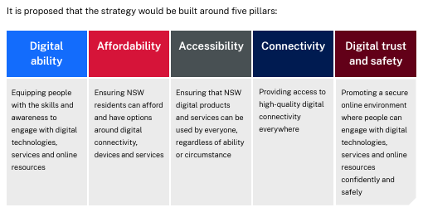

Source: NSW Government, NSW Digital Inclusion Strategy consultation document, p8.
We also support the proactive efforts made by the NSW Government to engage with people with disability and their representative organizations, to ensure that the strategy reflects their needs and concerns. PWDA supports the development of a strategy to ensure everyone can access, afford, and engage with, digital technologies, services and online resources. We are also committed to ensuring that supports are provided to enable that access, and this must include telephone and face to face formats.
PWDA believes that digital technology, well deployed, can offer many employment, educational, creative, service provision, communication and recreational opportunities for people with disability. The development of a NSW Digital Inclusion Strategy aligns with Australia’s Disability Strategy, especially Policy Priority 4. The guiding principles of this strategy are based on the 8 general principles contained within Article 3 of the Convention of the Rights of Persons with Disabilities (CRPD). We seek to ensure that this strategy maximises the potential benefits of digital technology for people with disability, especially to enable:
- choice and independence
- non-discrimination
- full participation and inclusion in society
- equality of opportunity
- accessibility
It must also recognize and avoid the creation of barriers, harm, and exclusion in its implementation. The rights of people with disability to choose if, how, and when, they engage with digital technology must also be respected, and alternatives provided to ensure services remain accessible for those who cannot or choose not to access digital technology.

Part 2 Addressing the consultation questions
The Digital Inclusion Strategy discussion paper asks eight (8) questions detailed below. PWDA will provide answers to the first 7 questions. We defer to our peers in the First Peoples Disability Network, Indigenous organisations and individuals to answer the eighth question on the opportunities digital technology offers, and the best ways to address barriers for Aboriginal communities. We are pleased that the NSW Government is specifically consulting with indigenous people and organisations on their views.
- What does it mean for you to be digitally included?

PWDA agrees with the 5 elements provided within the draft paper that speak to: affordability of devices and connectivity; accessible digital products, devices and services; having digital abilities and skills; making informed digital decisions and the ability to engage safely with digital technologies, services and resources.
To this we would add that digital inclusion also must also incorporate:
  - Full, accessible access to essential services as a priority
  - Information provision in accessible formats including EasyRead, Auslan, Braille, as well as community languages
  - Process functionality that is inclusive, for example enabling use with assistive technologies, access by mobile, or use in areas of poor signal
  - Supported decision making where necessary to assist with informed decision making
  - Removal of non-digital barriers to digital inclusion which could include having to attend inaccessible locations to register or set up identity

Digital technology evolves rapidly, and in order to keep abreast of issues and develop responsive solutions the expertise of people with disability needs to be sought and applied. In order for the strategy to be meaningful and effective, the NSW Government needs to commit to measuring the problems and barriers people with disability face including those identified in the 5 elements and any further barriers people with disability identify.

Recommendation 1 – The NSW Government should establish a consultative group composed of people with disability and their disability representative organisations to help identify barriers, respond to new issues as technology evolves, recommend solutions, advise on training design and evolve the strategy and its application to improve inclusion over time.

Recommendation 2 – In order to understand the needs the strategy aims to address the NSW Government should commit to measuring the problems barriers people with disability face (communities & areas of the state with no/ little/ expensive mobile and internet coverage), proportions of people with no access to affordable devices

- What challenges do you face in accessing and using the internet, digital technologies or online services?

People with disability face multiple challenges related to the use of digital technology and services, some of which are illustrated in the case studies above. These include, but are not limited to:
- Being unable to set up accounts, log onto digital platforms or services, or to verify themselves due to:
  - security tools like ‘Captcha’ that are inaccessible to people who use screen-reading technology,
  - authentication processes that rely on smart phone use for those who do not own, or cannot use one,
  - the use of face or iris scanning technology that people who are blind or have low vision may be unable to use
- Digital systems requiring very recent device or software models to access them that may be unaffordable or that may not yet be compatible with assistive technologies- whose upgrade times may lag
- Information provided to enable access, fault-find, or navigate technology, may be inaccessible or unclear- especially where EasyRead, telephone and in-person assistance are unavailable
- Forms or information about services may only be provided in PDF form, which is not accessible
- Services may only be available online- such as forms to apply for housing, pensions or a range of government services, but the person who needs the service is unable to apply online
- Services may require proof of identity or address that a person does not have, for example because all bills are not in their name, they have no documents after becoming homeless or fleeing violence
- A person may only have digital access via a mobile phone, but some elements of the website do not work on mobile phones- such as downloading documents, filling out forms or seeing some elements of web content
- The person may not have access to a stable internet connection, and each time the website or form stops working due to connectivity issues, they loose the data they have inputted, or the system treats this as a log-in failure or security breach and locks them out
- Service access processes, codes and passwords are too difficult or complex for a person to use or remember
- A person cannot maintain confidentiality and security when accessing a service due to a carer, spouse setting up passwords or authentication processes in ways they control
- People who need support to make decisions may not be able to get this from someone who understands the technology properly
- A person may not be able to afford to access a device or internet connection, or may only be able to afford limited data that prevents them from accessing digital technology in the ways they choose to

Recommendation 3 – The NSW Government should work with the disability consultative group to evaluate the digital documents and processes used by government, and core service providers, for accessibility and inclusion. It should then set standards for inclusion that address the needs of users who currently face exclusion.

- What specific aspects of digital inclusion are most important to you and your community? For example access to the internet, digital skills training, affordable devices. What challenges do you anticipate in the future?

  - The most critical issues for PWDA members and clients relate to access to core services such as housing, domestic and family violence services, education, critical supports for living, and essential services such as utilities and banking. The digital inclusion and accessibility issues outlined above, and explained in the case studies, can prevent people from being able to:
- complete applications for social housing or income support,
- access their money,
- obtain evidence essential for applications
- access assistance when things go wrong or services do not work
- book accessible transport
- access education and employment or essential resources required for it
- set up, purchase, maintain or change tenancies, and provision of essential services such as utilities and food
  - The NSW Government can establish and fund digital skills training, can control the ways that NSW Government departments use technology, could subsidize or fund access to digital devices, however it does not control:
- Internet and Telstra mobile coverage, which is a matter for the Federal Government, Telstra and NBN Corporation.
- Mobile coverage and service costs, which is provided by private companies
- The ways the Federal Government or other State Governments use technology
- The software, technology choices, business decisions and customer service provision by private companies providing essential services such as utilities
- The availability of inclusive choices to enable access to education technologies, adaptive software
- Assumptions, algorithms and data that feeds the development of technology such as AI, facial recognition, and medical diagnostic tools which may lead to it becoming ‘abelist’, racist or exclusionary
- Whether and how fast technology developers will enable cooperation between their systems and adaptive technologies such as screen-reading software
- Whether and how transparent companies and institutions will be about providing face to face or telephone service as an alternative to, or when things go wrong, with digital service provision

Any and all of these issues could lead to problems in the future for digital inclusion. A strategy will only lead to improvements in inclusion if resources are provided to address the gaps.

Recommendation 4 – The NSW Government must fund the resourcing of measures to address the identified barriers to digital inclusion

- What do you think should be the top priorities for improving digital inclusion in NSW?

  - Measurement of the problems
  - The development of a Digital Inclusion strategy that includes principles for inclusion and accessibility, a plan to address issues, measurement and reporting against strategic objectives
  - Mandatory information accessibility standards and Easy Read should be required for all government websites, essential service providers and all specialist service providers for people with disability.
  - The strategy and all of the standards need to be developed by working with people with disability, in order to better identify issues, improve accessibility, inclusion, information consistency and legibility.

- How can we collaborate to make digital inclusion a reality for everyone in NSW? How can different parts of the community, such as local businesses, schools and non-profits, collaborate to address these challenges?
In addition to convening a consultative group for the Digital Inclusion Strategy composed of people with disability and their DROs, PWDA Recommends the establishment of a Digital Inclusion Incubator Hub that would enable currently excluded groups and individuals to better innovate solutions and tools for inclusion, including by:
- encouraging people with disability, their families carers and DRO’s to identify problems
- helping different parts of the community, such as local businesses, schools and non-profits, to identify problems and offer to collaborate together and with people with disability to develop solutions to address these challenges
- recommending partnerships and codesign opportunities with the disability community
- providing seed funding and business support services to develop businesses and commercialise new opportunities.

Recommendation 5 – The NSW Government Digital should establish a digital inclusion incubator

- What initiatives or partnerships would you like to see in place to support digital inclusion efforts?

PWDA would like to see codesign with NSW Government’s Customer Service and key service departments, the strategy consultative group, people with disability and eventual experts identified via the incubator hub.

- How do you think new and advanced technologies can be used to make sure everyone in our community can easily use digital tools and be a part of the online world?

New technologies, and changes over time can enable people with disability to access more opportunities to communicate, work and participate in society. Standardizing the inclusion of voice command capability for iPhones in 2008 ensured that they were more inclusive for people who could not type, or see the screen. This technology has evolved over time and now people with disability can use standard digital assistants such as Alexa, Siri, Cortana to control apps and integrated household appliances, order groceries and schedule appointments. It is already possible to use digital templates and tools to design websites, produce documents, art and music. As voice command software, large language models and artificial intelligence (AI) evolve, opportunities will increase for people with disability to communicate, learn, work, create and develop new technology and businesses.

In order for inclusion to be maximised, there must be alternative face to face and telephone support provided to ensure that when problems arise, or people cannot access digital technology they can still access the services they need.

Recommendation 6 – For those who experience problems using digital technology, or are unable to do so, telephone and face to face alternatives must be provided.

- How can digital technology benefit Aboriginal communities, and what barriers should be addressed as a priority?

PWDA defers to our peers in the First Peoples Disability Network, Indigenous organisations and individuals to answer this question. We look forward to their insights and advice.

Recommendation 7 – The NSW Government must set inclusion targets, then regularly publish performance data tracking progress against them

Conclusion
The NSW Digital Inclusion Strategy provides an opportunity to work towards digital opportunities becoming accessible to the whole of the NSW community, especially those with disability. By addressing the challenges of connectivity, affordability, skills, and accessibility, the draft strategy strives to create a more equitable and inclusive digital future for everyone in NSW. However, it can only do so if the many and varied needs of people with disability are considered and acted on. PWDA believed the best way to improve inclusion is to centre the experience of people with disability and other excluded groups in the identification of issues, recommendations for solutions, and opportunities to innovate for future success.

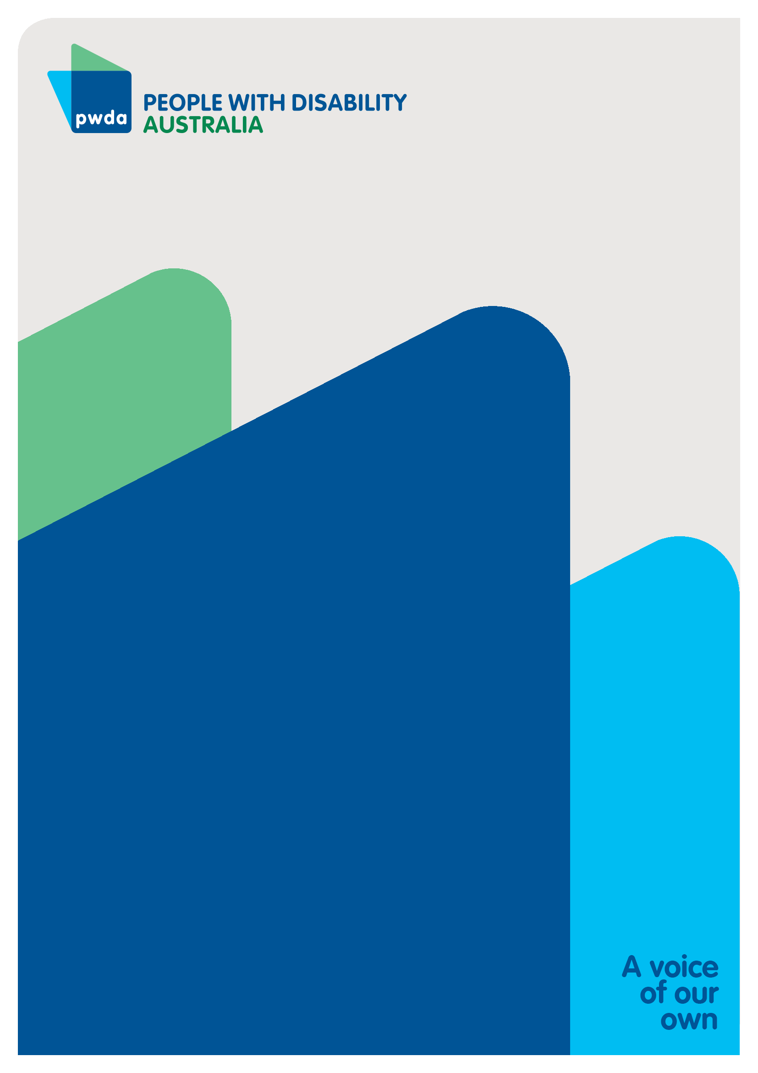
People with Disability Australia (PWDA) is a national disability rights and advocacy organisation made up of, and led by, people with disability.
For individual advocacy support contact PWDA between 9 am and 5 pm (AEST/AEDT) Monday to Friday via phone (toll free) on 1800 843 929 or via email at pwd@pwd.org.au
Submission contact
Bastien Wallace
Senior Policy Officer
E: bastienw@pwd.org.au

Australian Institute of Health and Welfare, People with Disability in Australia 2022 (2022) https://www.aihw.gov.au/reports/disability/people-with-disability-in-australia/contents/about; Australian Bureau of Statistics, Disability, Ageing and Carers, Australia: Summary of Findings (2019) https://www.abs.gov.au/statistics/health/disability/disability-ageing-and-carers-australia-summary-findings/latest-release#disability.
Rosemary Kayess and Therese Sands, Convention on the Rights of Persons with Disabilities: Shining a light on Social Transformation (UNSW Social Policy Research Centre, 2020); Australian Bureau of Statistics (n1); Australian Institute of Health and Welfare (n 1); Jeromey B Temple, Margaret Kelaher and Ruth Williams, ‘Discrimination and avoidance due to disability in Australia: evidence from a National Cross-Sectional Survey’ (2018) 18 BMC Public Health 1347.
Australian Institute of Health and Welfare (n 1) 163.
Anti-Discrimination NSW, Annual Report 2021-22 (2022) 15 https://antidiscrimination.nsw.gov.au/documents/annual-reports/anti-discrimination-annual-report-2021-22.pdf
Australian Institute of Health and Welfare (n 1) 163.
Committee on the Rights of Persons with Disabilities, General comment No. 6 (2018) Equality and non-discrimination CRPD/C/GC/6 (26 April 2018) [30]; Australian Human Rights Commission, Free and Equal. A reform agenda for federal discrimination laws (December 2021) 16; United Nations, Convention on the Rights of Persons with Disabilities (12 December 2006), article 5.
NSW Government, NSW Digital Inclusion Strategy: bridging divides, empowering lives, unlocking potential, P 4, accessed as at 12 June 20204, https://hdp-au-prod-app-nsw-haveyoursay-files.s3.ap-southeast-2.amazonaws.com/8717/1593/0148/Digital_Inclusion_Discussion_Paper_FINAL_1.pdf
NSW Government, NSW Digital Inclusion Strategy: bridging divides, empowering lives, unlocking potential, P 4, accessed as at 12 June 20204, https://hdp-au-prod-app-nsw-haveyoursay-files.s3.ap-southeast-2.amazonaws.com/8717/1593/0148/Digital_Inclusion_Discussion_Paper_FINAL_1.pdf
Commonwealth of Australia, Department of Social Services, Australia’s Disability Strategy 2021-2031, ‘People with disability are supported to access assistive technology’ P 21, last accessed 12 June 2024, https://www.disabilitygateway.gov.au/sites/default/files/documents/2021-11/1786-australias-disability.pdf
United Nations, Convention of the Rights of Persons with Disabilities, Article 3 General Principles last accessed 12 June 2024, https://social.desa.un.org/issues/disability/crpd/convention-on-the-rights-of-persons-with-disabilities-crpd
United Nations, Convention of the Rights of Persons with Disabilities, Article 3 General Principles last accessed 12 June 2024, https://social.desa.un.org/issues/disability/crpd/convention-on-the-rights-of-persons-with-disabilities-crpd
NSW Government, NSW Digital Inclusion Strategy: bridging divides, empowering lives, unlocking potential, P 4, accessed as at 12 June 20204, https://hdp-au-prod-app-nsw-haveyoursay-files.s3.ap-southeast-2.amazonaws.com/8717/1593/0148/Digital_Inclusion_Discussion_Paper_FINAL_1.pdf

