A framework for performance reporting and driving wellbeing outcomes in NSW

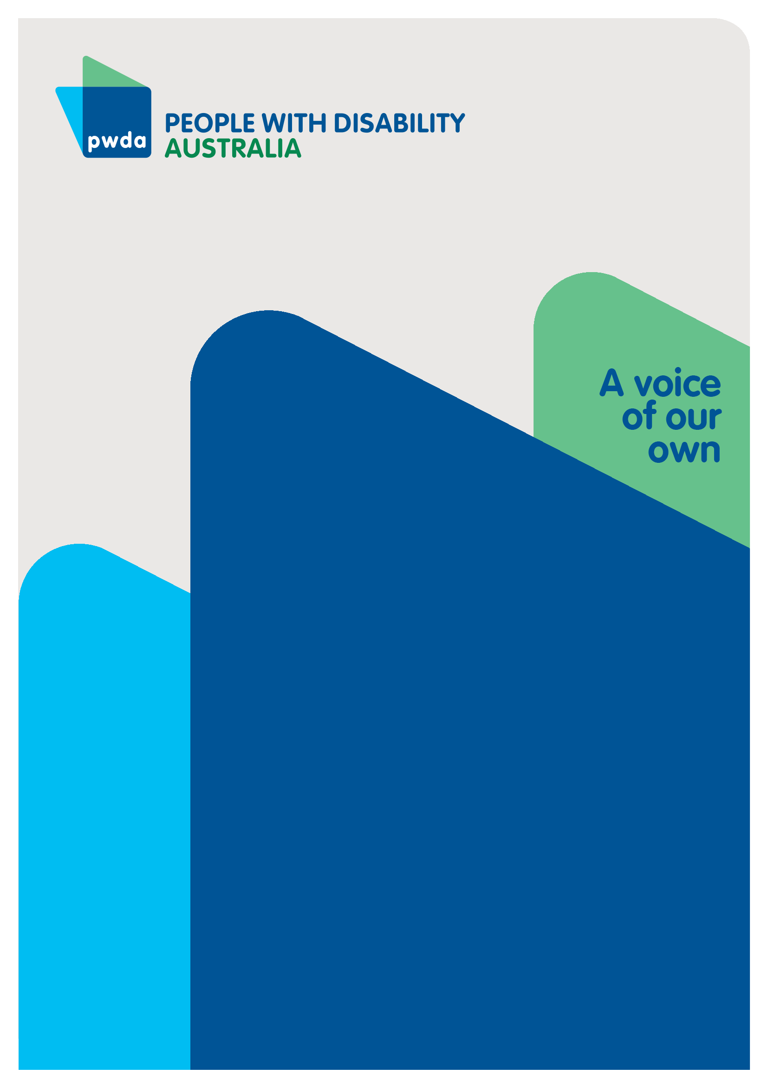
Submission to the Public Accounts Committee
July
2024

Copyright information
A framework for performance reporting and driving wellbeing outcomes in NSW – Submission to the Public Accounts Committee

First published in 2023 by People with Disability Australia Ltd.
Suite 10.01 Centennial Plaza, 10/300 Elizabeth Street, Surry Hills, New South Wales, Australia 2010
Email: pwd@pwd.org.au
Phone: +61 2 9370 3100 Fax: +61 2 9318 1372
URL: www.pwd.org.au

Typeset in Arial 12 and 14 pt and VAG Rounded 26 pt

© People with Disability Australia Ltd. 2023

The moral rights of the authors have been asserted

National Library of Australia Cataloguing-in-Publication data:

Creator(s): | Bastien Wallace
Title: | A framework for performance reporting and driving wellbeing outcomes in NSW – Submission to the Public Accounts Committee

All rights reserved. Except as permitted with the Australian Copyright Act 1968 (for example, a fair dealing for the purposes of study, research, criticism or review), no part of this book may be reproduced, stored in a retrieval system, communication or transmitted in any form or by any means without prior written permission. All inquiries should be made to the publisher at the address above.

Suggested citation: EXAMPLE BELOW

Wallace, B. A framework for performance reporting and driving wellbeing outcomes in NSW – Submission to the Public Accounts Committee, 26 July 2024, People with Disability Australia, Sydney.

About PWDA

People with Disability Australia (PWDA) is a national disability rights and advocacy organisation made up of, and led by, people with disability.
We have a vision of a socially just, accessible and inclusive community in which the contribution, potential and diversity of people with disability are not only recognised and respected but also celebrated.
PWDA was established in 1981, during the International Year of Disabled Persons.
We are a peak, non-profit, non-government organisation that represents the interests of people with all kinds of disability.
We also represent people with disability at the United Nations, particularly in relation to the United Nations Convention on the Rights of Persons with Disabilities (CRPD).
Our work is grounded in a human rights framework that recognises the CRPD and related mechanisms as fundamental tools for advancing the rights of people with disability.
PWDA is a member of Disabled People’s Organisations Australia (DPO Australia), along with the First People’s Disability Network, National Ethnic Disability Alliance, and Women with Disabilities Australia.
DPOs collectively form a disability rights movement that places people with disability at the centre of decision-making in all aspects of our lives.
The work of PWDA embraces the ‘Nothing About Us, Without Us’ motto of the international disability community and Disabled Peoples’ International, the international organisation representing national organisations of people with disability in over 130 countries.

Table of Contents
1
A framework for performance reporting and driving wellbeing outcomes in NSW 1
Submission to the Public Accounts Committee 1
Copyright information 2
About PWDA 3
Submission structure 6
Summary of Recommendations 6
Part 1 – A wellbeing framework 6
Part 2 – Key wellbeing domains 7
Introduction 10
Part 1 – A wellbeing framework 11
The Convention on the Rights of Persons with Disabilities (CRPD) 11
Part 2 – Key wellbeing domains 14
Housing 14
Education and Employment 16
Health 18
Safety 20
Voting 21
Digital Inclusion 21
Transport 21
Essential Services and Recreation 22
Conclusion 22

Submission structure
The Minister for Finance referred this inquiry to the Public Accounts Committee to look into an effective framework for reporting on the performance of NSW Government services. PWDA welcomes the opportunity to provide preliminary comments on the Framework for performance reporting and driving wellbeing outcomes in NSW.
The Committee has asked for submissions to response to the development of a process to allow the Government examine the outcomes achieved through its resource allocations, and their quality and impact on the wellbeing of the people of NSW. The rationale is that with the right measurements, the investments and activity of Government can be evaluated in order to better inform future decision making.
This work relates to the Commonwealth 'Measuring What Matters' national wellbeing framework and the OECD 'Framework for Measuring Well-being and Progress' that both seek to apply performance measures across many wellbeing domains beyond economic outputs. As this is the first time the NSW Government has proposed measuring wellbeing, in Part 1- A wellbeing framework, we have made broad recommendations about how to develop these measures.
PWDA recognises that the NSW State Government has different responsibilities to the Federal Government. In Part 2- Key wellbeing domains We have related our submission to areas that are within the power of the NSW State Government to act, and that are areas we have positions on that relate to key wellbeing domains in the National Wellbeing framework.

Summary of Recommendations

Part 1 – A wellbeing framework
Recommendation 1 Measurement- work with people with disability, the Australian Institute of Health & Welfare, Australian Bureau of Statistics and researchers to develop a consistent fit-for-purpose measurement framework to identify people with disability, accessibility issues and exclusion barriers in a disaggregated way
Recommendation 2 Co-design measurement with people with disability – undertake a co-design process with people with disability and their DROs to ensure that measurement upholds our CRPD rights, is effective, impactful and avoids unintended negative consequences
Recommendation 3 Standard setting- based on the measurements developed, set standards for information and service accessibility, employment and procurement by the NSW Government
Recommendation 4 Action audits – Based on the measurements established, develop an audit framework to identify the current state and ongoing performance against the standards, to recommend and report action taken against the standards
Recommendation 5 Customer feedback- Work with the co-design group, researchers, relevant experts within and outside government to develop accessible and inclusive ways to gather and report on customer feedback to improve outcomes
Recommendation 6 Impact measurement- Work with the co-design group, researchers, relevant experts within and outside government to develop an impact measurement framework based on achieving greater inclusion in conformity with the measurements v’s business as usual
Recommendation 7 Publication – We recommend that once the standards are set and action audits begin, annual reports be published

Part 2 – Key wellbeing domains

Recommendation 8:
NSW Government to sign up to the standard Silver Livable Design Standard for all new homes and to measure and report on where they are built
Recommendation 9:
Develop measures of housing accessibility for existing homes using a co-design process with people with disability and their DRO’s
Recommendation 10:
Require all public and social housing be audited against housing accessibility standards, and the results published, so housing support services are better able to identify options for people with disability. Encourage the rental and private sectors to use the accessibility standards.
Recommendation 11:
Review the housing application for social and affordable housing, to make the process accessible, and incentivise real estate agents, landlords and developers to do the same
Recommendation 12:
Develop measures of education inclusion using a co-design process with people with disability and their DRO’s, evaluate and report on the transition to inclusive education
Recommendation 13:
Develop measures, evaluate and report on the impact of learning supports on educational and wellbeing outcomes of children with disability
Recommendation 14:
Research the early learning and adult education support needs of people with disability, with the goal of developing appropriate measurement and supports to make education fully accessible over the life course
Recommendation 15:
Develop measures using a co-design process with people with disability and their DRO’s, evaluate and report on the employment of people with disability at all levels with the NSW Government and its suppliers
Recommendation 16:
Develop measures using a co-design process with people with disability and their DRO’s, to evaluate and report on the inclusion of people with disability in all of the health services and supports in NSW, both as recipients of care, and in the health care workforce
Recommendation 17:
Research and share effective ways to address gaps in service and inclusion, based on identified success
Recommendation 18:
Develop pilots and research opportunities with people with disability and their DRO’s, to identify new ways to address gaps in service and inclusion
Recommendation 19:
Develop a plan for improvements in personal safety and for people with disability, measure and report against it
Recommendation 20:
Develop a plan to improve the accessibility of voting for people with disability, measure and report against it
Recommendation 21:
Develop a plan to improve digital accessibility and inclusion for people with disability based on the strategy, then measure and report against it
Recommendation 22:
Develop and distribute measurement tools to identify unmet transport need, especially by people with disability and use this to inform the development of new services.
Recommendation 23:
Develop and distribute measurement tools to identify unmet accessibility needs, and a clearinghouse to share resources and best practice to address them

Introduction
PWDA welcomes the opportunity to provide preliminary comments on the Framework for performance reporting and driving wellbeing outcomes in NSW. PWDA is Australia’s peak cross-disability Disability Representative Organisation. Nationally more than 21.4 % of people had disability in 2022, according to Australian Bureau of Statistics data. The 1.74 million people with disability need access to essential services, government systems, processes, education health and wellbeing, and the transport and digital services that enable access.
When compared with people without disability, people with disability continue to experience discrimination and poorer life outcomes across all life domains. It is estimated that 22% of people aged over 15 with disability in Australia have experienced some form of discrimination compared with 15% of those without disability. Disability discrimination is the largest ground of complaint to Anti-Discrimination NSW (ADNSW) and the Australian Human Rights Commission (AHRC). Discrimination against people with disability appears deeply entrenched across systems.
Governments have an obligation to respect, protect and fulfil human rights. Disability Rights are Human Rights.
The overarching theme of this submission is that measures of wellbeing must be inclusive. Current budgeted spending and performance measures do not always reflect the needs, choices or wellbeing outcomes of people with disability.

Part 1 – A wellbeing framework
PWDA commends this inquiry referred to the Public Accounts Committee by the Minister for Finance to look into an effective framework for reporting on the performance of NSW Government services and driving wellbeing outcomes for NSW residents. Budget measurement and reporting against it provides an outputs-focused approach. The addition of the wellbeing framework provides the opportunity to measure outcomes and impact.
By combining both measurements, the NSW Government will be better able to reflect on what works to serve the people of NSW and solve problems, and what needs to change.
PWDA believes that our recommendations provide a process for developing an effective framework to measure what currently occurs, identify issues with current data and approaches, set standards, gather feedback, evaluate and report on performance. As this will be the first time such an exercise has been undertaken, we highlight the need to base this framework on sound research and effective co-design with people with disabilities and leading experts on Australian data and demography.

The Convention on the Rights of Persons with Disabilities (CRPD)
Developing the wellbeing framework for performance reporting and driving wellbeing outcomes in NSW is a good step towards upholding our CRPD rights.
Article 31 – Statistics and data collection requires data collection that is disaggregated as appropriate to help States Parties assess the barriers faced by people with disability and the implementation under the Convention of obligations. These obligations are contained within CRPD rights 3- 30

As this wellbeing performance and measurement focuses on institutions and the removal of barriers, it is likely to lead to improved opportunity the true will and preferences of people with disability to be identified and responded to. However, their choices including the right to say ‘no’ must be respected, and supported-decision making resources provided where necessary to ensure that any efforts to measure wellbeing do not impinge upon person’s right to choose.
The following recommendations should be applied to the entire wellbeing framework.
Recommendation 1:
Measurement- work with people with disability, the Australian Institute of Health & Welfare, Australian Bureau of Statistics and researchers to develop a consistent fit-for-purpose measurement framework to identify people with disability, accessibility issues and exclusion barriers in a disaggregated way
Recommendation 2:
Co-design measurement with people with disability – undertake a co-design process with people with disability and their DROs to ensure that measurement upholds our CRPD rights, is effective, impactful and avoids unintended negative consequences
Recommendation 3:
Standard setting- based on the measurements developed, set standards for information and service accessibility, employment and procurement by the NSW Government
Recommendation 4:
Action audits – Based on the measurements established, develop an audit framework to identify the current state and ongoing performance against the standards, to recommend and report action taken against the standards
Recommendation 5:
Customer feedback- Work with the co-design group, researchers, relevant experts within and outside government to develop accessible and inclusive ways to gather and report on customer feedback to improve outcomes
Recommendation 6:
Impact measurement- Work with the co-design group, researchers, relevant experts within and outside government to develop an impact measurement framework based on achieving greater inclusion in conformity with the measurements v’s business as usual
Recommendation 7:
Publication – We recommend that once the standards are set and action audits begin, annual reports be published

Part 2 – Key wellbeing domains

In order to improve wellbeing, PWDA calls for better measurement of key wellbeing domains that have a critical impact on the lives of people with disability including: housing, education, employment, health, safety, voting, digital inclusion, transport, essential services and recreational opportunities that people with disability access, or face barriers to using. In developing these measures, we call on the NSW Government to use a co-design process that includes people with disability and their disability representative organizations (DRO’s). This measurement must then be used to recognize problems, develop plans, and measure progress towards improved accessibility for people with disability, and wellbeing for all.

Housing
Housing is the most common issue driving people with disability to seek PWDA advocacy support in NSW, and almost 1,300 people using NSW Specialist Homelessness Services in 2021-22 reported a disability. PWDA has a ‘housing first’ approach, recognising that it is an essential pre-requisite for health, safety and wellbeing.
The NSW Government has failed to sign up to the Silver Livable Design Standard, meaning that inaccessible homes continue to be built, limiting the accessibility of private, social and public housing for people with disability. Processes for applying for private rental, social and affordable housing also use forms and processes that are inaccessible.
The NSW Government needs to measure how often inaccessible housing, or processes to obtain it, are a barrier to people with disability. It needs to take steps to address each of the barriers within its power, and to incentivise the private sector to do the same.
We have consistently raised concerns about:
- the lack of housing accessibility, and we strongly support the Building Better Homes Campaign, to ensure all homes are built to at least the Silver Livable Design Standard to enable more people to access housing
- access to housing where we choose to live, and with whom which impacts on our ability end segregated housing and live independently in the community
- access to public and social housing, that is safe, well maintained, and modified as required to meet our accessibility needs
- the accessibility of processes to apply for housing whether public, social or private housing, as the information about housing, forms to apply, references and documentary proof processes are often inaccessible and confusing
Recommendation 8:
NSW Government to sign up to the standard Silver Livable Design Standard for all new homes and to measure and report on where they are built
Recommendation 9:
Develop measures of housing accessibility for existing homes using a co-design process with people with disability and their DRO’s
Recommendation 10:
Require all public and social housing be audited against housing accessibility standards, and the results published, so housing support services are better able to identify options for people with disability. Encourage the rental and private sectors to use the accessibility standards.
Recommendation 11:
Review the housing application for social and affordable housing, to make the process accessible, and incentivise real estate agents, landlords and developers to do the same

Education and Employment
Everyone depends on education to develop to their full potential, and on employment and fair wages for their wellbeing. Quality education focused on achieving learning outcomes, is essential to prepare people for employment. In 2022, around 20% of public-school students had a disability, with 86% per cent of this group being educated in mainstream schools, 11% in separate support classes in mainstream schools and 3 per cent in schools for specific purposes (SSPs). In spite of significant investment, parents consistently raised concerns with our advocates that the learning outcomes of children with disability receive insufficient attention, and resources are too often applied to behaviour management.
Currently people with disability are twice as likely to be unemployed as other Australians. Whilst much employment law and reform is a federal matter, PWDA has called for employment targets for people with disability in the public service at seven per cent by 2025 and nine per cent by 2030. PWDA calls for immediate action to end segregation in education and employment.
In order to improve wellbeing, we need the NSW Government to measure the effectiveness of learning supports in helping children with disability achieve educational outcomes. We need better measurement and development of employment preparation programs, to ensure that people with disability are well prepared for the jobs they choose.
Education and training are lifelong processes, critical for preparing young children for school, and adults for employment in an ever-changing world. Over time the NSW Government needs to develop measures to evaluate the inclusion and wellbeing outcomes of early learning and further education, so that any gaps can be addressed.
Preparation for mainstream employment fails to serve people with disability if the job opportunities are not available. We call on the NSW Government to develop measures and processes to ensure that government employment and procurement processes promote inclusion.
We call on the NSW Government to support:
- the transition to inclusive education within 10 years in line with the Australian Coalition for Inclusive Education’s Driving Change roadmap
- investment in, evaluation of, and reporting on, projects and programs that support improvements in the learning outcomes of people with disability
- a structural and industry-wide transition from segregated employment to open employment
- inclusive education over the life course
- more ambitious public sector disability employment targets, including at executive levels, with a goal of nine per cent of public service positions being held by people with disability by 2030
- procurement policies and rules that to give preference to organisations
that pay people with disability the minimum wage, are disability inclusive and have accessible Information and Communications Technology (ICT)
Recommendation 12:
Develop measures of education inclusion using a co-design process with people with disability and their DRO’s, evaluate and report on the transition to inclusive education
Recommendation 13:
Develop measures, evaluate and report on the impact of learning supports on educational and wellbeing outcomes of children with disability
Recommendation 14:
Research the early learning and adult education support needs of people with disability, with the goal of developing appropriate measurement and supports to make education fully accessible over the life course
Recommendation 15:
Develop measures using a co-design process with people with disability and their DRO’s, evaluate and report on the employment of people with disability at all levels with the NSW Government and its suppliers

Health
Health and Wellbeing are interdependent, and the Disability Royal Commission (DRC) found that, in comparison with people without disability, people with disability have worse healthcare outcomes and lower life expectancy. Contributing factors include higher rates of preventable disease and risk factors for poor health such as overweight, inactivity and smoking, and rates of diabetes and asthma are higher than in the non-disabled population;as well as the barriers people with disability face when trying to access healthcare.
PWDA has previously called for:
- the upskilling of all NSW Health practitioners using a curriculum co-designed by people with disability and their representative organisations
- the funding of protective measures to prevent people with disability contracting COVID-19
- improvements in health data collection to understand how best to reduce fatalities and poor health outcomes for people with disability
We need evaluation and measurement of the services and supports that promote health and wellbeing, in order to identify how best to improve inclusion and the health outcomes of people with disability. The lived experience of people with disability makes a critical contribution to inclusive, accessible healthcare, and should be measured and encouraged.
PWDA recognizes that Federal Government funding and control may constrain what the NSW Government is currently able to achieve. However, measurement will assist in making the case for change where this is needed to improve accessibility, inclusion and wellbeing. It should also help identify opportunities to replicate good practice between services.
Many things contribute to health over the life course, and evaluation needs to encompass a broad range of supports and services that contribute to good health including:
- conception, pre- and post-natal care
- early years and family health support
- dental health
- health promotion education
- primary care and general practice
- women, LGBTIA+ and sexual healthcare services
- hospital and specialist services
- healthcare for chronic conditions
- mental health care
- community health supports
- rural and remote healthcare
- geriatric and elder-care
- aboriginal controlled health organizations
- health professional training and support
Recommendation 16:
Develop measures using a co-design process with people with disability and their DRO’s, to evaluate and report on the inclusion of people with disability in all of the health services and supports in NSW, both as recipients of care, and in the health care workforce
Recommendation 17:
Research and share effective ways to address gaps in service and inclusion, based on identified success
Recommendation 18:
Develop pilots and research opportunities with people with disability and their DRO’s, to identify new ways to address gaps in service and inclusion

Safety

People with disability need to be safe, and accessible ways to take action if we experience threats to our safety. We need:
- a supported decision-making framework that allows us to make decisions about their lives and respects individual will and preferences
- restrictive practices to be eliminated, and until they are we need clear public reporting on when they are used, accountability for when they are misused, and strategies to reduce their use
- a sufficiently resourced Official Community Visitor scheme to safeguard against harm to people with disability in closed settings
- accessible Domestic and Family Violence Services for women with disability who are approximately 40% more likely than women without disability to experience DFV
Recommendation 19:
Develop a plan for improvements in personal safety and for people with disability, measure and report against it

Voting
At the 2019 State election only 61 of the 92 NSW electorates had an accessible voting centre, and 55 of those 61 electorates had only a single voting centre which was fully accessible, forcing some voters to travel hundreds of kilometres in areas without public transport in order to vote. PWDA has called on the NSW Government to improve the voting process in NSW to increase accessibility and inclusion.

Recommendation 20:
Develop a plan to improve the accessibility of voting for people with disability, measure and report against it

Digital Inclusion
PWDA appreciates the NSW Government’s efforts to create a Digital Inclusion strategy. We do not currently have measurement for the unmet need and exclusion of people with disability from accessing government and essential services due to digital barriers, but our advocates spend many hours helping people try to navigate the complex processes, inaccessible forms and documents formats.
Recommendation 21:
Develop a plan to improve digital accessibility and inclusion for people with disability based on the strategy, then measure and report against it

Transport
PWDA has been encouraged by efforts to improve transport inclusion in NSW via the Accessible Transport Access Committee and standards reform. Consistent efforts are being made to address public transport accessibility issues, and to innovate to improve inclusion. However, there is no current measure to evaluate the impact of accessible and inclusive transport, or to identify gaps, and this framework offers a great opportunity.
There is also no measurement for the unmet need and exclusion of people with disability from the public transport system. It is also unclear what level of unmet need exists in communities un-served by public transport, and the harms people with disability experience as a result.
Recommendation 22:
Develop and distribute measurement tools to identify unmet transport need, especially by people with disability and use this to inform the development of new services.

Essential Services and Recreation
People with disability experience barriers to accessing essential services and recreational opportunities in their communities. From purchasing goods and setting up utilities, to going for a swim at the beach, joining a sports club or theatre group, obstacles and barriers prevent equal access. This exclusion impacts wellbeing, and the burden to overcome or adapt usually falls on the person with disability and their family. We currently have no way to measure the issues involved, or any resources set aside to address them
Recommendation 23:
Develop and distribute measurement tools to identify unmet accessibility needs, and a clearinghouse to share resources and best practice to address them

Conclusion
PWDA supports the efforts of the Minister for Finance and the Public Accounts Committee to develop an effective Framework for performance reporting and driving wellbeing outcomes in NSW. We recommend working experts in demography and people with disability to co-design measures, and then apply them to key domains that have significant impacts on wellbeing. By doing this the NSW Government will be able to get a much clearer picture of the impact achieved when resources are allocated, and will be able to develop a well-founded rationale for action, investment and change, based on what benefits the people of NSW.

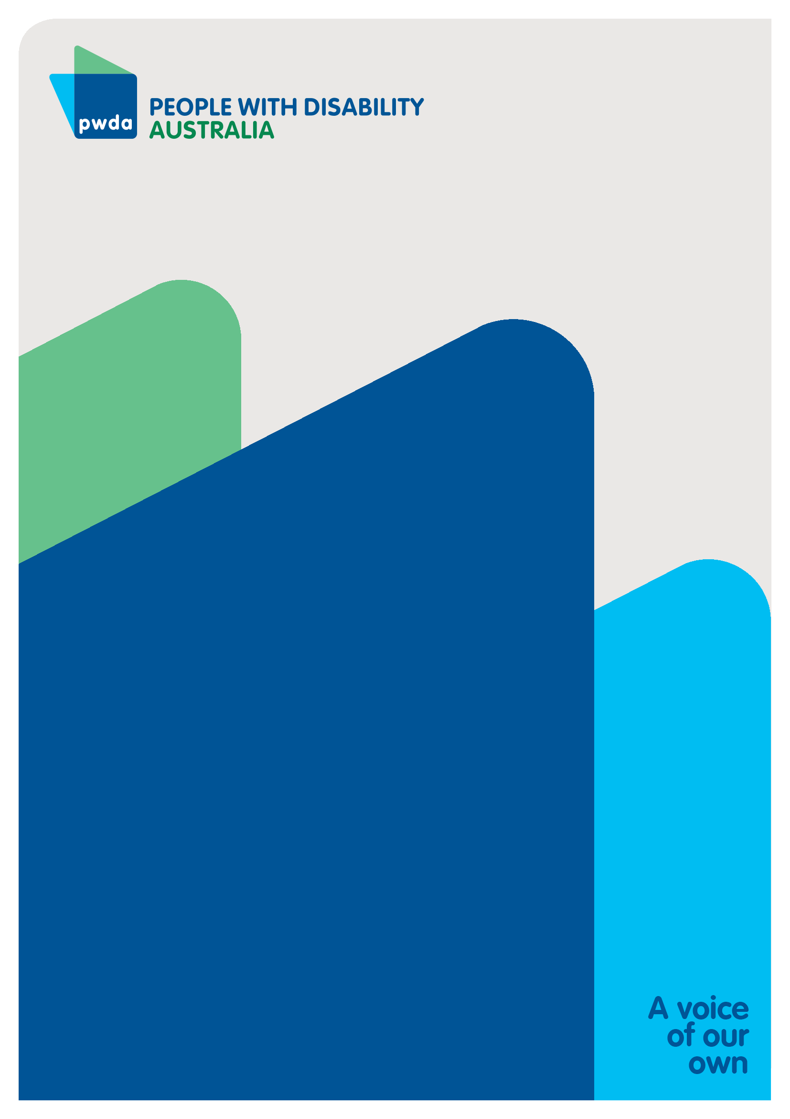
People with Disability Australia (PWDA) is a national disability rights and advocacy organisation made up of, and led by, people with disability.
For individual advocacy support contact PWDA between 9 am and 5 pm (AEST/AEDT) Monday to Friday via phone (toll free) on 1800 843 929 or via email at pwd@pwd.org.au
Submission contact
Bastien Wallace
Senior Policy Officer
E: bastienw@pwd.org.au

Endnotes

50 domains including: Overall life satisfaction, healthy, secure, personal safety, child safety, safe housing, sufficient income, national safety, online safety, sustainable, air quality, biodiversity, climate resilience, economic resilience, emissions reduction, fiscal sustainability, cohesive, acceptance of diversity, experience of discrimination, broadening access to work, digital preparedness, education attainment,
Australian Bureau of Statistics (4 July 2024), 5.5 million Australians have disability, ABS Website, accessed 10 July 2024, https://www.abs.gov.au/media-centre/media-releases/55-million-australians-have-disability.
21.4% of population of 8,153,000 = 174,474,200
NSW population 8,153,000. NSW Government, Key facts about NSW, updated 30 June 2022, last accessed 10 July 2024, https://www.nsw.gov.au/about-nsw/key-facts-about-nsw 21.4% with disability- Disability, Ageing and Carers, Australia: Summary of Findings 2022, 4 July 2024, last accessed 10 July 2024 https://www.abs.gov.au/statistics/health/disability/disability-ageing-and-carers-australia-summary-findings/latest-release
Rosemary Kayess and Therese Sands, Convention on the Rights of Persons with Disabilities: Shining a light on Social Transformation (UNSW Social Policy Research Centre, 2020); Australian Bureau of Statistics (n1); Australian Institute of Health and Welfare (n 1); Jeromey B Temple, Margaret Kelaher and Ruth Williams, ‘Discrimination and avoidance due to disability in Australia: evidence from a National Cross-Sectional Survey’ (2018) 18 BMC Public Health 1347.
Australian Institute of Health and Welfare (n 1) 163.
Anti-Discrimination NSW, Annual Report 2021-22 (2022) 15 https://antidiscrimination.nsw.gov.au/documents/annual-reports/anti-discrimination-annual-report-2021-22.pdf
Australian Institute of Health and Welfare (n 1) 163.
Committee on the Rights of Persons with Disabilities, General comment No. 6 (2018) Equality and non-discrimination CRPD/C/GC/6 (26 April 2018) [30]; Australian Human Rights Commission, Free and Equal. A reform agenda for federal discrimination laws (December 2021) 16; United Nations, Convention on the Rights of Persons with Disabilities (12 December 2006), article 5.
United Nations, Convention on the Rights of Persons with Disabilities, United Nations, last updated December 2006, last accessed 10 July 2024 https://social.desa.un.org/issues/disability/crpd/article-31-statistics-and-data-collection
United Nations, Convention on the Rights of Persons with Disabilities, United Nations, last updated December 2006, last accessed 10 July 2024 https://social.desa.un.org/issues/disability/crpd/convention-on-the-rights-of-persons-with-disabilities-crpd
Australian Government Australian Institute of Health and Welfare A, ‘Specialist homelessness services annual report 2021–22’, Australian Government Australian Institute of Health and Welfare, Australian Institute of Health and Welfare, last updated 8 December 2022, last accessed 13 November 2023. https://www.aihw.gov.au/reports/ homelessness-services/shs-annual-report/contents/clients-with-disability
https://pwd.org.au/budget-measures-to-progress-the-disability-agenda-in-nsw/
https://pwd.org.au/wp-content/uploads/2024/02/PWDA-Disability-Royal-Commission-Policy-Positions.docx
NSW Department of Education, Progress Report: Improving Outcomes for students with disability 2022, p 4-5, last accessed 12 October 2023 https://education.nsw.gov.au/content/dam/main-education/teaching-and-learning/disability-learning-and-support/our-disability-strategy/Progress_Report_Improving_outcomes_for_students_with_disability_2022.PDF
NSW Department of Education, Progress Report: Improving Outcomes for students with disability 2022, last accessed 12 October 2023 https://education.nsw.gov.au/content/dam/main-education/teaching-and-learning/disability-learning-and-support/our-disability-strategy/Progress_Report_Improving_outcomes_for_students_with_disability_2022.PDF
10% unemployment NSW Government- NSW Public Service Commission, What is Disability: Understanding disability in relation to the NSW public sector and broader community, last accessed 12 October 2023, https://www.psc.nsw.gov.au/culture-and-inclusion/disability-employment/understanding-disability/what-is-disability#:~:text=2.1%20million%20Australians%20of%20working,%25%20and%204.6%25%20respectively).
Royal Commission into Violence, Abuse, Neglect and Exploitation of People with Disability: Final Report, Volume 7, Inclusive education, employment and housing; summary and recommendations (2023), last accessed 11 October 2023, https://disability.royalcommission.gov.au/system/files/2023-09/Final%20Report%20-%20Volume%207%2C%20Inclusive%20education%2C%20employment%20and%20housing%20-%20Summary%20and%20recommendations.pdf
Royal Commission into Violence, Abuse, Neglect and Exploitation of People with Disability: Final Report, Nature and Extent of Violence, Abuse and Exploitation, Volume 3 p 218 last accessed 21 November 2023, https://disability.royalcommission.gov.au/system/files/2023-09/Final%20Report%20-%20Volume%203%2C%20Nature%20and%20Extent%20of%20Violence%2C%20abuse%2C%20neglect%20and%20exploitation.pdf
Royal Commission into Violence, Abuse, Neglect and Exploitation of People with Disability: Final Report, Nature and Extent of Violence, Abuse and Exploitation, Volume 3 p 219 last accessed 21 November 2023, https://disability.royalcommission.gov.au/system/files/2023-09/Final%20Report%20-%20Volume%203%2C%20Nature%20and%20Extent%20of%20Violence%2C%20abuse%2C%20neglect%20and%20exploitation.pdf Australian Bureau of Statistics. (2017-18). National Health Survey: First results. ABS. https://www.abs.gov.au/statistics/health/health-conditions-and-risks/national-health-survey-first-results/latest-release
Royal Commission into Violence, Abuse, Neglect and Exploitation of People with Disability: Final Report, Nature and Extent of Violence, Abuse and Exploitation, Volume 3 p 220 last accessed 21 November 2023, https://disability.royalcommission.gov.au/system/files/2023-09/Final%20Report%20-%20Volume%203%2C%20Nature%20and%20Extent%20of%20Violence%2C%20abuse%2C%20neglect%20and%20exploitation.pdf Vincent, J., et.al., The economic cost of violence, abuse, neglect and exploitation for people with disability, Report prepared for the Royal Commission into Violence, Abuse, Neglect and Exploitation of People with Disability, Taylor Fry, February 2023, p 106. Last accessed 21 November 2023 https://disability.royalcommission.gov.au/system/files/2023-09/Research%20Report%20-%20Economic%20cost%20of%20violence%2C%20abuse%2C%20neglect%20and%20exploitation%20of%20people%20with%20disability_0.docx
PWDA, Building Access Project, undated, last accessed 27 September 2023, https://pwd.org.au/projects/building-access-project/

