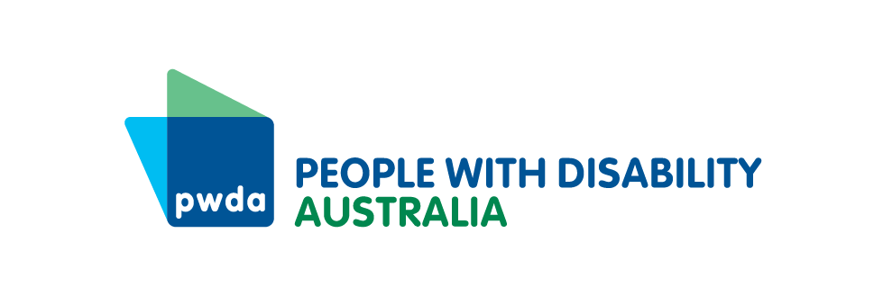

PO Box 666  
Strawberry Hills  
NSW 2012

+61 2 8365 0400  
Toll free 1800 422 015  
[pwd@pwd.org.au](mailto:pwd@pwd.org.au)[www.pwd.org.au](http://www.pwd.org.au/)

2 September 2024

Joint Standing Committee on Implementation of the National Redress Scheme  
PO Box 6021  
Parliament House  
Canberra ACT 2600

Delivered by email to [redress@aph.gov.au](mailto:redress@aph.gov.au)

Dear Committee Secretariat

Supplementary submission

Thank you for the opportunity to provide a further submission to the Joint Standing Committee on Implementation of the National Redress Scheme’s [*Inquiry into the Operation of the National Redress Scheme*](https://www.aph.gov.au/Parliamentary_Business/Committees/Joint/National_Redress_Scheme_Standing/Redress47/Submissions) (the Inquiry).

[People with Disability Australia](https://pwd.org.au/cosp17-day-4-round-up-13-june-2024/) (PWDA) is a funded national Redress Support Service. We provide information, referrals and support for survivors of institutional childhood sexual abuse with disability who may wish to interact with the National Redress Scheme (the Scheme). We provide information and support throughout all phases of a survivor’s Redress journey, with face-to-face support available in New South Wales and some areas of Queensland. We also provide phone and online information, referrals and support nationally.

PWDA has previously provided a submission and supplementary submission to the Inquiry. We welcome the opportunity to provide further updated information to the Inquiry, and note that this is in addition to, and is not intended to replace, our previous submissions.

This submission will address the following Terms of Reference (ToR) in relation to people with disability:

* ToR 2(b) – Availability of data and information about why application trends are varying from expectations
* ToR 4(b) – Opportunities for Scheme applicants to consider available legal options and to exercise their own choices
* ToR 5 – The performance and effectiveness of support services for Scheme applicants, including accessibility and resourcing and funding levels.

### ToR 2(b) – Availability of data and information about why application trends are varying from expectations

The Department of Social Services has advised that the rate of Scheme applications from women has been much lower than expected. PWDA’s National Redress Scheme Program’s intake data also reflects this trend, with most of our clients being male. This is concerning, given that women are more than three times as likely to have experienced child sex abuse compared to men, and indicates that women are experiencing barriers to accessing the Scheme.[1]

Our advocates report that women with disability experience a multitude of barriers to accessing the Scheme. This includes cost, social isolation, mental health challenges, stigma, religious and cultural practices, domestic and family violence and caring responsibilities. However, a gateway barrier is that many women with disability are unaware of the Scheme.

This is due in part to a lack of government service referral to the Scheme. Our advocates report that NSW Government health and social services, including child protection, health services and specialist women’s health services, lack knowledge about the scheme and are missing key opportunities to refer women with disability to the Scheme.

For example, one of our advocates reported that:

Many women with disability who are engaged with child protection and early intervention programs have encountered historical interactions with institutional care as a child. Often these women live with the additional trauma of childhood sexual abuse within the institutional setting(s). This then leads to concerns such as: self-harm, poor mental health, drug, alcohol or gambling addictions, and can also impact on their own ability to parent safely, which brings them into contact with government services. It is unfortunate that many government services including women’s health services have not heard of the National Redress Scheme, and therefore cannot refer these women to a redress support service for acknowledgement of their abuse.

To increase women with disability’s awareness and access to the Scheme, we recommend that:

**Recommendation 1:** The federal, state and territory governments must ensure that relevant government health and social services are trained to provide information about and make referrals to legal and advocacy support to access the Scheme in a way that is trauma-informed and accessible.

We also recommend that:

**Recommendation 2:** The Government coordinates and funds targeted outreach campaigns to reach women with disability to increase knowledge of and access to the Scheme. Outreach campaigns should be conducted in an accessible manner and be effective for people with disability who are unable to read or understand written information.

### Section 4(b) Opportunities for Scheme applicants to consider available legal options and to exercise their own choices

We are pleased that the Government has provided Knowmore Legal Services with additional funding. However, due to high demand, there are long waiting lists which have increased since the Scheme was opened to people in prison. There are also substantial waiting times for support service consults on client applications that are not urgent. As a result, people with disability do not have access to appropriate legal services in a timely manner, which causes further trauma.

While some community legal services assist with Scheme applications, they do not have specialist Scheme or disability expertise. Our advocates also report that clients have had negative experiences at private law firms and have been liable for fees when they have commenced a ‘no-win, no-fee’ arrangement but subsequently decided not to proceed.

To ensure people with disability have access to legal services to apply for the Scheme, we recommend that:

**Recommendation 3:** The Government should provide increased funding to the Knowmore Legal Services and/or similar specialist Scheme legal services to ensure that clients can access legal advice in a trauma-informed and accessible manner.

### Section 5 – The performance and effectiveness of support services for Scheme applicants, including accessibility and resourcing and funding levels

We are concerned that people with disability in prison are not receiving appropriate information about the Scheme. Currently, Scheme outreach to prisons is limited to the distribution of printed information packs, containing information about the Scheme and application forms.

People with disability are overrepresented in prisons, and may not be able to read, write, or understand information provided in information packs. In addition, people who spent their childhood in institutions often received disrupted education, which means they may also face barriers in reading, writing and understanding complex information.

People in prisons have also been provided with a telephone number to contact Knowmore Legal Services. However, people with disability who have been institutionalised as a child and are currently incarcerated often do not trust lawyers. For this cohort, individual disability advocacy services, that are trained to assist people with various disabilities, is often a more appropriate option.

Unfortunately the Government has not conducted an open Expression of Interest process for funding advocacy services to go into prisons. Additional funding has been provided to generalist Redress services, but not specialised disability advocacy services, such as those provided by PWDA. This has left PWDA unable to provide assistance to people with disability in prison.

Our advocates report that people with disability have been targeted in prison by individuals that share unsolicited and incorrect information about the Scheme to convince potential applicants to commence a ‘no-win, no-fee arrangement’, commonly known as ‘claim farming’. These individuals will often make money by selling information about potential applicants to private law firms. People with disability are at particular risk of this form of exploitation.

To ensure people with disability in prison have equal access to the Scheme and to combat misinformation and ‘claim farming’, we recommend that:

**Recommendation 4:** The Government creates a separate funding stream for specialist disability advocacy services to conduct outreach and individual advocacy for people with disability in prisons.

Thank you for the opportunity to provide further information. Should you have any queries regarding this submission, please contact my Senior Policy Officer, Ms Lisa Ira, via email at [lisai@pwd.org.au](mailto:lisai@pwd.org.au) or on 0409 431 088.

Yours sincerely

Megan Spindler-Smith

Acting Chief Executive Officer

People with Disability Australia

1. Australian Bureau of Statistics (2021-22), [Personal Safety, Australia](https://www.abs.gov.au/statistics/people/crime-and-justice/personal-safety-australia/2021-22), ABS Website, accessed 2 September 2024.