# 

# Proposals to increase voter engagement, participation and confidence

# Submission to the NSW Government Joint Standing Committee on Electoral Matters

August

2024

# Copyright information

*Proposals to increase voter engagement, participation and confidence – Submission to the NSW Government Joint Standing Committee on Electoral Matters*

First published in 2023 by People with Disability Australia Ltd.  
Level 8, 418a Elizabeth Street, Surry Hills, New South Wales, Australia 2010  
Head office also in Sydney  
Email:[pwd@pwd.org.au](mailto:pwd@pwd.org.au)  
Phone: +61 2 9370 3100 Fax: +61 2 9318 1372  
URL: [www.pwd.org.au](http://www.pwd.org.au)

Typeset in Arial 12 and 14 pt and VAG Rounded 26 pt

© People with Disability Australia Ltd. 2023

The moral rights of the authors have been asserted

National Library of Australia Cataloguing-in-Publication data:

|  |  |
| --- | --- |
| Creator(s): | Bastien Wallace |
| Title: | Proposals to increase voter engagement, participation and confidence – Submission to the NSW Government Joint Standing Committee on Electoral Matters*.* |

All rights reserved. Except as permitted with the *Australian Copyright Act 1968* (for example, a fair dealing for the purposes of study, research, criticism or review), no part of this book may be reproduced, stored in a retrieval system, communication or transmitted in any form or by any means without prior written permission. All inquiries should be made to the publisher at the address above.

*Suggested citation: EXAMPLE BELOW*

Wallace, B., *Proposals to increase voter engagement, participation and confidence – Submission to the NSW Government Joint Standing Committee on Electoral Matters,* 16 August 2024, People with Disability Australia, Sydney.

## About PWDA

People with Disability Australia (PWDA) is a national disability rights and advocacy organisation made up of, and led by, people with disability.

We have a vision of a socially just, accessible and inclusive community in which the contribution, potential and diversity of people with disability are not only recognised and respected but also celebrated.

PWDA was established in 1981, during the International Year of Disabled Persons.

We are a peak, non-profit, non-government organisation that represents the interests of people with all kinds of disability.

We also represent people with disability at the United Nations, particularly in relation to the United Nations Convention on the Rights of Persons with Disabilities (CRPD).

Our work is grounded in a human rights framework that recognises the CRPD and related mechanisms as fundamental tools for advancing the rights of people with disability.

PWDA is a member of Disabled People’s Organisations Australia (DPO Australia), along with the First People’s Disability Network, National Ethnic Disability Alliance, and Women with Disabilities Australia.

DPOs collectively form a disability rights movement that places people with disability at the centre of decision-making in all aspects of our lives.

The work of PWDA embraces the ‘Nothing About Us, Without Us’ motto of the international disability community and Disabled Peoples’ International, the international organisation representing national organisations of people with disability in over 130 countries.

Table of Contents

1

Proposals to increase voter engagement, participation and confidence 1

Submission to the NSW Government Joint Standing Committee on Electoral Matters 1

Copyright information 2

About PWDA 3

Introduction 6

The experience of PWDA individual advocates 7

Submission structure 7

Summary of Recommendations 8

Polling places 8

Informed voters 8

Improving access 8

Background 10

Specific discussion questions being considered are: 10

Relevant information 10

Polling places 12

Informed voters 14

Improving access 15

CRPD Rights 17

Discussion 18

How can we increase voter engagement and confidence in our electoral system? 18

What reforms are needed to increase the participation of groups in our community that have lower enrolment and turnout rates? 19

Conclusion 20

## Introduction

PWDA welcomes the opportunity to provide preliminary comments on the NSW Government Joint Standing Committee on Electoral Matters Proposals to increase voter engagement, participation and confidence.

PWDA is Australia’s peak cross-disability Disability Representative Organisation. Nationally 4.4 million Australians have a disability, around 17.7% of the population.[1]

When compared with people without disability, people with disability continue to experience discrimination and poorer life outcomes across all life domains.[2] It is estimated that 22% of people aged over 15 with disability in Australia have experienced some form of discrimination compared with 15% of those without disability.[3] Disability discrimination is the largest ground of complaint to Anti-Discrimination NSW (ADNSW)[4] and the Australian Human Rights Commission (AHRC).[5] Discrimination against people with disability appears deeply entrenched across systems.

Governments have an obligation to respect, protect and fulfil human rights.[6] Disability Rights are Human Rights.

The overarching theme of this submission is that elements of the voting process require reform to improve accessibility, engagement and access. By doing so, this will improve the accessibility, engagement and trust in the process, by people with disability. We have provided specific examples and recommendations related to polling places, informed voters and improving access to voting for people with disability.

### The experience of PWDA individual advocates

PWDA is funded by the NSW Department of Communities and Justice’s *Disability Advocacy Futures Program* to provide individual advocacy. The majority of our clients focus on seeking our assistance with issues related to housing, healthcare and education. However, clients have raised concerns about staying COVID-safe whilst voting, especially over the last two years since most control measures have been withdrawn. One of our team members who needed to use telephone voting reported having had difficulty hearing the options, due to the background noise present when they called.

### Submission structure

The Joint Standing Committee on Electoral Matters is investigating:

How can we increase voter engagement and confidence in our electoral system? and

What reforms are needed to increase the participation of groups in our community that have lower enrolment and turnout rates?

This submission/response to request is organised into six parts, and a conclusion:

* Part 1 provides background
* Part 2 looks at polling places
* Part 3 looks at informed voters
* Part 4 looks at improving access
* Part 5 explains our CRPD rights
* Part 6 is a brief discussion

# Summary of Recommendations

### Polling places

**Recommendation 1** **–** All electorates must work to ensure the majority of polling places are physically accessible to people who use mobility assistance devices

**Recommendation 2** **–**All electorates should provide at least one polling place suitable for people who need a ‘low sensory’ environment free of extra noise, physical and visual intrusions

**Recommendation 3** **–** All voting information (about the voting process, voting places, and candidates seeking election) should be provided in accessible formats at least 6 weeks in advance of the election

### Informed voters

**Recommendation 4** **–**Candidates for election must provide information about their policy positions in accessible formats 6 weeks prior to elections, and should provide contact information for voters need to engage with them in advance of election to inform themselves

**Recommendation 5** **–** Assisted decision making resources should be provided to voters who need them

### Improving access

**Recommendation 6** **–** Accessible technology assisted voting options should be provided in polling places, by phone, and online for voters who cannot attend a polling place, or who need to avoid COVID-19 or other infection. This must be for the same duration as other voting types, and options must be provided for electors who are overseas.

**Recommendation 7** **–** All staff at polling places should receive inclusion training to improve how they communicate with, and provide assistance to, voters, and where possible this should be delivered by staff with disability

# Background

### Specific [discussion questions](https://www.parliament.nsw.gov.au/committees/inquiries/Pages/inquiry-details.aspx?pk=3053#tab-termsofreference) being considered are:

The Joint Standing Committee on Electoral Matters is investigating how can we increase voter engagement and confidence in our electoral system?

What reforms are needed to increase the participation of groups in our community that have lower enrolment and turnout rates?

The inquiry will also consider options for technology assisted voting that have been identified by the NSW Electoral Commission. Further, the Committee will look at ways to improve systems for political donations, electoral funding and party governance, and specific laws that relate to electoral funding and political parties.

PWDA welcomes the opportunity to respond to these two questions, and we look forward to the selection and deployment of technology assisted voting. We will leave the matters of political donations, electoral funding and party governance to others for consideration. However, we are keen to see all information that is provided about candidates standing for election made accessible to all voters.

### Relevant information

At the 2019 State election only 61 of the 92 NSW electorates had a voting centre which was accessible, and 55 of those 61 electorates with a single voting centre which was fully accessible. However, voters may have had to travel hundreds of kilometres in areas without public transport in order to vote.

From the [Evaluation of NSW Electoral Commission services at the 2023 NSW State election Report](https://elections.nsw.gov.au/getmedia/2959fb31-b6a8-4dfc-a703-9def16d61bbc/nswec-sge23-independent-research-report.pdf)

**Key findings**

* + - 81% net satisfaction with overall voting experience.
    - 72% net confidence in election results.
    - 84% net satisfaction for fairness and impartiality of election.

# Polling places

Not all polling places are physically accessible for people who use mobility assistance devices. This could relate to facilities not being step-free, to a lack of accessible parking, or to polling places being inaccessible by public transport. In some electorates it is difficult and/or expensive to reach an accessible polling place and this is exacerbated when electorates are spread over a large geographic area.

People may not have confidence in the alternative voting methods provided. People who need to use telephone voting report difficulty remembering the long list of candidates, and that this reduces their confidence using this system. Applying for a postal vote, while it may assist a person who has physical access issues to obtain ballot form, does not help if the person needs assistance to read and understand the form. People may also struggle to return the form on time if postal facilities are not available close by.

**Recommendation 1** **–** All electorates must work to ensure the majority of polling places are physically accessible to people who use mobility assistance devices

Polling places can be overwhelming for people with sensory or psychosocial disabilities. Crowds, noise, and party supporters attempting to provide how to vote information, can be stressful. People may be unable to wait standing in queues. These experiences can lead to people avoiding voting.

From our representation on the Australian Electoral Commission’s Disability Advisory Committee, PWDA is aware of the successful low sensory voting trial held on Wednesday 16 August 2023 at pre-polling by the Victorian Electoral Commission in the Warrandyte by-election. Whilst some voters had issues with the behavior of campaign workers, overall low sensory voting was welcomed by this who used it. PWDA calls for low sensory voting options to be provided in every electorate, and for electoral and campaign workers to be trained to support this form of voting appropriately.

**Recommendation 2** **–** All electorates should provide at least one polling place suitable for people who need a ‘low sensory’ environment free of extra noise, physical and visual intrusions

The NSW Government strives to provide information about how to vote in a timely accessible manner. However polling places identified as accessible may not include all of the accessible features such as: wheelchair accessibility, virtual Auslan interpreter service, magnifier and maxi-pen. There may not be information included about accessible parking and or other features people need to access polling places. This can lead to confusion.

**Recommendation 3** **–** All voting information (about the voting process, voting places, voting facilities, and candidates seeking election) should be provided in accessible formats at least 6 weeks in advance of the election

# Informed voters

Currently candidates do not have to provide information about their policy positions in accessible formats. This can prevent people with disability from understanding what each candidate stands for. Candidates may also choose not to provide direct contact details in advance of an election, which makes it difficult for voters with disability to engage with them. All of this makes it difficult for people with disability to inform themselves in advance of an election, so that they can cast an informed vote. This undermines the democratic process and could contribute to mistrust trust in voting.

**Recommendation 4** **–** Candidates for election must provide information about their policy positions in accessible formats 6 weeks prior to elections, and should provide contact information for voters need to engage with them in advance of election to inform themselves

Some people with disability report that they have been discouraged from voting, rather than being provided with resources and assisted decision making to help them exercise choice.

**Recommendation 5** **–** Assisted decision making resources should be provided to voters who need them

# Improving access

PWDA is aware that the RFI for Technology Assisted Voting (TAV) for the 2027 State Election was issued in February 2024, and has closed. We strongly support providing accessible, inclusive Technology Assisted Voting as soon as possible. This will help more voters with disability in NSW cast their vote independently, in the same way as their peers.

For people in NSW who are blind or have low vision, telephone voting has been offered as an alternative. This is inaccessible for people who are deaf/blind. PWDA was pleased to learn that in the upcoming Local Government elections on the 14th of September Braille ballot papers will be made available to voters who need them.

Telephone voting requires voters to remember long lists, and it can be difficult to hear clearly if the person reciting the list is working in a place with background noise. During the last NSW State election telephone voting was not open for the same duration as polling places, and was not available to electors who were overseas

**Recommendation 6** **–** Accessible technology assisted voting options should be provided as soon as possible in polling places, and online for voters who cannot attend a polling place. Alternatives such as telephone voting must be provided for the same duration as other voting types, and options must be provided for electors who are overseas.

PWDA appreciates the efforts the NSW Government has made to improve voting accessibility and inclusion. Recruiting and training the 20,000 staff needed for the upcoming local government elections presents a huge logistical challenge over a relatively short timeframe.[7] We appreciate that people with disability are encouraged to apply for these roles, and we call on the Electoral Commission to utilise the lived experience of staff with disability to develop and provide inclusion training for staff at every polling place. In cases where face to face training is not feasible, we recommend developing video resources so that all staff at polling places can better understand how to communicate with and provide assistance to voters.

**Recommendation 7** **–** All staff at polling places should receive inclusion training to improve how they communicate with, and provide assistance to, voters, and where possible this should be delivered by staff with disability

# CRPD Rights

The [Convention on the Rights of Persons with Disabilities (CRPD)](https://social.desa.un.org/issues/disability/crpd/convention-on-the-rights-of-persons-with-disabilities-crpd)[8] requires the following:

[Article 29 - Participation In Political And Public Life](https://social.desa.un.org/issues/disability/crpd/article-29-participation-in-political-and-public-life)

“…States Parties shall guarantee to persons with disabilities political rights and the opportunity to enjoy them on an equal basis with others, and shall undertake:

a) To ensure that persons with disabilities can effectively and fully participate in political and public life on an equal basis with others, directly or through freely chosen representatives, including the right and opportunity for persons with disabilities to vote and be elected, inter alia, by:

i. Ensuring that voting procedures, facilities and materials are appropriate, accessible and easy to understand and use;

ii. Protecting the right of persons with disabilities to vote by secret ballot in elections and public referendums without intimidation, and to stand for elections, to effectively hold office and perform all public functions at all levels of government, facilitating the use of assistive and new technologies where appropriate;

iii. Guaranteeing the free expression of the will of persons with disabilities as electors and to this end, where necessary, at their request, allowing assistance in voting by a person of their own choice;

b) To promote actively an environment in which persons with disabilities can effectively and fully participate in the conduct of public affairs, without discrimination and on an equal basis with others, and encourage their participation in public affairs, including:

i. Participation in non-governmental organizations and associations concerned with the public and political life of the country, and in the activities and administration of political parties;…”

The voting process must uphold our CRPD rights. The real-world application of these rights requires that the State of NSW continue to evolve the voting processes, staff training, information about voting, polling places, and candidates to a standard of accessibility and inclusion that enables people with disability to exercise our political rights on an equal basis with people without disability.

# Discussion

### How can we increase voter engagement and confidence in our electoral system?

The Joint Standing Committee on Electoral Matters is investigating how voter engagement and confidence in the electoral system can be increased. PWDA recognises the efforts made by the NSW Electoral Commission to provide accessible information to voters about the voting process, and to provide alternative formats to enhance inclusion such as Auslan translation, Easy Read resources, and Braile ballots.

In order to be engaged in, and confident about, the process of voting, people with disability need to be able to inform themselves about each of the candidates in their local communities, and what they stand for. They then need accessible ways to contact these candidates to understand their policies and intentions, in order to be able to cast their vote with confidence. This is why PWDA has recommended changes to improve the accessibility of candidate information, and the publishing contact information prior to election to provide more inclusive ways for voters to inform themselves.

Historically some people with disability, particularly people with psychosocial disability, have been discouraged from voting. Alternatively, a carer or other person may have completed a ballot on their behalf in a way that does not express their will and preference. We have recommended that assisted decision-making resources be provided for voters who need them. This will assist more people to vote, and help ensure that all voters are able to express their will and preference.

### What reforms are needed to increase the participation of groups in our community that have lower enrolment and turnout rates?

As we have outlined, physical inaccessibility, information inaccessibility and a lack of provision for people who need low sensory environments could all be contributing to reductions in voter turnout for people with disability. Concerns about the transmission of COVID-19 can also mean that voters who face increased risk from infection may not feel safe to attend polling places.

PWDA appreciates that the NSW Electoral Commission is currently considering options for technology assisted voting. Until accessible technology assisted voting can be provided as an alternative to attending a polling place, accessible options like telephone voting should be made available to voters who cannot attend a polling place, or who need to avoid COVID-19 or other infection. These alternatives must be provided on the same basis as other forms of voting, and should be provided for electors who are overseas.

PWDA appreciated efforts by the NSW Electoral Commission to employ more people with disability to work on elections. We recommend as part of this employment, developing resources based on the lived experience of people with disability, to train all election staff to provide inclusive support. Given the timeline challenges involved, we recommend developing and sharing short videos, images and ‘point of view’ accounts. Improving training for electoral staff will help them provide the support required to make voting more inclusive and accessible.

# Conclusion

PWDA appreciates the opportunity to contribute to the NSW Government Joint Standing Committee on Electoral Matters Proposals to increase voter engagement, participation and confidence. The NSW Electoral Commission and the many staff across the state have worked to improve the accessibility of voting in NSW, however further reform is required.

Improving access to information in accessible formats about candidates seeking election, improving the number and types of accessible polling places, ensuring that wherever possible all accessibility barriers are removed, and improving staff training will all help build engagement and trust in the voting process, by people with disability in NSW.

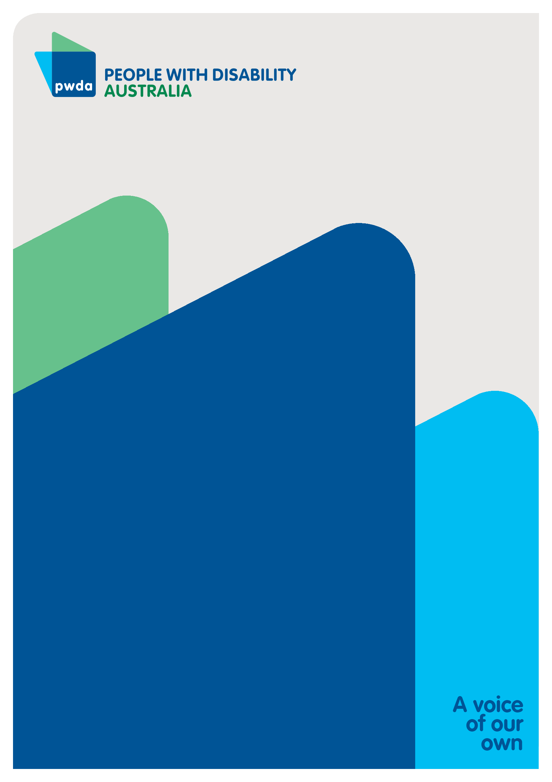People with Disability Australia (PWDA) is a national disability rights and advocacy organisation made up of, and led by, people with disability.

For individual advocacy support contact PWDAbetween 9 am and 5 pm (AEST/AEDT) Monday to Friday via phone (toll free) on **1800 843 929** or via email at [pwd@pwd.org.au](mailto:pwd@pwd.org.au)

**Submission contact**

Bastien Wallace

Senior Policy Officer

E: [bastienw@pwd.org.au](mailto:bastienw@pwd.org.au)

1. Australian Institute of Health and Welfare, *People with Disability in Australia 2022* (2022) <https://www.aihw.gov.au/reports/disability/people-with-disability-in-australia/contents/about>; Australian Bureau of Statistics, *Disability, Ageing and Carers, Australia: Summary of Findings* (2019) <https://www.abs.gov.au/statistics/health/disability/disability-ageing-and-carers-australia-summary-findings/latest-release#disability>**.** 
2. Rosemary Kayess and Therese Sands, *Convention on the Rights of Persons with Disabilities: Shining a light on Social Transformation* (UNSW Social Policy Research Centre, 2020); Australian Bureau of Statistics (n1); Australian Institute of Health and Welfare (n 1); Jeromey B Temple, Margaret Kelaher and Ruth Williams, ‘Discrimination and avoidance due to disability in Australia: evidence from a National Cross-Sectional Survey’ (2018) 18 *BMC Public Health* 1347.
3. Australian Institute of Health and Welfare (n 1) 163.
4. Anti-Discrimination NSW, *Annual Report 2021-22* (2022) 15 <https://antidiscrimination.nsw.gov.au/documents/annual-reports/anti-discrimination-annual-report-2021-22.pdf>
5. Australian Institute of Health and Welfare (n 1) 163.
6. Committee on the Rights of Persons with Disabilities, *General comment No. 6 (2018) Equality and non-discrimination* CRPD/C/GC/6 (26 April 2018) [30]; Australian Human Rights Commission, *Free and Equal. A reform agenda for federal discrimination laws* (December 2021) 16; United Nations, *Convention on the Rights of Persons with Disabilities* (12 December 2006), article 5.
7. NSW Electoral Commission, More than 20,000 paid roles on offer to deliver local council elections, 24 June 2024, last accessed 11 July 2024, https://elections.nsw.gov.au/about-us/media-centre/news-and-media-releases/lge24-paid-roles-on-offer
8. United Nations, Department of Economic and Social Affairs Social Inclusion, Convention on the Rights of Persons with Disabilities, last accessed 11 July, 2024, <https://social.desa.un.org/issues/disability/crpd/convention-on-the-rights-of-persons-with-disabilities-crpd>