# 

# AI For All – An Equitable Regulatory Framework for Australia

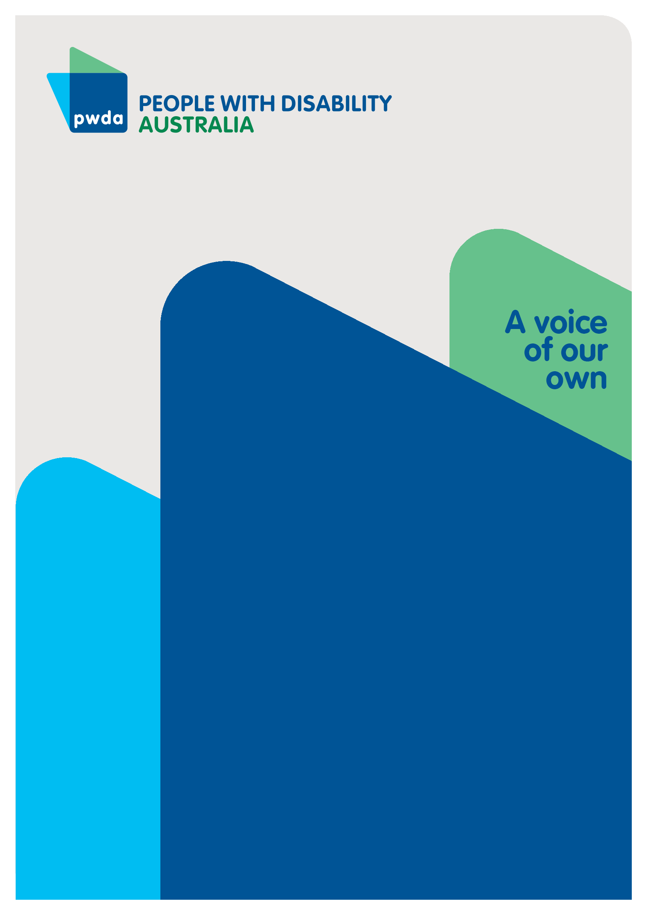Submission to the Department of Industry, Science and Resources on Safe and Responsible AI in Australia

October

2024

# Copyright information

AI For All – An Equitable Regulatory Framework for Australia - Submission to the Department of Industry, Science and Resources on Safe and Responsible AI in Australia

First published in 2023 by People with Disability Australia Ltd.  
Suite 10.01, Centennial Plaza, Level 10, 300 Elizabeth Street, Surry Hills, New South Wales, Australia 2010  
Head office also in Sydney  
Email:[pwd@pwd.org.au](mailto:pwd@pwd.org.au)  
Phone: +61 2 9370 3100 Fax: +61 2 9318 1372  
URL: [www.pwd.org.au](http://www.pwd.org.au)

Typeset in Arial 12 and 14 pt and VAG Rounded 26 pt

© People with Disability Australia Ltd. 2024

The moral rights of the authors have been asserted

National Library of Australia Cataloguing-in-Publication data:

|  |  |
| --- | --- |
| Creator(s): | Connor, Samantha; |
| Title: | AI For All – An Equitable Regulatory Framework for Australia - Submission to the Department of Industry, Science and Resources on Safe and Responsible AI in Australia |

All rights reserved. Except as permitted with the *Australian Copyright Act 1968* (for example, a fair dealing for the purposes of study, research, criticism or review), no part of this book may be reproduced, stored in a retrieval system, communication or transmitted in any form or by any means without prior written permission. All inquiries should be made to the publisher at the address above.

*Suggested citation: EXAMPLE BELOW:*

Connor, S., *AI For All – An Equitable Regulatory Framework for Australia - Submission to the Department of Industry, Science and Resources on Safe and Responsible AI in Australia*, 4 October 2024, People with Disability Australia, Sydney.

## About PWDA

People with Disability Australia (PWDA) is a national disability rights and advocacy organisation made up of, and led by, people with disability.

We have a vision of a socially just, accessible and inclusive community in which the contribution, potential and diversity of people with disability are not only recognised and respected but also celebrated.

PWDA was established in 1981, during the International Year of Disabled Persons.

We are a peak, non-profit, non-government organisation that represents the interests of people with all kinds of disability.

We also represent people with disability at the United Nations, particularly in relation to the United Nations Convention on the Rights of Persons with Disabilities (CRPD).

Our work is grounded in a human rights framework that recognises the CRPD and related mechanisms as fundamental tools for advancing the rights of people with disability.

PWDA is a member of Disabled People’s Organisations Australia (DPO Australia), along with the First People’s Disability Network, National Ethnic Disability Alliance, and Women with Disabilities Australia.

DPOs collectively form a disability rights movement that places people with disability at the centre of decision-making in all aspects of our lives.

The work of PWDA embraces the ‘Nothing About Us, Without Us’ motto of the international disability community and Disabled Peoples’ International, the international organisation representing national organisations of people with disability in over 130 countries.

Table of Contents

1

AI For All – An Equitable Regulatory Framework for Australia 1

Copyright information 2

About PWDA 3

Executive Summary 6

Introduction 8

The experience of PWDA individual advocates 9

Board concerns 9

Submission structure 10

Summary of Recommendations 12

1.What is ‘AI’? 14

2. Background on AI and Disability Rights 15

2.1 Current use of AI affecting people with disability 15

2.2 Intersection of AI and the UNCRPD 15

3. Defining High-Risk AI 16

3.1 Proposed principles 16

3.2 Implications for people with disability 17

3.3 High-risk AI based on intended and foreseeable uses 18

3.4 Responses to Consultation Questions 19

4. Proposed Mandatory Guardrails 20

4.1 Overview of the proposed guardrails 20

4.2 Additional guardrails proposed 20

4.3 Gaps in the proposed guardrails 21

4.4 Implementation challenges for the disability sector 22

4.5 Response to questions 22

5. Regulatory Options to Mandate Guardrails 24

5.1 Analysis of Options 24

5.2 Prohibited AI Practices 25

5.3 Key considerations for implementation 26

5.4 Response to Questions 27

6. Recommendations 28

7. Conclusion 31

8. References 32

## Executive Summary

People with Disability Australia (PWDA) welcomes the opportunity to respond to the Australian Government's proposals paper on ['Safe and Responsible AI in Australia'](https://storage.googleapis.com/converlens-au-industry/industry/p/prj2f6f02ebfe6a8190c7bdc/page/proposals_paper_for_introducing_mandatory_guardrails_for_ai_in_high_risk_settings.pdf). This submission analyses the proposed regulatory framework for artificial intelligence (AI) from a disability rights perspective, makes recommendations on regulating its operation, and identifies areas for further consideration.

Key points:

* AI has significant implications for people with disability, offering both potential benefits and risks.
* The proposed principles for defining high-risk AI are comprehensive but require stronger consideration of accessibility and intersectionality.
* PWDA supports the introduction of mandatory guardrails for   
  high-risk AI systems, with additional provisions for accessibility and assured individual rights.

Key recommendations include:

* Adopt a Whole-of-Economy Regulatory Approach (Option 3)
* Mandate accessibility requirements for AI systems
* Prohibit certain AI uses, such as social scoring and non-consensual emotion recognition
* Enhance human oversight and accountability measures
* Strengthen informed consent and data protection provisions
* Ensure inclusive representation and co-design with people with disability in the AI development processes
* Use the CRPD as the framework underpinning the regulation of AI

PWDA urges the government to prioritise the rights and needs of people with disability in the development of AI regulation, ensuring that technological advancements promote inclusion and equality.

## Introduction

PWDA welcomes the opportunity to provide a submission to the Department of Industry, Science and Resources on [Introducing mandatory guardrails in high risk settings: proposals paper](https://consult.industry.gov.au/ai-mandatory-guardrails).

PWDA is Australia’s peak cross-disability Disability Representative Organisation. Nationally 4.4 million Australians have a disability, around 17.7% of the population.[1]

When compared with people without disability, people with disability continue to experience discrimination and poorer life outcomes across all life domains.[2] It is estimated that 22% of people aged over 15 with disability in Australia have experienced some form of discrimination compared with 15% of those without disability.[3] Disability discrimination is the largest ground of complaint to Anti-Discrimination NSW (ADNSW)[4] and the Australian Human Rights Commission (AHRC).[5] Discrimination against people with disability appears deeply entrenched across systems.

Governments have an obligation to respect, protect and fulfil human rights.[6] Disability Rights are Human Rights. This submission aims to provide a comprehensive analysis of the proposed regulatory framework for artificial intelligence (AI) from a disability rights perspective. Our purpose is to ensure that the voices, experiences, and rights of people with disability are central to the development of AI regulation in Australia.

The overarching theme of this submission is that AI offers potential benefits and poses significant risks to people with disability. PWDA supports the introduction of mandatory guardrails for high-risk AI systems, to maximize benefits and reduce risks. Of the proposed regulatory options, PWDA strongly supports Option 3: Whole of economy approach, as it offers the strongest protections for people with disability.

### The experience of PWDA individual advocates

PWDA has is funded by the NSW Department of Communities and Justice’s *Disability Advocacy Futures Program* to provide individual advocacy. As outlined in our [submission](https://pwd.org.au/nsw-government-digital-inclusion-strategy/) to the NSW Government on their development of an inaugural [Digital Inclusion Strategy](https://hdp-au-prod-app-nsw-haveyoursay-files.s3.ap-southeast-2.amazonaws.com/8717/1593/0148/Digital_Inclusion_Discussion_Paper_FINAL_1.pdf), people with disability currently struggle to access critical services due to the creation of digital barriers. The evolution and expanding use of ‘Artificial Intelligence’ (AI), if not appropriately regulated, could duplicate or even increase the creation of barriers for people with disability.

### Board concerns

PWDA’s board considered the issue of AI and members shared their concerns and recommendations.

AI poses catastrophic and existential risksthat could disproportionately impact people with disabilities and exacerbate inequalities for vulnerable populations. We need proactive research initiatives on the future impact of advanced AI on disabled communities, and on safety research and ethical standards to mitigate potential harms people with disability and marginalized groups.

Australia needs to take an international leadership role in promoting inclusive AI standards that address both the immediate and future risks posed to marginalized communities, including people with disabilities. We need stricter controls on dual-use AI technologies, to prevent them from being repurposed to harm people with disabilities or other marginalized communities.

All general purpose AI should be defined and regulated as high risk. Developers and deployers of AI that causes harm must have joint culpability [liability] and clear, accessible legal remedies need to be provided. – Arun-

I don’t like AI and it should never be used. Only courts should be able to authorise the use of AI in facial recognition. Humans must remain in control of AI, people with disability will struggle to afford/ access new AI technology. -Kevyn-

### Submission structure

The Department of Industry, Science and Resources has asked for submissions on its [Introducing mandatory guardrails in high risk settings: proposals paper](https://consult.industry.gov.au/ai-mandatory-guardrails).

We have been asked for our on the proposals paper, [*Introducing mandatory guardrails for AI in high-risk settings*](https://storage.googleapis.com/converlens-au-industry/industry/p/prj2f6f02ebfe6a8190c7bdc/page/proposals_paper_for_introducing_mandatory_guardrails_for_ai_in_high_risk_settings.pdf)including*:*

* the proposed guardrails
* how we’re proposing to define high-risk AI
* regulatory options for mandating the guardrails.

This submission/response to request is organised into 6 parts and a conclusion:

* Part 1 looks at what AI is
* Part 2 provides a background on AI and disability rights
* Part 3 defines high risk AI
* Part 4 outlines proposed mandatory guardrails
* Part 5 provides regulatory options to mandate guardrails
* Part 6 provides recommendations
* Part 7 Conclusion

# Summary of Recommendations

#### **1. Adopt a Whole-of-Economy Regulatory Approach**

Implement Option 3 - a new AI-specific Act to implement guardrails across the entire economy.

2. Accessibility Requirements for AI Systems  
All AI systems must be developed with accessibility in mind.

#### **3. Prohibition of Certain AI Uses**

The use of AI for social scoring, emotion recognition in critical contexts and real-time biometric identification in public spaces must be strictly prohibited, with narrowly defined exceptions subject to rigorous safeguards

#### Guardrails for Human Oversight and Accountability

Organisations developing high-risk AI systems must establish clear accountability processes, ensuring human oversight at every level of AI decision-making, particularly in systems affecting people with disability.

#### **Informed Consent and Data Protection**

Disabled individuals must be informed when AI systems make decisions affecting them, with clear explanations of how those decisions are made. Consent mechanisms should be accessible, and privacy must be prioritised.

#### Inclusive Representation in AI Development

People with disability and accessibility experts should be included in AI development teams during design, to ensure that AI systems meet the needs of users with disabilities.

#### **7. Mandatory Impact Assessments**

Organisations must conduct and publish disability impact assessments for high-risk AI systems before deployment, and undergo ongoing monitoring.

#### **8. Funding for Disability-Led AI Research**

Establish dedicated funding streams for disability-led AI research and development

#### **9. AI Literacy and Capacity Building**

Develop and implement AI literacy programs specifically for the disability community.

#### **10. Accessible Complaint Mechanisms**

Establish accessible and effective complaint mechanisms for individuals to report issues with AI systems, including concerns about accessibility or discrimination.

#### **11. International Cooperation**

Actively engage in international efforts to develop harmonised AI standards and regulations that prioritise disability rights and accessibility.

12. Base AI Governance on the CRPD

Use the Convention on the Rights of Persons with Disability to inform the AI governance framework

## 1.What is ‘AI’?

This [discussion paper](https://storage.googleapis.com/converlens-au-industry/industry/p/prj2f6f02ebfe6a8190c7bdc/page/proposals_paper_for_introducing_mandatory_guardrails_for_ai_in_high_risk_settings.pdf) and our submission refer to AI, meaning Artificial Intelligence. However, it is important to recognize that the computer systems we currently refer to as AI are actually algorithmic processing systems that allow computers to mimic intelligence. They are different to human intelligence that involves the interplay between sensing and interacting with the environment, people and animals, problem-solving, creativity, perception, and memory.

AI systems are computers which are fed human designed algorithms and large data-sets, which they use to calculate what to do next, or how to solve a problem. This calculation is based on data derived from what happened previously. This may mimic human problem solving, and work faster or more accurately in some circumstances, but it is not the same. The below comparison by Bennett explains this (Bennett, M):

This image compares the differences between AI and human intelligence in three key areas. Here's the alternative text description:
Title: AI vs. human intelligence: Three important differences

The comparison is structured as a table with two columns labeled "AI" and "Human Intelligence," highlighting differences in three areas:
One-shot vs. multishot learning:
AI: May require millions or billions of samples to learn at a level exceeding average human intelligence, making humans generally more efficient learners than AI.
Human Intelligence: Can learn new concepts and ideas from a small number of samples, sometimes even from a single one, which is referred to as one-shot learning.
Imagination and recitation:
AI: Has the ability to recite information, either recalling it as presented or generating a new mashup of information that may be described as imagination, but is more accurately called synthetic recitation.
Human Intelligence: Can form ideas, mental sensations, and concepts of phenomena that are not present or do not exist, which is considered a key part of being human.
Multisensory input and output:
AI: In 2023, most AI systems do not possess multimodal learning abilities. However, autonomous vehicles can receive inputs from multiple types of sources to make navigational decisions.
Human Intelligence: Can receive and quickly integrate information from all senses to make decisions, with the ability to incorporate multimodal inputs and generate multimodal outputs.
This table succinctly captures the differences in learning processes, imagination capabilities, and sensory integration between AI and human intelligence.

It is important to recognise that if an AI system has been trained on material that normalises discrimination, those will be the values ‘baked in’ to how it works. The system may also include algorithms, or be programmed to answer questions, in ways that entail bias or exclusion.

These input biases are unlikely to be clear to human users, or those impacted by AI decisions. The level to which AI systems are ‘open’ or ‘closed’ in terms of their set up, the accessibility of the code or data sources, has a big impact on the ability to identify errors or biases that have led to problematic outcomes (Luna, A.). PWDA applauds the Government’s efforts to develop policy and regulation to maximise the benefits and avoid harmful outcomes if AI systems are not well designed and managed.

## 2. Background on AI and Disability Rights

### Current use of AI affecting people with disability

AI is already being deployed in various contexts that directly affect the lives of people with disability, including: assistive technologies, healthcare diagnostics, benefits and support assessment employment screening, smart home technologies, educational tools and mobility solutions.

This offers potential benefits for people with disability including: enhanced accessibility, improved healthcare, greater independence, educational opportunities, employment support and improved communication.

Despite its potential benefits, AI also poses significant risks and challenges for people with disability, including: algorithmic bias, privacy concerns, lack of accessibility, 0verreliance on technology, a lack of informed consent, job displacement, dehumanisation of care, and ethical concerns.

### 2.2 Intersection of AI and the UNCRPD

The development and deployment of AI technologies must be considered in light of the United Nations Convention on the Rights of Persons with Disabilities (UNCRPD).

Key intersections include:

* Equality and non-discrimination (Article 5)
* Accessibility (Article 9)
* Right to life (Article 10)
* Equal recognition before the law (Article 12)
* Privacy (Article 22)
* Education (Article 24)
* Health (Article 25)
* Work and employment (Article 27)
* Participation in political and public life (Article 29)

## 3. Defining High-Risk AI

### 3.1 Proposed principles

The government's proposed principles for defining high-risk AI provide a comprehensive framework for identifying AI systems that warrant increased regulatory scrutiny.

The eight principles cover:

1. Risk of adverse impacts on individual rights
2. Risk of adverse impacts on physical or mental health and safety
3. Risk of adverse legal effects or similarly significant effects
4. Risk of adverse impacts on groups or collective rights
5. Risk of adverse impacts on the broader economy, society, environment, and rule of law
6. The risk of adverse impacts on democratic processes, including undue influence on voting behaviour or the outcome of elections
7. The risk of adverse environmental impacts, including significant energy consumption or contribution to climate change
8. The severity and extent of those adverse impacts

### 3.2 Implications for people with disability

For the disability community, the principles set out by government have significant implications:

* **Rights:** If AI systems impact access to support services, decision-making autonomy, and equal participation in society.
* **Health and safety:** When AI applications are used in healthcare diagnostics, treatment planning, and to develop assistive technologies.
* **Legal effects:** If AI systems used for determining eligibility for disability benefits, assessing legal capacity, or making decisions about housing and services.
* **Group impacts:** When AI has the potential to systematically discrimination against people with disability as a protected class.
* **Broader impacts:** AI that fundamentally alters the provision of disability services or significantly impacts employment opportunities for people with disability could be captured here.
* **Democratic processes:** Ensuring accessible voting systems and preventing undue influence on disabled voters' decision-making.
* **Environmental impacts:** Considering the potential environmental costs of AI-powered assistive technologies and their lifecycle management.
* **Severity and extent:** This principle ensures that even localised impacts are considered if they severely affect disabled individuals or communities.

### 3.3 High-risk AI based on intended and foreseeable uses

AI use must be prohibited in the following situations:

* The use of real-time biometric identification systems in publicly accessible spaces
* Emotion recognition in decision-making processes that significantly affect individuals' rights or opportunities, including in employment, education, and law enforcement
* Social scoring as used to provide data matching in the job and employment network

AI use must be strictly controlled, subject to strict oversight and transparency requirements when used for:

* specific, time-limited law enforcement purposes with judicial authorisation
* emotion recognition in health research with consent and ethics approval
* data matching processes where algorithmic biases and lack of transparency can lead to significant harms

Given these risks, it is critical that people with disability be involved in the co-design of regulation. We recommend convening an advisory group, and consulting regularly as AI technology evolves so that issues related to accessibility, intersectionality, cultural safety, and unforeseen issues can be considered and the laws evolved over time.

### 3.4 Responses to Consultation Questions

#### Do the proposed principles adequately capture high-risk AI?

While the proposed principles provide a comprehensive framework, they could be strengthened by explicitly addressing accessibility as a risk factor and considering intersectionality more thoroughly. We recommend:

* including a specific principle that addresses cultural safety and the potential impacts of AI on First Nations people, and consulting widely with First Nations representative organisations, including First People’s Disability Network
* developing detailed sector-specific guidelines to complement the principles, particularly for areas critical to people with disability such as healthcare, employment, and education
* prohibiting AI-based social scoring systems, non-consensual emotion recognition in critical contexts, and real-time biometric identification in public spaces, with narrowly defined exceptions subject to rigorous safeguards.

Flexibility of principles to capture new and emerging forms of high-risk AI  
The principles are sufficiently flexible, but we recommend establishing a regular review process to ensure they remain relevant as AI technology evolves.

## 4. Proposed Mandatory Guardrails

### 4.1 Overview of the proposed guardrails

The government has proposed 10 mandatory guardrails for high-risk AI systems:

1. Establish, implement and publish an accountability process
2. Establish and implement a risk management process
3. Protect AI systems and implement data governance measures
4. Test AI models and systems and monitor once deployed
5. Enable human control or intervention
6. Inform end-users regarding AI-enabled decisions and interactions
7. Establish processes for people to challenge use or outcomes
8. Be transparent with other organisations across the AI supply chain
9. Keep and maintain records
10. Undertake conformity assessments

### 4.2 Additional guardrails proposed

#### Guardrail 3a: Ensure accessibility of AI systems

Organisations developing or deploying high-risk AI systems must ensure these systems are accessible to persons with disability.

This includes:

* Designing and developing AI systems following principles of universal design
* Ensuring compatibility with common assistive technologies
* Providing alternative formats for AI-generated content
* Conducting accessibility testing with diverse users, including persons with disability

#### Modification to Guardrail 6

AI-driven conversational agents, including chatbots and virtual assistants, must clearly identify themselves as AI at the beginning of any interaction. All AI-generated content, including text, images, audio, and video, must be clearly labelled as such.

#### Guardrail 7a

1. Enhance individual rights regarding AI systems Individuals have the right to:
2. Be informed when they are subject to a decision made by a high-risk AI system
3. Receive a meaningful explanation of how the AI system reached its decision
4. Contest decisions made by high-risk AI systems and request human review
5. Access these rights through accessible means, ensuring persons with disability can exercise them effectively

### 4.3 Gaps in the proposed guardrails

While the proposed guardrails provide a strong foundation, several gaps remain from a disability rights perspective including: requiring accessibility,a requirement that people with disability be involved in the design and development of AI systems, the need for AI systems to facilitate reasonable accommodations, insufficient consideration of the impact on people with multiple marginalised identities.

The guardrails focus on risk mitigation but do not create positive obligations to promote equality and inclusion, and there is no requirement for continuous disability awareness training for those developing and deploying AI systems.

### 4.4 Implementation challenges for the disability sector

Implementing these guardrails in the disability sector presents several challenges including: the resource constraints ofdisability service providers, the complex needsof people with disability, integration of AI with existing systems, ensuring guardrails don't stifle beneficial innovation, data limitations of the disability sector the need for capacity building of disability organisations and coordination across health, social services, education, and other sectors that impact people with disability's lives.

### 4.5 Response to questions

Application of mandatory guardrails to all General Purpose AI (GPAI) models  
PWDA supports applying mandatory guardrails to all GPAI models due to their pervasive impact and potential for unforeseen applications that could affect people with disability.

#### Suitable indicators for defining GPAI models as high-risk

We recommend a combination of approaches, including assessment against the high-risk principles, technical capability thresholds, and ongoing evaluation by an independent panel of experts, including disability rights advocates.

Do the proposed mandatory guardrails appropriately mitigate the risks of AI used in high-risk settings?   
While the proposed guardrails provide a strong foundation, we recommend additional guardrails specifically addressing accessibility requirements and enhanced individual rights for people with disability.

Incorporation of First Nations knowledge and cultural protocols  
We recommend explicitly including requirements for consultation with First Nations communities and adherence to Indigenous data sovereignty principles within the guardrails.

Distribution of responsibility across the AI supply chain  
The proposed distribution is generally appropriate, but we suggest strengthening requirements for developers to ensure accessibility and non-discrimination at the design stage.

Sufficiency of guardrails for GPAI  
While the guardrails provide a good starting point for GPAI, we recommend additional measures specifically addressing the unique challenges posed by these systems, such as more stringent testing requirements and ongoing monitoring.

Suggestions for reducing regulatory burden on SMEs  
We suggest a tiered approach to implementation, with simplified requirements and additional support for SMEs, while maintaining strong protections for people with disability.

## 5. Regulatory Options to Mandate Guardrails

### 5.1 Analysis of Options

#### Domain specific approach

Strong coordination mechanisms would be necessary to ensure consistent disability rights protections across domains. This could involve establishing a cross-sector disability rights advisory body to guide AI regulation (Vasudeva et al., 2021). It is critical to ensure that disability expertise is adequately represented in the process of adapting regulations in each sector. This aligns with the principle of "Nothing About Us Without Us" and the requirements of the UN Convention on the Rights of Persons with Disabilities (UNCRPD) (United Nations, 2006).

There is a risk that some sectors might deprioritise AI regulation, potentially leaving people with disability vulnerable in these areas. A mechanism to ensure comprehensive coverage across all relevant sectors would be necessary (Hutchinson et al., 2020).

While the domain-specific approach offers some benefits in terms of tailored regulations and leveraging existing expertise, it also presents significant challenges in ensuring comprehensive and consistent protection of disability rights across all areas impacted by AI. Careful consideration would need to be given to addressing these challenges if this approach were to be adopted.

Framework approach

The framework approach offers more potential for comprehensive and consistent protection of disability rights in AI regulation. However, its success would depend on the strength and specificity of the principles embedded in the framework, the effectiveness of the implementation process, and the ongoing involvement of the disability community. While it presents challenges in terms of complexity and potential for inconsistency, if carefully designed and implemented, this approach could provide a robust foundation for ensuring that AI development and deployment in Australia respects, protects, and fulfils the rights of people with disability.

#### Whole of economy approach

This option proposes introducing a new AI-specific Act to implement guardrails across the entire economy. This comprehensive approach aims to provide a unified regulatory framework for AI development and deployment, with significant implications for people with disability.

While a whole of economy approach offers the potential for comprehensive and consistent protection of disability rights in AI regulation, its success would depend on careful design, inclusive development processes, and robust implementation mechanisms. The prohibitions on high-risk AI practices could provide essential protections for people with disability, but care must be taken to ensure that the Act is sufficiently nuanced and flexible to address the complex and diverse impacts of AI on people with disability's lives. Prohibition of certain AI practices that pose unacceptable risks to fundamental rights is an essential aspect of this approach

### 5.2 Prohibited AI Practices

The proposal to prohibit certain AI practices that pose unacceptable risks to fundamental rights is an essential aspect of this approach. For people with disability, these prohibitions could provide important protections:

* **AI-enabled social scoring by governments:** This prohibition could protect people with disability from systemic discrimination based on their disability status or related factors (e.g., healthcare utilisation, benefit receipt).
* **Certain forms of biometric categorisation:** Prohibiting the inference of sensitive personal characteristics from biometric data could protect people with disability from unwanted disclosure of their disability status or related health information.
* **AI systems designed for manipulation:** This prohibition could protect people with disability, who may be particularly vulnerable to certain forms of manipulation, from exploitative AI practices.
* **AI systems exploiting vulnerabilities:** This is particularly relevant for people with disability, who might be more vulnerable to certain types of exploitation or manipulation due to their impairments or life circumstances.

Additional considerations for prohibited practices:

* **Automated decision-making in critical areas:** Consider prohibiting fully automated decision-making in areas critical to people with disability's rights and wellbeing, such as benefit eligibility determinations or healthcare/disability care and support rationing (Wachter et al., 2020).
* **Non-consensual use of disability-related data**: Prohibit the use of disability-related data for purposes not explicitly consented to by the individual, protecting against function creep and unauthorised profiling (EDF, 2021).
* **Inaccessible essential AI systems:** Consider prohibiting the deployment of AI systems essential for public life (e.g., in education, employment, or public services) if they are not fully accessible to people with disability (Trewin et al., 2019).

### 5.3 Key considerations for implementation

* **Inclusive consultation:** Extensive consultation with diverse disability communities will be essential in developing and implementing this approach (Vasudeva et al., 2021).
* **Harmonisation with existing laws:** Careful consideration must be given to how the new Act will interact with existing disability rights and anti-discrimination legislation (Goggin et al., 2019).
* **Flexible updating mechanisms:** The Act should include mechanisms for regular review and updating to keep pace with technological developments (Yeung, 2020).
* **Capacity building:** Significant investment in capacity building across government, industry, and the disability sector will be necessary to effectively implement and comply with the Act (Treviño-Guzmán & González-Pérez, 2020).
* **International cooperation:** Given the global nature of AI development, mechanisms for international cooperation and alignment should be built into the Act (Yeung & Lodge, 2019).

### 5.4 Response to Questions

Which legislative option will best address the use of AI in high-risk settings?  
PWDA strongly supports Option 3: Whole of economy approach, as it offers the most comprehensive and consistent protections for people with disability across all AI applications.

## 6. Recommendations

#### **1. Adopt a Whole-of-Economy Regulatory Approach**

Implement Option 3 - a new AI-specific Act to implement guardrails across the entire economy, as this offers the strongest protections for the rights of people with disability.

2. Accessibility Requirements for AI Systems  
All AI systems must be developed with accessibility in mind. This includes ensuring compatibility with assistive technologies, conducting accessibility testing with diverse users, and adhering to universal design principles (European Disability Forum [EDF], 2021)

#### **3. Prohibition of Certain AI Uses**

The use of AI for social scoring, emotion recognition in critical contexts (such as employment or education), and real-time biometric identification in public spaces must be strictly prohibited, with narrowly defined exceptions subject to rigorous safeguards (EDF, 2021; European Commission, 2020).

#### Guardrails for Human Oversight and Accountability

Organisations developing high-risk AI systems must establish clear accountability processes, ensuring human oversight at every level of AI decision-making, particularly in systems affecting people with disability (Department of Industry, Science and Resources [DISR], 2024).

#### **Informed Consent and Data Protection**

Disabled individuals must be informed when AI systems make decisions affecting them, with clear explanations of how those decisions are made. Consent mechanisms should be accessible, and privacy must be prioritised (EDF, 2021).

#### Inclusive Representation in AI Development

People with disability and accessibility experts should be included in AI development teams during design, to ensure that AI systems meet the needs of all users, particularly those with disabilities (EDF, 2021; United Nations [UN], 2024).

#### **7. Mandatory Impact Assessments**

Require organisations to conduct and publish disability impact assessments for high-risk AI systems before deployment, with ongoing monitoring and regular reassessments (UN, 2024).

#### 8. Funding for Disability-Led AI Research

Establish dedicated funding streams for disability-led AI research and development, focusing on projects that address the specific needs and priorities of the disability community (UN, 2024).

#### **9. AI Literacy and Capacity Building**

Develop and implement AI literacy programs specifically designed for the disability community, empowering people with disability to understand, engage with, and shape AI technologies (EDF, 2021).

#### **10. Accessible Complaint Mechanisms**

Establish accessible and effective complaint mechanisms for individuals to report issues with AI systems, including specific provisions for people with disability to raise concerns about accessibility or discrimination (EDF, 2021).

#### **11. International Cooperation**

Actively engage in international efforts to develop harmonised AI standards and regulations that prioritise disability rights and accessibility on a global scale (UN, 2024).

12. Base AI Governance on the CRPD

Use the Convention on the Rights of Persons with Disability to inform the AI governance framework

## 7. Conclusion

The development and deployment of AI technologies present both significant opportunities and challenges for people with disability. As Australia moves to regulate AI, it is essential that the rights, needs, and experiences of people with disability are centred in this process.

PWDA strongly supports the government's initiative to develop a comprehensive regulatory framework for AI. We believe that the whole-of-economy approach (Option 3) offers the most robust protection for people with disability's rights and the best opportunity to ensure that AI technologies are developed and deployed in ways that enhance, rather than hinder, the full participation of people with disability in all aspects of society.

The proposed guardrails and principles for defining high-risk AI provide a strong foundation, but they must be strengthened to fully address the unique risks and considerations relevant to the disability community. In particular, we emphasise the need for mandatory accessibility requirements, strong protections against algorithmic bias and discrimination, and meaningful involvement of people with disability in all stages of AI development and governance.

As AI continues to reshape our world, we have a unique opportunity to ensure that this technological revolution advances the rights and inclusion of people with disability. By implementing strong, rights-based regulation that centres disability perspectives, Australia can become a global leader in ethical and inclusive AI.

We urge the government to adopt our recommendations and to continue engaging closely with the disability community as this regulatory framework is developed and implemented. Only through ongoing collaboration and co-design can we ensure that AI truly serves the needs of all Australians, including people with disability.

## 8. References

Binns, R., & Kirkham, R. (2021). How could equality and data protection law shape AI fairness for people with a disability? ACM Transactions on Accessible Computing, 14(3), 1-32.

Bennett, M, Northeastern University, Artificial intelligence vs. human intelligence: Differences explained, 22 January 2024, last accessed 3 October 2024, <https://www.techtarget.com/searchenterpriseai/tip/Artificial-intelligence-vs-human-intelligence-How-are-they-different#:~:text=Humans%20tend%20to%20be%20superior,AI%20systems%20struggle%20to%20emulate>

Department of Industry, Science and Resources. (2024). Safe and responsible AI in Australia. Australian Government.

European Commission. (2020). White paper on artificial intelligence - A European approach to excellence and trust.

European Disability Forum. (2021). European Disability Forum position paper on the Artificial Intelligence Act.

Goggin, G., Hollier, S., & Hawkins, W. (2019). Internet accessibility and disability policy: Lessons for digital inclusion and equality from Australia. Internet Policy Review, 8(1).

Guo, A., Kamar, E., Vaughan, J. W., Wallach, H., & Morris, M. R. (2019). Toward fairness in AI for people with a disability: A research roadmap. preprint:1907.02227.

Hutchinson, B., Smart, A., Hanna, A., Denton, E., Greer, C., Kjartansson, O., Barnes, P., & Mitchell, M. (2020). Towards accountability for machine learning datasets: Practices from software engineering and infrastructure. In Proceedings of the 2021 ACM Conference on Fairness, Accountability, and Transparency (pp. 560-575).

Kee, K., Yeo, C., & Boo, Y. L. (2021). Artificial intelligence and accessibility: A discussion on ethical considerations. International Journal of Environmental Research and Public Health, 18(11), 5897.

Luna, A., The open or closed AI Dilemma, Bipartisan Policy Centre, 2 May 2024, last accessed 3 October 2024, https://bipartisanpolicy.org/blog/the-open-or-closed-ai-dilemma/

Sabatello, M. (2022). Artificial intelligence and disability rights. Columbia Human Rights Law Review, 53(3), 1012-1076.

Tilmes, N. (2022). Disability, fairness, and algorithmic bias in AI recruitment. Ethics and Information Technology, 24(2), 21.

Treviño-Guzmán, N., & González-Pérez, L. I. (2020). Artificial intelligence and disability: Towards an inclusive digital society. International Journal of Interactive Multimedia and Artificial Intelligence, 6(2), 80-86.

Trewin, S., Basson, S., Muller, M., Branham, S., Treviranus, J., Gruen, D., Hebert, D., Lyckowski, N., & Manser, E. (2019). Considerations for AI fairness for people with a disability. AI Matters, 5(3), 40-63.

United Nations. (2006). Convention on the Rights of Persons with Disabilities.

United Nations. (2024). Artificial intelligence and the rights of persons with disabilities.

Vasudeva, A., Sheikh, N. A., & Sahu, S. (2021). International Classification of Functioning, Disability, and Health augmented by telemedicine and artificial intelligence for assessment of functional disability. Journal of Family Medicine and Primary Care, 10(10), 3535-3539.

Wachter, S., Mittelstadt, B., & Russell, C. (2020). Why fairness cannot be automated: Bridging the gap between EU non-discrimination law and AI. Computer Law & Security Review, 41, 105567.

Whittaker, M., Alper, M., Bennett, C. L., Hendren, S., Kaziunas, L., Mills, M., Morris, M. R., Rankin, J., Rogers, E., Salas, M., & West, S. M. (2019). Disability, bias, and AI. AI Now Institute.

Yeung, K. (2020). Recommendation of the Council on Artificial Intelligence (OECD). International Legal Materials, 59(1), 27-34.

Yeung, K., & Lodge, M. (2019). Algorithmic regulation: An introduction. In K. Yeung & M. Lodge (Eds.), Algorithmic Regulation (pp. 1-18). Oxford University Press.

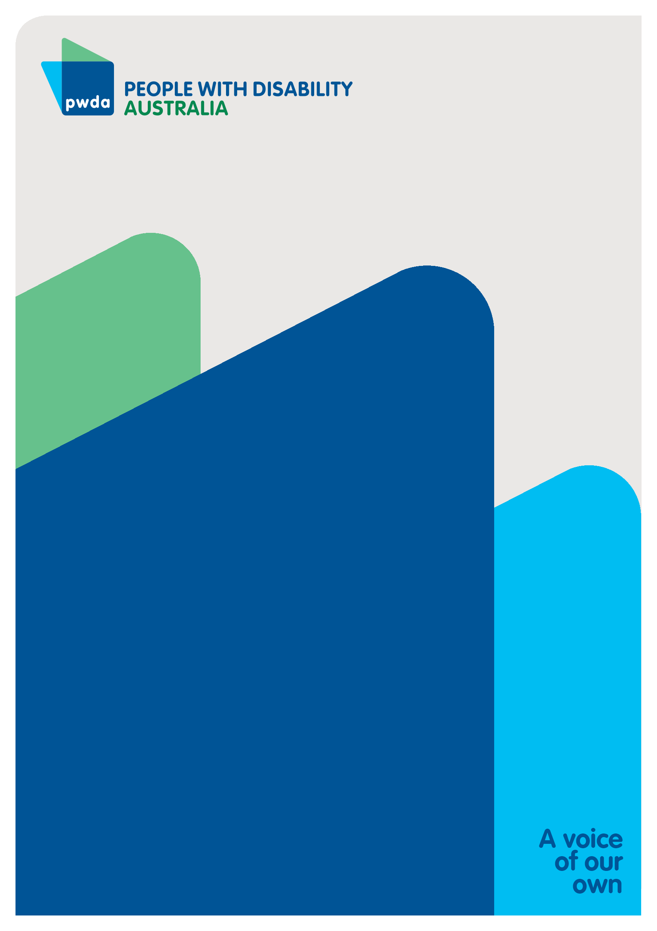People with Disability Australia (PWDA) is a national disability rights and advocacy organisation made up of, and led by, people with disability.

For individual advocacy support contact PWDAbetween 9 am and 5 pm (AEST/AEDT) Monday to Friday via phone (toll free) on **1800 843 929** or via email at [pwd@pwd.org.au](mailto:pwd@pwd.org.au)

**Submission contact**

Bastien Wallace

Senior Policy Officer

E: [bastienw@pwd.org.au](mailto:bastienw@pwd.org.au)

1. Australian Institute of Health and Welfare, *People with Disability in Australia 2022* (2022) <https://www.aihw.gov.au/reports/disability/people-with-disability-in-australia/contents/about>; Australian Bureau of Statistics, *Disability, Ageing and Carers, Australia: Summary of Findings* (2019) <https://www.abs.gov.au/statistics/health/disability/disability-ageing-and-carers-australia-summary-findings/latest-release#disability>**.** 
2. Rosemary Kayess and Therese Sands, *Convention on the Rights of Persons with Disabilities: Shining a light on Social Transformation* (UNSW Social Policy Research Centre, 2020); Australian Bureau of Statistics (n1); Australian Institute of Health and Welfare (n 1); Jeromey B Temple, Margaret Kelaher and Ruth Williams, ‘Discrimination and avoidance due to disability in Australia: evidence from a National Cross-Sectional Survey’ (2018) 18 *BMC Public Health* 1347.
3. Australian Institute of Health and Welfare (n 1) 163.
4. Anti-Discrimination NSW, *Annual Report 2021-22* (2022) 15 <https://antidiscrimination.nsw.gov.au/documents/annual-reports/anti-discrimination-annual-report-2021-22.pdf>
5. Australian Institute of Health and Welfare (n 1) 163.
6. Committee on the Rights of Persons with Disabilities, *General comment No. 6 (2018) Equality and non-discrimination* CRPD/C/GC/6 (26 April 2018) [30]; Australian Human Rights Commission, *Free and Equal. A reform agenda for federal discrimination laws* (December 2021) 16; United Nations, *Convention on the Rights of Persons with Disabilities* (12 December 2006), article 5.