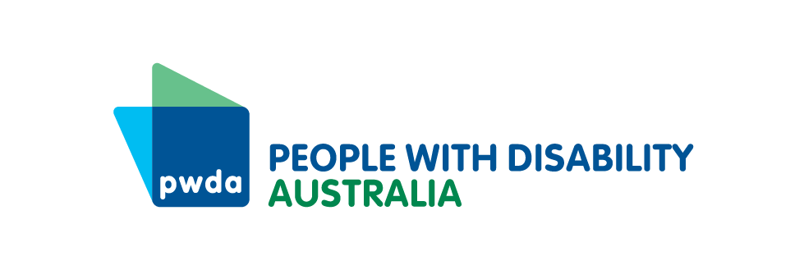

PO Box 666  
Strawberry Hills  
NSW 2012

Toll free 1800 422 015  
[pwd@pwd.org.au](mailto:pwd@pwd.org.au)[www.pwd.org.au](http://www.pwd.org.au/)

Tuesday 22 October 2024

**Notice of Annual General Meeting (AGM) of Members of People with Disability Australia Ltd ACN 621 720 143 (Company) and Agenda.**

The 2024 AGM of People with Disability Australia Ltd. (PWDA) will take place on **Thursday 14 November 2024. The AGM will commence at 6:00pm (AEDT) and is expected to finish at approximately 7:30pm (AEDT).**

**Register to attend the AGM**

* The AGM will be held online via Zoom
* Members must register by **5pm AEDT on Monday 11 November 2024**
* You can register by:
  + Phone: 1800 422 015
  + Email: pwd@pwd.org.au
  + Online: https://pwd.org.au/get-involved/elections-and-agm-papers/
* After you register you will be sent the AGM Zoom link via email.  
  **IMPORTANT: If you do not receive the AGM Zoom link by Wednesday 13 November 2024, please check your spam/junk mail or contact PWDA.**

**Voting at the AGM**

* At the AGM current PWDA members with voting rights will be asked to vote on a range of motions.
* You must be in the Zoom AGM meeting to vote or have nominated a proxy.

**IMPORTANT**: Voting via Zoom’s phone backup system is not possible. This means if you join the meeting via phone, you will not be able to vote at the meeting.

* If you plan to join by phone or are not able to attend the meeting but still wish to vote. Please complete the enclosed Proxy Voting form to nominate someone to be your proxy and vote for you in the way you have indicated.

**PWDA Annual Report**

The PWDA 2023-24 Annual Report has been published. It is available in the following formats on the PWDA website <https://pwd.org.au/about-us/annual-reports/>

* Accessible PDF
* Accessible Word document
* Easy Read
* Audio

**Additional information enclosed with this notice and agenda:**

1. AGM Explanatory Statement
2. Proxy Form and Explanatory Notes
3. Minutes of the 2023 Annual General Meeting
4. Returning Officer’s Report 2024
5. Easy Read AGM information

If you need the Annual Report or any of the listed documents in alternative formats or if you have any further questions or need assistance, please contact PWDA at [pwd@pwd.org.au](mailto:pwd@pwd.org.au) or call **1800 422 015**.

Yours sincerely

Marayke Jonkers  
Interim President

People with Disability Australia

**PWDA 2024 Annual General Meeting (AGM) Agenda**

**Date:** Thursday 14 November 2024

**Time:** 6pm – 7.30pm (AEDT)

**Venue**: Zoom

**Acknowledgement of Country**

**Opening and Welcome**

1. **Apologies and Proxies**
2. **Minutes of the 2023 Annual General Meeting**

2.1 Confirmation of the Minutes

2.2 Matters Arising

1. **Presentation of PWDA 2023-24 Annual Report**

3.1 President’s Report

3.2 Treasurer’s Report

3.3 Audited Financial Statements

1. **Appointment of Auditors**
2. **Report from Returning Officer**

5.1 Approval and adoption of Report from Returning Officer.

5.2 Approval of the appointment of Alexandra Bignell as Board Director in accordance with the Returning Officer’s Report.

5.3 Approval of the appointment of Priscilla Brice as Board Director in accordance with the Returning Officer’s Report.

5.4 Approval of the appointment of Presley Chihuri as Board Director in accordance with the Returning Officer’s Report.

5.5 Approval of the appointment of Daniel Flynn as Board Director in accordance with the Returning Officer’s Report.

5.6 Approval of the appointment of Trinity Fordas Board Director in accordance with the Returning Officer’s Report.

5.7 Approval of the appointment of Peter Freckleton as Board Director in accordance with the Returning Officer’s Report.

5.8 Approval of the appointment of Steph Travers as Board Director in accordance with the Returning Officer’s Report.

1. **Other Business**

6.1 Farewell and thank you to outgoing PWDA Board Directors

6.2 PWDA member panel discussion

6.3 Questions

1. **Close of meeting**