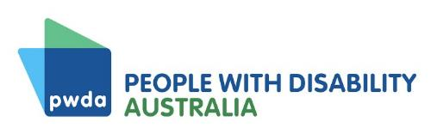

Annual Report

2023–24
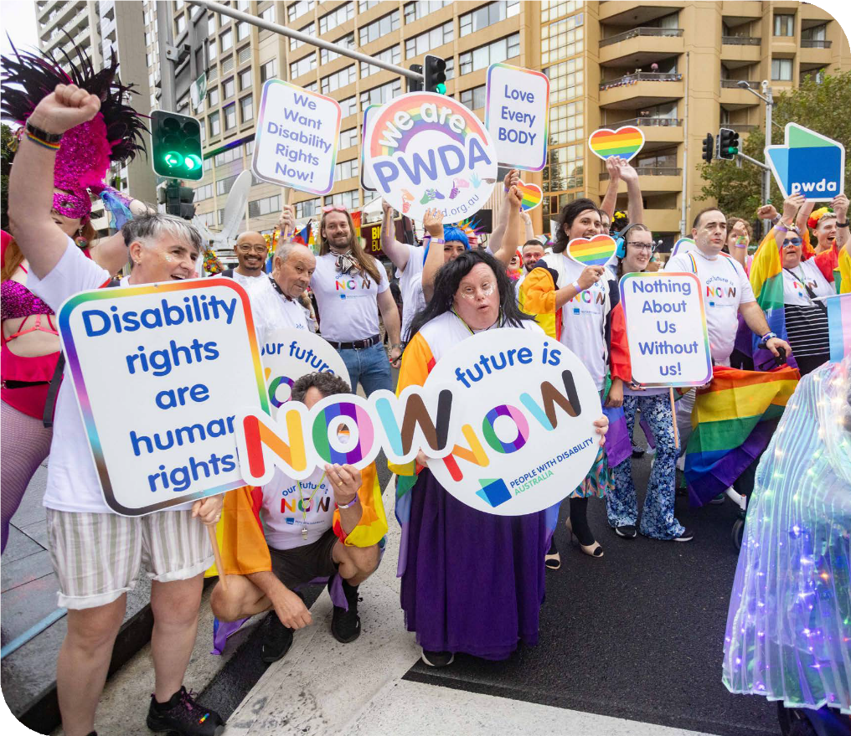

A voice of our own

Acknowledgment of Country
We acknowledge the Traditional Owners of the lands where we work, live, travel and gather, including the Gadigal people, the Dharug people, the Butchulla people, the Taribelang Bunda people, the Yugambeh language people, the Kabi Kabi people, the Jinibara people, the Tharawal people, the Ngunawal people, the Kalkadoon people, the Gureng Gureng people, the Badtjala people, the Awabakal people, the Gubbi Gubbi people, the Yuggera people, the Noongar people and the Stoney Creek Nations clan.
We recognise First Nations Peoples’ continued connection to the land and waters of these beautiful places, and acknowledge sovereignty was never ceded. We respect all Elders and Ancestors and any First Nations People reading this report.
Image Credits
We are grateful for the contributions of our staff, who have taken images featured in this report, along with photographers who feature their images on various photography websites. We recognise and thank all the members, supporters, staff and people
with disability featured in the photos in this report.
Acknowledgment of Contributors
PWDA acknowledges the lives and experiences of the people with disability represented in this report. We recognise and thank all the members, supporters and staff who have contributed information featured in this report.
Alternative Formats
Copies of this document are available in alternative formats from:
People with Disability Australia Ltd. (PWDA)
Postal Address
PO Box 666, Strawberry Hills NSW 2012
Street Address
Suite 10.01, Level 10 Centennial Plaza, 300 Elizabeth Street, Surry Hills NSW 2010
Phone (toll free): 1800 422 015
Email: pwd@pwd.org.au
Translating and Interpreting Service:
13 14 50
National Relay Service: 1300 555 727

ACFID Code of Conduct complaints
PWDA is a signatory to the Australian Council for International Development (ACFID) Code of Conduct. If you believe PWDA has breached the ACFID Code of Conduct, you may lodge a complaint with the ACFID Code of Conduct Committee at complaints@acfid.asn.au, telephone
+61 2 6285 1816 or contact PWDA.

Give feedback or lodge a complaint
Would you like to provide PWDA with feedback or lodge a complaint about our services or our work? We would be happy to hear from you. You can contact us at feedback@pwd.org.au or free call
1800 422 015. You can also lodge a complaint or provide feedback via our website at pwd.org.au/contact-us.

2

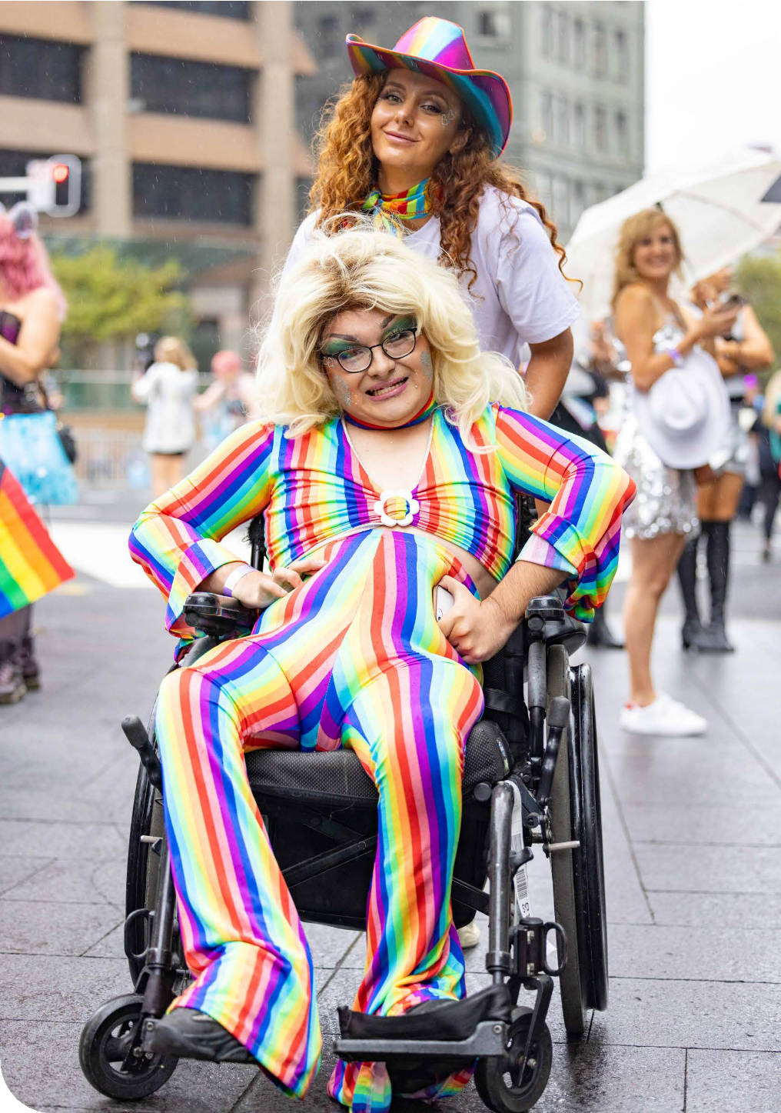
Image | PWDA members at the 46th Sydney Gay and Lesbian Mardi Gras Parade.

Annual Report 2023-24 | 3

Contents
About People with Disability Australia 6 President’s Message 8
CEO’s Message 14
Key statistics 18
Strategic Focus Areas 21
Represent 22
Advocate 32
Educate 53
Sustain 59
Financial Report 69

About People with
Disability Australia

Who we are
People with Disability Australia (PWDA) is the leading national cross- disability member driven organisation. We are a national peak disability rights and advocacy organisation, run by and for people with disability.
Founded in 1981, PWDA represents the interests of people with all kinds of disability. We’re a not-for-profit, community-based organisation. Our membership is made up of people with disability and organisations mainly constituted by people with disability.
Our vision is of a socially just, accessible and inclusive community, in which the human rights, belonging, contribution, potential and diversity of all people with disability are recognised, respected and celebrated with pride.

We work both nationally and internationally, and our work is grounded in a human rights framework that recognises the United Nations human rights conventions and related mechanisms as fundamental tools for advancing the rights of people with disability.
We deliver our programs, services and activities in partnership with our members and supporters as well as a variety of stakeholders across the government, disability, education and research sectors.
We receive funding from various sources, including the Australian, New South Wales and Queensland Governments and donations from our supporters.
We live our dream.
We have a clear vision for the purpose and impact of our work and have a comprehensive set of values, beliefs and principles that guide and inspire our work.

Our vision
We have a vision of a socially just, accessible and inclusive community, in which the human rights, belonging, contribution, potential and diversity of
all people with disability are recognised, respected and celebrated with pride.


Our purpose
Our purpose is to be a leading disability rights, advocacy and representative organisation of and for all people with disability, which strives for the realisation of our vision of a socially just, accessible, and inclusive community.

President’s Message

Dear PWDA community,
This year will go down in history in the disability rights movement, but not for the reasons many of us had hoped. The release of the government response to the Disability Royal Commission (DRC), the NDIS Amendment Bill (NDIS Bill), and the NDIS Review brought an emotional rollercoaster. After some beautiful moments of community coming together and member forums at
the beginning of the year, we were here to support each other through it all.
Instead of bringing landmark, once-in- a-lifetime change and enshrining the
United Nations Convention on the Rights of Persons with Disabilities (UNCRPD) while shining a spotlight on every area of society and the importance of engaging disabled people, the response to the DRC left members, our Board, and staff alike devastated and disappointed. Having shared our stories and relived traumas to ensure no one lives through these things again and create a better world, we all expected something more than 13 out of the 222 recommendations to be immediately actioned.
I am proud of our community for the way we came together, especially with the timing of this coinciding with the NDIS Bill, which threatened to take away life- changing support in the same week.
For me personally, it was a hectic two days. I found myself holed up in a hotel, preparing for a press conference that
occurred less than 45 minutes after the report's release. I joined leadership from other organisations in the sector to speak with the media. Subsequently, PWDA was mentioned in over 300 articles.
Now more than ever, we must push forward to ensure the promises of our full inclusion and our genuine choice and control are realised and that we as disabled people are at the centre of all decisions affecting our lives. PWDA played a loud and leading role in holding governments to account and demanding a meaningful response to the DRC. The violence, abuse, neglect, and exploitation voiced by everyone who gave evidence to the DRC and experienced by thousands of people with disability who
could not give evidence must not happen to future generations of disabled people.
I am proud we released PWDA's Response to the DRC, which provides a roadmap
for the implementation of the DRC's recommendations and, if adopted in full, would ensure real, lasting change comes from our Royal Commission. This report was built on the voices of our members and will guide our work for years to come as we fight for the actions it contains to be fully adopted by governments.
PWDA also continued to provide leadership on issues related to the ongoing COVID-19 pandemic. We heard from many members about their concerns regarding the Government's 'Living with COVID-19' strategy and the impact it has had on


Image | Marayke Jonkers, President People with Disability Australia (PWDA)

the most vulnerable in our community. In response, we developed a comprehensive Position Statement advocating for responses to pandemics that centre people with disability. We also made a submission and testified at the federal government COVID inquiry, focusing on current issues but also how the response could be better for people with disability in the event of future public health crises. As always, a number of our Board Directors have sat on external advisories, sharing information and bringing it back to our organisation.
As President and Chair of membership engagement, I have been passionate about being grassroots-led, with all decisions informed by and centring members' voices. The member forums have been a wonderful way to engage with our community, covering topics from COVID-19 to the NDIS Review, the DRC, and International Day
of People with a Disability, featuring past PWDA president Craig Wallace and DRC Commissioner Dr Rhonda Galbally AC.

As an organisation led by and for people with disability, I am pleased PWDA made our voices heard in forums across Australia and the globe this year. PWDA representatives were front and centre at Senate Committee hearings on the NDIS Bill, ensuring the voices of our members were read out directly by myself, giving testimony in two inquiries as well as part of our submissions and follow-up, putting members' voices into the hands of the politicians and decision-makers.
Our contributions to the NDIS Review and responding to proposed changes to the Scheme was a key focus this year. More of our members contributed to our NDIS consultations than any other in recent years. We have consistently advocated for
a scheme that supports the needs of people with disability and has the access and flexibility that our members rely on. PWDA's submissions and media activity highlighted the critical areas of improvement, such as participant choice and control, safeguarding, and the need for greater support for marginalised groups within the disability community.
We are deeply disappointed that this opportunity to improve and safeguard the NDIS for the future may be squandered. We will not stop fighting for an NDIS that meets the diverse needs of our community,
and we will continue to advocate for reforms that prioritise the rights, dignity, will, and preference of all participants. Not forgotten are the 80% of people with disability who
are not NDIS participants, and we continue to advocate for every person with a disability support need.
PWDA was also at international gatherings such as the Conference of State Parties
at the United Nations in New York and roundtables on responses to the DRC and domestic and family violence. I am proud to have been a part of these efforts and know PWDA will continue to ensure our members are represented wherever their voices need to be heard.
One of the ways we as an organisation keep disability issues top of mind for the community and government is through media representation. This year, we responded to various critical issues, including the DRC final report on eliminating restrictive practices, the NDIS data breach, proposed changes to the NDIS, the federal and state budgets, and less serious but
no less important issues such as the benefits of adaptive fashion for improving independence and confidence. Thank you to every media outlet for the ever-increasing level of coverage around issues pertaining to disability.
Our power lies in our community, and I want to take a moment to acknowledge the lives of those in our community who have passed away this year. We remember John Walsh AO, one of the key architects of the NDIS and a tireless disability rights campaigner, and much-loved grassroots disability rights activist Phineas (Phin) Meere.

We are grateful to John, Phin, and everyone who has come before us and contributed
to the fight for our rights to be protected, promoted, and upheld. Also, young Bodhi Boele, who we will remember dancing joyfully at Mardi Gras, whipping up the crowd into a huge cheer with his light-up wings and gigantic smile. It's an incredible gift for our organisation that he and his family joined our float and so proudly wore our rainbow T-shirts.
A personal highlight for me has been meeting members ‘out loud and proud’ at Mardi Gras for the past two years since its return after COVID. As the board, we are the representatives for the members, and to hear the joy in people's voices talking about travelling from all over the country to be part of this and proudly making costumes has been very special. It's a reminder of why it is so important not only to be creating an opportunity for members to be part of Mardi Gras and travel from around the country
to join in the celebration of who we are, but also to have been announced as the
National Peak for LGBTQIASB+ people with disability, with over 1/3 of our membership identifying as such.
The 2024 Mardi Gras reminded me of the last time I had felt so welcomed and included; the Sydney 2000 Paralympics.
That was 24 years ago, and it was the last time when I’ve seen a crowd of people so excited, welcoming, and celebrating people with disability. To see the crowd light up,
cheering, wanting high-fives and photos - no different to any other float - made my heart full for the future. That we, as disabled and intersectional people, can be embraced and celebrated for exactly who we are.
The word Paralympics comes from a Greek word that means parallel but equal. I am proud to be a Paralympian, proud to be a member of this organisation and proud to be a person with disability.
It’s important for the community to recognise, though, that the sporting heroes we’ve been cheering on for ten days in Paris return to this country as disabled people. They will also be impacted by the issues all of the rest of us face. It shouldn’t be every four years that we celebrate
the lives and achievement of people with disability.
We congratulate Rosemary Kayess on her appointment as Disability Discrimination Commissioner after an extensive career in human rights and disability advocacy and at the United Nations.
Of course, none of this would’ve been possible without the outstanding leadership of our CEO Sebastian Zagarella, and Deputy CEO Carolyn Hodge, who has
now been replaced by Megan Spindler- Smith,along with their remarkable teams and all of the staff. On behalf of the Board and myself, I say thank you.

The Board and I take seriously the responsibility of leading PWDA, representing our members' wishes, and ensuring we remain a genuine voice for disabled people. I would like to thank all of my Board colleagues for their dedication during their terms as directors. It has been a year of significant change within PWDA's leadership. Within months of the PWDA Annual General Meeting (AGM), I was elected President. Throughout the past year, we also farewelled Dr Michelle Hyde, Dr Zhila Hasanloo, and our past President and we thank them for their contributions.
I would also like to acknowledge our
Co-Vice Presidents, Kevyn Morris and Eva Sifis, and our continuing Board Directors, Dr Haidi Badawi, Arun Barramundi, Treasurer Presley Chihuri, and Secretary Suresh Rajan. We also welcome four
co-opted Board Directors: Daniel Flynn, Trinity Ford, Declan Lee, and Stuart Mawbey. I want to express my deep gratitude to all our Board Directors
for offering their time, expertise, and leadership. Volunteering to serve on the Board is no small commitment, and their work has been instrumental in steering PWDA through this period of reform and uncertainty.
The year ahead will bring significant change to the Board again, with the terms of myself and the other longest-serving member, Suresh Rajan, ending. The Board has put significant effort into succession planning and training for a smooth transition. I would
like to pay a special tribute to Suresh Rajan for his 13 years of service to PWDA, much of this serving on the Executive as Treasurer.
His financial acumen will be sorely missed. This year, he has continued to shine as a mentor to new Board Directors, especially co-opted future treasurers, as part of this succession planning.
Part of that succession planning has been the creation of a Board Liaison position
to ensure all Board Directors have their accessibility needs met seamlessly and that knowledge carries on beyond the AGM. Some basic administrative tasks, such as ensuring the President has access to the President inbox and the creation
of a President calendar, have been implemented. I’ve also tried to communicate with members about where we are at, which for many people these days is through social media, and I’ve enjoyed interacting with many of you.
I am just one of many who have been privileged to learn by sitting on this Board alongside great advocates, bringing together a world of professional and personal experience, friendships, and memories that will last a lifetime. One
of my final messages as President is to encourage you to consider whether you might be a Board Director of the future.
It isn't something I saw in my future, most definitely not a senior leadership role, and I'm very grateful for the mentoring
of now-retired Board Directors when I
first joined the Board and the related

accommodations that made it possible. This is an organisation where you get as much out as you put in, by having the opportunity to take positions we often don't get the chance to in paid employment, and with the supports and welcome we need in place. As I’ve been candid throughout my presidency about the way my own disability of a spinal cord injury has interacted
with my capacity to do the job - such as needing to use voice dictation or medical interruptions - I want to call attention to the fact I have spent my term as President serving from bed, healing a pressure
sore. While many of us may think there’s someone out there who can do a better job or that our disability might impact us, the first step is starting by joining a Board,
advisory, or running for election. We can do so much more with the remarkable support of this Board.
I congratulate in advance the incoming Board and elected leadership and encourage everyone to get behind the new Board and President. It's wonderful seeing new generations of leaders, advocates, and activists stepping in, but I know a lot of work goes on behind the scenes to keep the organisation
running. I look forward to supporting from the sidelines as the next chapter in this organisation's long history unfolds.
It's been a privilege to serve you as a Board Director and your President. As my four-year term ends and we once again face the prospect of new Board Directors
and leadership, I am reminded that this organisation is bigger than any one individual and thrives and adapts with each change. It started in a garage with a group of people living with disability, and while it shows my age, the organisation and I are the same age. It started in the International Year of People with Disability. The list of past President and Board Directors includes some of the most accomplished disability advocates in this country. They have left me big shoes to fill.
I know there are going to be extraordinary President and Board Directors in the future. They face challenges leading through the changes ahead, but our community is powerful. More and more young, strong, and diverse leaders are stepping in. I encourage everybody to support the Board and Executive elected after the AGM, and it's been a privilege
to have held the seat warm for you these past 12 months.
Marayke Jonkers
Interim President, PWDA

The President's message covers key milestones, achievements, and events that have occurred throughout Marayke's tenure on the Board and as Interim President, including those that took place after
the end of the 2023-24
financial year.

CEO’s Message

This year has been a significant one for the disability community, filled with major changes and challenges. I want
to acknowledge the incredible resilience of our community, particularly as we navigated a complex and emotionally charged reform agenda. This included key
milestones like the release of the Disability Royal Commission (DRC) Final Report and the Independent Review of the NDIS, alongside the ongoing impacts of the COVID-19 pandemic.
I am incredibly proud of PWDA's responses to these reforms. Despite the rapid pace
of change, our systemic and individual advocacy efforts have continued to make a meaningful impact on the lives of people with disability.
At a systemic level, we’ve represented the diverse voices of our community at state, national, and international forums, ensuring that our members' voices and needs are heard by decision-makers.
On the individual advocacy front, we've seen significant growth in client numbers due to outreach efforts and service referrals. We’ve met the increased demand without sacrificing the quality of our services
and maintained great outcomes for clients. Through our focus on continuous improvement, we reviewed work practices
and improved our telephony systems which has enhanced access to services while also reducing wait times. This commitment to excellence was demonstrated by our outstanding outcome in the National
Standards for Disability Services (NSDS) audit and maintaining our incredibly high client satisfaction scores. We've also expanded our efforts to support the most vulnerable in closed settings, particularly through our Redress Project and the Engage-In Project – which we’ve now embedded as business as usual.
Against a year of reform our operational plan provided the team clarity on priority activities which resulted in successes against all key pillars of our 2022-2025 Strategic Plan—representing, advocating, educating, and ensuring sustainability.
I'm proud to report growth in our membership for the second consecutive year, driven by our membership engagement strategy and a schedule of events designed to increase interaction with our members.
The reputation we’ve built for quality and expertise led to further opportunities, including invitations to join advisory groups and collaborate on important projects.
This also saw demand for our training services grow, and we adapted to the shift towards online learning and developing bespoke training packages to meet diverse needs. In turn this resulted in us venturing into new territories, offering new services such as accessibility consulting and developing Disability Inclusion Action Plans (DIAPs) and resources such as toolkits. This expansion of our fee-for- service offerings resulting in increased untied income.

Our initiatives—Talk Up, Building Access, and Advancing Women—have continued to create positive outcomes. As a result of the positive impact and real difference the Building Access Project has had on
vulnerable women and children the program is being or has been refunded once again. We thank our funders for recognising the value of this work.
PWDA proudly represented our LGBTQIASB+ community at Sydney’s annual Mardi Gras Parade; always an honour to be able to meet our members, like Bodhi, who took part in the parade with PWDA. Representing this intersection of identities is something we value deeply therefore one of the year’s highlights
was being recognised as the national representative peak body for LGBTQIASB+ people with disability.
Operationally this year also saw the completion of several major initiatives, including our organisation-wide policy review, the final phase of our Safety Management System, and implementation of the final phase of our Information Technology (IT) upgrades. These initiatives have improved both employee and client experiences, strengthened our data security, and ensured compliance with regulatory and legislative requirements.
This was evidenced by positive results from our National Standards of Disability Services (NSDS), Australian Council for International Development (ACFID), Work Health & Safety (WHS) and financial audits which also demonstrates our

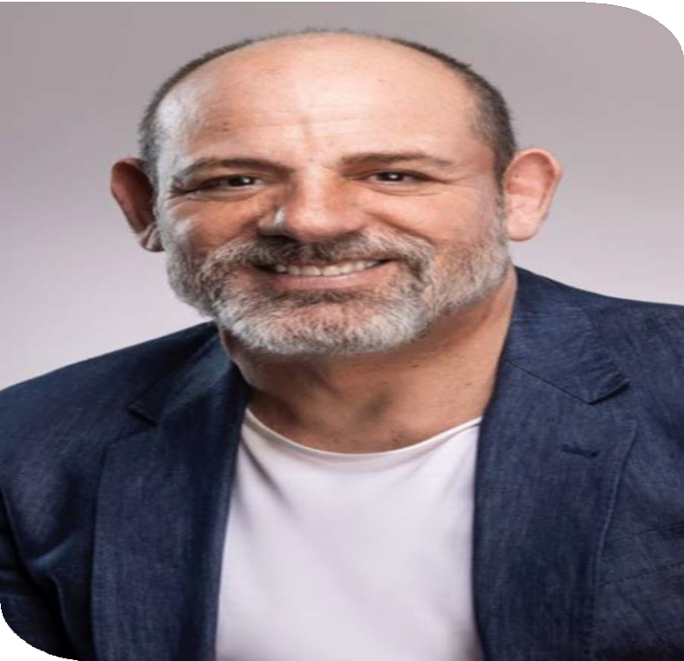
Image | Sebastian Zagarella,
Chief Executive Officer, PWDA

Annual Report 2023-24 | 15

ongoing commitment to good governance. Additionally, we successfully delivered PWDA’s next 12-month operational plan setting the organisation up for success for the next financial year and commenced work on PWDA’s first Disability Inclusion Action Plan.
Amongst this business we also achieved the relocation of our Sydney head office to a more accessible space. The move allowed us to design offices that met the
needs of our people – including sensory rooms, wayfinding and more phone rooms and meeting spaces so we can maintain contact with our clients, members and community. We also explored how to reduce our environmental impact introducing new waste reduction and electricity saving measures. Alongside allowing us to better serve our community the new office will make ongoing financial benefit to PWDA in the years to come.

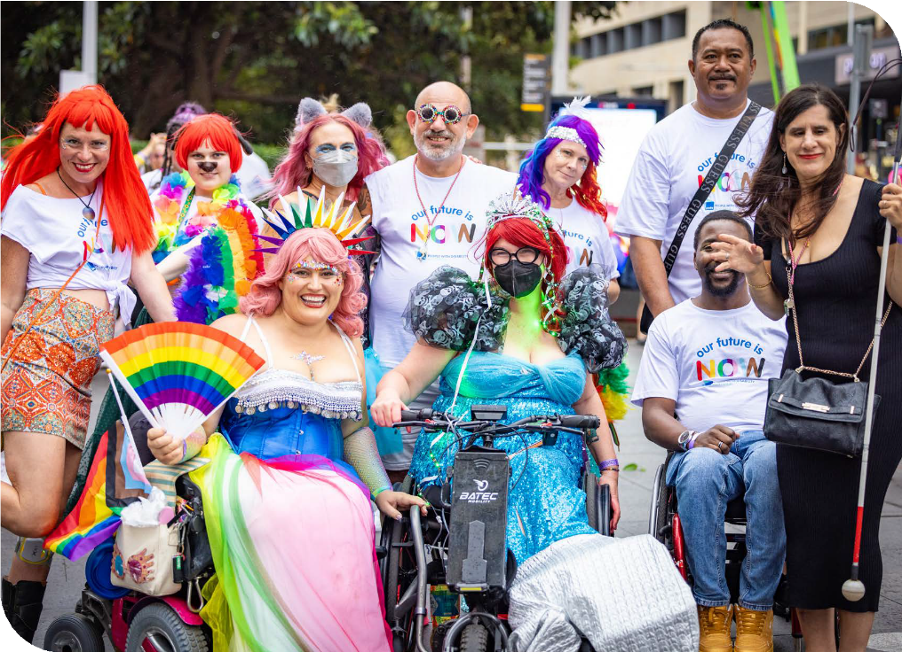
Image | PWDA CEO Sebastian Zagarella with PWDA Board Directors and PWDA members at the 46th Sydney Gay and Lesbian Mardi Gras Parade.

Our people remain at the heart of everything we do. This year, we introduced PWDA’s first performance framework, aligning staff workplans with our strategy and focusing
on professional development. We also embedded hybrid work practices, continuing to adapt to the changing work environment.
This year also brought significant leadership changes. We farewelled key team members like Lizzy Fowler, Director of Strategic Projects and Communications, and Carolyn Hodge, our Deputy CEO. Their contributions were invaluable, and I thank them for their passion, insights, and friendship. At the same time, I was pleased to welcome Megan Spindler-Smith as our new Deputy CEO and Karen Karakaya as our Director of People and Culture. They’ve already made a remarkable impact in their short time with us.
My thanks and gratitude goes to the PWDA team. It was rewarding to see the whole team’s hard work to deliver our operational plan priorities and progress our strategy. Everything we achieved this year would not have been possible without the extraordinary efforts of the whole team and the support of community and sector partners.
I'm also pleased to report a positive financial outcome for the third consecutive year, a testament to our team’s dedication and the successful implementation of our operational plan.
This ensures PWDA’s ongoing sustainability which allows us to continue advocating for human rights and our community at such a crucial time.
Throughout the year the Board has undertaken their duties with focus, dedication and passion and despite a number of changes to the Board their strong leadership and drive and care for the community continued without interruption.
I’d also like to express my gratitude to our interim President, Marayke Jonkers, for her effective, steady and compassionate leadership through a period of significant change and reform. Her commitment to disability advocacy is truly inspiring, and it has been a privilege to work alongside her.
I take this opportunity to extend my deepest thanks to Marayke and Suresh Rajan, and I thank all Board Directors, past and present, for their contributions and service to PWDA.
As we move forward, PWDA is stronger, and remains focused and committed to advancing the rights and interests of people with disability. Thank you for your continued support.
Warmly
Sebastian Zagarella,
Chief Executive Officer, PWDA

Key statistics

18%
<
increase in membership

76
<
<
reports, position statements and submissions

20
<
member focus groups, consultations and community events

2.7 million
<
people reached on social media

226,263
<
website visitors
47
media releases, statements and blog articles

47
training sessions delivered to over 1,800 people

63
staff members

566
Qantas Carer Concession Cards issued

This indicates a higher outcome than the previous year.
<

1,895
<
clients supported

44,352
occasions of client service
<

Number of advocacy cases by program

698
<
National Disability Advocacy Program (NDAP)

285
NDIS Appeals Program

132
<
Redress Project

54
<
Engage-In Project

113
<
Disability Housing Advocacy Service (DHAS)
219
Disability Housing Information Line (DHIL)
<

264
<
Disability Advocacy Futures Program (DAFP)

114
<
Disability Advocacy Futures Program (DAFP) Education

122
<
Queensland Disability
Advocacy Program (QDAP)



Individual Advocacy Client satisfaction
I am satisfied with the services I have received
96% of respondents rated this as high or very high

The service listened to me and understood my issues
97% of respondents rated this as high or very high

I am better able to deal with issues that I sought help with
84% of respondents rated this as high or very high

Strategic Focus Areas
Our organisation is guided by a three-year strategy. Launched in 2022, our 2022-25 Strategic Plan provides a clear vision for the future of PWDA. This plan helps guide the focus and priorities of our Operations Teams to deliver the outcomes we are committed to achieving; and ensures our programs, services and activities deliver maximum impact for our members, clients and people with disability more broadly.

Strategic Pillars
The 2022-25 Strategic Plan is underpinned by four Strategic Pillars, which outline our objectives:

Represent
Remain the leading national cross-disability member driven
organisation. Reflect the diversity of our community and represent their voice nationally and internationally.
Advocate
Advocate for the human rights of all people with disability at individual and systemic levels.
Educate
Drive positive change for people with disability through education and advocacy.
Sustain
Maintain a financially viable and
sustainable organisation.

Represent
Remain the leading national cross-disability member-driven organisation. Reflect the diversity of our community and represent their voice nationally and internationally.

Membership
PWDA is proud to be the national cross-disability peak for people with disability in Australia and pleased to see our membership growing by 18% - our second consecutive year of positive growth.
As the national cross-disability peak, it’s important we retain, expand and diversify our membership base across Australia
to ensure we reflect and represent the
diversity of our community.
As a Disabled People’s Organisation (DPO), we are led by and for people with disability. Our priorities and areas of focus are those our members tell us are most important to them.
PWDA has long had a strong ties to the LGBTQIASB+ community; with over 33% of our membership identifying as LGBTQIASB+. We were therefore proud to learn we had been selected as the national peak body for LGBTQIASB+ people with disability by the Australian Government.
Another focus was ensuring our members remained informed and consulted. In
a year of major reform, we made sure our members had opportunities to come
together, connect and share their views in accessible and safe spaces. This helped us gain a strong understanding of our
members' concerns and views so they were front and centre in our systemic advocacy work. Members took part in online member forums, individual and group interviews, focus groups, surveys, and direct communication with our staff and Board Directors. We are proud to have provided 20 engagement opportunities (including community events) for our members across the year.
Understanding our members' views allowed us to confidently represent them in our responses to the Disability Royal Commission’s (DRC) Final Report, the
NDIS Review’s “Working together to deliver the NDIS” report, the ongoing COVID-19 pandemic and much more.
Through our member forums we learnt that COVID-19 remained a major concern for our members. Their views and experiences helped shape our position statement.
We were proud to lead the way in this space. Our advocacy saw us joining the Australian Government’s COVID-19

Response Inquiry roundtable and providing advice to government on how to ensure people with disability are considered
in responses to the ongoing and future pandemics, you can read more about this in the Systemic Advocacy section of this report.
Equally important were other dedicated events focused on key areas of concern. With the welfare of our members central to our decision making the focus of one such event was to ensure our members could prepare for the Disability Royal Commission’s Final Report, reflect on a challenging year and share pride in the strength of our community.
Over the year our Board represented our members and shared their own personal experiences. It was a year that saw them provide evidence at Senate inquiries, the DRC, international human rights gatherings and to policymakers nationwide. You can read more about this work in the Advocate section of this report.
This year has been difficult for many of our members and our community. We thank all our members who gave up their time to
share their experience and expertise with us and our community.
As a DPO, our Board are all members of PWDA and people with a disability. As a member-driven organisation PWDA also provides pathways for members, to join the Board or work alongside our operations teams.
With a focus on ensuring our Board composition reflects our membership, in August 2023 when we called for members to join the PWDA Board to fill
two vacancies, we were thrilled to receive nominations from a large and diverse group of PWDA members. Members elected
Eva Sifis and Kevyn Morris and both were appointed to our Board at the PWDA AGM in November 2023.

Representing in the media
PWDA’s media presence grew significantly this year, with our spokespeople and positions represented in over 2,700 media items across TV, print, radio and online media. PWDA spokespeople provided expert commentary on a wide range of issues affecting people with disability.
Our proactive media engagement with both mainstream and disability-focused outlets ensured the perspectives and rights of people with disability were front and centre in national conversations.
Topics we engaged with included the DRC, Independent Review of the NDIS, and NDIS Amendment Bill, family and domestic violence reform, transport accessibility,
the housing crisis, and state and federal budgets.

International and National Representation
Representing our members and the broader disability community, both nationally and internationally, remained a top priority during the 2023-24 financial year.

National Representation
The voices of our members and the disability community informed our work across multiple policy areas as we promoted the full inclusion of people with disability in all aspects of life in Australia. This included actively participating in the Disability Royal Commission (DRC) and the Independent Review of the NDIS.
Throughout the year the PWDA Board and operations teams collaborated and met with a wide range of disability sector colleagues, services, government departments, community sector partners, and private sector stakeholders to promote advocacy services and the rights and needs of people with disability.
Our teams also participated in sector networking events, interagency and Local Health District meetings, as well as large- scale disability expos, where we connected with the community, answered questions, and provided support.
Current and former PWDA Board Directors
have been integral in raising the profile of important issues over the year. Some examples include, Interim President Marayke Jonkers speaking to the Senate Committee’s Public Hearing on the NDIS Amendment Bill, and former President David Abello addressing a Sydney Town
Hall rally opposing religious discrimination and promoting LGBTQIASB+ rights.

Advisory Committee Positions and Reference Groups 2023-24
PWDA continued to participate in a significant number of committees, networks, and advisories representing the interests of our membership this year. Highlights included:
National/International
NDIS Quality and Safeguards Commission Disability Sector Consultative Committee
NDIA Disability Representative and Carer Organisations CEO Meetings
NDIA Reform for Outcomes Workforce Capability Co-design Working Group
NDIS CALD Expert Advisory Group NDIA LGBTQIASB+ Advisory Group
DSS Disability Representative Organisations Forum

DSS Australia’s Disability Strategy Implementation Meeting
DSS Data Products and Insights Working Group
Our Voices, Our Lives, Our Way (OVOLOW) Project
DES Participant Reference Group Accessible Communications Working Group COVID-19 Disability Advisory Council
Standards Australia Technical Group and Committee
National Disability Data Asset Council
ARC Linkage Research Project on Disability Disaster Risk Reduction
ACOSS Income Support and Employment Policy Network
Community Housing Disability Network
Strengthening Medicare Implementation Oversight Committee
Australian Disability and Development Consortium
Australian Optional Protocol to the Convention against Torture (OPCAT) Network
NSW
Ageing and Disability Commission Disability Roundtable
Ageing and Disability Working Group of the NSW Coercive Control Implementation Taskforce
Building Better Homes Steering Committee and Strategic Advisory Group
NSW Disability Advocacy Network and Disability Policy Interagency
NSW Dept of Education Disability Strategy Reference Group
Guardianship Working Group
Greater Cities Commission Social Peaks Reference Group
NSW Civil and Administrative Tribunal (NCAT) Guardianship Division Consultative Forum
NSW Women’s Alliance
NSW Domestic, Family and Sexual Violence Sector Forum
Specialist Homelessness Services (SHS) Access and Withdrawal Working Group
NCOSS Forum of Non-Government Agencies (FONGA)
Equal Access to Democracy Advisory Group

Representation at community events
International Day of People with Disability 2023
We were honoured to have PWDA members Giancarlo de Vera, Anja Christoffersen, Ann- Mason Furmage and Dr Scott Avery named as 2023 International Day of People with Disability Ambassadors by the Australian Government Department of Social Services. Giancarlo de Vera, PWDA’s Senior Manager of Policy and a 2023 International Day of People with Disability Ambassador, also delivered a powerful address at Parliament House in Canberra on 30 November 2023.

“The power of ableism is the pressure to conform. But the antidote to ableism is the pride to simply be as imperfect,
yet full and complete human beings.”
Giancarlo de Vera

To mark International Day of People with Disability (IDPwD), on Thursday 7
December 2023, PWDA and Advocacy for Inclusion hosted a joint online members’ forum with respected and seasoned disability rights advocates Dr. Rhonda
Galbally AC and former PWDA President Craig Wallace.
At the event, members shared stories and reflected on the critical disability rights issues of the past, present, and future.
PWDA staff and members also participated in several IDPwD events across the country, sharing their experiences and reflections.
In Queensland, PWDA proudly supported the inaugural Gympie All Abilities Ball, an event designed to be both accessible and inclusive. This celebration brought the local community together to honour the
contributions of people with disability. It was a memorable night filled with joy, connection and recognition for everyone involved.
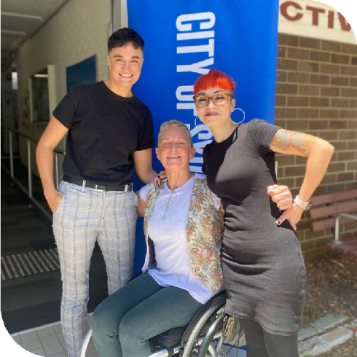
Image | PWDA staff members Summah, Polly and Janel at a City of Sydney IDPwD community event.

Our future is NOW!

“With nearly a third of our membership identifying as LGBTQIASB+, PWDA is proud to once again represent our members at this year’s Mardi Gras. Our presence sends
an important message to all of Australia – the rights of LGBTQIASB+ people with disability must be upheld and immediate action taken to
address the challenges we face.”
PWDA CEO
Sebastian Zagarella
On Saturday 5 March 2024, PWDA proudly represented people with disability who identify as LGBTQIASB+ once again at
the 46th Sydney Gay and Lesbian Mardi Gras Parade, calling for a future where our LGBTQIASB+ community has choice and control over their bodies, identities and sexuality.

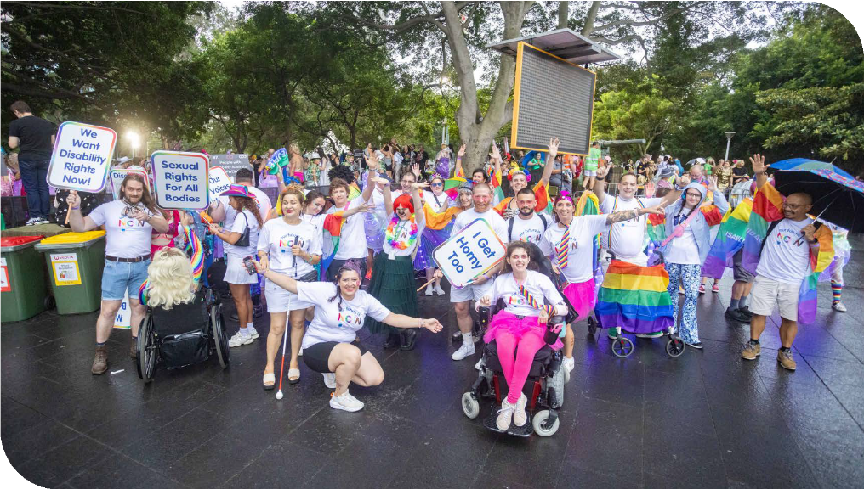
Image | PWDA members, staff and community at the 46th Sydney Gay and Lesbian
Mardi Gras Parade.

Leading Change, Our Way on International Women’s Day 2024
On Friday 8 March 2024, to mark International Women’s Day, PWDA hosted an event that created a space for women and gender diverse people with disability to connect and discuss leadership, overcoming barriers, accessibility and inclusion. This event was an initiative of PWDA’s Advancing Women with Disability in the Workplace Project.
Hosted by former PWDA Board Director Dr Michelle Hyde, PWDA’s ‘Leading Change’ event featured inspiring insights from Dr Sheelagh Daniels-Mayes, Akii Ngo, Ruth Bonser and PWDA Board Director Dr Haidi Badawi.
A key theme that emerged was the power of community. Ruth Bonser reflected on the importance of support networks and emphasised everyone has a role to play in driving change.

To complement the event, PWDA published a blog post by PWDA Board Director Dr Haidi Badawi, ‘What I want women with disability to know on International Women’s Day.’ The post was republished by multiple media outlets.

“It’s important to have people who believe in you so that you learn to believe in yourself. If
I was to believe what I grew up with, I would believe that nobody is looking for me to fulfil the leadership roles I have.”
Ruth Bonser

“Women with disability bring a unique perspective and resilience to the table, born out of their lived experiences.
Yet, they often face barriers that limit their participation and leadership in the workplace. It’s time we change this narrative.”
Dr Haidi Badawi

International Representation
PWDA continued to represent people with disability internationally. The goal of our international work is to uphold, defend and progress human rights and interests of people with disability.
This important work is done in collaboration with our Disabled People’s Organisations (DPOs) and Disability Representative Organisations (DRO) and with the support of civil society. A key part of this work is our engagement with the United Nations (UN). PWDA sent representatives to the 29th session of the Committee on the Rights of People with Disability in August 2023, the UN Commission on the Status of Women in March 2024, and the 17th session of
the Conference of States Parties to the Convention on the Rights of Persons with Disabilities (COSP17) in June 2024.
Conference of States Parties (COSP)
The 17th session of the Conference of States Parties to the Convention on the Rights of Persons with Disabilities (COSP17) took place at the UN Headquarters in New York from 11-13 June 2024.
As a founding member of DPO Australia (DPOA), PWDA’s participation in the annual Conference of States Parties (COSP)
is an important part of our work in the international human rights space.

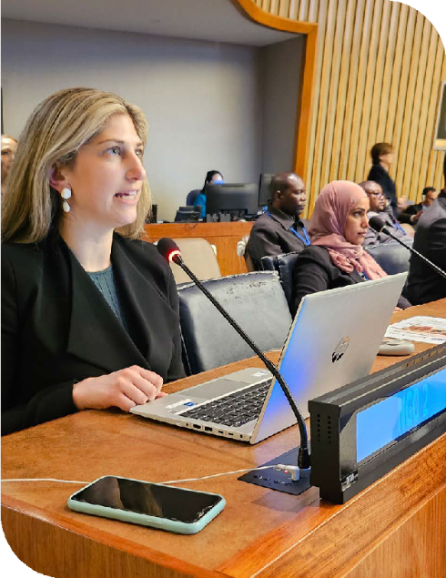
Image | PWDA Senior Policy Officer Lisa Ira speaking at the 17th session of the Conference of States Parties to the
Convention on the Rights of Persons with Disabilities (COSP17).

This year, PWDA was represented at COSP17 by Giancarlo de Vera, Senior Manager of Policy, and Lisa Ira, Senior Policy Officer.
COSP17’s overarching theme was “Rethinking disability inclusion in the current international juncture and ahead of the Summit of the Future.” PWDA had a
significant presence at the conference with Giancarlo de Vera and Lisa Ira contributing to many of the scheduled programs.

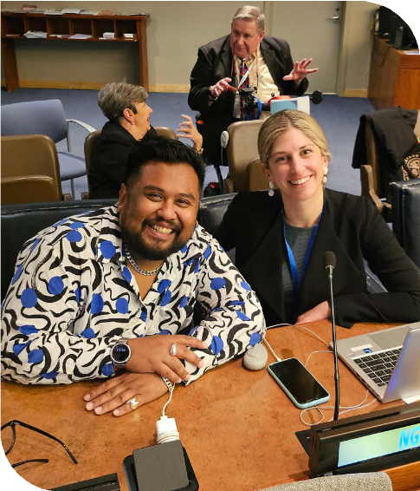
Image | PWDA Senior Manager of Policy Giancarlo de Vera and Senior Policy Officer Lisa Ira at the 17th session of the Conference of States Parties to the Convention on the Rights of Persons with Disabilities (COSP17).

Lisa Ira made an intervention (speech) at the Civil Society Forum on safeguarding people with disability in group homes
in a pandemic. Lisa Ira called on all States Parties to co-design a strategy for
safeguarding people with disability in group homes for future pandemics.
PWDA also delivered a well-received intervention on modern slavery, where Lisa Ira highlighted the importance of all governments recognising segregated employment and sheltered workshops as potential sites of modern slavery.
Giancarlo de Vera delivered a speech urging governments and civil society to ensure LGBTQIASB+ people
with disability are not left behind in employment by upholding the founding UN principles of equality and non- discrimination.
PWDA also hosted a side-event focused on advancing employment inclusion for LGBTQIASB+ people with disability. This event was the only side-event with a dedicated focus on LGBTQIASB+ people
with disability. The event was moderated by Giancarlo de Vera and featured a panel of speakers, including Emily Unity (COSP17 delegate from Children and Young People with Disability Australia), Charbel Zada (PWDA staff member), Uncle Paul Calcott (PWDA member and COSP delegate for Queensland Advocacy for Inclusion) and Annabelle Oxley (Queensland Council for LGBTI Health) as panellists. The opening remarks were provided by Ruby Mountford, Specialist Advisor on sexual orientation, gender identity and intersex rights at the Australian Human Rights Commission.
PWDA acknowledges the funding received from the Australian Government’s Department of Social Services to attend COSP17.

Hosting League of Persons with Disabilities Taiwan
PWDA is well regarded and our work respected worldwide. It is important we share our knowledge and support capacity building. This year we welcomed the opportunity to engage with the League of Persons with Disabilities Taiwan.
On 22 April 2024, PWDA hosted a large delegation from the League for Persons with
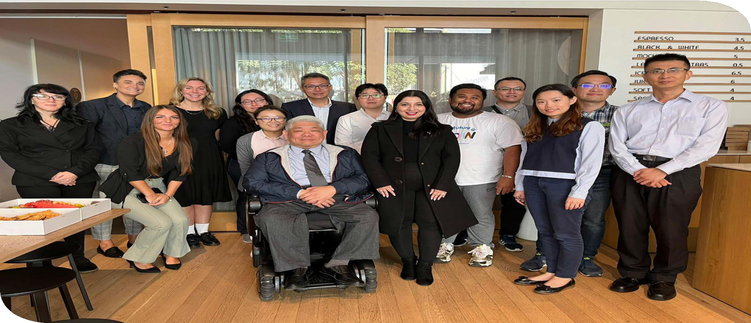
Disabilities from Taiwan. The delegation was interested in PWDA’s projects and approaches to meeting the diverse needs of intersectional people with disability.

Image | PWDA staff members and League for Persons with
Disabilities Taiwan Delegation.
They were also keen to understand the support PWDA Individual Advocates provide to people with disability.
It was a valuable exchange of experiences, emphasising the importance of continuing to strengthen our relationships with other organisations in our region.

Advocate
Advocate for the human rights of all people with disability at individual and systemic levels.

Systemic Advocacy
This year saw the Systemic Advocacy Team focus on pushing for changes called for by our members.
We heard strongly that the COVID-19 pandemic was not over and that more needed to be done to ensure the safety of people with disability as governments
adopted a ‘living with COVID-19’ approach. PWDA developed a COVID-19 Position Statement and Report that packaged the views of our members and the actions
they wanted to see to create greater safety and minimise exclusion. These important documents underpinned PWDA’s advocacy with state, territory and federal government decision-makers as we maintained calls for COVID-safe approaches.
The NDIS Review’s findings and the Disability Royal Commission’s Final Report dominated the year’s activities. PWDA’s responses to these reports were guided by member engagement throughout the year. As a result, PWDA has had opportunities to be involved in the co-design of solutions. One example includes PWDA’s Deputy CEO, Carolyn Hodge, taking part in the National Disability Insurance Agency (NDIA) Workforce Capability Working Group. The group aims to create a greater
understanding of disability and increase lived experience among the NDIA’s workforce.
Throughout the year, we continued to push for an end to the segregation of people with disability. We know that ending segregated housing means we need more accessible, safe and affordable housing to be built.
We also continued to see housing as a key issue for people accessing PWDA’s individual advocacy services. For these reasons, we focused on calling for more
housing that works for people with disability and being a strong disability voice in the development of a new National Housing and Homelessness Plan.
To support our housing advocacy PWDA remained a campaign partner of the Building Better Homes Campaign, participating in a series of actions to
pressure the NSW and WA governments to incorporate the Livable Housing Design
Standard found in the National Construction Code into legislation.
PWDA worked to support our colleagues at the First Peoples Disability Network (FPDN) by promoting the referendum for constitutional recognition of Aboriginal and
Torres Strait Islander People, and releasing a statement in support of an Aboriginal and Torres Strait Islander Voice to Parliament.

We were deeply saddened the referendum was unsuccessful.
The year also saw PWDA take a lead in the conversation on an Australian Human Rights Framework, which led to a strong recommendation from the Parliamentary Committee to enact a national Human Rights Act. This was in line with PWDA’s long-held position. The Committee also released a draft Human Rights Act, and we look forward to working with our partners to get the legislation locked in.
We also worked with our partners— especially the Justice and Equity Centre (JEC) (formerly the Public Interest Advocacy Centre)—to drive significant advocacy to improve the airline industry’s accessibility.
PWDA has seen some welcome wins this year that are consistent with our advocacy. For example, PWDA has long called for increases to income support payments and Commonwealth Rent Assistance to reduce the risk of people with disability living in poverty. Amidst a cost-of-living crisis, we were pleased to see a higher base rate
for JobSeeker and a 10% increase to Commonwealth Rent Assistance in this year’s Federal Budget.
Across the year, PWDA Individual Advocates have been actively supporting people with NDIS Review cases both within and outside of the Administrative
Appeals Tribunal (AAT). Collaboratively, our Systemic and Individual Advocacy Teams have been working to ensure the new
Administrative Review Tribunal adopts more inclusive practices that better serve people with disability. When the Administrative Review Tribunal Bill passed in May 2024, PWDA was pleased to see inclusions aligned with our advocacy. These included that the Tribunal’s processes be accessible for all parties, that the President can make practice directions about accessibility
and responding to diverse needs, and that the Council overseeing the Tribunal can investigate the accessibility and effectiveness of its decisions.
PWDA acknowledges the funding it receives from the Australian Government’s Department of Social Services through the Disability Representative Organisations (DRO) Program. This funding supports PWDA’s nationally focused systemic advocacy, including work related to the Disability Royal Commission and efforts
to engage people with disability during the NDIS Review.
PWDA acknowledges the funding it receives from the National Disability Insurance Agency (NDIA) to support co-design activities.

Disability Royal Commission
In January 2024, PWDA provided submissions to inform the Australian and NSW Governments’ responses to the Disability Royal Commission's (DRC) Final Report. PWDA also joined Disability Representative Organisations (DROs) in a submission to the Australian Government, raising key concerns about the need for greater inclusion of people with disability as genuine partners in designing and
implementing the reforms following the DRC.
In February 2024, PWDA released our Response to the DRC Final Report. This report and its 19 policy position statements reflected what PWDA members think about key recommendations and the change they want to see. We’ve used our media reach to highlight and advocate those positions, and we’ve actively worked with governments to influence their DRC responses.
The Australian Government and state and territory governments (bar Tasmania, which was in caretaker mode) released a
joint statement in March 2024 announcing they needed more time to respond to the DRC recommendations, committing to responding by mid-2024. PWDA called
for the extended timeline to be used by governments to spend more time genuinely consulting with and being led by people with disability and allowing Disabled People's Organisations (DPOs), like PWDA, enough time to engage with our members.

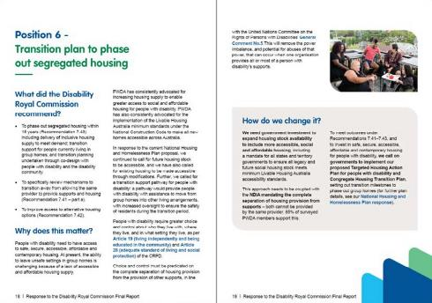

PWDA actively participated in consultation opportunities to represent the views
of people with disability, including Commonwealth and NSW Ministerial Forums from October 2023 to June 2024, taking part in joint sector advocacy, and engagement with Australian and NSW DRC Taskforces.
We continued to advocate for people with disability and their representative organisations to have a formal role as equal partners in all reform measures. This includes prioritising, sequencing, implementing, monitoring, and evaluating these reforms to ensure meaningful change. Additionally, we continued to
urge a coordinated approach between the Commonwealth and state and territory governments to enact the 19 policy positions outlined in our formal response to the DRC Final Report.

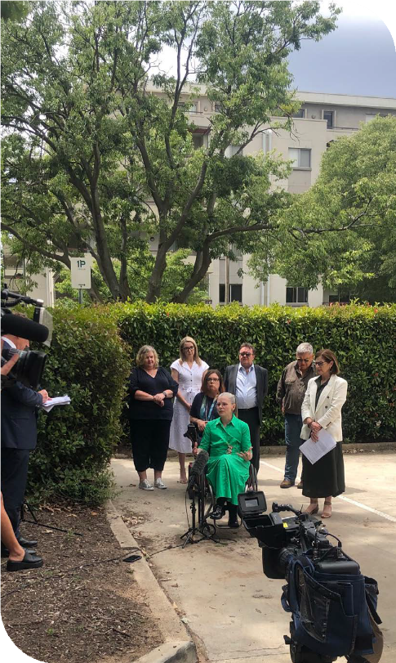
Image | Former PWDA President Nicole Lee addressing the media in Canberra.

National Disability Insurance Scheme Review
The start of the year was buzzing with activity, as PWDA wrapped up its extensive engagement with our national membership as part of the Independent Review of the
NDIS (NDIS Review). We thank all the members who engaged with us during this busy period. Following this consultation, we proudly released two reports and four submissions to the NDIS Review Team this year based on member feedback.
By the end of 2023, the NDIS Review released its Final Report, containing 26 key recommendations and 139 supporting actions. This paved the way for the highly contentious NDIS Amendment (Getting the NDIS Back on Track No. 1) Bill 2024.
PWDA made three submissions on the NDIS Amendment Bill in this financial year. Despite a lot of demands on the disability community, our members remained heavily engaged with the Systemic Advocacy Team and PWDA Board through significant consultations around the NDIS Amendment Bill. It was clear from these consultations our members had numerous concerns about the NDIS. Our submissions proudly reflected their views and were firmly rooted in a rights-based approach.
PWDA acknowledges the funding it received from the Australian Government to engage with people with disability on the NDIS Review.

New South Wales
This year, PWDA advocated for NSW policies and programs that are inclusive and responsive to the needs of people with disability. Our work was influenced by the two budgets that were delivered this year— the Minns Ministry delivered its first budget in October 2023 and a full budget in June 2024.
PWDA delivered a broadly focused pre-budget submission calling for a progressive disability agenda for NSW.
We advocated for investment to support the implementation of the Disability Royal Commission’s (DRC) NSW-focused recommendations, including in housing and inclusive homes, safety at home, inclusive communities, health and well-being, education, and employment.
In line with our advocacy, PWDA welcomed some increased investment in housing support this year. Further investment is needed to address the lack of affordable, safe and accessible housing which remained a key driver for people with
disability seeking support from PWDA's Individual Advocacy Services this year.
We will continue to advocate for greater investment in social and affordable housing and for NSW to sign on to the National Construction Code’s Liveable Housing Design Standards that would see new homes built to be accessible to all.
PWDA’s NSW advocacy also called
for greater investment in the Official Community Visitors Scheme – which is responsible for monitoring supported disability accommodation services, to help resolve issues and promote resident rights.
The rights of people with disability to be safe and included and to make their own decisions was another key focus following the release of the DRC Final Report.
We engaged with the NSW Government on Guardianship and championed supported decision-making in place of substitute decision-making. We have been active in Coercive Control and Specialist Homelessness Services Access and Withdrawal reforms – working alongside NSW Government and our colleagues in the Domestic and Family Violence Sector to ensure reforms are disability-inclusive and services are accessible for people with disability and their children.
PWDA’s systemic advocacy in NSW is made possible by the NSW Government’s Disability Advocacy Futures Program. We acknowledge this investment in driving our work to make NSW programs, systems and policies more inclusive and accessible.

Individual Advocacy
A key focus of PWDA's Strategic Plan is to remain client-centric, ensuring we
consistently deliver high-quality individual advocacy services while expanding our reach. In alignment with the National Standards for Disability Services (NSDS), we have continued to uphold best practices. No non-conformities were reported in our NSDS audit, reflecting our commitment to excellence across all individual advocacy programs. This year we have utilised new technology to improve service delivery, reducing wait times and enhancing our response capabilities. By refining our workflows, we can now reach clients
more efficiently, ensuring that people with disability at highest risk, especially those in closed settings, receive the free and independent support they need.
We have experienced significant growth
in client numbers this year following the Disability Royal Commission and as people with disability grapple with the changing NDIS landscape. PWDA has become a trusted source of information and expertise, not only for people with disability but also for government at all levels.
This year our individual advocacy approach has adapted so we can serve clients where and how they want to receive support. This has seen us reduce our physical footprint while placing advocates in the field more frequently, particularly in regional and remote areas where services and supports are often thin on the ground. We have
also delivered more remote support as
evidenced by the growth in phone enquiries to our Information and Referral service and the Disability Housing Information Line.
Supported by trauma-informed first responders, we have enhanced our technological infrastructure to provide quicker responses and ensure warm transfers, helping clients receive real-time assistance.
Throughout the year, we maintained all funding agreements, which ensures we can continue to deliver on our strategic priority of assisting people with disability in greatest need.
PWDA’s Strategic Plan directs our efforts in advocacy, and our individual advocacy services have been tasked with expanding their reach. This includes advocacy for students with disability and individuals in
closed settings, such as prisons. Our impact is visible through initiatives like the Engage- In Project and the growing client number for the Disability Advocacy Futures Program Education service.
Beyond providing one-on-one support, PWDA’s individual advocates play a critical role in shaping our systemic advocacy.
They highlight the challenges faced by people with disability and contribute to practical solutions that drive systemic change, ensuring our advocacy is informed by lived experience. Through training in self-advocacy and collaboration with sector partners, we continue to build capacity across the community, empowering people with disability to protect and uphold their rights.

National Disability Advocacy Program
PWDA supported 698 individual cases of advocacy, up from 535 the previous year, under the National Disability Advocacy Program (NDAP)
in New South Wales and Queensland.
Funded by the Australian Government Department of Social Services (DSS), the NDAP empowers individuals by helping them understand and uphold their rights and access necessary support and services.
This year, PWDA continued to provide individual advocacy support to people with disability in Queensland and New South Wales, assisting with a wide range of serious issues and empowering clients to self-advocate.
In New South Wales, NDAP services are available in both regional and metropolitan areas, including Sydney, Southern Tablelands, Wagga Wagga and remote services across the state. In Queensland, NDAP supports a wide range of regions, including Hervey Bay, Port Douglas– Daintree, the Sunshine Coast, Bundaberg, Maryborough, Logan-Beaudesert and Outback Queensland.
PWDA advocates play an important role in addressing human rights violations and
providing education on rights, accessibility, and inclusion. This year, advocates commonly supported clients with a range of housing issues, such as accessibility, tenancy, and homelessness, as well as
guardianship and legal matters, child safety concerns, and discrimination in employment and services. In addition, they continue to support their clients in addressing issues with NDIS-funded service providers and resolving issues with their NDIS plan.
PWDA advocates are also the first go-to for our systemic advocacy team, ensuring we reflect the voice and lived experience of our clients in our submissions and policy work.

“[My] PWDA Advocate couldn’t have been more helpful, informative and supportive.
I rang various agencies to try and get assistance with this matter after months of searching I found PWDA. My Advocate communicated succinctly and respectfully,
and understood what I wanted, and helped me navigate what appeared to be a daunting process.”
Client Testimonial

National Disability Insurance Scheme Appeals Program

“ [My] Advocate was amazing. Their knowledge, and expertise and ongoing support with a very complex and complicated case that had many layers was next level. They never gave up on us always had support for us. We won’t know the endless hours they spent chasing
the NDIS/ NDIA on behalf of our daughter. We are truly grateful for every second they helped us. We are pleased to have our prayers answered and see our daughter get
the equipment she needs to function at school, work and in the community.”
Client Testimonial
PWDA supported 285 individual cases of advocacy under the National Disability Insurance Scheme Appeals Program (NDIS Appeals Program).
Funded by the Australian Government Department of Social Services (DSS), the NDIS Appeals Program provides critical support to people seeking a decision review through the Administrative Appeals Tribunal (AAT).

PWDA acknowledges the funding provided by the Department of Social Services that makes PWDA’s NDAP service possible.
This year, PWDA continued to experience a high demand for individual advocacy support to navigate the NDIS and AAT appeals processes. Concurrently, the time taken to resolve cases increased this year for a range of reasons, including high demand at the AAT and the complexity of matters. Common issues clients sought our advocacy for included appealing NDIA decisions on access, reductions in funds, and changes in circumstances to ensure
adequate funding and access to reasonable and necessary supports. This included Supported Independent Living (SIL) and NDIS core supports.

Some cases can remain open for up to three years due to their complexity, with PWDA advocates providing continuous support. This includes explaining the review process, assisting with document preparation, advising on evidence, and attending AAT conferences alongside clients. The program also aims to build clients’ skills and confidence, empowering them to advocate for themselves more effectively in the future.
In response to the ongoing need for understanding of the AAT appeals process, PWDA developed advocacy sessions to help guide individuals and their families through the process, with a strong focus on self-advocacy. This initiative has been particularly beneficial for those unable to secure ongoing advocacy assistance.


On 28 May 2024, the Australian Parliament passed legislation to abolish the Administrative Appeals Tribunal (AAT) and replace it with a new body called the

“[My] Advocate went above and beyond to help me in the many situations and challenges we have faced together. With them, I felt
confident, certain, and hopeful. I believed that they had my best interests at heart, and
this was proven time and time again, to the point where I was able to relax and depend on that they would handle matters for me to my advantage.
Without them, I would have drowned in the quagmire that is our appeals system.”
Client Testimonial
Administrative Review Tribunal (ART). It will begin operating on 14 October 2024.
PWDA shared insights and experiences from the AAT process throughout the development of the new ART.
PWDA will continue to support all cases currently being assisted under the NDIS Appeals Program. When the ART is established, any remaining cases will be transitioned to the new tribunal. For clients who have already applied to the AAT, PWDA will ensure ongoing support throughout this transition.

PWDA acknowledges the support provided by Legal Aid Queensland and Legal Aid New South Wales to clients of our NDIS Appeals Program and acknowledges
the funding provided by the Australian Government’s Department of Social Services to operate the Program.

Queensland Disability Advocacy Program (QDAP)
PWDA supported 122 individual cases of advocacy under the Queensland Disability Advocacy Program (QDAP).

“I usually have a hard time trusting people especially with having my best interests at heart and not dealing with me as an individual and not just a number. Instead of this I knew I could trust [my] Advocate straight away and that they would help me, which they did. They explained everything I was confused about and helped me to calm down and understand when I became frustrated with the process. I can’t thank them enough for all they did and their help.”
Client Testimonial
Funded by the Queensland Government Department of Seniors, Disability Services and Aboriginal and Torres Strait Islander Partnerships, QDAP provides individual advocacy services to people in Noosa, the Sunshine Coast, Gympie and surrounding areas. The program helps individuals make informed decisions, build self-advocacy capacity, ensure fundamental needs
are met, and provides referrals to legal assistance and disability support services.
This year, PWDA supported clients with a range of matters, including access to
the NDIS, health care and other services, housing and tenancy, child safety, legal issues and experiences of abuse, neglect, violence and discrimination.
PWDA advocates attended a range of community meetings and interagencies.
This included participating in and contributing to monthly Queensland Independent Disability Advocacy Network and Queensland Advocacy for Inclusion activities.

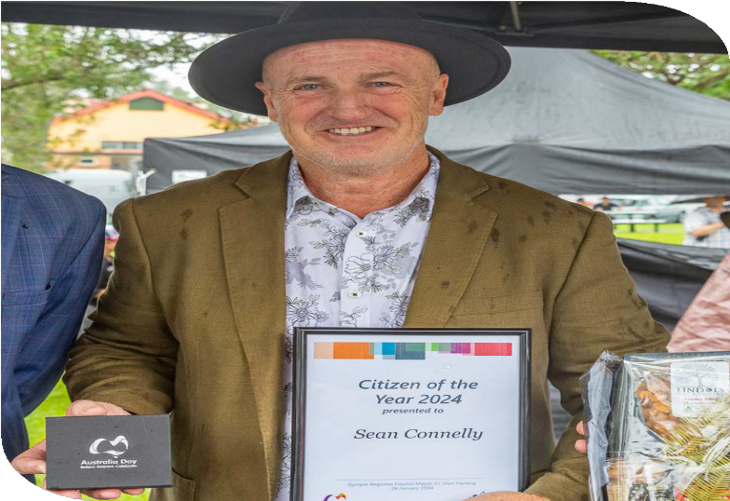
Image | PWDA staff member, Sean Connelly with his Gympie 2024 Citizen of the Year award.

“When my NDIS plan was cut significantly, I did not want to live or know how I would survive. I had lost my sight, my hope and did not think I could carry on. I contacted
PWDA and about a week later [my] Advocate walked though my door. From the moment he shook my hand my troubles melted away. He was calm, listened intently, understood my concerns and although
he made no promises, he completed my what he called Intake and then he lodged
an AAT appeal on the spot. He then went into battle against the NDIA and won me
everything I lost. He was like a guardian angel who was sent to me to save me after losing my sight and my partner. Now I can stay in my home with the support I need.”
Client testimonial

In Gympie, PWDA Advocate Sean Connelly initiated and hosted a monthly community group called the Queensland Disability Network, which was made up of and led
by people with disability. This is just one example of the high quality service we offer and the innovative and clever ways our teams provide advocacy support.
PWDA was proud to learn Sean was named Gympie’s 2024 Citizen of the Year in recognition of his advocacy work and contributions to the community.
PWDA acknowledges the QDAP funding provided by the Queensland Government Department of Seniors, Disability Services and Aboriginal and Torres Strait Islander Partnerships.

Disability Advocacy Futures Program
PWDA supported 264 individual cases of advocacy under the Disability Advocacy Futures Program (DAFP).
Funded by the NSW Government Department of Communities and Justice (DCJ), PWDA provides DAFP individual advocacy services across the Sydney, South Eastern Sydney and South Western Sydney Local Health Districts. The DAFP assists people with disability to access and address any issues with services and supports directly funded or provided by the NSW Government.
Through the DAFP, PWDA offers advocacy assistance and information to clients facing complex issues, providing guidance and referrals and engaging in community outreach activities to raise awareness of the program. The program also focuses on supporting residents of assisted boarding houses within the targeted Local Health Districts.
This year, the program experienced significant growth, with a 30% increase in the number of clients supported compared to the previous year. Enquiries to the program also increased by 40%, reflecting the community’s growing awareness of the individual advocacy support available from PWDA.
Housing-related issues accounted for 70% of advocacy cases, with key concerns including public safety, accessibility, unsafe living conditions and support with
transfer requests. These issues underscore the critical need for accessible housing, highlighting the importance of individual advocacy services and the need for systemic improvements in social housing policies.
PWDA acknowledges the funding provided by the NSW Department of Communities and Justice for DAFP services.

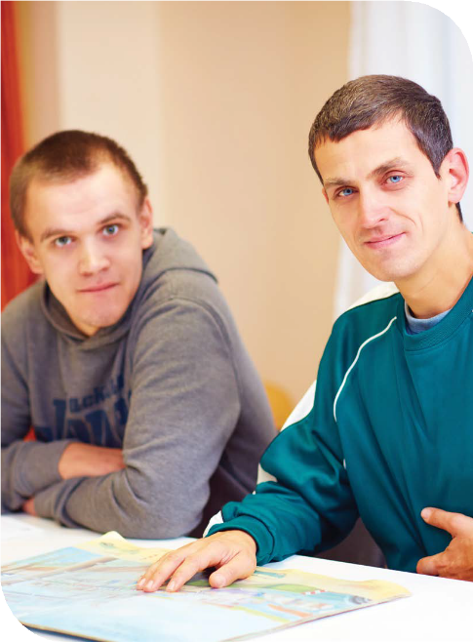

Disability Advocacy Futures Program - Education

“Everyone I spoke to at PWDA were very attentive and perceptive, understanding
the problems I was trying to resolve, better than I did sometimes! This was
particularly the case with [my] Advocate. She was always realistic about what I could aim for, whilst demonstrating complete determination to have my needs heard and acknowledged, and then followed through to receiving the outcome organisations claim to provide for people in my situation. It is something I’m not good at and I’ve learnt a lot out of the process, on top of my problem being resolved. I’m going to go forward to future situations much better prepared.”
Client Testimonial
PWDA supported 114 individual cases of advocacy under the Disability Advocacy Futures Program – Education (DAFPE), a 500% increase year-on-year.
Funded by the NSW Government Department of Education, PWDA provides individual advocacy support through
the DAFPE to students with disability in NSW public schools and their families and guardians across the Sydney, South
Eastern Sydney and South Western Sydney Local Health Districts.
Thanks to the dedication of PWDA’s advocates and project officers, this year the DAFPE saw the program further develop, supporting 114 student matters. Growing case numbers highlight the increased awareness of the program as it moved
into its second full year and reflects its increasing effectiveness. The program was also highly commended for its work by the Department of Education. The uptake of education-focused individual advocacy also underlines the need for continued advocacy support for students with disability.

PWDA advocates supported students and their families with a variety of issues, including facilitating meetings between families and schools. Outcomes included improving Individual Education Plans
(IEPs), securing increased School Learning Support Officer (SLSO) resources, increasing Integration Funding Support (IFS) and SLSO support, and assisting student transfers. Advocates also secured
commitments from schools to adopt more inclusive practices, improve transport arrangements, and provide access to allied health supports both within and outside of school settings.
PWDA acknowledges the funding that the NSW Department of Education provides via the NSW Department of Communities and Justice for the DAFP Education services.



Case Study – John*

John is a young student with disability who is enrolled in a mainstream NSW public primary school. Due to his age and
disability, John cannot travel independently to and from school.
John’s parents contacted PWDA after their application for John to access the Assisted School Travel Program (ASTP) was denied. They were informed the application was unsuccessful because John was enrolled
in a mainstream school and the program was said to be available only to students who attend a support unit or a School for Specific Purposes (SSP).
How we helped
The PWDA advocate explored appeal options for the ASTP and confirmed the service could, in fact, be provided to students in mainstream schools if mobility issues were present. John’s parents confirmed mobility was an issue for him.
The advocate then assisted the parents in obtaining evidence of John’s mobility issues from his occupational therapist and assisted in submitting an appeal to the ASTP
Panel. In the appeal, the advocate raised concerns that the ASTP policy appeared to be focused on school setting and type of disability rather than the rights of all
students with disability to access education, potentially making the policy discriminatory.
Outcomes achieved
As a result of the appeal, the ASTP Panel reviewed John’s application and found him to be eligible for the program. John’s application was approved, and he is now able to access the Assisted School Travel Program.
*The names of the people in this case study have been changed.

Disability Housing Advocacy Service
PWDA supported 113 cases of individual advocacy under the Disability Housing Advocacy Service (DHAS) and assisted 219 people via the 1800 Disability Housing Information Line (DHIL).
The DHAS and DHIL, both funded by the NSW Government Department of Communities and Justice (DCJ), support people with disability living in supported accommodation across NSW who have tenancy-related issues.
Over the past 12 months, we observed a steady demand for direct individual
advocacy support. The COVID-19 pandemic also changed the way clients prefer to engage with us driving a 70% increase in demand for the Helpline.
PWDA advocates helped address tenancy issues, preventing housing breakdowns, and helped protect a vulnerable cohort from abuse, unnecessary evictions, and homelessness.
PWDA advocates also assisted clients with Administrative Appeals Tribunal (AAT) cases. These included appeals related
to insufficient accommodation funding, rejections of funding applications, and requests for housing equipment.
PWDA acknowledges funding from the NSW Government Department of
Communities and Justice (DCJ) that makes the DHAS and DHIL available.

“[My] Advocate was completely professional, understanding, easy to communicate with, well informed, explained the process very clearly. We would highly recommend PWDA to anyone who needed this level of help with their Supported Disability Accommodation provider. We could not of done this without their support and we will be forever grateful to have had help from PWDA!”
Client Testimonial

Case Study - Wanda*

Wanda is a 47-year-old woman with complex support needs, including significant functional impairment and intellectual disability. She is a resident of a shared living facility.
Wanda’s safety was at risk because her Specialist Disability Accommodation (SDA) and Supported Independent Living (SIL) providers did not provide appropriate support. Because her accommodation could not be safely maintained, she was facing homelessness or long-term hospitalisation.
Wanda contacted PWDA for support to address the service issues and maintain her accommodation.
How we helped
After meeting with Wanda, her parents, and the SDA and SIL providers, it became clear that significant changes were required to ensure her ongoing safety and access to accessible accommodation. This required changes to the SDA category, additional supports, and assistive technologies and equipment.
Wanda’s advocate helped her to contact her clinical specialists and key supports to obtain the necessary evidence that explained the risks to her health and demonstrated the positive impact that additional services would have on her situation. The advocate helped support
and encourage Wanda though this lengthy process, and regularly engaged the services involved to ensure that her voice was heard.
Outcomes achieved
Wanda was able to achieve her goal of living safely and independently in the community.
*The names of the people in this case study have been changed.

PWDA Redress Project
PWDA supported 132 clients under the Redress Project.
The PWDA Redress Project helps adult survivors of institutional child sexual abuse with disability engage with the National Redress Scheme (Scheme). We offer a trauma-informed service that supports survivors in seeking acknowledgement
for the harm they’ve endured. PWDA advocates assist survivors to access and fully participate in the National Redress Scheme.
This year, the PWDA Redress Team achieved substantial growth in client support, with new client numbers increasing by 53% from the previous year.
PWDA advocates continued to support clients to safely navigate the complex application process and make informed choices about accessing the Scheme. This included providing support to access free legal services and counselling, ensuring their accessibility needs were met and obtaining direct personal responses from the agencies listed in their application.
The PWDA Redress Team continued to improve access to the Scheme by engaging in community outreach work, including holding workshops, travelling to regional and remote NSW, and engaging with our disability community to provide valuable information about the Scheme.
This year we also continued our collaboration with other NSW Redress Support Services to run workshops for services and organisations. These
workshops provided valuable information about the Scheme and highlighted the role Redress Support Services can play in assisting clients to participate safely and successfully in the Scheme.
PWDA acknowledges the Australian Government Department of Social Services funding that makes the PWDA Redress Project available.

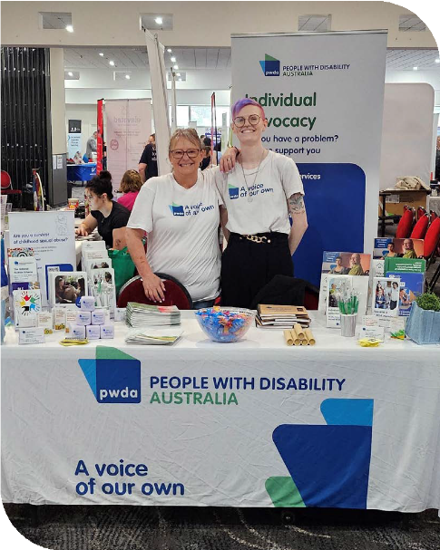
Image | PWDA Manager and Specialist Advocate Redress Linda Wiseham and Project Officer Tessa Newman at a disability community expo.

Case study – Brad*

Brad engaged PWDA’s Redress Team to assist with his application to the National Redress Scheme and support him throughout his Redress journey.
Brad is a man who cannot read or write, and his neurodiversity affects his communication and social interactions. These challenges often lead to Brad being stigmatised and misunderstood by others. He also has multiple physical disabilities. As a child
Brad was institutionalised and experienced childhood sexual abuse.
Because Brad has difficulty trusting others, it was very difficult for him to share his story and complete his Redress application. Brad was extremely courageous and persisted.
How we helped
The PWDA Redress advocate worked closely with Brad, building rapport and understanding his preferred communication methods so they could best support him.
The advocate supported Brad throughout his entire Redress journey, including filling out the application, gathering supporting documents, providing information and support throughout the process, and liaising with lawyers and the National Redress Scheme.
Outcomes achieved
Brad received a full offer of Redress, which he accepted. The advocate continued to assist Brad in completing his paperwork and applying for counselling, financial counselling and a direct personal response (apology) from the institution.
Brad was extremely happy with the outcome of the Redress process.
*The names of the people in this case study have been changed.



Engage-In Project

“For me it was really important and nice that I was not judged, felt safe and made to feel adequate. [My] Advocate
was caring kind and very professional.”
Client Testimonial

PWDA supported 54 clients under the Engage-In Project.
Over the last 12 months, PWDA's Engage- In Project has achieved substantial growth in client numbers despite the significant barriers to reaching people with disability in closed settings. The Project experienced a 90% increase in referrals and a 237% increase in new client numbers.
Engage-In advocates work side-by-side with people with psychosocial disability who are exiting closed settings, helping them identify goals and connect with services and supports. Across the year, the Engage- In Team supported clients in connecting back to their communities, building their confidence and skills to maximise choice and control, and reducing the risk of returning to the closed setting.
The model of individual advocacy support provided by Engage-In is directed by
the person with disability and is trauma informed in its operation.

This year, the Engage-In Team delivered 17 training sessions on “Engaging confidently with psychosocial disability” to PWDA
staff and a range of external service providers. The team also continued to lead a Community of Practice (COP) for the disability sector, facilitating access to knowledge and expertise that service
providers might not easily gain on their own, such as industry trends, techniques, and practices to improve how they work with people with psychosocial disability.
The Project has employed six (6) people with lived experience of psychosocial disability over the last 12 months, including the program manager and advocates.
PWDA acknowledges the funding provided by the Australian Government Department of Social Services (DSS) under an Information Linkages and Capacity Building Grant for the Engage-In Project. The funding concluded in June 2024. PWDA is actively seeking new funding to continue this important work.

Case Study – Bill*

Bill was referred to PWDA by their Legal Aid lawyer after sustaining multiple injuries from violent assaults while on remand, which had resulted in physical disabilities, including acquired brain injuries and significant memory issues.
Bill’s condition had worsened significantly as he did not receive timely medical attention. Bill was eventually admitted to the hospital for medical treatment and assessments, where he experienced significant delays, waiting over four (4) hours for tests. While
in the hospital he was prescribed nerve pain medication, but this medication was not permitted in the prison, leaving him in considerable pain.
Bill’s requests for medical records and discharge summaries from the prison were ignored.
How we helped
An Engage-In advocate intervened by contacting Justice Health NSW to
obtain further information and assist Bill in accessing his medical records from the hospital. This intervention was vital in ensuring Bill received the necessary
documentation to understand and manage his health conditions. The Engage-In Project aided Bill and his family, offering them some relief and assurance that Bill was not falling through the cracks.
Outcomes
The assistance provided by the Engage-In Project highlighted the neglect Bill faced and ensured that he received some level of care and support. This case demonstrates the importance of independent external advocacy for incarcerated individuals with disability.
*The names of the people in this case study have been changed.

Educate
Drive positive change for people with disability through education and advocacy.

Throughout 2023-24, PWDA continued to strengthen its Strategic Projects and Training division.

Strategic Projects and Training
In line with PWDA’s Strategic Plan pillar Educate, PWDA’s training and project work ensures that government, business and the broader community benefit from the lived expertise of people with disability and gain greater knowledge and awareness of
disability rights and inclusion. This year, the team worked to identify projects, partners and opportunities that align with our Vision and Purpose and which look to make a positive impact to the lives of, and address issues related to, the rights of people with disability.
Organisations we supported and/or partnered with this year include: Westpac, Australian Digital Health Agency (ADHA), NSW Treasury, Department of Finance, Settlement Services International (SSI), Department of Defence, Georges River Council, Wingecarribee Shire Council, University of South Australia, Australian Turf
Club, Housing Plus, Barnardos Australia, Orana Support, Mission Australia, Good Shepherd and Federal Circuit and Family Court of Australia.

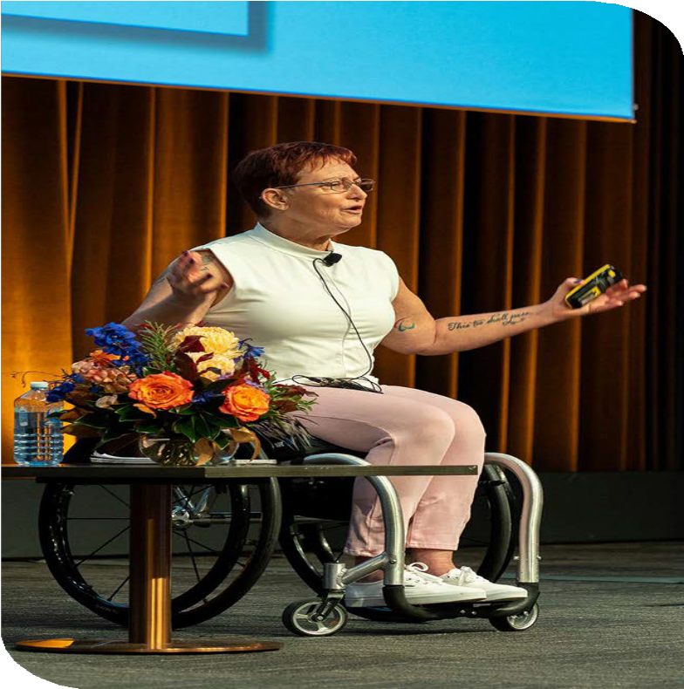
Image | PWDA Trainer Janel Manns presenting at the 2024 Independent Support Worker Summit.

Advancing Women with Disability in the Workplace
The Advancing Women with Disability in the Workplace Project (Advancing Women Project) aims to increase representation
in leadership roles, increase workforce participation and improve safety in workplaces for women with disability. The Project is funded by the Women’s Leadership and Development Program (WLDP), which is administered by the
Australian Government Department of the Prime Minister and Cabinet’s Office for Women.
Since the Project launched in 2023, PWDA has conducted extensive research, speaking with hundreds of women and gender diverse people with disability to identify the barriers they face in accessing work and decision-making opportunities. The data collected has been used by the Project’s Expert Advisory and Co-Design Panel to progress the development of its educational and mentorship programs.
In March 2024, Westpac signed on as the pilot partner for the Advancing Women Project. As part of this pilot program, PWDA developed a 20-week eLearning
mentorship program, set to launch with Westpac next financial year. This program will create shared learning experiences between mentors and mentees through an accessible, interactive online platform.
PWDA extends our gratitude to Westpac as our pilot partner. By participating in this initiative, Westpac is showcasing how
businesses can significantly and positively influence social change.
We also acknowledge the women and gender diverse individuals from the Advancing Women Expert Advisory and Co-Design Panel. Their continuous support in the research and design of the training and mentorship program has
been invaluable. Their voices, stories and contributions have shaped the 20-week mentorship pilot program into a meaningful initiative that strives to create safer workplaces for women with disability.

Building Access
TO INCLUDE PEOPLE WITH DISABILITY

Building Access Project
The Building Access for Women with Disability to Domestic and Family Violence Services Project (Building Access Project) is funded by Women NSW under the Domestic and Family Violence (DFV) Innovation Fund. The Project seeks to make

domestic and family violence services more accessible to women and children with disability.
Originally funded in 2017, the Building Access Project was granted an extension to continue its important work across the
2023-24 financial year. This year, leveraging the findings from the Building Access End
of Project Report published in November 2023, the team focused on developing impactful training and education for DFV service providers in Western NSW to enhance access for women and children with disability in this region.
The report revealed that women and children with disability encounter significant barriers when accessing DFV services.
Alarmingly, 57% of women interviewed had avoided seeking support due to negative past experiences, including dismissal, discrimination, and further harm. The report demonstrated that inclusive policies and practices produce better outcomes for women with disability, both as staff and clients of DFV services. These policies, along with accessibility audits and disability awareness training, build an environment of attitudinal accessibility.
The Building Access Project delivered training sessions in Mudgee, Dubbo, Orange, and other central locations, reaching a wide range of DFV services across Western NSW. These sessions were facilitated by women with disability who have experienced DFV.
Following the project’s success over the past year, the NSW Government
Department of Communities and Justice (DCJ) has announced its continued support for the Building Access Project into the next financial year.

“It built passion and awareness in the team – that was the value of the training. Meaningful accessibility wouldn’t have happened if we didn’t have the training from [Building Access] and all of the learnings from processes and policies in the Disability Inclusion Action Plan – and the systems built from being part of the project.”
The Haven

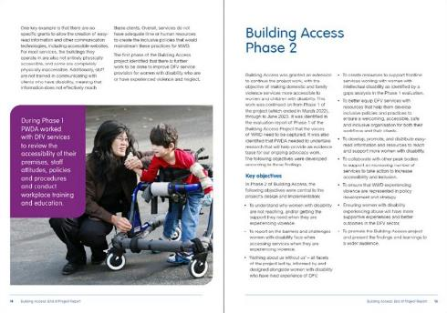


Talk Up
The primary objective of Talk Up is to help Aboriginal and Torres Strait Islander Peoples with disability understand their legal rights and advocate for themselves
in legal situations. This is done through the development of educational resources.
Funded by the Australian Government Department of Social Services (DSS), Talk Up was a consortium project, delivered in partnership with First Peoples Disability Network (FPDN) and The Australian Centre for Disability Law (ACDL). Talk Up concluded in April 2024.
Building on the success of prior consultation sessions delivered in Mount Druitt (2022) and Dubbo/Wellington (2023), the Talk Up Team held its final community consultation session in December 2023 at Jubullum Village, near Tabulam, NSW.
During this session, the Talk Up Team had yarns with community members about legal issues affecting them. The Talk Up resources received positive feedback, with community members saying these resources had a place in their community and could be useful.
PWDA would like to acknowledge our consortium partners, First Peoples Disability Network (FPDN) and the Australian Centre for Disability Law (ACDL), for their contributions and commitment to this project.

Australian Digital Health Agency
This year PWDA continued to work with the Australian Digital Health Agency (ADHA)
to improve accessibility and inclusion capabilities across the Agency. PWDA provided advice to enhance accessibility, raise awareness of the services and significantly lift engagement with the ADHA and its offerings by increasing people with disability’s confidence in using the ADHA’s digital health tools. Another focus was to increase the understanding of the needs, barriers, and enablers in the design and use of the Agency’s digital health technologies.
Through consultations with our community, PWDA developed a range of accessible resources for the ADHA, including Easy Read information sheets. We look forward to continuing our work with the ADHA
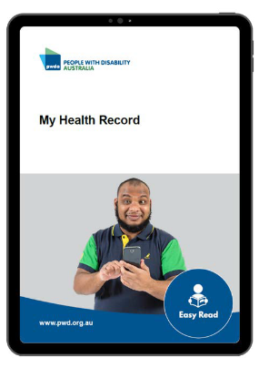
and making a positive impact on people with disability’s access to digital health technologies.

Training
47 sessions delivered to over 1,800 people.
All PWDA trainers are people with lived experience of disability. Over the past 12 months, we saw demand for PWDA training continue to grow and come from a wide range of stakeholders. While PWDA's Disability Confidence training remains a popular choice for many organisations,
we continue to experience an increasing number of requests for PWDA to deliver customised training sessions tailored
to specific challenges and needs of
organisations.
A key focus for the PWDA Training Team this year was updating the suite of PWDA training materials available. This included updating existing content to ensure we remain current, relevant and of the highest quality while also developing new training materials and programs. In response to changing preferences of clients and the COVID-19 pandemic, we have continued to expand our eLearning offerings. Our clients and stakeholders also continue
to appreciate and request face-to-face sessions, resulting in our lived experience trainers delivering sessions across the country.
We also commenced the development of our Learning Management System (LMS) to assist with the expansion of our eLearning courses. Having our own LMS will ensure
we can meet the growing demand from both organisations and individuals who wish to access PWDA workshops and training courses on demand.
This year, PWDA delivered training to organisations including large government departments (such as the Australian Government’s Department of Social Services and Department of Finance), local councils (with growing demand from rural and regional areas), community organisations, service providers and individual businesses.
Recognised for our expertise we also saw an increase in enquiries and requests
for advice and support. This saw PWDA expand our products and service offering including Disability Inclusion Action Plans (DIAPs) and saw our team join a range of Reference Groups, Advisory Bodies and Industry Committees, and deliver presentations at several conferences and summits. Central to the development and delivery of our content are people with lived experience. We thank all our PWDA
trainers, members and staff for generously
sharing their experiences.

“The facilitator was fantastic. Very engaging, personable, and generous in sharing his lived experience as a person living with a disability.”

Training and facilitation case studies
Centre for Volunteering AU and SSI e-learning Module Initiative
PWDA Trainer and Facilitator Janel Manns was a subject matter expert disability consultant and Volunteer Ambassador for the "Volunteer Voices: Diversity, Equity, Inclusion, and Belonging" initiative, launched on the Volunteering AU website. This project promotes inclusive practices in volunteer programs. In response to the significant decline in volunteering across Australia since the COVID-19 pandemic, Settlement Services International (SSI), funded by the Australian Government Department of Social Services partnered with the NSW Centre for Volunteering to develop online training e-learning modules
for volunteer involving organisations (VIOs).
The e-learning modules focus on the experiences of diverse communities, including First Nations people, newcomers, people with disability, and younger and older Australians. They address barriers to volunteering and offer solutions to enhance engagement with Australia’s diverse community. The e-learning modules are available as free resources for volunteer managers and the general public on the NSW Centre for Volunteering website.
The Rights Path Project
PWDA is also collaborating with Settlement Services International (SSI) on The Rights Path Project (TRPP). The Project which develops resources in Vietnamese, Khmer, Punjabi, and Urdu, aims to strengthens NDIS participants’ understanding of their rights and the quality of service they should receive. It also helps participants learn how to lodge a complaint about unsatisfactory services and guides NDIS service providers to meet their obligations under the NDIS Quality and Safeguarding Framework. The Project encourages collaboration among service providers, fostering best practices in promoting participants' rights and improving feedback and complaints processes.
Central and Eastern Sydney Primary Health Network (PHN)
In 2023, PWDA delivered a series of disability confidence training workshops for the Central and Eastern Sydney Primary Health Network (PHN) as they prepared to develop their first Disability Inclusion Action Plan (DIAP). The training provided 100 delegates from the PHN with a foundational understanding of inclusion, access barriers, and disability rights. Across five (5) days, PWDA hosted a two-hour workshop each day. The workshops were led by a PWDA trainer with lived experience of psychosocial disability, allowing participants to explore relevant scenarios and ask questions in a safe and supportive environment.

Sustain
Maintain a financially viable and
sustainable organisation.

This year PWDA focused on our people, clients and
members and improving their experiences. Professional development, improving accessibility and adopting new technologies were prioritised. PWDA also strengthened its position and impact through strategic alliances, expanded project work, products and services, and mission-driven partnerships. This work helps to increase the sustainability of our organisation by attracting a range of diversified funding sources.

PWDA Board
The past year has been exceptionally busy for our dedicated Board of Directors, who have consistently demonstrated a strong commitment to governance, representing our members and amplifying the voices of our community.
Despite the challenges of the relentless reform agenda, the Board actively engaged with our membership throughout the year, ensuring the key priorities and concerns
of our members were understood and addressed. Their passion and dedication, especially as volunteers, has been truly commendable.
This year, the Board focused on responding to important issues such as the ongoing COVID-19 pandemic, the Disability Royal Commission (DRC), the NDIS Review and NDIS Amendment Bill. They facilitated conversations in PWDA member forums, gave testimony at Senate hearings, and participated in webinars, advisory groups, and a vast amount of media engagements.
Internationally, our Board represented our members and community by speaking at the Committee on the Rights of Persons with Disabilities 29th session in Geneva in August 2023 and presenting on the topic of upholding the UN Convention on the Rights of Persons with Disabilities for people
with psychosocial disability in Korea in December 2023.

Governance and succession planning, vital to PWDA’s sustainability, also remained
a key priority. This focus proved essential in a particularly challenging year, as the Board not only navigated the significant issues affecting our community but also demonstrated resilience in the face of constant change.
At the PWDA Annual General Meeting (AGM) held on Wednesday 15 November 2023, we welcomed new Directors Eva Sifis and Kevyn Morris. They joined returning Board Directors Arun Barramundi, Haidi Badawi, Marayke Jonkers, Dr Michelle Hyde, Nicole Lee, Presley Chihuri, Suresh Rajan and Dr Zhila Hasanloo. The AGM also marked the departure of Co-Vice President Samantha Connor and Board Secretary Clare Gibellini, whose leadership and advocacy had helped navigate PWDA through the ongoing COVID-19 pandemic and shape our responses to the DRC and NDIS Review. Following the AGM, and
over the course of the year, the Board saw Dr Michelle Hyde, Nicole Lee and Dr Zhila Hasanloo make the decision to step off the Board. Nicole Lee’s departure in January saw Marayke Jonkers, one of our longest- serving Directors, elected by the Board
as Interim President until the 2024 AGM. Marayke’s deep knowledge, experience, and leadership ensured a smooth transition during this critical time for the disability community.
Throughout the year, the Governance Advisory Group and Strategic Directions
Advisory Group continued to provide valuable support to both the Board and the operations team.
PWDA extends immense gratitude to all past and present Board Directors for their tireless, game-changing advocacy on behalf of our members, the broader disability community, and our staff. Their passion, dedication, and voluntary efforts have been truly commendable, making a lasting impact on PWDA and the broader disability rights movement.

Best Practice and Employment
As a leading disability organisation being recognised as an accessible and inclusive workplace is critically important to PWDA. This year, we remained focused on supporting our workforce and improving our work environment.
The ongoing COVID-19 pandemic continued to impact the way we worked and how we provided services. For our staff the most important consideration was to keep them safe and improving our work
environment in order to remain COVID-safe.
As staff became more accustomed to working from home (WFH) and wanting to offer our team flexibility, we initially
trialled and then transitioned to hybrid work arrangements.

Following on from the success of the hybrid work arrangements, the decision was made to downsize our Sydney head office and in turn reduce the financial cost to the organisation. To ensure the new office was accessible and met client, member and staff needs, a PWDA staff working group was formed to help design the new office space. This saw us introduce a specific room for client visits, increase the number of phone rooms and accessible facilities, and introduce sensory spaces for staff
and clients to use. In May 2024, PWDA’s
Sydney office relocated to a new, more accessible and centrally located space at Suite 10.01, Level 10 Centennial Plaza, 300 Elizabeth Street Surry Hills.
The COVID-19 pandemic also brought changes in the meeting preferences of our clients. This year PWDA experienced a reduction in foot traffic at regional PWDA offices, while there was an increase in requests for in-home and telephone advocacy services. As a result, PWDA made the decision to close some of its regional offices. The Bowral office closed this year and plans to close the Mount Isa office commenced. In place of a physical office, PWDA has now boosted regional advocate capacity to allow our advocates to travel directly to clients. The timely transition to a new telephone system allowed us to effectively meet the changing preferences of our clients for how they access our services.
This year PWDA strengthened our commitment to reducing our environmental impact by using sustainable practices in
our day-to-day work. The implementation of new technology has allowed us to reduce staff travel and minimise printing and paper waste. Our new Sydney office has large windows that let in natural light, improving staff wellbeing while lowering energy usage. We also now follow a waste hierarchy system and have policies to ensure we think about the environment when making purchases. This includes looking at supply chains, how products are used, and recycling options at the end of the product’s life.
This year, PWDA implemented the final phase of our Information Communications and Technology (ICT) strategy, which saw us transition to cloud-based infrastructure. The upgrade with its enhanced functionality has significantly improved the quality of our employee, member and client experience. The upgrade has also reduced cyber risks, strengthened security across our technology platforms and introduced tighter controls to protect client data.
The transition to our new cloud-based telephony system and the introduction of improved workflows and client focused initiatives resulted in reduced wait times for client enquiries and information requests. During office hours staff are now able to respond more frequently in real time and within 24hrs.
The implementation of the new telephony system and Microsoft 365 and its collaborative tools saw further
improvements to our employee experience.

Annual Report 2023-24 | 61

With the successful implementation of this phase of the project and an eye on continuous improvement, the team is now developing a PWDA staff intranet. The PWDA intranet will enhance staff collaboration, access to information and resources. We are also improving the employee experience when using our HR and Payroll Platform.
Professional development remained a key priority across PWDA this year, with over 400 hours of training provided to our teams on topics such as Trauma Awareness
in Practice, Accidental Counselling, and Trauma Responsive Leadership. The training has provided practical skills and advanced knowledge to staff to help them best support clients and members.
As part of our focus on professional development, we introduced PWDA’s first performance framework, which includes workplans and professional development plans for all staff. This ensures every team member has clear goals and access to opportunities for growth and skill development.
We also focused on succession planning and career development. We are in the process of developing a succession planning framework, including objective setting and performance reviews, as well as a Me+1 succession guide to provide clarity for roles and opportunities for career growth for staff. To further support the development of staff, professional development plans were included in our work plans providing staff an opportunity to identify professional
development goals. Each work plan is aligned to PWDA's 2022-25 Strategic Plan and yearly operational plan.
In April this year, we welcomed Karen Karakaya as the Director of People and Culture, bringing over 14 years of
experience, much of it in the for-purpose sector. Part of Karen’s key focus is to review and strengthen our organisation’s culture and continuously improve the experience of all PWDA employees.
We also onboarded a new Manager of Governance and Compliance to ensure PWDA continues to meet its internal and external compliance requirements.

Disability Inclusion Action Plan
This year PWDA commenced the development of our first Disability Inclusion Action Plan (DIAP). With the help of access consultant and PWDA member Morwenna Collett, our members, clients, and staff contributed to surveys and focus groups to help lay the foundations of the DIAP.
The DIAP aims to ensure that we remain accessible and inclusive to everyone in our community, and work towards a society where the rights, belonging, potential,
and diversity of people with disability are recognised, respected, and celebrated. What we have learned so far will guide the next stage of its development.

Reconciliation Action Plan
This year, PWDA's inaugural Reflect Reconciliation Action Plan (RAP) was endorsed by Reconciliation Australia. We are one of the first organisations in Australia to produce a RAP Easy Read version, ensuring it is accessible to all.
A highlight of our reconciliation work is a unique artwork created by PWDA member and Wiradjuri Elder, Uncle Paul Constable-

Calcott. This artwork tells the story of our reconciliation journey and our commitment to deepening our relationships with Aboriginal and Torres Strait Islander people with disability.

Image | Artwork by PWDA member and Wiradjuri Elder, Uncle Paul Constable-Calcott.
Developing the RAP involved input from PWDA staff, including Aboriginal and Torres Strait Islander staff, as well as members, clients and other stakeholders. We are deeply grateful to everyone who contributed to this important work and helped shape the actions we will take to support reconciliation.

Case Study - Lee-Anne Pringle
Senior Manager, Individual Advocacy Queensland

Lee-Anne Pringle joined PWDA as an Individual Advocate based in the remote Queensland region of Mount Isa. She brings extensive experience from roles in the Queensland Police Force, the mining industry and the NDIS.
Recognising the need for a holistic approach to disability advocacy, Lee-Anne quickly established strong connections with local service providers, government
departments and community organisations. Her dedication and community engagement efforts improved local awareness and understanding of PWDA’s advocacy services across Mount Isa and access
to much-needed support for people with disability in the local community.

Lee-Anne’s commitment to making communities more accessible for people with disability and First Nations Peoples has been a driving force in her work with PWDA.

Image | PWDA Senior Manager, Individual Advocacy Queensland Lee-Anne Pringle and Individual Advocate Sean Connelly.

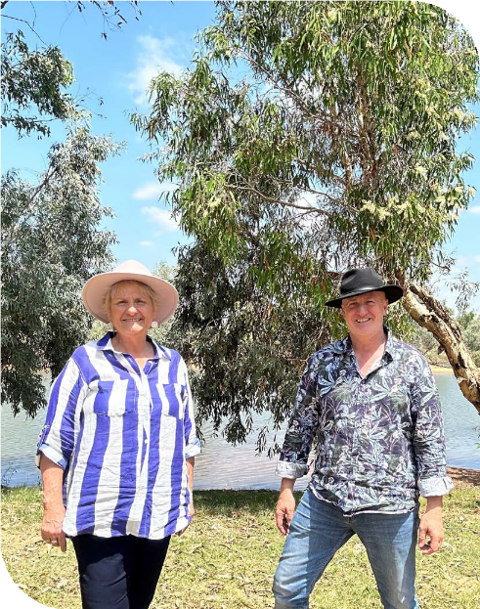
“In my role as a PWDA advocate I continue to push for a ‘tide of change’ in the local community. Everyone is responsible to make communities more accessible, and accountable to people with disability and First Nations Peoples.”
Lee-Anne Pringle

In 2023, Lee-Anne had the opportunity to move into a range of temporary leadership roles in the PWDA individual advocacy team, during this time she demonstrated her natural leadership skills. In early 2024, Lee-Anne was successful in her application to the permanent role of Senior Manager Individual Advocacy Queensland.
Throughout her employment at PWDA, Lee-Anne has achieved many successful outcomes for clients, staff and the organisation including chairing the Health and Safety Committee, supporting the development and implementation of key safety policies and the implementation
of our Safety Management System. This year, Lee-Anne worked on developing an PWDA Individual Advocacy Handbook to bring consistency and uniformity of practice and to build the capacity and confidence of advocates across PWDA.
Beyond her professional achievements, Lee-Anne is proud of her family, including her husband of 34 years David, their three
(3) children and three (3) grandchildren. Lee-Anne has also been able to draw on her skills and knowledge from working with PWDA to advocate for her grandson with disability.

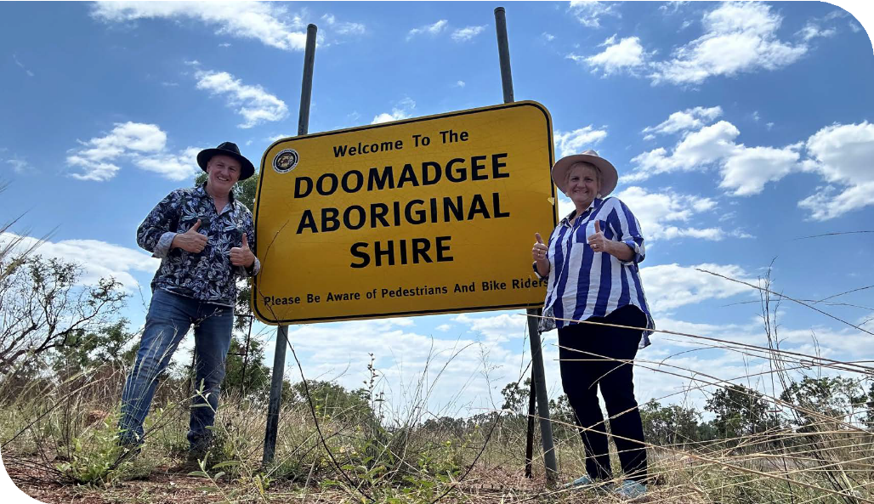

Image | PWDA Senior Manager, Individual Advocacy Queensland Lee-Anne Pringle and Individual Advocate Sean Connelly.

Qantas Carer Concession Card Program
The Qantas Carer Concession Card (QCCC) is issued to people with significant support requirements who through a physical, sensory, intellectual, cognitive,
or psychosocial disability or disabilities are unable to travel on the aircraft without the full-time assistance of a carer.
The QCCC allows cardholders and their carers to book discounted travel on Qantas flights.
PWDA’s Corporate Services team administers the program on behalf of Qantas. This year PWDA produced 566 cards, bringing the total cardholders for the program to 1,400.

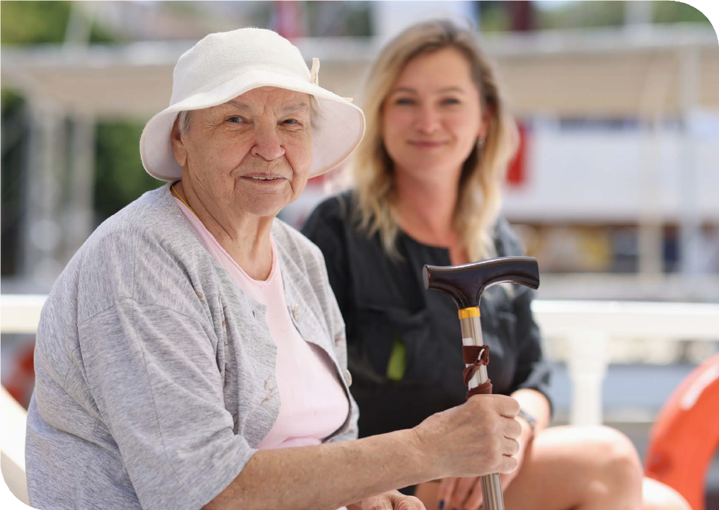

66

NSDS Audit Summary
The National Standards for Disability Services (NSDS) were adopted by the Australian Government in 2014 for advocacy agencies like PWDA. These standards cover six areas:
- Rights
- Participation and Inclusion
- Individual Outcomes
- Feedback and Complaints
- Service Access
- Service Management.
PWDA is regularly audited to ensure compliance with these Standards, and PWDA uses them as a guide and benchmark and to support continuous improvement.
This year, PWDA was audited against Standards 1, 3, 4, and 6 under both the NDAP and NDIS Appeals programs. The audit also reviewed our systemic advocacy work funded by the Australian Government Department of Social Services (DSS).
Auditors engaged with a random selection of PWDA clients, employees, and senior management to assess practices related to client rights, individual outcomes, feedback and complaints, and service management. PWDA successfully passed the audit with no non-conformances.
This outstanding result highlights the dedication and hard work of the PWDA team over the past 12 months in establishing effective processes to ensure best-practice service delivery.

ACFID Audit Summary
PWDA is a proud member of the Australian Council for International Development (ACFID), the peak body for Australian
Non-governmental organisations (NGOs) involved in international development and humanitarian work. As a member, PWDA is committed to upholding high standards of accountability, transparency, and ethical practice, aligning with ACFID's Code of Conduct.
This year’s ACFID audit required PWDA
to submit our annual report and financial statements to maintain accreditation, which we provided. We also completed the annual statistical survey, resulting in the issuance of our certificate of compliance.

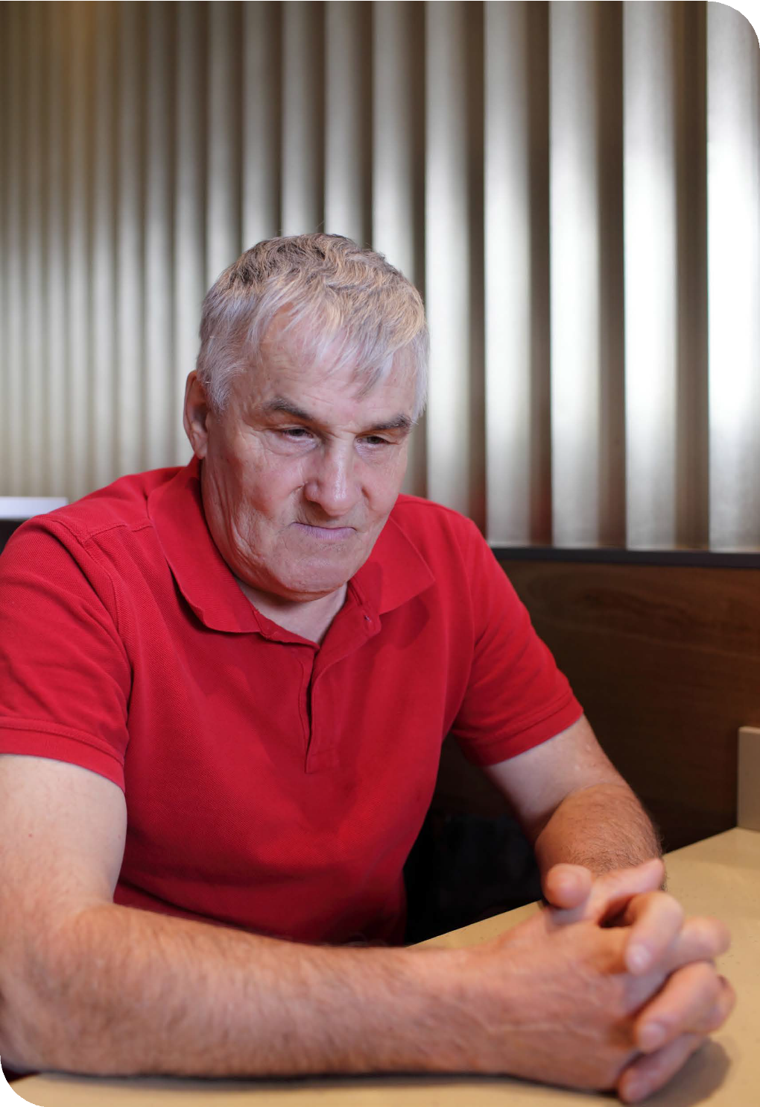

68

Financial Report
30 June 2024
People with Disability Australia Ltd. ABN 98 879 981 198

Contents
Directors’ report 71
Auditors Independence Declaration 73
Statement of profit or loss and
other comprehensive income 74
Statement of financial position 75
Statement of changes in equity 76
Statement of cash flows 77
Notes to the financial statements 78
Directors’ declaration 87
88
Independent Auditor's Report

PWDA recorded a surplus of $158,394 for the 2023-2024 year. The result reflects a responsibly managed budget, with 98.5% of income dedicated to the delivery of PWDA’s work, and 1.5% set aside as a surplus.
The result adds to the organisation’s financial reserves, which are an important buffer to any financial risk that may arise.
PWDA’s income was $10,708,546 for the year. Over 90% of PWDA’s income comes from government grants. These grants fund the programs and projects of PWDA across Australia. During the year we received funding from the Australian Government, as well as the New South Wales and Queensland state governments. We thank all these funding agencies for their ongoing support of our work.
Income grew in the 2023-2024 year. This growth included:
- An expansion of training and project services delivered on a fee for service basis
- Stronger interest earnings due to higher interest rates
- Indexation and supplementation that was provided for recurrent grants to meet higher Award wages and the impact of inflation on organisational costs.
Looking at expenses, our total expenditure for the year was $10,550,152. Our largest area of spending continues to be staffing. Employment costs make up nearly 74%
of the budget. This is consistent with other organisations in this sector.
In the 2023-2024 year a number of staff were added to allow us to undertake the expanded work of PWDA. Staffing costs also increased by the increase in the Award (via the Fair Wage Case) that underpins the salaries we pay our staff.
Travel and meetings costs returned to pre- pandemic levels, with staff able to move more freely to deliver services and come together as a team/organisation.
PWDA’s financial position is sound.
Equity reserves of $1,901,036 underpin the
organisation's financial health.
An unqualified audit opinion was issued by
our auditors ESV.

Directors’ report

The directors present their report on People With Disability Australia Ltd for the financial year ended
30 June 2024.

General information
Directors
The names of the directors in office at any time during, or since the end of, the year are:

Name | Position | Appointed/resigned
Samantha Connor | Vice President | Resigned 15 November 2023
Arun Bharatula | Board Director
Clare Gibellini | Secretary | Resigned 15 November 2023
Eva Sifis | Vice President | Appointed 15 November 2023
Haidi Badawi | Board Director
Kevyn Ross Morris | Vice President | Appointed 15 November 2023
Marayke Jonkers | Interim President
Michelle Hyde | Vice President | Resigned 19 December 2023
Nicole Lee | President | Resigned 11 January 2024
Presley Chihuri | Treasurer
Suresh Rajan | Secretary
Zhila Hasanloo | Board Director | Resigned 11 June 2024
Directors have been in office since the start of the financial year to the date of this report unless
otherwise stated.

Principal activities
The principal activity of People With Disability Australia Ltd during the financial year was to represent, support, educate and advocate for people with disability and undertake necessary activities and programs to achieve the organisation's objective.
No significant changes in the nature of the Company's activity occurred during the financial year.

Long term objectives
The Company's long term objectives are to:
- Empower people with disability as individuals, as specific population groups, and as a sector;
- Advocate for the human rights of people with disability at the individual, specific population group, and
sector levels;
- Effective representation of people with disability as a sector to the government and to the community
generally; as well as focus on sector development; and
- Build our organisational capacity to empower, advocate for, and represent people with disability.

Review of operations
The surplus of the Company amounted to $ 158,394 (2023: $481,700).
With reference to the ACFID Code of Conduct, PWDA confirms that during the year the organisation did not
receive any international aid and development revenue (2023: Nil).

Auditor's independence declaration
The auditor’s independence declaration in accordance with section 307C of the Corporations Act 2001 for the
year ended 30 June 2024 has been received and can be found on page 3 of the financial report.
Signed in accordance with a resolution of the Board of Directors:

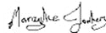
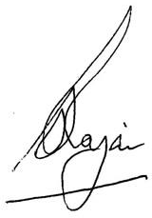

Marayke Jonkers President

Dated: 26 September 2024
Suresh Rajan Treasurer



Auditors Independence Declaration under sub division 60-C Australian
Charities and Not for Profits Commission Act 2012

As auditor of People with Disability Australia Limited for the year ended 30 June 2024, I declare that, to the best of my knowledge and belief, there have been no contraventions of:
- the auditor’s independence requirements as set out in the Australian Charities and Not-for-profits
Commission Act 2012 in relation to the audit; and
- any applicable code of professional conduct in relation to the audit.

Dated at Sydney on the 26th of September 2024.

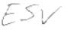

ESV Business Advice and Accounting

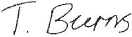

Travas Burns
Partner

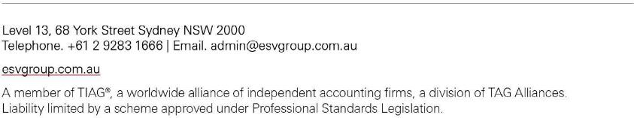

Statement of profit or loss and other comprehensive income
For the year ended 30 June 2024

Profit or loss | Note | 2024 $ | 2023 $
Revenue | 4 | 10,183,013 | 9,343,408
Interest income | 4 | 120,358 | 35,603
Other income | 4 | 405,175 | 343,107
 |  | 10,708,546 | 9,722,118
Expenses
Employee benefits expense |  | (7,777,892) | (6,522,138)
Depreciation and amortisation expense |  | (602,108) | (688,230)
Advertising |  | (87,297) | (90,842)
Meeting expenses |  | (104,288) | (112,370)
Consulting and professional fees |  | (466,324) | (537,579)
Electricity |  | (21,992) | (16,413)
Computer and website costs |  | (188,528) | (150,766)
Motor vehicle expenses |  | (39,205) | (36,649)
Other expenses |  | (442,821) | (379,744)
Repairs and maintenance |  | (39,278) | (40,094)
Program costs |  | (300,666) | (322,453)
Telephone and internet |  | (61,283) | (66,871)
Travel |  | (319,982) | (204,354)
Rental and operating lease expenses |  | (74,009) | (71,915)
Finance costs |  | (24,479) | -
Total expenses |  | (10,550,152) | (9,240,418)
Surplus before income tax |  | 158,394 | 481,700
Income tax expense |  | - | -
Surplus for the year |  | 158,394 | 481,700
Other comprehensive income for the year, net of tax |  | - | -
Total comprehensive income for the year |  | 158,394 | 481,700

Statement of financial position
As at 30 June 2024

Assets

Current assets | Note | 2024 $ | 2023 $
Cash and cash equivalents | 5 | 1,593,053 | 3,246,037
Trade and other receivables | 6 | 136,701 | 29,966
Other financial assets | 7 | 1,470,000 | 1,138,531
Other assets |  | 136,313 | 146,768
Total current assets |  | 3,336,067 | 4,561,302

Non-current assets
Property, plant and equipment | 8 | 985,163 | 132,416
Right-of-use assets | 9 | 977,307 | 428,361
Total non-current assets |  | 1,962,470 | 560,777
Total assets |  | 5,298,537 | 5,122,079
Liabilities

Current liabilities
Trade and other payables | 10 | 613,262 | 657,148
Lease liabilities | 9 | 252,885 | 448,139
Employee benefits | 12 | 571,521 | 490,205
Grants in advance |  | 236,395 | 1,545,130
Total current liabilities |  | 1,674,063 | 3,140,622

Non-current liabilities
Lease liabilities | 9 | 1,613,208 | -
Employee benefits | 12 | 46,971 | 88,815
Longterm provisions | 11 | 63,259 | 150,000
Total non-current liabilities |  | 1,723,438 | 238,815
Total liabilities |  | 7,501 | 3,379,437
Net assets |  | 1,901,036 | 1,742,642
Equity

Retained surpluses | 1,901,036 | 1,742,642
Total equity | 1,901,036 | 1,742,642

Statement of changes in equity
For the year ended 30 June 2024

2024 | Retained  surpluses $ | Total $
Balance at 1 July 2023 | 1,742,642 | 1,742,642
Surplus for the year | 158,394 | 158,394
Other comprehensive income | - | -
Balance at 30 June 2024 | 1,901,036 | 1,901,036

2023 | Retained  surpluses $ | Total $
Balance at 1 July 2022 | 1,260,942 | 1,260,942
Surplus for the year | 481,700 | 481,700
Other comprehensive income | - | -
Balance at 30 June 2023 | 1,742,642 | 1,742,642

Statement of cash flows
For the year ended 30 June 2024

Cash flows from operating activities | Note | 2024 $ | 2023 $
Receipts from grants and customers |  | 10,085,217 | 11,803,702
Payments to suppliers and employees | (10,904,502) |  | (9,657,463)
Interest received |  | 120,358 | 35,603
Interest received |  | (36,741) | -
Net cash provided by/(used in) operating activities |  | (735,668) | 2,181,842

Cash flows from investing activities
(Acquisition)/proceeds of plant and equipment | (162,448) | 2,055
(Acquisition)/proceeds of term deposits | (331,469) | 260,000
Net cash provided by/(used in) investing activities | (493,917) | 262,055

Cash flows from financing activities
Repayment of lease liabilities | (423,399) | (557,390)
Net cash (used in) financing activities | (423,399) | (557,390)

Net increase/(decrease) in cash and cash equivalents held |  | (1,652,984) | 1,886,507
Cash and cash equivalents at beginning of year |  | 3,246,037 | 1,359,530
Cash and cash equivalents at end of financial year | 5 | 1,593,053 | 3,246,037

Notes to the financial statements for the year ended 30 June 2024

The financial report covers People With Disability Australia Ltd as an individual entity. People With Disability Australia Ltd is a not-for-profit Company limited by guarantee, registered and domiciled in Australia.
The functional and presentation currency of People With Disability Australia Ltd is Australian dollars. Comparatives are consistent with prior years, unless otherwise stated.

- Basis of Preparation
The financial statements are general purpose financial statements that have been prepared in accordance with the Australian Accounting Standards - Simplified Disclosures and the Australian Charities and Not-for-profits Commission Act 2012.
The financial statements have been prepared on an accruals basis and are based on historical costs modified, where applicable, by the measurement at fair value of selected non-current assets, financial assets and financial liabilities.
Material accounting policies adopted in the preparation of these financial statements are presented below and
are consistent with prior reporting periods unless otherwise stated.

Historical cost convention
The financial statements have been prepared under the historical cost convention.

Critical accounting estimates
The preparation of the financial statements requires the use of certain critical accounting estimates. It also requires management to exercise its judgement in the process of applying the company's accounting policies. The areas involving a higher degree of judgement or complexity, or areas where assumptions and estimates are significant to the financial statements, are disclosed in note 3.

- Summary of Material Accounting Policy Information
  - New or amended Accounting Standards and Interpretations adopted
The entity has adopted all of the new or amended Accounting Standards and Interpretations issued by the Australian Accounting Standards Board ("AASB") that are mandatory for the current reporting period.
Any new or amended Accounting Standards or Interpretations that are not yet mandatory have not been early adopted.

  - Revenue and other income
Revenue from contracts with customers
The company recognises revenue as follows:
Revenue from contracts with customers
Revenue is recognised at an amount that reflects the consideration to which the company is expected to be entitled in exchange for transferring goods or services to a customer. For each contract with a customer, the company: identifies the contract with a customer; identifies the performance obligations in the contract; determines the transaction price which takes into account estimates of variable consideration and the time value of money; allocates the transaction price to the separate performance obligations on the basis of the relative stand-alone selling price of each distinct good or service to be delivered; and recognises revenue when or as each performance obligation is satisfied in a manner that depicts the transfer to the customer of the goods or services promised.
Variable consideration within the transaction price, if any, reflects concessions provided to the customer such as discounts, rebates and refunds, any potential bonuses receivable from the customer and any other contingent events. Such estimates are determined using either the 'expected value' or 'most
likely amount' method. The measurement of variable consideration is subject to a constraining principle whereby revenue will only be recognised to the extent that it is highly probable that a significant reversal in the amount of cumulative revenue recognised will not occur. The measurement constraint continues until the uncertainty associated with the variable consideration is subsequently resolved.
Amounts received that are subject to the constraining principle are recognised as a refund liability.
Grants
Grant revenue is recognised in profit or loss when the company satisfies the performance obligations
stated within the funding agreements.
If conditions are attached to the grant which must be satisfied before the company is eligible to retain the contribution, the grant will be recognised in the statement of financial position as a liability until those conditions are satisfied.
Interest
Interest revenue is recognised as it accrues using the effective interest method.
Donations
Donations collected, including cash and goods for resale, are recognised as revenue when the Company gains control of the asset.
Other income
Other revenue is recognised when it is received or when the right to receive payment is established.

  - Goods and services tax (GST)
Revenue, expenses and assets are recognised net of the amount of goods and services tax (GST),
except where the amount of GST incurred is not recoverable from the Australian Taxation Office (ATO).
Receivables and payable are stated inclusive of GST.
Cash flows in the statement of cash flows are included on a gross basis and the GST component of cash flows arising from investing and financing activities which is recoverable from, or payable to, the taxation authority is classified as operating cash flows.

  - Property, plant and equipment
Each class of property, plant and equipment is carried at cost or fair value less, where applicable, any accumulated depreciation and impairment.
Items of property, plant and equipment acquired for significantly less than fair value have been
recorded at the acquisition date fair value.
Plant and equipment
Plant and equipment are measured using the cost model.
Depreciation
Property, plant and equipment, excluding freehold land, is depreciated on a straight-line basis over the asset's useful life to the Company, commencing when the asset is ready for use.
Leased assets and leasehold improvements are amortised over the shorter of either the unexpired period of the lease or their estimated useful life.
The depreciation rates used for each class of depreciable asset are shown below:
Office equipment 20%
Motor vehicles 20%
Leasehold improvements 20%
At the end of each annual reporting period, the depreciation method, useful life and residual value of each asset is reviewed. Any revisions are accounted for prospectively as a change in estimate.

  - Financial instruments
Financial instruments relate to term deposits and are recognised initially on the date that the Company becomes party to the contractual provisions of the instrument.
On initial recognition, all financial instruments are measured at fair value plus transaction costs (except for instruments measured at fair value through profit or loss where transaction costs are expensed as incurred).

  - Cash and cash equivalents
Cash and cash equivalents comprises cash on hand, demand deposits and short-term investments which are readily convertible to known amounts of cash and which are subject to an insignificant risk of change in value.

  - Leases
At inception of a contract, the Company assesses whether a lease exists.
At the lease commencement, the Company recognises a right-of-use asset and associated lease liability for the lease term. The lease term includes extension periods where the Company believes it is reasonably certain that the option will be exercised.The right-of-use asset is measured using the cost model where cost on initial recognition comprises of the lease liability, initial direct costs, prepaid lease payments, estimated cost of removal and restoration less any lease incentives received.
The right-of-use asset is depreciated over the lease term on a straight line basis and assessed for impairment in accordance with the impairment of assets accounting policy.

The lease liability is initially measured at the present value of the remaining lease payments at the commencement of the lease. The discount rate is the rate implicit in the lease, however where this cannot be readily determined then the Company's incremental borrowing rate is used.
Subsequent to initial recognition, the lease liability is measured at amortised cost using the effective interest rate method. The lease liability is remeasured whether there is a lease modification, change in estimate of the lease term or index upon which the lease payments are based (e.g. CPI) or a change in the Company's assessment of lease term.
Where the lease liability is remeasured, the right-of-use asset is adjusted to reflect the remeasurement or is recorded in profit or loss if the carrying amount of the right-of-use asset has been reduced to zero.
Exceptions to lease accounting
The Company has elected to apply the exceptions to lease accounting for both short-term leases (i.e. leases with a term of less than or equal to 12 months) and leases of low-value assets. The Company recognises the payments associated with these leases as an expense on a straight-line basis over the lease term.

  - Employee benefits
Provision is made for the Company's liability for employee benefits, those benefits that are expected to be wholly settled within one year have been measured at the amounts expected to be paid when the liability is settled.
Employee benefits expected to be settled more than one year after the end of the reporting period have been measured at the present value of the estimated future cash outflows to be made for those benefits. In determining the liability, consideration is given to employee wage increases and the probability that the employee may satisfy vesting requirements. Cashflows are discounted using market yields on high quality corporate bond rates incorporating bonds rated AAA or AA by credit agencies, with terms to maturity that match the expected timing of cashflows. Changes in the measurement of the liability are recognised in profit or loss.

  - Provisions
Provisions are recognised when the Company has a legal or constructive obligation, as a result of past events, for which it is probable that an outflow of economic benefits will result and that outflow can be reliably measured.
Provisions are measured at the present value of management's best estimate of the outflow required to settle the obligation at the end of the reporting period. The discount rate used is a pre-tax rate that reflects current market assessments of the time value of money and the risks specific to the liability. The increase in the provision due to the unwinding of the discount is taken to finance costs in the statement of profit or loss and other comprehensive income.

  - Adoption of new and revised accounting standards
The Company has adopted all standards which became effective for the first time at 30 June 2024, the adoption of these standards has not caused any material adjustments to the reported financial position, performance or cash flow of the Company.

- Critical Accounting Estimates and Judgments
The Board of Directors make estimates and judgements during the preparation of these financial statements regarding assumptions about current and future events affecting transactions and balances.
These estimates and judgements are based on the best information available at the time of preparing the financial statements, however as additional information is known then the actual results may differ from the estimates.
The significant estimates and judgements made have been described below.

Employee benefits provision
As noted in the accounting policies, the liability for employee benefits expected to be settled more than 12 months from the reporting date are recognised and measured at the present value of the estimated future cash flows to be made in respect of all employees at the reporting date. In determining the present value of the liability, estimates of attrition rates and pay increases through promotion and inflation have been taken into account.

- Revenue and other income
Revenue from continuing operations

Revenue from contracts with customers (AASB 15) | 2024 $ | 2023 $
Operating grants | 10,183,013 | 9,343,408
Total revenue from operating grants | 10,183,013 | 9,343,408

Other revenue
Training income | 131,355 | 72,061
Donations | 10,205 | 21,263
Travel reimbursement | 24,773 | 25,965
Insurance reimbursement | 12,587 | 59,814
Rental income | 93,351 | 69,717
Interest income | 120,358 | 35,603
Gain on sale of asset | 890 | -
Other income | 132,014 | 94,287
Total other revenue | 525,533 | 378,710
Total revenue | 10,708,546 | 9,722,118
- Cash and cash equivalents

Cash and cash equivalents | 2024 $ | 2023 $
Cash at bank and in hand | 1,593,053 | 3,246,037
Total cash and cash equivalents | 1,593,053 | 3,246,037

- Trade and other receivables

Current | 2024 $ | 2023 $
Trade receivables | 88,720 | 25,306
Deposits | 47,981 | 4,660
Total current trade and other receivables | 136,701 | 29,966
- Other Financial Assets

Current | 2024 $ | 2023 $
Term deposits | 1,470,000 | 1,138,531
Total current trade and other receivables | 1,470,000 | 1,138,531
- Property, plant and equipment

Plant and equipment | 2024 $ | 2023 $
At cost | 304,963 | 265,684
Accumulated depreciation | (267,812) | (257,235)
Total plant and equipment | 37,151 | 8,449

Motor vehicles
At cost | 131,535 | 131,535
Accumulated depreciation | (113,541) | (109,619)
Total motor vehicles | 17,994 | 21,916

Leasehold Improvements
At cost | 960,510 | 570,517
Accumulated depreciation | (30,492) | (468,466)
Total leasehold improvements | 930,018 | 102,051
Total property, plant and equipment | 985,163 | 132,416

a. Movements in Carrying Amounts
Movement in the carrying amounts for each class of property, plant and equipment between the beginning and
the end of the current financial year:

Year ended 30 June 2024 | Plant and Equipment $ | Motor Vehicles  $ | Leasehold Improvements $ | Total $
Balance at the beginning of year | 8,449 | 21,916 | 102,051 | 132,416
Additions* | 39,279 | - | 960,510 | 999,789
Depreciation expense | (10,577) | (3,922) | (132,543) | (147,042)
Balance at the end of the year | 37,151 | 17,994 | 930,018 | 985,163
*During the year, People With Disability Australia Ltd entered into a new lease arrangement in which an incentive was received for leasehold improvements of $895,559. The lease incentive represents a non cash component therefore is not represented in the Statement of Cash Flows.

- Leases
Company as a lessee
The Company has leases over a range of assets including land and buildings and vehicles.
- Terms and conditions of leases
- Buildings
- The Company leases land and buildings for their corporate offices. The lease term is for 5 years.
- Vehicles
- The Company leases a vehicle with lease terms of 3 years, the lease payments are fixed during the
lease term.

Right-of-use assets

Year ended 30 June 2024 | Buildings  Total $
Balance at beginning of year | 428,361
Additions | 1,008,254
Amortisation | (459,308)
Balance at end of year | 977,307

Lease liabilities
The maturity analysis of lease liabilities based on contractual undiscounted cash flows is shown in the
table below:

Lease liabilities | < 1 year $ | 1 - 5 years $ | > 5 years $ | Total undiscounted lease liabilities $
2024 Lease liabilities | 420,300 | 1,844,835 | - | 2,265,135
2023 Lease liabilities | 448,139 | - | - | 448,139

- Trade and Other Payables

Current | 2024 $ | 2023 $
Trade payables | 186,687 | 117,709
GST and PAYG payable | 101,933 | 245,618
Sundry payables and accrued expenses | 324,642 | 293,821
Total trade and other payables | 613,262 | 657,148

Trade and other payables are unsecured, non-interest bearing and are normally settled within 30 days. The carrying value of trade and other payables is considered a reasonable approximation of fair value due to the short-term nature of the balances.

- Provisions

Non-current | 2024 $ | 2023 $
Make good provision | 63,259 | 150,000
Total provisions | 63,259 | 150,000

- Employee Benefits

Current liabilities | 2024 $ | 2023 $
Long service leave | 139,446 | 80,639
Provision for employee benefits | 432,075 | 409,566
Total current employee benefits | 571,521 | 490,205

Non-current liabilities | 2024 $ | 2023 $
Long service leave | 46,971 | 88,815
Total non-current employee benefits | 46,971 | 88,815

- Members' Guarantee
The Company is registered with the Australian Charities and Not-for-profits Commission Act 2012 and is a Company limited by guarantee. If the Company is wound up, the constitution states that each member is required to contribute a maximum of $ 1 each towards meeting any outstanding obligations of the Company.

- Key Management Personnel Disclosures
The remuneration paid to key management personnel of the Company is $1,328,348 (2023: $1,227,631).

- Auditors' Remuneration

Remuneration of the auditor ESV - Business advice and accounting | 2024 $ | 2023 $
Audit services | 19,500 | 18,100
Other services | 1,900 | 1,800
Total auditors' renumeration | 21,400 | 19,900

- Contingencies
In the opinion of the Board of Directors, the Company did not have any contingencies at 30 June 2024 (30 June 2023: None).

- Related Parties
a. The Company's main related parties are as follows:
There were no related party transactions during the financial year.

- Events after the end of the Reporting Period
No matters or circumstances have arisen since the end of the financial year which significantly affected or may significantly affect the operations of the Company, the results of those operations or the state of affairs of the Company in future financial years.

- Statutory Information
The registered office and principal place of business of the company is:
People With Disability Australia Ltd Suite 10.1 Level 10 300 Elizabeth Street Surry Hills NSW 2010

Directors’ declaration

The responsible persons declare that in the responsible persons' opinion:
- there are reasonable grounds to believe that the Company is able to pay all of its debts, as and when they become due and payable; and
- the financial statements and notes satisfy the requirements of the Australian Charities and Not-for-profits
Commission Act 2012.
Signed in accordance with subsection 60.15(2) of the Australian Charities and Not-for-profits Commission
Regulation 2013.

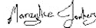

Marayke Jonkers President

Date 26 September 2024
Suresh Rajan Treasurer

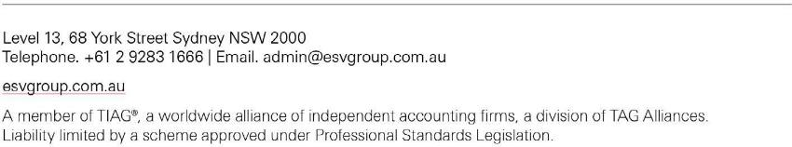
Independent Auditor's Report to the members of People With Disability Australia Ltd
Opinion
We have audited the accompanying financial report, being a general purpose financial report – simplified disclosures of People with Disability Australia Limited (the ‘Company’), which comprises the statement of financial position as at 30 June 2023, the statement of profit or loss and other comprehensive income, the statement of cash flows and the statement of changes in equity for the year ended on that date, notes comprising a summary of significant accounting policies and other explanatory information, and the directors’ declaration.
In our opinion the financial report of People with Disability Australia Limited has been prepared in accordance
with Division 60 of the Australian Charities and Not-for-profits Commission Act 2012, including:
- giving a true and fair view of the entity’s financial position as at 30 June 2024 and of its financial performance and cash flows for the year ended on that date; and
- ii. complying with Australian Accounting Standards – Simplified Disclosures and with Division 60
of the Australian Charities and Not-for-profits Commission Regulation 2013.

Basis of Opinion
We have conducted our audit in accordance with Australian Auditing Standards. Our responsibilities under those standards are further described in the Auditors Responsibilities for the Audit of the Financial Report section of our report. We are independent of the entity in accordance with the auditor independence requirements of the Corporations Act 2001 and the ethical requirements of the Accounting Professional and Ethical Standards Board’s APES 110 Code of Ethics for Professional Accountants (including Independence Standards) (the Code) that are relevant to our audit of the financial report in Australia. We have also fulfilled our other ethical responsibilities in accordance with the Code.
In conducting our audit, we have complied with the independence requirements of the Corporations Act 2001. We confirm that the independence declaration required by the Corporations Act 2001, which has been given to the directors of People with Disability Australia Limited would be in the same terms if given to the directors as at the time of this auditor’s report.
We believe that the audit evidence we have obtained is sufficient and appropriate to provide a basis for our
opinion.

Director’s Responsibility for the Financial report
The directors of the entity are responsible for the preparation of the financial report that gives a true and fair view in accordance with Australian Accounting Standards – Simplified Disclosures and the Australian Charities and Not-for-profits Commission Act 2012 and for such internal control as the directors determine it necessary to enable the preparation of the financial report that gives a true and fair view and is free from material misstatement, whether due to fraud or error.
In preparing the financial report, the directors are responsible for assessing the entity’s ability to continue as a going concern, disclosing, as applicable, matters related to going concern and using the going concern basis of accounting unless the directors either intends to liquidate the registered entity or to cease operations, or has no realistic alternative but to do so. The directors are responsible for overseeing the entity’s financial reporting process.

Auditor’s Responsibilities for the Audit of the Financial Report
Our objectives are to obtain reasonable assurance about whether the financial report as a whole is free from material misstatement, whether due to fraud or error, and to issue an auditor’s report that includes our opinion. Reasonable assurance is a high level of assurance, but is not a guarantee that an audit conducted in accordance Australian Auditing Standards will always detect a material misstatement when it exists. Misstatements can arise from fraud or error and are considered material if, individually or in aggregate, they could reasonably be expected to influence the economic decisions of users taken on the basis of the financial report.
A further description of our responsibilities for the audit of the financial report is located at the Auditing and Assurance Standards Board website at: www.auasb.gov.au/auditors_responsibilities/ar4.pdf. This description forms part of our auditor’s report.
Dated at Sydney on the 27th of September 2024.

ESV Business Advice and Accounting

Travas Burns
Partner



pwd.org.au


 pwd@pwd.org.au  1800 422 015
 PWDAustralia


PWD.Australia

