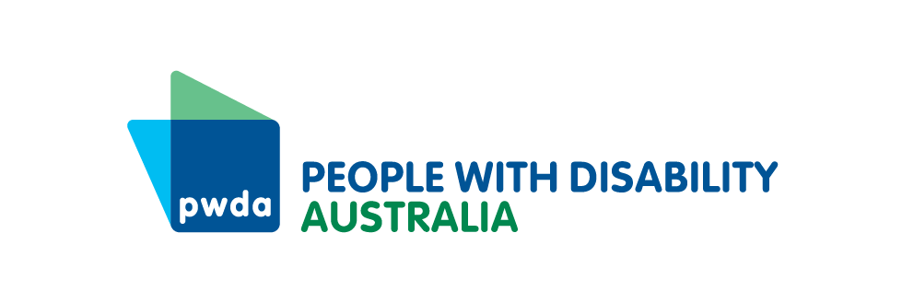

PO Box 666  
Strawberry Hills  
NSW 2012

+61 2 8365 0400  
Toll free 1800 422 015  
[pwd@pwd.org.au](mailto:pwd@pwd.org.au)[www.pwd.org.au](http://www.pwd.org.au/)

23 September 2024

Modern Slavery and Human Trafficking Branch  
Attorney General’s Department

Delivered via online Consultation Hub

To Whom It May Concern

Disability and forced marriage

Thank you for the opportunity to provide input to the Attorney-General’s Department’s [*Enhancing Civil Protections and Remedies for Forced Marriage* *Consultation Paper*](https://consultations.ag.gov.au/integrity/forced-marriage/). People with Disability Australia (PWDA) is Australia’s peak cross-disability Disability Representative Organisation and is funded by the Australian Government to represent the 1 in 6 Australians with disability nationally. Our organisation is made up of, and led by, people with disability. PWDA regularly participates in state, federal and international policy processes concerning modern slavery, with the goal of ensuring modern slavery efforts are disability inclusive.

This submission is endorsed by the following disability representative organisations:

* Women with Disabilities Australia
* National Ethnic Disability Alliance
* Inclusion Australia

In Australia there is a lack of data concerning the prevalence and nature of forced marriage of people with disability. However, the United Kingdom’s (UK) Forced Marriage Unit reported that in 2023, 24% of forced marriage cases involved victim-survivors with ‘mental capacity concerns’.[1] UK literature about this cohort has focused on victim-survivors with intellectual disability. This submission will also focus on intellectual disability, whilst acknowledging that other cohorts may also comprise the 24% of cases that raise mental capacity concerns.

This submission will first explore the nuances of forced marriage of people with intellectual disability and will then respond to Part 2 of the Consultation Paper (awareness raising and education) and Question 8 of Part 3 of the Consultation Paper (gaps in legal protections to prevent and respond to forced marriage).

### Intellectual disability and forced marriage

Forced marriage of people with intellectual disability differs in nature to forced marriage of people without intellectual disability. UK research has shown that:

* People with intellectual disability are often forced to marry to secure permanent care[2]
* Victim-survivors are likely to be male than female and in a higher age range[3]
* Duress may not be present as the person may acquiesce to getting married but not believe they have a choice, or may want to please their family[4]
* Duress may manifest itself differently and the person may appear happy about the marriage[5]
* Most cases are reported to statutory agencies through a third party[6]
* Victim-survivors often need ongoing support to meet their daily living needs[7]
* Males may have trouble accessing crisis accommodation, as many do not meet the needs of males with disability[8]

### Consultation Questions, Part 2: Enhancing education and awareness raising

Given the nuanced nature of forced marriage of people with intellectual disability, education and awareness raising must be targeted and tailored to this cohort. As a preliminary step, we need more data and research about intellectual disability and forced marriage in Australia. Once we understand the problem, we can ensure that education and awareness raising measures are efficient and effective.

Australia would benefit from commissioning a project similar to the University of Nottingham’s [My Marriage, My Choice](https://www.nottingham.ac.uk/research/groups/mymarriagemychoice/index.aspx) project, which explored forced marriage of people with intellectual disability in the UK. The My Marriage, My Choice project commenced with a study using the UK Forced Marriage Unit’s case data and perspectives from people with intellectual disability, family members, practitioners and other stakeholders.[9] The project team produced an array of high-quality educational materials based on the study, including a toolkit, practitioner workbook, case studies and a movie.

In this context, we recommend that:

**Recommendation 1:** The Australian Government co-designs and co-produces a research study to better understand the prevalence, causes and responses to forced marriage of people with disability in Australia.

**Recommendation 2:** The Australian Government commences collecting data about whether people at risk of or in a forced marriage have disability, the type(s) of disability and the supports they receive.

##### Q5. What topics could education or awareness raising activities focus on?

**Recommendation 3:** Education and awareness raising activities should include specific sections and modules on forced marriage of people with intellectual disability. Topics should include:

* Information about the specific nature, risk factors and motivators of forcing people with intellectual disability to marry
* Identifying warning signs of forced marriage in people with intellectual disability or in the behaviour of their families or spouses
* Case studies of forced marriage of people with intellectual disability
* Information about referral mechanisms when forced marriage is detected, including referral to individual advocacy and supported decision-making

##### Q6. Who should be involved in education and raising awareness in communities affected by forced marriage?

People with disability and our representative organisations must be involved in co-designing and delivering education and awareness raising in the disability community. Disability representative organisations can ensure that activities are based on a human rights model of disability and provide information in an accessible manner. This includes ensuring that all campaigns and information provided is accessible (including Easy Read).

**Recommendation 4:** Education and awareness raising about forced marriage of people with disability should be accessibly co-designed and co-delivered by people with disability, with a focus on including people with Intellectual Disability and our representative organisations.

##### Q7. Which groups in the community require education and increased awareness of forced marriage (e.g. frontline workers such as police, child protection and/or specific cohorts within the community)?

People with intellectual disability must receive targeted awareness raising about forced marriage, as many people with intellectual disability are unaware of their rights. This includes delivering education and training to disability self-advocacy groups.

Disability service providers, disability advocacy services and health care providers should also receive training about forced marriage to ensure they can recognise the signs in their clients and make appropriate referrals. Education and increased awareness should also be provided to disability safeguarding and oversight mechanisms (such as Official Community Visitor schemes).

Training should also be delivered to marriage celebrants to recognise the signs of forced marriage in people with intellectual disability, whilst also respecting the informed genuine will and preferences of people with intellectual disability to marry.

Government agencies that assist people with disability, such as Centrelink, child protection services and health services should also receive training.

**Recommendation 5:** Targeted education and awareness raising of forced marriage should be delivered to people with disability, disability advocacy services, disability service providers, disability safeguarding and oversight mechanisms, healthcare providers, marriage celebrants and Government agencies that assist people with disability.

### Consultation Questions, Part 3: Strengthening civil protections and remedies

##### Consultation Questions, Part 3, Question 8 – Do you think there are gaps in the existing legal protections available to respond to and prevent forced marriage in Australia? If so, what are those gaps and do they need a national response?

A key gap in addressing forced marriage of people with intellectual disability is the lack of supported decision-making in marriage laws and policies. Supported decision-making involves providing people with disability with supports to help them make decisions, including the decision to marry. Supported decision-making can take many forms, including support people, peer support, individual advocacy, communication assistance and interpreters.[10] Supported decision-making helps people to exercise their legal capacity and also constitutes a safeguarding mechanism.[11]

Article 12 of the Convention on the Rights of Persons with Disabilities recognises that all people with disability have an equal right to legal capacity and the right to access supported decision-making to exercise their legal capacity.[12] Consequently, the *Royal Commission into Violence, Abuse, Neglect and Exploitation* (Disability Royal Commission) recommended that the Australian Government and state and territory governments should review and reform laws concerning individual decision-making to give effect to the ‘supported decision-making principles’. The Disability Royal Commission’s supported decision-making principles include, amongst other matters, ensuring that people with disability have access to decision-making support.[13]

The Australian Government accepted this recommendation ‘in principle’, stating that:

‘The Australian Government and state and territory governments support taking steps to identify other relevant laws concerning decision-making that may require review regarding approaches to supported decision-making.’

The Australian Government also expressed commitment to:

… ongoing work to ensure people with disability who may require support to make decisions are provided that support.[14]

The current consultation is an excellent opportunity for the Government to act on its commitment to embed supported decision-making in Australian laws and policies. Specifically, reforms should be made to ensure that people with intellectual disability are provided with independent supported decision-making before a marriage is solemnised. This should include access to a decision ‘supporter’, who can help the person reach their own decision about whether to marry.

We recommend that:

**Recommendation 6:** The Government amends the Code of Practice for Marriage Celebrants to require celebrants to ensure that people with intellectual disability have access to independent supported decision-making before deciding whether to marry, and that the decision to marry represents the person’s genuine will and preferences.

It is important that celebrants are provided with appropriate training and education about supported decision-making, as well as information about who to contact if they suspect that a person with disability is being forced to marry. We therefore also recommend that:

**Recommendation 7:** The Government amends the *Guidelines on the Marriage Act 1961 for Authorised Celebrants* to provide celebrants with information about how to ensure that people with disability are provided with supported decision-making to exercise their right to legal capacity. The Guidelines should also set out what steps celebrants should take if they suspect a person with disability is being forced to marry, including referral to individual advocacy services.

Thank you again for the opportunity to provide our input to the consultation. Should you have any queries regarding this letter, please contact my Senior Policy Officer, Ms Lisa Ira, via email at [lisai@pwd.org.au](mailto:lisai@pwd.org.au) or on 0409 431 088.

Yours sincerely

Megan Spindler-Smith

Deputy-CEO

People with Disability Australia

**Endorsed by:**

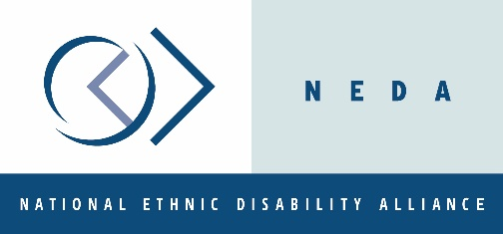

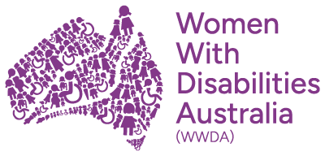



1. United Kingdom Government (2024) [*Forced Marriage Unit Statistics 2023*](https://www.gov.uk/government/statistics/forced-marriage-unit-statistics-2023/forced-marriage-unit-statistics-2023#victims-with-mental-capacity-concerns), accessed 17 September 2024.
2. University of Nottingham (2017) [*My Marriage, My Choice Toolkit*](https://www.nottingham.ac.uk/research/groups/mymarriagemychoice/guidelines-resources/index.aspx), accessed 17 September 2024, 7.
3. Ibid 20.
4. Ibid.
5. Clawson R and Kitson D (2010) [*Forced Marriage of People with Learning Disabilities*](https://www.anncrafttrust.org/wp-content/uploads/2019/03/Forced-Marriage-of-People-With-Learning-Disabilities-Final-Report-on-the-Research-Project.pdf), Ann Craft Trust, 19.
6. Ibid.
7. Ibid.
8. Ibid.
9. University of Nottingham (n 2) 2-3.
10. Royal Commission into Violence, Abuse, Neglect and Exploitation of People with Disability (2023) [*Final Report, Vol 6 - Enabling Autonomy and Access*](https://disability.royalcommission.gov.au/publications/final-report), 118.
11. Ibid.
12. *Convention on the Rights of Persons with Disabilities,* opened for signature 30 March 2007, 2515 UNTS 3 (entered into force 3 May 2008), art 12.
13. Australian Government (2024) [*Australian Government Response to the Disability Royal Commission*](https://www.dss.gov.au/disability-and-carers-australian-government-response-to-the-disability-royal-commission/australian-government-response-to-the-disability-royal-commission-and-supporting-documents), Department of Social Services, Australian Government, 81.
14. Ibid.