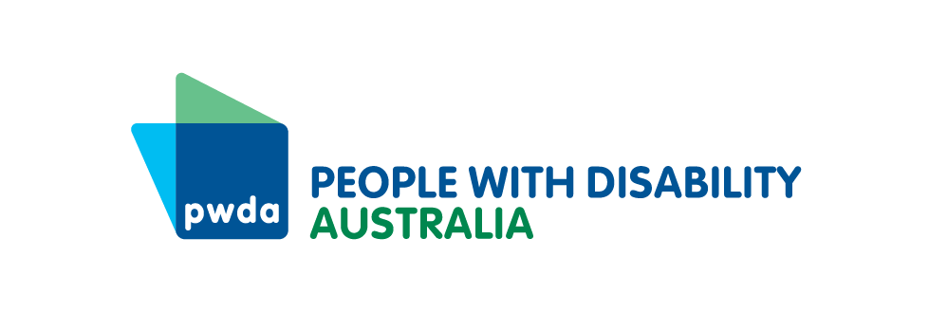

PO Box 666  
Strawberry Hills  
NSW 2012

+61 2 8365 0400  
Toll free 1800 422 015  
[pwd@pwd.org.au](mailto:pwd@pwd.org.au)[www.pwd.org.au](http://www.pwd.org.au/)

4 November 2024

Committee Secretary  
Senate Legal and Constitutional Affairs Committee  
PO Box 6100, Parliament House  
Canberra ACT 2600

Delivered by email to [legcon.sen@aph.gov.au](mailto:legcon.sen@aph.gov.au)

Dear Committee Secretary

# **Inquiry into the Criminal Code Amendment (Hate Crimes) Bill 2024**

Thank you for the opportunity to provide feedback on the *Criminal Code Amendment (Hate Crimes) Bill 2024* (Cth) (the Bill). [People with Disability Australia](https://pwd.org.au/cosp17-day-4-round-up-13-june-2024/) is Australia’s peak national cross-disability Disability Representative Organisation and Disabled People’s Organisation and is funded by the Australian Government to represent the 1 in 6 Australians with disability nationally.

This submission has been endorsed by Children and Young People with Disability Australia.

We commend the Government for introducing a Bill to criminalise threats to use force or violence against targeted groups and for expanding those groups to include disability, sex and LGBTQIA+ status. However, we are disappointed that the Bill does not criminalise serious forms of vilification perpetrated against targeted groups, as originally intended.

Vilification is a real and constant experience for many people with disability. The *Royal Commission into Violence, Abuse, Neglect and Exploitation of People with Disability* (Disability Royal Commission) bore witness to harrowing stories of the frequent, in some cases daily, vilification that people with disability experience. As one witness put it:

I can’t think of a single day that I have left the house without something being said or mocked or laughed at or questioned about my appearance.[1]

Experiences of frequent vilification caused many witnesses to fear for their safety and stopped some from leaving their house.

PWDA recognises the importance of freedom of speech, particularly the right of people to participate in peaceful political protests, however serious vilification must be criminalised to symbolically acknowledge and practically address its gravity.

If the amended Bill requires vilification to take place ‘in public’, the Bill should define public places to include congregated living settings, such as disability group homes and aged care homes. While these sites are residential, they are not ‘private’, given the presence of support workers, staff and other residents.Accordingly, our key recommendation to the Committee is:

**Recommendation 1:** that the Bill is amended to criminalise serious instances of vilification against targeted groups, including people with disability, while respecting the right of people to participate in peaceful political protests. Where there is a requirement that the vilification occurs in ‘public’, the Bill must specify that congregate living settings, including disability group homes and aged care homes, are public places for the purposes of vilification offences.

To support this key recommendation, our submission will first set out the Government’s rationale for criminalising threats of force or violence, and then demonstrate that the same rationale should apply to serious vilification. The submission will then make further recommendations about criminalising online hate speech and ensuring that the terms ‘force’ and ‘violence’ in provisions 80.2BA and 80.2BB of the Bill include disability-specific acts of violence.

1. **The Government’s rationale for criminalising threats of force or violence**

The Bill’s Explanatory Memorandum states that the Bill criminalises threats of force or violence against targeted groups because the harm caused ‘can be profound’, is an ‘attack on dignity’ and affects the ‘physical and psychological wellbeing’ of those targeted and the wider community.[2]

The Attorney-General’s Second Reading Speech recognises that while robust debate is a feature of democracy, there is a threshold where conduct becomes unacceptable and must be addressed. Specifically:

…conduct that urges or threatens the use of force or violence against individuals or groups in a manner which impacts their enjoyment of fundamental human rights and participation in society is not a legitimate expression of opinion.[3]

Serious vilification should also be criminalised as it has similar effects on dignity and mental health and prevents people with disability from enjoying their fundamental human rights, including participation in society.

1. **Serious vilification and harm to dignity and mental health**

Many people with disability face vilification as part of their daily lives. The cumulative impact of constant vilification on mental health can be devastating. Sadly, in some cases experiences of vilification have led to self-harm and suicide.[4]

Witnesses at the Disability Royal Commission’s Public Hearing 28 spoke about the profound mental health impacts of being exposed to frequent vilification and other abuse. One witness stated:

I am not able to recall every time stranger has sworn at me, accused me of faking my condition or being abusive towards me in another way since I have been vision impaired. This is because there have been too many occasions when this has happened over the years. While some of this abuse may not have been that serious or might, by itself, not seem to amount to much, the cumulative effect has been significant. It is unusual for a week to pass without me encountering some form of abuse when I'm simply going about my business.[5]

Another witness stated:

Those experiences [have] left me really frustrated. Left - even like over the time when I think of all those things that happen to me, I find like I'm useless, I'm worthless because they find that - for me, that I'm just a nuisance and I can't do anything. It make me feel really bad that I - every time when I go to my doctor I say, "Please, I will do anything, anything to make me - everything better for me.[6]

Importantly, serious vilification can evoke the same ‘fight or flight’ response as a threat of violence, with associated impacts on mental health. As one witness described:

You tense up. More often than not it happens from a car rushing by you. They yell at you, or it is from a distance from a crowd. You don't necessarily know where it's immediate - you can't identify. You don't know what they are doing. It's always yelled at. It's always yelled and so there is this - I use the word in the sound art "attack." And that's what it feels like. You brace, you immediately - is it coming again? Are they coming at me? Am I going to - have they gone? Do I keep walking? What do I do? Is - and that goes through one's mind very quickly. And so it is - you assess all these things rather quick. But there is a tense in the body, the heart rate will go up to the point where you will feel it in your ears.*[7]*

Another witness recounted that:

… They were clearly quite bored, decided to yell at me, calling me a f****** midget, laughing at me. And then, you know, immediately your adrenaline goes up.*[8]*

Serious vilification can also cause a person to fear or anticipate violence in the same way that a threat of violence does. For example, one witness recalled:

… I was on a tram, and a person who seemed to be quite intoxicated was yelling at me, and she had a bottle - a broken bottle in her hand, and I didn't know what she was going to do. But she kept on talking about my face and, you know, saying how ugly I was. And no one defended me on the tram, and I ended up getting off [the tram] … *[9]*

1. **Serious vilification and interference with fundamental human rights**

Not only does vilification harm mental health, it has a cascading effect on the enjoyment of a host of fundamental human rights set out in the *Convention on the Rights of Persons with Disabilities* (CRPD). For example, if a person is frequently vilified on public transport, they may be too frightened to use public transport to travel to work, school, or university. This infringes on their right to work (Article 27), right to education (Article 24) and in turn, right to an adequate standard of living (Article 28). More generally, people who are too afraid to leave their homes due to vilification cannot enjoy their right to be included in the community (Article 19).

The experience of being afraid to leave the house was a common theme in witness accounts at the Disability Royal Commission’s Public Hearing 28. For example, one witness recounted that:

There are some days when I'm not mentally prepared for the onslaught and just do not have it in me to go to battle with the world. On these days I simply won't leave the house.[10]

Another witness stated:

…I - no longer go out, as I said, roughly after 4 o'clock of a night-time. I don't go to friends' places for coffee even because getting to their place and that, I can be susceptible to these people attacking me. So, if a friend says, "Come around to tea tonight", I don't go and then they go, "Why didn't you turn up? I made plenty." And I can't - I don't really like to tell them, "Because I'm scared of going out."[11]

This experience can be exacerbated for people who face vilification based on intersecting identities. When they leave their home, they could be vilified for example, based on their disability, cultural heritage, their LGBTQIA+ identity, or a combination. As one witness explained:

I believe I experience violence and abuse when I'm out in the community because of my gender identity, Aboriginality, age and disability. Sometimes it may be due to one of these attributes; other times it may be a combination of them.[12]

This has led to some people with disability feeling the need to ‘hide’ from society as one or many of their intersecting and multiply marginalised identities may come under attack when they leave the house. It is important to note that hate speech can also be perpetrated by a member of a person’s own wider community. For example, an LGBTQIA+ person with disability may experience hate speech from other people with disability due to their LGBTQIA+ status.

One witness with disability who identifies as LGBTQIA+ described confining themselves to a predominately ‘online’ life to avoid vilification:

… I miss being able to just walk down the street, feel the sun on me. Like, today is a beautiful day. I miss the ability to just - just - just blend in, and sometimes I think I wish, you know, I wasn't born this way. And maybe if I just stayed presenting as a cis-gendered gay male, maybe people wouldn't have laughed at me or ridiculed me. Perhaps if I didn't have my walking aids, maybe that might have - I might have blended in more. I really can't tell. I just don't know which of the intersectionalities seems to get people so angry at me. Is it because I'm a bigger person and I take up too much of their space? And that they are angry the way I am? So, you know, I have to be content with the fact of being inside my own home is my world, because I know no one's going to come at me or hit me. That is my reality for the last couple of years now.[13]

Clearly serious vilification has similar effects on people with disability as threats to use force and violence – it significantly harms mental health and stops people with disability from enjoying their fundamental human rights and participation in society. Criminalising serious vilification perpetrated against people with disability sends a strong symbolic message that this type of abuse is extremely serious and will not be tolerated and gives people with disability access to justice for the harm caused.

1. **Online hate speech**

The Government must ensure that the Bill applies to online hate speech. Many people with disability rely on the internet to connect to others and socialise.[14] Social media has proved an instrumental tool for disability advocacy and provides access to online support groups.[15] In addition, many people with disability use the internet to access employment, experiences and services.[16] Accordingly, online hate speech causes significant harm to people with disability, including mental distress, relationship problems, reputational damage, work issues and financial loss.[17] It also means that people with disability cannot feel safe, even in their own homes.

To highlight the severity of online abuse of people with disability, we would like to draw the Committee’s attention to the following testimony from a witness at the Disability Royal Commission:

So, someone had posted my photo with me holding a glass of champagne, and it was on a forum called What the F*** forum, and below that there was 5 hundreds of comments about my face. People had said things like, what does your vagina look like? What the fuck is that? It looks like something that was partially digested by my dog. They described me as a lobster. And there was lots - and they diagnosed me as well. They said that I should be killed with fire.*[18]*

We recommend that:

**Recommendation 2:** The Government ensures that the crimes contained in the Bill, and any added serious vilification crime(s), include those perpetrated online.

1. **Defining ‘force’ and ‘violence’**

In addition to criminalising serious vilification, the Bill’s provisions criminalising threats to use force or violence (80.2BA and 80.2BB) could also be improved to better address threats against people with disability.

Threats of force or violence can take nuanced forms in relation to people with disability. For example, an act of force or violence may include taking away a person’s disability support (eg a wheelchair or cane), depriving them of access to food and water or using restrictive practices (such as mechanical, physical or chemical restraint). It is important the of ‘force’ and/or ‘violence’ captures this conduct. Accordingly, we recommend that:

**Recommendation 3:** The Government amends the Bill to specifically define what constitutes ‘force’ and ‘violence’ against people with disability, through co-design with people with disability and our representative organisations.

Thank you for the opportunity to provide our feedback on the Bill. If you would like to discuss this submission further, please contact Lisa Ira, Senior Policy Officer, via email at [lisai@pwd.org.au](mailto:lisai@pwd.org.au) or on +61 409 431 088.

Yours sincerely

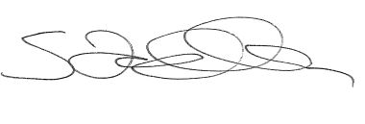

Sebastian Zagarella

Chief Executive Officer

People with Disability Australia

Endorsed by:

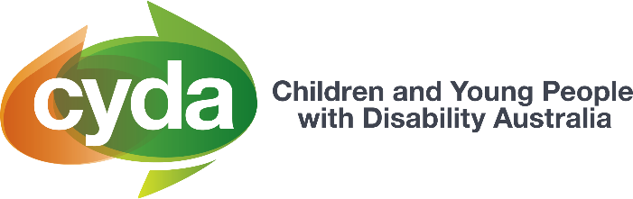

1. Disability Royal Commission (2022) [*Transcript of Proceedings – Public Hearing 28, Day 5*](https://disability.royalcommission.gov.au/system/files/2022-10/Transcript%20Day%205%20-%20Public%20hearing%2028%2C%20Brisbane_0.pdf), accessed 1 November 2024, 231.
2. Explanatory Memorandum, Criminal Code Amendment (Hate Crimes) Bill (Cth).
3. Commonwealth, *Parliamentary Debates*, House of Representatives, 12 September 2024 (Mark Dreyfus, Attorney-General).
4. UK Equality and Human Rights Commission (2009) [*Disabled people’s experiences of targeted violence and hostility*](https://www.equalityhumanrights.com/sites/default/files/research_report_21_disabled_people_s_experiences_of_targeted_violence_and_hostility.pdf%20;%20https:/www.inclusionlondon.org.uk/campaigns-and-policy/crime-and-disabled-people/justice-for-disabled-victims/), accessed 1 November 2024.
5. Disability Royal Commission (2022) [*Transcript of Proceedings – Public Hearing 28, Day 1*](https://disability.royalcommission.gov.au/system/files/2022-10/Transcript%20Day%201%20-%20Public%20hearing%2028%2C%20Brisbane.pdf), accessed 1 November 2024, 57.
6. Ibid 62.
7. Ibid 26.
8. Disability Royal Commission (2022) [*Transcript of Proceedings – Public Hearing 28, Day 2*](https://disability.royalcommission.gov.au/system/files/2022-10/Transcript%20Day%202%20-%20Public%20hearing%2028%2C%20Brisbane.pdf), accessed 1 November 2024, 103.
9. Disability Royal Commission (2022) [*Transcript of Proceedings – Public Hearing 28, Day 5*](https://disability.royalcommission.gov.au/system/files/2022-10/Transcript%20Day%205%20-%20Public%20hearing%2028%2C%20Brisbane_0.pdf), accessed 1 November 2024, 321.
10. Disability Royal Commission (2022) [*Transcript of Proceedings – Public Hearing 28, Day 1*](https://disability.royalcommission.gov.au/system/files/2022-10/Transcript%20Day%201%20-%20Public%20hearing%2028%2C%20Brisbane.pdf), accessed 1 November 2024, 8.
11. Disability Royal Commission (2022) [*Transcript of Proceedings – Public Hearing 28, Day 3*](https://disability.royalcommission.gov.au/public-hearings/transcript-day-3-public-hearing-28-brisbane), accessed 1 November 2024, 190.
12. Disability Royal Commission (2022) [*Transcript of Proceedings – Public Hearing 28, Day 1*](https://disability.royalcommission.gov.au/system/files/2022-10/Transcript%20Day%201%20-%20Public%20hearing%2028%2C%20Brisbane.pdf), accessed 1 November 2024, 7.
13. Disability Royal Commission (2022) [*Transcript of Proceedings – Public Hearing 28, Day 3*](https://disability.royalcommission.gov.au/public-hearings/transcript-day-3-public-hearing-28-brisbane), accessed 1 November 2024, 196.
14. United Kingdom House of Commons Petitions Committee (2019) [*Online abuse and the experience of disabled people*](https://publications.parliament.uk/pa/cm201719/cmselect/cmpetitions/759/759.pdf), accessed 1 November 2024.
15. Ibid.
16. Ibid.
17. Australian eSafety Commissioner (2024) [*Online hate speech – findings from Australia, New Zealand and Europe*](https://www.esafety.gov.au/research/online-hate-speech), accessed 1 November 2024,14. 
18. Disability Royal Commission (2022) [*Transcript of Proceedings – Public Hearing 28, Day 5*](https://disability.royalcommission.gov.au/system/files/2022-10/Transcript%20Day%205%20-%20Public%20hearing%2028%2C%20Brisbane_0.pdf), accessed 1 November 2024, 323.