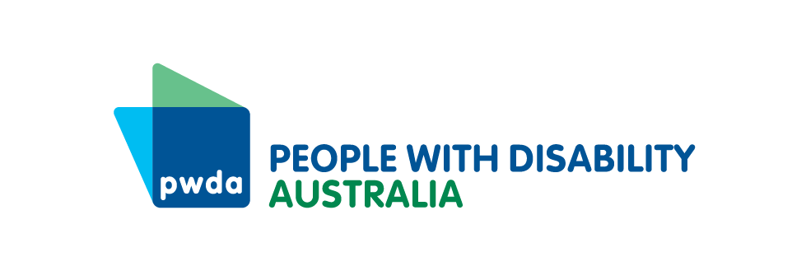

PO Box 666  
Strawberry Hills  
NSW 2012

+61 2 8365 0400  
Toll free 1800 422 015  
[pwd@pwd.org.au](mailto:pwd@pwd.org.au)[www.pwd.org.au](http://www.pwd.org.au/)

20 January, 2025

Ms Pauline Sullivan

Interim Aviation Industry Ombudsperson

Delivered by email to aviationcustomerrights@infrastructure.gov.au

Dear Pauline

## Aviation Customer Rights Charter

Thank you for the opportunity draft [Aviation Customer Rights Charter](https://www.infrastructure.gov.au/have-your-say/aviation-customer-rights-charter). People with Disability Australia (PWDA) is the national peak body representing the 1 in 5 Australians with a disability. Our work is underpinned by the rights and obligations contained within the [Convention on the Rights of Persons with Disability](https://social.desa.un.org/issues/disability/crpd/convention-on-the-rights-of-persons-with-disabilities-crpd).

On the 17th of October 2024, PWDA made a submission outlining recommendations for the Aviation Ombuds Scheme, which have not been repeated here. We will also work separately on the co-design of aviation-specific disability standards. However there are matters within, and omitted by, this draft charter that urgently need rectification.

Examining the [consultation paper](https://www.infrastructure.gov.au/sites/default/files/documents/aviation-customer-rights-charter-consultation-paper.docx), and reflecting on experiences within the past few weeks, we agree that overall the application of the draft charter would significantly improve travel for Australian Customers. However, the following issues arise under:

* **Proposed Right 1: Aviation industry customers have the right to be treated with dignity and respect, in an accessible and inclusive environment**

Airport and airline staff may be aware of how best to assist people with accessibility requirements, medical issues, implants or prostheses- but there is no requirement for them to act under the charter. Standards need to be set and enforced.

* **Proposed Right 2: Aviation industry customers have the right to accurate, timely and accessible information and customer service**

The information provided to customers about delays, cancellations and disruptions is often not provided, is provided late, or there are differences between what is announced, what appears on airline apps, in emails to customers etc. This needs to be prompt, accurate, consistent, stranded passengers should be informed in person especially where they have disabilities, health or additional needs. This information must be provided in accessible formats.

* **Proposed Right 3: Aviation industry customers have the right to prompt and fair remedies and support during and after cancellations, delays and disruptions**

Where fights are delayed, airline or airport staff must update passengers promptly, in accessible formats and must provide assistance as required to passengers to require special assistance to travel. PWDA recognises that airlines should not be ‘punished’ for things beyond their control but this requirement to provide information should not be limited. We also call for the provision of assistance to passengers with disability whose journeys are interrupted such that they are unable to return home overnight whist waiting for a replacement flight.

Where flights are to be delayed or disrupted for more than three hours the current meal voucher amount is inadequate to purchase food in airport, and for passengers needing to purchase nappies, period products or medicines during long wait times that exceed their supplies on hand, this is woefully inadequate. People may need access to specialist nutrition products or stoma supplies that are simply unavailable in airport, and long delays may mean they run out. Better plans are needed for these customers. Airline and airport plans need to reflect the fact that these days many people must take flights to access essential medical care, and the impact of delays on these customers is often not considered.

In the case of disrupted and rescheduled flights, passengers must be accurately informed of what is happening with their luggage. Currently the accuracy of information provided on where luggage is via apps, emails, and airport staff is poor, and often contradictory. This must be amended.

People with disability who need to use connecting flights, people whose flight has been rescheduled, people whose assistive equipment is checked in to the hold of the plane, all depend on their luggage arriving at their destination with them, but may be unable to manage re-checking it alone. In many airports there is no ability to access assistance to re-check luggage and assistive equipment onto an alternative flight for passengers who must remain waiting in the airport, and this must be rectified.

* **Proposed Right 4: Aviation industry customers have the right to safe and timely baggage handling and fair remedies for damage and delays**

No mention is made of the management of pets checked into the baggage area as luggage. Their safety and wellbeing during transit and in cases of delays and rescheduled flights requires particular consideration.

* **Proposed Right 5: Aviation industry customers have the right to the protection of their personal information**

When the bodies of passengers are scanned during the security process, security staff often demand personal information in a very public area about passengers, such as about implanted medical devices, ostomy, prosthetics and health conditions. This process can be intrusive, humiliating and traumatising, and should be reformed to protect privacy.

PWDA recognizes that the implementation of this Aviation Customer Rights Charter will improve the experience of travelling by air for many. Including these amendments offers the opportunity to maximize its positive impact.

Yours sincerely

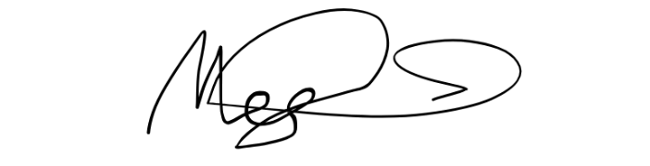

Megan Spindler-Smith

Deputy CEO

People with Disability Australia