Qantas Carer Concession Card Program Updates
This document tells you about the Qantas Carer Concession Card and what is changing to the program.
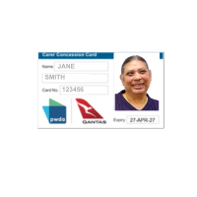 | The Qantas Carer Concession Card is for people with disability who need a carer to travel with them on a plane.  We will call it the QCCC.
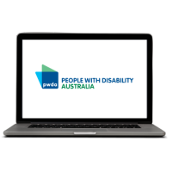 | You can find more details on the PWDA website at https://pwd.org.au/services/qantas-carer-concession-card
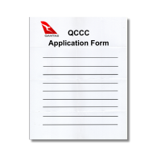 | The website has forms and information about the Qantas Carer Concession Card.
 | You can ask for support to read this document. This might be a  ⦁ Friend  ⦁ Family member  ⦁ Support person.

What is the Qantas Carer Concession Card
 | Qantas runs the QCCC program.
If you have a QCCC card you can get a discount on some tickets.

A discount means some tickets are cheaper.

 | Your carer can also get a cheaper ticket when they book with you.
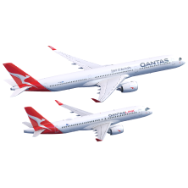 | This discount is for Qantas and QantasLink flights.

What is changing to the QCCC
 | From 28 January 2025 there will be new QCCC discounts.
 | The new QCCC discount is 30% off the base fare for domestic flights.  A domestic flight means the flight is only in Australia.
 | This means if you fly in Australia you pay less than other people.  The discount does not apply to carrier charges, fees and taxes.
 | You can use the QCCC discount for domestic Economy Red eDeal and Flex tickets.
 | You can use it for domestic Premium Economy Saver and Flex tickets.
 | You can also use it for domestic Business class tickets.
 | The new QCCC discount is 10% off the base fare for international flights excluding first class.  An international flight is when you travel from Australia to another country.
 | This means if you fly to other countries you pay less than other people.  The discount does not apply to carrier charges, fees and taxes.
 | You can use the QCCC discount for international tickets that are  - Economy Sale  - Economy Saver  - Flex.
 | You can use it for international tickets that are  - Premium Economy sale  - Premium Economy Saver  - Flex.
 | You can also use it for international tickets that are  - Business Sale  - Business Saver  - Flex.
 | You cannot use it for international First class tickets.

How is this different to the current QCCC program
 | The current program does not give a discount on domestic sale tickets.
 | The current program does not have any discounts on international flights.
 | The current program gives the QCCC cardholder a 10% discount on the base fare on selected domestic flights in economy class.
 | The current program gives the QCCC cardholder and carer a 50% discount but only on selected domestic flights in business class.

Answers to common questions about the QCCC changes
The new QCCC discount is for everyone with a Qantas Carer Concession Card.

This means both new and current card holders can use it.
 | The new QCCC discount will not change old bookings.  If you booked or changed your ticket on or before 27 January 2025 nothing will change.
 | If you booked or changed your ticket on or before 28 January 2025 you cannot get a refund for the new discount.  Refund means you get your money back.
 | The new discount only works for bookings made on or after 28 January 2025.
Current QCCC cardholders can book with the current discount until 27 January 2025.

After this date they cannot use the old discount.
 | If you have a QCCC and you do not need it anymore because of the changes you can ask for a refund.
 | The refund is for the $49.50 you paid to get a QCCC.
 | You can not get the discount if you book online.
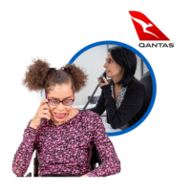 | You must still call the Qantas Specific Needs Assistance Line to book.
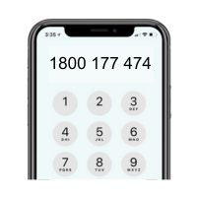 | You can call them on 1800 177 474.
 | Qantas wants to have more support for people to travel on planes.
 | When you book flights you will need to book them for you and your carer at the same time.
 | You and your carer must have seats next to each other on the flight.
 | When you book you must tell Qantas your QCCC number.
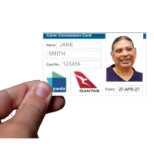 | You must carry your QCCC with you on the plane.
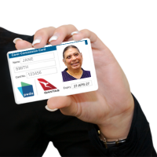 | You need to show your QCCC if someone asks to see it.
 | Qantas Frequent Flyer Points cannot be used to pay for a QCCC booking.
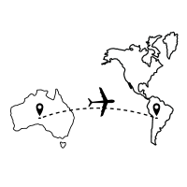 | You can get a QCCC discount on a  - 1 way international flight  - Return international flight.  You can only get a discount on these flights if they leave from Australia.

Contact Us
 | You can ask People with Disability Australia about the QCCC changes.
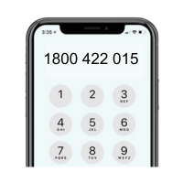 | Call us on 1800 422 015.
 | Email us on  qccc@pwd.org.au.
 | We are here to support you.
 | PWDA created this Easy Read using images from photosymbols.  License number 289869496357

