# 

# Roadmap to Improving Outcomes for People with Disability in Disaster Management

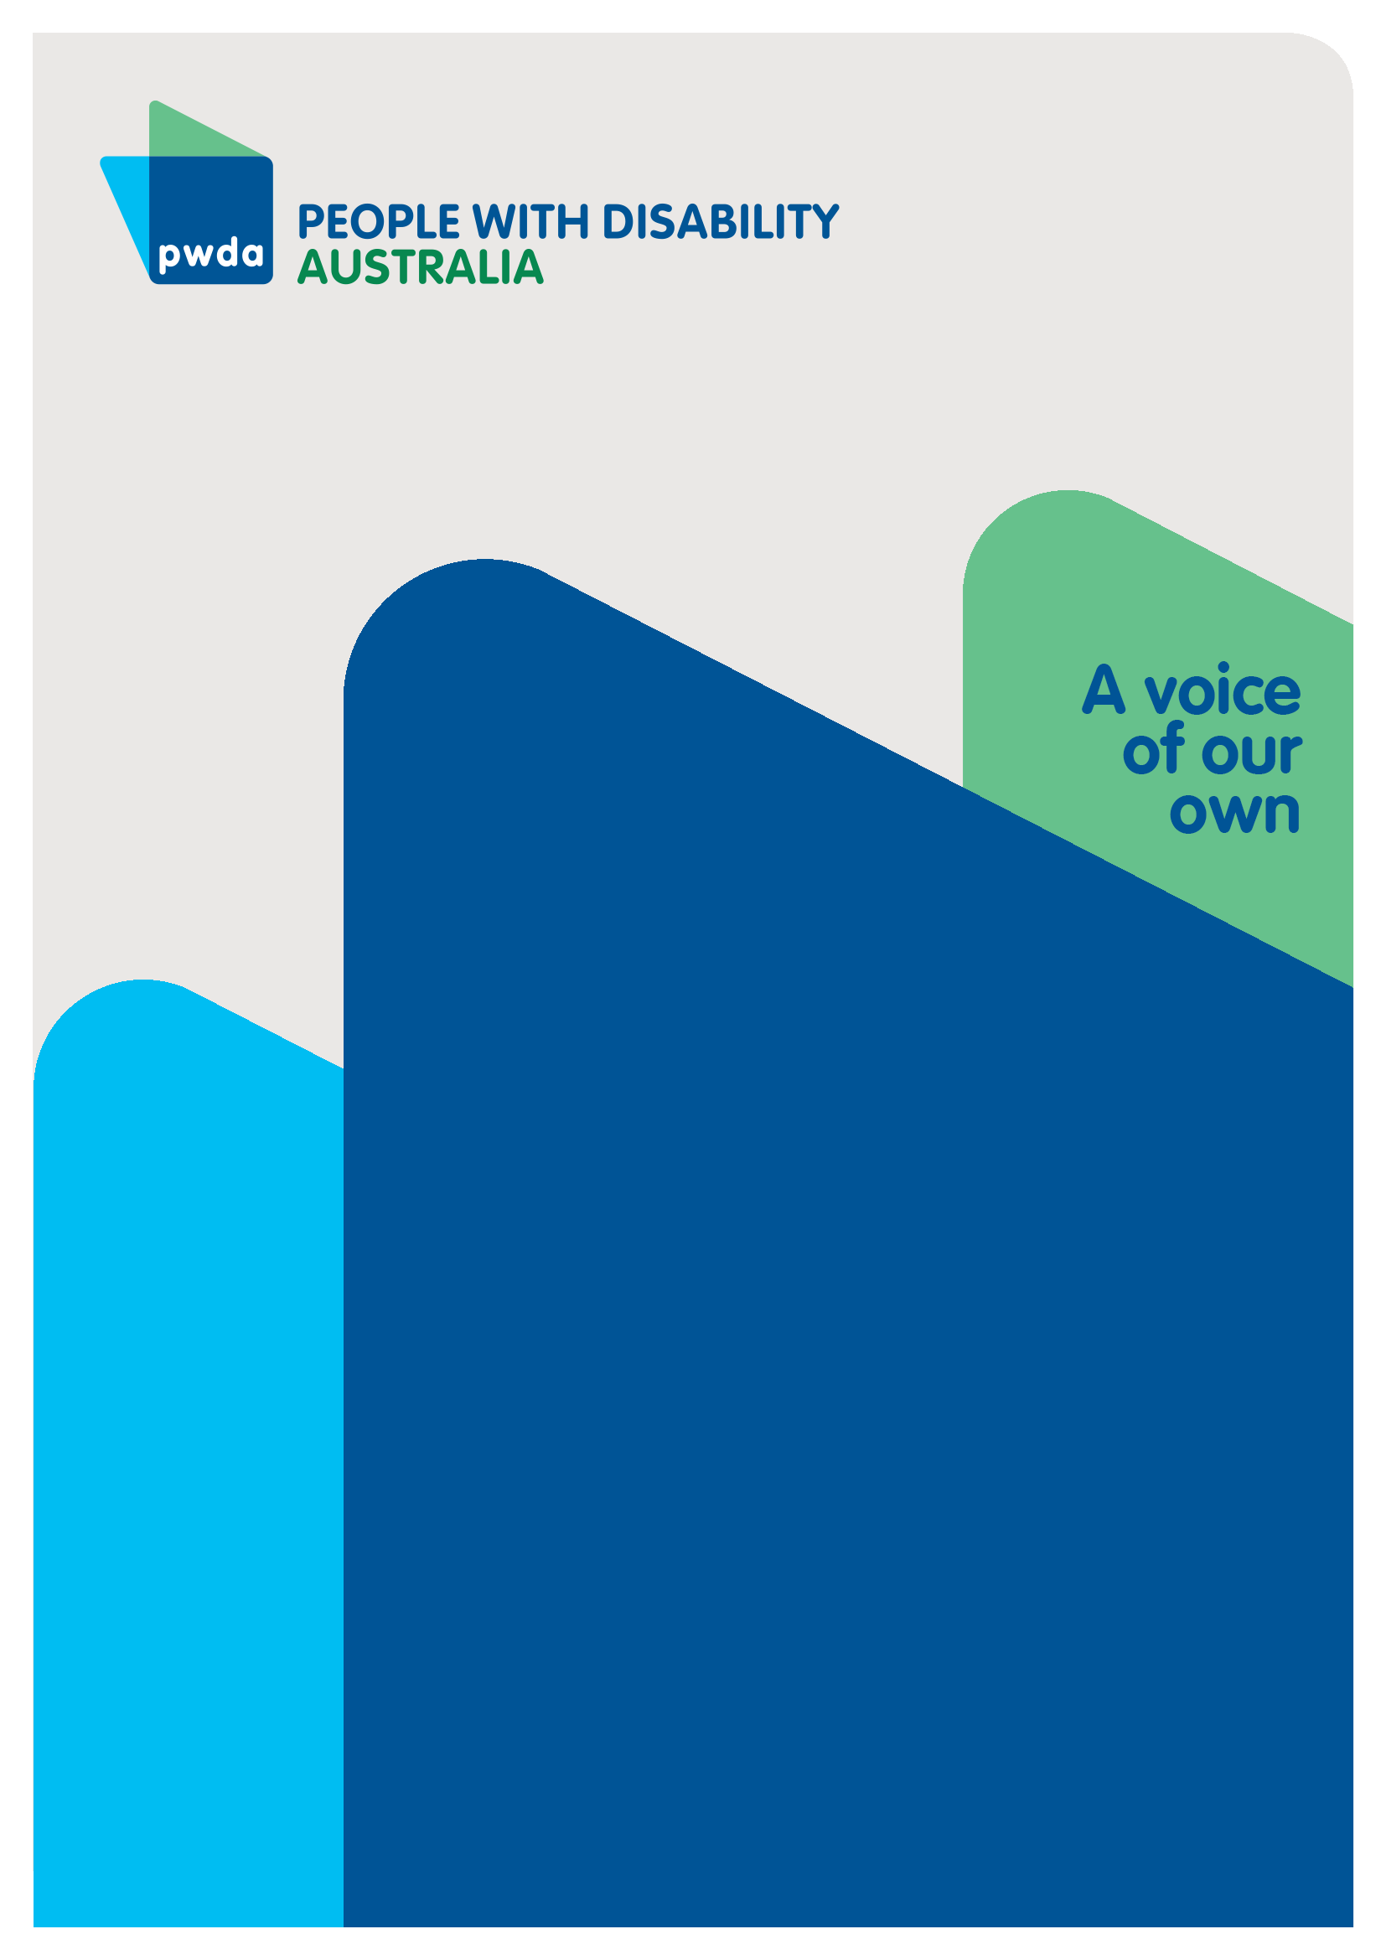

OctoBER 2024

# Copyright Information

Roadmap to Improving Outcomes for People with Disability in Disaster Management

First published in 2023 by People with Disability Australia Ltd.  
Suite 10.01, Centennial Plaza, Level 10, 300 Elizabeth Street, Surry Hills, New South Wales, Australia 2010  
Head office also in Sydney  
Email:[pwd@pwd.org.au](mailto:pwd@pwd.org.au)  
Phone: +61 2 9370 3100 Fax: +61 2 9318 1372  
URL: [www.pwd.org.au](http://www.pwd.org.au)

Typeset in Arial 12 and 14 pt and VAG Rounded 26 pt

© People with Disability Australia Ltd. 2024

The moral rights of the authors have been asserted

National Library of Australia Cataloguing-in-Publication data:

|  |  |
| --- | --- |
| Creator(s): | Wallace, Bastien; |
| Title: | Roadmap to Improving Outcomes for People with Disability in Disaster Management |

All rights reserved. Except as permitted with the *Australian Copyright Act 1968* (for example, a fair dealing for the purposes of study, research, criticism or review), no part of this book may be reproduced, stored in a retrieval system, communication or transmitted in any form or by any means without prior written permission. All inquiries should be made to the publisher at the address above.

Suggested citation: EXAMPLE BELOW:

Wallace, B., Roadmap to Improving Outcomes for People with Disability in Disaster Management, 30 October 2024, People with Disability Australia, Sydney.

Contents

1

Roadmap to Improving Outcomes for People with Disability in Disaster Management 1

Copyright Information 1

About PWDA 4

Introduction 6

Executive Summary 7

Summary of Recommendations 9

Consultation 13

International Disaster and Emergency Management Planning 16

Federal Disaster Management Framework 19

Australian Disaster preparedness Framework 21

Australian Emergency Management Arrangements Handbook 25

Emergency Management 25

National System Reviews 27

Emergency management in NSW 29

Who is involved and what is their responsibility? 29

Individual responses 41

Emergency planning 41

Emergency planning for people with disability 42

Are plans effective? 45

Communication 46

Evacuation 50

Safe place to shelter 52

Transport 54

Discussion 57

References 62

# About PWDA

People with Disability Australia (PWDA) is a national disability rights and advocacy organisation made up of, and led by, people with disability.

We have a vision of a socially just, accessible, and inclusive community in which the contribution, potential, and diversity of people with disability are not only recognised and respected but also celebrated.

PWDA was established in 1981, during the International Year of Disabled Persons.

We are a peak, non-profit, non-government organisation that represents the interests of people with all kinds of disability. Nationally 4.4 million Australians have a disability, around 17.7% of the population[1].

We also represent people with disability at the United Nations, particularly in relation to the United Nations Convention on the Rights of Persons with Disabilities (CRPD).

Our work is grounded in a human rights framework that recognises the CRPD and related mechanisms as fundamental tools for advancing the rights of people with disability.

PWDA is a member of Disabled People’s Organisations Australia (DPO Australia), along with the First People’s Disability Network, National Ethnic Disability Alliance, and Women with Disabilities Australia.

DPOs collectively form a disability rights movement that places people with disability at the centre of decision-making in all aspects of our lives.

The work of PWDA embraces the ‘Nothing About Us, Without Us’ motto of the international disability community and Disabled Peoples’ International, the international organisation representing national organisations of people with disability in over 130 countries.

When compared with people without disability, people with disability continue to experience discrimination and poorer life outcomes across all life domains[2]. It is estimated that 22% of people aged over 15 with disability in Australia have experienced some form of discrimination compared with 15% of those without disability[3]. Disability discrimination is the largest ground of complaint to Anti-Discrimination NSW (ADNSW)[4] and the Australian Human Rights Commission (AHRC)[5]. Discrimination against people with disability appears deeply entrenched across systems.

Governments have an obligation to respect, protect and fulfil human rights[6]. Disability Rights are Human Rights.

PWDA is funded by DJC’s *Disability Advocacy Futures Program* to provide individual advocacy. PWDA represents, and advocates for, the rights and views of our members.

## Introduction

PWDA attended the NSW State Emergency Management Committee (SEMC) Roundtable (the Roundtable) hosted by the NSW Department of Communities and Justice (DCJ), PWDA is a member of the NEMA Disability Inclusive Emergency Management (DIEM) Expert Advisory Panel (EAP) and will attend the National Emergency Management Agency’s Charitable, Not-for-Profit and Philanthropic Roundtable.

The purpose of this document is to contribute to discussions to improve the accessibility and inclusivity of emergency management planning, so that people with disability can be actively engaged in disaster management policy and decision making.

In its [Emergency Planning and Response Issues Paper](https://disability.royalcommission.gov.au/publications/emergency-planning-and-response),[7] and its [Statement of Concern[8]](https://disability.royalcommission.gov.au/publications/statement-concern-response-covid-19-pandemic-people-disability) the Disability Royal Commission expressed its concern over the impact of the COVID-19 pandemic, bushfires, floods and droughts on people with disability. PWDA has previously undertaken research, prepared responses and called for change to disaster and [emergency management](https://pwd.org.au/disability-sector-calls-for-pre-election-commitments-to-improve-disability-emergency-and-disaster-support/) and [COVID-19 measures](https://pwd.org.au/?s=Covid-19) to be more inclusive of people with disability to reduce their risk before, during and after a disaster.

As part of developing this report we have conducted surveys with members. These continue to reflect issues with disaster and emergency management that urgently need addressing. In order to discover what needs to change, we must:

* identify the plans for disasters and emergencies
* examine what currently occurs
* identify where the ‘gaps’ in planning and execution are that have occurred, and
* establish what could be changed, and how, in order to provide recommendations.

Based on the issues identified by members and through our research, PWDA has identified a range of issues, gaps, and has made recommended changes.

# Executive Summary

People with Disability Australia has developed comprehensive agenda for improving the inclusion of people with disability in emergency and disaster management planning and response at the federal, state, and local levels. The recommendations are designed to ensure that emergency management systems are accessible, inclusive, and responsive to the needs of people with disability, in line with the Sendai Framework for Disaster Risk Reduction.

People with disability and their DROs need to be included in the development disaster and emergency management policy and plans, using a co-design process to identify existing gaps and solutions (Recommendations 2, 3, 4).

Emergency management systems must prioritize accessibility. This includes ensuring that all services provide accessible information in clear, inclusive formats (Recommendations 5, 9, 10). PWDA further recommends that DROs be resourced to support emergency communication roles, providing a point of contact to ensure the accuracy of information and accessibility for diverse stakeholders (Recommendation 7).

PWDA advocates for the mandatory inclusion of disability awareness training for emergency management stakeholders, including completion of a free eLearning course and the Person-Centered Emergency Preparedness (P-CEP) Certificate Course (Recommendations 17, 18). This will help to integrate the needs of people with disability into the emergency planning and response process.

Plans must be developed to ensure that early evacuation procedures and emergency shelter facilities meet the needs of people with disability. PWDA recommends resource allocation to support the development of these plans, shelter upgrades, and early warning protocols (Recommendations 11, 12, 13).

Accessible transport mapping and plans for emergency transportation are necessary to ensure people with disability can evacuate safely (Recommendation 15). Additionally, healthcare providers should be consulted to ensure sufficient supplies and services are available during emergencies (Recommendation 14).

PWDA recommends that disability representation be embedded within national and state emergency management bodies, such as the National Emergency Management Agency (NEMA) and State Emergency Management Committees (SEMCs). Regular consultation with DROs and the inclusion of their knowledge is vital to improving the effectiveness of emergency management systems (Recommendations 16, 18). We also recommend resourcing programs that involve people with disability at the local level in planning, and education about local risks and hazards (Recommendation 19).

Adequate resourcing must be allocated to ensure that emergency management systems are inclusive. This includes flexible funding for DROs to respond effectively during emergencies and ensuring ongoing investment in programs that support the inclusion of people with disability in disaster resilience activities (Recommendations 8, 20).

In conclusion, PWDA's recommendations emphasize the need for a more inclusive, accessible, and responsive emergency management system that addresses the specific needs of people with disability. By integrating people with disability into all stages of emergency management—from planning and communication to training and response—Australia can create a disaster resilience framework that leaves no one behind.

# Summary of Recommendations

**Recommendation 1**

PWDA recommends greater involvement of people with disability in the development of Federal disaster and emergency management plans and policy, in line with the Sendai Framework recommendations

**Recommendation 2**

PWDA recommends each State work with people with disability and their DROs to develop a comprehensive evaluation of the issues and gaps for each service, and an appropriate response.

**Recommendation 3**

PWDA recommends a co-design process be used that is accessible, includes people with disability and their DROs, gathers lived experiences, issues, recommendations for change, and that reports outcomes and actions transparently

**Recommendation 4**

PWDA recommends a co-design process for identifying the resources required, so that P-CEPs can be prepared and implemented

**Recommendation 5**

PWDA recommends Federal, State and Local Governments prioritize resourcing emergency management so that it is accessible and inclusive

**Recommendation 6**

PWDA recommends mandating the provision of accessible information for all government services in a Disability Rights Act

**Recommendation 7**

PWDA recommends resourcing a community communications role to provide DROs and others with emergency information in a clear format, a point of contact to check accuracy with as they create resources for their stakeholders, funding to do this work including training staff in advance

**Recommendation 8**

PWDA recommends improving funding flexibility for DROs who respond in emergencies

**Recommendation 9**

PWDA recommends all forms of emergency communication should be reviewed and amended to provide accessible formats for everyone

**Recommendation 10**

PWDA recommends that all channels and methods of communication used be reviewed to maximise access

**Recommendation 11**

PWDA recommends the development of early evacuation communications planning and facility management to meet the needs of people with disability

**Recommendation 12**

PWDA recommends the allocation of resources to enable government and emergency management stakeholders who complete the P-CEP Certificate Training to meet the needs and identified barriers for people with disability

**Recommendation 13**

PWDA recommends the allocation of resources to enable communities to work with people with disability to identify and improve shelter accessibility issues, and access to information about them.

**Recommendation 14**

PWDA recommends that as part of developing the Health National Adaptation Plan healthcare providers be consulted on the types and quantities of supplies that communities will need in emergencies

**Recommendation 15**

PWDA recommends that transport mapping be undertaken, and plans be developed and resourced to provide accessible transport in emergencies

**Recommendation 16**

PWDA recommends that people with disability continue to be a priority cohort, and that their DROs be included in NEMA, State Emergency Management Committees (SEMCs) and Regional Emergency Management Committees (REMC) and their knowledge applied to emergency planning.

**Recommendation 17**

PWDA recommends that NEMA members, SEMCs and REMC members be required to complete the free eLearning Introduction to Disability Awareness course,[9] and the Emergency Sector Disability Awareness learning module[10]

**Recommendation 18**

PWDA recommends that at least one member of each REMC, to further complete the Person-Centred Emergency Preparedness (P-CEP) Certificate Course with a view to assisting with representing, and advocating for, people with disability by establishing and maintaining a regional forum for ongoing consultation and communication with people with disability and representative organisations and services

**Recommendation 19**

PWDA recommends SEMCs commission and fund the development of an initiative, including a program evaluation to support recurrent funding, to facilitate local involvement of people with disability in disaster preparedness, based on the European Centre for Forest Fires (ECFF) work titled ‘Leave No One Behind: Active Involvement of Persons with Disabilities in Disaster Preparedness and Response towards Strengthening Inclusive Disaster Resilience[11]’ to:

1. Enable people with disability to access information on their local risks and hazards and learn more about emergency management arrangements
2. Enable people with disability to identify risk reduction activities that can be undertaken in their home or business.
3. Enable people with disability to complete, with support if required, a risk-informed emergency plan relevant to their circumstances and location.

**Recommendation 20**

That NEMA and SEMCs work together with people with disability to develop roadmap to assist people with disability to identify and navigate the information, resources, tools, local hazards, plans and apps available, addressing any accessibility barriers

# Consultation

PWDA undertook a survey of members in August 2024 about Disaster Preparedness. Of the 113 respondents, 69 said they felt they knew their local risks and hazards and the majority of respondents identified their risks as being bushfire or floods.

69 respondents said they did not know what was happening in their area to reduce (mitigate or adapt to) the impact of natural hazards and risks. Of those who indicated they were aware, responses were limited and examples such as backburning and local clean-up activities were common.

83% of respondents said they have never been consulted about prevention.

There was a positive response about knowing where to look for the latest information if a person thought a disaster may impact them. However, this included relying on technology, including State and Local Government websites, SMS alerts and apps. Few people were aware that the official source for information was their local ABC radio station.

Only 36% (41) of PWDA survey participants indicated they had an emergency plan, and of those very few received any assistance to complete these.

When asked how prepared they felt if a disaster was to occur tomorrow, 24 people said not at all, 22 said not very well prepared, 17 responses were neutral, 27 people said they were somewhat prepared, and only 15 said they felt prepared.

Some of the feelings shared in the survey included:

“I don’t know how I would be able to leave my home without the assistive technology I use…the high level of ignorance…around accessibility does not give me confidence”.

“I rely on wheelchair taxis...how am I supposed to evacuate”.

“I feel extremely scared and fearful and unprepared and wouldn’t know where to go get support with this”.

“This survey made me more aware of the need to have a plan as I clearly don’t have one”.

“It’s complex and there are scenarios not everyone may consider”.

Although a large number of survey respondents said they knew about warning systems, most still did now know what they would do if they saw a message to ‘Act Now’ despite 53% of participants having been impacted by a disaster in the past.

When asked how well they thought they would be supported during a disaster, 31 respondents said not at all, 16 said not very well prepared, 27 responses were neutral, 18 said somewhat supported, and only 10 said they felt they’d be supported.

Some of the feelings share about when a disaster is occurring were:

“I’m concerned about the accessibility of services and if there would be enough to support everyone”.

“It can be chaotic and patchy…often Government funds are hard…to access”.

“A genuine effort would need to be made to create a framework to assist people living with disabilities following a natural disaster. Taking into account the exacerbation of underlying conditions, stressors and the fact that many of us live with insecurity of accommodation and social isolation”.

“Able bodied people were more easily able to access the…supplies and walk to each other’s homes to share information. I felt very alone, and total communications failure made it worse. The days I managed to get to the disaster centre there was no disability parking and when I asked for a sign to be put up they shrugged and didn’t care”.

37 survey participants said they were aware of recovery services, however the majority of respondents said they didn’t know where to go to find information.

When asked about what sort of recovery services and support they may need, the responses ranged from accommodation and transport, to food and clothing, and from financial support and assistance with physical tasks to mental health supports.

Of the members surveyed, 51 would like to be involved in further consultations about disaster management and informing policy and practices that ensure people with a disability are consulted, included, and supported.

The dominant themes were of gaps and deficits between what people with disability needed and wanted in emergencies, compared with what was planned, communicated, made available or possible. Broadly the areas identified related to communication, resourcing, transport, emergency supplies, services and resources, and emergency and recovery resources.

We need to examine overall plans, identify how these gaps and deficits have arisen, and what could be done to rectify them.

# International Disaster and Emergency Management Planning

In 2015 Australia endorsed the [United Nations Sendai Framework for Disaster Risk Reduction 2015–2030](https://www.undrr.org/publication/sendai-framework-disaster-risk-reduction-2015-2030),[12] the international framework for reducing and preventing disaster risks. Adopted in 2015 at the third United Nations World Conference in Japan, it recognised

“*Disaster risk reduction requires an all-of-society engagement and partnership. It also requires empowerment and inclusive, accessible and non-discriminatory participation, paying special attention to people disproportionately affected by disasters*” and that “*Disaster risk reduction requires a multi-hazard approach and* *inclusive risk-informed decision-making based on the open exchange and dissemination of disaggregated data, including by sex, age and disability, as well as on easily accessible, up-to-date, comprehensible, science-based, non-sensitive risk information, complemented by traditional knowledge*”.

The Sendai Framework is the first major agreement of the post-2015 development agenda, with seven targets and four priorities for action. It was endorsed by the UN General Assembly following the 2015 Third UN World Conference on Disaster Risk Reduction (WCDRR), and it set the Global targets of the Sendai Framework:

1. Substantially reduce global disaster mortality by 2030, aiming to lower average per 100 000 global mortality between 2020–2030 compared to 2005–2015.

2. Substantially reduce the number of affected people globally by 2030, aiming to lower the average global figure per 100 000 between 2020–2030 compared to 2005–2015.

3. Reduce direct disaster economic loss in relation to global gross domestic product by 2030.

4. Substantially reduce disaster damage to critical infrastructure and disruption of basic services, among them health and educational facilities, including through the development of their resilience by 2030.

5. Substantially increase the number of countries with national and local disaster risk reduction strategies by 2020.

6. Substantially enhance international cooperation to developing countries through adequate and sustainable support to complement their national actions for implementation of this Framework by 2030.

7. Substantially increase the availability of and access to multi-hazard early warning systems and disaster risk information and assessments to the people by 2030.

Australia signed up to the Sendai framework which set four priorities for disaster risk management:

“1: Understanding disaster risk.

2: Strengthening disaster risk governance to manage disaster risk.

3: Investing in disaster risk reduction for resilience.

4: Enhancing disaster preparedness for effective response and to “Build Back Better” in recovery, rehabilitation and reconstruction.”

The Sendai Framework recommends inclusive engagement, partnership, and investing in women and people with disability to lead and promote the design and implementation of accessible disaster risk policies, plans and standards.[13] It sets 10 risk reduction essentials under its [Disaster Resilience Scorecard](https://www.cascade-bsr.eu/sites/cascade-bsr/files/03_msb_-_sendai_framework_for_disaster_risk_reduction.pdf),[14] highlighting people with disability and disabled persons organisations need to be part of disaster risk assessments. 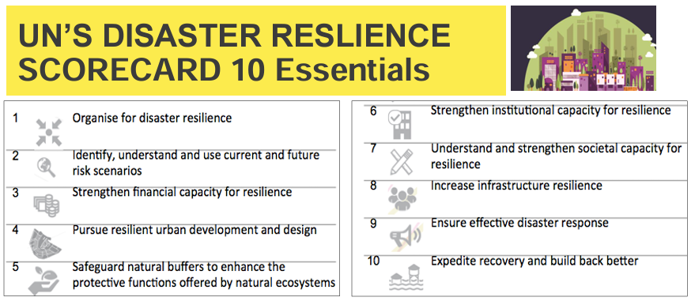

Figure 10 Essentials UN Disaster Resilience Scorecard

## Federal Disaster Management Framework

The Commonwealth Government has two frameworks to help prepare for disasters:

* The National Disaster Risk Reduction Framework (2018) - translates the Sendai Framework into the Australian context outlining a coordinated approach to reducing disaster risk and highlighting the disproportionate risks to vulnerable groups[15]
* The Australian Disaster Preparedness Framework (2018) – is a guideline that outlines the skills or capabilities needed to prepare for, manage and recover from severe to catastrophic disasters.[16]

It highlights essential capabilities required to meet the essential needs of affected citizens, including provision of care across health, disability, psychological and aged sectors.

The [National Disaster Risk Reduction Framework](https://www.homeaffairs.gov.au/emergency/files/national-disaster-risk-reduction-framework.pdf) is a multi- sector collaboration led by the National Resilience Taskforce, within the Australian Government Department of Home Affairs. The framework was co-designed with representatives from all levels of government, business and the community sector.

It sets a 2030 vision and goals for disaster risk reduction in Australia where all sectors of society:

* make disaster risk-informed decisions,
* are accountable for reducing risks within their control
* invest in reducing disaster risk in order to limit the cost of disasters when they occur.

**Goals:**

* take action to reduce existing disaster risk
* minimise creation of future disaster risk through decisions taken across all sectors
* equip decision-makers with the capabilities and information they need to reduce disaster risk and manage residual risk

National priorities

The National Disaster Risk Reduction Framework identifies four national priorities that guide action to reduce disaster risk. Each priority has five-year outcomes that are supported by strategies for action: 2019–2023. The priorities are:

1. Understand disaster risk
2. Accountable decisions
3. Enhanced Investment
4. Governance, ownership and responsibility

As pictured in Figure 1 of the [Australian Government Crisis Management Framework](https://www.pmc.gov.au/resources/australian-government-crisis-management-framework-agcmf/introduction/hierarchy-documents)[17] there are 5 levels of plans.

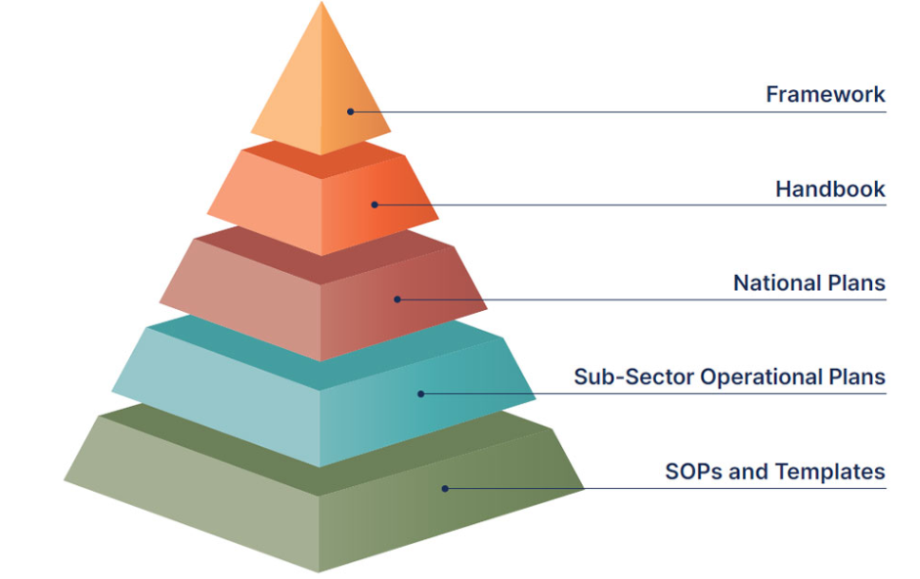

This encompasses the complexity and multi-level, multi-agency, multi-organisation approach required before, during and after a crisis. The Framework contributes to:

* + saving lives and reducing harm
  + protecting property and the environment and safeguarding national interests and assets
  + providing national leadership and maintaining public trust and confidence in government systems
  + national capability sharing and prioritisation
  + continual improvement

### Australian Disaster preparedness Framework

The [Australian Disaster Preparedness Framework](https://www.homeaffairs.gov.au/emergency/files/australian-disaster-preparedness-framework.pdf) is intended to support Australia to develop the required capability to effectively prepare for and manage severe to catastrophic disasters.

The purpose of the framework is to inform:

“…thinking about national preparedness levels and the associated capability and capacity requirements from both a national and jurisdictional perspective. As such, it assists all jurisdictions to understand extant capability levels and gaps in ensuring effective preparation for, and management of, severe to catastrophic disasters…” [(p26)](https://www.homeaffairs.gov.au/emergency/files/australian-disaster-preparedness-framework.pdf)

It is supposed to cover all hazards, be borderless, globally linked and locally enabled, simple, agile and scalable, adaptable, outcomes based and timely. In order to have a prepared Australia its cycle of improvement components include ([p16-17](chrome-extension://efaidnbmnnnibpcajpcglclefindmkaj/https:/www.homeaffairs.gov.au/emergency/files/australian-disaster-preparedness-framework.pdf)):

* Establish effective governance, roles and responsibilities
* Understand risks and consequences
* Understand capability requirements
* Enhance and develop capabilities
* Foster partnerships
* Plan and coordinate capabilities and partnership
* Inform policy, investment and expectations

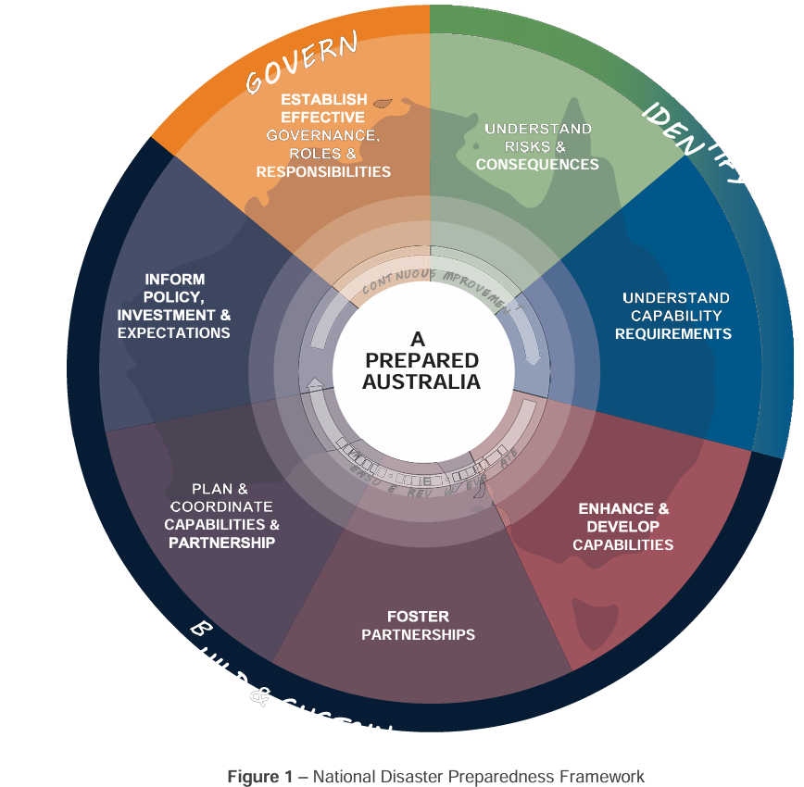

People with disability and Disability Representative Organisations (DRO’s) can provide invaluable input into the development of these high-level frameworks, strategies and plans and challenges with their implementation through:

* scenario testing
* providing feedback and training to enhance national capability requirements
* identifying potential points of system failure and providing recommendations for change
* user acceptance testing for systems and technologies, and
* working as staff and volunteers in emergency management roles.

In the framework as pictured in Figure 2, this fits the final three implementation elements.

A flowchart illustrating the 'Application of the Australian Disaster Preparedness Framework,' split into two sections: 'Jurisdiction' and 'Implementation.'

In the 'Jurisdiction' section (left), processes include 'Scenario Analysis,' 'Risk Assessment,' 'Testing Disaster Scenarios from Severe to Catastrophic,' 'Assessing Available Capability & Capacity,' and identifying 'Capability & Capacity Gaps.'

This section also highlights the importance of 'Building and Sustaining Capabilities,' which involves 'Enhancing and Developing Capabilities,' 'Fostering Partnerships,' 'Planning and Coordinating Capabilities and Partnerships,' and 'Informing Policy, Investment, & Expectations.'

Each step emphasizes collaboration across states, territories, government levels, private sectors, non-governmental organizations, and international partners to achieve national thresholds and priorities.

The 'Implementation' section (right) details the steps jurisdictions take to align with the framework, including establishing preparedness frameworks, determining capability requirements, identifying national capability gaps, and finding resources in various sectors to fill these gaps.

The process concludes with enhancing, developing, building, and sustaining capabilities, highlighting an 'Increasing Level of Maturity' as jurisdictions progress through these steps.

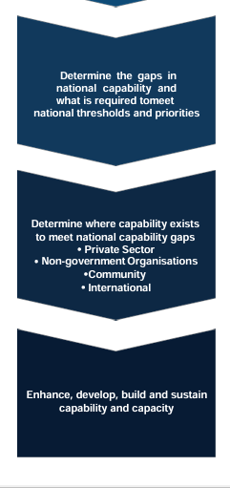

• Determine the gaps in national capability and what is required to meet national thresholds and priorities

• Determine where capability exists to meet national capability gaps: Private sector, non-government Organisations, Community, International

• Enhance, develop, build and sustain capability and capacity.

Whilst these frameworks aim to implement the priorities identified in the Sendai Framework, neither incorporates its recommendation to include people with disability in design and implementation of accessible disaster risk plans.

**Recommendation 1**

PWDA recommends greater involvement of people with disability in the development of Federal disaster and emergency management plans and policy, in line with the Sendai Framework recommendations

### Australian Emergency Management Arrangements Handbook

The [Australian Emergency Management Arrangements Handbook](https://knowledge.aidr.org.au/resources/handbook-australian-emergency-management-arrangements/)[18] describes the emergency management roles and responsibilities of all levels of government, non-government organisations (NGOs), businesses, communities and individuals. It has been updated to reflect legislative changes resulting from the [Royal Commission into National Natural Disaster Arrangements recommendations](https://www.royalcommission.gov.au/node/948).[19]

State and territory governments have primary responsibility for emergency management within their jurisdiction. The 2023 [Australian Emergency Management Arrangements Handbook](https://knowledge.aidr.org.au/resources/handbook-australian-emergency-management-arrangements/) has identified 11 core principles that underpin and guide emergency management activities, and it describes the emergency management roles and responsibilities of all levels of government, non-government organisations (NGOs), businesses, communities and individuals. The [disaster resilience collection](https://knowledge.aidr.org.au/media/10162/handbook_aema_web_2023.pdf)[20] sits under these arrangements.

### Emergency Management

Some disasters relate to international or global issues that are impossible for Australia to prevent, and that require international treaties, collaboration and responses. These include things like falling space debris, solar flares that can destroy electronics, international conflict, volcanic eruptions, terrorism, pandemic infections and tsunamis.

Australia has [National emergency management plans](https://www.health.gov.au/resources/collections/emergency-management-plans)[21] for domestic and international health emergenciesincluding:

* [National arrangements and agreements](https://www.health.gov.au/resources/collections/emergency-management-plans#national-arrangements-and-agreements)
* [Chemical, Biological, Radiological or Nuclear (CBRN) Incidents](https://www.health.gov.au/resources/collections/emergency-management-plans#chemical-biological-radiological-or-nuclear-cbrn-incidents)
* [Communicable diseases](https://www.health.gov.au/resources/collections/emergency-management-plans#communicable-diseases)
* [Hazard emergencies](https://www.health.gov.au/resources/collections/emergency-management-plans#hazard-emergencies)

Within each of these areas specific plans exist to address specific hazards

Australia also has a [Department of Home Affairs Emergency Response Plan](https://www.homeaffairs.gov.au/about-us/our-portfolios/emergency-management/emergency-response-plans)[22] which covers

* [Physical assistance overseas](https://www.homeaffairs.gov.au/about-us/our-portfolios/emergency-management/emergency-response-plans#content-index-1)
* [State and territory requests for assistance](https://www.homeaffairs.gov.au/about-us/our-portfolios/emergency-management/emergency-response-plans#content-index-2)
* [Evacuation from overseas](https://www.homeaffairs.gov.au/about-us/our-portfolios/emergency-management/emergency-response-plans#content-index-3)
* [Overseas mass casualty](https://www.homeaffairs.gov.au/about-us/our-portfolios/emergency-management/emergency-response-plans#content-index-4)
* [Space debris re-entry](https://www.homeaffairs.gov.au/about-us/our-portfolios/emergency-management/emergency-response-plans#content-index-5)
* [Aviation disaster response](https://www.homeaffairs.gov.au/about-us/our-portfolios/emergency-management/emergency-response-plans#content-index-6)

Other emergencies relate to natural hazards Australians are more accustomed to such as bushfires, floods, cyclones and storms, which devastate Australian communities and are intensifying. Our population is increasing and the task of preventing loss of life and property is more complex. No one jurisdiction, agency or organisation has the knowledge or capacity to manage these emergencies alone.

Australia has a strong baseline of standing capabilities[23] but these are not nationally integrated to enable a holistic, national response to large-scale, multi-jurisdictional severe to catastrophic events. The responsibility for disaster preparedness and risk reduction is shared but not equal, and all sectors of society need to be involved.

The Australian public rightly expects that severe to catastrophic disasters will be dealt with effectively to minimise loss of life and property and ensure that recovery can occur as quickly as possible. We expect governments and institutions to plan and prepare to avoid impacts, for example by:

* setting planning controls that prevent homes being built in fire or flood prone areas
* completing hazard reduction burns
* ensuring dams and flood defences are well managed
* properly resourcing and training emergency service response staff
* maintaining a national stockpile of equipment and resources for use in emergencies
* ensuring emergency communication is accessible, well planned and well resourced
* having plans for accessible, effective evacuation and emergency accommodation
* resourcing recovery services.

Equally governments expect individuals and communities to be prepared and to respond appropriately. This could be by having an emergency plan, preparing appropriately by reducing hazards at home through fire or flood mitigation measures. As the government’s [own reporting](https://www.aph.gov.au/Parliamentary_Business/Committees/House/Economics/FloodInsuranceInquiry/Report) has demonstrated, even in communities where it is possible to insure against fire and flood risk, policies no longer operate effectively to reduce the impact of natural disasters like floods, storms and fire.[24]

### National System Reviews

On the 25th October 2024, two significant reports referred to as the Glasser review and the Colvin review, were released reviewing disaster and emergency management.

The [final report of the Glasser Review](https://www.nema.gov.au/sites/default/files/2024-10/20240813%20-%20Glasser%20Review%20-%20Final%20Report_copy%20edit.PDF)[25] led by Dr Robert Glasser, was informed by the [Royal Commission into National Natural Disaster Arrangements](https://www.royalcommission.gov.au/natural-disasters) and its recommendations on how the Australian Government at all levels should work together. The Glasser review acknowledged rapid planetary warming, the likelihood that climate-amplified, national-scale hazards will become more frequent, have greater social impact, and there will be less time to recover.

The [Glasser review](https://www.nema.gov.au/sites/default/files/2024-10/20240813%20-%20Glasser%20Review%20-%20Final%20Report_copy%20edit.PDF) identified the need to integrate approaches to address risks and threats, and that as well as focusing on immediate challenges, governance meetings must do more to address emerging and more fundamental challenges, the underinvestment in risk reduction and resilience, and the need for significant change to address the emerging risks. Its recommendations addressed eight key including:

* The lack of National or Commonwealth leadership on leading resilience efforts to prepare the country for increasing risks
* The need for the National Emergency Management Ministers Meeting (NEMMM) to increase its focus on strategic risk and a resilience agenda that delivers a more disaster resilient nation, this body in its expanded form as an on-going Ministerial Council reporting to the National Cabinet, was considered an effective response to Royal Commission Recommendation
* For the Australia-New Zealand Emergency Management Committee (ANZEMC) to strengthen its focus on strategic risks in support of the NEMMM, elevate the importance of disaster risk reduction and resilience
* The National Coordination Mechanism is the right mechanism to advise the National Cabinet has access to appropriate authoritative expertise in a crisis
* Planning and public policy development needs to accelerate to meet the more frequent need for national facilitation and coordination of both emergency response relief and early recovery from more frequent and destructive national-scale disasters.

The [Independent Review of Commonwealth Disaster Funding](https://www.nema.gov.au/about-us/governance-and-reporting/reviews/independent-review-of-commonwealth-disaster-funding) (Colvin Review)[26], led by Andrew Colvin AO APM, supported by a team from NEMA and Deloitte, examined how the Australian Government spends money on disasters. It sought to identify ways to improve disaster funding so that we:

* reduce risks
* are ready for disasters
* better respond when they happen
* help people recover
* make communities stronger

It also examined state, territory and local government roles and responsibilities.

The [Glasser review](https://www.nema.gov.au/about-us/governance-and-reporting/reviews/independent-review-of-national-natural-disaster-governance-arrangements) makes no direct mention of disability, and the [Colvin review](https://www.nema.gov.au/about-us/governance-and-reporting/reviews/independent-review-of-commonwealth-disaster-funding) twice mentions ‘injury and disability’ on page 68 as a cost category for economic disaster, at page 71 and 96 it acknowledges the inaccessibility of the disaster funding application process for people with disability. A fifth of Australians have a disability and many of them work and volunteer in the organizations and groups that respond to disasters. The fact people with disability are only mentioned in the report examining how the government spends money, could be viewed as a tacit characterization of people with disability as ‘victims’ or a cost to government. This ignores the key contributions many people with disability play in combatting and responding to disasters and the untapped potential they offer in policy, resilience and the development of innovative solutions.

In line with recommendation 1, PWDA recommends that people with disability continue to be a priority cohort, and that their DROs be included in NEMA, State Emergency Management Committees (SEMCs) and Regional Emergency Management Committees (REMC) and their knowledge applied to emergency planning. We would also recommend increased inclusion of people with disability and their DROs in policy development, resilience and response planning to help identify issues, resource needs and ways to improve approaches for everyone.

In order to better understand where problems are occurring, we have examined NSW in greater detail as an example response, by the most populous Australian State.

## Emergency management in NSW

### Who is involved and what is their responsibility?

The [NSW State Emergency and Rescue Management Act](https://legislation.nsw.gov.au/view/html/inforce/current/act-1989-165)[27] sets out the roles, powers and responsibilities of people in an emergency. The [NSW State Emergency Management Plan 2023](https://www.nsw.gov.au/sites/default/files/noindex/2024-02/State_Emergency_Management_Plan_2023.pdf)[28] (EMPLAN) sets out the roles and responsibilities of the different government departments, agencies, emergency services and service providers with respect to emergencies.

It is complemented by the [State emergency management sub plans](https://www.nsw.gov.au/rescue-and-emergency-management/sub-plans),[29] action plans for specific hazards or events that contain more detailed information. These are complimented by [regional plans and management](https://www.nsw.gov.au/emergency/rescue-and-emergency-management/regional-plans-and-management)[30] for the 11 emergency management regions made up of NSW local government areas. Regional plans describe how emergencies are managed on a regional basis.

The [State Rescue Policy](https://www.nsw.gov.au/emergency/rescue-and-emergency-management/state-rescue-policy)[31] sets out the efficient and effective maintenance of rescue services throughout NSW. [State Rescue Board Accredited Rescue Units](https://www.nsw.gov.au/emergency/rescue-and-emergency-management/state-rescue-policy/state-rescue-board-accredited-rescue-units)[32] lists the accredited rescue units in NSW.

The best way to identify the roles and responsibilities of different agencies can be found in described in Annexure 12 of the [EMPLAN](https://www.nsw.gov.au/rescue-and-emergency-management/state-emergency-management-plan-emplan). The only mention of disability in the whole document can be found at page 45:

“636 Agencies should specifically consider how to provide community warnings and public information to community groups with diverse communication and accessibility needs that could impair their capacity to access, understand and act on the warnings/public information provided. The groups include (but are not limited to) people with disability, such as people who are deaf or hard of hearing, people who are blind or have low vision, or people with physical disability.”

No mention is made of Easy Read, Easy English, psychosocial disability, learning difficulty, supported decision making in the whole document.

Drawing on Annexure 12 of the EMPLAN where the roles and responsibilities are described, the table below notes a non-exhaustive range of needs people with disability have identified in our survey or P-CEP reports, that are not being addressed.

| **Service** | **Area of Responsibility** | **Function needed by people with disability but not described** |
| --- | --- | --- |
| NSW Police Force | **Response**: Deputy Commissioner Controls and coordinates, communicates with other agencies and the media, protect people from injury and death and property from damage, crime prevention, victim registration | Communication in accessible formats and with relevant DROs and service providers,  Plan to maintain access to life-sustaining services and supports during evacuation and emergency  Plan to protect assistive technology from damage |
|  | **Prevention**: Communications planning, support other agencies to information about prevention and preparedness | Ensure accessible formats, refer to support if needed |
|  | **Preparedness**: Conduct communication and multi-agency training | Ensure accessible formats  Disability awareness training |
|  | **Response**: Assist combat agencies to develop & implement communications strategy  Provide whole of government approach to public information | Ensure accessible formats |
|  | **Recovery**: Public information handover to recovery agency | Ensure accessible formats |
| NSW Ambulance | **Supporting Agency Role**: Coordinated incident response, prioritised casualty management, casualty triage, treatment and transport | Disability awareness training |
| Fire & Rescue NSW | **Prevention**: identify and address community risk, develop strategic partnerships to enhance community safety, increase community and business resilience, investigate and inform safety programs, research identify and address major community risk | Additional risk identification for those unable to drive/ access transport to flee, or to protect themselves or their home |
|  | **Preparation**: train and equip residents near bushland to protect themselves | Accessible communication, emergency management plans, assisted decision making, alternatives for those unable to protect themselves |
| NSW Rural Fire Service | **Prevention**: manage hazard reduction, enact declarations (total fire ban), provide arson awareness, provide approvals conditions for development in bush-fire prone areas | Is arson awareness communication accessible? |
| NSW State Emergency Services | **Combat Agency**: Deal with floods, storm impacts, prepare for tsunami, provide warnings | Advise people with disability/ DROs as early as possible to help with preparation  Disability awareness training |
|  | **Response**: lead response to storms, floods & tsunami to protect safety, health, life and property | Who is responsible for considering access to supports if a person is cut off by storm or flooding?  Who reports power outage that means a person’s life sustaining or assistive equipment does not work? |
| Department of Regional NSW Primary Industries | **Combat Agency Role:** prevention and preparedness for emergency and major endemic outbreaks of animal and plant diseases, food safety emergencies | Disability awareness training  Accessible information for primary producers with disability and for people regarding plant and animal diseases, food safety |
|  | **Response**: Identify pests, diseases and invasive species, food safety issues, identify at risk animals, | May need additional communication plan to help people with disability to identify food safety, water safety, contamination and risk issues. |
| NSW Telco Authority | **All phases**: protection of critical infrastructure and deployment of network augmentation | Planning for people with disability who depend on mobile/ internet connectivity to run apps, assistive technologies and devices. Call-alert systems |
|  | **Prevention**: hazard assessment, and infrastructure protection programs | Testing of alternatives used in emergencies to ensure connectivity can be achieved by people with disability |
|  | **Preparedness**: Support combat agencies and functional areas to develop plans, conduct training | Disability awareness training  [NB: expectation that people with disability purchase a satellite phone or signal providing device at $1500-$2500 apiece may be unreasonable] |
|  | **Recovery**: Support telecommunications to access damaged infrastructure, provide telecommunications for disaster recovery facilities, responders and volunteers | Provision of signal/ connectivity in disaster recovery as adaptive and communication equipment people with disability depend on won’t operate or may stop working if software updates can’t be made |
| Department of regional NSW, NSW Public Works | **Functional area**: Coordinate and mobilise engineering resources for emergency response and initial recovery | Engineered solutions such as flood barriers could protect key homes and facilities critical to the safety of people with disability |
|  | **Prevention**: Identify hazards, prevention and mitigation, provide input to policies, codes, & emergency management plans | Are the needs of people with disability for engineered solutions incorporated into plans? |
|  | **Recovery**: Communicate with SERCON and help manage recovery projects, make-safe operations and establish recovery centres | Is there an accessibility requirement? |
|  | **Supporting Agency Role**: coordinate engineering resources in response to recovery, coordinate repair to public buildings & infrastructure requested by combat agencies, coordinate supply of goods and services in response to emergency and recovery | Are the needs for different goods and services by people with disability considered? Prioritised? |
| Department of Climate Change, Energy, the Environment and Water | **Combat Agency**: Control and coordination of System Black emergency or energy supply (when power is lost to 60% or more of NSW) | Priority response for people with disability |
|  | **Functional area role**: inform and connect stakeholders regarding energy/ liquid fuels incident/ emergency | Who gets informed? Are DROs included because it will be critical to manage what happens when energy is unavailable to people with disability and their carers |
|  | **Prevention**: maintain emergency risk management contribute to prevention & response plans, participate in utility service provider infrastructure programs & exercises | Advance identification of homes and facilities critical for people with disability- provision of backup capacity |
|  | **Preparedness**: Help develop and maintain energy and utility services emergency management plans & operating procedures | Are DROs involved? |
|  | **Recovery**: Collaborate with EUSFA and Emergency Services Organizations to facilitate access to impacted infrastructure to enable restoration, analyse impact and debrief to get lessons learned | There needs to be some form of proactive identification of action and reporting on supply to homes where people depend on energy supply to run lifesaving equipment |
| NSW Environmental Protection Authority | **Functional Agency Role**: identify and assess environmental hazards, take proactive action to reduce impact in an emergency | Where is the role for indigenous knowledges? Where is planned protection of vulnerable species? Indigenous lands? |
|  | **Prevention**: Regulate activities that may pose environmental hazards and undertake compliance | Is there a plan to protect and inform people with disability who may be vulnerable to particular activities? |
| NSW Health | **Combat Agency**: for human health emergencies and pandemics | This did not work well during COVID-19 for many people with disability |
|  | **Functional Area Role**: ensure capability to prevent, prepare for, respond to and recover from emergencies, coordinate health response during emergencies, apply NSW HEALTHPLAN (sub-plan to the EMPLAN) | Did not work well during COVID-19 and it appears the needs of people with disability were not planned for |
|  | **Prevention & Preparedness**: Maintain policies & procedures, the NSW HEALTHPLAN, representation on State & national emergency committees including Australian Health Protection Principal Committee | DROs need to have input and be represented on these committees |
|  | **Response**: provide immediate relief to impacted communities whilst providing BAU services elsewhere, coordinate mobilisation of health resources, coordinate health communication, provide Liaison Officers to Emergency Operation Centres | During COVID diversion of resources severely impacted people with disability who depended on health and allied health services that were removed. Planning of communication, service provision and supports to access testing, vaccination and healthcare often neglected the needs of people with disability or excluded them.  People who are Deaf-Blind still don’t have a Covid-safe healthcare plan |
| Transport for NSW | **Combat Agency Role**: Maritime for coastal waters oil & other spills |  |
|  | **Functional Agency Role**: Coordinate transport services required by Combat Agency and other Functional areas whilst maintaining BAU operations | Transport needs for people with disability are not planned for and met well in rural and regional communities and areas with poor/ no accessible public transport.  Accessible taxi service is poor/ non-existent. Services during disruptions/ repairs are often inaccessible.  Community Transport is specifically not for evacuation in emergencies – Confirmed a the Electrify 2024 conference |
|  | **Prevention**: Identify vulnerable & critical assets (transport a& freight) and prioritise mitigation | People with disability and their carers need to be prioritised |
|  | **Preparedness**: partner to achieve asset resilience, plan & deliver early mitigation | Where is transport plan for people with disability to escape disaster? |
|  | **Response**: Immediate relief, repair, make-safe, re-establish essential freight routes for re-supply, deploy assets to support Combat Agencies to protect life and critical infrastructure, coordinate provision of support to Combat Agencies, Functional Areas and Supporting Agencies, provide whole of network advice to Combat Agencies to inform decision making, contribute to response planning | What is the plan to provide information as early as possible to DROs about transport issues? |
|  | **Recovery**: Make Safe and prioritise works to critical assets and infrastructure relevant to public safety and humanitarian necessity e.g. cut off communities | Need to understand that ‘cut off’ is different for people who have cars compared with people who don’t |
| Department of Communities and Justice | **Functional Agency Role**: responsible for coordinating the provision of welfare services to disaster affected people | Has not worked well historically for many people with disability, needs DRO representation to improve |
|  | **Prevention**: State Welfare Services Functional Area Coordinator (WelFAC) contributes to the review of emergency plans and policies including planning for emergency evacuation centres | Review for accessibility needed and corrective action |
|  | **Preparedness**: WelFAC contributes to State preparedness planning through SEMC including: implement training to develop knowledge and skills of the Department of Communities & Justice welfare services, ensure Participating Organisations are resourced and training volunteers, conduct exercises, map capability and workforce sustainability, ensure adequate numbers of trained & available personnel ensure operational preparedness with evacuation centre kits & on-call arrangements | This is not working. Many evacuation centres not well equipped [e.g. to cope with influx in numbers, provide accessible facilities, fight spot fires threating location], May not be accessibly located for people without cars to get to, no provision of emergency comms once telephone towers go out, no backup power supply, disability awareness training inadequate/ non-existent for volunteers and workers, services dependent on volunteers struggling to recruit, deployed volunteers becoming sick and injured, unprepared to listen to volunteers, no engagement with DROs |
|  | **Response**: Immediate relief: emergency accommodation, sustenance, material aid, personal support, multi-faith chaplaincy, child-safe, transition from emergency evacuation | Needs DRO consultation urgently. What about inclusion, accessibility, DFV, provision of disability supports, specialised nutrition, medications??? |
| Premier’s Department | Policy coordination, secretariat support to SEMC coordinate capability development in the emergency services sector | Fund DROs to develop training |
| The Cabinet Office | **Central Coordination**: policy advice, prepare statutory instruments | I would strongly recommend getting it written in as a condition that all people with disability and their DROs have to be consulted on planning for and changes to emergency management |
| NSW Reconstruction Authority | Mitigation and adaptation, long term preparedness, community centred recovery, long term rebuilding and reconstruction | Needs input form people with disability |
| Aboriginal Affairs NSW | Ensure the voices of Aboriginal people are represented | Needs to include indigenous people with disability AND must ensure there is accountability to take action, not just listen and ignore |
| NSW Department of Education | All schools plus TAFE | Consultation with people with disability needed |
|  | Prevention: Identify, assess and mitigate hazards, reduce impacts of emergency | Access to learning supports? |
| Department of Customer Service, Emergency Information Coordination Unit | Lead agency to ensure the emergency management sector has the most up-to-date spatial data and intelligence available to deal with emergencies and major events | Is this accessible for staff and volunteers with disability? What about DROs and planning? What about people with limited/ no access to connectivity and up to date digital devices? |
| Multicultural NSW | Providing interpreting and translation services, monitoring / addressing risks & sharing information related to community harmony & Resilience, supporting affected communities and individuals | What about multicultural people with disability? What about listening to and gathering cultural needs? |

This exercise highlights a range of critical issues and questions. In many cases people with disability know what they need and can share solutions to problems. PWDA could help governments develop and convene co-designed working groups or advisory forums to ensure that a broad range of people with different disabilities can share their experiences and ideas to improve plans.

**Recommendation 2**

PWDA recommends each State work with people with disability and their DROs to develop a comprehensive evaluation of the issues and gaps for each service, and an appropriate response.

**Recommendation 3**

PWDA recommends a co-design process be used that is accessible, includes people with disability and their DROs, gathers lived experiences, issues, recommendations for change, and that reports outcomes and actions transparently

## Individual responses

### Emergency planning

Responding to an emergency from the individual’s perspective is captured in the model from page 5 of [The Evacuation Planning Handbook](https://knowledge.aidr.org.au/media/10505/handbook_evacuation_planning_2023.pdf).[33]

A flowchart illustrating a culturally safe and effective evacuation process for Indigenous people at risk from natural and other hazards. The process is enclosed within an oval labeled 'Dialogue' and 'Relationships,' emphasizing the importance of communication and community connections.

The steps in the process are:

'Being prepared' leads to 'Communicating risk and rights.'
This leads to 'Decision to stay or leave.'
If the decision is to 'Stay,' it directs to 'Shelter in the safest place in the community.'
If the decision is to 'Leave,' it leads to 'Follow directions of emergency services.'
Both the 'Stay' and 'Leave' paths eventually lead to 'Return home.'
The flowchart highlights the interconnectedness of preparedness, communication, and decision-making in the evacuation process, ensuring cultural safety and community-centered responses.

Australians are encouraged to develop an emergency plan in advance, tailored to their needs and circumstances, to help ensure they are prepared. The Australian Institute for Disaster Resilience (AIDR) maintains a Handbook Collection knowledge hub of [free resources](https://knowledge.aidr.org.au/collections/handbook-collection/)[34] and templates [exist](https://www.ses.nsw.gov.au/emergency-plan/)[35] that have been created by the SES and others to help individuals and families to develop an emergency plan. They consistently encourage people to:

* know your local risks and hazards (preparedness),
* undertake relevant risk reduction activities at your home (prevention),
* have an emergency plan (preparedness),
* stay informed when an event arises in your area (preparedness),
* if you at risk or in danger act accordingly (response), and
* know how to seek support after a disaster (recovery).

The development of an emergency plan requires that individuals understand their risk. It used to be possible for people to use the [My Hazards App](https://www.insurancebusinessmag.com/au/news/breaking-news/ica-rolls-out-new-mobile-app-168925.aspx) to identify the hazards relevant to their local area (fire, flood, storm, tsunami etc) and plan for them. Since its 2019 launch the Insurance Council has taken it down. It will not always be clear to people which hazards to plan for.

Executing an emergency plan requires accurate information that enables a person to know when it is time to begin. Apps like [Readi](https://readiapp.com.au/) may be helpful in bringing all the information together in one place about what is happening in real time, however a large proportion of Australia has no mobile signal, many people have little or no internet connectivity and devices and app technology are not accessible to everyone. This can make it hard of people to decide what to do. Emergency plans may also require resources that are not be available to an individual, and they need a lot of other things to work well. These include but are not limited to timely communication, a safe place to shelter, a safe route to evacuate to, and safe transport.

### Emergency planning for people with disability

People with disability are encouraged to develop a Person-Centred Emergency Preparedness Plan[36] (PCEP) using a workbook developed to help with planning for what they need. Research projects have been undertaken by [Collaborating 4 Inclusion[37]](https://collaborating4inclusion.org/) on understanding the needs of people with disability, to develop resources. These projects are:

* [Disability Inclusive Disaster Risk Reduction (DIDRR) Framework and Toolkit for Collaborative Action](https://collaborating4inclusion.org/didrr-framework-and-toolkit-for-collaborative-action/)[38]

This includes short videos on: A roadmap for DIDRR, Coproduced tools everyone can use, Stakeholders and their role, DIDRR Framework for Collaborative Action. The DIDRR sets out [7 ways to strengthen collective capabilities](https://collaborating4inclusion.org/wp-content/uploads/2024/06/7Ways-to-StrengthenCollectiveCapabilities.pdf) namely:

1. Inclusive understanding of needs
2. Holistic approach
3. Targeted support
4. Effective Communication
5. Building trust
6. Ensuring Representation
7. Removing barriers

* [Person Centred Emergency Preparedness](https://collaborating4inclusion.org/pcep/)

This contains links to the P-CEP Tools, P-CEP Implementation, P-CEP Certificate Course and P-CEP Evidence.

* [Disability Inclusive Emergency Planning (DIEP)](https://collaborating4inclusion.org/diep/)

This is about the local community-led conversations in NSW, Victoria, Queensland and Western Australia.

* [Emergency Centre Disability Awareness (ESDA)](https://collaborating4inclusion.org/emergency-sector-disability-awareness/)

This is a 3-part introductory learning module for the emergency sector on disability inclusion in emergency management

* [Disability Inclusive Disaster Risk Reduction (DIDRR) Australia](https://collaborating4inclusion.org/didrr-australia/)

This defines terms like: Community-based Service Provider, Disability Representative/ Advocacy Organisation and Service recipient, and it links to the Scoping Study and National Consultations.

* [Disability and Disaster Resilient Queensland](https://collaborating4inclusion.org/disability-inclusive-disaster-risk-reduction/)

This focuses on putting disability inclusion into action and links to the DIDRR framework and Toolkit, P-CEP Resources, P-CEP Peer Leadership, a Webinar Series: Collaborating for DIDRR, Disability Inclusive Emergency Planning and Research, and a Video Series: DIDRR in Action

* [Leave Nobody Behind (NSW)](https://collaborating4inclusion.org/leave-nobody-behind)

This contains resources that: explain the LNB Project, share National Survey Findings, link to the P-CEP Short Course, [Disability Inclusive Emergency Planning Forums](https://collaborating4inclusion.org/diep/) (reports from [Newcastle](https://collaborating4inclusion.org/wp-content/uploads/2023/03/Newcastle_FINAL_DIEP_report_832023.pdf), [Wollondilly](https://collaborating4inclusion.org/wp-content/uploads/2023/03/Wollondilly_DIEP-report_8-Sept_2022.pdf), [Blue Mountains](https://collaborating4inclusion.org/wp-content/uploads/2023/03/BMCC_DIEP_report_May_2022.pdf), [Bega Valley Shire](https://collaborating4inclusion.org/wp-content/uploads/2023/04/Bega_DIEP-report_09042023.pdf), [Shoalhaven](https://collaborating4inclusion.org/wp-content/uploads/2023/04/Shoalhaven_DIEP-report_April-2023.pdf), [Singleton](https://collaborating4inclusion.org/wp-content/uploads/2023/04/Singleton_DIEP-report_22-April-2022.pdf), [Hawkesbury](https://collaborating4inclusion.org/wp-content/uploads/2023/05/Hawkesbury_DIEP-report_24-April-2022_update.pdf), [Bellingen](https://collaborating4inclusion.org/wp-content/uploads/2023/07/Bellingen_DIEP-Forum.pdf), [Coffs Harbour](https://collaborating4inclusion.org/wp-content/uploads/2023/07/Coffs-Harbour_DIEP-report.pdf), [Richmond Valley](https://collaborating4inclusion.org/wp-content/uploads/2023/09/Richmond-Valley_DIEP-26-June-2023.pdf) and [Tweed Heads](https://collaborating4inclusion.org/wp-content/uploads/2023/09/Tweed-Heads_DIEP-28-June-2023.pdf)) and [DIDRR NSW](https://collaborating4inclusion.org/leave-nobody-behind/didrr-nsw/).

These reports persistently raise the issue of personal plans, the need for/ lack of a plan to communicate with people with disability, transport (or the lack of it) as a barrier, challenges related to isolation, the ‘dominant message to the public from emergency services that ‘you’re on your own’, lack of information and service accessibility especially if you don’t use apps, the lack of planning for power outages – when technology won’t work, evacuation centre accessibility,

* [Disability Inclusive Emergency Planning Victoria](https://collaborating4inclusion.org/inclusive-emergency-management-victoria/)

This aims to provide locally driven disability inclusive emergency management planning in Victoria and links to video resources providing: an overview of the P-CEP peer education program, a P-CEP in action webinar, and P-CEP for providers.

* [Homelessness and Disaster](https://collaborating4inclusion.org/home/homelessness-and-disaster/)

This links to videos about the: homelessness and disaster project, lived experience of homelessness, P-CEP homelessness outreach guide, and a learning module.

* [Get Ready Together WA](https://collaborating4inclusion.org/diep/reports-wa/)

This links to DIAP reports on forums held in Mundaring and Rockingham.

* [COVID-19](https://collaborating4inclusion.org/home/covid-19-person-centred-emergency-preparedness/)

This contains a COVID-19 planning resource for people with disability.

* [Have your say](https://collaborating4inclusion.org/didrr-australia/#have-your-say)

This defines terms like: Community-based Service Provider, Disability Representative/ Advocacy Organisation and Service recipient, and it links to the Scoping Study and National Consultations.

* [Community Inclusion](https://collaborating4inclusion.org/media-inclusion-and-disability/communicating4inclusion/)

This links to a video Indonesian and Auslan about disability, and the MIDRAC project that brought people together to change the way that disability and inclusion is discussed in the community.

* [Empowerment Stories](https://collaborating4inclusion.org/cbr-pacific/empowerment-stories/)

This links to video resources about community-based inclusion – The Pacifica Way.

### Are plans effective?

The definition of a plan according to the Oxford English Dictionary is “a detailed proposal for doing or achieving something”.[39] At present P-CEPs cannot rightly be called ‘plans’, as so many of the elements that would be necessary for them to operate effectively, do not exist. This is especially highlighted in the NSW Reports. Educating people about the need for a plan, or how to prepare one, provides no improvement in personal safety in an emergency, if barriers prevent them executing the plan.

Below we have examined obvious barriers that persistently arose for our members, and in reports, in the areas of: Communication, Evacuation, Safe Place to Shelter and Transport. We have also made recommendations for change.

Critically, this work is ‘backwards looking’, focusing on the experience of disasters that have happened previously, at the expense of planning for impending issues or addressing less well-reported issues. This includes but is not limited to earthquakes, solar flares that could render most electronic equipment useless, the lack of inclusion of many items in the national stockpile of supplies people with disability need in an emergency. Examples include PEG feeding supplies, stoma supplies, catheters, oxygen and dialysis supplies for those who need them, and critical medications many depend on.

**Recommendation 4**

PWDA recommends a co-design process for identifying the resources required, so that P-CEPs can be prepared and implemented

**Recommendation 5**

PWDA recommends Federal, State and Local Governments prioritize resourcing emergency management so that it is accessible and inclusive

### Communication

Decision making in any emergency depends on accessible, accurate, timely information. Individuals depend on this information to decide whether to shelter in place, to evacuate or to undertake other roles as part of the emergency response. As highlighted repeatedly in our member survey and the analysis of roles and responsibilities in the NSW EMPLAN, access to accessible, timely, readily understood communication is poor.

#### Accessible communication

In an article in the Conversation Dr Ariella Meltzer highlighted the [lack of provision of information in accessible formats](https://theconversation.com/crisis-communication-saves-lives-but-people-with-disability-often-arent-given-the-message-224968),[40] and her research revealed:

* the [lack of timely and accessible communication resources created during the COVID-19 pandemic](https://www.disabilityinnovation.unsw.edu.au/information-accessibility-people-disability-during-covid-19)[41] and the [difficult conditions the accessibility sector](https://www.csi.edu.au/research/better-acknowledging-and-resourcing-the-information-accessibility-sector-in-australia/)[42] (DROs, community organizations, expert consultants) faced creating them
* that there is no official standard for Easy English and Easy Read, and there has not been consistent Australian research into what works well
* a lack of central resourcing such as a community communications role to provide DROs and others with information in a clear format and a point of contact to check accuracy with as they create resources for their stakeholders
* although the 2023 Disability Services and Inclusion Act has a provision to provide funding to support accessible information, no funding has been given and there is no dedicated, ongoing funding for the creation of accessible information
* DROs who have government funding do not have the flexibility to redirect it in emergencies to respond

The accessibility and accuracy of Australia’s emergency management information needs to be improved. By contrast the United Kingdom mandates the provision of accessible information, so all government institutions are required to provide accessible information.

Previous work was undertaken to develop a [standardized set of Auslan signs](https://auslanemergency.com.au/wp-content/uploads/2016/07/NEMP-Auslan-Signs.pdf)[43] for communicating in emergencies. It was hoped this would help overcome dialect differences in Auslan between northern and southern Australia. There needs to be greater promotion and resourcing of this project.

The legibility of emergency information could be greatly improved with a co-designed, nationally standardized set of icons and agreed translations. This could help overcome differences in Easy Read formats, could compliment the Auslan signs, and it could assist with translation into other languages.

In Australia we are accustomed to warning symbols that relate to the hazards around us. Stop-signs, and pedestrian crossings are represented in similar ways globally, and act as consistent, visual symbols for all road users, those needing to train assistance animals, and explain their meaning in accessible formats or different languages. We are also accustomed to other signs and symbols that are developed to be as intuitive as possible. Examples below are drawn from pages 27 of the [National Aquatic and Recreational Signage Style Manual](https://www.lifesavingsupport.com.au/Downloads/National-Aquatic-Recreation-Signage-Manual.pdf)[44] provide

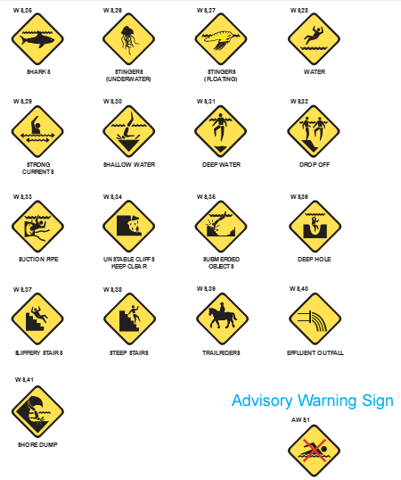 A chart outlining standardized shapes, symbols, and colors for different classes of signage, used to communicate regulations, permissions, warnings, safety information, mandatory safety instructions, and general information.

The columns represent different classes: Regulation, Permissible, Warning, Safety, Safety Mandatory, and Information.
The rows describe the attributes for each class:
'Shape' row: Various geometric shapes are used, including circles for Regulation and Information, diamonds for Warning, and squares for Safety and Safety Mandatory.
'Symbol' row: Outlines or solid shapes in different colors (red, green, yellow, etc.) depending on the sign class.
'Background' row: Specifies background colors such as black, white, yellow, green, and blue.
'Colour' row: Lists colors for symbols and text to match each sign type.
'Enclosure' row: Shows the color of the border around each symbol, such as red for Regulation and green for Permissible.
'Example' row: Displays common examples, including 'No Dogs' (Regulation), 'Dog Allowed' (Permissible), 'Wildlife Crossing' (Warning), 'First Aid' (Safety), 'Emergency Shower' (Safety Mandatory), and 'Accessibility' (Information).
This chart provides a guide to the visual standards for signage, ensuring consistent and accessible communication across different types of public and safety signs.

The format for developing signs in Australia has a logic of symbolic colours and shapes, explained in the table at page 25, to assist with this process.

Some existing symbols may be relevant others could be readily developed. Legibility could be enhanced through a co-design process with people with disability, so that a set of symbols could be used to indicate critical information such as when it is time to evacuate early, any threats that do not currently have a symbol, and other vital information. The wide dissemination of accepted symbols and education of everyone involved in emergency management could greatly improve communication consistency and legibility.

**Recommendation 6**

PWDA recommends mandating the provision of accessible information for all government services in a Disability Rights Act

**Recommendation 7**

PWDA recommends resourcing a community communications role to provide DROs and others with emergency information in a clear format, a point of contact to check accuracy with as they create resources for their stakeholders, funding to do this work including training staff in advance

**Recommendation 8**

PWDA recommends improving funding flexibility for DROs who respond in emergencies

**Recommendation 9**

PWDA recommends all forms of emergency communication should be reviewed and amended to provide accessible formats for everyone

**Recommendation 10**

PWDA recommends that all channels and methods of communication used be reviewed to maximise access

#### Timely communication

PCEPs work on the presumption that people with disability will evacuate themselves early in emergency situations. However, nowhere in federal or state frameworks or strategies is there a communication plan that provides for an early warning to be given to people with disability.

Our research with the Rural Fire Service indicated that there may be some local knowledge of aged care and group home facilities. If there is time in an emergency, someone in the local brigade may doorknock or call to provide a warning. However, the RFS had no knowledge of where people with disability lived in the community who also need early warnings. The lack of plan to provide early warnings also arose repeatedly as a theme in the NSW [Disability Inclusive Emergency Planning Forums](https://collaborating4inclusion.org/diep/).

In our research with an SES member who has experience of disability, they identified that the stage at which people with disability should evacuate early is called ‘watch and act’. However, at this stage no emergency shelters would be open for those who need them, as they remain closed until an emergency is declared. The format of warnings at this stage is also complicated and difficult to interpret, even for experts.

PWDA is aware that national broadcasters get early access to emergency related information under embargo. It would be worth exploring whether people with disability and their DRO’s could register for early information and receive it at the same stage journalists are informed. NSW Police are already able to SMS all mobile phones in geographic areas, so alerts need not require the ability to use smartphones and apps.

**Recommendation 11**

PWDA recommends the development of early evacuation communications planning and facility management to meet the needs of people with disability

### Evacuation

Evacuation is a risk management strategy that may be used to mitigate the effects of an emergency on a community by moving people to a safer location. For an evacuation to be effective, it must be appropriately planned and implemented. There must be an accessible, safe:

* route to evacuate along
* location(s) to evacuate to
* transport to get there.

The warning to evacuate needs to be received in time for the evacuation to take place.

The purpose of [The Evacuation Planning Handbook](https://knowledge.aidr.org.au/media/10505/handbook_evacuation_planning_2023.pdf)[45] is to provide authoritative guidance to people within government and its agencies, non-government organisations and communities on how to plan for the orderly management of an evacuation before, during and after an emergency or disaster.

This version incorporates recommendations, observations and learnings from inquiries following the Black Summer bushfires, and recent catastrophic flooding, and it mentions the additional support people with disability may need to evacuate, the need for assistance animals to be evacuated with them. The 1 page [quick guide](https://knowledge.aidr.org.au/media/5516/evacuation-planning-quick-guide.pdf) provides a checklist for consideration under the 5 key areas:

1. Decision to evacuate
2. Warning
3. Withdrawal
4. Shelter
5. Return

However, mentioning the need for additional support is not the same as ensuring it is provided. For people with disability who require support by people who do not live in their home, any planning must entail that person also being able to render the required assistance.

There is an accompanying handbook for [Planning Evacuations with Indigenous Communities that covers the needs and additional risks faced by indigenous communities during emergency evacuations and it is recommended that this be considered alongside Evacuation Planning (AIDR 2023) when developing an evacuation plan.](https://www.aidr.org.au/media/11031/aidr_indigenous_evacuation_companion.pdf) The principles required to be applied to each step of evacuation planning are:

* Know and respect people’s rights
* Foreground connection with community
* Work within existing community governing institutions
* Provide a safe and welcoming environment for Elders
* Acknowledge the sanctity of family
* Relieve anxiety, don’t add to it

This handbook does not just place all the planning burden on Indigenous individuals and communities. It has an educative function for emergency management organisations and personnel, calling them to (amongst other things) reflect on whether they ‘…know and engage with the local community organisation/s…know how many residents are located within a community… [or about their] infrastructure or access challenges…’

The [P-CEP Certificate Course](https://collaborating4inclusion.org/wp-content/uploads/2023/03/P-CEP_Certificate_Course_-_EOI__Learning_Objectives.pdf) could operate in a similar way, but if it remains ‘optional’ to undertake, and no resources are allocated to address the barriers people with disability face, P-CEPs will still not work effectively as emergency plans.

**Recommendation 12**

PWDA recommends the allocation of resources to enable government and emergency management stakeholders who complete the P-Cep Certificate Training to meet the needs and identified barriers for people with disability

### Safe place to shelter

Evacuation requires a safe place to shelter, and these may need to change. The nature of the threat may mean that the buildings that would be chosen during flooding will be different that in a bushfire. Buildings identified as emergency shelters may be inaccessible, leaving communities with nowhere for people with disability to evacuate to.

The lived experience of our staff with disability includes having to remain at home rather than evacuate, as there was nowhere accessible in their community to evacuate in their electric wheelchair with their animals. Separated from their spouse, they had to sandbag their home and try to help their 92-year-old neighbour. They were unable to access any care or therapeutic supports for over a week till the flood waters receded. These sort of access barriers to functional supports people depend on during emergencies were acknowledged in the [Australian Journal of Emergency Management](https://knowledge.aidr.org.au/resources/ajem-october-2019-increasing-involvement-of-people-with-disability/)[46], and need to be addressed.

When the power was cut off our team member’s electric wheelchair stopped working as it could not be charged. Not only did this mean the staff member had to drag themselves around their home, but there was no way to move and protect an expensive electrical wheelchair from rising floodwaters. In their plan, the staff member had used available information that indicated their home would not flood, but this proved inaccurate. Evaluating whether a person’s come can be used safely to shelter requires accurate information to be made available.

We are also aware that [equipment](https://krisisbags.com/krisis-flood-bags-dry-bags-how-do-they-work/)[47] exists that could be used to protect assistive devices so people with disability can preserve and use equipment after floods. More information needs to be shared about equipment and strategies to help people shelter safely at home and protect the equipment they depend on.

Another PWDA team member was caught in an emergency shelter in the 2019 bushfires identified accessibility issues including: the lack of emergency electricity supply, or ability to communicate the critical needs of families with babies to anyone, and the inaccessibility of any facilities for showering for people with mobility disabilities. The lack of electricity made it impossible to boil water, charge communication or assistive technology.

Once they returned home the staff member also participated in efforts by surf clubs outside the fire zone to identify, communicate, source, and transport back, the supplies the community needed. This highlighted the challenges related to supplying medications that people depended on to stay safe, the need for items not initially thought of such as period products, nappies, and baby formula.

More work needs to be done to ensure that there are safe, accessible places to evacuate to, where the needs of people with disability can be met in an emergency. It may also be unclear to people preparing a P-CEP which buildings may be used, or how accessible they are. Even when maps or relevant information exists it is not always accessible to the public. This information needs to be clear and publicly accessible.

A recent workshop to inform the development of Health National Adaptation Plan that responds to the 9 health-related risks identified in [Australia’s first National Climate Risk Assessment](https://www.dcceew.gov.au/climate-change/publications/ncra-first-pass-risk-assessment)[48] it was clear that the health workforce could also play a critical role in advising which supplies are needed in communities to keep people safe. General Practitioners, community nurses, and local health providers will be best placed to advise on the quantities of supplies people need to stay safe in an emergency situation, without needing to collect and share the private health information of individuals. This could include identifying the supplies of equipment the community needs ordinarily like: stoma equipment, catheters, medicines required for psychosocial disabilities, addiction disorders, ongoing conditions such as asthma, diabetes, cancer, or HIV.

More work needs to be done to identify and share information with people with disability about their local emergency shelters, shelter accessibility, local hazards impacting access to those shelters, to enable better planning. Communities need to do more to improve the accessibility of emergency shelters, and to plan for supplies and equipment that will be needed to keep people safe.

**Recommendation 13**

PWDA recommends the allocation of resources to enable communities to work with people with disability to identify and improve shelter accessibility issues, and access to information about them.

**Recommendation 14**

PWDA recommends that as part of developing the Health National Adaptation Plan healthcare providers be consulted on the types and quantities of supplies that communities will need in emergencies

### Transport

Any expectation of evacuation, either when an emergency is declared, or in advance, depends on transport access. Emergency management planning needs to account for the fact that many people with disability do not own, or drive, private motor vehicles.

In many areas there is no accessible public transport, or none available after hours. However, PWDA has encountered an expectation that somehow all people with disability will be able to arrange a family member or carer in a private vehicle to evacuate them, if they are unable to do this themselves. This ignores the fact that:

* Not everyone with a disability has care services
* Carers may provide services to multiple people with disability, and cannot be responsible for evacuating everyone in an emergency
* Care service providers have their own families to evacuate
* Family members and people who provide care services may have their route to the person with disability, or the work vehicle they use to carry out caring tasks, blocked by flood or fire

A mapping exercise needs to be undertaken to identify those communities without accessible public transport, or where night-time, weekend or wheelchair accessible transport is unavailable. The [Bus Industry Taskforce Third Report](https://www.transport.nsw.gov.au/system/files/media/documents/2024/NSW-Bus-Industry-Taskforce-Third-Report.pdf)[49] makes it clear where no bus service exists, but does not distinguish whether the bus service is accessible or not, whether it runs regularly, at night or on weekends.

##### A map of New South Wales, Australia, showing the distribution of different geographic areas marked by colored dots: Greater Sydney in blue, Outer Metropolitan in green, and Regional areas in orange. The map highlights the concentration of population or service locations, with dense clusters of orange dots in rural and regional areas, green dots around the Outer Metropolitan zone near Sydney, and blue dots concentrated in the Greater Sydney area. Key cities, towns, and neighboring regions like the Australian Capital Territory and parts of Victoria are labeled for reference.

Train network maps for [metro](https://transportnsw.info/sydney-trains-network-map) and [regional](https://www.mynrma.com.au/-/media/travel/documents/15-regional-network-map.pdf) can serve a similar role, but have the same challenges

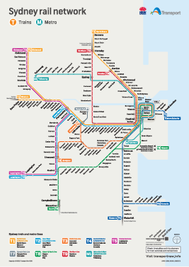 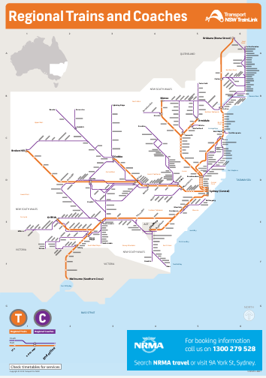

An indexed station guide gives an indication of the sparse level of wheelchair accessible stations. And although Transport for NSW has [online explanations and journey planning](https://transportnsw.info/travel-info/using-public-transport/accessible-travel/access-to-trains-in-nsw) resources for accessible travel, some trains and most coaches are inaccessible, or travel too infrequently to be used for emergency evacuations.

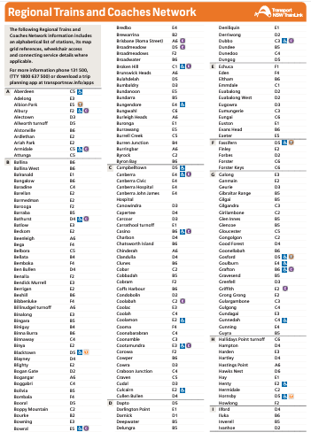 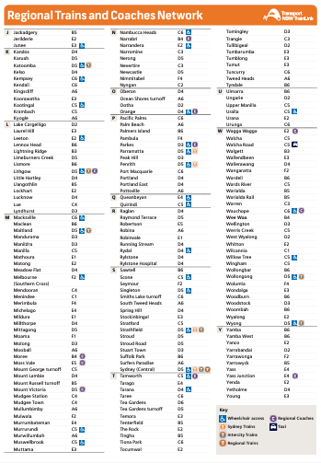

On the 15-16th October a member of PWDA staff the attended the annual [Community Transport Conference](https://www.cto.org.au/conference-2024-2/) We learned that community transport, which is often the only form of accessible public transport, is not planned to be part of any emergency evacuation. If community transport providers do help with evacuations, they must do so as volunteers- accepting the costs, issues and liabilities themselves. Community transport services also do not usually operate outside 9-5, meaning that if a person with disability needs to evacuate there may be nobody available to call.

For a P-CEP to work there must be accessible forms of public transport people with disability can access to execute their plan. More work needs to be done to plan for accessible transport during emergencies and for early evacuation of people with disability. Community transport vehicles may be the only form of accessible vehicle available in many rural and regional communities and they should be able to be used.

**Recommendation 15**

PWDA recommends that transport mapping be undertaken, and plans be developed and resourced to provide accessible transport in emergencies

# Discussion

The number and severity of disasters in Australia in the last five years has been unprecedented, [50] resulting in a number of enquiries and recommendations being made by Government, including the 2020 NSW Bushfire Inquiry[51] and 2022 NSW Flood Inquiry[52]. The National Emergency Management Agency (NEMA) has recognized that “recent experiences across Australia of increasingly intense, frequent and compounding disasters highlight the importance of disability inclusive disaster preparation[53].

In spite of the recognition of the issues, the UNDRR 2023 Global Survey Report on Persons with Disabilities and Disasters[54] found that limited progress has been made in disability inclusion over the past 10 years.

State and federal legislation and governance outlines the roles and responsibilities of policy and decision makers along with the roles and responsibilities of emergency services and supporting agencies. PWDA has contributed to the development of the P-CEP, but it is clear from the above that the ability of people to prepare and respond to emergencies is hampered by a lack of resources, clear communication, accessible information, accessible safe shelters, and transport issues.

On 31 March 2022, PWDA and the Queenslanders with Disability Network (QDN) wrote an [open letter](https://pwd.org.au/wp-content/uploads/2022/03/Joint-Open-Letter-QDN-PWDA-Leave-no-one-behind.pdf)[55] to all parties contesting the Federal election. It called for action, resourcing and investment into ensure that people with disability in Australia are included and represented across all levels of (emergency management) policy, practice and research to improve the safety and wellbeing of people with disability before, during and after a disaster.

The letter, with signatories from Australia’s leading disability rights, advocacy and peak body organisations, included the issues paper ‘Clearing a path to full inclusion of people with disability in emergency management policy and practice in Australia[56]’ which provided five recommendations, and associated actions, all of which are still relevant today:

* Build nationally consistent standards for including disability representation into all emergency management arrangements (policies, practices and activities) at all levels of government.
* Prioritise collaborative and inclusive disability research that will assist government and emergency personnel to understand and respond to the extra support needs of people with disability in emergencies.
* Provide person-centred resources, support, and advocacy where needed for people with disability to self-assess their risks and tailor personal emergency preparedness to their support needs and situation.
* Develop a nationally consistent approach to capacity development for community and disability service providers and disability advocates in person-centred emergency preparedness and service continuity planning.
* Provide explicit policy guidance on who takes responsibility for the extra support needs of people with disability in emergency situations including, how that support should be organised and delivered before, during and after disaster, and how the responsibilities of different stakeholders will be guided and outcomes measured.

NEMA developed, in 2023, the Disability Inclusive Disaster Risk Reduction (DIDRR) Program to ‘improve national capability in policy guidance and resource development for more disability inclusive disaster management’ engaging, with $1 million funding under the Disaster Risk Reduction Package (DRRP), the University of Sydney Centre for Disability Research and Policy[57] to develop National DIDRR Guiding Principles and Standards for disability inclusive disaster arrangements and a toolkit to operationalise planning and practices.

Emergency management policy still lacks the acknowledgement of people with disability and their unique needs relating specifically to accessibility and mobility which make them more vulnerable during a disaster. Whilst the impact of disasters on people with disability is well known and documented, it remains theoretical and there is still a systemic failure in policy design and the integration of considerations to improve prevention, preparedness, response and recovery guidelines to achieve improved outcomes for people with disability or organisations and individuals who provide services and support.

Without overarching policy, emergency management strategy and procedures often fail to address the issues and situations which place people with disability at greater risk, and furthermore do not provide a foundation to justify further investment of resources into the planning for measures that can result in quantitative and qualitative emergency management outcomes for people with a disability including risk reduction and improved resilience.

The NSW Disability Inclusion Action Plan 2021-2025[58], to support the implementation of the Australian Government Department of Social Services’ Australia’s Disability Strategy 2021-2023[59], highlights the need for better systems and processes including regulations to be inclusive of emergency management and safety. This remains predominantly in discussion only noting from the most recent progress report[60] that:

“*A forum was held on Emergency Preparedness. Over 55 participants discussed the opportunities to better link people with disability, the sector and advocates with resources to prepare for the next critical event such as a flood, fire, pandemic, drought or medical emergency*”

This suggests whilst consultation is taking place there is little that has been done in terms of changes to policy despite the increasing frequency of disasters and awareness of the vulnerability and greater risk for people with disability.

Australia’s Disability Strategy 2021-2023 Outcomes Framework[61] key system measures “% (and number) of disaster management services that have disability inclusive plans in place” and population measure “% of people with disability who report having participated in an informal learning activity in the last 12 months” have yet to be developed according to the National Disability Data Asset[62].

People with disability and their DRO’s have so much to offer the Australian community in terms of their ability to identify issues and gaps and recommend solutions for emergency management planning that could save many lives. We need a plan to include their experience at local, regional, state and federal levels, and to resource the recommended solutions.

Australia already benefits from the many staff and volunteers with disability who serve in government at all levels, combat agencies, service providers and Aboriginal controlled organizations. Their experience and intersectional knowledge needs to be systematically gathered, appreciated, reflected in plans and their voices and perspectives included in decision making.

**Recommendation 16**

PWDA recommends that people with disability continue to be a priority cohort, and that their DROs be included in NEMA, State Emergency Management Committees (SEMCs) and Regional Emergency Management Committees (REMC) and their knowledge applied to emergency planning.

**Recommendation 17**

PWDA recommends that NEMA members, SEMCs and REMC members be required to complete the free eLearning Introduction to Disability Awareness course, [63] and the Emergency Sector Disability Awareness learning module.[64]

**Recommendation 18**

PWDA recommends that at least one member of each REMC, to further complete the Person-Centred Emergency Preparedness (P-CEP) Certificate Course with a view to assisting with representing, and advocating for, people with disability by establishing and maintaining a regional forum for ongoing consultation and communication with people with disability and representative organisations and services

**Recommendation 19**

PWDA recommends SEMCs commission and fund the development of an initiative, including a program evaluation to support recurrent funding, to facilitate local involvement of people with disability in disaster preparedness, based on the European Centre for Forest Fires (ECFF) work titled ‘Leave No One Behind: Active Involvement of Persons with Disabilities in Disaster Preparedness and Response towards Strengthening Inclusive Disaster Resilience[65]’ to:

1. Enable people with disability to access information on their local risks and hazards and learn more about emergency management arrangements
2. Enable people with disability to identify risk reduction activities that can be undertaken in their home or business.
3. Enable people with disability to complete, with support if required, a risk-informed emergency plan relevant to their circumstances and location.

**Recommendation 20**

That NEMA and SEMCs work together with people with disability to develop roadmap to assist people with disability to identify and navigate the information, resources, tools, local hazards, plans and apps available, addressing any accessibility barriers

# References

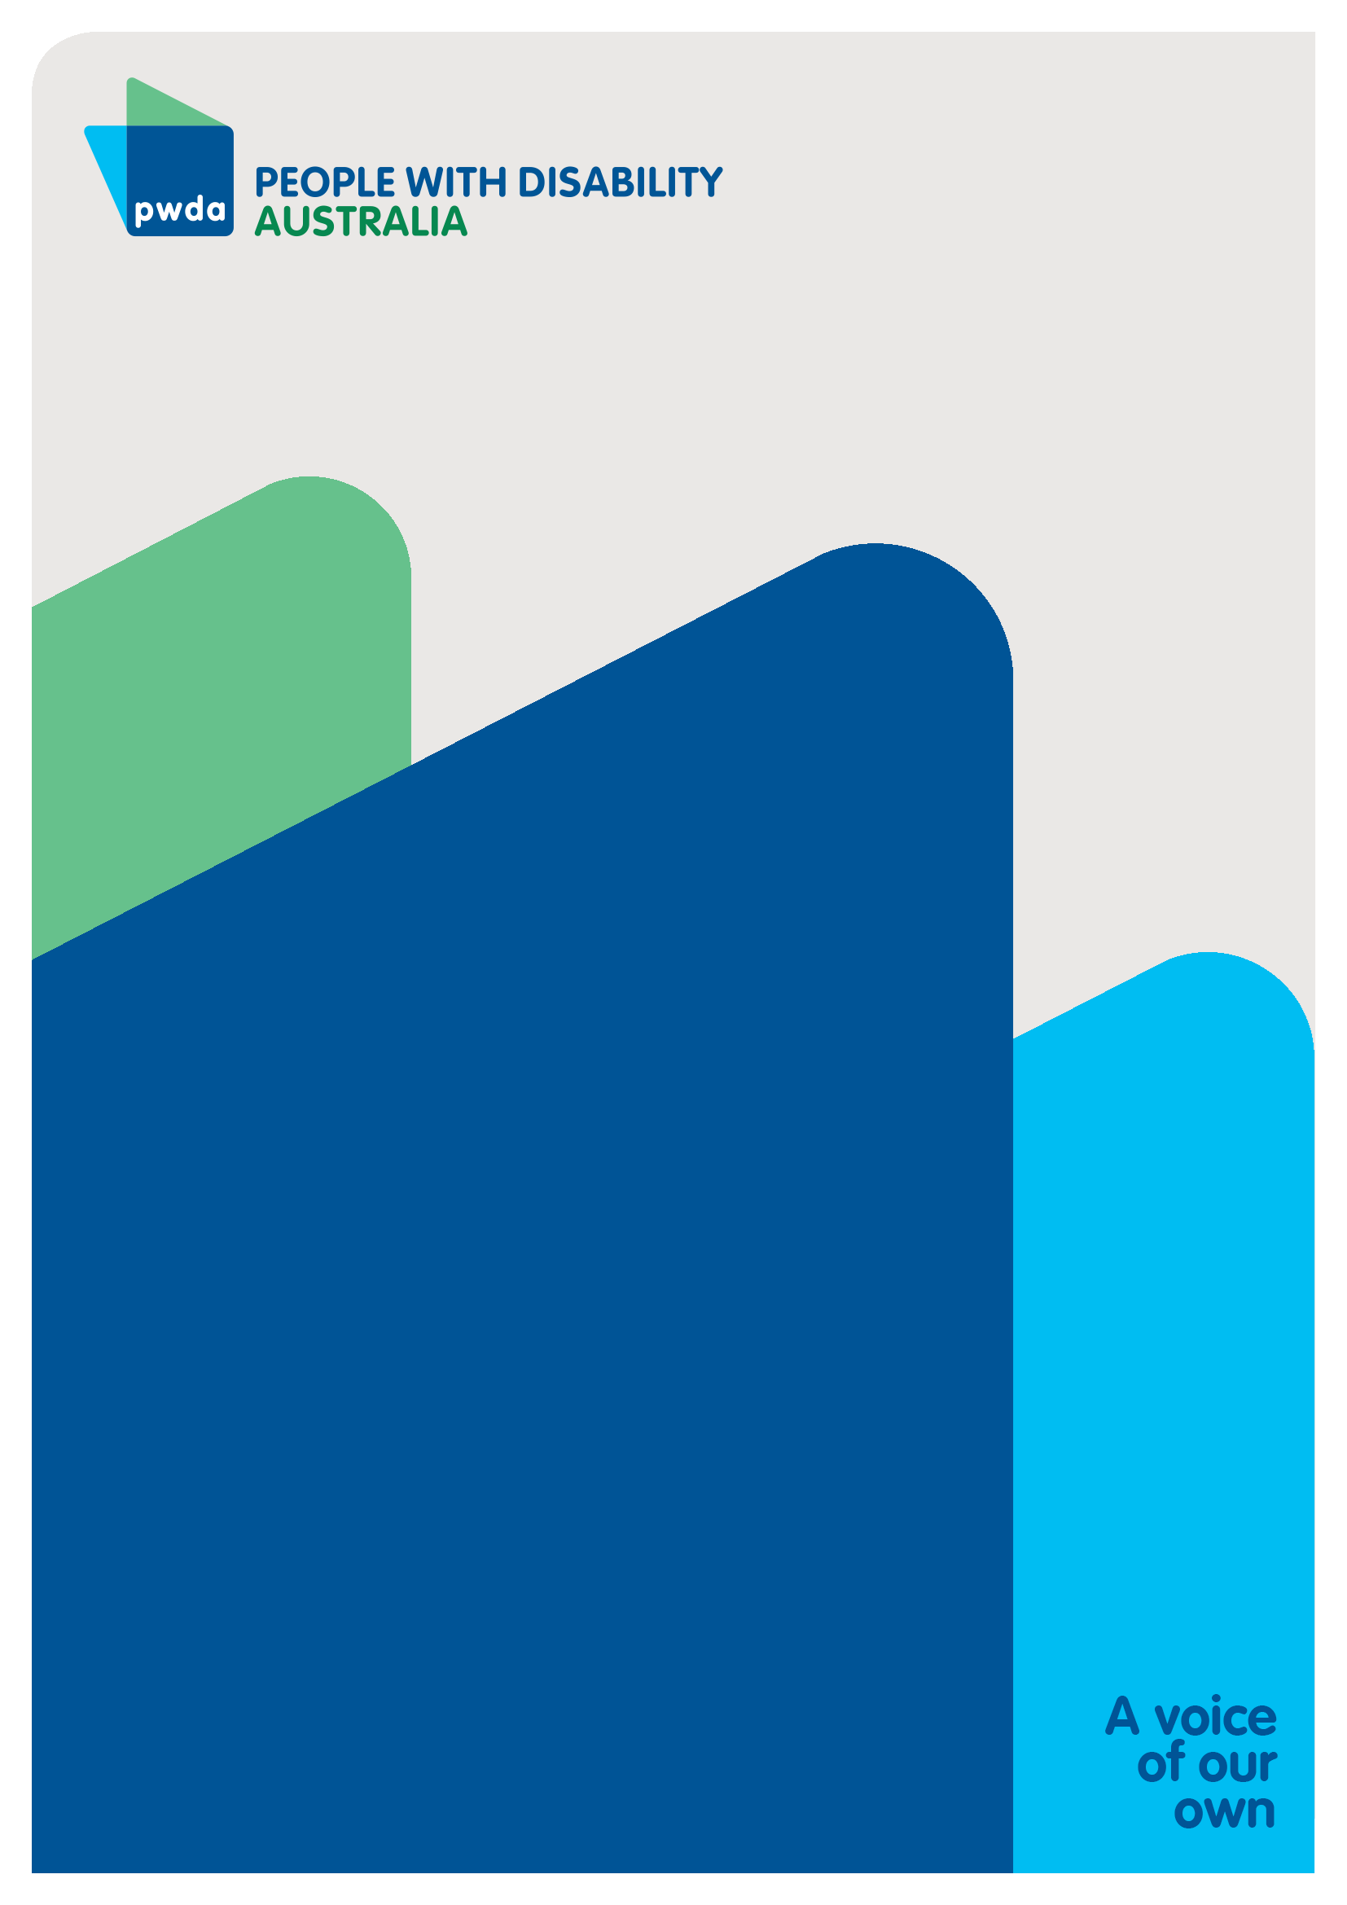

People with Disability Australia (PWDA) is a national disability rights and advocacy organisation made up of, and led by, people with disability.

For individual advocacy support contact PWDAbetween 9 am and 5 pm (AEST/AEDT) Monday to Friday via phone (toll free) on **1800 843 929** or via email at [pwd@pwd.org.au](mailto:pwd@pwd.org.au)

**Report Contact**

Bastien Wallace

Senior Policy Officer

E: [BastienW@pwd.org.au](mailto:BastienW@pwd.org.au)

1. Australian Institute of Health and Welfare, *People with Disability in Australia 2022* (2022) <https://www.aihw.gov.au/reports/disability/people-with-disability-in-australia/contents/about>; Australian Bureau of Statistics, *Disability, Ageing and Carers, Australia: Summary of Findings* (2019) <https://www.abs.gov.au/statistics/health/disability/disability-ageing-and-carers-australia-summary-findings/latest-release#disability>**.** 
2. Rosemary Kayess and Therese Sands, *Convention on the Rights of Persons with Disabilities: Shining a light on Social Transformation* (UNSW Social Policy Research Centre, 2020); Australian Bureau of Statistics (n1); Australian Institute of Health and Welfare (n 1); Jeromey B Temple, Margaret Kelaher and Ruth Williams, ‘Discrimination and avoidance due to disability in Australia: evidence from a National Cross-Sectional Survey’ (2018) 18 *BMC Public Health* 1347.
3. Australian Institute of Health and Welfare (2024) *People with disability in Australia*, AIHW, Australian Government, (n 1) 163, accessed 05 November 2024, <https://www.aihw.gov.au/reports/disability/people-with-disability-in-australia/contents/summary>
4. Anti-Discrimination NSW, *Annual Report 2021-22* (2022) 15, <https://antidiscrimination.nsw.gov.au/documents/annual-reports/anti-discrimination-annual-report-2021-22.pdf>
5. Australian Institute of Health and Welfare (2024) *People with disability in Australia*, AIHW, Australian Government, (n 1) 163, accessed 05 November 2024, <https://www.aihw.gov.au/reports/disability/people-with-disability-in-australia/contents/summary>
6. Committee on the Rights of Persons with Disabilities, General comment No. 6 (2018) Equality and non-discrimination CRPD/C/GC/6 (26 April 2018) [30]; Australian Human Rights Commission, Free and Equal. A reform agenda for federal discrimination laws (December 2021) 16; United Nations, Convention on the Rights of Persons with Disabilities (12 December 2006), article 5.
7. Royal Commissioninto Violence, Abuse, Neglect and Exploitation of People with Disability, Emergency planning and response issues papers, 15 April 2020, last accessed 5 November 2024, <https://disability.royalcommission.gov.au/publications/emergency-planning-and-response>
8. Royal Commissioninto Violence, Abuse, Neglect and Exploitation of People with Disability Statement of concern - The response to the COVID-19 pandemic for people with disability, 26 March 2020, last accessed 5 November 2024, <https://disability.royalcommission.gov.au/publications/statement-concern-response-covid-19-pandemic-people-disability>
9. Disability Awareness. Introduction to Disability Awareness. <https://disabilityawareness.com.au/elearning/disability-awareness/>
10. The University of Sydney, Emergency Sector Disability Awareness <https://collaborating4inclusion.org/emergency-sector-disability-awareness/>
11. European Center for Forest Fires, Leave No One Behind <https://www.preventionweb.net/media/97508/download?startDownload=20240920>
12. United Nations Office for Disaster and Risk Reduction, Sendai Framework for Disaster Risk Reduction 2015–2030, 2015, last accessed 5 November 2024, <https://www.undrr.org/publication/sendai-framework-disaster-risk-reduction-2015-2030>
13. Sendai Framework for Disaster Risk Reduction 2015-2030, UNISDR/GE/2015 – ICLUX EN5000 1st edition, March 2015, [19d], p 13. <https://www.undrr.org/publication/sendai-framework-disaster-risk-reduction-2015-2030>.
14. Janet Edwards National Implementation of the Sendai Framework Swedish Civil Contingencies Agency, presentation, last accessed online 5 November 2024, [https://www.cascade-bsr.eu/sites/cascade-bsr/files/03_msb_-_sendai_framework_for_disaster_risk_reduction.pdf P 6-7](https://www.cascade-bsr.eu/sites/cascade-bsr/files/03_msb_-_sendai_framework_for_disaster_risk_reduction.pdf%20P%206-7) &18
15. National Disaster Risk Reduction Framework, Australian Government Department of Home Affairs, 2018, last accessed 5 November 2024, <https://www.homeaffairs.gov.au/emergency/files/national-disaster-risk-reduction-framework.pdf> p 8
16. Australian Disaster Preparedness Framework: A guideline to develop the capabilities required to manage severe to catastrophic disasters, Australian Government Department of Home Affairs, 2018, last accessed 5 November 2024, <https://www.homeaffairs.gov.au/emergency/files/australian-disaster-preparedness-framework.pdf>.
17. Australian Government, Department of Prime Minister and Cabinet, Australian Government Crisis Management Framework, last accessed 5 November 2024, <https://www.pmc.gov.au/resources/australian-government-crisis-management-framework-agcmf/introduction/hierarchy-documents>
18. Australian Government, National Emergency Management Agency, Australian Disaster Resilience Knowledge Hub, Australian Emergency Management Handbook, last accessed 5 November 2024, https://knowledge.aidr.org.au/resources/handbook-australian-emergency-management-arrangements/
19. The Royal Commission Into National Natural Disaster Arrangements, Report, 30 October 2020, last accessed 5 November 2024, <https://www.royalcommission.gov.au/natural-disasters/report>
20. Australian Emergency Management Arrangements, Australian Disaster Resilience Handbook Collection 2023, last accessed 5 November 2024, <https://knowledge.aidr.org.au/media/10162/handbook_aema_web_2023.pdf>
21. Australian Government, Department of Health and Aged Care, Emergency Management Plans, last accessed 5 November 2024, https://www.health.gov.au/resources/collections/emergency-management-plans
22. Australian Government, Department of Home Affairs, Emergency Response Plans, last accessed 5 November 2024, <https://www.homeaffairs.gov.au/about-us/our-portfolios/emergency-management/emergency-response-plans>
23. Police, Fire, Ambulance, SES, RFS, Hospitals and Health Services etc
24. Parliament of Australia, Flood failure to future fairness, report - October 2024, last accessed 5 November 2024, <https://www.aph.gov.au/Parliamentary_Business/Committees/House/Economics/FloodInsuranceInquiry/Report>
25. Dr Robert Glasser Chair Independent Review of National Natural Disasters Governance Arrangements, Independent Review of National Natural Disaster Governance Arrangements – Final Report, 5 December 2023, released 25 October 2024, <https://www.nema.gov.au/sites/default/files/2024-10/20240813%20-%20Glasser%20Review%20-%20Final%20Report_copy%20edit.PDF> P1-13
26. Andrew Colvin AO APM, Australian Government, Independent Review of Commonwealth Disaster Funding, released 25 October 2024, <https://www.nema.gov.au/sites/default/files/2024-10/Independent%20Review%20of%20Commonwealth%20Disaster%20Funding%20-%20Final%20report%20-%20Medium%20Res.PDF>
27. NSW Government, State Emergency and Rescue Management Act 1989 No 165

    Current version for 11 December 2023, last accessed 5 November 2024,

    <https://legislation.nsw.gov.au/view/html/inforce/current/act-1989-165>
28. NSW Government, State Emergency Management Plan 2023, last accessed 5 November 2024, <https://www.nsw.gov.au/sites/default/files/noindex/2024-02/State_Emergency_Management_Plan_2023.pdf>
29. NSW Government, State emergency management sub-plans, last accessed 5 November 2023, <https://www.nsw.gov.au/rescue-and-emergency-management/sub-plans>
30. NSW Government, Regional plans and management, last accessed 5 November 2024, <https://www.nsw.gov.au/emergency/rescue-and-emergency-management/regional-plans-and-management>
31. NSW Government, State Rescue Policy, last accessed 5 November 2024, <https://www.nsw.gov.au/emergency/rescue-and-emergency-management/state-rescue-policy>
32. NSW Government, State Rescue Board Accredited Rescue Units, last accessed 5 November 2024, https://www.nsw.gov.au/emergency/rescue-and-emergency-management/state-rescue-policy/state-rescue-board-accredited-rescue-units
33. Australian Institute for Disaster Resilience (2023) Evacuation Planning East Melbourne, Australia, last accessed 5 November 2024, <https://knowledge.aidr.org.au/media/10505/handbook_evacuation_planning_2023.pdf>
34. Australian Government, Australian Institute for Disaster Resilience, Australian Disaster Resilience Knowledge Hub, last accessed 5 November 2024, <https://knowledge.aidr.org.au/collections/handbook-collection/>
35. NSW State Emergency Service, Emergency Plan, last accessed 5 November 2025, <https://www.ses.nsw.gov.au/emergency-plan/>
36. Collaborating 4 Inclusion, Person-Centred Emergency Preparedness <https://collaborating4inclusion.org/pcep/pcep-learning-resources/about-pcep-course-revised/>
37. Collaborating 4 Inclusion, Disability-Inclusive Emergency Planning <https://collaborating4inclusion.org/diep/>
38. Collaborating 4 Inclusion, DIDRR Framework and Toolkit for Collaborative Action, last accessed 5 November 2024, <https://collaborating4inclusion.org/didrr-framework-and-toolkit-for-collaborative-action/>
39. Oxford English Dictionary, Last accessed 5 November 2024, <https://www.oxfordlearnersdictionaries.com/definition/english/plan_1>
40. Dr Ariella Meltzer, Crisis communication saves lives – but people with disability often aren’t given the message, The Conversation, 15 April 2024, <https://theconversation.com/crisis-communication-saves-lives-but-people-with-disability-often-arent-given-the-message-224968>
41. UNSW - Disability Innovation Institute, Dr Ariella Meltzer, UNSW Centre for Social Impact Information accessibility for people with disability during COVID-19, last accessed 5 November 2024, <https://www.disabilityinnovation.unsw.edu.au/information-accessibility-people-disability-during-covid-19>
42. Centre for Social Impact, Dr Ariella Meltzer, Better acknowledging and resourcing the information accessibility sector in Australia, April 2024, last accessed 5 November 2024, <https://www.csi.edu.au/research/better-acknowledging-and-resourcing-the-information-accessibility-sector-in-australia/>
43. An Australian Government Initiative, National Disasters: Prepare, Respond, Recover, National Auslan Communication for Emergencies, last accessed 5 November 2024, <https://auslanemergency.com.au/wp-content/uploads/2016/07/NEMP-Auslan-Signs.pdf>
44. Lifesaving Victoria, National Aquatic and Recreation Signage Manual: Third edition, , last accessed 5 November 2024, <https://www.lifesavingsupport.com.au/Downloads/National-Aquatic-Recreation-Signage-Manual.pdf>
45. Australian Institute for Disaster Resilience (2023) Evacuation Planning East Melbourne, Australia, last accessed 5 November 2024, <https://knowledge.aidr.org.au/media/10505/handbook_evacuation_planning_2023.pdf>
46. Australian Government NEMA, Australian Institute for Disaster Resilience, , Australian Disaster Resilience Knowledge Hub, Increasing involvement of people with disability, Australian Journal of Emergency Management, October 2019 edition last accessed 5 November 2024, <https://knowledge.aidr.org.au/resources/ajem-october-2019-increasing-involvement-of-people-with-disability/>
47. Krisis Flood Bag <https://krisisbags.com/krisis-flood-bags-dry-bags-how-do-they-work/>
48. Australian Government, Department of Climate Change, Energy, Environment and Water, National Climate Risk Assessment: First pass assessment report 2024, last accessed 5 November 2024, <https://www.dcceew.gov.au/climate-change/publications/ncra-first-pass-risk-assessment>
49. NSW Government, NSW Bus Industry Taskforce, The Forgotten Mode: NSW Bus Industry Taskforce Document Title a call to action for buses, May 2024, last accessed 5 November 2024, <https://www.transport.nsw.gov.au/system/files/media/documents/2024/NSW-Bus-Industry-Taskforce-Third-Report.pdf>
50. Department of Home Affairs, Australian Disasters <https://www.disasterassist.gov.au/find-a-disaster/australian-disasters>
51. NSW Government, NSW Bushfire Inquiry <https://www.nsw.gov.au/departments-and-agencies/premiers-department/access-to-information/nsw-bushfire-inquiry/nsw-bushfire-inquiry-report>
52. NSW Government, NSW Flood Inquiry <https://www.nsw.gov.au/nsw-government/engage-us/floodinquiry>
53. National Emergency Management Agency, Disability Inclusive Disaster Preparation <https://nema.gov.au/disability-inclusive-disaster-preparation>
54. United Nations Office for Disaster Risk Reduction, 2023 Global Survey Report on Persons with Disabilities and Disasters <https://www.undrr.org/report/2023-gobal-survey-report-on-persons-with-disabilities-and-disasters>
55. People With Disability Australia and Queenslanders with Disability Network, Open Letter to 2022 Federal Election Parties <https://pwd.org.au/wp-content/uploads/2022/03/Joint-Open-Letter-QDN-PWDA-Leave-no-one-behind.pdf>
56. Villeneuve, M. (2020). Clearing a path to full inclusion of people with disability in emergency management policy and practice in Australia. Centre for Disability Research and Policy. The University of Sydney, NSW, 2006.
57. The University of Sydney, Faculty of Medicine and Health, Centre for Disability Research and Policy <https://www.sydney.edu.au/medicine-health/our-research/research-centres/centre-for-disability-research-and-policy.html>
58. NSW Department of Communities and Justice, NSW Disability Inclusion Action Plan 2021-2025 <https://dcj.nsw.gov.au/documents/community-inclusion/disability-inclusion/nsw-disability-inclusion-plan/nsw-disability-inclusion-plan.pdf>
59. Department of Social Services, Australia’s Disability Strategy 2021-2031 <https://www.dss.gov.au/disability-and-australias-disability-strategy-2021-2031>
60. NSW Department of Communities and Justice, NSW Disability Inclusion Plan 2021-2025 and Disability Inclusion Action Plan 2021-2025 <https://dcj.nsw.gov.au/documents/community-inclusion/disability-inclusion/nsw-disability-inclusion-plan/2022-2023-Progress-Report.pdf>
61. Department of Social Services, Australia’s Disability Strategy 2021-2031 Outcomes Framework <https://www.disabilitygateway.gov.au/sites/default/files/documents/2021-11/1816-outcomes-framework.pdf>
62. National Disability Data Asset <https://www.ndda.gov.au/>
63. Disability Awareness. Introduction to Disability Awareness. <https://disabilityawareness.com.au/elearning/disability-awareness/>
64. The University of Sydney, Emergency Sector Disability Awareness <https://collaborating4inclusion.org/emergency-sector-disability-awareness/>
65. European Center for Forest Fires, Leave No One Behind <https://www.preventionweb.net/media/97508/download?startDownload=20240920>