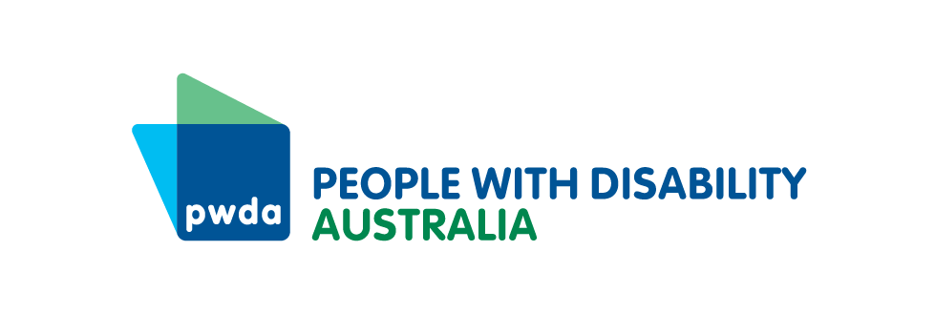

PO Box 666  
Strawberry Hills  
NSW 2012

+61 2 8365 0400  
Toll free 1800 422 015  
[pwd@pwd.org.au](mailto:pwd@pwd.org.au)[www.pwd.org.au](http://www.pwd.org.au/)

20 January, 2025

Homes NSW

Delivered by email to [homelessness.strategy@homes.nsw.gov.au](mailto:homelessness.strategy@homes.nsw.gov.au)

Dear Sir or Madame

## Re: Homes NSW draft NSW Homelessness Strategy 2025-2034

Thank you for the opportunity to respond to the Homes NSW [draft NSW Homelessness Strategy 2025-2034](https://www.facs.nsw.gov.au/download?file=860870).

[People With Disability Australia](https://pwd.org.au) (PWDA) is Australia’s national peak disability organisation, representing the 1 in 6 Australians with disability. We are the leading disability rights advocacy and representative organisation and the only national cross-disability organisation representing the interests of people with all kinds of disability. We are a not-for-profit and non-government organisation, and our membership is comprised of people with disability and organisations primarily constituted by people with disability, including the [PWDA Board](https://pwd.org.au/about-us/our-board/) and many members of [our staff](https://pwd.org.au/about-us/our-staff/).

## Our Work

PWDA co-chairs the [Building Better Homes Campaign](https://buildingbetterhomes.org.au/) with the [Physical Disability Council of NSW](https://www.pdcnsw.org.au/) (PDCN) where we call on all States and Territories in Australia to adopt the National Construction Code (NCC) for all new dwellings, which includes the mandatory [Livable Housing Design Silver Standard](https://livablehousingaustralia.org.au/lha-silver/" \t "_blank). This standard provides a minimum level of accessibility for people with disability, reducing the need for expensive modifications to enable access.

In previous submissions we have also called for housing for essential workers to be built to NCC standards and for the definition of ‘Essential Worker’ to be widened to include disability, aged care, child care and social services workers, all of whom are paid less than nurses, paramedics, teachers, allied health care workers, police officers and fire fighters- the government’s original eligibility list.

We have also called for all homes built in Transport Oriented Design precincts to meet NCC standards and for 50% of them to be allocated to become affordable housing, with rent set at no more than 30% of a person’s income.

Reviewing the [draft NSW Homelessness Strategy 2025-2034](https://www.facs.nsw.gov.au/download?file=860870), the [consultation paper](https://www.facs.nsw.gov.au/download?file=860872) and [background documents](https://www.facs.nsw.gov.au/housing/nsw-response-to-homelessness/new-nsw-homelessness-strategy-2024-2034), we have addressed the questions posed below.

**Questions:**

1. **What do we need to consider as we implement services and system reform guided by these principles over the next 10 years?**

Homelessness prevention efforts should focus on people with disability. 22% of people living in social housing in NSW have the Disability Support Pension as their primary income and 44% are seniors – meaning more likely to become disabled as part of the aging process.

**Applying for Housing**: The process of applying for housing, whether in the commercial, public or social housing sectors, is inaccessible for people with psychosocial disability, for people who use assistive communication technologies, for people on low incomes who cannot afford up to date digital devices, data or internet plans, or for people who may lack the documentation in their own name to prove a rental history if they have lived in a congregate setting or with family. The Homes NSW Discussion Paper admits that the application, allocation and waitlist process is a huge barrier.

We recommend as a start, ensuring all processes are provided in Easy English and Easy Read formats, to improve comprehension and more easily enable the use of assistive technologies or translation tools. We recommend that once Homes NSW has made its own application process accessible, that it leads a process of standards improvement for the wider housing sector.

People with disability are often required to re-prove their disability, often with expensive reports from specialists who it takes many months to get an appointment with. Where a disability is of a type that does not change, this should not happen, and all proofs should only have to be provided once.

For people with disabilities whose support needs increase, the assessment process needs to be made more accessible and affordable.

We also need a recognition and adoption of accessible application processes by Real Estate Agents and the firms that verify identity, for housing applications in the private market. People with disability need the application process, information and documents to be in accessible formats, and for private rental accommodation to be advertised in ways that make clear how physically accessible it is (step-free access, showers etc).

As part of improving the efficiency of allocation processes, we recommend Homes NSW work to provide agencies and non-profits working to assist people into housing with a map of what housing exists where, and what is available (single/ family/ accessibility features).

**Suitable Housing:** There is a lack of suitable housing available or being built for people who have, or acquire over time, a disability that impacts physical accessibility. Only Social Housing and homes built using the NSW Pattern book designs will conform with the National Construction Code that requires homes to be built to a minimum standard that would at least enable a person who uses a wheelchair to be able to enter the home, access doorways, access at least one bathroom and bedroom on the ground floor, that would be able to be modified to fit grab-rails to the bathroom walls if needed. This means that most homes built will not be required to meet the standard, meaning that far more people with disability will need to access social housing than would otherwise occur if all housing was accessible.

Housing needs to be built and upgraded to meet better thermal and acoustic standards to improve the safety, amenity and wellbeing of occupants.

In order for homes to be suitable for people with disability, they also need to be accessible to travel to and from the home, and people must be able to access the supports they have already engaged or require to live full lives.

**Housing Modification:** Much of the public, social and private housing stock is inaccessible to people with disability due to stair access, narrow doorways, internal stairs, bathrooms whose dimensions are too small and whose walls too weak to fit rails. Houses may be capable of being modified, but inappropriately built apartments often cannot, lest structural elements are compromised. Furthermore, private landlords cannot be compelled to allow modifications.

As Australians age, an increasing proportion of the population will require modifications or end up prematurely in aged care if they cannot be made.

1. **Which principles should be prioritised and why?**

The order of principles is correct in terms of priorities, but the lived experience of people with disability and their needs should be incorporated in each of the principles.

**Questions:**

1. **To make homelessness rare, what should NSW prioritise for action and why?**

* 10,000 people a month are becoming homeless (UNSW & Homelessness Australia Dec 2024 report), and 3 million Australians are at risk of homelessness (Impact Economics and ACOSS data). We need to stop more people becoming homeless by supporting more people to remain in private housing- whether through rent subsidies, financial assistance, compelling banks to lower interest rates. As long as the problem keeps increasing at this rate there is no hope of making homelessness brief and non-recurring.
* Homes NSW and the government needs to increase the supply of a range of quality accessible and appropriate housing types in NSW, including social, affordable and key worker housing.

If the NSW Government releases land for housing development it must allocate at least 50% to public and social housing, otherwise a government asset (land) will only be turned into more Air B&Bs and unaffordable rentals that benefit only developers and the wealthy.

* Support people leaving government services into appropriate housing.
* Ensure all housing is built to the National Construction Code standard, increasing the supply of accessible housing. This gives people with disability the opportunity to rent privately – that they will otherwise be excluded from.
* People need to be able to access longer leases, especially where housing modification has been undertaken to improve accessibility for tenants who need this.
* Repairs and maintenance needs to be made proactively and responsively to promote the wellbeing of tenants

1. **What opportunities and risks are there for implementing actions under this outcome?**

There is an opportunity to reduce the strain on public and social housing by ensuring all new housing is built to meet the National Construction Code standards, and a risk that by not doing this, people with disability will have no choice outside the social housing system. Building new housing takes years to have an impact, but over 1 million homes are empty each night in Australia (13 million bedrooms), around 9.4% of NSW homes (2021 Census and AHURI data). The NSW Government needs to do more to incentivise the use of these properties to house people. The NSW and Federal Governments contribute to the National Rental Affordability Scheme that “…offers tax and cash incentives to providers of new dwellings, provided they are rented to low, and moderate, income households at 20% below market rates..” This could be altered to provide land tax or income tax incentives to rent existing properties to low income, renters at below market rent. Ideally negative gearing and capital gains tax benefits should be restricted to landlords who rent properties rather than using them for Air B&B or short term lets. The tax system should incentivise landlords to: rent properties at below market rates for needy families, provide longer leases and enable accessibility modifications to be made.

1. **What types of target(s) would be most useful to measure our impact and why?**

Measure who is homeless, for how long, where, and why. Measure what proportion of people who are homeless have disability, and what kinds of housing they need to accommodate them. Measure where housing is located, whether it is accessible, how long it is empty and why. Have a target to minimise homelessness and maximise housing utilisation.

#### Homelessness is brief

**Outcome 2 - When homelessness does occur, people are quickly connected to housing and the supports they need**

**Questions:**

1. **To make homelessness brief, what should NSW prioritise for action and why?**

Homes NSW needs to prioritise providing the resources and information (for example mapping of available homes and types) that local coordination groups need to understand housing availability. It also needs to require that screening, triage, assessment, intake and referral services that are provided accessible and inclusive- and to resource reforming these where needed.

1. **What opportunities and risks are there for implementing actions under this outcome?**

There are opportunities to co-develop policy and process improvements with people with disability and their DROs. PWDA’s successful Building Access program has helped make domestic violence housing and services more accessible for women or their children who have a disability. Homes NSW could support services to partner with disability representative organisations to co-design policy and service improvement.

1. **What types of target(s) would be most useful for measuring our impact and why?**

Current numbers and demographics of people who are homeless or seeking assistance to avoid homelessness, vs historical numbers. Numbers of people turned away from services and why.

#### Homelessness is not repeated

**Outcome 3 - When homelessness does occur, people do not experience multiple episodes of homelessness**

**Questions:**

1. **To ensure homelessness is not repeated, what should NSW prioritise for action and why?**

People with disability at risk of homelessness may need access to wrap-around supports to maintain their housing. For people with physical disability, changes in their condition or health may mean that they need modifications to adapt housing accessibility over time. People with psychosocial disability, trauma or complex needs may need a range of supports to help them maintain housing, social connections and their wellbeing.

These services need to be co-located with social housing, and to be delivered accessibly.

1. **What opportunities and risks are there in implementing actions under this outcome?**

There is an opportunity to create local jobs for residents by supporting training in service provision. This could include supporting residents of social housing to study to acquire qualifications to maintain or modify homes, or to provide mentoring and psychosocial supports drawing on lived experience.

Where possible Homes NSW could use Local Allocation Strategies (for example see [Local Allocation Strategies Policy – Southern Cross Housing](https://scch.org.au/policies-forms-fact-sheets/local-allocation-strategies-policy/) and [Inner City Local Allocation Strategy | Family & Community Services](https://www.facs.nsw.gov.au/housing/factsheets/inner-city-local-allocation-strategy)). At present these tend to be used to try and address existing challenges, though they could potentially be used in a more proactive way to help co-locate people around jobs, resources, education, health facilities or other supports to improve wellbeing and community engagement outcomes.

Small scale development appears to work best for social housing tenants and the broader community, however this may not be possible. Where small scale is not possible, Homes NSW could use a spatial mix of dwellings within project sites, using [Mixed-communities-for-FPA-Final](https://cityfutures.ada.unsw.edu.au/documents/463/Mixed-communities-for-FPA-Final.pdf) or [Visioning varieties of “mixed tenure” development   | City Futures Research Centre Blog](https://blogs.cityfutures.unsw.edu.au/news/visioning-varieties-mixed-tenure-development). Alternatively, Homes NSW could use a portfolio management approach to facilitate more mixed-use communities where overall targets for social and affordable households would be contracted, but tenants could stay in the same home if their financial position changed.

There is also an opportunity to redevelop group homes as people with disability are enabled to choose where they live and with whom. It can be difficult to access housing suitable for larger families, so there is an opportunity to redevelop group homes to meet this need.

1. **What types of target(s) would be most useful to measure our impact and why?**

It would be useful to measure the number and types of social housing available (1, 2, 3+ bedrooms, different accessibility features), the numbers of people who are homeless, for how long and the reason(s).

Yours sincerely

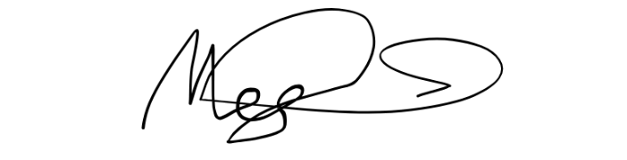

Megan Spindler-Smith

Deputy CEO

People with Disability Australia