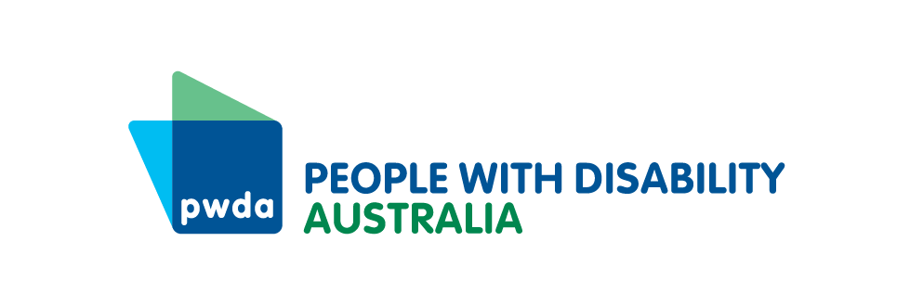

PO Box 666  
Strawberry Hills  
NSW 2012

+61 2 9370 3100  
Toll free 1800 422 015  
[pwd@pwd.org.au](mailto:pwd@pwd.org.au)[www.pwd.org.au](http://www.pwd.org.au/)

28 October 2024

Portfolio Committee No. 8 – Customer Service

NSW Legislative Council

NSW Parliament House

6 Macquarie Street

Sydney NSW 2000

Delivered via inquiry website: <https://www.parliament.nsw.gov.au/committees/inquiries/Pages/inquiry-details.aspx?pk=3071#tab-submissions>

Dear Portfolio Committee No. 8

# **Public Toilets and People with Disability in NSW**

People with Disability Australia (PWDA) welcomes this opportunity to provide comment on the inquiry into public toilets in New South Wales (NSW). PWDA is Australia’s peak cross-disability Disability Representative Organisation and is funded to provide cross-disability systemic advocacy on behalf of people with disability in NSW under the Department of Communities and Justice’s *Disability Advocacy Futures Program*.

Nationally, 2022 data shows 5.5 million Australians have a disability, around 21.4% of the population ([ABS 2024](https://www.abs.gov.au/statistics/health/disability/disability-ageing-and-carers-australia-summary-findings/latest-release)). This is an increase from 17.7% in 2018. In NSW the most recent 2018 data shows 16.9% of the population have a disability, equivalent to 1,346,200 residents ([ABS 2019](https://www.abs.gov.au/statistics/health/disability/disability-ageing-and-carers-australia-summary-findings/2018)). People with disability continue to experience discrimination and poorer life outcomes across all life domains when compared with those without disability ([Kayess & Sands 2020](https://disability.royalcommission.gov.au/system/files/2020-09/Research%20Report%20-%20Convention%20on%20the%20Rights%20of%20Persons%20with%20Disabilities%20Shining%20a%20light%20on%20Social%20Transformation.pdf); [ABS 2024](https://www.abs.gov.au/statistics/health/disability/disability-ageing-and-carers-australia-summary-findings/latest-release)).

Design decisions around our built environments and public spaces continue to act as barriers to the full participation and inclusion of people with disability in the community.

The lack of public toilets that are accessible to people with disability, are safe, support our diverse accessibility needs and which offer privacy is one specific and significant barrier to community inclusion that continues to be of concern to people with disability in NSW.

People with disability in NSW are concerned that:

* There are not enough accessible public toilets, particularly accessible toilets with adult change facilities based on the ‘Changing Places’ design.
* The number of public toilets including accessible public toilets is declining. There is considerable concern that the significant decrease in public toilets seen in the United Kingdom and United States and the well documented associated social harm including increased social isolation that ensued will occur in NSW.
* Existing public toilets are often poorly maintained. They are not safe, private or hygienic.
* Toilets are not placed in the best areas. In some cases, accessible toilets are placed in areas which are difficult to access in the first instance. Many accessible toilets are being kept locked.
* They are not sure who to talk to about public toilets in their local areas to seek improvements and voice concerns and are not confident they will be listened to.

A barrier to the full participation of a person in society is by nature political as it restricts access to public life and full citizenship (Kitchin & Law 2001, 289). A lack of accessible public toilets and changing places in NSW continues to *specifically* exclude people with disability from the public sphere. Thus, the provision of appropriate public toilets and indeed the individual act of toileting is a serious political issue for people with disability (Slater & Jones 2021, 51, 67).

Evidence directly links the provision of appropriate and accessible public toilets with increased ‘independence, autonomy, well-being and social participation’ of people with disability (Carnemolla et al 2024). Accessible public toilets facilities are rights affirming and support the fuller expression of ‘citizenship’ by supporting engagement in public and cultural life (Wiseman, 2019, 796; Darcy & Taylor 2009, 421). Similarly, by supporting the sharing of space between people with disability and those without they affirm that people with disability are of value, providing a powerful symbol of being welcomed, and promotion of a sense of belonging (Wiseman 2019, 802).

Because they promote autonomy and participation, accessible public toilets can be seen as one enabler of other fundamental human rights. Article 4 of the United Nations [Convention on the Rights of Persons with Disabilities](https://www.ohchr.org/en/instruments-mechanisms/instruments/convention-rights-persons-disabilities) (CRPD) makes clear that governments must take all appropriate measures to promote and realise the rights of persons with disability. PWDA submits that Article 4 (1)(f) of the CRPD extends this to include the direct and indirect provision of accessible public toilets. PWDA submits that Article 4 also by necessity requires legislative and administrative oversight of the provision of accessible public toilets in NSW by the state government.

More broadly there have been calls to recognise that access to public toilets should be explicitly recognised as a standalone fundamental human right separate to a right to basic sanitation and clean water. Such a right should be expressly included in domestic legislation. In the United States there are moves to see how this may be incorporated within state public health laws (Weinmeyer 2024). PWDA submits that given its significance as an enabler of other rights, access to appropriate public toilets should be seen as a human right.

Central to the design and placement of public toilets that meet the needs of people with disability is recognition by planners, designers, policy makers and the community that people with the same disability can experience that disability in different ways. Proper accessible public toilet design needs to reflect this multifaceted and intersectional nature of toilet use (Slater & Jones 2021, 55; Wiseman 2019, 790).

This means that people with disability must be consulted with through a co-design process around the placement and design of accessible public toilets. PWDA notes that Article 4 (3) of the CRPD places an obligation on governments ‘[i]n the development and implementation of legislation and policies to implement the present Convention, and in other decision-making processes concerning issues relating to persons with disabilities’ to ‘closely consult with and actively involve persons with disabilities, including children with disabilities, through their representative organizations’.

#### Recommendations

1. People with disability and their representative organisations must be key partners of the co-design process alongside decision-makers and other stakeholders at all levels of the standard design and review, facility design and placement of accessible public toilets in NSW.

Such a co-design process must demonstrate how the lived experience of people with disability is reflected in outcomes.

1. The NSW government should introduce new legislation or amend existing legislation to provide that NSW residents have a right to access accessible public toilets that are fit for purpose.
2. The NSW government should introduce new legislation or amend existing legislation to establish a body to provide oversight, coordination and review of the design, placement and construction of public toilets (including accessible) throughout NSW. This body must include people with lived experience of disability. Such a body will work with local councils to:
   1. ensure that all communities have sufficient accessible public toilets for their needs
   2. all accessible public toilets are built and maintained to the maximum accessible standard.
3. The NSW government should introduce new legislation, rules or regulations, or amend exiting legislation, rules or regulations to reflect that the design, placement and public engagement with public toilets must be guided by the Public Toilet Design Principles outlined by Katherine Webber in her 2019 Churchill Fellow Report ‘[Exploring Accessibility and Inclusion in Public Toilets’](https://universaldesignaustralia.net.au/wp-content/uploads/2019/09/projectReport-Webber-K-2018.pdf) and as amended by PWDA. These principles are (PWDA amendments are underlined):

* SAFETY & PRIVACY – All users want to feel safe, and have both audible and visual privacy, when using a toilet as it is private and vulnerable human function
* ACCESSIBILITY – Design must meet the specific user needs including minimal standards for physical and sensory accessibility. This also includes circulation spaces, handles, height of fixtures and lighting or sound management
* INCLUSION – Design to meet the needs of all populations, including ~~minority~~ marginalised groups. This includes a preference to single stall physical designs, signage that reflects all bodies and the review and enforcement of anti-discrimination policies
* LOCATION & AVAILABILITY – Toilets need to be easily locatable and provided in the appropriate number to respond to the number of users. This includes how far people need to travel to access them and the accessibility of the environment they are located in
* ATTRACTIVENESS – Aesthetics are important to make people feel comfortable. The design of the toilets should be a continuation of the place it is located in
* EASE OF MAINTENANCE & HYGIENE – Materials used in the construction need to allow for easy cleaning, resistance to vandalism and durable while still being functional and welcoming
* SUSTAINABLE – Design and maintenance needs to consider the use of resources such as water and electricity
* COMMUNICATION – Toilets need to be easy to find via signage or apps, include relevant information about operating hours and maintenance requests as well to be able to determine if a stall is available or occupied from a distance, this includes tactile ground surface indicators (TGSIs) and Braille or tactile signage
* COST EFFECTIVENESS – Considering public toilets as an investment in public amenity also ensure value for money and consideration of maintenance costs across the lifespan of toilets.

PWDA is happy to assist the Committee in its work and would welcome the opportunity to appear before it to speak about this letter and address other specific matters raised by the Committee in its terms of reference.

If you wish to discuss this letter, please contact Mr Julian Laurens, Senior Policy Officer at [julianl@pwd.org.au](mailto:julianl@pwd.org.au), or via telephone on 0490 534 059.

Yours sincerely

Megan Spindler-Smith signature on a white background



Megan Spindler-Smith

Deputy CEO, PWDA.