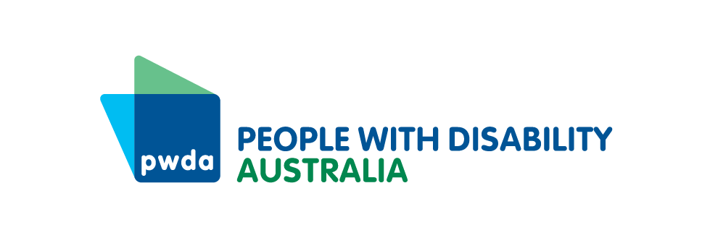

PO Box 666  
Strawberry Hills  
NSW 2012

Toll free 1800 422 015  
[pwd@pwd.org.au](mailto:pwd@pwd.org.au)[www.pwd.org.au](http://www.pwd.org.au/)

17 January 2025

# **Qantas Carer Concession Card Program Updates**

Thank you for being a current Qantas Carer Concession Card (QCCC) card holder.

Qantas has chosen People with Disability Australia (PWDA) to help people get Qantas Carer Concession Cards.

Qantas is making changes to the Qantas Carer Concession Card (QCCC) Program. These changes will help customers with disability travel more easily. This supports Qantas Group's Access and Inclusion Plan.

Here are the updates to the QCCC Program:

* Access to sale fares.
* A new discount on international flights departing from Australia.
* A simpler fare structure where all available fares will have a discount.

**Starting 28 January 2025, the following changes will apply:**

* **30% off base fares for domestic and regional flights** (not including carrier charges, fees, and taxes) including sale fares in all cabin classes.
* **New 10% discount off base fares of all international fares departing from Australia** (not including carrier charges, fees, and taxes) including sale fares in Business, Premium Economy, and Economy classes.

With this letter, we have included a document explaining the updates.

You can get more information by:

* Visiting the QCCC webpage on the PWDA website. https://pwd.org.au/services/qantas-carer-concession-card/
* Contacting PWDA via phone or email.

We are here to help.

Easy Read documents are also available to download on the same page. If you prefer, we can send these documents to you by post or email.

**For questions about getting or renewing a Qantas Carer Concession Card (QCCC), contact PWDA:**

* + Phone: 1800 422 015 (toll-free)
  + Email: [qccc@pwd.org.au](mailto:qccc@pwd.org.au)

**For questions about flight bookings or fare changes, contact Qantas:**

* + Phone: Qantas Specific Needs Assistance Line on 1800 177 474.

Yours sincerely

Sebastian Zagarella

CEO

People with Disability Australia