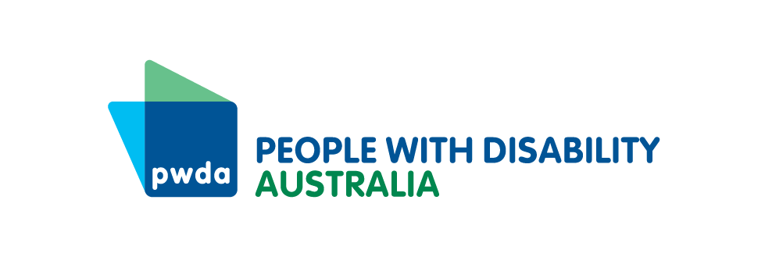

Investing in a more inclusive NSW offers returns for everyone. The identifiable cost savings available in the short-term speak to the urgency of taking action on inclusion.

We have reflected investment and cost savings for the financial year. However, investing in ending homelessness within 10 years offers the opportunity for NSW to avoid a compounding trajectory of negative impacts on educational achievement, employment, health and law enforcement that homelessness causes.

|  |  |  |
| --- | --- | --- |
| Item | 2025/6 Investment by Government | 2005/6 Cost Saving |
|  |  |  |
| Healthcare | | |
| Healthcare Disability awareness training development | $312,260 |  |
| Health and wellbeing savings from improving disability access to prevention measures[1] |  | $1,498,000,000 |
| Skilled | | |
| Education investment in 3 pilots to learn how best to support improved learning outcomes in schools for children with disability | $300,000 |  |
| Investing in Housing | | |
| Signing up to the National Construction Code | $0 |  |
| Current cost of people in NSW being homeless[2] | $6,510,000,000 |  |
| Building to end homelessness within 10 years[3] | $2,600,000,000 |  |
| Annualised cost saving[4] |  | $3,910,000,000 |
| Investing in homelessness services | | |
| Together Home[5] | $11,300,000 |  |
| Housing Maintenance & Accessibility Upgrades[6] | $35,000,000 |  |
| Preventing homelessness for 1300 people[7] |  | $241,800,000 |
| Safety | | |
| Safe Housing (OCV)[8] | $15,061,000 |  |
| Savings from stopping violence and abuse[9] |  | $16,704,000,000 |
| Inclusive DFV services[10] | $1,802,817 |  |
| Inclusion | | |
| Inclusive Communities[11] | $1,000,000 |  |
| Foundational Supports[12] | $1,000,000,000 |  |
| Total investment called for | $10,174,776,077 |  |
| Total available savings |  | $22,353,800,000 |
| Balance |  | $12,179,023,923 |

1. Based on the ACE Prevention Study of 123 illness prevention measures to improve population health in Australia. T, Carter R, Barendregt J, Mihalopoulos C, Veerman L, Magnus A, et al. Assessing cost-effectiveness in prevention (ACE-Prevention): Final Report. Brisbane: University of Queensland & Melbourne: Deakin University; 2010. Last accessed 10 October 2023 <https://public-health.uq.edu.au/files/571/ACE-Prevention_final_report.pdf> Investing in preventative healthcare could save the healthcare system $140 billion over 20 years according to the Productivity Commission. Productivity Commission (2017). Shifting the dial: 5 year productivity review, last accessed 10 October 2023, <https://www.pc.gov.au/inquiries/completed/productivity-review/report/productivity-review.pdf> People with disability have historically had poor access to preventative healthcare, but if access barriers were removed and the 21.4% of people with disability enabled to access in line with the AMA recommendation, then 1.19B worth of health savings could be achieved per year. Australian Medical Association, Health is the best investment; shifting form a ‘sickcare’ system to a healthcare system, last accessed 10 October 2023, <https://www.ama.com.au/sites/default/files/2023-06/Health-is-the-best-investment-shifting-from-a-sickcare-system-to-a-healthcares-system.pdf> $140B x 0.214 = =$29.9B / 20 years = $1.14B
2. Over 35,000 people in NSW are homeless - Homes NSW, Draft Homelessness Strategy 2025-2035 Presentation, 3 December 2024 and homelessness costs government $186,000 on average per person, per year NSW Government, Department of Communities and Justice, *Pathways to Homelessness final report* December 2021, last accessed 28 September 2023, <https://www.facs.nsw.gov.au/download?file=823631>
3. Over a decade ending homeless is projected to cost around a third of the cost of the current rates of homelessness
4. 6.51B x 10=65.1B 2.60 x 10=26B 65.1-26= 31.9B/10= $3.91B per year
5. Same as previous budget
6. Same as previous budget
7. 1300 people x $186,000 cost of homelessness per year = $241,800,000
8. In 2023/4 the Office of the Community Visitor (OCV) visited 1,465 visitable services throughout NSW, including 1,183 disability supported accommodation services, 17 assisted boarding houses, and 265 residential out-of-home care services. The 3,376 individual visits and raised and monitored 7,053 issues.

   The number of visitable services increased 19% (to around 2,990 visitable facilities), but the baseline budget of the scheme was unchanged. Only 48% of visitable services were visited. NSW Government, Ageing & Disability Commission, Official Community Visitors, last accessed 17/12/2024, <https://ageingdisabilitycommission.nsw.gov.au/documents/reports-and-submissions/adc-annual-reports/OCV-Annual-Report_2023-2024_-_final.pdf>

   This is too low and contributes to ongoing poor safety outcomes for people with disability. PWDA recommends doubling the funding from $7,530,500 in 2023-4 to $15,061,000.
9. 1.74 x $9,600 = $16.7 Billion

   NSW population 8,153,000 - NSW Government, Key facts about NSW, updated 30 June 2022, last accessed 17 December 2024, <https://www.nsw.gov.au/about-nsw/key-facts-about-nsw> 21.4% with disability- Disability, Ageing and Carers, Australia: Summary of Findings, Chart People with disability by State of usual residence updated 24 October 2019, last accessed 17 December 2024 <https://www.abs.gov.au/statistics/health/disability/disability-ageing-and-carers-australia-summary-findings/latest-release> so **1,744,742 people in NSW with disability**.

   Royal Commission into Violence, Abuse, Neglect and Exploitation of People with Disability, Research Report – Economic Cost of violence, abuse, neglect and exploitation of people with disability, last accessed 17 December, 2024, estimates the economic cost of violence, abuse, exploitation and neglect of people with disability costs **$9,600 per person, per annum** <https://disability.royalcommission.gov.au/publications/economic-cost-violence-abuse-neglect-and-exploitation-people-disability> At that point 4.8 million Australians (19% of the population) had a disability, and this accounted for the economic costs of failing to provide equal access to employment, services, housing, costs arising from hospital treatment and reduced quality of life.
10. Women with disability are approximately 40% per cent more likely to experience Domestic and Family Violence (or DFV), and need accessible services. We call on the NSW Government to invest $1,802,817 each year for 5 years in the delivery of the PWDA Building Access Project to all 75 Core and Cluster DFV services. PWDA, Building Access Project, undated, last accessed 17/12/2024, <https://pwd.org.au/projects/building-access-project/>
11. PWDA recommends establishing a $1M grant pool for community organizations to apply to in order to improve accessibility for people with disability
12. PWDA recommends budgeting $1B for foundational supports to enable people with disability to access the government and essential services they need