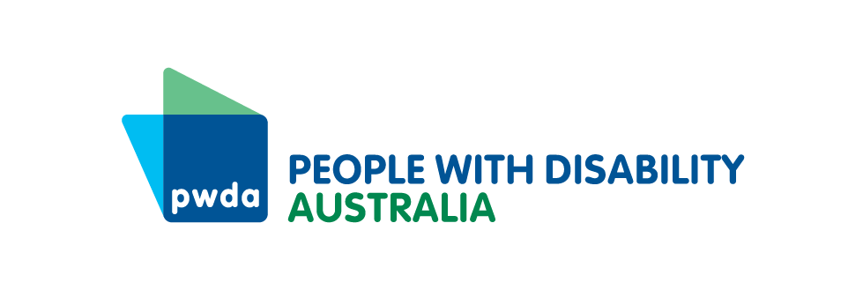

PO Box 666  
Strawberry Hills  
NSW 2012

Toll free 1800 422 015  
[pwd@pwd.org.au](mailto:pwd@pwd.org.au)[www.pwd.org.au](http://www.pwd.org.au/)

14 February 2025

NSW Department of Transport

Trainlink Coach Network Review

Sent via email to: trainlinkcoachreview@transport.nsw.gov.au

Dear Caroline,

Thank you for the opportunity to comment on the review of the four [Trainlink Coach Network plans](https://www.haveyoursay.nsw.gov.au/trainlink-coach-network-review).

## About PWDA

[People With Disability Australia](https://pwd.org.au) (PWDA) is Australia’s national peak disability organisation, representing the 1 in 6 Australians with disability. We are the leading disability rights advocacy and representative organisation and the only national cross-disability organisation representing the interests of people with all kinds of disability. We are a not-for-profit and non-government organisation, and our membership is comprised of people with disability and organisations primarily constituted by people with disability, including the [PWDA Board](https://pwd.org.au/about-us/our-board/) and many members of [our staff](https://pwd.org.au/about-us/our-staff/).

PWDA is represented in national working groups to reform the disability transport standards, on the NSW Accessible Transport Advisory Council and in work to co-design disability standards in Aviation. We are keen to ensure that more people in NSW have accessible public transport that enables them to reach work, education, services and social opportunities. This is especially important for people with disability, who are more likely than the non-disabled population to be unable to operate a private motor vehicle.

## The problems

A range of things are needed to make existing public transport more accessible. People who use wheelchairs and mobility assistance devices require step-free transport infrastructure and vehicles that enable their access, including when they cannot transfer out of their wheelchair. For people with communication, sensory or psychosocial disabilities, information about public transport, wayfinding, booking, and the travel process needs to be made accessible using braille, hearing loops, Easy Read and formats that allow assistive communication technologies to be used. Guide dog and assistance animal handlers need to have their right to access public transportation with their animal respected.

However, for people in rural and regional NSW there may be little-to-no useable public transport that enables them to get where they need to go. People needing a wheelchair accessible taxi struggle with poor levels of availability and reliability in some communities, or complete non-availability in others. The current service levels provided by NSW Trainlink could enable a person with disability to book a journey to take a holiday or visit family. Unfortunately, they do not run frequently enough to health, education or key commercial hubs to operate as a public transport service for people in rural and regional communities who cannot access private vehicles.

In some parts of rural and regional NSW community transport can provide accessible travel for some journeys, but services are limited. Currently these services are unable to be used should a person need to evacuate in an emergency.

Previously people with disability who required accessible services may have been expected to relocate away from rural and regional NSW to access them. However, current rental vacancy rates in regional NSW are [0.9% and 1.8% for greater Sydney](https://www.planning.nsw.gov.au/policy-and-legislation/housing/housing-supply-insights/quarterly-insights-monitor-q2/current-housing-pressures) record [high rental rates](https://dcj.nsw.gov.au/content/dam/dcj/dcj-website/documents/about-us/families-and-communities-statistics/housing-and-rent-sales/issue-149-rent-tables-sep-2024-quarter.xlsx) make this impossible. It is imperative therefore that accessible public transport networks are provided in rural and regional NSW as soon as possible.

People with complex needs in rural or regional communities [struggle to obtain the specialist healthcare](https://www.ruralhealth.org.au/sites/default/files/publications/nrha-disability-factsheet-feb-2023-final.pdf) they need or the evidence required to get on the NDIS or access foundational supports. This is compounded by a lack of accessible public transport and wheelchair accessible taxis being unreliable or non-existent in much of rural and regional NSW.

## Technical Details

PWDA appreciates that Transport for NSW has selected a style of road coach that enables a person using a wheelchair or mobility aid that conforms with the dimensions to board, remain in their mobility aid, to board via a wheelchair lift, and to have the device anchored for travel. This greatly assists passengers who are unable to transfer independently to a bus seat, or for whom a bus seat is unsuitable.

Of the fleet of 52 coaches, the 41 seat coaches have 2 wheelchair spaces, and the 32 & 18 seat coaches have 1 wheelchair space. This severely limits access and can have the effect of splitting up couples or families wishing to travel, or forcing people to delay their journey for days if not weeks- effectively making it impossible to rely on being able to access this service as needed for a person unable to transfer out of their wheelchair.

The width limitation set is 70cm, the length at 130cm and the total weight of a mobility aid and its user cannot exceed 300kg. The customer and any equipment they need must fit within this footprint. PWDA understands that this limit on dimensions aligns with the train standards. However, the current aviation standard for using a mobility aid to access an aeroplane sets a width limit of 80cm. It is likely that manufacturers of mobility aids will be more familiar with aviation standards, and that the devices that they produce may not fit within the specified footprint.

PWDA appreciates that lifts and ramps that facilitate boarding, and anchor points that enable the safe securing of mobility assistance devices for travel all have limits. We also recognise the need for more data to be gathered to understand the needs people have and the designs of mobility assistance technology, to better enable safe integration and use on public transport.

**Recommendation**: PWDA recommends all states and territories to meet with the mobility aide sector to discuss current standards for dimensions and weight of mobility assistance devices, with the aim of identifying:

* the most common dimensions in use
* safe processes and technologies to enable the fixing of mobility assistance devices within vehicles
* crash safety tolerances
* how public transport and the built environment in Australia can be made accessible for more people, in greater numbers, more often.

## [North Coast](https://www.haveyoursay.nsw.gov.au/trainlink-coach-network-review/north-coast)

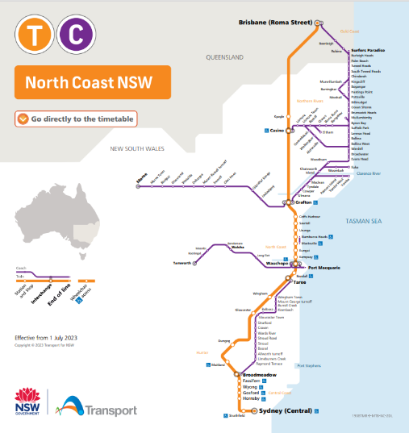

PWDA commends the proposed changes for 2026 to NSW Trainlink coaches in the North Coast region including:

* Increased frequency of routes 135 and 136 from Broadmeadow to Taree and back, from weekdays to 7 days per week, and the addition of Taree Manning Street and Newcastle Interchange stops.
* Service enhancements between Port Macquarie and Wauchope, providing both northbound and southbound connections, and the expanded travel between the North Coast and Queensland including between Grafton, Coffs Harbour, the northern rivers, Gold Coast and Brisbane to and from Port Macquarie.
* Introduction of the AP1 route that will operate on Tuesday, Friday and Sunday between Armidale and Port Macquarie and return, providing an Armidale to North Coast connection three days per week and a connection at Wauchope to the rail services that provide access to and from Coffs Harbour, Grafton, the Northern Rivers, Gold Coast and Brisbane.

PWDA notes the removal of Robina and Etham from the network ‘to reflect passenger demand’. However, it is worth considering that demand may have been suppressed due to service timing, frequency or features not meeting the needs of customers. We would encourage Transport for NSW to survey communities and ask what they would need in a public transport service to enable community access for those who do not own, or cannot operate, private motor vehicles.

## [North Western NSW](https://www.haveyoursay.nsw.gov.au/trainlink-coach-network-review/north-west)

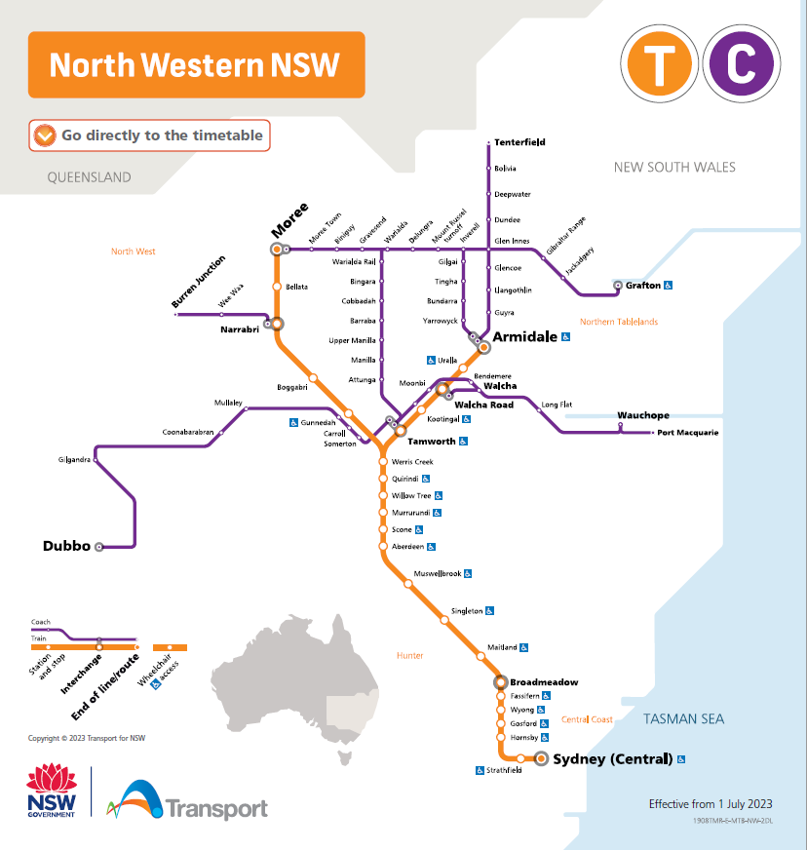

In North Western NSW PWDA looks forward to improvements in the NSW TrainLink coaches in 2026 including the:

* New AP1 route that will operate on Tuesday, Friday and Sunday between Armidale and Port Macquarie and return, providing an Armidale to North Coast connection three days per week and a connection at Wauchope New daily Route T
* New M1 route between Tamworth and Muswellbrook and return, for a new day-return link to and from Newcastle via rail interchange at Muswellbrook.
* Additional Wednesday service on Routes 361 and 362 between Tamworth and Dubbo and return, increasing this from 2 to 3 days per week
* New Armidale CBD stop for Routes 327, 328, 337 and 338 Tenterfield to Armidale and return, and Inverell to Armidale and return.

PWDA notes that whilst improved, these services fall well short of a public transport service to enable community access for those who do not own, or cannot operate, private motor vehicles. We call on Transport for NSW to survey the community to identify what they need, and to focus on those communities facing greatest transport disadvantage due to remoteness, a lack of access to trains and other public transport services.

## [Western NSW](https://www.haveyoursay.nsw.gov.au/trainlink-coach-network-review/west)

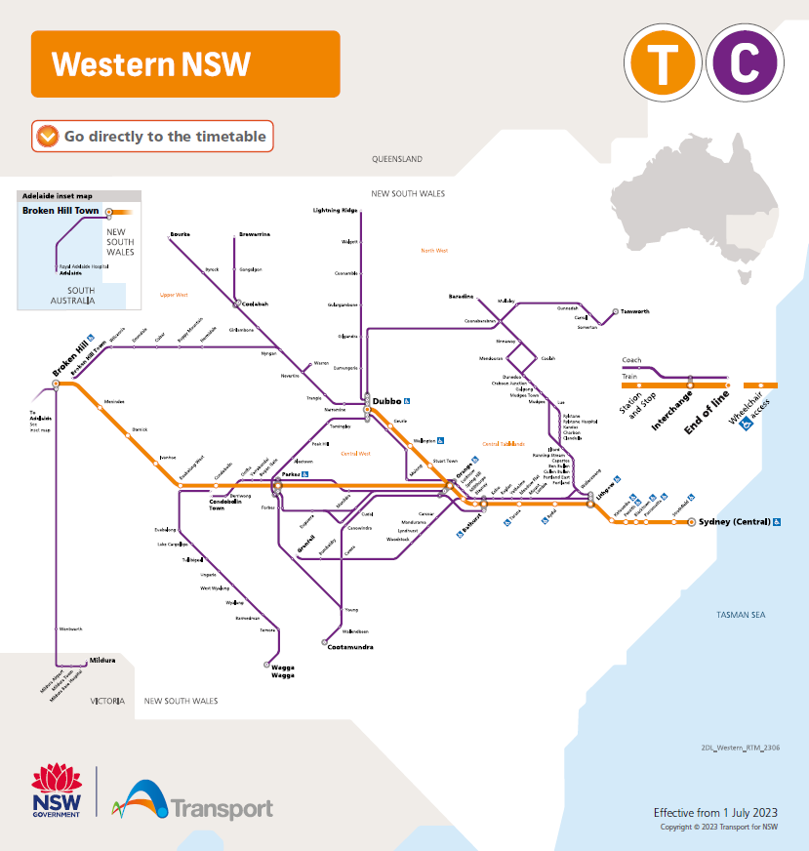

##### In the West Region PWDA looks forward to improvements to NSW TrainLink service in 2026 including the new:

* connection betweenDubbo Airport**,** Nyngan, Bourke and Broken Hill**,** and
* day-return option connecting Wilcannia, Cobar and Nyngan with Dubbo on Tuesdays.

PWDA notes that whilst improved, these services fall well short of a public transport service to enable community access for those who do not own, or cannot operate, private motor vehicles. We call on Transport for NSW to survey the community to identify what they need, and to focus on those communities facing greatest transport disadvantage due to remoteness, a lack of access to trains and other public transport services.

## [Southern NSW](https://www.haveyoursay.nsw.gov.au/trainlink-coach-network-review/south)

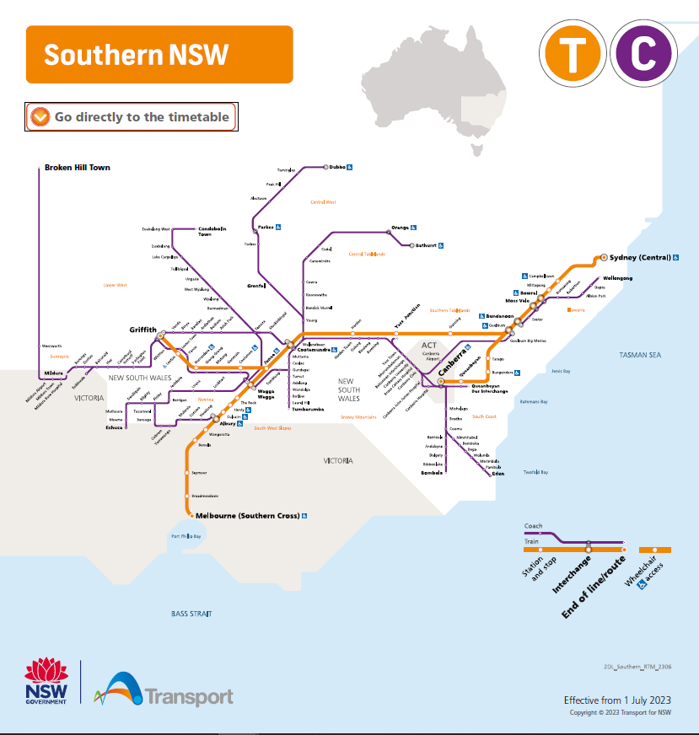

The changes proposed to NSW TrainLink coaches for the South Region in 2026 offer improved services including:

* the new route Wednesday and Saturday, Yass Junction to Young, and Thursday and Sunday Young to Yass Junction, connecting with rail services to provide a faster, more direct service between Young and Sydney.
* The addition of Lake Cargelligo as a stop for all Condobolin-Wagga Wagga-Condobolin services 7-days per week
* Increased service frequency for Jindabyne and Bombala and the new, more-direct route to Cooma.
* The uplift of the Goulburn-Canberra-Goulburn day-return service from 5 to 7 days a week
* Simplification of Condobolin to Wagga Wagga services, serving the same stops 7-days per week and increasing frequency to several locations.
* The Mildura to Cootamundra route has been repointed to Wagga Wagga to improve local connections.
* Improved rail connections for the Griffith to Cootamundra route
* better connections to and from Wagga Wagga and improved rail connections at Cootamundra for the coach services to Gundagai, Tumut, Batlow and Tumbarumba
* Cooma passengers will have the choice of a morning service to Canberra 7-days per week and an afternoon service to Canberra 4-days per week (both with ongoing rail connections to Sydney).

PWDA notes that whilst improved, these services fall well short of a public transport service to enable community access for those who do not own, or cannot operate, private motor vehicles. We call on Transport for NSW to survey the community to identify what they need.

PWDA would be very happy to discuss this further or work with NSW Transport to ensure a more accessible and inclusive transport system. If you have any questions, please reach out to our **Senior Policy Officer, Bastien Wallace** – [bastienw@pwd.org.au](mailto:bastienw@pwd.org.au) .

Yours sincerely



Megan Spindler-Smith

Deputy CEO

People with Disability Australia