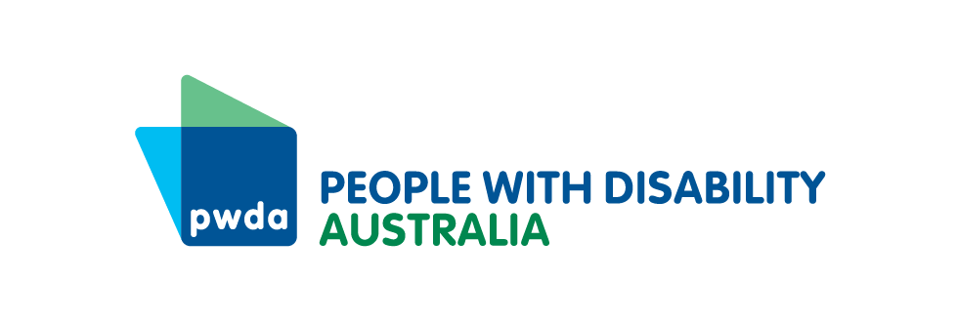

PO Box 666  
Strawberry Hills  
NSW 2012

Toll free 1800 422 015  
[pwd@pwd.org.au](mailto:pwd@pwd.org.au)[www.pwd.org.au](http://www.pwd.org.au/)

# PWDA Privacy Collection Notice for PWDA Individual Advocacy Services

***Personal information we collect:***

PWDA understands that the privacy and personal information of our clients is very important.  To provide you with advocacy services, we collect personal information about you including your name and contact details, and information about the matters you require assistance with. We may also collect sensitive information about you including information about your medical conditions, disabilities or health needs, membership of schemes such as the National Disability Insurance Scheme (NDIS) and your health-related experiences, as well as information about your ethnic origin, sexual orientation and criminal history (as applicable). Our privacy policy sets out more information about the kinds of personal information and sensitive information we may collect about you.

***How we collect personal information:***

We generally collect personal information directly from you, although when we provide you with advocacy services we may collect information about you from third parties such as family members, your guardian, health care providers or other agencies with your consent or where you have authorised them to contact us on your behalf, including any parties listed in the section above this Statement.

***Purposes for which we collect personal information:***

PWDA collects and uses your personal information for the purpose of providing you with advocacy services, communicating with you, managing our business activities and functions (including promoting disability rights, conducting disability advocacy and providing representation for people with disability), and to improve the quality of our products and services, as further set out in our privacy policy. We may also use your personal information as notified to you at the time of collection, or as permitted or required by law. Without your personal information we may not be able to provide our advocacy services and other requested products and services to you.

We may need to contact you from time to time for the purposes of providing our services.  Other communications from PWDA such as our newsletter, other updates about PWDA’s services, advocacy, news and events are optional.  You may opt-in to receiving these optional communications by contacting PWDA.

***Who we may disclose your personal information to:***

When providing advocacy services, we usually disclose your personal information to:

* any parties listed in the section above this Statement;
* health professionals involved in services we provide you;
* if you are receiving support through the NDIS or support from any government program, we may disclose your information to those agencies if required by them;
* specific organisations for authorised purposes where you have provided your consent, including to the police, for example to lodge police or medical reports and victim impact statements in connection with providing advocacy services to you;
* your parent(s) or guardian(s) – unless you ask us not to do so, we assess that you have the capacity to make such a decision, or we are not required by law to make such disclosure; and
* other persons we notify you of at the time the information is collected, or as permitted or required by relevant laws.

At this time, all parties referred to above are located within Australia, however this may change in the future and if it does, we will update our privacy policy accordingly.

***How you can obtain further information:***

PWDA’s Privacy Policy and Access to Information Policy contains further details about our privacy practices, how you may access and correct the personal information we hold about you, how you may make a privacy complaint and how we will deal with any complaint.

It is important you review both our Privacy Policy and Access to Information Policy available at [https://pwd.org.au/about-us/policies/privacy/](https://pwd.org.au/about-us/policies/privacy/%20). An Easy Read version of our Privacy Policy and Access to Information Policy is available at the above link.