About our Privacy Policy
 | This is Easy Read information about People with Disability Australia’s Privacy Policy.  We say PWDA for short.
 | The Privacy Policy is PWDA’s rules about how we use people’s personal information and keep it private.
 | You can ask us for a copy of the full policy.  Our privacy policy is on our website.  https://pwd.org.au/about-us/policies/privacy/
 | Please tell us if you would like some help to read the information.

Everyone has a right to privacy
 | The law says people have the right to have their personal information kept private.  PWDA follows the law to keep your information safe.

What is Personal Information?
 | Your personal information is things like:  Your name.
 | Where you live.
   | How to contact you, such as your email address and phone number.
 | How old you are.
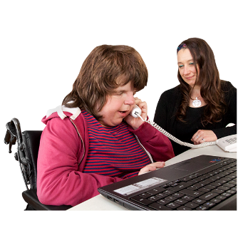 | The kind of work you do.
 | It can also be other information about you or that people know is about you.
 | The law says we must keep some kinds of personal information even more private.  This is called sensitive information.
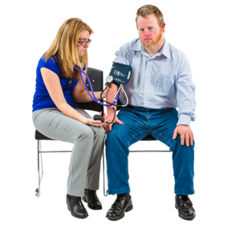 | Sensitive information includes things like  Your health or disability.
 | If you are in the NDIS.
 | Your cultural background – such as being Aboriginal, Torres Strait Islander, African, or Asian.
 | Your sexual orientation.  This means who you are attracted to.
 | Your criminal history.  This means you have been in trouble with the law.
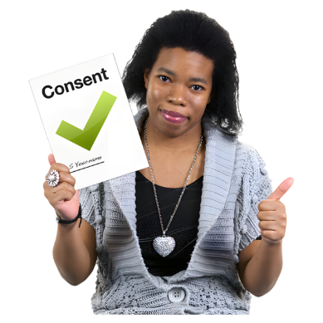 | We only collect your sensitive information if we need it to do our work.  We must always get your consent for us to have your sensitive information.  Consent means you say it is OK. You can choose to say it is not OK.

How we get your information
 | We usually get your personal information directly from you.  This could be when you:
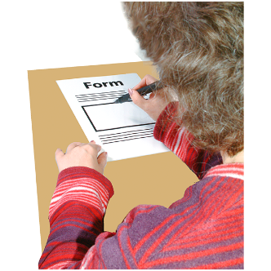   | Fill in a membership form or apply for a Qantas Concession Card.  Donate some money to PWDA.  Ask us for information.  Use our services.  Fill in one of our surveys.  Tell us about your experiences.
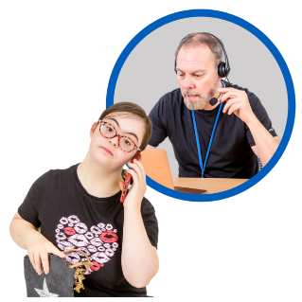  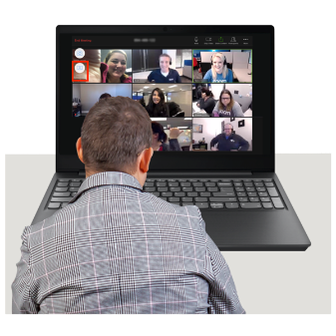 | Take part in a PWDA event or activity.  Learn new things with PWDA training programs.  Share your story for a PWDA project or research.  Use social media to contact PWDA.  Contact us in any way.
 | If you use PWDA services, other people like your doctor might give us information about you.
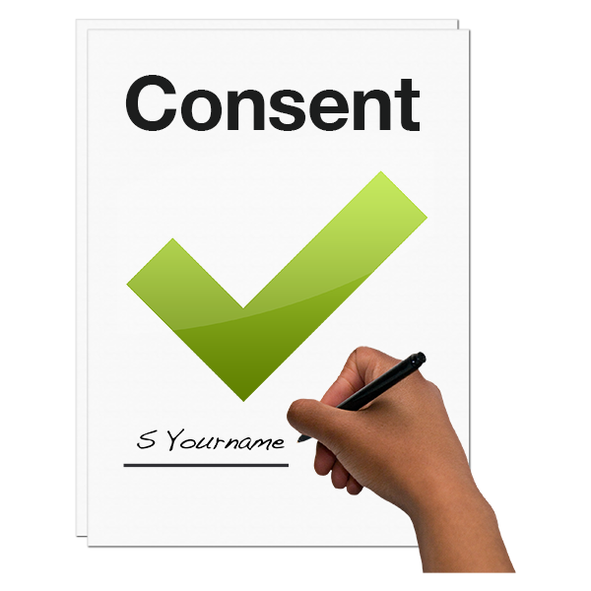 | We need your consent to get your information from other people. Or if you have told someone else they can contact PWDA about you.  This could be your family, guardian or another organisation helping you to get services or information from PWDA.

Our website
 | Our website is set up with cookies.  Cookies collect some of your information when you use the website.  This makes it easier for you if you use the website more than once.
 | Cookies also help PWDA to learn why people use our website.  This helps us make our online information and services better.
 | You can set your computer or other device to stop cookies so our website doesn’t collect your information. But this will mean you can’t see or use some of the things on our website.
 | If you use links on our website to go to other websites, they won’t follow our Privacy Policy. They will have their own privacy policies.
 | Some other websites we use, like YouTube or Google, might also collect some of your information when you visit our website.

What happens if we can’t collect your personal information?
 | It is best if we have your name and contact information.  But you might not want to share them.
 | We need your personal information to give you the service or information you want.  Without it we might not be able to help you or the service might not be as good or useful.
 | Sometimes we can help you without your details.  For example if you need general information and we can answer it quickly.
 | But if you want help through our services, we usually need your real name and contact information.

Why do we collect and use your personal information?
 | There are different reasons why we collect people’s information.
 | The kind of information depends on why you are in contact with us.  We need people’s personal information to help us do our work.
 | This includes making sure people get the services and help they need.
 | Speaking up to government for the rights of people with disability.
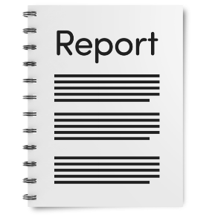 | Writing reports about the work we do.
 | Getting money to help us do our work.
 | Making sure we follow the law about how we must work.
 | Helping us to put things right if you have a complaint about PWDA.
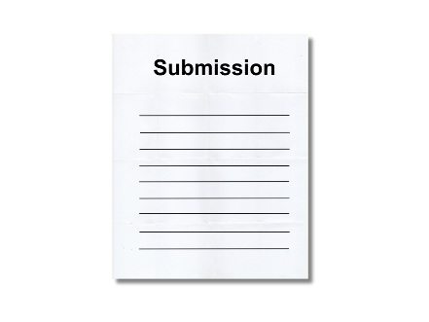 | We also collect information to make submissions to government and make our services better.

Using your stories
 | If you share your story with PWDA we might use it to tell the government about what needs to change.
 | If we want to use your name with your story, we will ask your permission first.
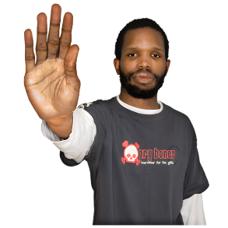 | If you say no, we will tell your story without using your name or details.

Direct Marketing
 | Direct marketing is when we send you news about our services, the work we do, and other things we think you will like.
 | We might send it in different ways such as email, mail or SMS (text message).
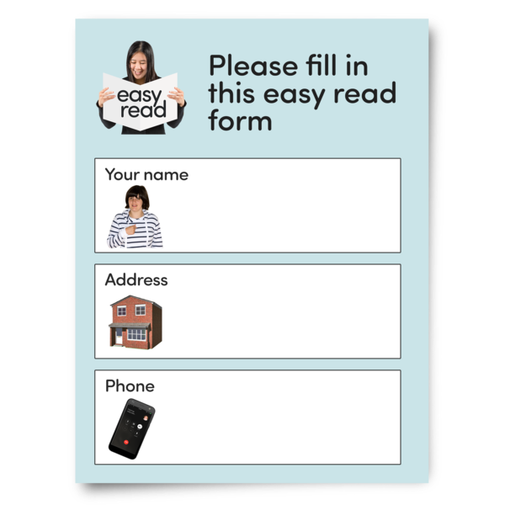 | You can choose not to get direct marketing from us.  This is called opting out.  You can stop getting our marketing by opting out on the email, SMS, or by telling us on the phone or email.
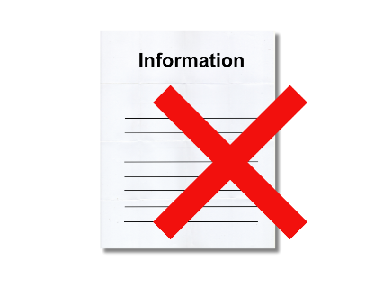 | We never give your personal information to other organisations so they can do direct marketing to you.

Who can we give your information to?
 | We only give your personal information to people who need it to do their work.  This is our staff and other people who do work for PWDA.
 | We make sure all these people know they must keep your information private.
We might need to share your information with the government or other groups.
We will always ask for your consent and get your permission before we do this.
 | We sometimes use stories people share with us to help our work.  We always for your consent to use your story. Or we make sure no one can tell it's your story by not using your details.
 | We sometimes use other trusted companies to help us, like IT support.  We make sure they keep your information private and safe.

Can I stay anonymous?
 | Sometimes you can contact us without giving your name or use a made-up name.  A made-up name is called a pseudonym.
 | But for most services we will need your real name to help you.

What happens if information is lost or stolen?
 | Sometimes information can be lost or accessed without permission. This is called a data breach.
 | If this happens, PWDA will:  Quickly check what happened  Work to fix the problem  Tell the people affected  Tell the Australian Information Commissioner if needed.

Can I see my personal information at PWDA and make sure it is correct?
 | You can ask for a copy of the information we have about you. We can usually show it to you.
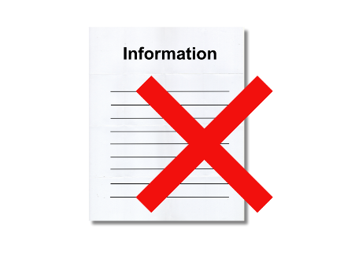 | We might not be able to let you see it if it includes other people’s personal information.
 | You can ask PWDA to change any wrong information about you. If we think it does not need to change, we will add a note to say you don’t agree.
 | We won’t charge you any money to ask to see your information or to make any changes to it.
 | We will always do our best to communicate with you in the way that works best for you.

How do we keep your information safe?
 | We always follow the law and our Privacy Policy to keep your personal information safe.
 | We work hard to keep your personal information safe, whether it is written down or on the computer.
 | We keep your information safe with passwords and locked cabinets. Only people who need it for their job can see it.
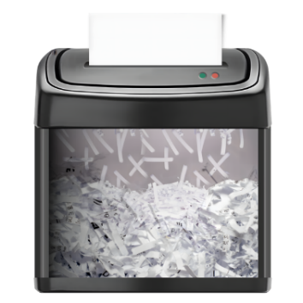 | All information that is no longer needed is destroyed or made anonymous.

Contacting Us and Making a Complaint
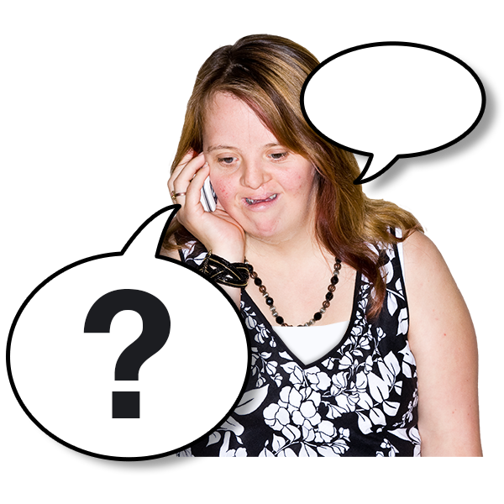 | You can contact us if you have any questions about privacy at PWDA.
 | You can tell us if you have a problem with how we keep your information private. You have the right to complain.
 | PWDA can organise support to make a complaint if you need it.
 | We will keep your questions or complaints private.
 | If you have a question or want to make a complaint, you can contact our Governance and Compliance Coordinator.
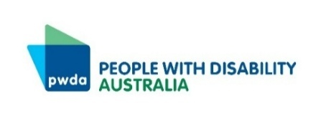 | People with Disability Australia
 | Email: feedback@pwd.org.au
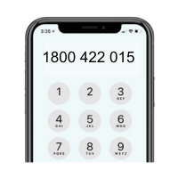 | Free Call: 1800 422 015
 | PO Box 666  Strawberry Hills NSW 2012
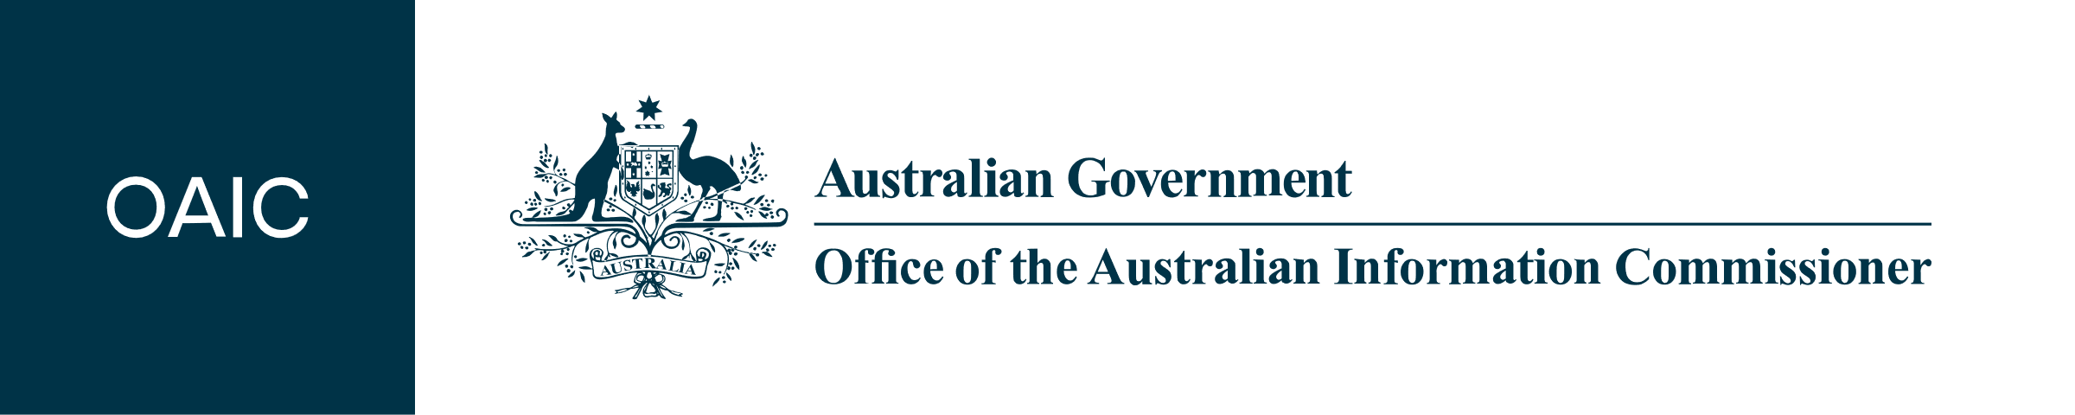 | If you are not happy with how PWDA handles your complaint, you can contact the Office of the Australian Information Commissioner (OAIC).
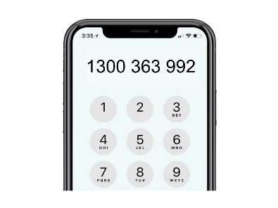 | Phone: 1300 363 992
 | Email: enquiries@oaic.gov.au

Changes to the Privacy Policy
 | If PWDA makes changes to this policy, we will put the new information on our website.
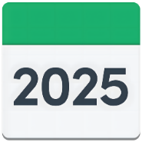   | The last time we updated our Privacy Policy was on 13 January 2025.

