PWDA Privacy Collection Notice
 | PWDA cares about your privacy.
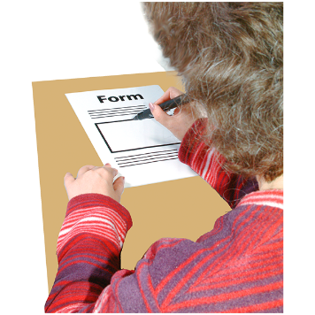 | We collect your personal information to help you.
 | We need your name and contact details.
 | We also need to know what you need help with.
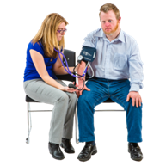 | We might ask about your health or disability.
 | We might ask if you are in the NDIS.
 | We might ask about your cultural background – such as being Aboriginal, Torres Strait Islander, African, or Asian.
 | We might ask about your criminal history.
 | We collect information directly from you.
 | Sometimes, we get information from others.
 | We might talk to your family or guardian.
 | We might talk to your doctor or other helpers.
 | We use your information to help you.
 | We use it to talk to you.
 | We use it to improve our services.
 | We might contact you sometimes.
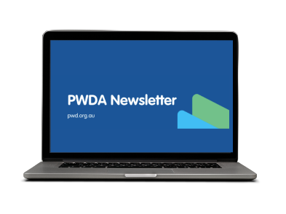 | You can choose to get our newsletter.
 | We share your information with certain people.
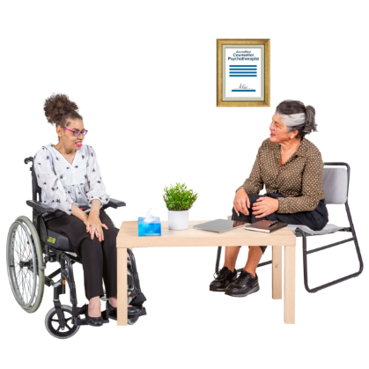 | We might share it with health professionals.
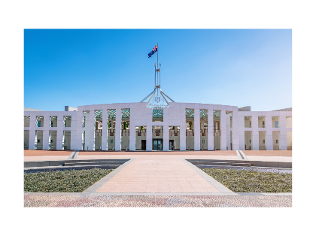 | We might share it with NDIS or government.
 | We might share it with the police if needed.
 | We might share it with your parents or guardian.
 | We tell you who we share it with.
 | Right now, we only share in Australia.  This might change in the future.
 | Check our privacy policy for more details.
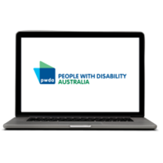 | Our privacy policy is on our website.  https://pwd.org.au/about-us/policies/privacy/
 | We have an Easy Read version too.
 | More information about the information we collect can be found in our Access to Information Policy.
Our Access to Information Policy is on our website.
https://pwd.org.au/about-us/policies/privacy/
 | We have an Easy Read version too.
 | If you have a question or want to make a complaint, you can contact our PWDA Governance and Compliance Coordinator.
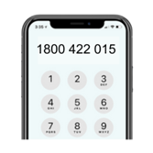 | Free Call: 1800 422 015
 | Email: feedback@pwd.org.au
 | PO Box 666  Strawberry Hills NSW 2012

