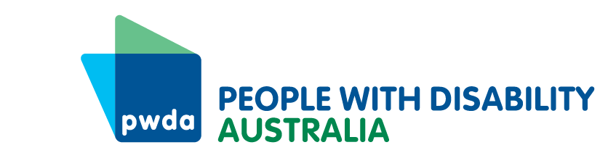
PO Box 666
Strawberry Hills
NSW 2012
Toll free 1800 422 015
pwd@pwd.org.au
www.pwd.org.au
Tuesday 21 October 2025

Notice of Annual General Meeting (AGM) of Members of People with Disability Australia Ltd ACN 621 720 143 (Company) and Agenda.
The 2025 AGM of People with Disability Australia Ltd. (PWDA) will take place on Thursday 13 November 2025. The AGM will commence at 6:00pm AEDT and is expected to finish at approximately 8:00pm AEDT.
Register to attend the AGM
- The AGM will be held online via Zoom
- Members must register by 5:00pm AEDT on Monday 10 November 2025
- You can register by:
  - Phone: 1800 422 015
  - Email: pwd@pwd.org.au
  - Online: https://pwd.org.au/get-involved/elections-and-agm-papers/
- After you register you will be sent the AGM Zoom link via email.
IMPORTANT: If you do not receive the AGM Zoom link by Wednesday 12 November 2025, please check your spam/junk mail or contact PWDA.
Voting at the AGM
- At the AGM current PWDA members with voting rights will be asked to vote on a range of motions.
- You must be in the Zoom AGM meeting to vote or have nominated a proxy.
IMPORTANT: Voting via Zoom’s phone backup system is not possible. This means if you join the meeting via phone, you will not be able to vote at the meeting.
- If you plan to join by phone or are not able to attend the meeting but still wish to vote. Please complete the enclosed Proxy Voting form to nominate someone to be your proxy and vote for you in the way you have indicated.
PWDA Annual Report
The PWDA 2024-25 Annual Report has been published. It is available in the following formats on the PWDA website https://pwd.org.au/about-us/annual-reports/
- Accessible PDF
- Accessible Word document
- Easy Read
Additional information enclosed with this notice and agenda:
- AGM Explanatory Statement including information on Special Resolutions
- Proxy Form and Explanatory Notes
- Minutes of the 2024 Annual General Meeting
- Returning Officer’s Report 2025
- Easy Read AGM information
If you need the Annual Report or any of the listed documents in alternative formats or if you have any further questions or need assistance, please contact PWDA at pwd@pwd.org.au or call 1800 422 015.
Yours sincerely
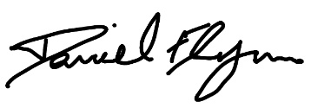
Daniel Flynn
Acting President
People with Disability Australia

PWDA 2025 Annual General Meeting (AGM) Agenda
Date: Thursday 13 November 2025
Time: 6:00pm – 8:00pm AEDT
Venue: Zoom
Acknowledgement of Country
Opening and Welcome
- Apologies and Proxies
- Minutes of the 2024 Annual General Meeting
2.1 Confirmation of the Minutes
2.2 Matters Arising
- Presentation of PWDA 2024-25 Annual Report
3.1 President’s Report
3.2 Treasurer’s Report
3.3 Audited Financial Statements
- Appointment of Auditors
- Report from Returning Officer
5.1 Approval and adoption of Report from Returning Officer
5.2 Approval of the appointment of Wildaliz De Jesús Arocho as Board Director in accordance with the Returning Officer’s Report
5.3 Approval of the appointment of Jeramy Hope as Board Director in accordance with the Returning Officer’s Report
5.4 Approval of the appointment of Jarrod Sandell-Hay as Board Director in accordance with the Returning Officer’s Report
5.5 Approval of the appointment of Tahlia-Rose Vanissum as Board Director in accordance with the Returning Officer’s Report
- Special Resolutions
6.1 Special Resolution [1] - Trinity Ford
6.2 Special Resolution [2] - Daniel Flynn
- Other Business
7.1 Farewell and thank you to outgoing PWDA Board Directors
7.2 PWDA member panel discussion
7.3 Questions
- Close of meeting.

