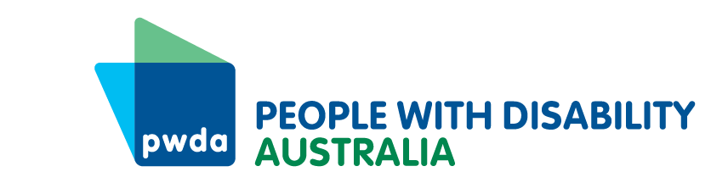
PO Box 666
Strawberry Hills
NSW 2012
+61 2 9370 3100
Toll free 1800 422 015
pwd@pwd.org.au
www.pwd.org.au
October 5th, 2025
Department of Infrastructure, Transport, Regional Development, Communications
GPO Box 594,
CANBERRA ACT 2601
Submitted via web portal: https://www.infrastructure.gov.au/have-your-say/aviation-consumer-protections-primary-legislation

To Whom it May Concern,

Re: Aviation Consumer Protections – primary legislation
Thank you for the opportunity to respond to the Aviation Consumer Protections – primary legislation.
People with Disability Australia (PWDA) is the national peak representative body for the 1 in 5 Australians with a disability. We are also one of the co-chairs together with the Australian Federation of Disability Organisation (AFDO) on the steering group with the Justice and Equity Centre (JEC) and the Department of Infrastructure, Transport, Regional Development, Communications, Sport and the Arts on the co-design of the disability aviation standards.
In 2024 PWDA responded to The Aviation Industry Ombuds Scheme—Consultation paper and we are pleased that some of the issues we identified then have been addressed. We are also pleased that the Aviation Consumer Protection Consultation Paper has been provided in accessible formats.
With regard to the questions raised about the primary legislation, PWDA has the following feedback:
- Does the proposed regulation of airline services, airport services and airport accessibility services cover the core elements of the aviation consumer experience? Are there any missing elements?
PWDA believes that there does need to be some amendment made.
Problems may arise if a booking is made by a travel agent who does not pass on details about the assistance required, which then leads to a person with disability being denied boarding. The regulations need to cover this.
Excluding security screening is a mistake, as many of the traumatic experiences people with disability have when they fly relate to this. There must be recourse for people with disability who experience poor or traumatic treatment as part of security screening.
There needs to be a course of action and remedy available for people related to the disability profile for flying. People with disability need to be able to choose who they authorise to access the profile, to be able to view the information stored, to be able to correct information retained within it, and to be able to understand when the information has been accessed and by whom.
Currently personal injury appears to be excluded from the scheme, and it would be better if it were incorporated into the scheme. People with disability may be injured during transfers between their own mobility devices and airport devices, or by using airport devices. By incorporating personal injury into the scheme, not only could the process for redress be streamlined, but robust data collection could help inform more timely design changes in ways that lengthy court cases do not.
- Are there any operational or technical considerations regarding international flights that would affect their regulation under the framework?
The scheme should apply to everyone, with airlines flying into Australia also being bound. If more than one scheme applies, complainants should have a choice of forum.
- Are there any operational or technical considerations regarding airport accessibility services that would affect their regulation under the framework?
It is not clear whether the framework will be adequate in situations where a person is completely refused access and accommodations that they need due to their disability, or where they are refused a flight unless they employ a carer. It is possible an airline could refuse to accept them as a customer, and deny that a relevant relationship had ever existed. In communities only served by a single airline, this could have the effect of prohibiting travel, or of making it too expensive for the person to travel. This would be life shortening in these communities who often are required to fly to a major centre for medical treatment.
By limiting remedies to ‘consumers’, defined as people who pay for services, this creates a problem. The example used at page 26 of Raj highlights this as a non-paying visitor to an airport may be needed to help another customer. If Raj had been the adult co-parent of a child who he needed to help to the gate, but whose mother had paid for the ticket. If the lack of accessible signage meant he was not able to get his child to the gate on time, Raj would not have any recourse, and it is doubtful whether the child or the other co-parent would either.
6. Is the role of the Aviation Consumer Protection Authority (ACPA) as proposed sufficient to protect aviation consumers and lift consumer standards, while not imposing undue regulatory burden and costs on the sector?
No. This proposed scheme is weighted too heavily in favour of the airlines and against customers, in a market with little competition. PWDA recommended European style standardised compensation in order to address the huge imbalance in power between consumers and the aviation sector, to provide rapid and effective remedies and a disincentive for the poor behaviours that are regularly reported.
A lengthy complaints-based system is onerous for all customers, and especially people with disability. The requirement that the person with disability try to resolve things first with the airline will be unworkable if there is no accessible process. It also has the potential to re-traumatise a person who has experienced discrimination or injury at the hands of an airline.
Allowing 30-day waiting periods for resolution is completely inappropriate for a person whose mobility aid has been lost or damaged. Alternative Dispute Resolution can have the effect of disadvantaging the party with the least power, and a person whose community is only served by one airline will be at an even greater level of power imbalance.
People dependent on airlines to access essential healthcare could easily have their conditions worsen, or even lose their lives, trying to achieve a resolution via the process outlined.
7. Do the proposed functions and powers of the Aviation Consumer Ombusdperson (ACO) provide sufficient capability to efficiently resolve consumer complaints and improve consumer standards? If not, what should change and why?
No. As outlined at 1.2.3 of the Consultation Paper,
“…determinations of the ACO would not create legally enforceable rights for individual complainants, the ACPA may pursue enforcement measures… [or] enforcement of ACO decisions through the courts…”
This is far from an efficient, effective or reliable resolution for consumers, and allows far too much scope for airlines and airports to ignore or avoid their responsibilities. The court system is overloaded and matters take months to years to resolve. Aviation customers need prompt, fair, and consistent decisions, that are enforceable and uphold their rights.
When people with disability pursue matters through the courts currently, it can take years to achieve an outcome, and often the cost of pursuing a matter runs to thousands of dollars. Even if these fees are covered by community legal services, this represents a significant burden on the courts that could be avoided.
As outlined in our previous submission, PWDA is seeking a well-developed scheme with a prescribed set of automatic remedies for simpler matters. This would reduce the burden on customers and administrators of the scheme and the courts and provide a disincentive to bad behaviour by the airlines.
If you need any further information, please contact our Senior Policy Officer, Bastien Wallace.
Yours sincerely
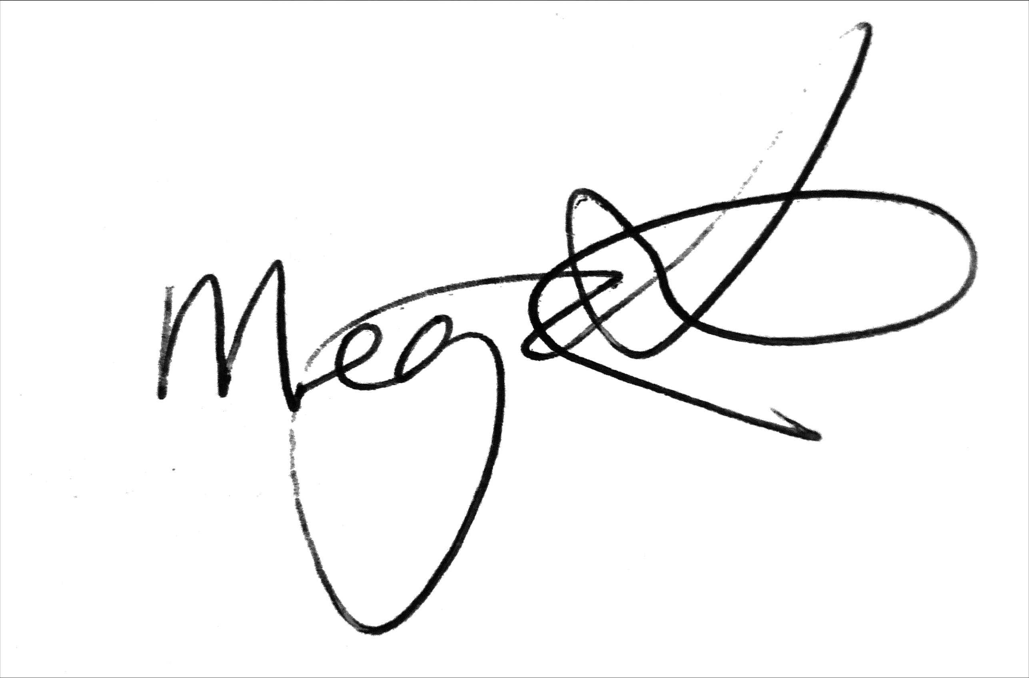
Megan Spindler-Smith
Deputy CEO
People with Disability Australia

