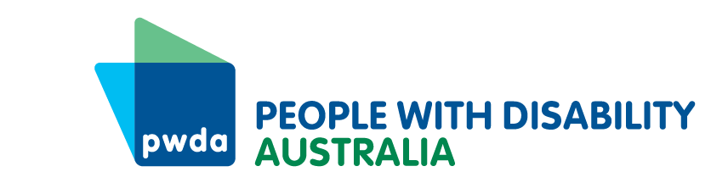
PO Box 666
Strawberry Hills
NSW 2012
+61 2 9370 3100
Toll free 1800 422 015
pwd@pwd.org.au
www.pwd.org.au
October 26th, 2025
Department of Infrastructure, Transport, Regional Development, Communications
GPO Box 594,
CANBERRA ACT 2601
Submitted via web portal: https://www.infrastructure.gov.au/have-your-say/aviation-consumer-protections-subordinate-legislation-including-aviation-consumer-protections

To Whom it May Concern,

Re: Aviation Consumer Protections – subordinate legislation
Thank you for the opportunity to respond to the Aviation Consumer Protections – subordinate legislation.
People with Disability Australia (PWDA) is the national peak representative body for the 1 in 5 Australians with a disability. We are also one of the co-chairs together with the Australian Federation of Disability Organisation (AFDO) on the steering group with the Justice and Equity Centre (JEC) and the Department of Infrastructure, Transport, Regional Development, Communications, Sport and the Arts on the co-design of the disability aviation standards.
In 2024 PWDA responded to The Aviation Industry Ombuds Scheme—Consultation paper and we are pleased that some of the issues we identified then have been addressed. We are also pleased that the Aviation Consumer Protection Consultation Paper has been provided in accessible formats.
Before turning to the questions provided, there is a question whether the primary or subordinate legislation captures flights within a state. For example, a flight from Wagga Wagga to Sydney would be regulated by the NSW State Government, and many flights from regional communities to Brisbane are regulated by the Queensland government. PWDA would like to ensure that these consumer protections will be extended to people flying within the same state, as well as those flying interstate or overseas.
Flights from smaller airports in regional communities are often only available via a single carrier, and may provide the only realistic way to access essential services and healthcare. Should that single carrier choose to behave in ways that fall short of the standards in the consumer protections, customers would be unable to choose an alternative company. It is critical that consistent consumer protections are extended to intra-state travel.
With regard to the questions raised about the primary legislation, PWDA has the following feedback:
4. Do the proposed Charter standards cover the core elements of the aviation consumer experience relating to the delivery of airline services, airport services and airport accessibility services? Are there any missing elements?
The Charter also needs to cover minimum standards for in-flight experience, including assistance to board, access to information in accessible formats, using features and amenities within the plane (entertainment, information, bathrooms, food), and preparation for emergencies. The charter does not specify that people with disability must not be subjected to less favourable pricing, or prevented from accessing special fares, neither does it specify with respect to complaint handling that this needs to be in accessible formats.
The Charter standards for communication (p45) specify “…easily-understood standardised format…” however this is not the same as accessible communication which should include Auslan, Braille, Easy Read, face to face and telephone communication, and community languages. This also needs to be specified with regard to flight disruption communication, because the current specification of “…text messages, apps and/or other channels…”will not work for people who are unable to use these devices.
5. Do the proposed Charter standards reflect reasonable standards? Are there any operational or technical considerations that would affect the ability of airlines or airports to meet the proposed standards?
The charter needs to specify that the provision of booking information in “easily-understood format” includes accessible formats such as Auslan, Easy English, community languages, audio versions and braille.
The requirement for the provision of information about flight disruptions and unreasonable delays “directly to passengers via text messages, apps and/or other channels” will not help those unable to use digital devices. The charter needs to specify that information needs to be provided face to face and by telephone for those who need this.
The refund requirement at d. is inadequate for passengers whose travel is urgent. A refund within 14 days will not help a traveller who now needs to urgently arrange travel to attend a critical medical appointment. This needs to be amended to enable a passenger to receive a refund quickly so that they can make alternative travel arrangements.
8. If different cost recovery levies are applied to regulated entities based on the nature or size of their operations, what metrics should be used to differentiate them?
Cost recovery based on the nature and size of operations appears logical. There may also need to be some form of sanction applied for repeat offences, where it is clear that an entity is not endeavouring to change prohibited behaviour.
9. For each of the duration/situation timeframes listed in Table 4 of the consultation paper (1 to 3 hours, 3 to 6 hours, 6 to 12 hours and more than 12 hours) what are reasonable values for food and drink vouchers per meal, and how many food and drink vouchers should affected passengers receive?
A sensible start for determining the voucher values offered would be to align it to the meal allowance amounts for business travellers under the Fringe Benefits Tax allowances, as airport pricing is generally at a premium rate and stranded passengers are generally unable to leave the airport to shop around.
Meal | Major Cities | Country centres
Breakfast | $34.75 | 31.15
Lunch | 39.10 | 35.55
Dinner | 66.65 | 61.30
Accommodation should be offered for delays of 12 hours or more, and anyone requiring an overnight stay who is not able to be provided with their luggage should receive an additional payment to enable them to purchase toiletries and a change of clothes. We would recommend at least $200 per person.
The next challenge for passengers facing delay is that consumables other than food may need to be purchased and the amounts set out for meals may be inadequate. Baby nappies, formula, PEG feeding supplies, period products, supplies for people who have a stoma or incontinence, medications, could all be needed for delayed passengers. In cases where the airport has a pharmacy purchasing these items may leave delayed passengers significantly out of pocket. We recommend providing a health voucher to cover these costs that could reimburse the passenger based on actual expenditure.
Where an airport does not have a pharmacy on premises, arrangements must be made to enable delayed passengers to access these products.
None of these provisions mention or make allowances for the needs of passengers who travel with an assistance animal. In the case of delay, provisions must be made for the supply of appropriate food, drink and relief for that animal. I know of no airport that stocks petfood supplies. Provision must be made for delayed animals to be able to eat and toilet according to its needs, and the standards updated to require this.
The current minimum level of assistance exempts the airline from being required to provide vouchers or accommodation in situations when the reason for the delay or cancellation is out of the airlines’ control. This blanket approach is not appropriate for passengers with disability.
PWDA calls for the minimum level of assistance must be offered in every situation for people with disability, and that every customer who needs it should be able to access the health voucher or provision for these needs outlined above. Provision must also be made for every assistance animal to eat and toilet based on its needs.
If you need any further information, please contact our Senior Policy Officer, Bastien Wallace.
Yours sincerely
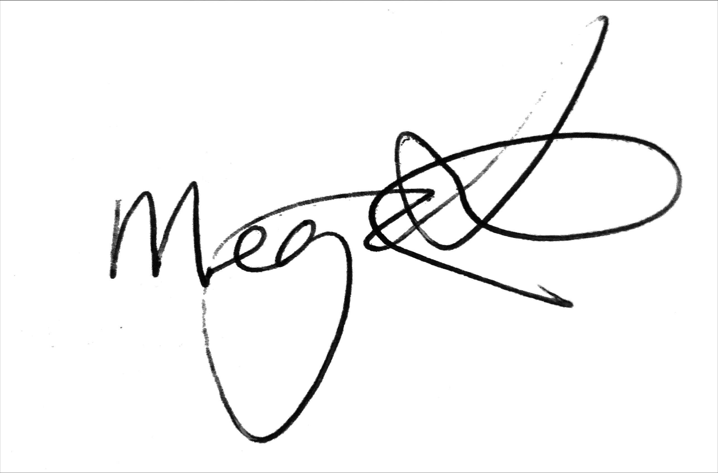
Megan Spindler-Smith
Deputy CEO
People with Disability Australia

