Annual Report
2024–25

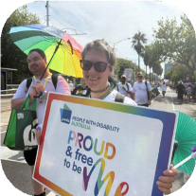
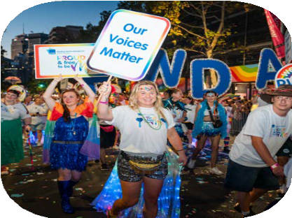
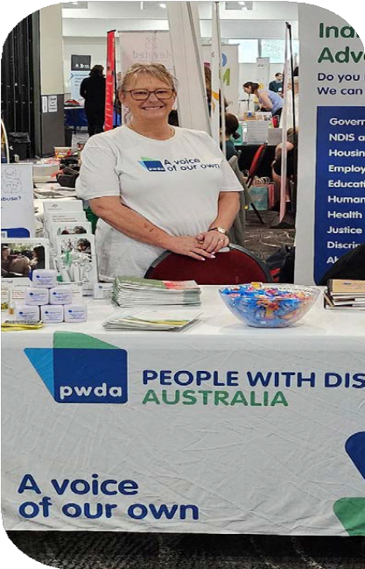
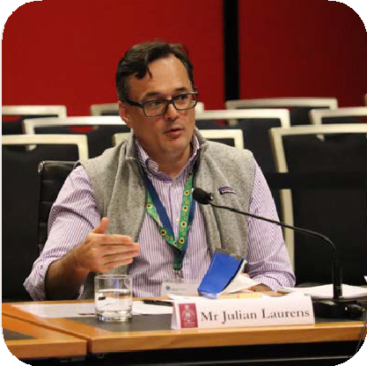
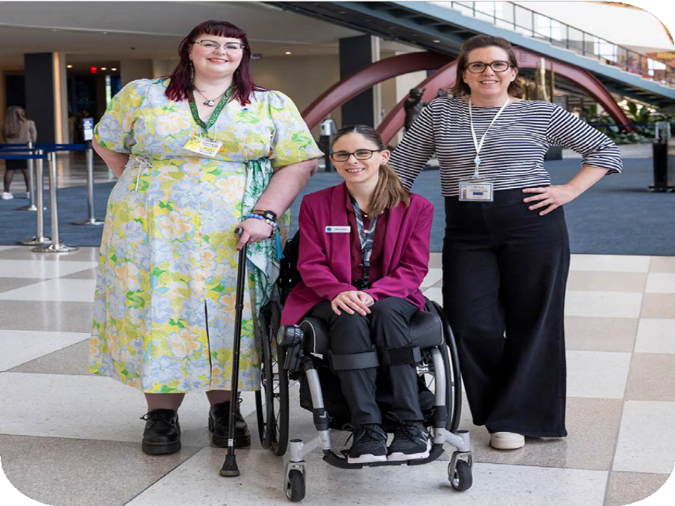

Acknowledgment of Country
We acknowledge the Traditional Owners of the lands where we work, live, travel and gather, including the Gadigal people, the Dharug people, the Butchulla people, the Badtjala people, the Taribelang Bunda people, the Yugambeh language people, the Kabi Kabi people, the Jinibara people, the Tharawal people, the Ngunawal and Ngambri people, the Kalkadoon people, the Gureng Gureng people, the Badtjala people, the Awabakal people, the Gubbi Gubbi people, the Yuggera people, the
Noongar people, the Bundjalung people, the Gugu-Badhun people, the Turrbal people, the Wiradjuri people, the Wurundjeri people, and the Stoney Creek Nations clan.
We recognise First Nations Peoples’ continued connection to the land and waters of these beautiful places, and acknowledge sovereignty was never ceded. We respect all Elders and Ancestors and any First Nations People reading this report.
Image Credits
We are grateful for the contributions of our staff, who have taken images featured in this report, along with photographers who feature their images on various photography websites. We recognise and thank all the members, supporters, staff and people
with disability featured in the photos in this report.
Acknowledgment of Contributors PWDA acknowledges the lives and experiences of the people with disability represented in this report. We recognise and thank all the members, supporters and staff who have contributed information featured in this report.
Alternative Formats
Copies of this document are available in alternative formats from:
People with Disability Australia Ltd. (PWDA)
Postal Address
PO Box 666, Strawberry Hills NSW 2012
Street Address
Suite 10.01, Level 10 Centennial Plaza, 300 Elizabeth Street, Surry Hills NSW 2010
Phone (toll free): 1800 422 015
Email: pwd@pwd.org.au
Translating and Interpreting Service:
13 14 50
National Relay Service: 1300 555 727

ACFID Code of Conduct complaints PWDA is a signatory to the Australian Council for International Development (ACFID) Code of Conduct. If you believe PWDA has breached the ACFID Code of Conduct, you may lodge a complaint with the ACFID Code of Conduct Committee at complaints@acfid.asn.au, telephone
+61 2 6285 1816 or contact PWDA.

Give feedback or lodge a complaint Would you like to provide PWDA with feedback or lodge a complaint about our services or our work? We would be happy to hear from you. You can contact us at feedback@pwd.org.au or free call
1800 422 015. You can also lodge a complaint or provide feedback via our website at pwd.org.au/contact-us.

2

Contents
About People with Disability Australia 4 President’s Message 6
CEO’s and Deputy CEO’s Message 9
Key statistics 12
Strategic Focus Areas 14
Represent 15
Advocate 23
Educate 43
Sustain 50
Financial Report 62
Easy Read Annual Report 88

About People with Disability Australia

Who we are

People with Disability Australia (PWDA) is a national peak disability rights and advocacy organisation, run by and for people with disability. We are the leading national cross-disability member driven organisation for people with disability in Australia.
Founded in 1981, PWDA represents the interests of people with all kinds of disability. We’re a not-for-profit, community-based organisation. Our membership is made-up of people with disability and organisations mainly constituted by people with disability. In July 2024, PWDA was appointed as the national peak body representing LGBTQIA+ people with disability.
Our vision is of a socially just, accessible and inclusive community, in which the human rights, belonging, contribution, potential and diversity of all people with disability are recognised, respected and celebrated with pride.

We work both nationally and internationally, and our work is grounded in a human rights framework that recognises the United Nations human rights conventions and related mechanisms as fundamental tools for advancing the rights of people with disability.
We deliver our programs, services and activities in partnership with our members and supporters as well as a variety of stakeholders across the government, disability, education and research sectors.
We receive funding from various sources, including the Australian, New South Wales and Queensland Governments, and donations from our supporters.
We live our dream. We have a clear vision for the purpose and impact of our work and have a comprehensive set of values,
beliefs and principles that guide and inspire our work.

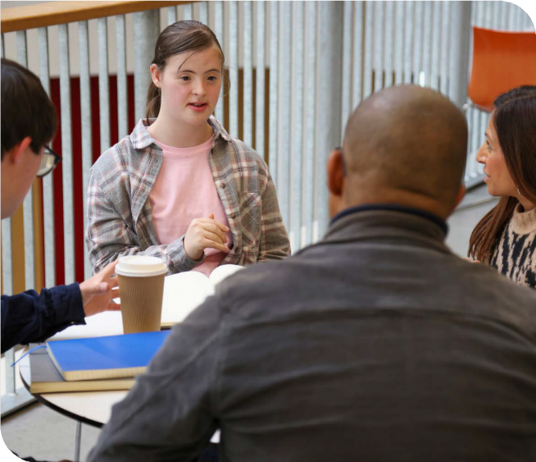

Our vision
We have a vision of a socially just, accessible and inclusive community, in which the human rights, belonging, contribution, potential and diversity of
all people with disability are recognised, respected and celebrated with pride.

Our purpose
Our purpose is to be a leading disability rights, advocacy and representative organisation of and for all people with disability, which strives for the realisation of our vision of a socially just, accessible, and inclusive community.

President’s Message

This past year has been a big one for PWDA – not only in our public-facing work, but also in the vital work we’ve been doing behind the scenes to make PWDA stronger, safer, and more sustainable for the years ahead.
This financial year was my first as both a PWDA Board Director and as President, having taken over from the incomparable Marayke Jonkers at the end of her term in November 2024. Eva Sifis returned as Co- Vice President for the second year of her term, serving alongside the newly elected Daniel Flynn. Kevyn Morris also returned for another year, while we were joined by newly appointed Directors Steph Travers as Secretary, Stuart Mawbey as Treasurer, Daniel Flynn, Priscilla Brice, Peter Freckleton, Presley Chihuri, and Alexandra Bignell.
I would like to thank Daniel Flynn for stepping in as Acting President when I was sick, away, or unable to perform the role.
I want to extend my heartfelt gratitude to outgoing Directors – Dr Haidi Badawi, Arun Barramundi, Declan Lee, Marayke Jonkers, and Suresh Rajan. Their dedication, service, and leadership were instrumental in guiding PWDA and the disability community through a challenging year. The organisation and
current Board are deeply grateful for all they did. We are especially thankful to office- holders – Marayke as President and Suresh as Secretary – for their lengthy service
and advocacy for our members and the community more broadly.
During the year, Peter Freckleton and Presley Chihuri have also ceased to be Directors of PWDA. We wish to
acknowledge Peter and Presley's respective contributions to PWDA and thank them for their service.
It has been a busy eight months since the new Board took up this important work.
We have worked with the community through the wake of the NDIS Review and subsequent reforms, a federal election campaign that largely ignored us, and the resulting restructure of government.
With the support of our staff and members, we’ve focused on strengthening our systems and processes this year. We
are in the process of overhauling how we approach policy and governance reviews, introducing new structures to ensure our work reflects best practice and the voices of people with disability.
We’ve also begun shaping our new Strategic Plan. This plan will be co-designed with members through the Strategic

Directions Advisory Group. Work to date has included an in-person Board strategic planning day and a review of our vision, mission, and values. We’re excited to share more soon and grateful to everyone who has already contributed.
It has been a privilege to work with such a collaborative and thoughtful group of people on our Board. We’ve shared the load across media, events, and advocacy, and it’s been heartening to see so many Board Directors stepping up to represent PWDA.
PWDA has continued influencing media cycles and policy – speaking on income support, foundational supports, the future of the NDIS, housing, and more. I was honoured to speak at Parliament House in Canberra alongside ACOSS, community groups, and cross-bench politicians on income support payments. It’s been powerful to see our community standing together on these big issues and holding truth to power.
PWDA was recently funded as the national peak for LGBTQIA+ people with disability, and we’re proud to be collaborating with Inclusive Rainbow Voices and others to build that work. Being able to combine support for my identity as a disabled
trans lesbian fills me with immense pride. Priscilla has been a brilliant support here – we are lucky to have their expertise and
perspective shaping our work in this space.

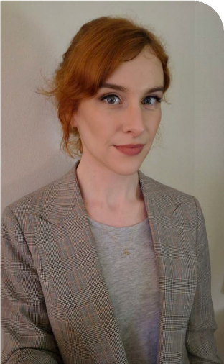
Trinity Ford, President, PWDA.

Personally, it was an honour to represent PWDA – and trans people – at the United Nations 69th Commission on the Status of Women (CSW69) in New York this year.
I spoke as part of our collaboration with Women With Disabilities Australia, using that platform to speak truth in a space where disabled voices are too often erased. More recently, our delegates Steph Travers, Alexandra Bignell, and Deputy CEO Megan Spindler-Smith represented PWDA at
the 18th Conference of the States Parties (COSP18), where they proudly supported the diversity of our members and spoke on a number of intersectional issues for First Nations and LGBTQIA+ people with disability.
I also pay my respects, on behalf of the organisation, to our members and
people with disability who died this year. This includes disability advocate and longtime member Glenda Lee – the “feisty crip” who helped establish the Physical Disability Council of South Australia. We remember PWDA member Peter Lane- Collett, who passed away in January after bravely fighting COVID-19 in hospital.
We also mourn the losses of members Jennifer Ashton and John Gordon, and the many disabled people who died from abuse, neglect, and exploitation, often in
segregated settings and closed institutions, whose names are not always known to us.
PWDA gives deep thanks to the Centre for Inclusive Design (CFID), who in closing
down last year, selected our organisation to inherit their assets. This includes valuable inclusive design resources which we are platforming. We are also establishing an emerging leaders scholarship with a portion of the funds, to carry on part of CFID’s mission.
It has been a big year. All of us in the disability rights movement carry a serious weight on our shoulders, to build ourselves a better world. So PWDA is not slowing down, and we thank everyone in our community for your energy, your ideas, and your commitment.
It has been my great honour to serve as your President this year. At my first address to the membership, I introduced myself as a training lawyer and disability advocate. It was a natural decision to put my career on the backburner when I was asked to lead this Board. Now looking at the talent on this current Board, and in our pool of nominees, I step down with relief and excitement for what is no doubt to come.
In solidarity, Trinity Ford President, PWDA.

CEO’s and Deputy CEO’s Message

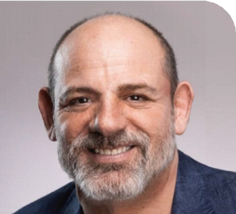
Sebastian Zagarella, CEO, PWDA.
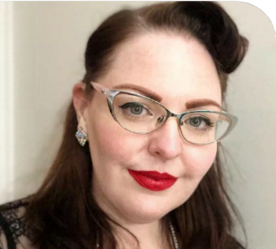
Megan Spindler-Smith, Deputy CEO, PWDA.
This year has been another pivotal one for our community. The only clear constant we have had is continuing complex and shifting changes. Through feeling the deep impacts of past systemic decisions and
broader social inequities, our members and community, Board, and staff have remained committed to our strong, consistent drive for people with disability – centred on disability affirming priorities of our members and Board.
Despite ongoing challenges with NDIS reforms and changes to government structure, we’ve achieved significant outcomes across all areas of our work.
From strong and collaborative disability rights focused systemic advocacy and providing dedicated individual advocacy, driving social change through our disability centric and co-designed programs and training delivery, to meaningful and staff- centred organisational and cultural change, all underpinned by meaningful member engagement, our whole team has continued to lead with heart and purpose.
Systemic advocacy this year has been framed by our community’s ongoing push for the implementation of the Disability

Royal Commission’s recommendations, the NDIS Review, and many pivotal moments both at a national and state/territory level.
Our individual advocacy teams continued to provide client centric, essential, high-quality support to people navigating complex systems. We saw an increased need across all advocacy programs, with over 2,000 people supported this year alone.
Thank you to all our staff who worked hard this year to continuously improve our services, along with a new team of
specialised intake officers we have proudly reduced the wait times for our clients and members to access support and advice.
We are proud that feedback from clients remains overwhelmingly positive, with 85% satisfaction ratings and many sharing that PWDA’s support was life-changing.
Internally, we’ve worked together to strengthen our ways of doing, systems and processes to prioritise the psychosocial safety of our staff, members and community. We also rolled out PWDA’s first performance and development framework, aligning staff work and development needs with strategic priorities, and embedding a culture of communication, reflection, growth and accountability.
This year, our role as the national peak body for LGBTQIA+ people with disability became even more meaningful, and we’re proud to carry that responsibility. We were once again part of the Sydney Gay and Lesbian Mardi Gras Parade, a powerful moment of joy and representation, and this year were also able to expand our representation for our community for the first time at Midsumma in Melbourne. We also launched a national survey of our LGBTQIA+ disability community to ensure that our future work responds to and represents the needs of our members.
We want to recognise the achievements and thank our incredible team – staff, Board, volunteers and advocates – who bring dedication, care and expertise to their roles every day. Their contributions are the backbone of our organisation.
We thank you, our community for your ongoing trust and support as we continue to work towards a disability-affirming, more
accessible and inclusive future for all people with disability.
Warmly,
Sebastian Zagarella and Megan Spindler-Smith Chief Executive Officer and
Deputy Chief Executive Officer, PWDA.

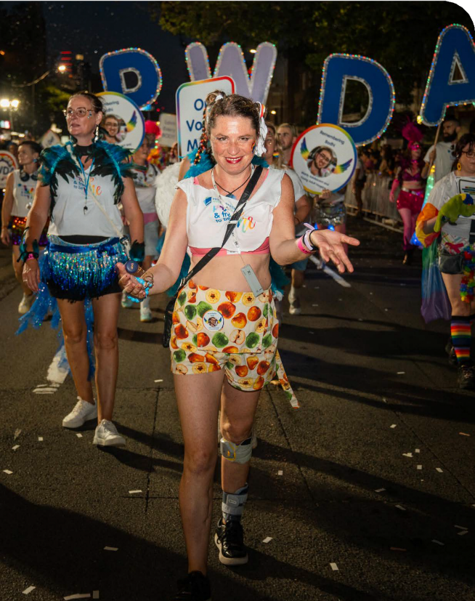
PWDA Co-Vice President Eva Sifis with PWDA members at the 47th Sydney Gay and Lesbian Mardi Gras Parade.

Key statistics
21% increase in membership
67 reports, position statements and submissions
27 PWDA member focus groups, consultations and events
3.02 million people reached on social media
243,709 website visitors
85 media releases, news and blog articles
37 training sessions delivered to over 950 people
63 staff members
903 Qantas Carer Concession Cards issued
2,014 clients supported
39,575 occasions of client service

Individual Advocacy Client satisfaction

I am satisfied with the services I have received
85% of respondents rated this as high or very high

The service listened to me and understood my issues
90% of respondents rated this as high or very high

I am better able to deal with issues that I sought help with
82% of respondents rated this as high or very high

Strategic Focus Areas
The 2022-25 Strategic Plan is underpinned by four Strategic Pillars, which outline our objectives:

Represent
Remain the leading national cross-disability member driven
organisation. Reflect the diversity of our community and represent their voice nationally and internationally.
Advocate
Advocate for the human rights of all people with disability at individual and systemic levels.
Educate
Drive positive change for people with disability through education and advocacy.
Sustain
Maintain a financially viable
and sustainable organisation.

14

Represent
Remain the leading national cross-disability member driven organisation. Reflect the diversity of our community and represent their voice nationally and internationally.

Membership
This year PWDA achieved a 21% growth in membership.
A key focus this year was to gain a deeper understanding of our members’ priorities and to increase engagement and representation across all our events, activities and work.
As a Disabled People’s Organisation (DPO) we are led by, for and with people with disability.
Throughout the year, PWDA hosted a series of co-designed events and forums. Topics and themes included the Disability Royal Commission recommendations, International Day of People with Disability, LGBTQIA+ people with disability and the Australian Federal Election.
We also began developing new member- led blog opportunities, storytelling initiatives and reinstated our PWDA Board Advisories – groups led by PWDA Directors and members.

International and National Representation
PWDA’s advocacy efforts both within Australia and internationally represented our members and the broader disability community across various reforms, ensuring the voices of our community shaped top- level decisions in Australia and globally.

National Representation
This year, through consultation, focus groups, feedback sessions, interviews and surveys, PWDA members and the
disability community shared their priorities, experiences and hopes for systemic reform which informed PWDA’s advocacy positions, statements and submissions to government.

PWDA advocated for people with disability in the Federal Election, releasing our 2025 Election Platform and urging candidates and parties to commit to seven key priorities for disability rights and full inclusion. We contributed to the Federal Budget process with our detailed Pre-Budget submission and media engagement.
PWDA staff and Board Directors participated in committees, advisory groups, and national events. Thank you to Board Directors Eva Sifis and Daniel Flynn who represented PWDA at our national online International Day of People with Disability event. Board Director Stuart Mawbey who represented the organisation at several working groups and led reprioritising disaster readiness as a priority from the Board. They also contributed expertise alongside Senior Policy Officer Bastien Wallace at the National Emergency Management Agency (NEMA) Exercise Convergence event. We also thank Board Director Kevyn Morris for sharing their expertise, representing PWDA at the National Prevention Framework for Elder Abuse Steering Committee.

In the media
PWDA secured national and regional coverage, amplifying disability community voices, ensuring our members’ concerns were heard across platforms, while holding governments accountable to real-world outcomes for people with disability.
PWDA spokespeople including President Trinity Ford, Deputy CEO Megan Spindler- Smith and Director Steph Travers, provided expert commentary on a wide range of issues and positions represented in over 1290 media items across TV, print, radio and online media.
Our media outreach also supported key campaigns including Raise the Rate and income support reforms, NDIS reforms and foundational supports, and the call for accessible housing in the National Construction Code.

In the community
International Day of People with Disability
On Tuesday 3 December, to mark International Day of People with Disability (IDPwD) PWDA hosted A Voice of Our Own – a national online conference created by and for people with disability.

Hundreds of people across Australia joined online, bringing together community voices to share lived experiences, showcase creativity and discuss what our future must be.
The event featured an exciting line-up of speakers and performers, activists and advocates, all who are PWDA members, including Akii Ngo, Dr Alastair McEwin AM, Eliza Hull, Ann-Mason Furmage, Belinda

Kochanowska, Dr. Scott Avery, Hannah Solomons, Leigh Creighton, Marayke Jonkers, Naomi Anderson and Uncle Paul Constable-Calcott.
Speakers were joined by PWDA President Trinity Ford and Co-Vice Presidents Eva Sifis and Daniel Flynn, who participated in the discussions and shared their expertise and perspectives.
PWDA is grateful to all the speakers who contributed to this event. PWDA would also like to acknowledge the funding received from Australia’s Disability Strategy – National Disability Conference Initiative 2024-2025.
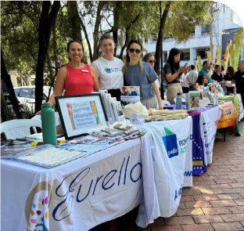
IDPwD event in Burwood, attended by PWDA staff Ramona and Crystal pictured here with a representative from a local community organisation.
PWDA staff and members also took part in IDPwD events across the country, contributing their lived experiences and reflections to national conversations on inclusion, rights and disability pride.
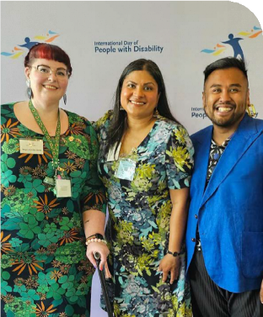
PWDA Deputy CEO Megan Spindler-Smith with 2024 IDPwD Ambassador and MC Sara Shams and PWDA Senior Manager of Policy Giancarlo De Vera at the Australian Government's morning tea celebrating International Day of People with Disability.

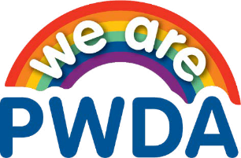

LGBTQIA+ National Peak
Over the past 12 months, PWDA advanced representation of LGBTQIA+ people with disability, launching our plan to integrate
a LGBTQIA+ intersectional needs plan, contributing to the National Action Plan on LGBTQIA+ Health and Wellbeing, and
developing a PWDA strategy in partnership with Inclusive Rainbow Voices and other key organisations.
PWDA engaged in high-level advisory and working groups to advocate for the rights of LGBTQIA+ people with disability in policy and systems reform. We co-authored a joint submission on the SOGIESC chapter of Australia’s Universal Periodic Review NGO Shadow Report and is helping Equality Australia refine the final version to reflect lived experiences.
In June 2025, we launched our first national survey of LGBTQIA+ people with disability to document discrimination, inclusion, service access, and systemic barriers. The data will guide our advocacy and strengthen sector-wide evidence.
Additionally, we participated in an Inclusive Rainbow Voices session on foundational supports, attended the National Disability Research Partnership (NDRP) workshop on LGBTQIA+ data gaps, and began planning a community-led LGBTQIA+ Disability Advisory Network.
Connecting with our LGBTQIA+ community
Throughout the year, PWDA prioritised increasing the visibility and connections of our LGBTQIA+ community. Guided by input from our LGBTQIA+ members, the
theme “Proud and Free to be Me” unified all
activities.

‘Proud and Free to be ME’ is a call from LGBTQIA+ people with disability for a society, where they are ‘free to be me’
- free to be unapologetically themselves, free from discrimination, violence, and restrictions from an inaccessible society. We will continue to fiercely fight for equal rights, and loudly and
proudly celebrate the diverse shades of LGBTQIA+ people with disability to the world!

Midsumma Festival
On Sunday 2 February 2025, PWDA participated in the Midsumma Pride March in Victoria for the first time. Our involvement showcased our community to a wider audience, letting Australia know that people with disability are an important part of the LGBTQIA+ community.

We march because LGBTQIA+ people with disability belong in every space — proudly,
unapologetically, and with the full freedom to be themselves. Our presence at Midsumma is a powerful statement against the
invisibility and exclusion that too many in our community still face.
PWDA President Trinity Ford.

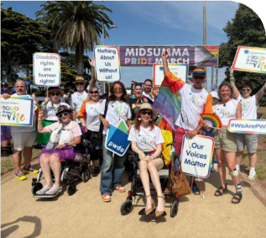
PWDA President Trinity Ford, Co-Vice President Eva Sifis and CEO Sebastian Zagerella with PWDA members at the 2025 Midsumma Pride March.

Sydney Mardi Gras Festival
PWDA participated in the 2025 Sydney Gay and Lesbian Mardi Gras Festival including Fair Day and the 47th Sydney Mardi Gras Parade.
On Sunday 16 February, PWDA hosted a Fair Day Community Stall at Victoria
Park, providing an important opportunity to connect directly with LGBTQIA+ community members with disability, share information about our work, and advocate for the rights and inclusion of LGBTQIA+ people with disability.
Just weeks later, on Saturday 1 March, PWDA members, staff, and Board Directors took part in the 47th Sydney Mardi Gras Parade on Oxford Street. This vibrant celebration highlighted the intersection of

LGBTQIA+ and disability identities, with participants reflecting on the significance of embracing and celebrating their full, authentic selves.

Being surrounded by queer people with disability,
who understand without needing to say anything, is a magical and transformative experience. It makes me feel proud and free to be me.
PWDA member, Caitlin.
Free to Be Proud National Online Event
On 19 February, PWDA hosted a national online event, ‘Free to be Proud,’ celebrating LGBTQIA+ disability pride. Hundreds of people nationwide joined PWDA members and advocates to discuss barriers faced
by our community. PWDA President Trinity Ford and CEO Sebastian Zagarella joined speakers Daniel McDonald, Margherita Coppolino, Isabella Choate, Margie McCumstie, Is Hay and Hayden Moon to explore creating meaningful change. The event also featured member representation from the LGBTQIA+ community, amplifying our collective voice.

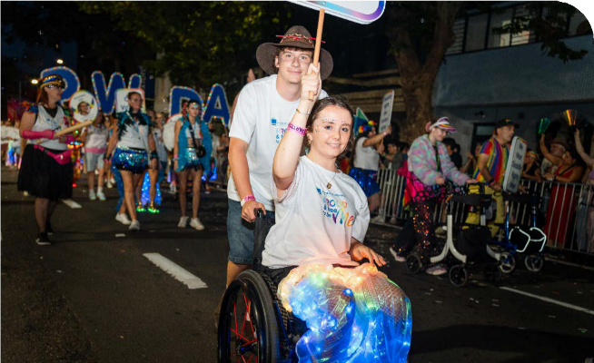
PWDA member, Caitlin at the 47th Sydney Mardi Gras Parade with PWDA.

International Representation
PWDA strengthened its international advocacy through deep engagement with the United Nations system, global DPO networks and key international forums.
We amplified the voices of people with disability, emphasising that the Convention on the Rights of Persons with Disabilities (CRPD) is a binding obligation, not optional.
We championed disability-inclusive global policies, advocated for Australian perspectives, and fostered international
solidarity with sister DPOs. Throughout, we reaffirmed that people with disability must be central to all global decision-making affecting us.
In November, PWDA hosted a delegation of representatives from five different disability organisations from the southern provinces of South Korea. The organisations represented were Jangsan Welfare Center, Geoje City Independent Living Center,
Gi-Jang Independent Living Center, Busan Center for Independent Living and Busan Disabled Persons Employment Help Center. It was a valuable exchange of experiences, emphasising the importance of continuing to strengthen our relationships with other organisations in our region.
PWDA also met with the UN Special Rapporteur during his November visit to Melbourne. This meeting offered an opportunity to speak directly about the lived experiences of people with disability in Australia and highlight the risks of modern slavery within these settings.
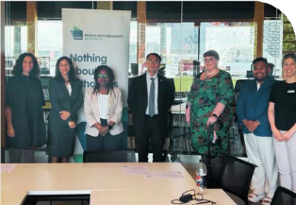
Left to right: AHRC Director, Disability Rights, Sophia Rinaldis, NEDA CEO, Samara Rodway, Australian Red Cross Adviser, Kudzi Nhatarikwa, UN Special Rapporteur on Contemporary Forms of Slavery, Prof Tomoya Obokata, PWDA Deputy CEO, Megan Spindler-Smith, PWDA Senior
Manager of Policy, Giancarlo de Vera, PWDA
Senior Policy Officer, Lisa Ira.

We are active members in global DPO networks and participated in regional advocacy through the Pacific Disability Forum and Commonwealth Disabled Peoples Forum, and contributed as an executive member of the Australian Disability and Development Consortium. This work was part of collective efforts on treaty body engagement and international human rights reviews.

PWDA President Trinity Ford represented PWDA at the United Nations 69th session of the Commission on the Status of Women (CSW69) at UN Headquarters in New York in March 2025. This was a critical opportunity to ensure Australian women with disability were represented and to advocate for their meaningful inclusion in global policy discussions.
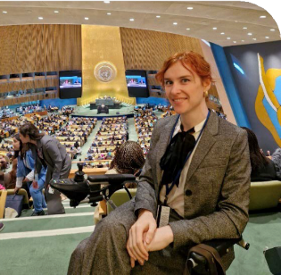
PWDA President Trinity Ford at the Commission on the Status of Women (CSW69).
PWDA is proud to have been part of the Disabled Peoples’ Organisations Australia (DPOA) delegation to the 18th
Session of the Conference of States Parties (COSP18) to the CRPD which took place from Tuesday 10 – Thursday 12 June 2025.
PWDA’s representatives Deputy
CEO, Megan Spindler-Smith, PWDA Board Directors, Steph Travers, Alexandra Bignell and PWDA Member, Tahlia-Rose Vanissum (Woppaburra Woman and First Nations Disability and Gender Justice Advocate) contributed across multiple
high-level sessions.

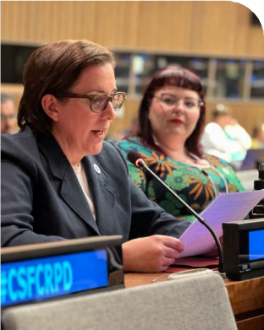
PWDA Board Director, Alexandra Bignell and Deputy CEO, Megan Spindler-Smith at the 18th Session of the Conference of States Parties (COSP18).

Advocate
Advocate for the human rights of all people with disability at individual and systemic levels.

Systemic Advocacy
PWDA played a central role in ensuring wide-ranging cross-disability systemic advocacy, ensuring the voices of people with disability were front and centre
in decision-making processes across government, systems and community settings. We continued to work on a national, state (NSW), and international level, driving reforms and safeguarding disability rights.

National
During this period, PWDA co-authored and endorsed multiple submissions to the NDIS Amendment Bills (No.1 and 2), representing the concerns of members and the wider disability community, ensuring we as people with disability were central to NDIS reform. PWDA co-led advocacy on the sexual supports policy, engaged in ongoing co- design working groups, and advocated for clarity and safeguards around foundational supports.
We worked closely with Disability Representative Organisations (DROs), the Department of Social Services (DSS), and the National Disability Insurance Agency (NDIA) to amplify member concerns
about access and rights. In response to the Disability Royal Commission, we
analysed government actions, monitored implementation, and ensured a human rights-based approach remained central.
Housing remained a key issue. Our national housing advocacy included co-signing
the Building Better Homes submission and engagement in policy platforms for accessible housing.
Additionally, PWDA national systemic advocacy extended into major policy areas, including:
- Restrictive practices – hosting forums and workshops that connected stakeholders nationally and in NSW.
- Domestic and family violence (DFV) – embedding a disability lens in the National Plan to End Violence Against
Women and Children and participating in numerous state-level reference groups.

- Disaster management – launching a comprehensive lived experience-
informed resource, to support inclusive emergency planning and inform state and national reviews.
- Transport, telecommunications, AI, and automated decision-making frameworks – through submissions and collaboration with regulators.

New South Wales
Through the Disability Advocacy Futures Program (DAFP), PWDA’s systemic advocacy shaped inclusive policy and service reform at the NSW state level, grounded in insights from individual advocacy and direct community engagement.
Key achievements included:

- Housing – co-chairing the Building Better Homes campaign, influencing social housing and new development standards, appearing before parliamentary hearings, and contributing to national accessible housing policy platforms.
- Homelessness – contributing to the Specialist Homelessness Services (SHS) Access and Withdrawal Policy Working Group. We influenced policy on accessibility and exclusion and co- developed resources like accessibility checklists for SHS providers.
- Domestic and family violence (DFV) – contributing to NSW reference and working groups and fed into national frameworks to ensure responses reflected the realities of people with disability. We provided key feedback on policing guidelines and state strategies.
- Transport – our work led to a $15 million state investment in accessible taxis. We continued working through the Accessible Transport Advisory Council and other working groups to influence system and service improvements.
- Law and voting rights – we led advocacy on guardianship law reform, financial management reviews, and voting access, appearing at committee hearings and maintaining engagement with electoral reform bodies.
- Education – we hosted forums on inclusive education, pushing for alignment with the Disability Royal Commission’s recommendations and open employment outcomes.
- Disaster management – we developed a comprehensive agenda pushing for the adoption of our recommendations outlined in our Roadmap to Improving Outcomes for People with Disability in Disaster Management.
- Framing the NSW budget submission in the wellbeing framework that we supported the development of for all NSW.

This work ensured NSW-specific reforms were both responsive to lived experience and aligned with national policy change.
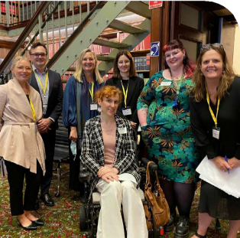
Left to right: Family Advocacy Capacity Development Coordinator, Laura Abrahams, PWDA Senior Policy Officer, Julian Laurens,
Family Advocacy Systemic Advocacy and Campaigns Manager Leanne Varga, Family Advocacy Capacity Development
Coordinator, Talia Roshan, PWDA Deputy CEO, Megan Spindler-Smith, Family Advocacy Executive Officer, Cecile Sullivan Elder, and PWDA President Trinity Ford in front.

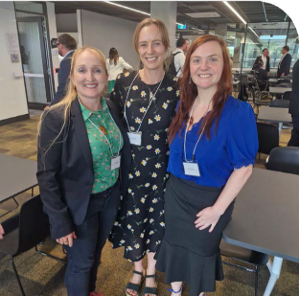
Left to right: PWDA Senior Policy Officer Bastien Wallace, Summer Foundation Head of Policy, Communications and Systems Change, Jessica Walker, PDCN Systemic Advocacy Manager, Kelly Temple at the NSW Government Livable Housing forum as part of the Building Better Homes Campaign in NSW.

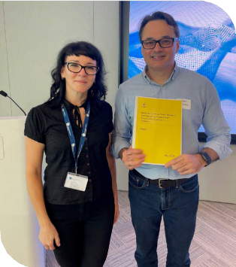
PWDA Individual Advocate, Ülker Arcan and
PWDA Senior Policy Officer, Julian Laurens.

International Advocacy
PWDA’s systemic advocacy extended to global platforms, ensuring international human rights mechanisms respond to the voices of people with disability. We prepared submissions to the UN Special
Rapporteur on Slavery and the UN Working Group on Arbitrary Detention, exposing
the exploitation of people with disability in segregated housing and employment.
PWDA also led a joint submission ahead of the UN Working Group’s visit to Australia.
In 2025, PWDA President Trinity Ford represented PWDA at the UN Commission on the Status of Women (CSW69), advocating for inclusion of women with disability in global policy.
At the 18th Session of the Conference of States Parties (COSP18) to the CRPD, our delegation highlighted urgent issues such as de-institutionalisation, disability-led AI development, Indigenous and intersectional disability leadership, and the impacts
of anti-diversity narratives. PWDA also hosted a side event exploring systemic and cultural change through a disability justice lens, sparking international dialogue on
co-design, inclusive systems, and power- sharing.
Through active participation in UN forums and side events, PWDA reinforced the global importance of data justice, culturally safe service design, and disability-led solutions.

Acknowledgements
PWDA acknowledges the funding it receives from the Australian Government’s Department of Social Services’ Disability Representative Organisations Program
to undertake nationally focused systemic advocacy – including Disability Royal Commission focused work and additional support to engage people with disability during the NDIS Review.
PWDA acknowledges the funding it receives from the National Disability Insurance Agency to support co-design activities.
PWDA acknowledges the funding it received from the Australian Government’s Department of Social Services to attend the 69th Session of the United Nations Conference on the Status of Women (CSW69) and 18th Session of the Conference of States Parties (COSP18).

Individual Advocacy
In 2024-25, PWDA’s Individual Advocacy Program supported over 2,000 people with disability across NSW and Queensland, responding to increased demand for advocacy services, managing over 5,000 enquiries.
Across PWDA advocacy programs, advocates helped clients navigate complex issues, understand their rights, and enhance choice and inclusion during ongoing system reforms. PWDA also

remained a trusted source of support, amid ongoing uncertainty from the Disability Royal Commission and changes to the NDIS.
Advocates worked alongside clients and partnered with key services including Legal Aid, Knowmore, housing providers, the Tenants’ Union, Summer Foundation and SDA Alliance. The team also worked closely with schools, the Department of Education, regional community organisations, the NDIA, and DSS. PWDA also contributed
to national advocacy networks such as the Queensland Independent Disability Advocacy Network to advance systemic
change and ensure more equitable access to rights-based support.
Advocates identified systemic issues such as NDIS delays, inconsistent decisions, housing communication gaps, and support disparities in schools. PWDA engaged with government agencies to improve tribunal processes, contributed to NSW legislation, and promoted transparency in NDIS decisions, leading to broader reforms.
We are proud of the vital support our advocates have provided to clients this year. Feedback received highlighted the value of working with advocates who are knowledgeable, attentive, and clear in communicating options.
Many clients shared that, without this advocacy, they would have struggled
to resolve their issues due to complex systems, structural barriers, and limited access to clear information.

There are no words to fully express the kind, attentive and professional experience I had with my PWDA advocate. I am truly grateful and will always remember this experience as a major contributor to moving forward from past traumas. Thank you!!!

National Disability Advocacy Program
PWDA supported 627 individual cases of advocacy, under the National Disability Advocacy Program (NDAP) in New South Wales and Queensland.

Through the National Disability Advocacy Program (NDAP) PWDA advocates delivered impactful, rights-based advocacy across a broad range of issues affecting people with disability.

Clients gained confidence through support that clarified options and provided ongoing support during times of crisis, reducing overwhelm and distress. Key efforts focused on resolving urgent housing matters, preventing evictions, securing accessible housing, and avoiding hospital discharge to unsuitable aged care.
Advocates also assisted with NDIS negotiations, safeguarding essential supports amid funding challenges, and helped challenge unfair treatment. They also helped individuals understand complicated systems like the NDIS, Centrelink, child protection and guardianship.
Beyond individual cases, advocates contributed to improved system responses by supporting clients to communicate
with service providers and engage in collaborative problem-solving.
In New South Wales, NDAP services are available in both regional and metropolitan areas, including Sydney, Southern Tablelands, Wagga Wagga and remote services across the state. In Queensland, NDAP supports a wide range of regions, including Hervey Bay, Port Douglas– Daintree, the Sunshine Coast, Bundaberg, Maryborough, Logan-Beaudesert and Outback Queensland.
We acknowledge the funding from the Australian Government Department of Social Services (DSS) which makes this advocacy possible.

NDIS Administrative Review Tribunal (ART)
PWDA supported 299 individual cases of advocacy under the NDIS Administrative Review Tribunal (ART) in New South Wales and Queensland.

This year, PWDA advocates supported a growing number of people with disability to navigate complex appeal processes in the Administrative Appeals Tribunal (AAT) and Administrative Review Tribunal (ART),
expanding services across Queensland and areas of New South Wales.
Due to more matters being escalated to the ART and delays in decisions, many
individuals found themselves without critical funding and at risk of harm.
With a focus on building 'self-advocacy' skills, PWDA launched monthly ART clinics and education sessions to increase client’s knowledge, understand their rights and prepare for appeals. These clinics also helped identify vulnerable individuals who required ongoing assistance.
Outcomes achieved this year included supporting clients to overturn decisions that had withdrawn necessary support, enabled community participation, and assisted individuals to secure safe, accessible housing. Advocates provided clear, accessible information about ART

processes, helped clients identify and gather evidence, liaised with legal services, and ensured each person’s choices were central to decision-making.

… My PWDA advocate was there for every step of the process. Together, we
attended case conferences with the NDIS lawyers, trying to reach an agreement.
When that wasn’t possible, I decided to take the matter to the Tribunal. My PWDA
advocate supported me with the volume of paperwork, emails, deciphering NDIS language, finding legal help, reading my statements, offering guidance, and communicating on my behalf. Most importantly, my PWDA advocate made sure my voice was heard… Before the case conference, I was scared, but knowing my PWDA advocate was there, quietly cheering me on, reminded me I was not alone.
PWDA also collaborated with the NDIA to address systemic barriers, delivering
presentations to government agencies and
contributing expertise to consultations on legislative changes. New ART resources were developed, including ART consent forms, brochures, and information sheets to improve consistency and access to support.
Client feedback reflected the program’s effectiveness, with many describing the advocacy as life-changing, respectful, and essential in navigating complex and often intimidating processes.
PWDA acknowledges the funding provided by the Australian Government’s Department of Social Services (DSS). PWDA also acknowledges the support provided by Legal Aid Queensland, Legal Aid New South Wales and community partners who supported people to exercise their rights and choices.

Case Study:

PWDA helps Thomas secure essential NDIS supports

Thomas is a young person with disability who relies on consistent, individualised support to take part in everyday activities and remain engaged with his community. When his NDIS plan was reviewed, funding for the 1:1 weekend support he needed to attend his day program was not approved. This decision disrupted his regular routine, created uncertainty for his future participation, and placed significant emotional and practical strain on both Thomas and his family.

How PWDA helped
Thomas contacted PWDA after several unsuccessful case conferences at the Administrative Review Tribunal (ART) failed to resolve the funding issue. His PWDA advocate worked closely with him and his support network to organise a legal aid appointment for advice on the proposed agreement. Based on this advice, Thomas decided to strengthen his case by gathering targeted evidence and preparing clear responses to the NDIS’s concerns.
The PWDA advocate supported Thomas to identify key information he wanted to share, ensured his voice remained central to the process, and maintained regular communication with all parties involved. At every step, Thomas’s choices, rights, and goals were prioritised.

Outcomes achieved
With skilled advocacy support, Thomas successfully overturned the NDIS decision and secured all the requested supports.
As a result, he was able to continue attending his day program with appropriate 1:1 weekend support, maintaining his routine, reducing stress for his family, and avoiding the need for a full tribunal hearing.
This case highlights the critical role advocacy plays in ensuring people with disability can access the supports they need to live the life they choose.
*The names of the people in this case study have been changed.

30

Queensland Disability Advocacy Program (QDAP)
PWDA supported 165 individual cases of advocacy under the Queensland Disability Advocacy Program (QDAP).

PWDA QDAP advocates in Noosa, the Sunshine Coast, Gympie and surrounding areas empowered people with disability to make informed choices, assert rights, stay safe, and connect to communities.
They resolved issues like NDIS access delays, sudden reductions in support, barriers to safe and accessible housing and urgent NDIS appeals to stop people
from losing support or being sent to hospital unnecessarily. Additionally, advocates provided targeted assistance to older residents, people living alone in rural communities, and those with limited access to technology.
The PWDA QDAP team conducted outreach, including free clinics and info sessions, to expand support and strengthen local partnerships. Reflective and peer- learning practices ensured continuous improvement, helping staff adapt to
emerging challenges such as policy updates and guardianship increases.
PWDA acknowledges the QDAP funding provided by the Queensland Government Department of Seniors, Disability Services and Aboriginal and Torres Strait Islander Partnerships.

Attention to detail, transparency, and unquestionable support from my PWDA advocate were consistently insightful throughout our journey navigating the NDIA appeals process. This support enabled my husband to
be granted access after a long, emotionally draining experience.

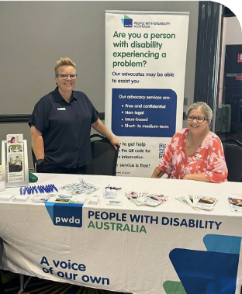
PWDA QLD advocates at a community outreach event.

My PWDA advocate was a pillar of strength with an empathetic approach,
guiding us towards a positive outcome. We appreciated their punctuality and unwavering commitment, which went above and beyond expectations. They consistently demonstrated understanding and strength as we worked through this challenging time, and we want to encourage them to continue supporting others who are striving for a positive future.

Case Study:

Empowering a young First Nations woman to reunite with her family

Cara is a young First Nations woman with disability who had experienced long-term disadvantage and multiple interactions with government systems. When her children were removed from her care, she was not connected to any support services and had little understanding of the child protection process. Without legal guidance or a support network, Cara struggled to meet service requirements and felt overwhelmed, isolated, and powerless to advocate for her family.

How PWDA helped
The PWDA advocate provided clear information about how the child protection system works and supported Cara to express her views in meetings with child safety authorities. To strengthen her support network, the advocate connected Cara with a local counselling service and assisted her to apply for Legal Aid. Cara also engaged a local law firm for legal advice.
The PWDA advocate worked with her to prepare for and participate in a family
group meeting, helping Cara communicate her goals and contribute meaningfully to decisions about her children’s care.

Outcomes achieved
With advocacy support, Cara gained the confidence and tools to take part in key decisions affecting her family. She
secured legal representation, improved her understanding of the system, and actively participated in planning for her children’s future. As a result, Cara’s children have now returned home, and she has established long-term connections to local support services.
This case highlights the power of accessible, culturally appropriate advocacy in helping people navigate complex systems, uphold their rights, and reconnect with community and family.
*The names of the people in this case study have been changed.

Disability Advocacy Futures Program
PWDA supported 262 individual cases of advocacy under the Disability Advocacy Futures Program (DAFP).

PWDA DAFP advocates supported people with disability across Sydney’s South Eastern Sydney and South Western Sydney Local Health Districts, helping them access and resolve issues with NSW Government services, including discrimination, essential access, complaints, and system navigation.
A key highlight was resolving housing related issues for over 70% of clients, including support with priority transfers, urgent repairs and accessibility modifications. In several cases, this prevented imminent risk of homelessness or serious health impacts.
Advocates worked in a culturally responsive way, using interpreters and support networks, resulting in positive client feedback with many people reporting improved confidence, reduced stress, and greater clarity in navigating their available options.
The team engaged in community outreach through presentations, expos, and partnerships, including regular visits to Assisted Boarding Houses.
Systemic issues like delays and poor communication with NSW Housing were identified, informing broader advocacy for responsive, inclusive services.
PWDA acknowledges the funding provided by the NSW Department of Communities and Justice (DCJ) for DAFP services.

My advocate was outstanding and a pure diamond.
Supportive above and beyond and I’m so grateful for her efforts and support and guidance. She’s invaluable and a leader in her field.

Case Study:

Cheryl’s journey to safer, accessible housing

Cheryl, a woman with disability and multiple health conditions, faced serious safety and accessibility challenges in her public housing. As her health declined, she was increasingly unable to manage daily activities in her deteriorating home. Despite making repeated complaints to Homes NSW, attending two NSW Civil and Administrative Tribunal (NCAT) hearings, and spending over $6,000 on professional reports, only minimal repairs were undertaken. When Cheryl declined an unsuitable housing offer due to access
barriers, she was removed from the transfer list without clear explanation or alternatives.

How PWDA helped
PWDA advocates worked closely with Cheryl to escalate her housing transfer request and ensure her disability-related needs were formally recognised. They supported her to access temporary accommodation when mould and structural issues made her home uninhabitable
and helped her lodge a formal complaint.
Advocates guided her through the NCAT process, helped her liaise with housing officers, and ensured she was informed of her rights at every step. Cheryl was supported to speak up and successfully
paused rent payments during the period she was unable to live in her home.

Outcomes achieved
Cheryl received a compensation payment and Homes NSW committed to major repairs including full mould remediation, kitchen and bathroom upgrades, and carpet replacement. Advocates ensured her temporary housing needs were met and
helped her submit a new transfer application that clearly outlined her requirement for a ground-floor, accessible home.
*The names of the people in this case study have been changed.

Disability Advocacy Futures Program - Education
PWDA supported 74 individual cases of advocacy under the Disability Advocacy Futures Program – Education (DAFPE).

Through DAFPE PWDA provides free, individual advocacy for students with disability in NSW public schools and their families and guardians across Sydney’s South, Eastern Sydney, and South Western Sydney Local Health Districts.
This year, the PWDA Futures Education team addressed issues such as poor school communication, limited Individual Support Plan implementation, inadequate mainstream classroom support, access barriers to programs like the Assisted School Travel Program, bullying, and systemic discrimination.
They provided guidance on Department policies, helped students and parents prepare for meetings, and liaised with schools and authorities, often preventing disengagement and securing necessary accommodations.
The team engaged over 1,000 community members through expos, interagency meetings, and presentations, while DAFP advocates highlighted systemic gaps,
including the lack of enforceable guidelines for schools’ obligations.
PWDA acknowledges the funding that the NSW Department of Education provides via the NSW Department of Communities and Justice (DCJ) for the DAFP Education services.

Our advocate was helpful in advocating with me to
support my child in receiving the support he required by the Department of Education.

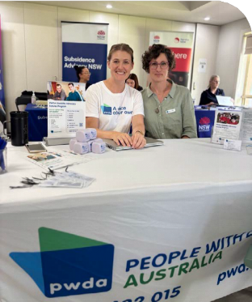
PWDA advocates conducting community outreach.

Case Study:

Supporting Tristan’s right to inclusive education

Tristan, a young student with disability enrolled in a NSW public school support unit, was experiencing ongoing health and anxiety issues that impacted his learning and wellbeing. Despite professional advice, the school failed to provide the necessary adjustments or communicate effectively with Tristan and his family. This resulted
in Tristan being unable to attend school regularly or participate fully in his education.

How PWDA helped
PWDA advocates worked alongside Tristan and his family to raise concerns with the school and escalate the matter to the Director of Educational Leadership. The PWDA advocate ensured Tristan’s voice and rights were heard, helped communicate professional recommendations to the Department, and supported the family through complex processes to secure the adjustments needed.

Outcomes achieved
As a result of this advocacy, the Department approved additional funding for Tristan’s return to school with 1:1 support. He was also offered a place at his preferred school, which was accepted for the following term. With a more supportive environment and the right adjustments in place, Tristan was able to re-engage in education. His family reported feeling empowered and better equipped to support his learning journey.
*The names of the people in this case study have been changed.

Disability Housing Advocacy Service
PWDA supported 83 cases of individual advocacy under the Disability Housing Advocacy Service (DHAS) and assisted 298 people via the 1800 Disability Housing Information Line (DHIL).

The DHAS and DHIL programs provide free, accessible information, early intervention, and advocacy to support people with disability living in supported accommodation across NSW, ensuring stable living, informed choices, and rights protection.
In the past year, PWDA advocates worked alongside clients to navigate complex matters, including AAT cases, the withdrawal of essential supports, and concerns regarding tenancy rights and housing security.
Advocates played a vital role in safeguarding clients’ rights and dignity by challenging eviction notices, addressing unsafe living conditions, or ensuring housing providers adhered to fair and transparent tenancy agreements.
Insights from this work informed systemic advocacy, including reporting directly to the NSW Government. This collaboration is contributing to the development of the
Shared Living Arrangements Act, helping to strengthen rights and safeguards for people with disability. As the sector prepares
for upcoming reforms, PWDA remains dedicated to preventing homelessness and unsafe housing.
PWDA acknowledges funding from the NSW Government Department of
Communities and Justice (DCJ) that makes the DHAS and DHIL available.

Case Study:

Finding Greg safe and stable housing

Greg was living in an unsafe NSW boarding house without access to essential supports. Without the right services, he struggled to manage daily tasks, maintain his health, and feel secure in his living environment.
These challenges also led Greg to have contact with the justice system. When his application for Specialist Disability Accommodation (SDA) and Supported Independent Living (SIL) was declined,
Greg was left vulnerable and at serious risk.

How PWDA helped
PWDA advocates supported Greg to understand the appeals process and build a strong case for SDA and SIL. The PWDA
advocates worked closely with Greg and his network to document the risks associated with his living situation. They gathered evidence from disability and community supports and helped Greg prepare for meetings and clearly expressed why these supports were essential to his safety
and wellbeing. The advocates ensured Greg’s voice remained central throughout the process and that all concerns were effectively communicated to decision- makers.

Outcomes achieved
As a result of PWDA advocacy, Greg’s application for SDA and SIL was approved. He was able to transition into safe, stable accommodation with the support he needs to live independently and participate more fully in community life. This outcome significantly improved Greg’s wellbeing and restored a sense of control and dignity to his daily living.
*The names of the people in this case study have been changed

PWDA Redress Project
PWDA supported 206 clients under the Redress Project, a 56% increase from the previous year.

The National Redress Scheme was established in response to
recommendations by the Royal Commission into Institutional Responses to Child Sexual Abuse in 2018.
PWDA is a leading National Redress Scheme Support Service. For the second consecutive year, the PWDA Redress Team achieved substantial growth in client numbers, supporting 206 adult survivors of institutional child sexual abuse with disability to safely navigate the complex application process, and make informed access to the Scheme.
This year the PWDA Redress Team expanded awareness and access to the National Redress Scheme through broad outreach across NSW, including workshops in collaboration with Redress Support Services and Knowmore legal. For many community services and survivors living in isolated areas, it was the first time they had received this information.
PWDA remains committed to ensuring information on the National Redress Scheme is accessible to all. This year PWDA worked closely with DSS to develop accessible resources for the DSS website
and to offer guidance and support to the DSS policy team on supported decision- making for people with disability applying to the National Redress Scheme. The PWDA Redress Team also provided information and support to the National
Centre for Action on Child Sexual Abuse for educational packages designed to assist GP’s and allied health professionals who work with people who have experienced institutional child sexual abuse.
PWDA acknowledges the Australian Government Department of Social Services (DSS) funding that makes the PWDA Redress Support Service available.
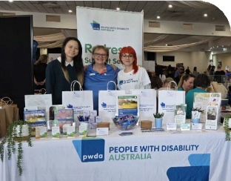
PWDA Redress Team and advocates at a community engagement event.



When I was a child,
I experienced abuse that
I would not wish to happen to anyone. I kept my secrets for over 40 years. I disclosed to a work colleague a few years ago and shared
my experiences with her. Although she was very sympathetic, she did not have the capacity to ease my pain. Then, the people from PWDA Redress visited my workplace in a remote NSW town and spoke about the Redress Scheme and how they could support me to apply. About
a week later, I called the number on the brochure.
I am extremely grateful that the PWDA Redress Team visited my town. I would not have known that there was help for me.

Client:

Supporting Ruth to begin their Redress journey

Ruth is a First Nations woman living with disability in a remote area of NSW. Ruth had never disclosed or received support for the historic childhood sexual abuse she experienced in relation to an institution.
The lasting impact of these experiences continued to affect Ruth’s health and sense of safety. Ruth became aware of the National Redress Scheme when PWDA’s
Redress Team visited their workplace during an outreach visit.

How PWDA helped
Building trust was central to the support provided. The PWDA advocate began with a series of conversations focused on listening and creating a culturally safe, confidential space. Ruth felt more comfortable with
a family member present and noted this strengthened their relationship.
Given the distress the process brought up, the advocate helped Ruth access free counselling arranged in a neighbouring town to support her need for privacy and anonymity.
After several counselling sessions, Ruth felt ready to begin her application for the National Redress Scheme.

Outcomes achieved
With PWDA advocacy support, Ruth prepared and submitted her application and was eligible for an advance payment.
This reduced financial stress and supported
Ruth’s overall wellbeing.

Ruth is now attending regular counselling and reports a significant improvement in her mental health and sense of hope for the future. Ruth shared that without the outreach visit and dedicated advocacy, she may never have accessed support or
applied for redress. This case highlights the importance of trauma-informed, culturally respectful advocacy in reaching and empowering people who might otherwise remain unsupported.
*The names of the people in this case study have been changed

42

Educate
Drive positive change for people with disability through education and advocacy.

Strategic Projects and Training
In 2024–25, the leadership and insight of our trainers and strategic projects team staff continue
to shape inclusive practices across a wide range of settings. Through this work, PWDA helps to ensure government agencies, businesses and community organisations learn directly from the lived experience of people with disability, and build practical skills in disability rights, inclusive practice and systemic change.

Strategic Projects

Advancing Women with Disability in the Workplace
Funded by The Department of Prime Minister and Cabinet under the Women’s Leadership and Develop Program (WLDP), the Advancing Women with Disability in
the Workplace project aims to increase leadership representation, workforce participation, and workplace safety for women with disability. Launched in 2023, it addresses structural and attitudinal barriers through phased initiatives.
In 2024-25, the project entered its second and third phases, piloting a 20-week
co-designed education and mentorship program with Westpac, pairing women

with disability (mentees) with women in leadership roles (mentors). The pilot formed nine mentorships, one of which led to a leadership role, demonstrating real-world impact of the program and its potential for sustainable impact.
Co-designed with women with disability and guided by advisory input, the program
included e-learning on disability awareness, inclusive leadership, ableism, and safety, alongside workshops like ‘Leading Inclusively’ led by Dr Michelle Hyde using yarning circle methodology. Resources were tailored and refined through participant feedback.

Michelle’s facilitation was inspiring and deeply impactful.
Her ability to create a meaningful and inclusive space left a lasting impression, with participants expressing eagerness to engage with her work in the future.
Pilot program participant
Participants valued the experience, citing increased connection, confidence, and sense of belonging. Mentors reported expanded understanding of accessibility and enhanced leadership practices. The program fostered mutual learning, skill- building, and organisational shifts toward inclusive culture and systemic change.
Beyond the pilot, 15 organisations participated in discovery and learning sessions. The project’s findings gained international recognition when PWDA Project Officers Summah McKinnon and Shannon Welch, presented at Curtin University and the University of Sydney, attracting interest from Women
in Leadership Vietnam, marking a global milestone for disability inclusion and leadership equity.
We acknowledge the funding from The Department of Prime Minister and Cabinet under the Women’s Leadership and Develop Program (WLDP).
We also acknowledge the women and gender diverse individuals from the Advancing Women Expert Advisory and Co-Design Panel and participants in the program and workshops.

Building Access
TO INCLUDE PEOPLE WITH DISABILITY

Building Access Project
The Building Access for Women with Disability to Domestic and Family Violence (DFV) Services Project (Building Access Project) aims to make domestic and
family violence services more accessible to women and children with disability.
Launched in 2017 and extended to 2025, it is NSW’s only statewide initiative supporting victim-survivors with disability through sector-wide training and capacity building.
In 2024-25, the project delivered peer-led, full-day regional workshops in Wollongong, Nowra, and Orange, engaging 50 Domestic and Family Violence (DFV) professionals from 22 organisations. Facilitators with lived experience provided authentic insights, boosting confidence and understanding of barriers – physical, systemic, informational, and attitudinal – and practical strategies to improve access.
Co-designed with stakeholders, training resources included Easy Read materials and handbooks on understanding, recognising and reporting sexual abuse, and supporting people with intellectual disability who have experienced DFV. Participant feedback underscored the peer- led model’s impact, prompting immediate organisational changes and fostering interagency collaboration.

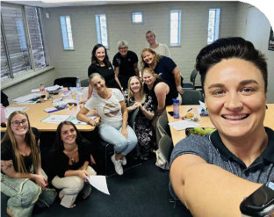
PWDA Building Access Project Officers with
workshop participants.

The program’s engaging, practical approach fostered sustainable attitude shifts, advanced inclusive practices, and highlighted systemic issues to inform future efforts.
PWDA acknowledges the funding from the NSW Department of Communities and Justice (DCJ) by Women NSW under the Domestic and Family Violence (DFV) which makes Building Access Project possible. Following the project’s success over the past year, the NSW Government Department of Communities and Justice
(DCJ) has announced its continued support for the Building Access Project into the next financial year.

Australian Digital Health Agency
This year PWDA continued to work with the Australian Digital Health Agency on the ‘Enhancing Inclusion and Accessibility at the Australian Digital Health Agency (the Agency)’ project to enhance accessibility and inclusion of digital health tools.
The initiative was delivered through three interconnected projects:
- Needs Assessment and Gap Analysis: Launched in May 2024, this project gathered insights from people with disability through surveys, interviews, and focus groups, resulting in a report with ten key recommendations to improve inclusive practices.
- Development of Accessible Resources: Begun in July 2024, this project co-created Easy Read and
video materials on privacy, security, and technology, enhancing usability for users with access needs.
- Public Education Campaign: Starting August 2024, PWDA delivered webinars on digital health tools and privacy, supported by captions and Auslan, reaching over 100 attendees and increasing community confidence and understanding.
Together, the three projects contributed to both immediate and long-term outcomes. In the short-term, people with disability gained access to tailored, accessible information about digital health services. Longer-term outcomes include increased confidence and usage of the Agency’s digital health tools, stronger relationships between the Agency and disability communities, and the building of the Agency’s capacity to embed inclusive design principles.



Training
37 sessions of high quality, accessible education delivered to over 950 people.

In 2024-25, PWDA responded to strong demand for training, consultancy, and education, delivering impactful sessions led by facilitators with lived experience of
disability. Popular training modules included Disability Fundamentals, Facilitating Access, and Engaging Confidently with Psychosocial Disability. We also offered tailored training to meet organisations’ specific needs, challenges and workplace contexts. Across the year, training was delivered to a diverse mix of partners including the Department of Finance, University of South Australia, the National Portrait Gallery, Vinnies, TAFE NSW, local councils and many others.
With a commitment to continuous improvement, the training team updated the PWDA training suite to ensure current, practical, and best practice-aligned content, with flexible, interactive materials suitable
for in-person and online delivery. Participant feedback emphasised the value of trainers with lived experience.
We also began implementing a Learning Management System (LMS) to improve access to PWDA training, particularly
for self-paced and on-demand learning,
enabling broader reach and more inclusive,
flexible education.

Alongside training delivery, the training team contributed expert input to strategic initiatives, supported organisations with Disability Inclusion Action Plan (DIAP) development, reviewed Australian Occupational Therapy Standards, served on advisory bodies and working groups, and presented at key sector events.

Training and facilitation case studies

Australia and New Zealand School of Government (ANZSOG)
In June 2025, the PWDA training team designed and conducted a tailored training program for the Australia and New Zealand School of Government (ANZSOG) in Melbourne. The two-day session was specifically created for the Student & Program Experience team.
The purpose of the training was to enhance accessibility and foster more inclusive learning environments and enrolment procedures for students seeking to study at ANZSOG. The team identified key barriers to inclusion and collaboratively explored strategies to address them. The training was attended by nine team members, all
of whom found the session to be highly informative and motivating.

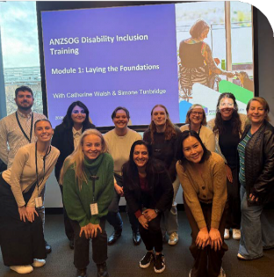
PWDA Trainers with the ANZSOG Student

I’m truly so grateful to have done this training with PWDA. Since the sessions, I have seen the world in a new light; constantly seeing societal flaws, areas of improvement, and wonderful advancements all from a different lens.
Thank you, Simone and Catherine for opening our eyes to all that encompasses disability. I’m looking forward to carrying this knowledge with me going forward, and continuing my education in the disability space.
& Program Experience team.

DirtyFeet Ltd
PWDA Training and Facilitator Janel Manns delivered a Facilitating Access training session to the energetic team at DirtyFeet, a Sydney-based, not-for-profit contemporary dance studio.
The DirtyFeet staff undertook the three-hour Facilitating Access workshop providing a comprehensive understanding of how their business can address barriers experienced by people with disability.

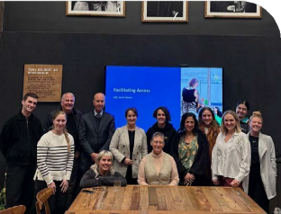
PWDA Training and Facilitator Janel Manns
surrounded by DirtyFeet staff.

This was the most impactful access and disability training I have ever participated in. Janel’s openness, generosity, and deep knowledge created a space of genuine empowerment and transformation. As an artist and leader with unseen disabilities, I often navigate this work from both a personal and professional lens. This training not only affirmed my lived experience but
expanded my understanding and connection to the broader human rights framework that underpins access and inclusion.
It felt like an invitation to lead with even greater clarity, courage, and care. Janel’s encouragement of the work we’re doing at DirtyFeet reminded me that advocacy is not separate from artistry, it lives within it. I leave this training feeling more equipped, more seen, and more committed to embedding this work in everything I do, now and into the future.
Sarah-Vyne Vassallo, Director of Artistic Operations and Inclusive Practice, DirtyFeet Ltd

Sustain
Maintain a financially viable and sustainable organisation.

PWDA Board
At the People with Disability Australia (PWDA) 2024 Annual General Meeting (AGM) held on Thursday 14 November, PWDA members approved the appointments of Board Directors Alexandra Bignell, Priscilla Brice, Presley Chihuri, Daniel Flynn, Trinity Ford, Peter Freckleton and Steph Travers for two-year terms.
Directors Kevyn Morris and Eva Sifis also
returned for the second year of their two-year terms.
The AGM also marked the departure of outgoing Board Directors President
Marayke Jonkers, Secretary Suresh Rajan, Dr Haidi Badawi, Arun Barramundi and Declan Lee.
Following the AGM, the Board elected Trinity Ford as Interim President and appointed Stuart Mawbey as a Board Director until the 2025 AGM. In January 2025, the PWDA Board formally appointed its executive positions, with Trinity Ford
as President, Daniel Flynn and Eva Sifis
as Co-Vice Presidents, Stuart Mawbey as Treasurer, and Steph Travers as Secretary.
Peter Freckleton and Presley Chihuri have since ceased to be directors of PWDA.

Board Committees and Advisory Groups
Working alongside the operational team our Board committees and advisory groups give advice and support to our Board of Directors and executive team in many important areas. A key priority of this year was strengthening our systems and processes. This work ensured all new processes and policies reflect best practice and the voices of people with disability.
We thank all committee and advisory group members for sharing their time and expertise.

Finance and Risk Committee (FARC)
This year, the Finance and Risk Committee (FARC) worked hard to make sure PWDA

stays financially strong and sustainable. The committee was closely involved in developing the annual budget and worked with the executive team to keep spending responsible and transparent.
A strategic focus was further diversifying independent income from projects and training. The committee also explored better opportunities for long-term investment of equity and reviewed key financial policies, strategic partnerships, and organisational risks to help secure PWDA’s future.
Voting Members: Stuart Mawbey (Chair), Steph Travers, Kevyn Morris and Daniel Flynn. Ex officio: Trinity Ford.

Strategic Directions Advisory Group (SDAG)
The Strategic Directions Advisory Group (SDAG) played an important role in 2025 in rebuilding PWDA’s strategic
engagement with members. Working closely with the organisation, SDAG began the work developing PWDA’s new strategic pillars – Represent, Advocate, Educate,
and Innovate – and the refresh of the organisation’s vision, mission, and values that will guide the next Strategic Plan.
The group also began designing an all- members survey to inform strategic priorities and partnered with the Members’ Engagement Advisory Group (MEAG) on a joint consultation that provided valuable
insight into members’ expectations and experiences. Together, this work has laid strong foundations for the next stage of strategic planning, helping ensure PWDA’s future direction remains grounded in member voice and lived experience.
PWDA thanks the members of SDAG for their collaboration and commitment throughout 2025.
- Convener: Alexandra Bignell.
- Co-Convener: Daniel Flynn.
- Members: Alice Anderson, Ruth Bonser, Zac Chau, Matthew Hammond, Andrew Hennell, Melinda Paterson, Emily Stuart.

Governance Advisory Group (GovAG)
The Governance Advisory Group (GovAG) played a vital role throughout 2025 in strengthening the organisation’s governance foundations. GovAG helped
ensure PWDA’s ongoing governance reform and policy review processes were grounded in the perspectives and priorities of our members.
During the year, GovAG worked with the PWDA operational team to support the Policy Review Project, helping to update and improve key organisational policies and strengthen their connection to PWDA’s broader governance framework. The group’s insights helped ensure these documents reflect both sound governance

principles and the lived experience of PWDA’s diverse membership.
PWDA extends sincere thanks to the members of GovAG for their commitment and thoughtful contributions throughout 2025. Their work has been central to ensuring that PWDA remains a truly member-driven organisation.
- Convener: Alexandra Bignell.
- Co-Convener: Daniel Flynn.
- Members: Alice Anderson, Danielle Jones-Resnik, Sirani McNeil, Katrina Reed, Dr Michelle Ronksley-Pavia PhD, FHEA, Alex Pankau, Fiona Shultz, Michael Varga.

Membership Engagement Board Advisory Group (MEAG)
The Membership Engagement Advisory Group (MEAG) this year played a key role in deepening member and community engagement. Board-led events and member forums created new opportunities for members to directly engage with Directors, ask questions, and share their views.
- Co-Convenors: PWDA Directors
Steph Travers and Eva Sifis.
- Members: James O'Brien, Michael Varga, Sirani McNeill, Tony Thiveos, Natahlia Gazia, Christine Mattey.
This year, the PWDA Board resolved to establish a new Governance and

Nominations Committee (GNC) to support with strengthening governance process, this committee will be active in the next financial year.

Trinity Ford,
President


Daniel Flynn,
Co-Vice President


Eva Sifis,
Co-Vice President


Stuart Mawbey,
Treasurer


Steph Travers,
Secretary


Alexandra Bignell,
Director


Priscilla Brice,
Director


Kevyn Morris,
Director

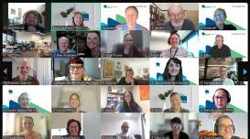
Best Practice and Employment
Employee engagement and wellbeing was a priority for PWDA this year. In August 2024, PWDA conducted its first Have Your Say Employee Engagement Survey, receiving an overwhelming 92% response rate from our people.

Our Diverse People
As of 30 June 2025, PWDA employs a total of 63 staff members. Our workforce comprises 41 full-time employees, 14 part- time employees, and 8 casual employees.
PWDA is committed to lived experience in leadership and fostering a safe, inclusive and representative organisation. In May 2025, 60% of our staff identified as having a disability, chronic medical condition, and/ or being neurodivergent. Our staff have a diverse range of genders, sexual identities, and cultural backgrounds with 6% of staff identifying as being First Nations.
An incredible 93% of respondents said they believe in the overall purpose of PWDA, showing that our work is not just understood, but deeply meaningful to our team. 84% of staff said they believe in our values, highlighting that our day-to-day culture is grounded in principles our people align with and care about.
This level of value alignment is a strong indicator of trust, motivation, and a positive workplace culture and affirms that we are on the right path to continue building a workplace where everyone feels connected, empowered, and proud to be part of PWDA.
As part of our ongoing commitment to employee wellbeing, this year PWDA introduced Sonder. Sonder goes beyond a traditional Employee Assistance Program. It’s a holistic, 24/7 support service that offers confidential, free access to a team of medical, mental health, and personal safety professionals. This support is available not only to all PWDA staff and Board Directors but also extends to their immediate families.

We continued to invest in continuous improvement and professional development through the rollout of two key initiatives: a new Induction Program and a Leadership Development Program.
The new Induction Program was developed to ensure new employees feel informed, welcomed, and supported from day one. It aims to boost confidence, clarify roles, and foster a safer, respectful, and compliant workplace.
A key component to this is our new Induction Guidebook, which includes an individualised work plan to guide employees through their probation period with clear expectations and tailored support.
To ensure consistent, accessible onboarding, we also developed four fully accessible online induction modules.
Our Leadership Development Program focuses on building confident, capable leaders who can foster safe, supportive, and high-performing teams. This year, all PWDA leaders completed training in:
- Mental Health First Aid – equipping leaders to recognise the signs and symptoms of common mental health problems and how to respond and support mental health needs of our people.
- Managing Psychosocial Risks – promoting psychologically safe work environments by equipping leaders with the practical skills to support employees. We believe at its core, a workplace culture that prioritises safety and health builds a thriving workforce.
- Managing Workplace Investigations – ensuring fair, effective and respectful issue resolution for our staff and clients.

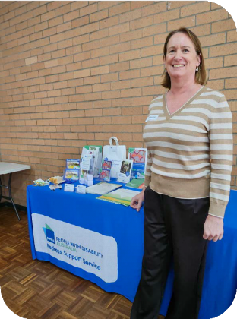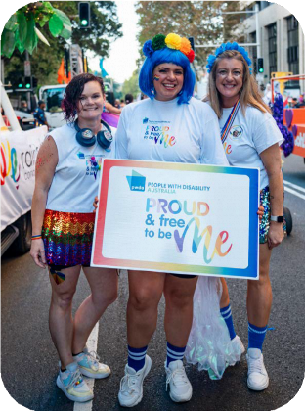
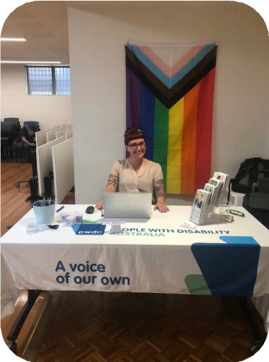
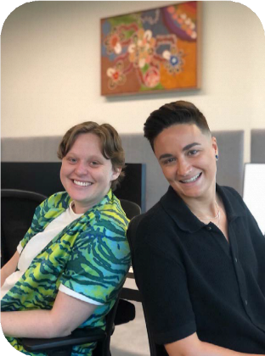

Case Study:

Marco Maclean,
PWDA People and Culture Advisor

Marco joined PWDA in September 2024

It has sometimes been difficult to navigate the world of work, not knowing whether to disclose my disability
to employers. At PWDA
I felt safe to disclose this information without fear of discrimination.
Marco Maclean
in the role of People & Culture Advisor bringing with him over 15 years’ experience in People and Culture. Marco holds a master’s degree in human resource management.
Marco has lived experience of disability (cerebral palsy) and is also part of the LGBTQIA+ community. Originally from the UK, he moved to Australia with his partner in 2018.
Marco applied to work at PWDA to use his skills and experience to support an organisation where he feels seen and
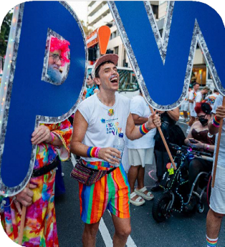
accepted. This career move is important to him on both a personal and professional level.

Marco with PWDA members at the 47th Sydney Gay and Lesbian Mardi Gras Parade.

56

Marco is passionate about fostering an inclusive and diverse work environment. He is committed to breaking down unnecessary barriers to employment for people with disability.
Marco is leading several impactful initiatives at PWDA including our Disability Inclusion Action Plan (DIAP). Marco is also guiding the Employee Values Working Group, focusing on developing shared staff values that shape our interactions and culture.
Another exciting piece of work is developing our Recruitment Strategy to create a standout careers page on our website and show people how PWDA is an inclusive employer of choice.
A recent highlight for Marco was marching with PWDA in the 47th Sydney Gay and Lesbian Mardi Gras Parade. ‘I was very proud to be part of it. It’s so important to raise awareness and increase visibility of people with disability in the LGBTQIA+ community’.
Since joining PWDA, Marco has also become an Advisory Panel member for Cerebral Palsy Australia. Supporting them with their strategic direction from lived experience perspective and taking part in
research on ageing with cerebral palsy.

Outside of work Marco is passionate about fashion, film, art, jazz and loves to go to the beach at the weekend.
We are incredibly proud to have Marco as part of the PWDA team. His unique blend of professional expertise, along with lived experience and unwavering commitment to inclusion brings real strength to our work and culture. Marco’s contributions are already making a significant impact, and we look forward to continuing to grow and learn with him as we work towards a more inclusive and equitable future for all.


Reconciliation Action Plan
58
This year marked the first stage of PWDA’s reconciliation journey through our Reflect Reconciliation Action Plan (RAP). We committed to building a strong foundation of awareness, respect, and relationships with Aboriginal and Torres Strait Islander peoples, and are proud of the steps taken so far.
We acknowledged and celebrated key cultural dates throughout the year, including National Reconciliation Week (NRW)
and NAIDOC Week. We encouraged reflection across the organisation, with staff participating in events and discussions focused on this year’s themes.
Internationally, we highlighted the rights of First Nations people with disability,
co-hosting a side event at the Conference of States Parties (COSP18) to the UN Convention on the Rights of Persons
with Disabilities in New York. The session focused on restrictive practices and the need for culturally safe support and policy reform. We welcomed the opportunity to use this platform to amplify underrepresented voices and strengthen our commitment to inclusion and justice.
Internally, we focused on better understanding our role in reconciliation, including mapping out future opportunities for cultural learning, improving respectful workplace practices, and identifying ways to engage more meaningfully with First Nations communities.
Our Reflect RAP has helped start important conversations and shape a stronger, more inclusive culture. We’re grateful to the Aboriginal and Torres Strait Islander people who’ve shared their knowledge and stories with us so far.
This coming year we are focusing on building our cultural capability within our team and strengthening this foundation before we progress to the next stage of our RAP journey.

Qantas Carer Concession Card Program
The Qantas Carer Concession Card (QCCC) is issued to people with significant support requirements who through a physical, sensory, intellectual, cognitive,
or psychosocial disability are unable to travel on the aircraft without the full-time assistance of a carer.
The QCCC allows cardholders and their carers to book discounted travel on Qantas flights. PWDA’s Corporate Services team administers the program on behalf of Qantas. This year PWDA produced 903 cards, which is 62% increase from the previous year of 566.
PWDA also entered into a new agreement with Qantas in December 2024. Coming into effect in January 2025, the program now provides greater discounts to cardholders and a simpler fare structure, it also added international flight discounts which had never been available. These changes led
to a surge in new applications, expanding discounted travel access.

National Standards for Disability Services Audit Summary
As a government funded advocacy agency under the National Disability Advocacy Program (NDAP), every year or so, PWDA is independently assessed for compliance with the National Standards for Disability Services (NSDS). This quality assurance system has been designed to ensure people with disability are involved in all aspects and stages of this process.
In October 2024 PWDA participated in a recertification audit against all six NSDS standards:
- Rights
- Participation and Inclusion
- Individual Outcomes
- Feedback and Complaints
- Service Access
- Service Management.
The auditors also assessed if PWDA had been adhering to its policies, procedures and objectives and if we pursued continuous improvement opportunities.
In addition, all evidence of compliance provided by PWDA was examined and analysed.

Annual Report 2024-25 | 59

Part of the audit process included auditor interviews with a sample group of clients that were diverse in their age range, disability and gender. These clients provided feedback on their experiences with PWDA and confirmed that in their initial meetings, PWDA provided them with information on their rights and responsibilities and the responsibilities of PWDA. The clients added that they felt respected and safe and all information was given to them in a format of their choice.
Advocates were described as easy to talk to, trustworthy and aware of their client’s needs. Clients also felt they were
knowledgeable of procedural requirements, such as NDIS appeals.
The following feedback was shared with the auditors:
“My advocate doesn’t force their point of view in my decision-making process.”
“My advocate always provides options prior to me making any decision.”
“My advocate makes me feel comfortable.”
Clients also said:

- PWDA maintained the highest level of security and privacy with their documentation.
- Advocates were well trained suitably skilled and displayed a high level of professionalism.
- They were encouraged and supported to raise any concerns with PWDA.
- They felt comfortable to provide feedback, make a complaint or resolve a dispute without fear of adverse consequences.
“The advocate went above and beyond their expectation.”
They felt PWDA advocates and staff listened and would act appropriately and promptly on feedback received.
Employees and Senior management also participated in interviews, during which the auditors assessed that PWDA had appropriate procedures, controls and guidelines in place and that all roles and responsibilities were clearly defined.
Client and employee files were also reviewed as part of the assessment process.
PWDA successfully passed the audit with no non-conformances and received a Certificate of Approval in February 2025.
This outstanding result highlights the dedication and hard work of the PWDA team over the past 12 months in establishing effective processes to ensure best-practice service delivery.

60

Australian Council for International Development
The Australian Council for International Development (ACFID) is the peak body for Australian non-governmental organisations (NGOs) involved in international development and humanitarian work.
PWDA is a signatory to the ACFID Code of Conduct, which is a voluntary, self- regulatory industry code of good practice. The aim of the Code is to improve the outcomes of international development and increase stakeholder trust. As a Code signatory PWDA is committed to uphold high standards of accountability, transparency, and ethical practice.
As an ACFID Member, PWDA must be compliant with all aspects of the Code and continuously monitor our compliance.
PWDA is assessed each year against Code requirements, which sets out 9 high level Quality Principles and 33 associated Commitments. Implementation of the Code is supported by the ACFID Quality Assurance Framework that describes how members are assessed and verified.
Every three years specific principles are selected as focus areas to improve compliance with the Code and enhance good practice by providing additional support and verification for members.
The focus area process is also used to review the Code standards to ensure they remain relevant and effective.
PWDA completed the ACFID 2023-2024 assessment in November 2024 and received a Certificate of Compliance in March 2025.

Financial Report
30 June 2025
People with Disability Australia Ltd. ABN 98 879 981 198

Contents
Directors’ report 64
Statement of profit or loss and
other comprehensive income 67
Statement of financial position 68
Statement of changes in equity 69
Statement of cash flows 70
Notes to the financial statements
for the year ended 30 June 2025 71

62

PWDA’s result for the 2024-2025 financial
year was a surplus of $1.17 million. This significant outcome enhances the organisation’s reserves and includes an
extraordinary $980k donation of managed funds from the Centre for Inclusive Design (CFID), which drove the increase in total income from $10.6 million in the prior
year to $11.1 million this year. Alongside this significant one-off event, PWDA also achieved an operating surplus of $193k, which reflects stronger fee-for-service and training income, as well as consistent investment and interest returns.
The majority of PWDA’s funding comes from government grants, both federally as well as from the New South Wales and Queensland state governments. PWDA thanks all its funding agencies for their ongoing support.
PWDA’s overall expenditure dropped slightly this year, across several expense categories, most notably leasing costs and professional fees. Staffing remains PWDA’s largest area of spend, accounting for around three quarters of its cost base.
At the end of the financial year, the organisation has $3.1 million in reserves, which have been bolstered during the year by this strong overall result. These reserves represent between 3 to 4 months’ worth of operating expenditure, which provides a buffer against unforeseen events and sound liquidity into the future.
An unqualified audit opinion was issued by
our auditors ESV.

Directors’ report

The Directors present their report, together with the financial statements, on the Company
for the year ended 30 June 2025.

Directors
The following persons were Directors of the Company during the whole of the financial year
and up to the date of this report, unless otherwise stated:

Name | Position | Appointed/resigned
Alexandra Bignell | Board Director | Appointed 14 November 2024
Daniel Flynn | Co-Vice President | Appointed 5 August 2024
Eva Sifis | Co-Vice President
Kevyn Morris | Co-Vice President
Priscilla Brice | Board Director | Appointed 14 November 2024
Stephanie Travers | Secretary | Appointed 14 November 2024
Stuart Mawbey | Treasurer | Appointed 5 August 2024
Trinity Ford | President | Appointed 5 August 2024
Arun Bharatula | Board Director | Resigned 14 November 2024
Declan Lee | Board Director | Appointed 05 August 2024 and  resigned 14 November 2024
Haidi Badwai | Board Director | Resigned 14 November 2024
Marayke Jonkers | Interim President | Resigned 14 November 2024
Peter Freckleton | Board Director | Appointed 14 November 2024  and resigned 24 April 2025
Suresh Rajan | Secretary | Resigned 14 November 2024
Principal activities
The principal activity of People With Disability Australia Ltd during the financial year was to represent, support, educate and advocate for people with disability and undertake necessary activities and programs to achieve the organisation's objective.
No changes in the nature of the Company's activities during the financial year.
Long term objectives
The Company's long term objectives are to:
- Empower people with disability as individuals, as specific population groups, and as a
sector;

- Advocate for the human rights of people with disability at the individual, specific
population group, and sector levels;
- Effective representation of people with disability as a sector to the government and to
the community generally; as well as focus on sector development; and
- Build our organisational capacity to empower, advocate for, and represent people with disability.
Review of operations
The surplus of the Company amounted to $1,173,382 (2024: $158,394).
With reference to the ACFID Code of Conduct, the Company confirms that there were no international aid and development revenue received during the year ended 30 June 2025 (30 June 2024: $nil).
Members' Guarantee
If the Company is wound up, the constitution states that each member is required to contribute a maximum of $1 each towards meeting any outstanding obligations of the Company. At 30 June 2025 the number of members was 4,182 (2024: 3,461).
Auditor's independence declaration
A copy of the auditor's independence declaration as required by Subdivision 60C of the Australian Charities and Not-for-profits Commission Act 2012 is set out immediately after this Directors' report.
This report is made in accordance with a resolution of Directors. On behalf of the Directors

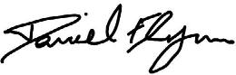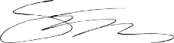

Daniel Flynn Director
Stephanie Travers Director

Dated: 13 October 2025.

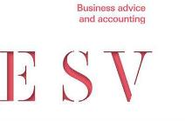
Auditors Independence Declaration under sub division 60-C Australian Charities and Not for Profits Commission Act 2012
As auditor of People with Disability Australia Limited for the year ended 30 June 2025, I declare that, to the best of my knowledge and belief, there have been no contraventions of:
- the auditor’s independence requirements as set out in the Australian Charities and Not-for-profits Commission Act 2012 in relation to the audit; and
- any applicable code of professional conduct in relation to the audit.
Dated at Sydney on the 13th of October 2025.

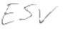

ESV Business Advice and Accounting

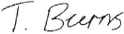

Travas Burns
Partner

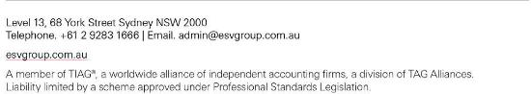

Statement of profit or loss and other comprehensive income
For the year ended 30 June 2025

Profit or loss | Note | 2025 $ | 2024 $
Revenue | 4 | 11,144,013 | 10,588,188
Interest revenue calculated using the effective interest method |  | 108,625 | 120,358
Expenses
Employee benefits expense |  | (7,655,689) | (7,777,892)
Depreciation and amortisation expense |  | (394,985) | (602,108)
Advertising and promotion |  | (55,341) | (87,297)
Meeting expenses |  | (82,394) | (104,288)
Consulting and professional fees |  | (343,425) | (466,324)
Telecommunications |  | (249,796) | (249,811)
Program costs |  | (322,402) | (300,666)
Travel |  | (347,876) | (359,187)
Rental and other property related costs |  | (121,996) | (135,279)
Other expenses |  | (366,862) | (442,821)
Finance costs | 5 | (138,490) | (24,479)
Total expenses |  | (10,079,256) | (10,550,152)
Surplus for the year attributable to the members of People With Disability Australia Ltd |  | 1,173,382 | 158,394
Other comprehensive income for the year |  | - | -
Total comprehensive income for the year attributable to the members of People With Disability Australia Ltd |  | 1,173,382 | 158,394

The above statement of profit or loss and other comprehensive income should be read in conjunction with the
accompanying notes.

Statement of financial position
As at 30 June 2025

Assets

Current assets | Note | 2025 $ | 2024 $
Cash and cash equivalents | 6 | 5,216,732 | 1,593,053
Trade and other receivables | 7 | 136,213 | 136,701
Financial assets at amortised cost | 9 | - | 1,470,000
Prepayments and other |  | 217,161 | 136,313
Total current assets |  | 5,570,106 | 3,336,067

Non-current assets
Financial assets at fair value through profit or loss | 8 | 857,020 | -
Property, plant and equipment | 10 | 783,287 | 985,163
Right-of-use assets | 11 | 784,198 | 977,307
Total non-current assets |  | 2,424,505 | 1,962,470
Total assets |  | 7,994,611 | 5,298,537
Liabilities

Current liabilities
Trade and other payables | 12 | 842,118 | 613,262
Lease liabilities | 13 | 324,718 | 252,885
Employee benefits | 14 | 549,411 | 571,521
Grants received in advance |  | 1,778,693 | 236,395
Total current liabilities |  | 3,494,940 | 1,674,063

Non-current liabilities
Lease liabilities | 13 | 1,288,491 | 1,613,208
Employee benefits | 14 | 68,464 | 46,971
Provisions | 15 | 68,298 | 63,259
Total non-current liabilities |  | 1,425,253 | 1,723,438
Total liabilities |  | 4,920,193 | 3,397,501
Net assets |  | 3,074,418 | 1,901,036
Equity

Retained surpluses | 3,074,418 | 1,901,036
Total equity | 3,074,418 | 1,901,036

The above statement of financial position should be read in conjunction with the accompanying notes.

Statement of changes in equity
For the year ended 30 June 2025

2025 | Retained  surpluses $ | Total $
Balance at 1 July 2024 | 1,901,036 | 1,901,036
Surplus for the year | 1,173,382 | 1,173,382
Other comprehensive income | - | -
Total comprehensive income for the year | 1,173,382 | 1,173,382
Balance at 30 June 2025 | 3,074,418 | 3,074,418

2024 | Retained  surpluses $ | Total $
Balance at 1 July 2023 | 1,742,642 | 1,742,642
Surplus for the year | 158,394 | 158,394
Other comprehensive income | - | -
Total comprehensive income for the year | 158,394 | 158,394
Balance at 30 June 2024 | 1,901,036 | 1,901,036

The above statement of changes in equity should be read in conjunction with the accompanying notes.

Statement of cash flows
For the year ended 30 June 2025

Cash flows from operating activities | Note | 2025 $ | 2024 $
Receipts from grants and customers (inclusive of GST) |  | 11,648,536 | 10,085,217
Payments to suppliers and employees (inclusive of GST) |  | (9,375,836) | (10,904,502)
Interest received |  | 108,625 | 120,358
Interest and other finance costs paid |  | (138,490) | (36,741)
Net cash from/(used in) operating activities |  | 2,242,835 | (735,668)
Cash flows from investing activities
Receipts/(payments) for term deposits |  | 1,470,000 | (331,469)
Payments for property, plant and equipment |  | - | (162,448)
Distributions received |  | 163,728 | -
Net cash from/(used in) investing activities |  | 1,633,728 | (493,917)
Cash flows from financing activities
Repayment of lease liabilities |  | (252,884) | (423,399)
Net cash (used in) financing activities |  | (252,884) | (423,399)
Net increase/(decrease) in cash and cash equivalents |  | 3,623,679 | (1,652,984)
Cash and cash equivalents at the beginning of the financial year |  | 1,593,053 | 3,246,037
Cash and cash equivalents at end of the financial year | 6 | 5,216,732 | 1,593,053

The above statement of cash flows should be read in conjunction with the accompanying notes.

Notes to the financial statements for the year ended 30 June 2025
Note 1 General information
The financial statements cover People With Disability Australia Ltd as an individual entity. The financial statements are presented in Australian dollars, which is People With Disability Australia Ltd's functional and presentation currency.
People With Disability Australia Ltd is a not-for-profit unlisted public company limited by guarantee, incorporated and domiciled in Australia. Its registered office and principal place of business is:
People With Disability Australia Ltd Suite 10.1 Level 10 300 Elizabeth Street Surry Hills NSW 2010
A description of the nature of the Company's operations and its principal activities are
included in the Directors' report, which is not part of the financial statements.
The financial statements were authorised for issue, in accordance with a resolution of Directors, on on 13 October 2025. The Directors have the power to amend and reissue the financial statements.
Note 2 Material accounting policy information
The accounting policies that are material to the Company are set out below. The accounting policies adopted are consistent with those of the previous financial year, unless otherwise stated.
New or amended Accounting Standards and Interpretations adopted
The Company has adopted all of the new or amended Accounting Standards and Interpretations issued by the Australian Accounting Standards Board ('AASB') that are mandatory for the current reporting period. The adoption of these Accounting Standards and Interpretations did not have any significant impact on the financial performance or position of the Company.
Any new or amended Accounting Standards or Interpretations that are not yet mandatory have not been early adopted.

Basis of preparation
These general purpose financial statements have been prepared in accordance with the Australian Accounting Standards - Simplified Disclosures issued by the Australian Accounting Standards Board ('AASB'), the Australian Charities and Not-for-profits Commission Act 2012 and the New South Wales legislation the Charitable Fundraising Act 1991 and associated regulations as appropriate for not-for profit oriented entities.
Historical cost convention
The financial statements have been prepared under the historical cost convention, except for, the revaluation of financial assets at fair value through profit or loss.
Critical accounting estimates
The preparation of the financial statements requires the use of certain critical accounting estimates. It also requires management to exercise its judgement in the process of applying the Company's accounting policies. The areas involving a higher degree of judgement
or complexity, or areas where assumptions and estimates are significant to the financial
statements, are disclosed in note 3.
Revenue recognition
The Company recognises revenue as follows:
Grant income
Grant income is recognised at the point in time when the monies are received, and obligations have been met in relation to the grant program. Funds received in advance of obligations are deferred and recognised over time as income as the related expenses are incurred and obligations are met.
Donations
Donations collected, including cash and goods for resale, are recognised as revenue when the Company gains control of the asset.
Interest
Interest revenue is recognised as interest accrues using the effective interest method. This is a method of calculating the amortised cost of a financial asset and allocating the interest
income over the relevant period using the effective interest rate, which is the rate that exactly discounts estimated future cash receipts through the expected life of the financial asset to the net carrying amount of the financial asset.

Other revenue
Other revenue is recognised when it is received or when the right to receive payment is established.
Income tax
As the Company is a charitable institution in terms of subsection 50-5 of the Income Tax Assessment Act 1997, as amended, it is exempt from paying income tax.
Current and non-current classification
Assets and liabilities are presented in the statement of financial position based on current and non-current classification.
An asset is classified as current when: it is either expected to be realised or intended to
be sold or consumed in the Company's normal operating cycle; it is held primarily for the purpose of trading; it is expected to be realised within 12 months after the reporting period; or the asset is cash or cash equivalent unless restricted from being exchanged or used to settle a liability for at least 12 months after the reporting period. All other assets are classified as non-current.
A liability is classified as current when: it is either expected to be settled in the Company's normal operating cycle; it is held primarily for the purpose of trading; it is due to be settled within 12 months after the reporting period; or there is no right at the end of the reporting period to defer the settlement of the liability for at least 12 months after the reporting period. All other liabilities are classified as non-current.
Cash and cash equivalents
Cash and cash equivalents includes cash on hand, deposits held at call with financial institutions, other short-term, highly liquid investments with original maturities of three months or less that are readily convertible to known amounts of cash and which are subject to an insignificant risk of changes in value.
Trade and other receivables
Trade receivables are initially recognised at fair value and subsequently measured at amortised cost using the effective interest method, less any allowance for expected credit losses. Trade receivables are generally due for settlement within 30 days.
The Company has applied the simplified approach to measuring expected credit losses, which uses a lifetime expected loss allowance. To measure the expected credit losses, trade receivables have been grouped based on days overdue.

Other receivables are recognised at amortised cost, less any allowance for expected credit losses.
Financial assets
Financial assets are initially measured at fair value. Transaction costs are included as part of the initial measurement, except for financial assets at fair value through profit or loss. Such assets are subsequently measured at either amortised cost or fair value depending on their classification. Classification is determined based on both the business model within which such assets are held and the contractual cash flow characteristics of the financial asset unless an accounting mismatch is being avoided. Financial assets are derecognised when the rights to receive cash flows have expired or have been transferred and the Company has transferred substantially all the risks and rewards of ownership. When there is no reasonable expectation of recovering part or all of a financial asset, its carrying value is written off.
Financial assets at amortised cost
A financial asset is measured at amortised cost only if both of the following conditions
are met: (i) it is held within a business model whose objective is to hold assets in order to collect contractual cash flows; and (ii) the contractual terms of the financial asset represent contractual cash flows that are solely payments of principal and interest.
Financial assets at fair value through profit or loss
Financial assets not measured at amortised cost or at fair value through other comprehensive income are classified as financial assets at fair value through profit or loss. Typically, such financial assets will be either: (i) held for trading, where they are acquired for the purpose of selling in the short-term with an intention of making a profit, or a derivative; or
(ii) designated as such upon initial recognition where permitted. Fair value movements are
recognised in profit or loss.
Impairment of financial assets
The Company recognises a loss allowance for expected credit losses on financial assets which are measured at amortised cost. The measurement of the loss allowance depends upon the Company's assessment at the end of each reporting period as to whether the financial instrument's credit risk has increased significantly since initial recognition, based on reasonable and supportable information that is available, without undue cost or effort to obtain.
Where there has not been a significant increase in exposure to credit risk since initial
recognition, a 12-month expected credit loss allowance is estimated. This represents a

portion of the asset's lifetime expected credit losses that is attributable to a default event that is possible within the next 12 months. Where a financial asset has become credit impaired or where it is determined that credit risk has increased significantly, the loss allowance is based on the asset's lifetime expected credit losses. The amount of expected credit loss recognised is measured on the basis of the probability weighted present value of anticipated cash shortfalls over the life of the instrument discounted at the original effective interest rate.
The loss allowance reduces the asset's carrying value with a corresponding expense through
profit or loss.
Property, plant and equipment
Plant and equipment is stated at historical cost less accumulated depreciation and impairment. Historical cost includes expenditure that is directly attributable to the acquisition of the items.
Depreciation is calculated on a straight-line basis to write off the net cost of each item of
property, plant and equipment (excluding land) over their expected useful lives as follows: Leasehold improvements 5 years
Office equipment 3 years
Motor vehicles 5 years
The residual values, useful lives and depreciation methods are reviewed, and adjusted if appropriate, at each reporting date.
Leasehold improvements are depreciated over the unexpired period of the lease or the estimated useful life of the assets, whichever is shorter.
An item of property, plant and equipment is derecognised upon disposal or when there is no future economic benefit to the Company. Gains and losses between the carrying amount and the disposal proceeds are taken to profit or loss.
Right-of-use assets
A right-of-use asset is recognised at the commencement date of a lease. The right-of-use asset is measured at cost, which comprises the initial amount of the lease liability, adjusted for, as applicable, any lease payments made at or before the commencement date net of any lease incentives received, any initial direct costs incurred, and, except where included in the cost of inventories, an estimate of costs expected to be incurred for dismantling and removing the underlying asset, and restoring the site or asset.

Right-of-use assets are depreciated on a straight-line basis over the unexpired period of the lease or the estimated useful life of the asset, whichever is the shorter. Where the
Company expects to obtain ownership of the leased asset at the end of the lease term, the depreciation is over its estimated useful life. Right-of use assets are subject to impairment or adjusted for any remeasurement of lease liabilities.
The Company has elected not to recognise a right-of-use asset and corresponding lease liability for short-term leases with terms of 12 months or less and leases of low-value assets. Lease payments on these assets are expensed to profit or loss as incurred.
Impairment of non-financial assets
Non-financial assets are reviewed for impairment whenever events or changes in circumstances indicate that the carrying amount may not be recoverable. An impairment loss is recognised for the amount by which the asset's carrying amount exceeds its recoverable amount.
Recoverable amount is the higher of an asset's fair value less costs of disposal and value-in- use. The value-in-use is the present value of the estimated future cash flows relating to the asset using a pre-tax discount rate specific to the asset or cash-generating unit to which the asset belongs. Assets that do not have independent cash flows are grouped together to form a cash-generating unit.
Trade and other payables
Trade and other payables represent liabilities for goods and services provided to the Company prior to the end of the financial year and which are unpaid. Due to their short- term nature they are measured at amortised cost and are not discounted. The amounts are unsecured and are usually paid within 30 days of recognition.
Lease liabilities
A lease liability is recognised at the commencement date of a lease. The lease liability is initially recognised at the present value of the lease payments to be made over the term of the lease, discounted using the interest rate implicit in the lease or, if that rate cannot be readily determined, the Company's incremental borrowing rate. Lease payments comprise of fixed payments less any lease incentives receivable, variable lease payments that depend on an index or a rate, amounts expected to be paid under residual value guarantees, exercise price of a purchase option when the exercise of the option is reasonably certain to occur, and any anticipated termination penalties. The variable lease payments that do not depend on an index or a rate are expensed in the period in which they are incurred.

Lease liabilities are measured at amortised cost using the effective interest method. The carrying amounts are remeasured if there is a change in the following: future lease payments arising from a change in an index or a rate used; residual guarantee; lease term; certainty
of a purchase option and termination penalties. When a lease liability is remeasured, an adjustment is made to the corresponding right-of use asset, or to profit or loss if the carrying amount of the right-of-use asset is fully written down.
Provisions
Provisions are recognised when the Company has a present (legal or constructive) obligation as a result of a past event, it is probable the Company will be required to settle the obligation, and a reliable estimate can be made of the amount of the obligation. The amount recognised as a provision is the best estimate of the consideration required to settle the present obligation at the reporting date, taking into account the risks and uncertainties surrounding the obligation. If the time value of money is material, provisions are discounted using a current pre-tax rate specific to the liability. The increase in the provision resulting from the passage of time is recognised as a finance cost.
Employee benefits
Short-term employee benefits
Liabilities for wages and salaries, including non-monetary benefits, annual leave and long service leave expected to be settled wholly within 12 months of the reporting date are measured at the amounts expected to be paid when the liabilities are settled.
Other long-term employee benefits
The liability for annual leave and long service leave not expected to be settled within 12 months of the reporting date are measured at the present value of expected future
payments to be made in respect of services provided by employees up to the reporting date. Consideration is given to expected future wage and salary levels, experience of employee departures and periods of service. Expected future payments are discounted using market yields at the reporting date on national government bonds with terms to maturity and currency that match, as closely as possible, the estimated future cash outflows.
Defined contribution superannuation expense
Contributions to defined contribution superannuation plans are expensed in the period in
which they are incurred.

Goods and Services Tax ('GST') and other similar taxes
Revenues, expenses and assets are recognised net of the amount of associated GST, unless the GST incurred is not recoverable from the tax authority. In this case it is recognised as part of the cost of the acquisition of the asset or as part of the expense.
Receivables and payables are stated inclusive of the amount of GST receivable or payable. The net amount of GST recoverable from, or payable to, the tax authority is included in other receivables or other payables in the statement of financial position.
Cash flows are presented on a gross basis. The GST components of cash flows arising from investing or financing activities which are recoverable from, or payable to the tax authority, are presented as operating cash flows.
Commitments and contingencies are disclosed net of the amount of GST recoverable from, or payable to, the tax authority.
Comparative figures
Comparatives have been realigned where necessary, to be consistent with current year
presentation. There was no effect on deficit, net assets, or equity.

Note 3 Critical accounting judgements, estimates and assumptions
The preparation of the financial statements requires management to make judgements, estimates and assumptions that affect the reported amounts in the financial statements. Management continually evaluates its judgements and estimates in relation to assets, liabilities, contingent liabilities, revenue and expenses. Management bases its judgements, estimates and assumptions on historical experience and on other various factors, including expectations of future events, management believes to be reasonable under the circumstances. The resulting accounting judgements and estimates will seldom equal the related actual results. The judgements, estimates and assumptions that have a significant
risk of causing a material adjustment to the carrying amounts of assets and liabilities (refer to
the respective notes) within the next financial year are discussed below.
Employee benefits provision
As discussed in note 2, the liability for employee benefits expected to be settled more than 12 months from the reporting date are recognised and measured at the present value of the estimated future cash flows to be made in respect of all employees at the reporting date. In determining the present value of the liability, estimates of attrition rates and pay increases through promotion and inflation have been taken into account.

Note 4 Revenue

Revenue | 2025 $ | 2024 $
Operating grants | 9,740,232 | 10,183,013
Other revenue
Other revenue | 1,403,781 | 405,175
Revenue | 11,144,013 | 10,588,188
Disaggregation of revenue
The disaggregation of revenue from contracts with customers is as follows:

Major product lines | 2025 $ | 2024 $
Federal Government grants | 5,865,839 | 6,320,844
State Government grants | 3,811,987 | 3,716,076
Other Government grants | 62,406 | 146,093
Total major product lines | 9,740,232 | 10,183,013

Geographical regions | 2025 $ | 2024 $
Australia | 9,740,232 | 10,183,013
Total geographical regions | 9,740,232 | 10,183,013

Timing of revenue recognition | 2025 $ | 2024 $
Revenue transferred over time | 9,677,826 | 10,036,920
Revenue transferred at a point in time | 62,406 | 146,093
Total timing of revenue recognition | 9,740,232 | 10,183,013

Top 10 sources of Government funding are as follows:

Government funding | 2025 $ | 2024 $
Federal Government
Department of Social Services | 3,202,090 | 3,133,473
Department of Health Disability and Ageing | 2,341,265 | 2,889,535
Department of the Prime Minister and Cabinet | 322,484 | 297,836
Total Federal Government | 5,865,839 | 6,320,844
State Government
New South Wales Government | 3,318,166 | 3,432,814
Queensland Government | 493,821 | 283,262
Total State Government | 3,811,987 | 3,716,076
Other funder
Other | 62,406 | 146,093
Total Government funding | 9,740,232 | 10,183,013

Note 5 Expenses
Surplus includes the following specific expenses:

Expenses | 2025 $ | 2024 $
Finance costs  Interest and finance charges paid/payable on lease liabilities | 138,490 | 24,479
Leases  Short-term and low-value assets lease payments | 104,723 | 74,009
Superannuation expense  Defined contribution superannuation expense | 740,343 | 727,586

Note 6 Cash and cash equivalents

Current assets | 2025 $ | 2024 $
Cash at bank | 2,816,732 | 1,593,053
Cash on deposit | 2,400,000 | -
Total cash and cash equivalents | 5,216,732 | 1,593,053
Note 7 Trade and other receivables

Current assets | 2025 $ | 2024 $
Trade receivables | 133,210 | 88,720
Deposits | 3,003 | 47,981
Total current trade and other receivables | 136,213 | 136,701
Note 8 Financial assets at fair value through profit or loss

Non-current assets | 2025 $ | 2024 $
Investments in managed funds | 857,020 | -
Total non-current assets | 857,020 | -
Note 9 Financial assets at amortised cost

Current assets | 2025 $ | 2024 $
Term deposits | - | 1,470,000
Total non-current assets | - | 1,470,000

Note 10 Property, plant and equipment

Non-current assets | 2025 $ | 2024 $
Leasehold improvements - at cost | 960,510 | 960,510
Less: Accumulated depreciation | (213,447) | (30,492)
Total leasehold improvements | 747,063 | 930,018
Office equipment - at cost | 304,963 | 304,963
Less: Accumulated depreciation | (282,811) | (267,812)
Total office equipment | 22,152 | 37,151
Motor vehicles - at cost | 131,535 | 131,535
Less: Accumulated depreciation | (117,463) | (113,541)
Total motor vehicles | 14,072 | 17,994
Total property, plant and equipment non-current assets | 783,287 | 985,163
Reconciliations
Reconciliations of the written down values at the beginning and end of the current financial
year are set out below:

Year ended 30 June 2025 | Leasehold Improvements $ | Office Equipment $ | Motor Vehicles $ | Total $
Balance at 1 July 2024 | 930,018 | 37,151 | 17,994 | 985,163
Depreciation expense | (182,955) | (14,999) | (3,922) | (201,876)
Balance at 30 June 2025 | 747,063 | 22,152 | 14,072 | 783,287
Note 11 Right-of-use assets

Non-current assets | 2025 $ | 2024 $
Buildings - right-of-use | 1,008,254 | 1,008,254
Less: Accumulated depreciation | (224,056) | (32,008)
Total buildings | 784,198 | 976,246
Motor vehicles - at cost | - | 38,185
Less: Accumulated depreciation | - | (37,124)
Total motor vehicles | - | 1,061
Total right-of-use assets non-current assets | 784,198 | 977,307
The Company leases land and buildings for its offices under agreements of 5 years with, in some cases, options to extend. The leases have various escalation clauses. On renewal, the terms of the leases are renegotiated. The Company also leases a vehicle under an agreement of 3 years.

Reconciliations
Reconciliations of the written down values at the beginning and end of the current financial
year are set out below:

Year ended 30 June 2025 | Buildings $ | Motor Vehicles $ | Total $
Balance at 1 July 2024 | 976,246 | 1,061 | 977,307
Depreciation expense | (192,048) | (1,061) | (193,109)
Balance at 30 June 2025 | 784,198 | - | 784,198
Note 12 Trade and Other Payables

Current liabilities | 2025 $ | 2024 $
Trade payables | 22,078 | 186,687
GST and PAYG payable | 308,647 | 101,933
Sundry payables and accrued expenses | 511,393 | 324,642
Total trade and other payables | 842,118 | 613,262
Note 13 Lease liabilities

Lease liabilities | 2025 $ | 2024 $
Current liabilities  Lease liability | 324,718 | 252,885
Non-current liabilities  Lease liability | 1,288,491 | 1,613,208
Total non-current liabilities | 1,613,209 | 1,866,093
Future lease payments
Future lease payments are due as follows:
Within one year | 434,748 | 420,300
One to five years | 1,445,112 | 1,844,835
Total lease liabilities | 1,879,860 | 2,265,135
Note 14 Employee Benefits

Employee Benefits | 2025 $ | 2024 $
Current liabilities
Long service leave | 64,143 | 139,446
Employee benefits | 485,268 | 432,075
Total liabilities | 549,411 | 571,521
Non-current liabilities
Long service leave | 68,464 | 46,971
Total non-current liabilities | 617,875 | 618,492

Note 15 Provisions

Non-current liabilities | 2025 $ | 2024 $
Lease make good | 68,298 | 63,259
Lease make good
The provision represents the present value of the estimated costs to make good the premises leased by the Company at the end of the respective lease terms.
Movements in provisions
Movements in each class of provision during the current financial year, other than employee benefits, are set out below:
2025

Movements in provisions | Lease make good $
Carrying amount at the start of the year | 63,259
Additional provisions recognised | 5,039
Carrying amount at the end of the year | 68,298
Note 16 Key management personnel disclosures
Compensation
The aggregate compensation made to Directors and other members of key management personnel of the Company is set out below:

Compensation | 2025 $ | 2024 $
Aggregate compensation | 704,096 | 1,328,348
Note 17 Remuneration of auditors
During the financial year the following fees were paid or payable for services provided by
ESV Business Advice and Accounting, the auditor of the Company:

Remuneration of auditors | 2025 $ | 2024 $
Audit services - ESV Business Advice and Accounting  Audit of the financial statements | 19,300 | 19,500
Other services - ESV Business Advice and Accounting  Other services | 1,500 | 1,900
Total remuneration of auditors | 20,800 | 21,400
Note 18 Contingent liabilities
The Company did not have any contingent liabilities as at 30 June 2025 and 30 June 2024.

Note 19. Related party transactions
Key management personnel
Disclosures relating to key management personnel are set out in note 16.
Transactions with related parties
There were no transactions with related parties during the current and previous financial
year.

Receivable from and payable to related parties
There were no trade receivables from or trade payables to related parties at the current and previous reporting date.
Loans to/from related parties
There were no loans to or from related parties at the current and previous reporting date.

Note 20 Economic dependency
The Company is reliant on the ongoing receipt of financial assistance from the Australian
government to continue delivering its programs.
During the year ended 30 June 2025, the Company received funding in excess of
$9,740,232 (2024: $10,183,013) from various government sources as disclosed in note 4.
As at 30 June 2025, the Directors have no reason to believe that the government grants will not continue.
Note 21 Events after the reporting period
No matter or circumstance has arisen since 30 June 2025 that has significantly affected, or may significantly affect the Company's operations, the results of those operations, or the Company's state of affairs in future financial years.

Directors' declaration
In the Directors' opinion:
- the attached financial statements and notes comply with the Australian Accounting Standards - Simplified Disclosures, the Australian Charities and Not-for-profits Commission Act 2012 and New South Wales legislation the Charitable Fundraising Act 1991 and associated regulations and other mandatory professional reporting requirements;
- the attached financial statements and notes give a true and fair view of the Company's financial position as at 30 June 2025 and of its performance for the financial year ended on that date; and
- there are reasonable grounds to believe that the Company will be able to pay its debts as and when they become due and payable.
Signed in accordance with a resolution of Directors. On behalf of the Directors

Daniel Flynn Director
Dated: 13 October 2025.
Stephanie Travers Director

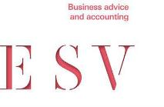
Independent Auditor's Report to the members of People With Disability Australia Limited
Opinion
We have audited the accompanying financial report, being a general purpose financial report – simplified disclosures of People with Disability Australia Limited (the ‘Company’), which comprises the statement of financial position as at 30 June 2025, the statement of profit or loss and other comprehensive income, the statement of cash flows and the statement of changes in equity for the year ended on that date, notes comprising a summary of material accounting policies and other explanatory information, and the directors’ declaration.
In our opinion the financial report of People with Disability Australia Limited has been prepared in accordance with Division 60 of the Australian Charities and Not-for-profits Commission Act 2012, including:
- giving a true and fair view of the entity’s financial position as at 30 June 2025 and of its financial performance and cash flows for the year ended on that date; and
- complying with Australian Accounting Standards – Simplified Disclosures and with
Division 60 of Australian Charities and Not-for-profits Commission Regulation 2013.
Basis of Opinion
We have conducted our audit in accordance with Australian Auditing Standards. Our responsibilities under those standards are further described in the Auditors Responsibilities for the Audit of the Financial Report section of our report. We are independent of the entity in accordance with the auditor independence requirements of the Corporations Act 2001 and
the ethical requirements of the Accounting Professional and Ethical Standards Board’s APES 110 Code of Ethics for Professional Accountants (including Independence Standards) (the Code) that are relevant to our audit of the financial report in Australia. We have also fulfilled our other ethical responsibilities in accordance with the Code.
In conducting our audit, we have complied with the independence requirements of the Corporations Act 2001. We confirm that the independence declaration required by the Corporations Act 2001, which has been given to the directors of People with Disability Australia Limited would be in the same terms if given to the directors as at the time of this auditor’s report.

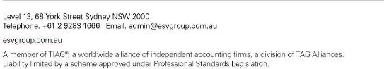

We believe that the audit evidence we have obtained is sufficient and appropriate to provide
a basis for our opinion.
Director’s Responsibility for the Financial report
The directors of the entity are responsible for the preparation of the financial report that gives a true and fair view in accordance with Australian Accounting Standards – Simplified Disclosures and the Australian Charities and Not-for-profits Commission Act 2012 and for such internal control as the directors determine it necessary to enable the preparation of the financial report that gives a true and fair view and is free from material misstatement, whether due to fraud or error.
In preparing the financial report, the directors are responsible for assessing the entity’s ability to continue as a going concern, disclosing, as applicable, matters related to going concern and using the going concern basis of accounting unless the directors either intends to liquidate the registered entity or to cease operations, or has no realistic alternative but to do so. The directors are responsible for overseeing the entity’s financial reporting process.
Auditor’s Responsibilities for the Audit of the Financial Report
Our objectives are to obtain reasonable assurance about whether the financial report as a whole is free from material misstatement, whether due to fraud or error, and to issue an auditor’s report that includes our opinion. Reasonable assurance is a high level of
assurance, but is not a guarantee that an audit conducted in accordance Australian Auditing Standards will always detect a material misstatement when it exists. Misstatements can arise from fraud or error and are considered material if, individually or in aggregate, they could reasonably be expected to influence the economic decisions of users taken on the basis of the financial report.
A further description of our responsibilities for the audit of the financial report is located at the Auditing and Assurance Standards Board website at: www.auasb.gov.au/auditors_ responsibilities/ar4.pdf. This description forms part of our auditor’s report.
Dated at Sydney on the 14th October 2025.

ESV Business Advice and Accounting

Travas Burns
Partner

Annual Report
2024 to 2025

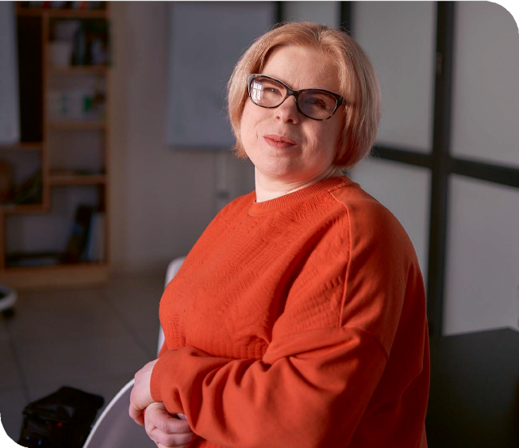

This is the annual report for
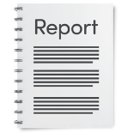
People with Disability Australia. We will say PWDA for short.

An annual report says what work we did this year.



This annual report is from 2024 to 2025.

Message from the president


This message is from Trinity Ford. Trinity is the president of PWDA.

President


The President helps make decisions about how PWDA runs.


This year we have worked hard to make PWDA better.

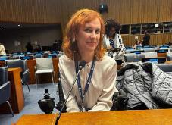
Trinity spoke at a United Nations event in New York.



PWDA got new board directors.

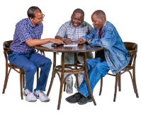
Board directors are a group of members who help run PWDA.

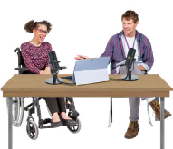
Our board directors talk about PWDA work in the media and at events.

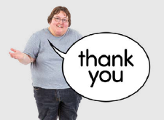
We want to thank all old and new board directors for their hard work.


We also talked about PWDA members who died this year.


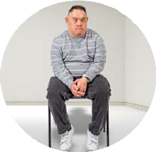
Many people with disability still die because

- Other people do things to hurt them

- They do not get the care they need.


We remember them even if we do not know all their names.


We will keep speaking up to make the world better for people with disability.

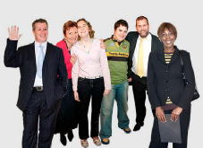
Thank you to everyone in our community for your help.

Message from the CEO and Deputy CEO



This is a message from

- Sebastian Zagarella

- Megan Spindler-Smith.



They are the bosses of PWDA.


This year was hard for many people with disability.


Lots of big changes happened.


We worked hard to make things better.


We took part in important meetings and talks.


Our advocacy teams helped people with hard problems.

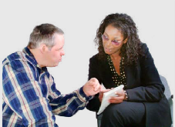
Advocacy means to support others to speak up for their rights.


We made our services better and wait times shorter.


We thank our staff for their hard work.


We thank the government for giving money for our advocacy services.


We thank you for supporting us.

Our strategic plan











PWDA has a strategic plan.

PWDA
Strategic Plan
2022–2025


Our strategic plan says what work PWDA needs to do.


Our strategic plan has 4 areas.

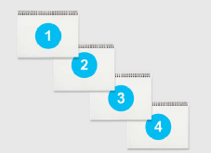
We will tell you next

- What the areas are

- What we did for each area.

Area 1 Represent


Area 1 is Represent.


Represent means we tell everyone what people with disability want.

This year lots of people with disability became PWDA members.




We did lots of things with our members like

- Events

- Surveys
Surveys are when we give our members questions to answer.

- Meetings.



Our members told us

- What they think

- What they need.


We made sure we used what they told us in our work.


In Australia we did lots of work about the rights of people with disability.
Disability Rights



We spoke to the government about what our members want them to change.


We did lots of work with LGBTQIA+ people with disability.

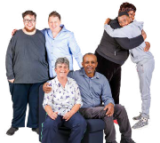
LGBTQIA+ means the different ways people
can love and feel about who they are.

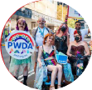
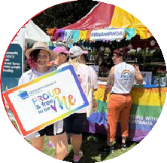
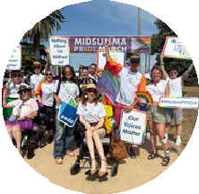
We joined events like

- The Sydney Gay and Lesbian Mardi Gras Parade

- Fair Day

- Melbourne Midsumma March.


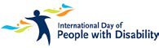
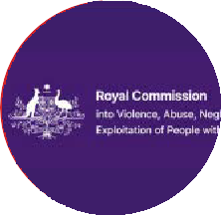
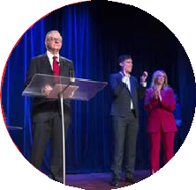
We also had lots of different events for

- LGBTQIA+ people with disability

- International Day of People with Disability

- The Disability Royal Commission

- The Australian Federal Election.


We spoke about disability rights in other countries.




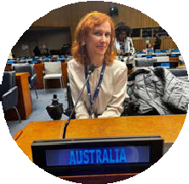
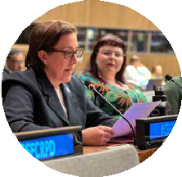

PWDA spoke at the United Nations Conference of State Parties to the Convention on Rights of Persons with Disabilities. COSP18 for short.
PWDA representatives at COSP18 were
- Deputy CEO Megan Spindler-Smith

- Board Director Steph Travers

- Board Director Alexandra Bignell

- PWDA Member Tahlia-Rose Vanissum.

President Trinity Ford spoke at the Commission on the Status of Women at United Nations.

Area 2 Advocate


Area 2 is Advocate.

Advocate means we support all people with disability to get their rights.


We spoke up at lots of meetings about how to make disability rights better.


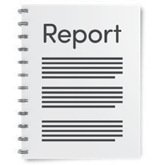
We also wrote lots of reports to the government.


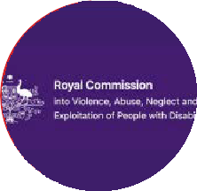
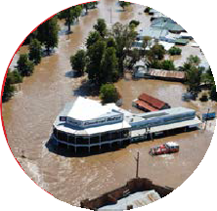
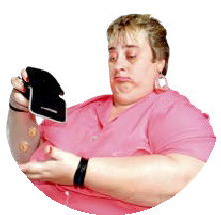
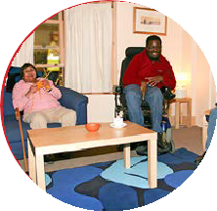

We wrote and spoke about topics like

- Changes to the NDIS

- The Disability Royal Commission

- Disaster and emergencies
A disaster or emergency is when something very bad happens and people may need help quickly to stay safe.

- Housing for people with disability

- Support to get paid

- Stopping bad things from happening to people with disability.

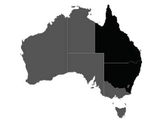
This year we supported over 2 thousand people in NSW and QLD.



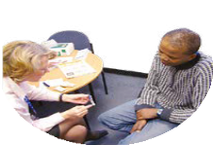

We helped people with disability deal with big issues like
- The NDIS

- Places they live

- Issues at school

- Health

- Abuse.

Abuse means when someone hurts you bad.

Area 3 Educate


Area 3 is educate.

Educate means we teach everyone about people with disability and their rights.


This year PWDA did lots of work with other groups and organisations.

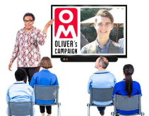
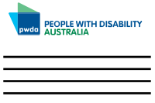
We gave training to 37 organisations.



The training was about things like

- How to make workplaces better for people with disability

- How to talk about people with disability.


All our trainers are people with disability.

We worked hard this year to make our training better.



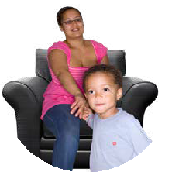
This year we worked on some big projects about

- Women with disability in workplaces

- Making it easier for women and children with disability to use services

- People with disability understanding online health information better.

Area 4 Sustain


Area 4 is sustain.

Sustain means we make sure PWDA can work well for a long time.


We had our Annual General Meeting on Wednesday 14 November 2024.
We say AGM for short.

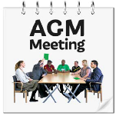
At the AGM there were changes to our board.






At the AGM we said goodbye to these board directors
- President Marayke Jonkers

- Secretary Suresh Rajan

- Dr Haidi Badawi

- Arun Barramundi

- Declan Lee.



Board directors Kevyn Morris and Eva Sifis
returned for the second year of their 2 year terms.




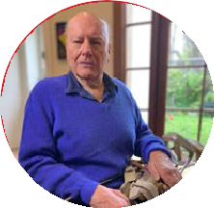


At the AGM these new board directors joined the board
- Trinity Ford

- Steph Travers

- Alexandra Bignell

- Peter Freckleton

- Priscilla Brice

- Presley Chihuri

- Daniel Flynn.


After the AGM Trinity Ford was chosen to be president.

President



Daniel Flynn and Eva Sifis became co-vice presidents.

Co-Vice Presidents


Co-vice presidents means both will step up together if the president can not do their job.


Steph Travers became secretary.

Secretary

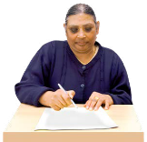
The secretary writes down what happens at board meetings and helps sort things out.


Stuart Mawbey became a board director only until the 2025 AGM.


Stuart Mawbey became treasurer.

Treasurer

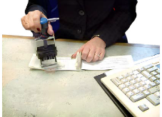
The treasurer helps to look after PWDA money.


This year the board worked hard to

- Make the way we work better

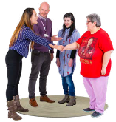
- Help more members join things at PWDA.


This year our staff did lots of work to make sure
PWDA can keep doing a good job.





We gave jobs to 63 people.
63

Many PWDA staff are people with disability or
live with other health conditions.

PWDA staff have different genders and come from lots of different communities.

We made sure our staff were safe and well.


We made the technology we use like computers better.


We helped our staff learn and become leaders.


We made sure our services are safe for everyone.

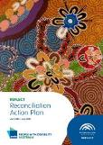
This year we continued work on our
Reconciliation Action Plan.


Our Reconciliation Action Plan helps us work together with Aboriginal and Torres Strait Islander people.

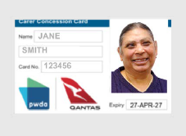
We helped people with disability get a
Qantas Carer Concession Card.


This card is for people with disability who need a carer to travel with them on a plane


PWDA passed the audit for the National Standards for Disability Services.

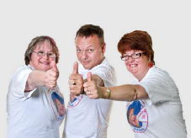
An audit is a check to make sure we are doing a good job.


National Standards for Disability Services
say how to do things to keep people safe.

Contact us



If you want support from PWDA you can

1800 422 015

- Call us on 1800 422 015

- Email us at pwd@pwd.org.au



pwd.org.au

pwd@pwd.org.au 1800 422 015
PWDAustralia

PWD.Australia

