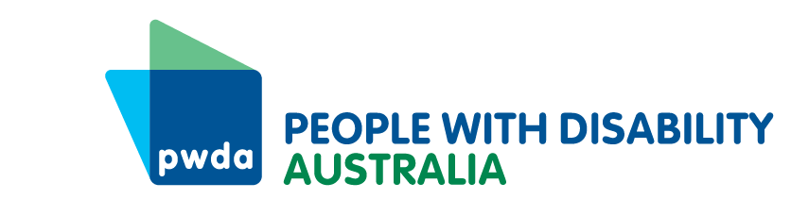
PO Box 666
Strawberry Hills
NSW 2012
+61 2 9370 3100
Toll free 1800 422 015
pwd@pwd.org.au
www.pwd.org.au
Mr Matt Johnson
Director – Committees
nswreconstructionauthority@parliament.nsw.gov.au
3 October, 2025

Dear Matt,

Re: Review of the operations of the NSW Reconstruction Authority regarding the NSW East Coast severe weather from May 2025
Thank you for the opportunity to provide feedback to the review of the operations of the NSW Reconstruction Authority regarding the NSW East Coast severe weather from May 2025. People with Disability Australia (PWDA) is the peak advocacy organisation for the 1 in 5 Australians with a disability.
With regard to disasters detailed in the terms of reference, being:
“i) the severe weather caused by ex-Tropical Cyclone Alfred from 3 March 2025,
ii) the major electricity outages affecting Far West NSW from 17 October 2024,
iii) the catastrophic floods affecting the Central West region in 2024”
PWDA would like to raise a number of issues.

Evacuation Centres
At the September National Emergency Management Agency (NEMA) meeting to discuss the upcoming higher risk weather season carers were unfairly criticised for evacuating clients to emergency centres and leaving them unattended. This failed to recognise that people with disability share their supports, and one carer may be attempting to evacuate many clients. This necessarily involves leaving a client at the centre to go back and get others, or for the carer to evacuate their own family. Instead of criticising carers of people with disability, emergency evacuation centre planning needs to reflect this reality.

Energy
In order to remain at home or to shelter in place, people with disability and elders may need power to:
- run refrigerators to keep medication cold
- keep back to base or fall alert alarm systems operating
- keep a mobile phone or assistive communication device operating
- charge mobility assistance devices.
Energy providers prioritise customers who need power for life support equipment, but lengthy periods without energy can impact people’s ability to shelter in place safely. People who use medical equipment at home are encouraged to have a plan for energy outages, but it may not be possible for them to enact these plans. People on low incomes may find purchasing batteries or generators unaffordable, and people cut off from their supports due to shelter in place orders may not be able to start or operate a generator by themselves. Resilience plans related to energy supply need to better account for these issues.

Accessible Evacuation
The Far West, Central West have no effective, accessible public transport and Northern NSW has very little to enable people who are unable to drive to evacuate. We learned at the NEMA planning event for the 2025-6 higher risk season that evacuations ahead of the Californian fires were fast and effective for residential facilities for elders and people with disability. This is because the responsibility for advanced planning and providing busses, workforce, and any equipment needed, was handled and funded by the Sherrif’s Department. People with disability were not left alone to try to ‘help themselves’ in the middle of the night with only a 20-minute warning of an imminent and severe fire threat.
We urgently need emergency evacuation plans that properly provide for the needs of people with disability who cannot drive, have no accessible public transport, or who are unable to evacuate without assistance.
PWDA has conducted research with people with disability and has developed recommendations to make disaster and emergency responses more accessible, inclusive and to improve outcomes. If you have questions or need further information, please do not hesitate to contact Bastien Wallace our Senior Policy Officer at bastienw@pwd.org.au.
Yours sincerely
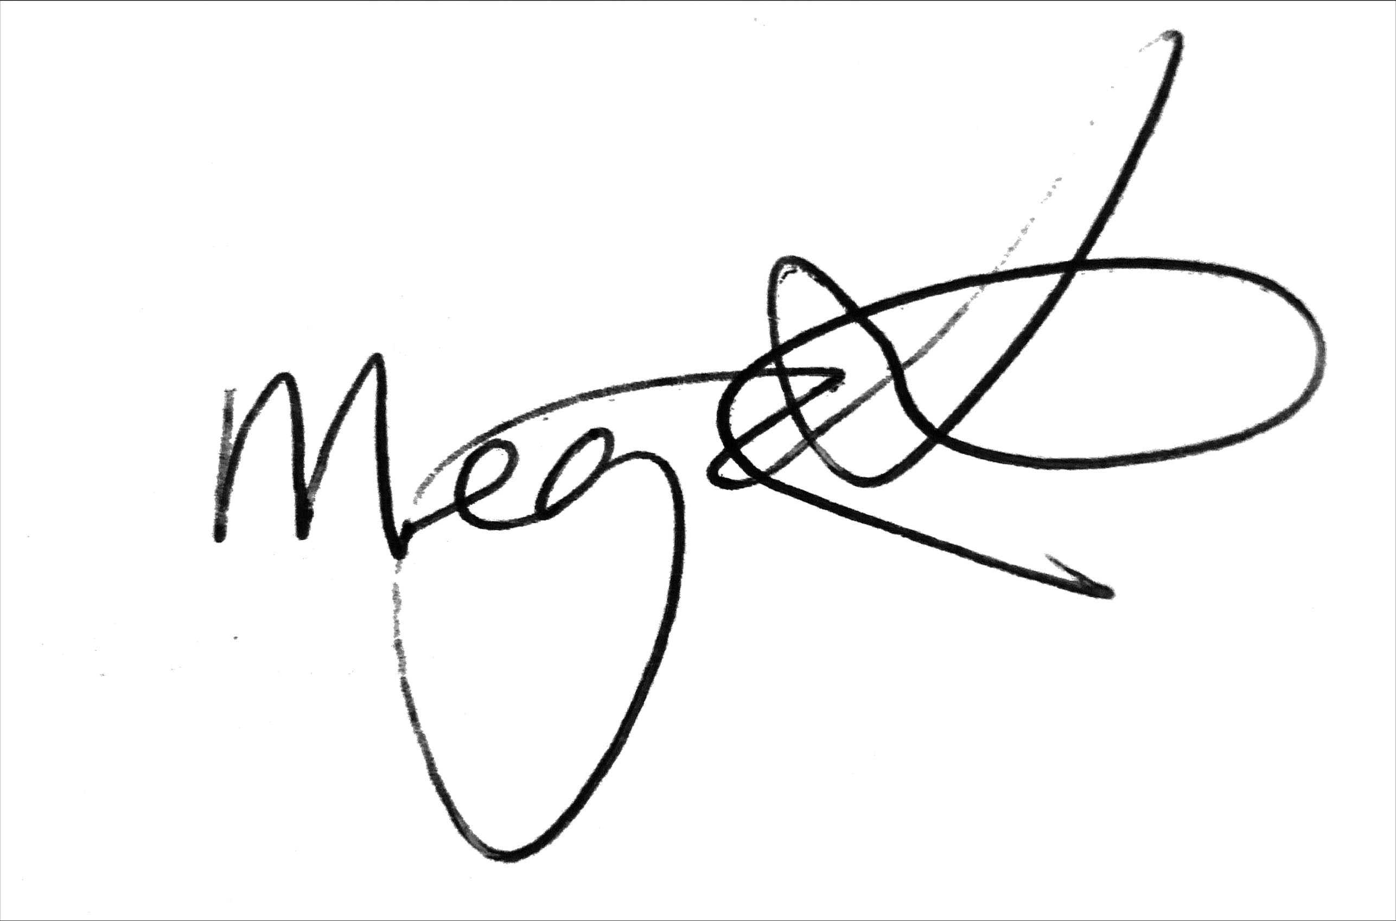
Megan Spindler-Smith
Deputy CEO
People with Disability Australia

