‘Fight for Me Instead of Making Me Fight’

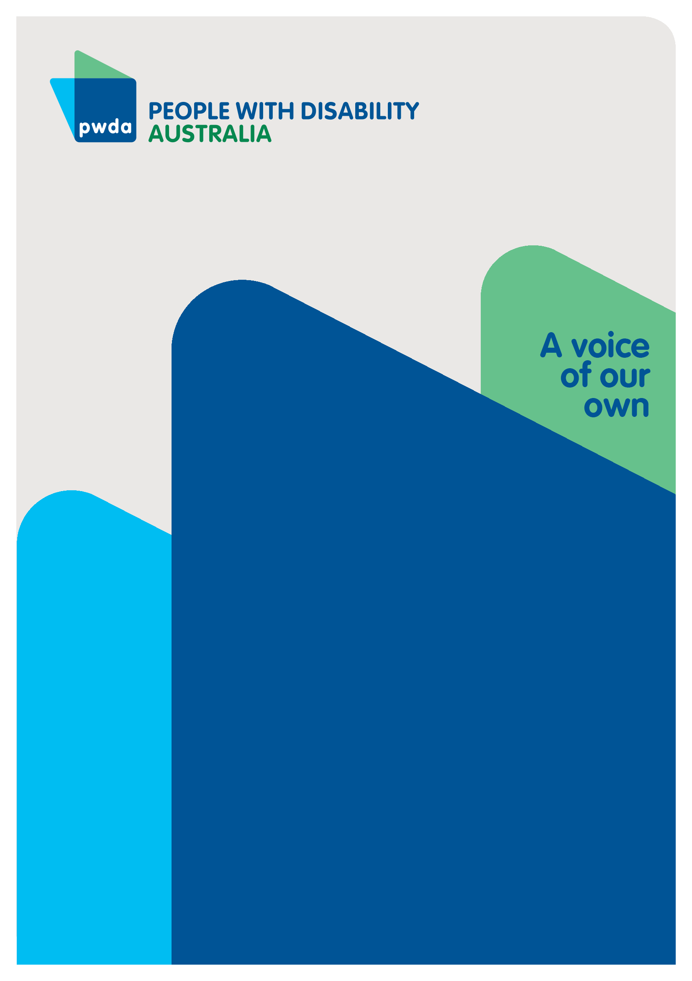
Submission to the Attorney-General’s Department’s Disability Discrimination Act 1992 (Cth) Review
October
2025

Copyright information
Fight for Me Instead of Making Me Fight – Submission to the Attorney-General’s Department’s Review of the Disability Discrimination Act 1992 (Cth) Review

First published in 2025 by People with Disability Australia Ltd.
Suite 10.01| Centennial Plaza | Level 10, 300 Elizabeth Street | Surry Hills NSW 2010
Email: pwda@pwd.org.au
Phone: 1800 422 015 Fax: +61 2 9318 1372
URL: www.pwd.org.au
Typeset in Arial 12 and 14 pt and VAG Rounded 26 pt
© People with Disability Australia Ltd. 2025
The moral rights of the authors have been asserted
National Library of Australia Cataloguing-in-Publication data:

Creator(s): | People with Disability Australia
Title: | ‘Fight for Me Instead of Making Me Fight’ – Submission to the Attorney-General’s Department’s Review of the Disability Discrimination Act 1992 (Cth) Review.

All rights reserved. Except as permitted with the Australian Copyright Act 1968 (for example, a fair dealing for the purposes of study, research, criticism or review), no part of this book may be reproduced, stored in a retrieval system, communication or transmitted in any form or by any means without prior written permission. All inquiries should be made to the publisher at the address above.

Suggested citation:

People with Disability Australia, ‘Fight for Me Instead of Making Me Fight’ – Submission to the Attorney-General’s Department’s Review of the Disability Discrimination Act 1992 (Cth) Review, 17 October 2025, People with Disability Australia, Sydney.

About PWDA
People with Disability Australia (PWDA) is a national disability rights and advocacy organisation made up of, and led by, people with disability.
We have a vision of a socially just, accessible and inclusive community in which the contribution, potential and diversity of people with disability are not only recognised and respected but also celebrated.
PWDA was established in 1981, during the International Year of Disabled Persons.
We are a peak, non-profit, non-government organisation that represents the interests of people with all kinds of disability.
We also represent people with disability at the United Nations, particularly in relation to the United Nations Convention on the Rights of Persons with Disabilities (CRPD).
Our work is grounded in a human rights framework that recognises the CRPD and related mechanisms as fundamental tools for advancing the rights of people with disability.
PWDA is a member of Disabled People’s Organisations Australia (DPO Australia), along with the First People’s Disability Network, National Ethnic Disability Alliance and Women with Disabilities Australia.
DPOs collectively form a disability rights movement that places people with disability at the centre of decision-making in all aspects of our lives.
‘Nothing About Us, Without Us’ is the motto of Disabled Peoples’ International.

Table of Contents
Introduction 6
Summary of Recommendations 7
Methodology 9
Part 1 – Updating understandings of disability and disability discrimination 10
Definition of disability 10
Intersectionality 12
Definition of direct discrimination 13
CRPD 15
Part 2 – Positive duty to eliminate discrimination 17
The case for a positive duty 17
Part 3 – Encouraging inclusion of people with disability 20
A positive duty to provide adjustments 20
Definition of and considerations for unjustifiable hardship 22
Part 4 – Improving access to justice 24
Offensive behaviour and vilification 24
Part 6 – Modernising the DDA 26
Assistance animals 26
Part 7 – Further options for reform 27
Accessibility of complaint mechanisms 27
A national human rights act 28
Conclusion 29

Introduction
PWDA welcomes the opportunity to contribute to the Attorney-General’s Department’s review of the Disability Discrimination Act 1992 (Cth) (DDA). As a national, cross-disability, organisation led by and for people with disability, PWDA brings the lived experience, expertise and priorities of our community to this review. As an organisation with United Nations Economic and Social Council Consultative (ECOSOC) Status, PWDA also brings in-depth knowledge of the CRPD and its applicability in respect to discrimination laws.
This submission is based on:
- Input from PWDA’s Board (comprised of people with disability)
- A national member and community survey
- Insights from our individual advocacy team, which directly assists people with disability
The feedback we received was consistent and compelling. The current complaints-based model is retraumatising, inaccessible and ineffective. Obligations to provide adjustments are poorly understood, and the law too often enables, rather than prevents, discrimination. The DDA must be modernised to reflect the CRPD and shift from a reactive and individualised complaints model to a proactive and systemic model, accompanied by strong, and well-resourced, enforcement mechanisms. The submission focuses on the discussion questions most relevant to the feedback we received from our Board members, member and community survey and individual advocacy team.
It is crucial that we seize upon this opportunity to reform the DDA in a way that is transformative, rather than merely ‘tweaking’ a system that has time and time again proved inadequate, and in many cases harmful.

Summary of Recommendations
Recommendation 1 – The definition of disability should be amended to accord with the CRPD’s principles and philosophy, while ensuring that it does not inadvertently narrow coverage or create new evidentiary hurdles. The final definition should be formulated through targeted consultations with people with disability and legal experts.

Recommendation 2 – The definition of disability, or subordinate legislation, must include an express, non-exhaustive, list of disabilities, including neurodivergence and psychosocial disability. The definition section or subordinate legislation must also state that fluctuating disabilities are considered disabilities for the purposes of the DDA.

Recommendation 3 – A new provision must be added to the DDA identifying that discrimination can occur on the basis of a particular protected attribute ‘or a particular combination of 2 or more protected attributes’.

Recommendation 4 – The definition of direct discrimination is amended in accordance with Disability Royal Commission’s Recommendation 4.23(1) to replace the comparator test with the detriment test.

Recommendation 5 – Amend the definition of direct discrimination in the DDA to require applicants to prove that the treatment occurred and respondents to prove that the treatment was not on the basis of the person’s disability, in accordance with Disability Royal Commission’s Recommendation 4.23(1A).

Recommendation 6 – The CRPD must be included in the objects provision of the DDA.

Recommendation 7 – The DDA is amended to establish a positive duty to prevent discrimination. The parameters and requirements of the positive duty must be co-designed with people with disability.
Recommendation 8 – The DDA is amended to create a stand-alone duty to provide adjustments, in accordance with Disability Royal Commission’s Recommendation 4.26.

Recommendation 9 – The proposed positive duty to eliminate discrimination and positive duty to provide adjustments must be accompanied by robust, well-resourced enforcement powers for the Australian Human Rights Commission or another designated regulator. This mechanism should include the power to impose civil penalties for non-compliance with the DDA.

Recommendation 10 – Amend s 11 of the DDA to reflect the Disability Royal Commission’s Recommendation 4.32, while also amending s 11(1) to provide that in determining unjustifiable hardship, regard can only be had to the list of relevant factors, as opposed to ‘all relevant circumstances’. Duty-holders must also be required to substantiate their determinations with evidence.

Recommendation 11 – Amend the DDA to protect people from offensive behaviour, harassment and vilification in line with Disability Royal Commission’s Recommendations 4.29 and 4.30. The definition of public places in these provisions must extend to online spaces and disability group homes and aged care homes.

Recommendation 12 – Reforms to the DDA must be accompanied by an accessibility review of the Australian Human Rights Commission’s complaint mechanisms and the provision of funding required to ensure full accessibility.
Recommendation 13: The Australian Government enacts a national human rights act that expressly incorporates immediate rights in the CRPD, by individually listing each CRPD right or by reference to incorporation of the CRPD into the legislation.

Methodology
This submission has been informed by input from members of our Board, who are people with disability, feedback from our individual advocacy team and a national member and community survey.
The national member and community survey was conducted from 27 August 2025 to 4 September 2025. A total of 303 responses were received. Among respondents, 86% identified as a person with a disability, 34% as a supporter of a person with a disability, and 5% selected ‘Other’, including advocates and professionals in the disability sector. Some respondents identified across multiple categories. A total of 12 questions were asked, combining multiple-choice and open-text.
Please note that the data analysis and findings presented in this submission are based on the responses from the 86% of participants who identify as a person with a disability.

Part 1 – Updating understandings of disability and disability discrimination

Definition of disability
- How should disability be defined in the Disability Discrimination Act?
- What factors should be considered in developing a new definition of disability?
The DDA’s definition of disability must be sufficiently expansive to cover all types of disability, including emerging understandings of disability. Crucially, it must clearly convey that people with disability are rights holders, signalling that accommodation measures are a necessity, not a ‘luxury’.
PWDA endorses Women with Disabilities Australia’s (WWDA) recommendation that the definition of disability should be consistent with the CRPD’s principles and philosophy, which recognises people with disability as rights holders, that disability results from the interaction between people with impairments and attitudinal and environmental barriers and acknowledges that disability is an evolving concept. However, care must be taken to ensure that the definition of disability and any reference to the interaction of impairment and barriers does not inadvertently narrow coverage or create new evidentiary hurdles. In particular, the definition should not require people to prove that their disability is caused by an interaction between impairment and environmental barriers.
Recommendation 1: The definition of disability should be amended to accord with the CRPD’s principles and philosophy, while ensuring that it does not inadvertently narrow coverage or create new evidentiary hurdles. The final definition should be formulated through targeted consultations with people with disability and legal experts.

An inclusive list of disabilities
In addition, the DDA’s definition of disability, or subordinate legislation, should set out an express list of disability types covered by the DDA. The list must be inclusive, rather than exhaustive, to ensure that it encompasses new understandings of disability, provided they fit within the CRPD definition of disability set out above.
Including an express list of disabilities will empower people with disability to advocate for their rights contained in the DDA. People with disabilities that are not well understood will be able to clearly point to a provision that shows they are entitled to the DDA’s protections.
In particular, the list must expressly include neurodivergence (neurodivergent people) and psychosocial disability, which are often poorly understood. Survey respondents told us that neurodivergence, in particular, is often misunderstood and not accepted as a disability that requires adjustments. One of the survey-respondents highlighted the impact this has had in many areas of life:
In education, I was not offered many chances to catch up in subjects I was emotionally overwhelmed in. I was also not offered any alternate modes of communication for the material. In employment my states of emotional overwhelm were interpreted as laziness, rather than having the chance to express what my barriers were. Finally, in health care, my Asperger's Syndrome diagnosis was considered invalid by Centrelink, cutting off any chance of receiving NDIS assistance or DSP in times of hardship.
Similarly, the definition section of the DDA or subordinate legislation must clarify that fluctuating disabilities are considered disabilities for the purposes of the DDA.
Recommendation 2: The definition of disability, or subordinate legislation, must include an express, non-exhaustive, list of disabilities, including neurodivergence and psychosocial disability. The definition section or subordinate legislation must also state that fluctuating disabilities are considered disabilities for the purposes of the DDA.

Intersectionality
4. Could any other changes be made to the Disability Discrimination Act to recognise and provide protection for people with disability who have intersecting identities, or addressing compounding discrimination?
People with disability often experience discrimination based on the impacts of intersectionality, actual and perceived identities and lived experiences. One witness at the Royal Commission into Violence, Abuse, Neglect and Exploitation of People with Disability (Disability Royal Commission), who is a First Nations transgender woman with disability, articulated the profound impact that discrimination and harassment based on multiple attributes has had on her life:
… I miss being able to just walk down the street, feel the sun on me. Like, today is a beautiful day. I miss the ability to just - just - just blend in, and sometimes I think I wish, you know, I wasn't born this way. And maybe if I just stayed presenting as a cis-gendered gay male, maybe people wouldn't have laughed at me or ridiculed me. Perhaps if I didn't have my walking aids, maybe that might have - I might have blended in more. I really can't tell. I just don't know which of the intersectionalities seems to get people so angry at me. Is it because I'm a bigger person and I take up too much of their space? And that they are angry the way I am? So, you know, I have to be content with the fact of being inside my own home is my world, because I know no one's going to come at me or hit me. That is my reality for the last couple of years now.
While in practice the AHRC can handle complaints of discrimination of different grounds together, the DDA must be amended to imbed this practice and provide the same facility to Courts. This will be particularly important if changes are made to the DDA that increase the opportunity for people with disability to bring matters to the Court.
PWDA supports the approach recommended by Australian Human Rights Commission (AHRC) recommended in its Free and Equal Final Report on reforming federal discrimination law:
Reform 35: A new provision should be added across all federal discrimination laws which identifies that discrimination may occur on the basis of a particular protected attribute ‘or a particular combination of 2 or more protected attributes’.
Recommendation 3: A new provision must be added to the DDA identifying that discrimination can occur on the basis of a particular protected attribute ‘or a particular combination of 2 or more protected attributes’.

Definition of direct discrimination
5. What test should be used to ensure that the definition of direct discrimination is easy to understand and implement for both duty holders and people with disability, and why?
PWDA supports the Disability Royal Commission’s recommendation to remove the comparator test, and instead adopt the detriment test, which requires a person to prove they have been treated unfavourably because of their disability.
The comparator test, which requires a person to prove that they have been treated less favourably than a hypothetical person without disability would have been treated in the similar circumstances, is inherently problematic and open to cause injustices.
This was demonstrated in the Purvis v New South Wales decision. In Purvis, a high school student with a brain injury experienced repeated violent outbursts, including assaults on staff. The school suspended and then excluded him, and he alleged disability discrimination under the DDA. The High Court applied the comparator test in s 5 of the DDA by asking how a student without the disability, in the same or not materially different circumstances, would have been treated. The majority defined the comparator as a non-disabled student who engaged in the same violent conduct. It held that such a student would also have been suspended or expelled, so the treatment was not less favourable and there was no direct discrimination.
This framing failed to recognise that the violent conduct was a manifestation of the student’s disability. This approach not only punishes the person with disability, but also removes the focus from what supports the school could provide to enable him to remain at school.
We agree with the Disability Royal Commission that the comparator test should be replaced with a test that hinges on whether the person has been treated unfavourably on the ground of their disability.
Recommendation 4: The definition of direct discrimination is amended in accordance with Disability Royal Commission’s Recommendation 4.23(1) to replace the comparator test with the detriment test.
6. How should the burden of proof be addressed in the Disability Discrimination Act?
The Federal Court decision in Sklavos held that a person seeking reasonable adjustments under the DDA must show not only that they were disadvantaged by a failure to provide reasonable adjustments, but also that this failure was because of their disability. This has made it much harder for people with disability to prove discrimination unless there is explicit evidence that the denial of adjustment directly relates to their disability.
For this reason, we agree with the Disability Royal Commission’s recommendation to require the applicant to prove that the treatment occurred and then shift the burden of proof onto the respondent to prove that the treatment was not on the basis of the person’s disability.
Recommendation 5: Amend the definition of direct discrimination in the DDA to require applicants to prove that the unfavourable treatment occurred and respondents to prove that the unfavourable treatment was not on the basis of the person’s disability, in accordance with Disability Royal Commission’s Recommendation 4.23(1A).

CRPD
10. Should the Disabilities Convention be included in the objects provision of the Disability Discrimination Act?
PWDA strongly supports the inclusion of the CRPD in the objects provision of the DDA. Not all lawyers, tribunal members, or decision-makers are versed in international law. Naming the CRPD in the DDA’s objects prompts parties and courts to engage with CRPD principles, ensuring arguments are raised and tested consistently rather than depending on individual expertise.
In addition, reference to the CRPD keeps the DDA up to date with evolving understandings of discrimination. Under the Vienna Convention on the Law of Treaties, Article 31(3), treaty interpretation takes account of subsequent agreements, subsequent practice, and relevant rules of international law in force between the parties. As such, referring to the CRPD in the objects provision of the DDA would enable the DDA to remain in alignment with international human rights developments without constant statutory amendment.
From a foreign affairs perspective, inserting the CRPD in the objects provision of the DDA provides an excellent opportunity for the Australian Government to further its reputation as a leader in CRPD implementation globally.
Recommendation 6: The CRPD must be included in the objects provision of the DDA.

Part 2 – Positive duty to eliminate discrimination

The case for a positive duty
PWDA strongly supports the establishment of a positive duty to eliminate discrimination. The resounding message we received from our member and community survey is that the current complaints-based system is ineffective, retraumatising and inaccessible. For respondents who had made a discrimination complaint, the majority said ‘nothing happened’ or that their complaints were ignored. Of those who did not complain, 68% reported that they did not complain as they did not think it would change anything. As one survey respondent highlighted:
‘If I ever pointed out the unsuitable set up for people with disability in an office, shop or venue, the person who ‘listened’ was useless to take it further to any level to act on it or change anything. You quickly learn not to waste your time to complain.’
Survey respondents told us that making complaints is often burdensome and traumatic, which has compounded effects for people with disability who already deal with many barriers in their day-to-day life:
- ‘Trying to make complaints was exhausting and retraumatising. The process is not designed for people with intellectual disability, ADHD, or dyslexia; it was full of legal jargon, long delays, and no clear outcomes. I felt that instead of protecting me, the system protected the employer.’
- ‘Honestly, I was out of emotional energy. I could have taken it to a lawyer, apparently my experience applied to human rights law, but I was feeling so burnout I didn't have it in me to pursue anything.’
- ‘I have limited energy and I need it to live for the good quality moments of life and not spend time on the negative experiences. I do not want to relive the traumatic and horrible experiences, after each occurrence of these experiences...’
In most cases, there is an intrinsic power imbalance between the person with disability and duty-holder. This can be due to the resources of the duty-holder or their ability to retaliate against people with disability when complaints are made, particularly in the context of employment. In many cases, the opportunity to complain is cut off at the first instance when internal complaints are met by reprisal or inaction:
In the context of employment, several survey respondents explained:
- ‘In my experience, across different workplaces and multiple sectors, complaints are cut off once you tell a manager/ executive/ HR representative. They simply deny the claim, or they begin a retaliation process, such as performance review, or threats not to renew your contract, or to block career progression.’
- ‘I was worried that complaining would lead to further mistreatment at work, which eventually happened when I was placed on Leave Without Pay and later terminated.’
- ‘The level of abuse and bullying increases tenfold when you make a complaint.’
The complaints-based system is clearly insufficient for addressing discrimination. While we support improvements to the current complaints-based system, it is fundamentally incapable of delivering justice if it continues alone. A broader, systemic approach, which does not rely on individuals making complaints is direly needed. As one survey respondent succinctly put it:
‘Fight for me, instead of making me fight.’
In addition to reducing the burden placed on people with disability to make complaints, a positive duty would require organisations and institutions to actively consider the lived experiences of people with disability and take steps to remove ableist structures that are too often assumed to be neutral or harmless. This obligation is particularly crucial for people with disabilities that remain poorly understood or routinely overlooked.
As one survey respondent explained:
‘Discrimination for someone like me isn't just about what's said, it's about what's assumed, what's withheld, and what's never designed with us as neurodivergent (autistic, ADHD, Asperger's) in mind. I want the DDA to reflect that. Not just to protect us from harm, but to actively dismantle the systems that make us invisible.’
We strongly recommend that:
Recommendation 7: The DDA is amended to establish a positive duty to prevent discrimination. The parameters and requirements of the positive duty must be co-designed with people with disability.
Please refer to recommendation 9 in Part 3 of this submission regarding penalties and enforcement mechanisms that must accompany the positive duty to eliminate discrimination.
14. What costs, benefits and other impacts would duty holders experience in meeting a positive duty under the Disability Discrimination Act? If you are an existing duty holder under the Disability Discrimination Act, please specify how you think meeting a positive duty would impact you.
We understand that duty-holders, particularly small businesses, may be concerned about the resources involved in implementing a positive duty. However, resource expenditure can be mitigated through receiving appropriate guidance and training materials supplied by Government. For example, materials could be developed for training staff on disability awareness and how to support staff with disability.
Secondly, businesses have much to gain from eliminating discrimination. For example, accessible shops will enable more customers with disability to make purchases, and employers will be better able to retain staff with disability and boost their productivity.

Part 3 – Encouraging inclusion of people with disability

A positive duty to provide adjustments
16. Would the creation of a stand-alone duty to provide adjustments better assist people with disability and duty holders to understand their rights and obligations?
PWDA strongly supports amending the DDA to create a clear, standalone, positive duty on organisations to provide adjustments. Our survey revealed that many duty-holders do not properly understand their obligation to provide reasonable adjustments, or the kinds of adjustments that they are required to make.
Consequently, people with disability are commonly put in a position where they must ‘fight for their rights’. For example, one survey respondent highlighted that there is a real lack of awareness and adjustments for autistic students at university:
As an autistic adult who studied in higher education, I have experienced discrimination that is often subtle, systemic, and deeply entrenched in institutional norms. It's not always overt exclusion, it's the constant pressure to mask, to decode vague instructions, and to perform neurotypical communication styles just to be seen as competent or credible.
In academic settings, I've been penalised for needing literal language, for asking clarifying questions, or for taking longer to process abstract tasks. I've had to fight for recognition that my cognitive style isn't a deficit, it's a different way of engaging with the world. Yet policies often treat neurodivergence as a checkbox, not a lived reality. Learning Access Plans are rarely co-designed with us, and accommodations are reactive, not proactive, I've been expected to generalise skills across contexts without support, and when I couldn't, it was framed as a personal failure rather than a systemic gap.
As highlighted by the same survey respondent, institutions that ban the use of Artificial Intelligence, for example, take away an important support that can greatly increase accessibility for people with disability.
By legislating a positive duty to provide adjustments, the burden will shift to duty-holders to understand and provide adjustments. The duty should include close consultation with the person with disability about the adjustments they require.
Recommendation 8: The DDA must be amended to create a stand-alone duty to provide adjustments, in accordance with Disability Royal Commission Recommendation 4.26.
A strong theme that emerged from our survey was that the AHRC ‘lacks teeth’ and duty-holders do not take the DDA ‘seriously’. For the positive duty to prevent discrimination and positive duty to provide adjustments to be effective, they must be accompanied by well-resourced enforcement mechanisms. Positive duties without enforcement mechanisms and penalties will simply replicate the weaknesses of the existing framework.
The lack of enforcement mechanisms contrasts starkly to other areas of law. In Queensland, a business that hands a customer a plastic drinking straw, a product which, for many people with disability, is not a convenience but a vital accessibility aid for managing conditions such as quadriplegia or dysphagia, faces a maximum penalty of 50 penalty units, or nearly $7,000, under the Waste Reduction and Recycling Act 2011 (Qld). By contrast, if that same business were to block its wheelchair ramp or use its accessible toilet as a storeroom, the Disability Discrimination Act 1992 (Cth) offers no fines. Rather, it relies on individuals to make complaints and go through lengthy and traumatic dispute resolution processes to uphold their rights.
We suggest that the Australian Government examines the United Kingdom’s Equality Act 2006 (UK), which grants the Equality and Human Rights Commission’s powers to conduct formal investigations, compel information, enter binding agreements and seek injunctions for human rights breaches, including the failure to provide reasonable accommodation.
Recommendation 9: The proposed positive duty to eliminate discrimination and positive duty to provide adjustments must be accompanied by robust, well-resourced enforcement powers for the Australian Human Rights Commission or another designated regulator. This mechanism should include the power to impose civil penalties for non-compliance with the DDA.

Definition of and considerations for unjustifiable hardship
19. What is your preferred approach to achieving greater fairness and transparency in claims of unjustifiable hardship?
Our survey revealed that the unjustifiable hardship exception is commonly claimed in bad faith, operating as a ‘get out of jail free card’ for many duty-holders. As one of our Board members put it:
‘Employers misuse unjustifiable hardship as a defence. It has become a blanket escape hatch allowing organisations to sidestep their responsibilities.’
This test of unjustifiable hardship is clearly too broad and subjective. Although the onus is on respondents to establish unjustifiable hardship, s 11 of the DDA does not expressly require duty-holders to provide objective evidence. In practice, this, combined with the broad list of factors that can be considered, gives duty-holders wide scope to resist making reasonable adjustments.
S 11 of the DDA provides that in determining whether a hardship is an unjustifiable hardship, ‘all relevant circumstances of the particular case must be taken into account’, including a list of five factors. PWDA supports the Disability Royal Commission’s recommendation that consultation with the person with disability and consideration of alternative measures should be added to that list. However, s 11 should be amended to remove the reference to ‘all relevant circumstances’ and instead provide that only the factors in the list can be taken into account.
PWDA does not support the Issues Paper’s proposed alternative definition, which requires an assessment of whether the benefit to the person and community would be outweighed by the detriment and cost to any person concerned. This definition ventures dangerously into weighing up the fundamental human rights of people with disability against ‘inconvenience’ to others, which is contradictory to human rights frameworks and understandings of disability. Further, the language risks further imbedding ableist attitudes that view disability as an ‘inconvenience’.
Recommendation 10: Amend s 11 of the DDA to reflect the Disability Royal Commission’s Recommendation 4.32, while also amending s 11(1) to provide that in determining unjustifiable hardship, regard can only be had to the list of relevant factors, as opposed to ‘all relevant circumstances’. Duty-holders must also be required to substantiate their determinations with evidence.

Part 4 – Improving access to justice

Offensive behaviour and vilification
27. How could the Disability Discrimination Act be amended to protect people with disability from offensive behaviour and/or harassment?
30. Given the recent legislative developments, are there any further gaps in the legislative framework that could be addressed by amendments to the Disability Discrimination Act to protect people with disability from vilification?
PWDA supports the Disability Royal Commission’s Recommendation 4.29, which recommends a new provision making it unlawful for a person to offend, insult, humiliate or intimidate another person or group of people in a public place because of their disability. We also support recommendation 4.30 which recommends inserting a provision making it unlawful to vilify a person in public based on disability.
As noted in our submission to the Inquiry into the Criminal Code Amendment (Hate Crimes) Bill 2024, serious instances of vilification against people with disability must be criminalised, without the requirement that the conduct include threats of force or violence. This is because the impact of serious vilification is similar to instances of threats of violence.
Unfortunately, this was not achieved by the Bill. As a result, serious vilification of people with disability is not sufficiently addressed in federal criminal law. As noted in thea Issues paper, the DDA does not currently include specific protections from people with disability from vilification and it is only unlawful if it can be characterised as another form of prohibited discrimination under the DDA. As such, it is crucial that the DDA is amended to, at the very least, make vilification unlawful, and ideally it should be criminalised.

Definition of public places
PWDA recommends that any definition of ‘public place’ in provisions relating to offensive behaviour and vilification expressly covers disability group home and aged care homes. While these are residential settings, staff and other visitors can enter common areas. This will ensure that the DDA covers offensive behaviour and vilification by visitors or staff, including support workers.
It is also crucial that the provisions cover offensive behaviour, harassment and vilification that takes place online.
Recommendation 11: Amend the DDA to protect people from offensive behaviour, harassment and vilification in line with Disability Royal Commission’s Recommendations 4.29 and 4.30. The definition of public places in these provisions must extend to online spaces and disability group homes and aged care homes.

Part 6 – Modernising the DDA

Assistance animals
38. How could the protections for assistance animals be clarified for both people with disability and duty holders, including in relation to evidence of training, evidence or standards of hygiene and behaviour that are appropriate for a public place?
Our survey revealed that many people with disability who use assistance dogs face discrimination in various settings, including shops, taxis and restaurants. As one survey-respondent highlighted, discrimination persists even where animals are clearly identified as assistance animals:
When travelling with my daughter and her accredited assistance dog we have been questioned and refused entry into certain shops but especially from Uber or taxi drivers. The dog wears a vest with assistance dog clearly printed on it and also has her accreditation ID card attached to her lead.
While assistance animal users may be protected by law against discrimination, this is not translating into practice. This often means that people with disability must fight for their basic rights, which is onerous and expensive. For example, in Mulligan v Virgin Australia Airlines Pty Ltd (2015) Virgin Australia refused to let Mr Mulligan, a man with cerebral palsy, travel with his assistance dog who was trained to assist him with mobility, vision and hearing. Virgin Australia refused to allow the assistance dog to board its cabins because the dog was not trained by an accredited organisation. The Court held that an animal may be an assistance animal under the DDA if it is has received relevant training, regardless of who provided the training. The Court ruled that Virgin Australia’s conduct constituted unlawful discrimination and awarded compensation to Mr Muligan. While this was ultimately a successful outcome for Mr Mulligan, it took five years and two court cases from Virgin Australia’s initial refusal to allow the assistance dog onboard to achieve this result. This again demonstrates the need for the AHRC or other regulatory body to have enforcement powers, as recommended above in recommendation 9.
PWDA continues to support the establishment of Assistance Animal National Principles. Please refer to our submission to the Department of Social Services’ Assistance Animal National Principles consultation for our recommendations regarding what should be included in the National Principles. The Assistance Animal National Principles should be accompanied by a public awareness campaign, targeting duty-holders to increase awareness of assistance animal user’s rights and requirements.

Part 7 – Further options for reform

Accessibility of complaint mechanisms
A strong theme that came across in our member and community survey was the inaccessibility of current discrimination complaints mechanisms. As one survey-respondent put it:
Complaint handling agencies are often inaccessible for people with disability. Barriers include structural and physical access barriers, information and complaint procedures in inaccessible formats (e.g. complaints to be provided in writing) and centralised agencies with few outreach mechanisms, therefore placing a heavy reliance on the complainant being able to come to them when they lack the means to do so.
For some, the inaccessibility of complaints mechanisms has meant they have had to abandon their complaint:
Complexity of bureaucracy and depleted energy meant I could not continue with the process.
It is crucial that complaint mechanisms for disability discrimination are accessible for all people with disability. This includes, for example, providing information in easy-read and ensuring access to decision-making supports and interpreters free of charge when needed.
To ensure complaint mechanisms are accessible, we recommend that:
Recommendation 12: Reforms to the DDA must be accompanied by an accessibility review of the Australian Human Rights Commission’s complaint mechanisms and the provision of funding required to ensure full accessibility.

A national human rights act
We wish to use this opportunity to advocate for a national human rights act, which would run alongside, and enhance the DDA. Importantly, a national human rights act would assist in ensuring that laws themselves are not discriminatory.
The Parliamentary Joint Committee on Human Rights recommended a ‘dialogue model’ for the proposed human rights act. This includes requiring Parliament to expressly consider human rights when making laws, require the judiciary to interpret laws in a way that is compatible with the human rights act and requiring the Attorney-General to trigger a process for reviewing a law where a Court has found a parliamentary intention to override human rights contained in the human rights act.
Recommendation 13: The Australian Government enacts a national human rights act that expressly incorporates immediate rights in the CRPD, by individually listing each CRPD right or by reference to incorporation of the CRPD into the legislation.

Conclusion
The evidence presented by people with disability is clear. The current arrangements are not delivering equal outcomes and are placing a disproportionate burden on individuals to pursue redress through processes that are inaccessible and retraumatising.
This review is a crucial opportunity to re-design the DDA to place the onus on society, rather than individuals, to promote inclusion and diversity. Systemic problems can only be addressed with systemic measures.
A positive duty to prevent discrimination and to provide adjustments will contribute to systemic change, that in the long run will reduce costs, including conciliation and litigation costs. More importantly, it will reduce the financial and societal costs of excluding people with disability from society.
PWDA urges the Australian Government to adopt these reforms in full and to co-design their implementation with people with disability and our representative organisations.

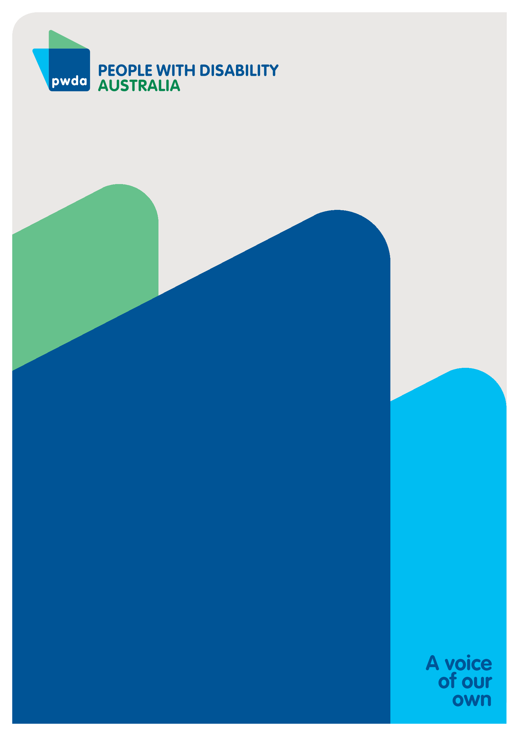
People with Disability Australia (PWDA) is a national disability rights and advocacy organisation made up of, and led by, people with disability.
For individual advocacy support contact PWDA between 9 am and 5 pm (AEST/AEDT) Monday to Friday via phone (toll free) on 1800 843 929 or via email at pwd@pwd.org.au
Submission contact
Lisa Ira
Expert Advisor – International and Human Rights
E: lisai@pwd.org.au

Disability Royal Commission (2022) Transcript of Proceedings – Public Hearing 28, Day 3, accessed 1 November 2024, 196.
Australian Human Rights Commission (2021), Free and Equal: A reform agenda for federal discrimination laws, Australian Human Rights Commission, accessed 6 October 2025, 302.
Australian Human Rights Commission (2023), Free & Equal: Revitalising Australia’s Commitment to Human Rights — Final Report, Australian Human Rights Commission, accessed 6 October 2025.
Purvis v New South Wales (Department of Education and Training) (2003) 217 CLR 92.
Purvis v New South Wales (Department of Education and Training) (2003) 217 CLR 92.
Disability Royal Commission (2023) Final report – Executive summary, Our vision for an inclusive Australia and recommendations, Australian Government, accessed 6 October 2025.
Sklavos v Australian College of Dermatologists [2017] FCAFC 128.
Waste Reduction and Recycling Act 2011 (Qld) s 99GD.
Equality Act 2006 (UK).
Mulligan v Virgin Australia Airlines Pty Ltd [2015] FCAFC 130.
Parliamentary Joint Committee on Human Rights (2024), Inquiry into Australia’s Human Rights Framework, Parliament of Australia, Commonwealth of Australia, accessed 6 October 2025.

