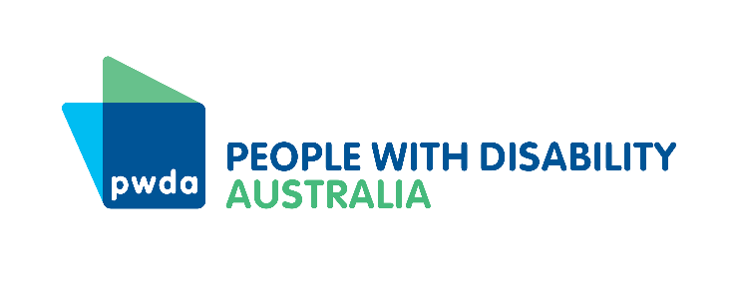
PWDA Language Guide:

A guide to language about disability
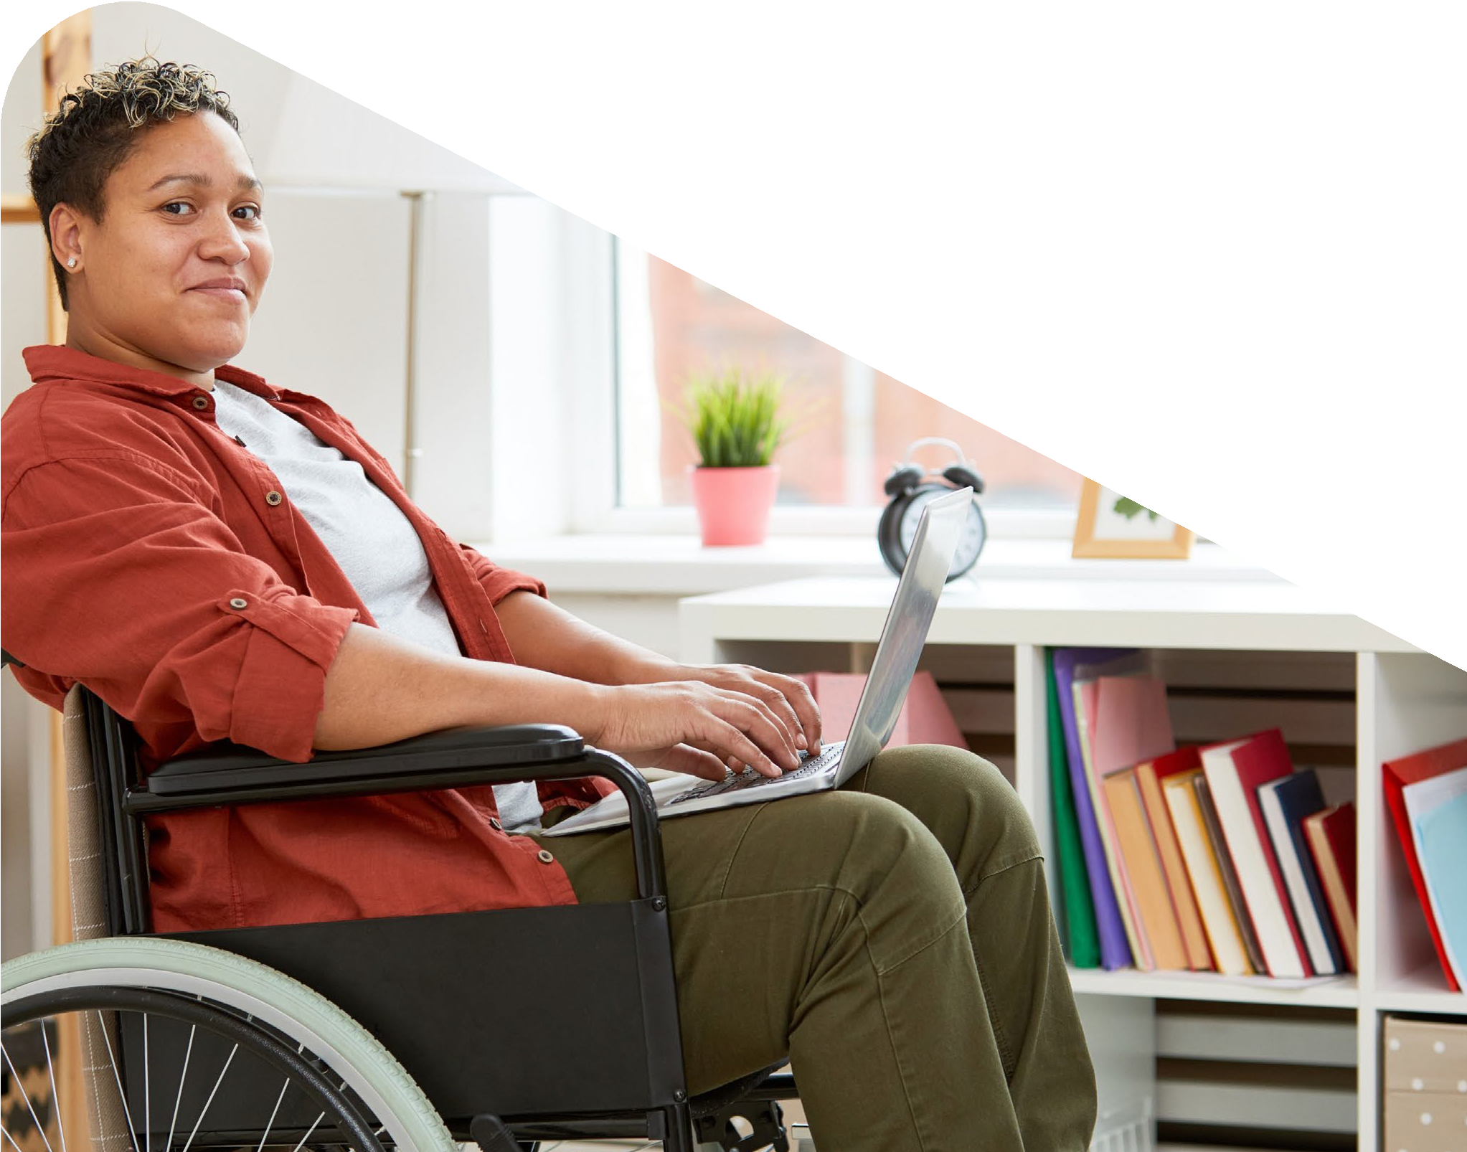
Aug 2021 Update
Contents
Introduction 3
About People with Disability Australia 5
Social model of disability 6
Human rights model of disability 6
Identity-first vs person-first language 7
Ableism and the impact of ableist language 9
Reporting on disability 10
Whose story are you telling? 12
Who is telling the story? 12
Words to describe people with disability 13
Commonly used phrases 15
People with disability 15
People with cognitive/intellectual disability 16
Neurodiverse people 16
People with psychosocial disability 17
People with sensory disability 19
People without disability 19
Neurotypical people 20
Disability euphemisms 20
Vulnerable 21
Victim/survivor 21
Lived experience (of disability) 21
Carer/support Worker 22
Advocacy 22
Glossary of terms 23

Introduction
This guide has been written by people with disability to assist the general public and media outlets in talking about and reporting on disability. The language (words and phrases) that people use about people with disability has an impact on the social narrative about people with disability, how we are perceived and treated by the general public, which affects the systemic structures in society. It also has an impact on our sense of self, how feel about ourselves, how we navigate society, and interact with other people. It is important that there is awareness of the meaning behind the words that are used when talking to, referring to, or working with people with disability.
There are 4.4 million people with disability in Australia. We watch television, read online stories, listen to the radio or podcasts and share news on social media. However, stories about us often don’t reflect the diversity of our lives.
People with disability are often described in ways that discriminate and demean us. Expressions such as ‘victim’ or ‘sufferer’ suggest we are unhappy about our lives, or that we wish we were ‘normal’.
Words like these contain an implicit, and deeply offensive, assumption that we are to be viewed as objects of pity.
They perpetuate harmful stereotypes.
People with disability lead meaningful lives. We work. We have families. We contribute to our community in myriad ways. We are entitled to respect. Many of us are proud of being people with disability and we want that identity to be affirmed in our private lives as well as in the public sphere.
All too often, family members, service providers and academics speak on our behalf, or over us. ‘Inspiration porn’, emotive triumph-over-the-odds stories whose purpose is to inspire viewers to be grateful for their non-disabled lives, is rife in mainstream society. We want to tell our own stories in language we identify with. When people talk about us, we want them to be respectful.
This guide:
- Unpacks some of the key factors which influence disability-related language
- Provides advice for media workers reporting on disability-related content
- Identifies commonly misused terms and recommends suitable alternatives.
Content note: This guide contains examples of offensive language.

About People with Disability Australia
People with Disability Australia (PWDA) is a national disability rights and advocacy organisation made up of and led by people with disability.
We have a vision of a socially just, accessible, and inclusive community in which the rights, contribution, potential, and diversity of people with disability are not only recognised and respected but also celebrated.
PWDA was established in 1981, during the International Year of Disabled Persons. We are a peak, non-profit, non-government organisation that represents the interests of people with all kinds of disability.
PWDA also represents people with disability at the United Nations, particularly in relation to the Convention on the Rights of Persons with Disabilities (CRPD).
Our work is grounded in a human rights framework that recognises the UN human rights conventions and related mechanisms as fundamental tools for advancing the rights of people with disability.
PWDA is a member of Disabled People’s Organisations Australia (DPO Australia), along with the First People’s Disability Network, National Ethnic Disability Alliance and Women with Disabilities Australia.
DPOs collectively form a disability rights movement that places people with disability at the centre of decision-making in all aspects of our lives.
‘Nothing About Us, Without Us’ is the motto of Disabled Peoples’ International (DPI).

Social model of disability
In this guide, we use the term ‘disability’ in the context of the internationally recognised social model of disability, which describes disability as a social construct.
Under the social model of disability, societal barriers are considered to be obstacles to a person’s equal participation, not their impairment. For example, a flight of stairs for a wheelchair user, or an employer’s ignorance about mental health in relation to an employee with a psychosocial disability.
The social model rejects the medical model of disability, which sees disability as an individual deficit, a deviation from the ‘norm’. Under the medical model, experts intervene to treat, care for and protect people with disability.
The power relations inherent in the medical model of disability are commonly referred to as ableism. The medical model is all about what a person cannot do and cannot be.

Human rights model of disability
The social model of disability, which has dominated disability rights advocacy for more than 40 years, paved the way for the UN Convention on the Rights of Persons with Disabilities (CRPD).
The CRPD and the human rights model of disability goes a step further, recognising dignity as a fundamental human right and freedom.
The human rights model therefore acknowledges a person’s impairment as part of human diversity. The model also acknowledges people with disability’s need for equitable support, even after social barriers have been removed, so they can enjoy their rights on an equitable basis.

Identity-first vs person-first language
Person-first language (people with disability) and identity-first language (disabled people) are both used in Australia.
People with disability often have strong preferences for one term or the other, so it is best to follow the lead of the person or group you are talking about. It’s okay to ask.
If that isn’t possible, use person-first language or refer to a person by their name.
PWDA, government, and non-government institutions predominantly use person-first language when referring to people with disability. This is to avoid unnecessary focus on a person’s impairment.
The dehumanisation of people with disability has a long history, so we choose to preface our language with a reminder of personhood.
Many people with disability, however, prefer identity-first language, which positions disability as an identity category.
For example, ‘I am a disabled person’, like ‘I am an Australian person’ or ‘I am a bisexual person’.
Disability is an aspect of our life that we can’t control, but which we embrace as part of who we are. Identity-first language signifies membership of a wider cultural group.
Some specific communities, such as Autistic and Deaf communities, may not define themselves as disabled at all. Deaf people identify as being part a cultural group with a different first language. Capital letters are used to signify an alternative cultural identity, as in ‘Queer’ or ‘Black’.
Some people with disability have reclaimed terms such as ‘crip’, ‘spaz’, and ‘mad’, in much the same way as the LGBT+ community has reappropriated the word ‘queer’. By taking possession of derogatory labels that were once controlled by others, they aim to destigmatise them.
Other people with disability still find such language offensive. It would be inappropriate to use these terms if they do not apply to you.
Phrases such as ‘the disabled’ are not recommended because they reduce people to their disability.
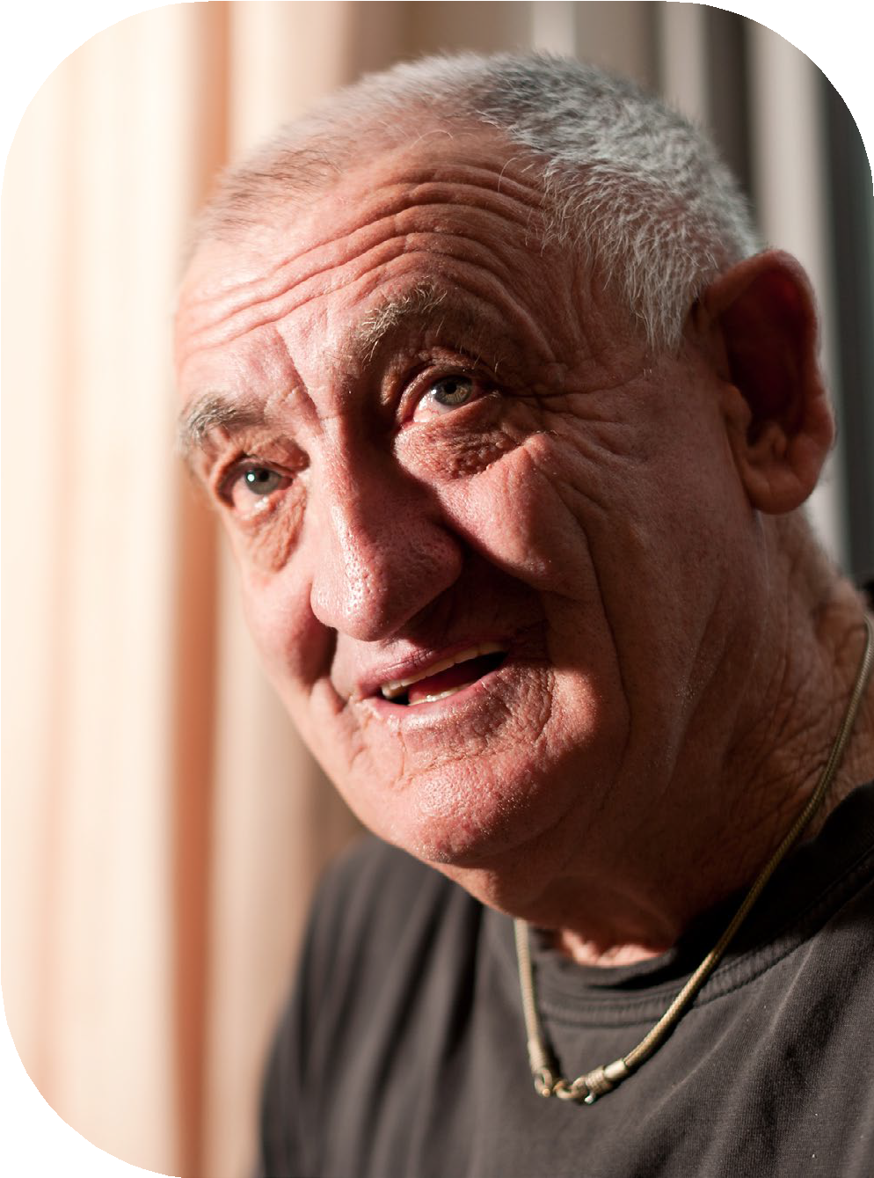

Ableism and the impact of ableist language
Ableism is the systemic exclusion and oppression of people with disability by people without disability. It is often expressed and reinforced through language.
Ableist language refers to language that is derogatory, abusive or negative about disability.
Some words are inoffensive in certain contexts but ableist in others (for example, it is appropriate to call window coverings ‘blinds’, but the word ‘blind’ would become derogatory if you were saying ‘the Prime Minister was blindly following advice’).
Many negative and derogatory words for people with disability – such as ‘retard’, ‘moron’, ‘cretin’, ‘Mongol’ and ‘idiot’ – have medical origins. That does not justify their use. These terms, once prominent in medical textbooks and scientific journals, hark back to an era in which eugenics was used to justify the forced sterilisation and institutionalisation of people with disability. These terms are offensive.
A word’s meaning cannot be erased by good intentions. If you slip up, acknowledge your mistake and/or apologise.
PWDA does not support the use of euphemisms or made-up words, such as ‘handicapable’ or ‘differently-abled’ or ‘special needs’ to refer to people with disability. These terms are ableist and condescending.

Reporting on disability
Disability is part of human diversity, not something to be sensationalised or sentimentalised. Avoid stories where, if the main subject’s disability isn’t mentioned, there would be no hook to the story.
If a person has achieved something newsworthy, like winning a national portrait prize or scaling a snow-covered mountain peak, that’s worth celebrating. However, journalists should not frame the story as if a person’s disability makes their accomplishment more poignant or incredible. It isn’t a surprise when people with disability achieve something.
If the fact that the person has disability was removed, would the story be about a mundane, everyday activity? Generally, if a person with disability is doing something that is ordinary for a person without disability, it’s probably ordinary for us as well.
The late Australian comedian and disability activist Stella Young often spoke out against what she termed ‘inspiration porn’. This is the kind of emotive media portrayal of a person with disability that results in other people feeling grateful for their lack of impairment. Such stories objectify people with disability as tragic figures.
These portrayals are exploitative and offensive.
Avoid referring to a person as being ‘inside’ the disability (for example, ‘the man inside the paralysed body’) or ‘beyond’ their disability (for example, ‘she transcended her disability’). Our bodies and/or minds cannot be separated from who we are.
We don’t have a person without disability hidden inside us.
Ask each person with disability how they like to be described. When in doubt, refer to the person with disability by their name.

Whose story are you telling?
When reporting on disability, be sure to centre that story around the person/people with disability. All too often, people with disability are spoken for, or over, by family members, advocates, academics and other non-disabled people who claim authority and expertise over our lives.
Be aware of whose story you are telling. Is it the ‘brave’ tale of a mother who loves her adult child with disability, while the person with disability is only mentioned in relation to how their existence affects everyone else?
Too often, stories about people with disability are actually stories about the people without disability that surround them. Caring for, supporting, befriending, parenting, or working with a person with disability should not be presented as a commendable act, because this implies that the most credible outcome would have been for the person with disability to have been abandoned and neglected by all.
People with disability have the same human rights as everyone else. It’s not newsworthy when those rights are upheld.

Who is telling the story?
When reporting on an issue that specifically affects people with disability, it is best practice to employ a journalist with disability to cover it. You are more likely to get accurate reporting on disability from someone with disability. If you don’t have at least one reporter with disability on staff, or a freelance journalist with disability to call upon, it is time to seek them out.
People with disability make up close to 20 per cent of the population, which means about one in five people in this country can speak with authority on the subject.
You should also hire people with disability to report on non-disability-related issues.
People with disability are not one homogenous group; an Autistic person may have a very different experience of disability to a person with a below-the-knee leg amputation. There is not one spokesperson for all people with disability.
Designated Disabled People’s Organisations (DPOs) are led by, and for, people with disability. These organisations will have a different perspective to organisations that include or represent disability service providers, support workers, families, or commercial business.

Words to describe people with disability
Paying attention to the language you use when talking about people with disability is not about being politically correct, it’s about being respectful. What is acceptable for one person with disability might not be acceptable for another.
Where possible, ask the person how they like to be described. If in doubt, use person-first language or refer to that person by name.
When referring to people with disability:
- Reference a person’s disability only when it’s relevant.
- Focus on the person, not the disability.
- Use the word disability as an uncountable noun, e.g., person or people with disability, NOT person with a disability or people with disabilities.
An uncountable noun cannot be measured. (For example, advice or happiness.) When disability is used as an uncountable noun, as in the sentence ‘disability affects 4.4 million people in Australia’, it refers to a quality or state.
When disability is used as a countable noun, as in the sentence ‘there are many sensory disabilities’, it refers to a specific condition. ‘A disability’ is not a specific condition.
PWDA does not support the use of qualifiers such as ‘multiple’, ‘severe’, or ‘high-functioning’. This language is based on the medical model of disability and suggests some kind of hierarchy. A person either identifies as disabled or they do not. However, some people with disability self-identify under these categories. In those instances, we recommend you follow their lead.
Don’t describe a person as ‘being’ their condition – for example, ‘Vanessa is paraplegic.’ ‘Vanessa has paraplegia’ is correct. The exception is people and groups that use identity-first language to describe themselves, in which case you should do the same: ‘Vanessa is Deaf.’
Avoid descriptions that suggest pity. Terms such as ‘afflicted by’, ‘stricken with’, and ‘victim’ imply a person with disability is suffering or has a reduced quality of life.
Use neutral language, instead. For example: ‘He has muscular dystrophy.’

Commonly used phrases
Here are examples of phrases that are commonly used in relation to disability. These lists contain examples of outdated or offensive language and phrases that should not be used, alongside their appropriate and respectful alternatives.

People with disability

What not to say | What to say
People living with disability, the disabled | People/women/children with disability
Suffers from, victim of, afflicted by, crippled by, incapacitated by | Zhang has a chronic health condition
Paraplegic (which describes the person as their impairment) | Vanessa has paraplegia/quadriplegia
Confined to a wheelchair, wheelchair-bound*, wheelchair person | Aya uses a wheelchair or mobility device
*Wheelchairs are liberating to a person who can’t walk.
Bedbound’ and ‘housebound’ are acceptable because they describe limitations.

People with cognitive/intellectual disability
What not to say | What to say
Intellectually challenged, mentally retarded, mentally disabled, mentally defective, handicapped, simple, special needs* | Suresh has a cognitive disability/ intellectual disability
Downy, mongoloid | Sarah has Down syndrome
Demented | Maria has dementia
Brain-damaged, brain impaired | Will has acquired brain injury
*People with disability have rights not needs.

Neurodiverse people
Neurodiversity is a term coined by Australian sociologist Judy Singer in the late 1990s to describe ‘the limitless variability of human cognition.’ It includes people on the autism spectrum as well as those with other conditions, such as dyslexia, dyspraxia, dysgraphia and attention deficit hyperactivity disorder (ADHD). Even though it’s not a medical condition, some people have embraced the term to describe themselves, as in ‘a person with neurodiversity’.
Other terms, such as neuroatypical and neurodivergent have since emerged. Read more on the subject on Judy Singer’s blog.
Some people on the autism spectrum identify as autistic/Autistic. They consider autism to be a cultural identity beyond the medical diagnosis and may or may not identify as having disability. It is appropriate to describe someone who identifies this way as ‘an autistic person’, but do not call anyone ‘an autistic’ (similar to ‘the disabled’).

What not to say | What to say
Aspy/aspie, profoundly autistic, mild autism | Karim has autism, or Karim is on the autism spectrum
High functioning/low functioning | Sue is autistic/Autistic  (if she identifies that way)
Mental | Li is neuroatypical/ neurodiverse/ neurodivergent
Hyper/hyperactive, space cadet | Marcia has ADHD
Slow learner, stupid | Florence has a learning disability

People with psychosocial disability
Psychosocial disability arises when someone with a mental health condition encounters social barriers that prevent them from participating equally in society. Psychosocial disability may restrict a person’s ability to concentrate, to cope with multiple tasks, to interact with others, to accept constructive feedback, and/or to manage stress.
What not to say | What to say
Crazy, insane, mad, manic, mentally ill, mentally unstable, loony, nuts, psycho(tic), psychopath(ic) | Lowana has psychosocial disability/ a mental health condition
Benjamin is schizophrenic (which describes the person as their illness), schizo | Benjamin has schizophrenia
Jolene is borderline | Jolene has borderline personality disorder
Depressive | Van has depression

People with sensory disability
Sensory disability, or sensory impairment, affects one or more of a person’s senses (touch, hearing, sight, taste, smell, spatial awareness.)
What not to say | What to say
Martin is deaf as a doorpost, Martin is a deafie | Martin is d/Deaf*, hard of hearing (HOH)
The blind, person without sight, blind as a bat, blindie | Mina is blind, has a vision impairment, Mina is a person with low vision
Mute, dumb | Frances is non-verbal

People without disability
What not to say | What to say
Able-bodied*, abled*, healthy, hearing, normal, sighted, of sound body, well | Person without disability, non-disabled person
*Some people with disability reject the term ‘able-bodied’ because it implies people with disability lack able bodies. People with disability who use identity-first language, however, tend use ‘abled’ to describe people without disability, and ‘able-bodied’ to describe people without physical or mobility-related disability for the purposes of consistency.

Neurotypical people
When referring to someone who is not neurodiverse or does not have an intellectual, psychosocial, or cognitive disability:
What not to say | What to say
Normal, of sound mind | Victoria is neurotypical

Disability euphemisms
Euphemisms are at best condescending.
At worst, they are offensive.
Be respectful but be direct. Terms to avoid include:
- diffability
- differently abled
- handicap(ped)
- handicapable
- special needs
- with different abilities.

Vulnerable
The term ‘vulnerable’ should be used with care. It comes from the Latin word for ‘wound’ and can suggest that people with disability are frail and in need of protection. We aren’t inherently vulnerable because of our disability, but rather because of the acts and/or omissions of the society in which we live. For example, government spending cuts that might result in us being imprisoned in our own homes with minimum support. ‘Most vulnerable’, an emotive term favoured by politicians, should be avoided altogether. Such paternalistic language is diminishing to people with disability. However, during the COVID-19 pandemic, PWDA has been using the term ‘clinically vulnerable’ to describe people with disability who are more at risk than the wider population. An example of a person who is clinically vulnerable to COVID-19 is someone with chronic inflammatory lung disease.

Victim/survivor
‘Survivor’ is a problematic word.
Some women who have experienced domestic violence, for example, will not identify with the term. Instead, they may identify as resilient or they might say they were ‘unsafe’ or they were in an ‘unsafe place’. Victim or victim/survivor should also be used judiciously and only if the person identifies as such. Victim implies helplessness and lack of autonomy.
Avoid using this word wherever possible.

Lived experience (of disability)
‘Lived experience (of disability)’ should only be used for people with disability.
It should never be used to describe the experiences of family or support workers without disability. ‘Lived experience’ can also be used in relation to people who may have experienced disability in the past, but don’t any longer.

Carer/support Worker
Choose ‘support worker’ or ‘family member’ over carer as in ‘primary carer’, paid
carer’ or ‘unpaid carer’. The word ‘carer’ infantilises a person with disability and plays into an ableist model of burden, charity and sacrifice.

Advocacy
Organisations such as PWDA, which operate within a human rights framework, use an advocacy model. The ultimate goal of this approach is to empower people with disability to practice self-representation.
When describing this kind of approach, the most appropriate terms to use include ‘human rights-based advocacy’, disability advocacy’, individual advocacy’ and ‘systemic advocacy’. These terms distinguish such an approach from methods used by social workers and medical practitioners.
Terms such as ‘clinical practice’ or direct practice’ are used in medical settings to describe counselling and case work.

Glossary of terms
Terminology | What not to say | What to say
When referring to a person of short stature or with a form of dwarfism | Dwarf  midget | person of short stature
When referring to someone with an intellectual disability | Intellectually challenged  mental defective mentally retarded mentally disabled simple  special  moron  retard  retarded  imbecile  cretin | person with cognitive disability  person with intellectual disability
When referring to someone who has Down syndrome | downy  mongol(oid) | person with Down syndrome
When referring to someone who has learning disability | slow  slow learner  retarded  special needs | person with learning disability
When referring to a person with Attention Deficit Hyperactivity Disorder (ADHD) | hyper hyperactive | person with ADHD
When referring to a person with a brain injury | brain-damaged  brain-impaired | person with a brain injury
When referring to someone who has autism | aspy/aspie autistic  high functioning autism  profoundly autistic | autistic person, person with autism  person on the autism spectrum  neuroatypical neurodivergent

