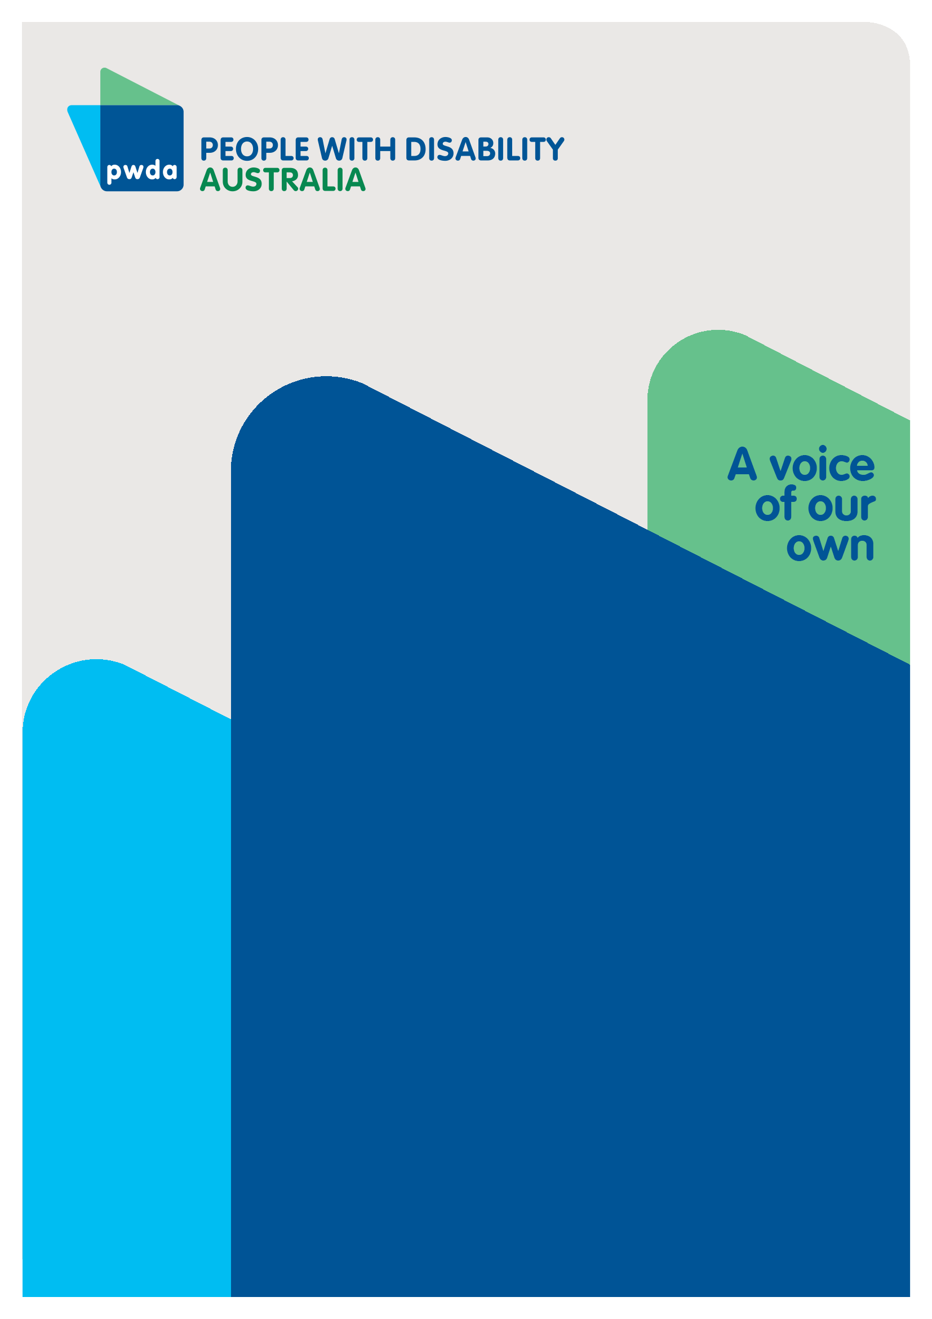
PWDA Survey: Changes to the Disability Discrimination Act (DDA)
Summary Report
5 September
2025

Copyright information
PWDA Survey: Changes to the Disability Discrimination Act (DDA) Summary Report
First published in 2025 by People with Disability Australia
Suite 10.01, Level 10, Centennial Plaza, 300 Elizabeth St, Surry Hills, NSW 2010
Head office also in Sydney
Email: pwd@pwd.org.au
Phone: +61 2 9370 3100
Fax: +61 2 9318 1372
URL: www.pwd.org.au
Typeset in Arial 12 and 14 pt and VAG Rounded 16, 22 and 26 pt
© People with Disability Australia 2024
The moral rights of the authors have been asserted
National Library of Australia Cataloguing-in-Publication data:
Creator(s): | People with Disability Australia
Title: | PWDA Survey: Changes to the Disability Discrimination Act (DDA) Summary Report
All rights reserved. Except as permitted with the Australian Copyright Act 1968 (for example, a fair dealing for the purposes of study, research, criticism or review), no part of this book may be reproduced, stored in a retrieval system, communication or transmitted in any form or by any means without prior written permission. All inquiries should be made to the publisher at the address above.
People with Disability Australia, PWDA Survey: Changes to the Disability Discrimination Act (DDA) Summary Report, 5 September 2025, People with Disability Australia, Sydney

About PWDA
People with Disability Australia (PWDA) is a national disability rights and advocacy organisation made up of, and led by, people with disability.
We have a vision of a socially just, accessible and inclusive community in which the contribution, potential and diversity of people with disability are not only recognised and respected but also celebrated.
PWDA was established in 1981, during the International Year of Disabled Persons.
We are a peak, non-profit, non-government organisation that represents the interests of people with all kinds of disability. In July 2024, PWDA was appointed as the national peak body representing LGBTQIA+ people with disability.
We also represent people with disability at the United Nations, particularly in relation to the United Nations Convention on the Rights of Persons with Disabilities (CRPD).
Our work is grounded in a human rights framework that recognises the CRPD and related mechanisms as fundamental tools for advancing the rights of people with disability.
PWDA is a member of Disabled People’s Organisations Australia (DPO Australia), along with the First People’s Disability Network, National Ethnic Disability Alliance and Women with Disabilities Australia.
DPOs collectively form a disability rights movement that places people with disability at the centre of decision-making in all aspects of our lives.
‘Nothing About Us, Without Us’ is the motto of Disabled Peoples’ International.

Contents
PWDA Survey: Changes to the Disability Discrimination Act (DDA) 1
Copyright information 2
About PWDA 3
Introduction 5
Summary of key findings – National survey 6

Introduction
People with Disability Australia (PWDA) has a national membership of people with disability. Many of our members were pivotal in establishing the National Disability Insurance Scheme (NDIS).
In August 2025, The Australian Government announced a review of the Disability Discrimination Act 1992 (DDA) and is currently seeking input from the disability community to inform potential improvements.
PWDA launched a national survey to inform our submission for this review and identify changes needed in the DDA to make it protect our rights and be better for people with disability.
The survey was conducted from 27 August 2025 to 4 September 2025, closing at 5:00 pm AEST. A total of 303 responses were received. Among respondents, 86% (246) identified as a person with a disability, 34% as a supporter of a person with a disability, and 5% (15 individuals) selected "Other," including advocates and professionals in the disability sector. Some respondents identified across multiple categories. A total of 12 questions were asked, combining multiple-choice and open-text.
Please note the data analysis and findings presented in this report are based on the responses from the 86% of participants who identify as a person with a disability.

Summary of key findings
The survey highlights systemic discrimination against people with disability in Australia. Despite attempts to report, respondents face repeated barriers, finding complaints processes ineffective, retraumatising, and inaccessible.
Most common areas of discrimination: employment (74%), education (50%), housing (32%). These areas were repeatedly cited as inaccessible and discriminatory.
- 61% of people have tried to make a complaint about discrimination they have experienced.
- Of those people who complained most said “nothing happened” or complaints were ignored.
- Of those who did not complain, 67.9% selected “I did not think it would change anything” as the reason stopping them from making a complaint.
- There were strong calls for a simpler complaint process and more education / awareness, and stronger enforcement and penalties.
Respondents called for reform of the DDA, including:
- Stronger enforcement and penalties.
- A positive duty on organisations to prevent discrimination.
- More accessible, simplified complaint systems.
- Greater awareness and education across society.

Question 1 In what areas of your life have you experienced discrimination? (tick all that apply)
Answered 239. Skipped: 7
Answer Choices | TOTAL | QTY
Education | 49.79% | 119
Employment | 73.64% | 176
Housing | 31.80% | 76
Health care | 53.14% | 127
Transport | 43.10% | 103
Government services | 46.03% | 110
Shops, cafes, or other businesses | 45.19% | 108
Online or digital access | 25.10% | 60
Other (please specify) | 20.08% | 48
Comments:
- Employment was the most reported area of discrimination, with 73.6% (176 respondents) selecting this option.
- Education followed at 49.8% (119 respondents).
- Housing was also significant, reported by 31.8% (76 respondents).
20.08% (48 respondents) selected ‘other’. Common areas of discrimination include:
- Widespread, structural discrimination across work, education, housing, health, and public life.
- Financial services and essential services
- Some mentioned discrimination in defence/military-related contexts and medical rehabilitation.
Anywhere where I am considered not disabled enough because I don't have an obvious physical or mental disability.

Question 2: Tell us more about the discrimination you experienced.
Answered: 217: Skipped
Respondents provided details of discrimination across employment, health care, education, government services, housing, daily life and more. The responses highlight systemic ableism, lack of reasonable adjustments, and exclusionary practices across institutions.
Areas of discrimination often overlapped — for example, difficulty in employment directly affecting access to housing, health, and services. Participants also pointed to widespread disrespect, lack of accommodations, and systemic neglect.
“Forced to resign from employment, difficulty in getting housing, difficulty in accessing medical care.”
Key Themes
- Employment: Many respondents described being denied jobs, overlooked for promotion, forced to resign, or placed on unfair performance plans. A lack of workplace adjustments and negative attitudes were consistent barriers.
“Not given a reasonable workplace adjustment in one job and not allowed to take medical leave in another workplace, despite having medical certificates in both instances.”
“After disclosing my disabilities, I was placed on unpaid leave, put on a PIP plan that seemed designed to push me out, and later terminated.”

- Health care: People reported being dismissed, misdiagnosed, denied accessible equipment, and subjected to unsafe practices (e.g., lack of infection control during COVID). Experiences included both as patients and as health care workers.
“Health care issues as premises and medical machines are not accessible (e.g., cannot be weighed at my local GP or see a dentist within my local area).
- Government and Public Services: Respondents described exclusion through inaccessible processes, ID requirements, delays, and poor treatment at agencies such as Centrelink, NDIS, and other government departments. Many noted systems designed without considering the access and inclusion of people with disability.
“Government services require ‘Strong ID’ now for both licences and passports and I do not drive or travel, I can’t access online services without enough ID.”
“Delays and poor accessibility made it hard to get support and advocacy.”
“Inability to purchase life or health insurance due to pre-existing conditions… inability to catch public transport… Centrelink partner income requirements preventing independence.”

Questions 3: If you experienced discrimination, did you try to make a complaint? (tick one)
Answered: 239. Skipped: 7
Answer choices | TOTAL | QTY
Yes | 61.09% | 146
No | 28.87% | 69
I am unsure | 5.44% | 13
I prefer not to say | 4.60% | 11
Comments
- More than half (61.09%) of respondents reported trying to pursue a complaint when they faced discrimination.
- Nearly one-third (28.87%) did not attempt to make a complaint.
- Around 10% were unsure or chose not to answer, possibly signalling a lack of awareness about options, or fear of negative consequences.

Question 4: If yes, what happened after you complained? Please include any barriers you faced in accessing justice, for example, a lawyer may have told you that the case would not succeed.
Answered: 151. Skipped: 95
Responses reveal widespread dissatisfaction with complaints processes. Many reported inaction, dismissal, or retaliation rather than meaningful resolution. A smaller number described partial outcomes, but often insufficient or tokenistic.
There is a general feeling of disillusionment and lack of trust in the effectiveness of existing complaint mechanisms.
A few noted that formal processes sometimes led to advice, mediation, or minor adjustments, but rarely full justice or systemic reform.
Key Themes
- No meaningful action: Many respondents said “nothing happened” or their complaints were ignored or dismissed.
“Nothing. Those I complained about lied about the circumstances, and the organisation believed them.”
“Complaint was made to an employer and company director, but no action was taken despite acknowledgment.”
- Disbelief and retaliation: Several described being disbelieved, manipulated, or facing backlash after making complaints (e.g., demotion, job loss, hostility from management).
“Backlash from the school. It wasn’t worth complaining further.”
“Gaslighting, manipulation, outright lies, ghosting, and bullying were the response.”

- Complex and inaccessible processes: Complaints processes were described as complex, slow, or impossible to navigate, leaving people exhausted.
“Complexity of bureaucracy and depleted energy meant I could not continue with the process.”
- Limited accountability: Even where staff were “counselled” or organisations acknowledged issues, respondents felt there was no real change.
“The manager was allegedly counselled, but the negative behaviour continued.”

Question 5: If no, what stopped you from making a complaint? (tick all that apply)
Answered: 162. Skipped: 84
Answer choices | TOTAL | QTY
It was too difficult to make a complaint | 51.23% | 83
I did not know where to go | 33.33% | 54
I did not think it would change anything | 67.90% | 110
I was worried that something bad might happen | 39.51% | 64
Other (please specify) | 29.01% | 47
Comments
- “I did not think it would change anything” – the most common reason, reported by 67.9% (110 people).
- “It was too difficult to make a complaint” – selected by 51.2% (83 people).
- “I did not know where to go” – selected by 33.3% (54 people).
29.01% of respondents selected ‘other’. Common themes identified include:
- Mental health and energy costs: Several people said pursuing a complaint would worsen their wellbeing, so they avoided it.
- Negotiation instead of formal processes: Some opted for informal resolution because formal complaints were too draining.
- Fear of retaliation: A number worried about being misunderstood, judged, or facing backlash from managers or institutions.
- Past negative experiences: Respondents noted that previous complaints had gone nowhere, so they saw no point in trying again.
- Distrust of authority: There was a recurring belief that managers or higher-level staff were aligned with the people being complained about, making the process biased.
“I feared being misunderstood or judged for how I feel.”
“Previous complaints have gotten nowhere.”
“It was better for my mental health at the time not to make a complaint.”

Question 6: Please tell us more about your experience trying to make a complaint about discrimination.
Answered: 146. Skipped: 100
Responses identified recurring themes that the complaint process was exhausting, ineffective, and often retraumatising. Few reported achieving meaningful outcomes. Instead, many faced dismissal, retaliation, or endless bureaucracy.
Key Themes
- Exhaustion and trauma: Complaints were described as draining and retraumatising, requiring significant time, energy, and resilience that many respondents did not have.
“It was traumatic. Schools are the worst. I’d sooner leave than complain again.”
“Trying to make complaints was exhausting and retraumatising.”
“Employers and schools don’t care (despite promises), so it feels useless to try.”
- Dismissal and minimisation: Employers, schools, and agencies often dismissed complaints as “misunderstandings” or failed to take them seriously.
“Attempted to raise complaints up to work health and safety level, but the process was derailed.”
“Manager said it was a misunderstanding. When asked to clarify, they continued to gaslight.”
- Bureaucratic and inaccessible processes: Processes were complex, slow, unclear, and often inaccessible to people with disability.
- Retaliation and risk: Some reported backlash, worsening treatment, or fear of negative consequences after lodging complaints.
- Tokenism without change: Even when formal submissions were made (e.g., to commissions or inquiries), respondents felt these did not lead to practical outcomes.
- Loss of trust in the DDA: Some participants directly stated that the Disability Discrimination Act (DDA) is ineffective or ignored in practice.
“DDA is ignored in Australia… no one takes it seriously.”

Question 7: Is there anything else you’d like to tell us about how the DDA can be made better?
Answered: 159. Skipped: 87
Responses were broad but carried clear messages: the DDA is outdated, weakly enforced, and poorly understood, and systemic change is needed. Participants called for stronger protections, more awareness, and structural reform.
Key Themes
- Ableism and cultural attitudes: People felt society does not see disabled people as equals, describing Australia as deeply ableist.
“People don’t view people with a disability as equals. We live in a very ableist society where ableism is ingrained.”
- Stronger enforcement: Calls for the DDA to have real “teeth,” including penalties, stricter guidelines for employers, and a positive duty on institutions to prevent discrimination.
“The DDA should have stronger enforcement mechanisms and penalties.”
- Accessibility of complaints system: Suggestions included a universal method of contact for complaints, clearer processes, and education of frontline professionals (e.g., GPs). Respondents said the law needs updating to reflect current realities, intersectionality, and stronger protections.
“A universal method of contact for complaints that is easy to use must be established.”
“It must take intersectionality into account, and not expect individuals to negotiate alone.”
- Education and awareness: Many emphasised the need to raise awareness of rights under the DDA among both the disability community and the broader public.
“Improve the law and standards… More awareness about the DDA within the community.”
People completing the survey

Question 8: I am (tick all that apply)
Answered: 246. Skipped: 0
 | TOTAL | QTY
A person with disability | 100.00% | 246
A person who supports a person with disability | 24.39% | 60
Other (please specify) | 4.47% | 11
Comments:
Among respondents with a disability, 24.39% also support a person with a disability, while 4.47% selected ‘other’, identifying as advocates, disability sector workers, and professionals.

Question 9: Do you identify as any of the following: (tick all that apply)
Answered: 234. Skipped: 12
Answer Choices | Responses | QTY
Aboriginal and / or Torres Strait Islander | 5.56% | 13
From a culturally or linguistically diverse (CALD) background | 14.96% | 35
Member of the LGBTQIA+ community | 28.63% | 67
Woman or girl with disability | 70.09% | 164
Trans and / or gender diverse | 7.26% | 17
Young person with disability (under 25 years) | 5.13% | 12
Older person with disability (65+ years) | 15.81% | 37
A person living in a rural or remote area | 20.09% | 47
I prefer not to say | 1.28% | 3
Other (please describe): _______________ | 5.56% | 13

Comments:
- Women and girls with disability made up most respondents (70.09%).
- 28.63% of respondents identify as LGBTQIA+ and 7.26% as trans and/or gender diverse.
- 14.96% as CALD and 5.56% First Nations.
- 20.09% came from rural or remote areas.

Question 10: What state or territory do you live in? (tick one)
Answered: 245. Skipped: 1
 | TOTAL | QTY
NSW | 40.41% | 99
VIC | 22.04% | 54
TAS | 1.63% | 4
WA | 4.49% | 11
SA | 9.39% | 23
ACT | 3.27% | 8
NT | 0.00% | 0
QLD | 18.78% | 46
Comments:
- NSW was the largest contributor (40.41%)
- Most responses came from eastern states (NSW, VIC, QLD), which together made up more than 80% of the total.
- Tasmania (1.63%) and NT were underrepresented, with NT having no respondents at all.

Question 11: Where do you live in Australia?
Answered: 244. Skipped: 2
Answer Choices | TOTAL | QTY
Major City | 60.66% | 148
Rural or regional area | 35.66% | 87
Remote area | 0.41% | 1
Prefer not to say | 2.46% | 6
(please describe) | 0.82% | 2
Comments:
- Most respondents (60.66%) live in major cities
- Over one-third (35.66%) live in rural or regional areas
- Only one person identified as living in a remote area.

Question 12: What is your age group? (tick one)
Answered: 246. Skipped: 0
 | TOTAL | QTY
Under 18 | 0.41% | 1
18 - 24 | 3.25% | 8
25 - 34 | 6.91% | 17
35 - 44 | 22.76% | 56
45 - 54 | 26.42% | 65
55 - 64 | 22.76% | 56
65+ | 15.45% | 38
I prefer not to say | 2.03% | 5
Comments:
- Most respondents are between 35 and 64 years old (72% combined)
- A significant 15.5% are 65+
- Very few respondents were under 25 (only 9 people total).




