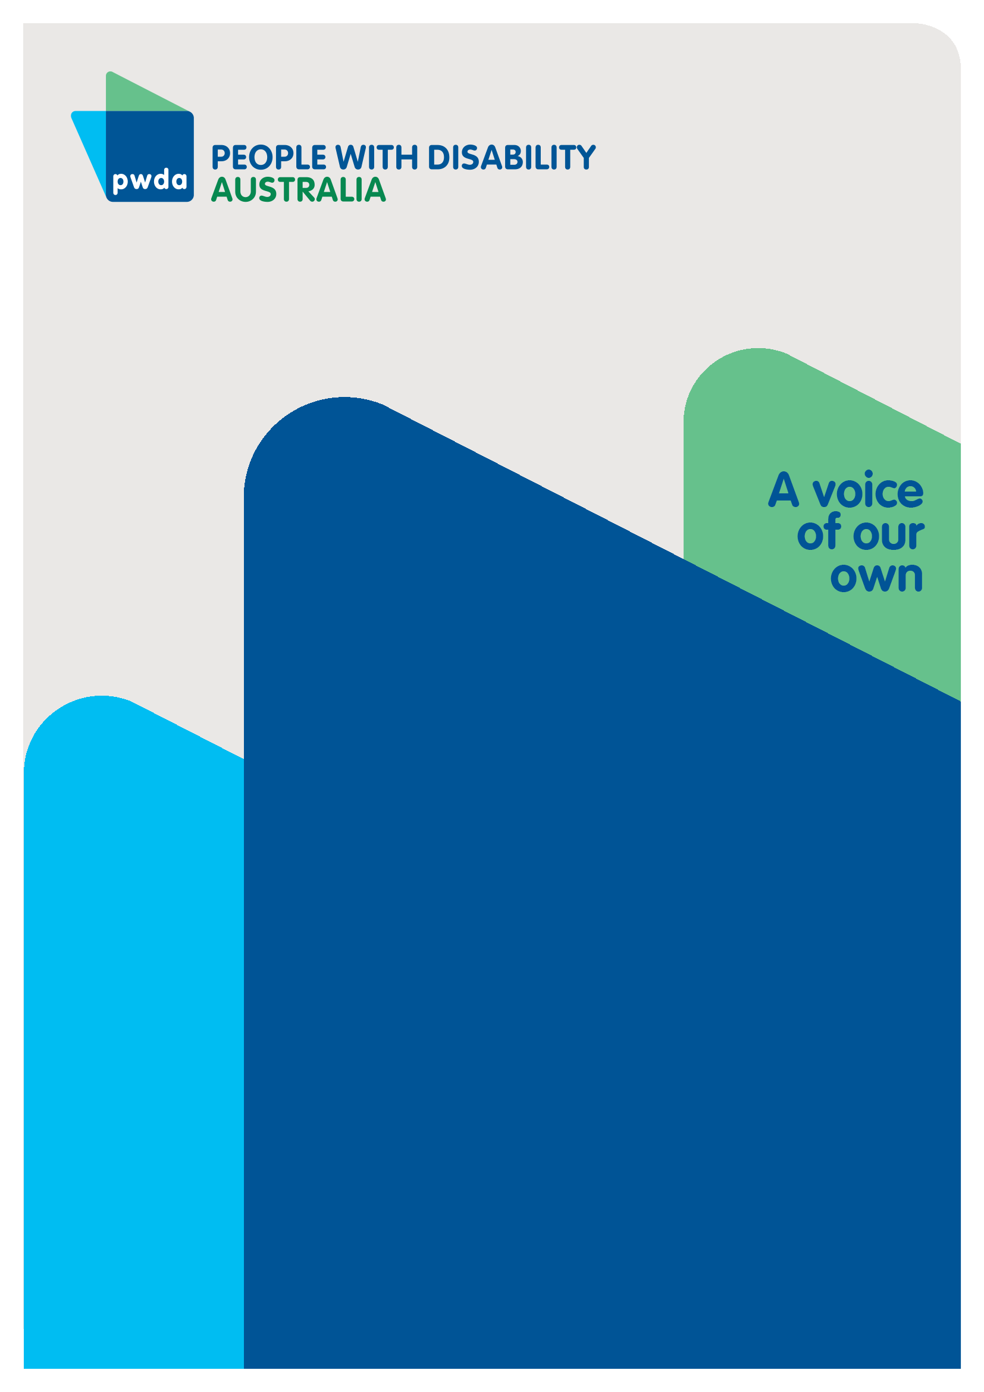
PWDA Pre-Budget Submission to the Australian Treasury for the 2026-27 Federal Budget

JANUARY
2026

Copyright information
PWDA Pre-Budget Submission to the Australian Treasury for the 2026-27 Federal Budget

First published in 2026 by People with Disability Australia Ltd.
Suite 10.01 Centennial Plaza | Level 10, 300 Elizabeth Street Surry Hills, New South Wales, Australia 2010
Email: pwd@pwd.org.au
Phone: +61 2 9370 3100 Fax: +61 2 9318 1372
URL: www.pwd.org.au

Typeset in Arial 12 pt and VAG Rounded 26 and 16 pt

© People with Disability Australia Ltd. 2026

The moral rights of the authors have been asserted.

National Library of Australia Cataloguing-in-Publication data:

Creator(s): | People with Disability Australia
Title: | PWDA Pre-Budget Submission to the Australian Treasury for the 2026-27 Federal Budget

All rights reserved. Except as permitted with the Australian Copyright Act 1968 (for example, a fair dealing for the purposes of study, research, criticism or review), no part of this book may be reproduced, stored in a retrieval system, communication or transmitted in any form or by any means without prior written permission. All inquiries should be made to the publisher at the address above.

Suggested citation:

People with Disability Australia (2026) PWDA Pre-Budget Submission to the Australian Treasury for the 2026-27 Federal Budget, Sydney, Australia.

Table of Contents
Copyright information 2
About PWDA 4
Introduction 5
Summary of recommendations 7
Recommendations 8
Conclusion 18

About PWDA
People with Disability Australia (PWDA) is a national disability rights and advocacy organisation made up of, and led by, people with disability.
We have a vision of a socially just, accessible and inclusive community in which the contribution, potential and diversity of people with disability are not only recognised and respected but also celebrated.
PWDA was established in 1981, during the International Year of Disabled Persons.
We are a peak, non-profit, non-government organisation that represents the interests of people with all kinds of disability.
We also represent people with disability at the United Nations, particularly in relation to the United Nations Convention on the Rights of Persons with Disabilities (CRPD).
Our work is grounded in a human rights framework that recognises the CRPD and related mechanisms as fundamental tools for advancing the rights of people with disability.
PWDA is a member of Disabled People’s Organisations Australia (DPO Australia), along with the First People’s Disability Network, National Ethnic Disability Alliance, and Women with Disabilities Australia.
DPOs collectively form a disability rights movement that places people with disability at the centre of decision-making in all aspects of our lives.
The work of PWDA embraces the ‘Nothing About Us, Without Us’ motto of the international disability community and Disabled Peoples’ International, the international organisation representing national organisations of people with disability in over 130 countries.

Introduction
Over the past few years, the stage has been set to enable decisive government action to promote the rights of people with disability, following two landmark inquiries that concluded in 2023 - the Royal Commission into Violence, Abuse, Neglect and Exploitation of People with Disability (Disability Royal Commission) and the Independent Review of the National Disability Insurance Scheme (NDIS Review). Yet government responses have fallen short of the disability community’s expectations. Legislative changes have placed essential supports at risk, while underfunding and failure to prioritise continue to leave people with disability behind.
While the 2025/26 Federal Budget included some welcome investments - including in Foundational Supports, supplementation for independent disability advocacy, and support for NDIS appeals - it did not reflect the level of urgent, targeted action required in areas where people with disability are consistently overrepresented and disproportionately impacted, and where the Disability Royal Commission and the NDIS Review identified that reform is most needed.
The 2026/27 Budget provides a critical opportunity to commit to key priorities that will advance implementation of Disability Royal Commission and NDIS Review recommendations, lift people with disability out of poverty, and promote disability rights and full economic and social inclusion of Australians with disability.
In this Pre-Budget Submission, PWDA calls for targeted commitments in the 2026/27 Budget to address critical gaps affecting the 5.5 million Australians with disability, including measures that:
- Enable inclusion and access to supports and services, both within the NDIS and through establishing funded supports that sit outside the NDIS
- Ensure economic justice amid cost-of-living and housing crises that disproportionately affect people with disability
- Protect the human rights of people with disability and actively address disability discrimination
- Strengthen and extend government commitment to genuine codesign and disability-led research
PWDA’s recommendations focus on long-term system sustainability, addressing avoidable costs, and preventing cost-shifting to health, housing, justice, and crisis services. Our submission highlights that a modest upfront investment can lead to significantly lower public expenditure over time. Failing to act raises fiscal risks - through increased hospital and emergency service utilisation, rising housing instability and homelessness, and greater pressure on crisis, safeguarding, and justice systems.

Summary of recommendations
Recommendation 1: Invest in an NDIS that is truly accessible, equitable, safe and fair
Recommendation 2: Fund a long-term agreement for nationally consistent Foundational Supports
Recommendation 3: Incentivise participation in work and improve income security for people with disability through adjustments to Disability Support Pension settings
Recommendation 4: Raise the Rate of income support payments and remove the partner income test
Recommendation 5: Invest in accessible housing and mandate the Livable Housing Design Silver Standard
Recommendation 6: Fund the development and implementation of a national human rights act
Recommendation 7: Progress and implement reform of the Disability Discrimination Act 1992 (Cth)
Recommendation 8: Properly fund individual and systemic advocacy services to promote, protect and enforce the rights of people with disability
Recommendation 9: Invest in a national Supported Decision-Making Framework
Recommendation 10: Further invest in lived expertise by taking a genuine co-design approach to all policy, legislation and regulatory reforms
Recommendation 11: Continue to invest in disability-led research

Recommendations

Enable inclusion and access to supports and services, both within the National Disability Insurance Scheme (NDIS) and through establishing funded supports that sit outside the NDIS

Recommendation 1: Invest in an NDIS that is truly accessible, equitable, safe and fair
The NDIS is a vital investment in the long-term economic and social inclusion of people with disability. The scheme is also a key contributor to the Australian economy – for every $1 invested in the NDIS, $2.25 in economic value is generated for Australia.
Funding cuts and eligibility restrictions weaken the scheme’s effectiveness and reduce participant choice, control and access to essential services, shifting costs to healthcare and social services and ultimately increasing long-term costs for Australia.
The 2026/27 Federal Budget presents an opportunity to carefully consider the impact of funding cuts and changes to eligibility, so decisions do not undermine access to essential supports or the integrity of the NDIS or shift costs onto other government services. The 2026/27 Federal Budget provides an opportunity to:
- Guarantee long-term, sustainable funding to maintain the integrity of the NDIS.
- Prevent or reverse cost-cutting measures and reforms that limit access to essential supports for people with disability, as this ultimately shifts costs to other government services.
- Guarantee current NDIS participants will remain in the NDIS until viable Foundational Supports and mainstream services are available and accessible to all.
Benefits: A fully funded and participant-led NDIS enables people with disability to live independently, participate in the workforce and contribute to their communities, while reducing pressure on other government services. While implementation may involve increased upfront investment, this approach will be cost-effective over the long term.

Recommendation 2: Fund a long-term agreement for nationally consistent Foundational Supports
The ongoing lack of clarity, including in relation to the implementation and long-term sustainability, of Foundational Supports (and one of its targeted programs Thriving Kids) continues to be a significant concern, including funding, scope, and participation rate expectations. While PWDA acknowledges investment in Foundational Supports in the 2025/26 Federal Budget and the ongoing negotiations between the Commonwealth and states and territories, the Australian Government must:
- Ensure the 2026/27 Federal Budget reflects adequate federally supported resourcing for the implementation of general and targeted Foundational Supports, including Thriving Kids and mental health supports, as the NDIS New Framework Planning is expected to begin in mid-2026.
- Ensure Foundational Supports are designed, implemented, delivered and reviewed in a way which is responsive to the needs of people with disability and maximises inclusion, equitable access, regardless of location, even within each state or territory. People with disability and their representative organisations must be supported to take a key role in the design, implementation and evaluation of Foundational Supports through ongoing co-design.
- Provide a clear estimation of the demand and expected participation levels for Foundational Supports across all states and territories, across general and targeted supports.
- Provide a clear estimation of funding required across all states and territories based on accurate modelling.
- Ensure continued funding for existing disability-affirming services and programs, and increased funding where it is reasonably anticipated that demand will grow in line with the broader rollout of all Foundational Supports, including Thriving Kids and mental health targeted supports.
These supports are essential, not optional for the 5.5 million Australians with disability, including the nearly 5 million who aren’t on the NDIS.
Disability supports outside the NDIS must be delivered in an accessible and equitable manner and be available to all. They must be truly supplementary to the NDIS and should not cause individuals to lose reasonable and necessary supports before viable alternatives are available.
Benefits: Long-term investment in these critical, often lifesaving and life-enabling supports, will change lives and reduce strain on other government systems including hospitals, community and crisis services.

Ensure economic justice amid cost-of-living and housing crises that disproportionately affect people with disability

Recommendation 3: Incentivise participation in work and improve income security for people with disability through adjustments to Disability Support Pension settings
Many people live with long-term health conditions that make sustained participation in work uncertain or insecure. Fluctuations in health, levels of workplace support, and broader labour market conditions can disrupt employment, underscoring the need for a social security safety net that is stable and responsive to these realities for people with disability.
Current Disability Support Pension (DSP) rules, however, create financial and administrative barriers that deter workforce participation.
The Australian Government must:
- Lower the taper rate from 50c to 30c to reduce Effective Marginal Tax Rates to more manageable levels and encourage people to increase work hours without incurring steep financial losses.
- Extend the suspension period from 2 years to 10 years to provide confidence to trial work without losing the DSP safety net, recognising that finding and sustaining suitable employment can take years, and that health conditions may fluctuate.
Benefits: These measures will deliver significant benefits to individuals, reducing the poverty often experienced by DSP recipients, as well as delivering significant fiscal and social returns.

Recommendation 4: Raise the Rate of income support payments and remove the partner income test
As living costs continue to increase, many people with disability who depend on income support are finding it increasingly difficult to meet basic needs, with a significant number living in poverty.
Disabled Australians face unique cost of living pressures. The additional expenses that come with disability mean that current payment levels do not provide an adequate standard of living. The financial hardship experienced by many people with disability stems from the way policies and systems have been structured, rather than from disability itself.
The Australian Government must ensure that social security settings - including JobSeeker, the Disability Support Pension, and Commonwealth Rent Assistance - are sufficient to meet the needs of people with disability. This requires increasing payment rates so people with disability can achieve financial security and, at an absolute minimum, live above the poverty line.
The current income support system ties financial support to a partner’s income through the partner income test, creating financial penalties based on relationship status and assuming all relationships are safe and equitable. For many people, this is not the case. Financial dependence increases the risk of economic abuse and can leave people trapped in unsafe situations. The partner income rules can undermine autonomy, equality, and the ability of people with disability to enter and exit relationships safely and on equal terms.
While Section 24 of the Social Security Act 1991 (Cth) provides discretion for a person to be treated as single for income support purposes ‘due to the existence of family and/or domestic violence’, this provision is limited and operates under strict, discretionary guidelines that require assessment of complex circumstances that can be difficult to disclose or substantiate.
The Australian Government must:
- In line with the Raise the Rate campaign, increase JobSeeker, the Disability Support Pension and Commonwealth Rent Assistance to cover the real cost of living for people with disability.
- Remove the partner income test across all income support payments.
Benefits: Increasing income support payments will help people with disability afford essentials, take part in economic and community life, and reduce the risk of preventable health and housing crises. Removing the partner income test will support financial independence for those who rely on income support. Together, these measures can increase personal safety, reduce reliance on crisis and emergency services and help lower long-term costs for government.

Recommendation 5: Invest in accessible housing and mandate the Livable Housing Design Silver Standard
Accessible and affordable housing remains in critically short supply, leaving many people with disability with little choice but to live with family members or in institutional settings, often contrary to their preferences and rights. People with disability face a heightened risk of homelessness and housing insecurity, and this must be explicitly addressed in housing policy and funding decisions.
While the 2025/26 Budget prioritised safe, secure and affordable housing, it did not explicitly address accessibility. For people with disability, housing cannot be considered safe or secure unless it is accessible.
Accordingly, the Australian Government must:
- Mandate the Livable Housing Design Silver Standard in the National Construction Code across all states and territories and provide funding to support consistent implementation and compliance.
- Commit to, and adequately resource, a national housing strategy that ensures a sufficient supply of accessible, affordable and appropriate housing for people with disability.
Benefits: Appropriate housing is a cornerstone of economic security and social participation. Expanding the supply of accessible housing reduces the risk of homelessness, enables independent living, and decreases long-term government expenditure on institutional care, health interventions and emergency accommodation for people with disability. Investment in accessible housing also delivers broader community benefits, supporting older Australians and families and reducing the need for costly retrofitting and modifications. Designing homes to be accessible from the outset ensures housing stock is fit for the whole community, now and into the future.

Protect the human rights of people with disability and actively address disability discrimination

Recommendation 6: Fund the development and implementation of a national human rights act
The Parliamentary Joint Committee on Human Rights recommended a ‘dialogue model’ for a proposed human rights act. This includes requiring Parliament to expressly consider human rights when making laws, require the judiciary to interpret laws in a way that is compatible with the human rights act and requiring the Attorney-General to trigger a process for reviewing a law where a Court has found a parliamentary intention to override human rights contained in the human rights act. PWDA supports the enactment of a national human rights act that expressly incorporates immediate rights in the Convention on the Rights of Persons with disabilities (CRPD), by individually listing each CRPD right or by reference to incorporation of the CRPD into the legislation.
Accordingly, in the 2026/27 Federal Budget the Australian Government must:
- Allocate dedicated funding to support the development, consultation, and enactment of a national human rights act. This includes funding for legislative drafting, public engagement, and expert advisory support.
- Ensure sustainable resourcing for a central oversight body to deliver and monitor the functions established under the legislation, and to build capacity of public servants, legal practitioners, and the broader community to uphold rights under a national human rights act.

Recommendation 7: Progress and implement reform of the Disability Discrimination Act 1992 (Cth)
PWDA welcomes the Australian Government’s investment in and the commencement in 2025 of the review of the Disability Discrimination Act (DDA) 1992 (Cth).
However, we are concerned about the lack of clear timeframes for the review’s finalisation and subsequent development of legislation. Urgent reform is needed, as the current legislation relies heavily on burdensome individual complaints processes and is compromised by broad exceptions for duty-holders. As part of the government response to the Disability Royal Commission, the government committed to the review and modernisation the DDA. To deliver a more inclusive and disability-affirming DDA, the 2026/27 Federal Budget must:
- Allocate dedicated resources for the development of the legislation, including funding for legislative drafting, further public engagement, and expert advisory support.
Benefits: Strengthening and enforcing the human rights of people with disability will help ensure no one is left behind and reduce the risk of repeating the systemic failures identified by the Disability Royal Commission. Establishing a national human rights act, alongside a modernised DDA, will help prevent human rights violations, reduce discrimination, provide tools for challenging injustices, and promote an understanding and respect for human rights. The active implementation of a modernised DDA will increase the capacity and safety for workforce participation and social engagement of people with disability.

Recommendation 8: Properly fund individual and systemic advocacy services to promote, protect and enforce the rights of people with disability
PWDA welcomes the recent government commitment to extend the Disability Representative Organisations funding program, recognising the critical role of systemic advocacy during ongoing disability reforms.
With rapid and simultaneous reforms affecting people with disability, it is essential that advocacy organisations are adequately funded to provide both individual and systemic advocacy. This includes supporting the disability community to access information and understand, navigate, and respond to changes as they occur. This ensures that people with disability can uphold their rights, navigate complex and changing systems effectively, and participate fully in reforms and decisions that affect them.
The 2026/27 Federal Budget must:
- Establish long-term, predictable funding arrangements for the systemic and individual advocacy sectors through multi-year agreements.
- In line with the review and development of the new Commonwealth Individual Disability Advocacy Program (IDAP), commit to IDAP Program funding to support individual advocacy organisations with establishment, capability development, and transition initiatives, ensuring this important work is professional, effectively resourced, and sustainable.
- Provide urgent, short-term funding to ensure independent advocacy services can continue operating and avoid closures.
- Allocate dedicated funding for rural, remote and specialist individual advocacy services.
- Investment in individual advocacy workforce development, training, and capacity-building initiatives.
- Ensure government funding aligns with the implementation of recommendations of the Disability Royal Commission and NDIS Review that relate to systemic and individual advocacy.
Benefits: Properly funded Independent Advocacy and Disability Representative Organisations ensure people with disability can assert their rights, access safety, and obtain justice and remedies. Investing in individual and systemic advocacy not only protects individuals but strengthens systemic oversight and responsiveness, reduces long-term costs for government and society, and supports stability and long-term organisational development.

Recommendation 9: Invest in a national Supported Decision-Making Framework
PWDA welcomes the initiatives progressed in 2025 and calls for continued federal leadership to establish a nationally consistent approach to supported decision-making across all government systems, consistent with the Disability Royal Commission Research Report: Diversity, dignity, equity and best practice: A framework for Supported Decision Making.
In the 2026/27 Federal Budget the Australian Government must:
- Fully fund the development and implementation of a national Supported Decision-Making Framework, guided by the Disability Royal Commission’s research and recommendations, and ensure that people with lived expertise - including people with communication support needs and higher support needs, and their representative organisations - are involved in co-design at every stage.
Benefits: Supported decision-making upholds the human rights of people with disability to make decisions about their own lives and have those decisions respected, as recognised under the CRPD. It affirms the right to equal legal capacity and access to the supports needed to exercise that capacity, and promotes greater choice, opportunity, and independence.

Strengthen and extend government commitment to genuine codesign and disability-led research

Recommendation 10: Further invest in lived expertise by taking a genuine co-design approach to all policy, legislation and regulatory reforms
PWDA welcomes the Government’s commitment to co-design of NDIS reforms and we acknowledge that co-design efforts have been undertaken. However, momentum for genuine, meaningful co-design has slowed.
Recent NDIS reforms have seen many participants exit the scheme without access to Foundational Supports or accessible mainstream services, highlighting the urgent need for reform processes that are genuinely inclusive and guided by lived experience.
The disability community holds extensive expertise in designing systems that are fair, accessible, and effective for all. The co-design of the new Aviation Disability Standards, for example, shows that when people with disability and their organisations are properly resourced to participate, reforms are better informed by lived expertise and more likely to deliver practical, rights-based outcomes.
In the 2026/27 Federal Budget the Australian Government must:
- Fund and prioritise the lived expertise of people with disability and their representative organisations by embedding genuine co-design across all reforms. Co-design must be structured, scoped, and consistently applied across all reform processes - not ad hoc or piecemeal.
- Provide dedicated budget allocations to resource facilitation, capacity building, and co-design that continues through to the monitoring and evaluation of reform measures. This should include sufficient time for meaningful engagement, properly paced processes, and fair remuneration for participation, ensuring reforms are effective, equitable, and sustainable.
- Ensure funded co-design extends to all policy, legislative, and regulatory reform, so people with disability and their representatives are actively involved in shaping decisions that affect them across government.

Recommendation 11: Continue to invest in disability-led research
Ongoing investment in disability-led research infrastructure supports the effective implementation of Australia’s Disability Strategy, including outcomes related to safety, rights, inclusion, and wellbeing for people with disability.
The National Disability Research Partnership (NDRP) plays a critical role in funding and mobilising research by and with people with disability, strengthening research capability, and supporting the translation of evidence into policy and practice across government systems. Sustained funding helps ensure that reforms affecting people with disability are informed by evidence that reflects lived experience and is designed for real-world policy and practice impact.
PWDA recommends the Australian Government:
- Continues to invest in disability-led research to ensure policy and program decisions are informed by high-quality, inclusive, and lived-experience-led evidence.
Benefits: Centring the lived experience of people with disability and their representative organisations throughout reform - from policy design to implementation, and ongoing monitoring and evaluation - produces more informed, effective, and equitable outcomes, while also generating long-term efficiencies and potential cost savings for government.

Conclusion
People with disability were largely invisible in the 2025/26 Federal Budget. PWDA strongly urges the Australian Government to implement the recommendations outlined in this submission in the 2026/7 Federal Budget. These measures are not luxuries - they are essential to addressing critical gaps that currently leave many people with disability behind. Fulfilling this obligation will require an explicit and adequately funded commitment in the 2026–27 Federal Budget.

Submission contact
Michelle Keogh
Acting Director, Systemic Advocacy
E: michellek@pwd.org.au

