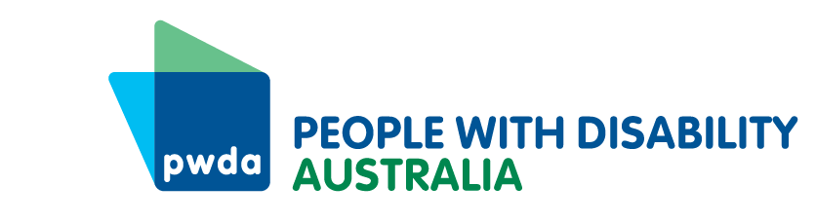
PO Box 666
Strawberry Hills
NSW 2012
+61 2 8365 0400
Toll free 1800 422 015
pwd@pwd.org.au
www.pwd.org.au
20 November 2025
Australian Government
Department of Education
Submitted through Review website: https://submit.dese.gov.au/jfe/form/SV_9ZxsFvqryz2mARg
Dear Department of Education Review team

2025 Review of the Disability Standards for Education

This submission
This submission responds to Topic 1 and Topic 2 contained in the Discussion Paper. It draws upon the experience of Individual Advocates at People with Disability Australia (PWDA). PWDA has also made a submission to the current Review of the Disability Discrimination Act 1992 (Cth) which contains recommendations regarding positive duties and reasonable adjustments.

This submission makes six (6) recommendations.

About People with Disability Australia (PWDA)
PWDA is a leading national disability rights and advocacy peak organisation made up of, and led by, people with disability. We were established in 1981, during the International Year of Disabled Persons. We have a vision of a socially just, accessible and inclusive community in which the contribution, potential and diversity of all people with disability is not only recognised and respected but also celebrated.

Our work is grounded in a human rights framework that recognises the United Nations Convention on the Rights of Persons with Disabilities (CRPD) and related mechanisms as fundamental tools for advancing the rights of people with disability. PWDA embraces the ‘Nothing About Us, Without Us’ motto of the international disability community and Disabled Peoples’ International.

PWDA receives funding under the Commonwealth Department of Social Services Disability Representative Organisation (DRO) program to communicate the views of its members to the Australian Government. We also represent people with disability at the United Nations, particularly in relation to the CRPD.

PWDA is a member of Disabled People’s Organisations Australia (DPOA), along with the First People’s Disability Network (FPDN), National Ethnic Disability Alliance (NEDA), and Women with Disabilities Australia (WDA). DPOs collectively form a disability rights movement that places people with disability at the centre of decision-making in all aspects of our lives.

Response to Discussion Paper Topic 1 – Effective implementation of the Standards

School understanding of the Disability Standards for Education
Our Individual Advocates identify that in general there is a strong awareness of the Disability Standards for Education (DSE) within the public primary and secondary school systems, and that this has improved since the 2020 Review and the Disability Royal Commission. However, four issues continue to persist.
Firstly, it is observed that awareness is not always uniform within a school. For example, it is usually the case that a school principal has a good awareness, but individual teachers may not have a clear understanding of their intent and application in their classroom setting. They can be seen as a type of external ‘administrative burden’, rather than as a set of Standards to be applied proactively to guide teaching practice. This can lead to a concern being escalated to school senior management that may have been dealt with earlier. This puts further strain on the parents/carers, the students, and the school.
Secondly, while awareness of the DSE is high, and our Individual Advocates report that schools are open to supporting students with disability, Advocates also report that the actual application of the DSE can on occasion be ‘patchy’. By this we mean that not all schools may fully understand the extent of their obligations in a practical sense, such as in the provision of all/certain reasonable adjustments for example. This results in considerable ‘to and froing’ between parents and carers and their advocates with the school, drawing out a process and putting a strain on participants.
Thirdly and relatedly, parents and carers continue to report that the onus of raising questions about what reasonable adjustments are available and appropriate can continue to fall on them, and they may not receive all the support they expect from the school to identify and source appropriate adjustments, and review how well adjustments are working. This creates a burden for those parents and carers.
Fourthly, while PWDA Individual Advocates experience is that schools’ efforts at collaboration on adjustments has improved, the experience of some parents and carers is that the process seemed to lack ‘warmth’ or ‘good faith’ or similar, and they felt like they were not welcome and a ‘problem’ in pushing for things the student was entitled to. There has been a feeling expressed that some schools (or individuals in them) are not really concerned about actual ‘inclusive education’, and that it is resisted at some level. This is concerning as students with disability have a right to an inclusive education, free from discrimination.
It is important to note that our Individual Advocates do continue to encounter instances of conduct/behavior by a school which could amount to actual discrimination. In such cases, matters which appear to breach the Disability Discrimination Act 1992 (Cth) or other legislative provisions are referred to appropriate legal services.
Recommendation 1 – Continued training on the DSE for teachers
All people working in an educational setting should be required to undertake ongoing training (and ‘refreshers’) on disability awareness, the Convention on the Rights of Persons with Disabilities (CRPD), and the Disability Standards for Education (DSE) and their obligations under them. For classroom teachers, this must include training on how the DSE should be incorporated into everyday classroom teaching practice, and how issues that arise can be:
- de-escalated and appropriately dealt with at the earliest possible time,
- in a way that reduces tension and confusion, and
- supports the student with disability to continue learning without disruption.
Schools should be provided with financial assistance to assist them in providing training for staff on disability awareness, disability rights, inclusive curriculum design, and the DSE.
Recommendation 2 – Review resources for schools on obligations
The Department of Education should review existing resources or develop new resources for schools to ensure they clearly outline the extent of the school’s obligations under the Disability Standards for Education, and where the school can go when it needs further assistance.
Recommendation 3 – Work collaboratively with students with disability to find and implement reasonable adjustments
Schools should ensure that they are proactive in supporting parents and carers of a student with disability to identify and source appropriate reasonable adjustments for the student. Timely feedback should be provided to parents and carers as to the efficacy of adjustments. Fully funded training must be made available to support schools and teachers to develop the skills to engage in real inclusive collaboration, which is culturally safe, rights affirming, recognises intersectionality, and is student centered.

Parents and Carers understanding of the Disability Standards for Education
PWDA Individual Advocates identify that most of the parents and carers they work with have some understanding of the Disability Standards for Education (DSE). They note that the co-designed information resources for students with disability and their caregivers developed by the Australian Government with Children and Young People with Disability are very high quality and useful. But not everyone is accessing these and similar resources or utilizing them to their fullest. Advocates note that while the level of awareness of the DSE has improved since the 2020 Review and the Disability Royal Commission, it is not uniform in depth of understanding. PWDA Individual Advocates have identified that the lack of understanding of the DSE amongst some parents and carers, combined with school dispute handling processes that are not always clear, can unfortunately escalate situations, creating significant tension between the school and the parents and carers. This has a negative impact on the students. One PWDA Individual Advocate noted that
We see cases where, when we are brought in by the parents to support them and the student with disability, we can see that the school has done what is required of them under the DSE. But the parents may not accept the outcome. It appears they don’t always understand the limitations of the DSE, what it means in practice, or the actual obligations of the school. This is not just the parent’s ‘fault’, and I don’t want to suggest that – they may be confused by the processes and things, or the school may not have communicated things properly. And this problem is made worse if the parent or carer has an intellectual disability or cognitive impairment for example and the school has not provided information in a way that is fully accessible to them.

Recommendation 4 – Clear processes
Schools must ensure that processes around resolving queries or complaints that would come under the Disability Standards for Education are understood amongst all school staff, and are provided to parents, carers and students with disability in community languages and accessible formats, including Easy Read.
Recommendation 5 – Information for parents and carers on the scope of the DSE
The Department of Education should review resources for parents, carers and students with disability and ensure they clearly state the intent of the Disability Standards for Education (DSE), their operation, and the obligations they and the schools have under them. Importantly, resources must describe clearly what the limitations on a school under the DSE are, articulating what a school can and cannot do. Resources should provide information on what other resources for the student might be available if the DSE does not apply, such as cases where, for example, the student’s health condition is not recognised as a disability by the relevant Department.
These must be available in a range of community languages and in a range of accessible formats. The Department of Education should review existing guides to the DSE in ‘Easy Read’ formats to ensure that they are widely available, easily accessed, and up to date.
Efforts should be made to understand why some people may not be accessing community led co-designed information resources such as those developed by Children and Young People with Disability Australia, and other information resources generally and develop strategies to get such resources to those groups.

Response to Discussion Paper Topic 2 – Inclusive decision-making
While we have noted previously that since the 2020 Review and the Disability Royal Commission awareness of the Disability Standards for Education (DSE) has grown amongst schools, parents, carers and students with disability, our Individual Advocates have also noted that problems persist, that discrimination does continue, and the right to inclusive education, and inclusive decision-making is not always upheld.
A critical theme that continues to be raised, which cuts across the issues identified above, is the inadequacy or lack of transparency or clarity around how complaints or queries are dealt with, despite some guidance being provided in the DSE. We have noted that the application and interpretation of the DSE can vary amongst schools and within schools depending on who you talk to.
Practical principles and frameworks that more clearly explain how inclusive decision-making must operate are required.
PWDA submits that such principles focused on consultation, issues resolution and complaints handling must be incorporated into the DSE as a matter of priority. These principles can exist alongside any other existing legislated complaints mechanisms. We are concerned that further delays at this stage for more consultation as to the incorporation of the existing Draft Principles would continue to maintain a problematic situation for all stakeholders.
We would prefer that the Draft set of principles for consultation, issues resolution and complaints handling under the Disability Standards for Education (Draft Principles) presented in the 2025 Discussion Paper be revised internally to consider as much as practicable any recommendations made by the Disability Royal Commission, amend the principles accordingly, and then incorporated and made operational now. These principles do place proactive obligations on schools to identify individual needs, provide adjustments and supports, and provide other necessary support and information to assist the student or associate to participate in the ‘consultation, issues resolution and complaints handling processes.’ That provides time before the next review of the DSE to gather real operational experience and identify what needs to be changed. Delay condemns parents, carers and students with disability to more years of confusion. We need some real practical change now.
Recommendation 6 – Incorporate the Draft Principles into the Standards
The Draft Principles outlined at Attachment B in the Discussion Paper should be included in the Disability Standards for Education (DSE) via Option 3 - include a requirement to follow the principles when applying the Standards after final review by the Department of Education for relevant alignment with the Disability Royal Commission recommendations. As stated in the Discussion Paper (p. 12) Option 3 requires “an education provider to follow the principles when they consult, resolve issues or handle complaints arising in relation to the Standards and a student or prospective student.”
The Principles must be made available to parents, carers and students with disability in community languages and accessible formats including Easy Read.
We recommend further that all school policies and internal dispute resolution and complaints handling processes should be consistent with the Draft Principles, regardless of if the matter comes under the DSE.
If you have any questions about this submission, please contact Mr Julian Laurens, Senior Policy Officer at: julianl@pwd.org.au
Yours sincerely
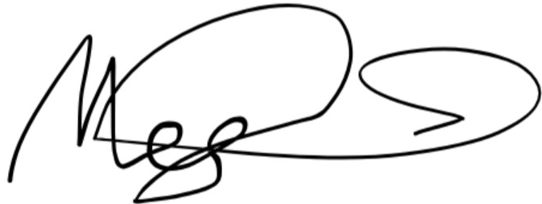
Megan Spindler-Smith
Acting CEO
People with Disability Australia

United Nations Convention on the Rights of Persons with Disabilities, Article 24 – Education; United Nations Committee on the Rights of Persons with Disabilities, General Comment No. 4 on Article 24 – the right to inclusive education.
See relevantly Kate de Bruin, Shiralee Poed & Robert Jackson (2024) Performance of Australia’s Disability Standards for Education 2025: a policy analysis and evaluation, International Journal of Inclusive Education, 28:14, 3533-3553.

