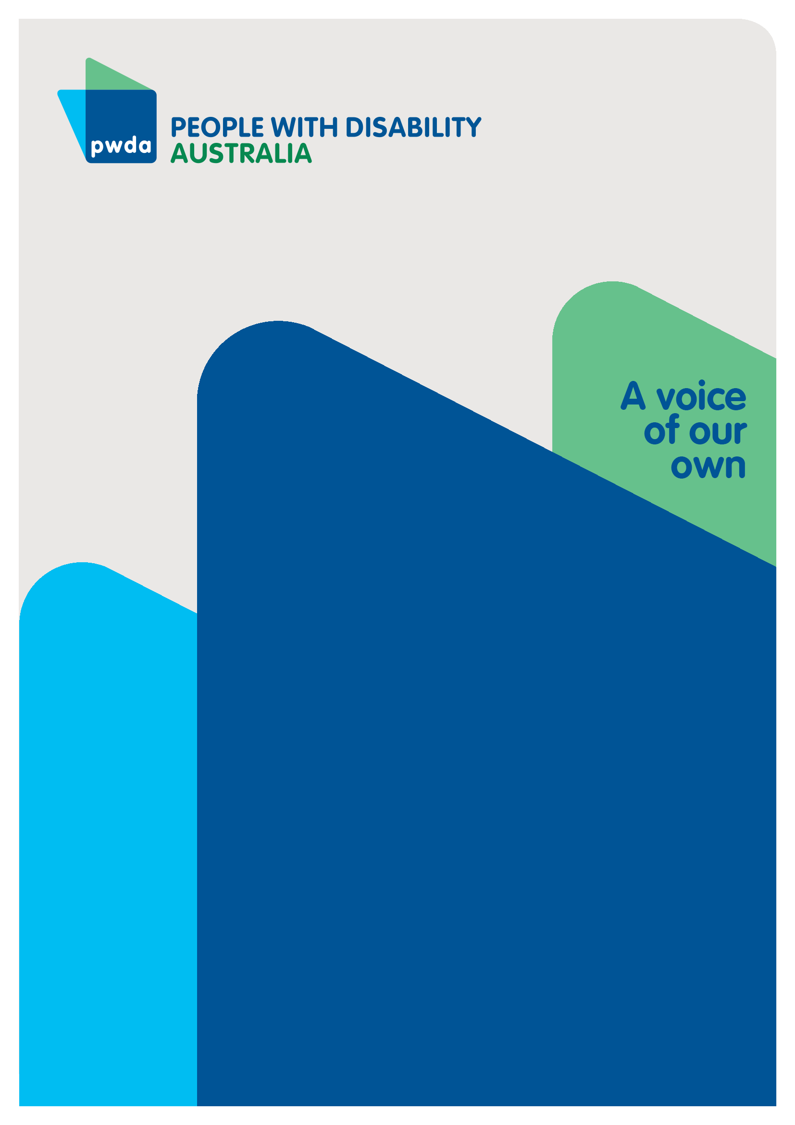
Submission to the NDIS Amendment (Integrity and Safeguarding) Bill 2025
FeBRUARY
2026

Copyright information
Submission to the NDIS Amendment (Integrity and Safeguarding) Bill 2025

First published in 2025 by People with Disability Australia Ltd.
Level 10, 300 Elizabeth St, Surry Hills NSW, 2010
Head office also in Sydney
Email: pwda@pwd.org.au
Phone: +61 2 9370 3100 Fax: +61 2 9318 1372
URL: www.pwd.org.au

Typeset in Arial 12 and 14 pt and VAG Rounded 26 pt

© People with Disability Australia Ltd. 2023
The moral rights of the authors have been asserted

National Library of Australia Cataloguing-in-Publication data:

Creator(s): | People with Disability Australia. C Pirani
Title: | Submission to the NDIS Amendment (Integrity and Safeguarding) Bill 2025

All rights reserved. Except as permitted with the Australian Copyright Act 1968 (for example, a fair dealing for the purposes of study, research, criticism or review), no part of this book may be reproduced, stored in a retrieval system, communication or transmitted in any form or by any means without prior written permission. All inquiries should be made to the publisher at the address above.

Suggested citation:

People with Disability Australia, Pirani, C., Submission to the NDIS Amendment (Integrity and Safeguarding) Bill 2025

About PWDA
People with Disability Australia (PWDA) is a national disability rights and advocacy organisation made up of, and led by, people with disability.
We have a vision of a socially just, accessible and inclusive community in which the contribution, potential and diversity of people with disability are not only recognised and respected but also celebrated.
PWDA was established in 1981, during the International Year of Disabled Persons.
We are a peak, non-profit, non-government organisation that represents the interests of people with all kinds of disability.
We also represent people with disability at the United Nations, particularly in relation to the United Nations Convention on the Rights of Persons with Disabilities (CRPD).
Our work is grounded in a human rights framework that recognises the CRPD and related mechanisms as fundamental tools for advancing the rights of people with disability.
PWDA is a member of Disabled People’s Organisations Australia (DPO Australia), along with the First People’s Disability Network, National Ethnic Disability Alliance and Women with Disabilities Australia.
DPOs collectively form a disability rights movement that places people with disability at the centre of decision-making in all aspects of our lives.
‘Nothing About Us, Without Us’ is the motto of Disabled Peoples’ International.

Introduction
The National Disability Insurance Scheme Amendment (Integrity and Safeguarding) Bill 2025 (the Bill) was introduced into the Senate on 26 November 2025 and referred to the Senate Community Affairs Legislation Committee on 27 November 2025 for inquiry and report. The Bill proposes amendments to the NDIS Act 2013 to strengthen the powers of the NDIS Quality and Safeguards Commission (the Commission) and to make targeted operational changes to the National Disability Insurance Agency (NDIA).
PWDA welcomes stronger safeguards against violence, abuse, neglect and exploitation and supports a stronger penalty regime for providers who wilfully cause harm to participants’ health and safety and their physical, mental and financial wellbeing. We support anti-promotion orders that curb predatory marketing and misleading claims and the introduction of a 90‑day cooling‑off period for participant withdrawal.
However, the Bill introduces expanded administrative and enforcement powers that, without commensurate participant rights, risk reducing participant choice and control.
We propose targeted amendments to embed external merits review, dignity of risk, supported decision‑making, proportionate compliance for small/community‑controlled providers, and safeguards around information‑gathering and evidentiary certificates.

Summary of Recommendations
Recommendation 1: Provide Administrative Review Tribunal (ART) external merits review for key Commission and NDIA decisions and orders (including information demands, determinations, banning orders and anti‑promotion orders), with stays where appropriate and plain‑language reasons.
Recommendation 2: Legislate objective, published criteria and procedural fairness for banning orders and anti‑promotion orders (notice, reasons, right to be heard, time‑limited interim orders, and external review).
Recommendation 3: Insert explicit dignity‑of‑risk and supported decision‑making principles and duties into the NDIS Act and co‑design rules and guidance with people with disability.
Recommendation 4: Issue risk‑enablement guidance and expectations aligned to the High Intensity Support Skills Descriptors (HISSD) to avoid risk‑averse withdrawal of complex supports.
Recommendation 5: Legislate a proportionality duty for the Commission and establish a Small Provider Support Program to avoid thin‑market harms, and enable compliance by sole traders, small and community‑controlled providers.
Recommendation 6: Strengthen the 90‑day cooling‑off period through NDIA‑initiated extensions (without extra paperwork) where vulnerability is evident (for example, to ensure those who have complaints in with providers or are facing domestic and family violence, incarceration or hospitalisation, have guaranteed continuity of funding until other matters are resolved.
Recommendation 7: Mandate statutory co‑design for subordinate legislation, guidance and implementation with people with disability and representative organisations (including PWDA and First Peoples Disability Network), with “what we heard/changed” reporting. Extend consultation timelines.
Recommendation 8: Require plain‑language reasons and ART review rights where plan variations reduce total funding; ensure access to independent advocacy to contest reductions.

Response to the Bill

External Review Rights
The Bill substantially expands monitoring and enforcement tools (including evidentiary certificates and broader information-gathering powers) and creates new offence settings. While stronger safeguards are warranted to address serious misconduct, affected parties require accessible, timely avenues to challenge contested facts or disproportionate exercises of power.
External merits review via the Administrative Review Tribunal (ART) is the Commonwealth’s primary mechanism to ensure legality, rationality and fairness in administrative decision-making.
The Robodebt Royal Commission found that inadequate external review and weak accountability exacerbated harm, especially when automated or expedited processes displaced human rights considerations. Embedding ART review for key Commission and NDIA actions (e.g., banning orders, anti‑promotion orders, information demands and related determinations) reduces the risk of error and protects participant rights without impeding proportionate enforcement against bad actors.
Impact: ART review, combined with plain‑language reasons, improves transparency and trust for participants, providers and workers. It also creates systemic feedback that help refine regulatory guidance over time, supporting consistent, predictable decision‑making aligned with the NDIS Review’s call for fairer, clearer processes.
Recommendation 1: Provide Administrative Review Tribunal (ART) external merits review for key Commission and NDIA decisions and orders (including information demands, determinations, banning orders and anti‑promotion orders), with stays where appropriate and plain‑language reasons.
The Bill also introduces expanded banning powers (now including consultants and auditors) and anti‑promotion orders to curb predatory marketing and conflicts of interest. These powers fill genuine gaps and respond to sector risks identified by the Commission.
Expanding banning orders to consultants and auditors and introducing anti‑promotion orders to curb predatory marketing, are appropriate responses to identified risks.
The Bill also widens the range of people against whom a banning order can be made, beyond NDIS providers and their staff, to prevent “unsuitable persons’ from providing services. This may impact Indigenous participation in the workforce as the most criminalised population group.
To avoid arbitrary or discriminatory outcomes, the Act should require objective, published criteria; procedural fairness (notice, reasons, right to be heard); and time‑limited interim orders only where necessary. These elements uphold natural justice while preserving the regulator’s ability to act swiftly where participant safety is at risk.
Impact: Clear criteria and due process encourage compliant behaviour, deter misconduct, and reduce legal contestation costs. They also protect consultants with lived‑experience and First Nations/community‑controlled organisations from unintended exclusion, consistent with human‑rights‑based regulation.
Recommendation 2: Legislate objective, published criteria and procedural fairness for banning orders and anti‑promotion orders (notice, reasons, right to be heard, time‑limited interim orders, and external review).

Dignity of Risk
The NDIS Review and the Disability Royal Commission emphasised supported decision‑making and dignity of risk as fundamental to safe, quality supports and ordinary lives.
The significant new penalties are justified, however without any mechanism for lawful, participant-led risk-taking providers will increasingly refuse supports involving everyday risk (for example: beach access, sport, community living, innovative supports). This proportionately impacts participants with high and complex needs. Choice, control, flexibility, self-determination and dignity of risk will be reduced in practice.
Updated High Intensity Support Skills Descriptors (HISSD) emphasise person‑centred practice for high‑risk supports. Without guidance, higher penalties can unintentionally incentivise providers to withdraw from complex supports.
An express dignity‑of‑risk principle and a duty to provide supported decision‑making will anchor provider and regulator conduct in human rights
Commission‑issued risk‑enablement guidance — explicitly linking to HISSD — will help providers and auditors show good‑faith, and offer rights‑affirming practice while managing risk.
This will ensure that compliance does not translate into blanket risk avoidance by reducing incentives to avoid higher‑risk cohorts.
Codifying these principles provides auditable expectations for auditors and investigators and offers participants and advocates a clear reference point when contesting risk‑averse decisions, aligning with HISSD’s person‑centred approach to high‑risk supports.

Recommendation 3: Insert explicit dignity‑of‑risk and supported decision‑making principles and duties into the NDIS Act and co‑design rules and guidance with people with disability.
Recommendation 4: Issue risk‑enablement guidance and expectations aligned to the High Intensity Support Skills Descriptors (HISSD) to avoid risk‑averse withdrawal of complex supports.

Proportionate Compliance
Compliance requirements can place a heavy burden on small, regional and community-controlled providers, including First Nations organisations, increasing the risk they may leave the market — particularly in thin markets. This highlights the need for active market stewardship and proportionate regulation as outlined in the NDIS Review.
A proportionality duty would require the Commission to consider provider size, risk and impacts on participants when exercising its powers. A dedicated Small Provider Support Program — such as technical help and practical templates — would help protect culturally safe and local supports.
Impact: Proportionality protects participant choice and control while preserving deterrence for serious misconduct. It reduces inadvertent consolidation and supports sustainable compliance cultures across diverse provider types.
Recommendation 5: Legislate a proportionality duty for the Commission and establish a Small Provider Support Program to avoid thin‑market harms, and enable compliance by sole-traders, small and community‑controlled providers.

Withdrawing from the NDIS
The Bill introduces a 90‑day cooling‑off period for participant withdrawal to guard against coercion and allow reconsideration. To be effective, the setting must recognise participants who cannot easily self‑advocate during crises (for example, those experiencing domestic and family violence, incarceration, hospitalisation).
Enabling NDIA‑initiated extensions — without extra paperwork — to vulnerable individuals ensures the safeguard works for those most at risk. Funding independent advocacy and guaranteeing continuity of supports during cooling‑off (and any extension) are essential to uphold rights and prevent harm.
Impact: These adjustments still allow for the Bill’s protective intent while respecting autonomy and access. They also minimise administrative churn and reduce the likelihood of re‑entry downstream due to ill‑informed exits.
Recommendation 6: Strengthen the 90‑day cooling‑off period through NDIA‑initiated extensions (without extra paperwork) where vulnerability is evident (for example, to ensure those who have complaints in with providers or are facing domestic and family violence, incarceration or hospitalisation, have guaranteed continuity of funding until other matters are resolved.

Co-design Commitment
The Department and the Commission have previously signalled ongoing consultation with DROs, however this remains a matter of ongoing concern for the disability community. To rebuild trust, consultation should be elevated to a statutory “co‑design duty” for legislation and implementation, with transparent “what we heard/changed” reporting.
Co‑design with people with disability and DROs ensures reforms are workable, rights‑affirming and responsive to lived experience. It also supports cultural safety and equity objectives. Sufficient time must be allowed to enable engagement with people with lived experience.
Impact: A legislated duty reduces the risk of unintended consequences, supports smoother transitions, and provides an accountability mechanism for iterative improvement.
Recommendation 7: Mandate statutory co‑design for legislation, guidance and implementation with people with disability and representative organisations with “what we heard/changed” reporting.

Appeals process and information-gathering safeguard
Enhanced information‑gathering powers and evidentiary certificates can improve responsiveness and streamline litigation, but without thresholds, reasonable timeframes, plain‑language reasons and contestability through external review, these tools risk undermining natural justice — particularly for self‑managers, plan managers and small providers. The Robodebt Royal Commission demonstrates the significant harm that can flow from unchecked executive powers and inaccessible review pathways.
The Bill enables the NDIA and the NDIS Quality and Safeguards Commission to request and compel information and documents "on demand," and to withhold payments if this information is not provided.
These changes strengthen the information gathering powers of the NDIS Commission to require relevant information and documents from registered NDIS providers in a shorter timeframe than the 14 days currently allowed. The NDIA also has the power to request information from anyone making a claim.
If the requested information or documentation is not provided within the specified timeframe (which is 14 days by default but can be extended or shortened in certain circumstances), the NDIA can withhold payment unless participants or providers produce unspecified evidence “on demand.” With no defined evidentiary thresholds, these are effectively open-ended powers.
• Self-managers and plan-managers will bear the immediate burden
• Refusals will push providers into private debt recovery for supports already delivered
• There is still no external review right for s45 determinations which cover who gets paid, how they get paid, and whether a payment is permissible under the funding limits of a participant’s plan.
The combined effect of expanded s45 powers and the absence of s46 review rights could produce similar impacts to Robodebt, with debts or refusals that participants cannot meaningfully challenge, with enforcement outsourced to providers. There must be safeguards to ensure participants’ right to independent advocacy when contesting proposed reductions.
Requiring plain‑language reasons and ART review for reductions, with funded advocacy, aligns with administrative justice principles and Robodebt lessons on accessible review.
Impact: Clear reasons and review rights maintain trust, reduce disputes, and help participants navigate changes safely — supporting better outcomes and system integrity.
Recommendation 8: Require plain‑language reasons and ART review rights where plan variations reduce total funding; ensure access to independent advocacy to contest reductions.

Conclusion
PWDA supports decisive, rights‑affirming integrity reforms. And we support the stronger safeguards proposed by the National Disability Insurance Scheme Amendment (Integrity and Safeguarding) Bill 2025.
However, the Bill has significant consequences for participant autonomy, choice and control, and flexibility — particularly for those already facing the greatest restrictions.
Only with the targeted amendments proposed — external merits review, procedural fairness for orders, dignity of risk and supported decision‑making, proportionate regulation, strengthened cooling‑off safeguards, and co‑design duty — can the Bill deliver both real safety, choice and control for people with disability.
We look forward to collaborating further to ensure the reforms create a more equitable NDIS that meets the individual needs of all participants.
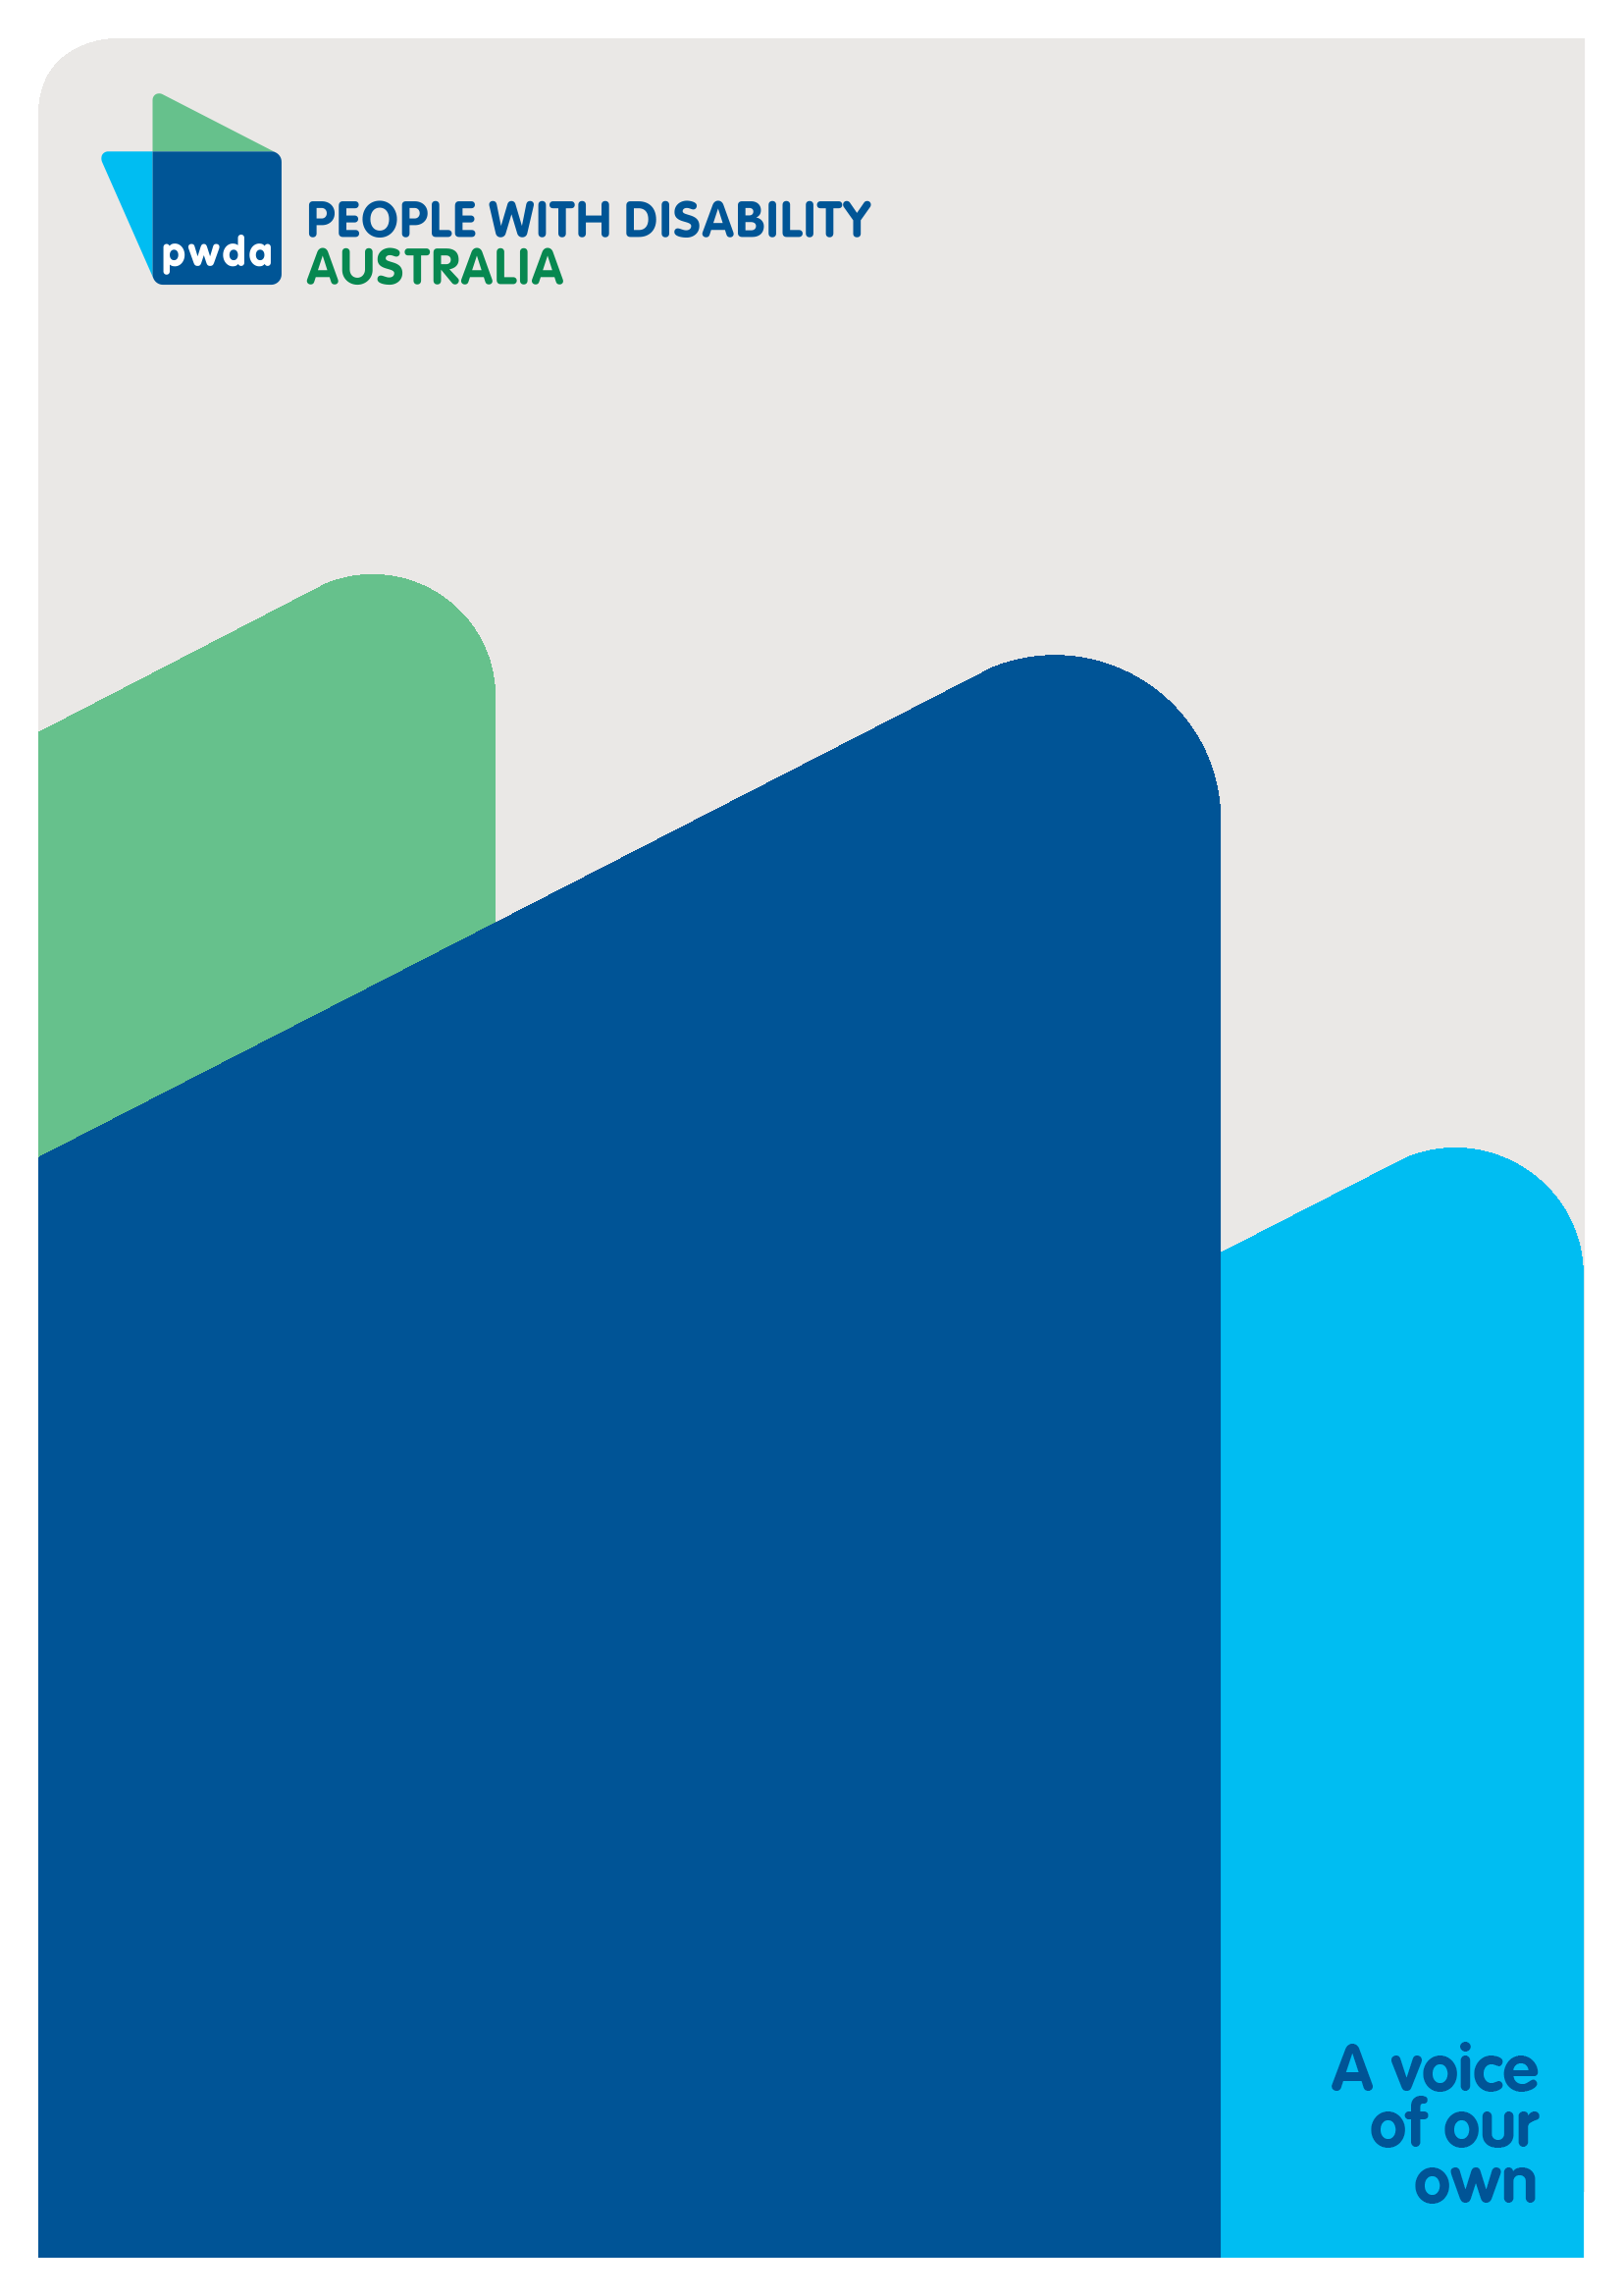
People with Disability Australia (PWDA) is a national disability rights and advocacy organisation made up of, and led by, people with disability.
For individual advocacy support contact PWDA between 9 am and 5 pm (AEST/AEDT) Monday to Friday via phone (toll free) on 1800 843 929 or via email at pwd@pwd.org.au
Submission contact
Clara Pirani
Senior Policy Officer
E: clarap@pwd.org.au

Parliament of Australia. National (2025) National Disability Insurance Scheme Amendment (Integrity and Safeguarding) Bill 2025. https://www.aph.gov.au/Parliamentary_Business/Bills_Legislation/Bills_Search_Results/Result?bId=s1478%20%20;
Ibid
Independent Review of the NDIS (2023) — Final Report. https://www.ndisreview.gov.au/sites/default/files/resource/download/working-together-ndis-review-final-report.pdf
NDIS Quality and Safeguards Commission — Media: Integrity and Safeguarding Bill to strengthen regulatory powers (28 Nov 2025) and Reform Hub. https://www.ndiscommission.gov.au/media-centre/integrity-and-safeguarding-bill-strengthen-regulatory-powers ; https://www.ndiscommission.gov.au/about-us/ndis-commission-reform-hub/ndis-act-rules-and-standards
Australian Government Department of Health, Disability and Ageing — Bill overview and reforms hub (Integrity & Safeguarding 2025). https://www.health.gov.au/resources/publications/ndis-amendment-integrity-and-safeguarding-bill-2025-overview
Independent Review of the NDIS (2023) — Final Report. https://www.ndisreview.gov.au/sites/default/files/resource/download/working-together-ndis-review-final-report.pdf
Royal Commission into Violence, Abuse, Neglect and Exploitation of People with Disability (2023) — Final Report. https://disability.royalcommission.gov.au/publications/final-report
Independent Review of the NDIS (2023) — Final Report. https://www.ndisreview.gov.au/sites/default/files/resource/download/working-together-ndis-review-final-report.pdf
Ibid
Royal Commission into the Robodebt Scheme — Report (7 July 2023). https://robodebt.royalcommission.gov.au/publications/report

