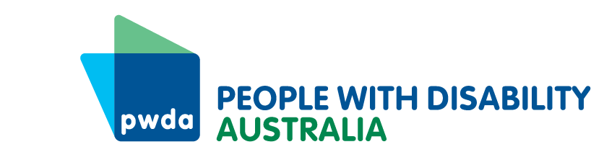
PO Box 666
Strawberry Hills
NSW 2012
+61 2 9370 3100
Toll free 1800 422 015
pwd@pwd.org.au
www.pwd.org.au
February 23, 2026.
The Treasury,
Langton Crescent,
Parkes ACT 2600.
NCCmodernisation@treasury.gov.au
To Whom it May Concern,
Re: Streamlining and modernising the National Construction Code
Thank you for the opportunity to respond to the Federal Department of Treasury’s call for ideas on Streamlining and Modernising of the National Construction Code (NCC). We are supported in this submission by Disability Advocacy NSW, who provide free individual advocacy support services in two thirds of NSW,
People With Disability Australia (PWDA) is Australia’s national peak disability organisation, representing the 1 in 6 Australians with disability. We are the leading disability rights advocacy and representative organisation and the only national cross-disability organisation representing the interests of people with all kinds of disability. We are a not-for-profit and non-government organisation, and our membership is comprised of people with disability and organisations primarily constituted by people with disability, including the PWDA Board and many members of our staff.
PWDA together with the Physical Disability Council of NSW (PDCN) co-chairs the Building Better Homes Campaign that calls for all states in Australia to implement the standards included in the National Construction Code of 2022. At this time NSW and Western Australia refuse to do this.
The lack of accessible housing is barrier to people with disability being able to access housing or support services when fleeing domestic and family violence. In October 2023 PWDA made a submission to the National Housing and Homelessness Plan Issues paper. In this response we detailed our experience supporting people with disability who had housing and homelessness as a primary or secondary issue. We also shared our experience from the Building Access project working with Domestic and Family Violence services in NSW to improve the accessibility of crisis accommodation for women and their children.
PWDA is funded under the National Disability Advocacy Program, Disability Advocacy Futures Program and Disability Housing Advocacy Service to provide advocacy support to people with disability. Twenty five percent of our total work across these, and all of our programs, relates to housing and homelessness. Building all new housing to NCC standards will increase the proportion of accessible housing, enabling people with disability and access needs to have greater choice over where they live.
PWDA supports in principle:
- Reforms to the Governance and process of the Australian Building Codes Board (ABCB),
- Reducing Complexity and the regulatory burden- especially by reducing state and territory variations in the application of the accessible design standards within the NCC
- Making the NCC more useable through making it easier to navigate and understand
- Removing barriers to the uptake of new materials, products and modern methods of construction (MMC) provided accessibility standards are maintained
It is critical to ensure that these reforms take the opportunity to uphold and enforce the application of the NCC and the Livable Housing Design Standard for housing accessibility, nation-wide.
Turning to the questions posed about the specifics of the proposed reforms. The current governance model requires that the 18 members of the ABCB include an independent Chair (appointed by the BMM), a representative from the Commonwealth, state and territory agencies responsible for building matters, up to 7 industry representatives (appointed by the BMM and only three of which are currently filled) and a representative of the Australian Local Government Association. There is currently no representation by end-users of housing, or people with disability.
PWDA recommends that the terms of reference for the ABCB be updated, to include a disability housing expert on this board with full voting rights, as the fundamental purpose of the standards is to ensure housing is fit for people to live in. This will help ensure that the needs and concerns of housing users are not forgotten or displaced by industry perspectives.
There is also a requirement in the Australia's Disability Strategy Targeted Action Plans Report 2025 – Inclusive Homes and Communities report for all governments over the next 3 years to work with people with disability to achieve the goal of people with disability live in inclusive, accessible, and well-designed homes and communities.
PWDA sees the role of the NCC as setting national minimum standards, and providing pathways to encourage the adoption of best practice. The inconsistent adoption and application of the NCC has led to over 25% (600 pages) of its 2000 pages being dedicate to state and territory variations. This unnecessary complexity could be avoided through consistent application of the standards nation-wide.
PWDA supports making the NCC easier to use and understand. We support proposals to “…use AI to improve useability of the 3-volume 2000-page NCC to assist tradies, small businesses and households.” We are concerned that elements of the standards or necessary references remain behind paywalls, and this should immediately be rectified.
PWDA also recommends that the modernisation of the NCC, and the use of MCC, also consider the need for standards to include the increasing need for fire and flood safety for those sheltering in place and evacuating from their homes. Members report difficulties evacuating when their single access point is cut off in an emergency situation.
If you need any further information, please contact Bastien Wallace at bastienw@pwd.org.au
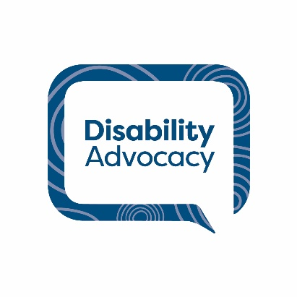
Yours sincerely
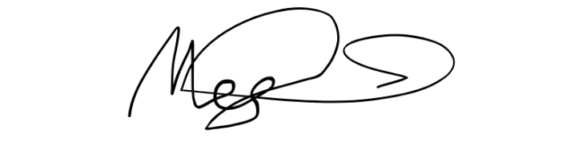
Megan Spindler-Smith
Acting CEO
People with Disability Australia

Streamlining and Modernising the National Construction Code: Discussion paper p 6 accessed 19 January 2026, https://consult.treasury.gov.au/c2025-722616
Australia's Disability Strategy Targeted Action Plans Report 2025 – Inclusive Homes and Communities last accessed 20/1/2026, https://www.disabilitygateway.gov.au/sites/default/files/documents/2025-12/Targeted_Action_Plans_IHC_Summary_Report_2025.docx p 3
Streamlining and Modernising the National Construction Code: Discussion paper p 10 accessed 19 January 2026, https://consult.treasury.gov.au/c2025-722616
Property Australia, AI and building reforms aim to tackle housing crisis https://www.propertycouncil.com.au/property-australia/ai-and-building-reforms-aim-to-tackle-housing-crisis

