Submission on the NDIS Rules: New Framework Planning

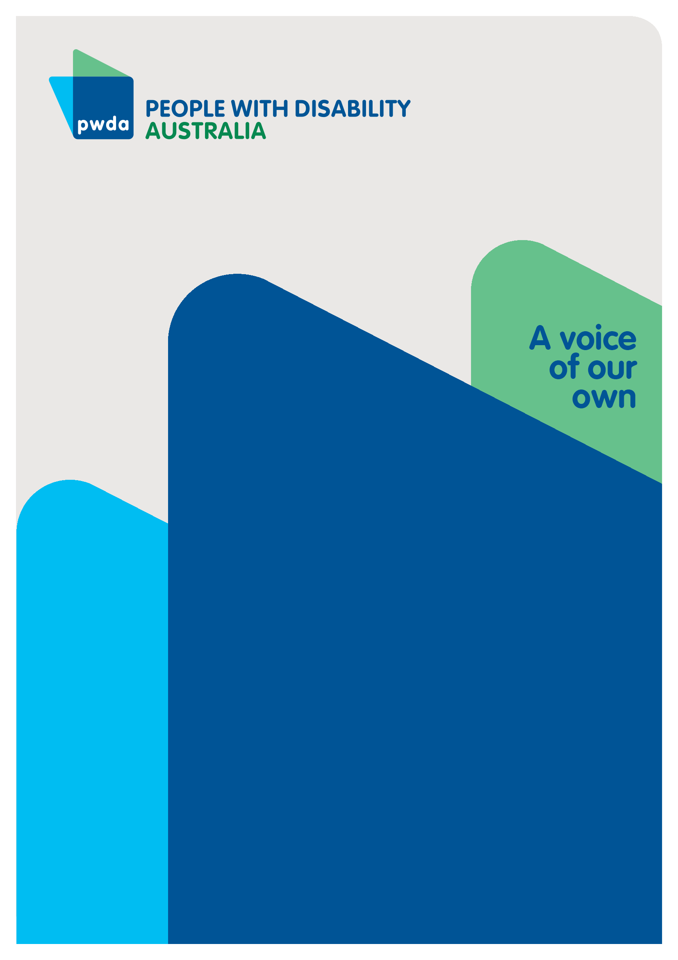
March
2026

Copyright information
Submission to the NDIS Rules: New Framework Planning
First published in 2026 by People with Disability Australia Ltd.
Suite 10.01| Centennial Plaza | Level 10, 300 Elizabeth Street | Surry Hills NSW 2010
Email: pwd@pwd.org.au
Phone: 1800 422 015
URL: www.pwd.org.au
Typeset in Arial 12 and 14 pt and VAG Rounded 26 pt
© People with Disability Australia Ltd. 2026
The moral rights of the authors have been asserted
National Library of Australia Cataloguing-in-Publication data:
Creator(s): | People with Disability Australia
Title: | Submission to the NDIS Rules: New Framework Planning
All rights reserved. Except as permitted with the Australian Copyright Act 1968 (for example, a fair dealing for the purposes of study, research, criticism or review), no part of this book may be reproduced, stored in a retrieval system, communication or transmitted in any form or by any means without prior written permission. All inquiries should be made to the publisher at the address above.
Suggested citation:
People with Disability Australia; Submission to the NDIS Rules: New Framework Planning, March 2026.

About PWDA
People with Disability Australia (PWDA) is a national disability rights and advocacy organisation made up of, and led by, people with disability.
We have a vision of a socially just, accessible and inclusive community in which the contribution, potential and diversity of people with disability are not only recognised and respected but also celebrated.
PWDA was established in 1981, during the International Year of Disabled Persons.
We are a peak, non-profit, non-government organisation that represents the interests of people with all kinds of disability.
We also represent people with disability at the United Nations, particularly in relation to the United Nations Convention on the Rights of Persons with Disabilities (CRPD).
Our work is grounded in a human rights framework that recognises the CRPD and related mechanisms as fundamental tools for advancing the rights of people with disability.
PWDA is a member of Disabled People’s Organisations Australia (DPO Australia), along with the First People’s Disability Network, National Ethnic Disability Alliance and Women with Disabilities Australia.
DPOs collectively form a disability rights movement that places people with disability at the centre of decision-making in all aspects of our lives.
‘Nothing About Us, Without Us’ is the motto of Disabled Peoples’ International.

Table of Contents
Submission to the NDIS Rules: New Framework Planning 1
Copyright Information 2
About PWDA 3
Introduction 4
Summary of Recommendations 8
Discussion 12
The consultation process 12
Notice of Impairments 14
Notice to have a New Framework Plan 16
Support Needs Assessments 17
Replacement Support Needs Assessments 21
Reasonable and Necessary Budgets 23
Stated Supports 24
Plan Variations 25
NDIS Supports 27
Funding Periods 28
The Appeals Process 29
Conclusion 31

Introduction
PWDA welcomes the opportunity to respond to the NDIS Rules: Public Consultation on New Framework Planning (NFP). This consultation is critically important as it directly affects the supports many people rely on every day to live, work and participate in community life and the Rules determine every aspect of participants’ experiences of the NDIS.
Far-reaching changes like this require time, support and accessible information for people with disability to understand what is being proposed and to respond in meaningful ways.
The Australian Government’s NDIS new framework planning: what we heard summary report stated people said communication regarding changes to the NDIS must be clear, timely and meet different communication needs.
Survey respondents said they felt that consultation processes were not transparent and felt tokenistic. They felt engagement with the disability community is limited and some decisions are made before consulting. They asked for clear information about how the NDIS rules are used.
People were also worried about moving to new framework plans before foundational supports are ready, and asked for a slow and supported change, with trauma informed communication.
Despite these findings, the Australian Government released a large volume of consultation materials on January 23, 2026, less than five months prior to the first group of participants transitioning to the new framework.
The consultation materials and briefings with the Department of Health, Disability and Ageing (DHDA) contain significant gaps in information, for example, no details about potential changes to the budget methodology, no updates on the NDIS Support rule and a lack of clarity about how I-CAN based tools will work in practice, replacement needs assessments and plan variations.
PWDA recognises the significant complexity and challenges involved in delivering NDIS reform, however, codesign and consultation cannot be considered genuine or effective unless the Government provides the disability community with full and timely access to all relevant information.
PWDA has consistently called for disability-affirming, trauma-informed and community-centred approaches to NDIS communication and consultation. We remain deeply concerned that these principles are not always reflected in how major changes are developed and announced.
On January 23, 2026, PWDA released a NDIS New Framework Planning member and community consultation survey to understand community views about the NFP consultation process and the proposed changes to NDIS Rules. The survey was sent out the same day the Government released the consultation materials, to ensure PWDA’s response would meet the consultation deadlines and incorporate the information available at the time.
We received a total of 213 responses. Survey findings indicate confusion and distress within the disability community about the design and implementation of the proposed NDIS New Planning Framework with 63% of respondents saying the consultation documents did not provide them with enough time to be ready for the changes and 30% stating they were unsure.
Only 10% of respondents felt the NDIA and providers would be ready to implement these changes within the proposed timelines.
"The documents felt unclear and potentially contradictory"
"To fully understand the proposed changes, clearer information is needed about how unresolved or disputed impairments will be handled before a participant transitions to a new framework plan. The documents do not explain whether existing omissions or errors in impairment recognition will be corrected first or carried forward into the new system.”
While respondents recognise that reform to planning may be necessary, they consistently express concern that the proposed model risks undermining participant choice and control, weakening independent review safeguards, and increasing reliance on automation.
Respondents report that consultation materials lack sufficient operational detail to assess impact and risk. We echo this concern, as any consultation based on limited detail and acknowledged gaps in information has the potential to become irrelevant or provide ineffective feedback that becomes out of date once further specific information and guidance becomes available.
A deeply concerning theme across responses is the psychological impact of proposed reforms, particularly the way changes were communicated and perceived instability in essential supports, due to forthcoming changes.
Respondents describe panic, severe anxiety, trauma and feeling unsafe as participants, and experiences of suicidal ideation linked to planning instability and funding uncertainty.
PWDA’s submission and recommendations are based on responses to our survey and the limited information available in the consultation materials and from the DHDA’s briefings with DROs. We may need to update our recommendations when the Government releases further, critical information regarding proposed changes under the NFP.
This submission addresses the concerns of our members and the disability community, and strives to assist the Australian Government to ensure that changes to NDIS Rules under the New Framework Planning will:
- protect participant rights and safety
- safeguard choice and control
- guarantee access to essential supports
- hold the Scheme to its legislative obligations
- and will have a strong base in human rights and the UN Convention on the Rights of Persons with Disabilities (UNCRPD).

Summary of Recommendations
Recommendation 1 - PWDA urges the Australian Government to release all outstanding information and details of the current state of Rule development which is essential to understanding the proposed NFP. Given that the first group of participants is expected to transition to the new framework in less than four months, withholding this information undermines the intent and integrity of the consultation process.

Recommendation 2 - Provide DROs with access to exposure drafts of all relevant NDIS Rules and Instruments to ensure genuine codesign and adjust the timelines to allow for informed consultation.

Recommendation 3 - Regulate CEO “own initiative” powers by introducing mandatory safeguards, independent verification, and procedural fairness requirements.
Recommendation 4 - Address structural power imbalance by aligning participant and NDIA constraints and embedding independent oversight.
Recommendation 5 - Require the Notice of Impairments to Include a clear explanation of the specific diagnoses or conditions under each impairment category and clarify how interacting disabilities will be assessed.
Recommendation 6 - Establish and publish a minimum notice period for transition to New Framework Plans.

Recommendation 7 - Provide clear, early, and publicly available criteria for inclusion in Group 1 which should only include people aged above 18 with defined lower complexity needs, in geographical areas with adequate providers and services and ensuring equity for remote and First Nations participants.

Recommendation 8 - Ensure people with complex needs are given the time and supported decision-making supports to ensure co-design.

Recommendation 9 - Support needs assessments must be led or meaningfully informed by qualified allied health professionals, incorporate participant-chosen evidence, and operate within a rights-based, trauma-informed framework.

Recommendation 10 - People must be able to review the draft of the support needs assessment before it is finalised and submitted. This ensures there is the opportunity to correct any misunderstandings that could result in delayed access to critical supports.

Recommendation 11 - Publish clear guidance on how I-CAN 6 scores translate into funding to ensure I-CAN 6 scores are not used as de facto funding caps. Develop a public explanation of the scoring-to-funding logic, so participants can understand how their assessment leads to specific budget decisions.

Recommendation 12 - Strengthen procedural fairness by ensuring human review and transparent decision-making. Every decision informed by I-CAN 6 undergoes documented human reasoning, not just automated scoring — particularly since the support needs assessment report must inform budgets under new rules.

Recommendation 13 - Clearly define the role, limits, and safeguards surrounding the use of I-CAN 6, the personal and environmental circumstances questionnaire and the targeted assessment, if required.
Recommendation 14 - Publish a simple, participant-focused guide to clarify the roles of the NDIA and the NDIS Quality and Safeguards Commission.

Recommendation 15 - Guarantee accessible pathways for replacement assessments and meaningful review where assessments are flawed or disputed.

Recommendation 16 - Clearly define access, timeframes, and triggers for replacement assessments and provide participants with clear, transparent reasons why their request for a replacement assessment was denied.

Recommendation 17 - Strengthen replacement assessments by requiring additional safeguards beyond re-use of I-CAN 6.

Recommendation 18 - Ensure replacement assessments function as a genuine remedy, not a procedural formality.

Recommendation 19 - Make reasonable and necessary budget-setting transparent, participant-facing, and outcomes-focused.

Recommendation 20 - Ensure budgets are genuinely individualised and informed by participant-chosen evidence and incorporate flexibility to meet individuals’ needs, real-world costs and lived experience.
Recommendation 21 - Limit the use of stated supports and require a clear, rights-based justification.

Recommendation 22 - Strengthen transparency, participation, and review rights in decisions to apply stated supports.

Recommendation 23 - Amend the rules/guidance so that plan variations are the default response to most changes in circumstances unless the NDIA can clearly justify why a full needs assessment (or reassessment) is necessary.

Recommendation 24 - Add enforceable safeguards so NDIA discretion — especially CEO/Agency-initiated actions — can’t be exercised in ways that undermine participant rights. This includes mandatory notice, reasons, and strengthened review protections whenever the NDIA refuses a variation and instead directs a participant to a needs assessment.

Recommendation 25 - Re-embed person-centred decision-making within the current list-based framework to ensure participant choice and control.

Recommendation 26 - If the lists are retained, they must be significantly reformed to ensure they are broad enough to accommodate diverse disability-related needs, developed transparently and applied consistently; and designed with recognition of lived experience and intersectional disadvantage.

Recommendation 27 - PWDA recommends that the Australian Government undertake and publish a formal assessment of the compatibility of the NDIS support lists and replacement rule with Australia’s obligations under the UNCRPD, particularly Articles 3(a), 19, 20, 24, 28 and 30
Recommendation 28 - Make longer funding periods the default, with shorter periods used only as a last resort or at participant’s request.
Recommendation 29 - Introduce stronger safeguards and limits on CEO discretion.
Recommendation 30 - Strengthen review and variation rights for funding periods.
Recommendation 31 - Publicly disclose current Agency proposals on where ADM or AI will be used in New Framework Planning – including in the budget allocation process – how it operates, the datasets it relies on, the degree of human oversight and capacity for positive intervention.
Recommendation 32 - Publish any legal advice about the reviewability of new framework plans at the Tribunal and ensure all aspects of the NFP rules are explainable, can incorporate all relevant information, and that the plan budget is capable of being meaningfully challenged at internal and external review.

Discussion

The consultation process
The application of NDIS Rules under the NFP will govern and affect every aspect of a participant’s experience, and any reforms must therefore be approached with care, clarity and genuine engagement.
For people with disability to meaningfully respond to reforms of this scale, they must be given adequate time, tailored support and accessible information that clearly explains what is being proposed and how it may affect them. This includes thoughtful planning regarding when and how information is released, the format of consultation materials to ensure they are accessible, and the level of support available to communities to help them engage.
PWDA has consistently advocated for disability-affirming, trauma-informed and community centred approaches to NDIS communication and consultation. We remain deeply concerned that these principles continue to be inconsistently applied to major announcements and reform processes.
The Australian Government’s NDIS new framework planning: what we heard report confirmed that people want communication that is clear, timely and responsive to diverse communication needs. Many community members reported that consultation processes often felt opaque or tokenistic, with engagement occurring late in the process and key decisions appearing predetermined. Participants also expressed a desire for clear information about how the NDIS Rules operate and are applied.
The NFP consultation materials, the method in which they were released and the corresponding deadlines for responses failed to meet any of the community’s previously stated concerns about the way changes to the NDIS are communicated.
The Government only provided an Easy Read version of the discussion paper, with no Easy Read versions of the fact sheets and explanatory documents and all the materials failed to provide critical information required to inform genuine feedback.
For example, no details were provided on:
- the budget methodology
- how I-CAN based tools will work in practice, weighting of tools, including interaction with other decision-making tools.
- the NDIS Supports permanent rule
- review rights
- replacement needs assessments
- and plan variations.
The consultation materials were released on Friday January 23, the day prior to a public holiday Monday, with the first briefing meeting with the DHDA taking place one day later, on Tuesday. This timing denied DROs the opportunity to distil and circulate the information in an accessible format and gather feedback and prepare questions for the first briefing. Many participants rely on supported decision-making, communication supports and accessible materials to safely and successfully engage in the consultation process. The NFP consultation materials were released at a time when many participants had limited access to the support workers, advocates and clinicians they rely on, denying them the opportunity to participate in the consultation.
Recommendation 1 - PWDA urges the Australian Government to release all outstanding information and details of the current state of Rule development which is essential to understanding the proposed NFP. Given that the first group of participants is expected to transition to the new framework in less than four months, withholding this information undermines the intent and integrity of the consultation process.
Recommendation 2 - Provide DROs with access to exposure drafts of all relevant NDIS Rules and Instruments to ensure genuine codesign and adjust the timelines to allow for informed consultation.

Notice of Impairments
PWDA welcomes the decision to provide every participant with a Notice of Impairments and is pleased that the consultation materials confirm that decisions to vary or not vary a notice are reviewable decisions under s99 and participants retain access to internal review and external merits review.
Despite those improvements, PWDA remains concerned about the concentration of unilateral power in the CEO, particularly powers exercised:
- Without participant initiation
- Without mandatory procedural steps
- Without independent oversight
Under the NFP, the Instrument dealing with the issuing and variation of Notices of Impairment given to participants under section 32BA:
- Explicitly authorises CEO-initiated variation
- Makes that power optional (“allows them to do so”)
- Ties it only to the CEO being “satisfied” a notice is incorrect
While the consultation materials describe Notices of Impairments as administrative clarity tools, they do not exclude their use in eligibility reassessment or access decisions.
In fact, it explicitly lists eligibility reassessments, support needs assessments and new or re-interpreted impairment information as triggers for CEO-initiated variation.
Another concern is the practical application of the Notice of Impairment, which only lists broad impairment categories (e.g., cognitive, physical, psychosocial). It does not identify the person’s actual diagnoses or specific conditions, even though the NDIA relies on detailed diagnostic information to understand a participant’s functional needs and determine appropriate funding.
If the NDIA intends to use the Notice of Impairments for decision-making, yet the Notice only contains broad categories rather than the participant’s actual diagnoses, then the Notice becomes too vague to meaningfully assist participants — but still powerful enough to limit what the NDIA believes they need.
Without making assumptions, if support needs based on functional requirements —rather than diagnosis-specific impairment information — is intended to be the way forward, this needs to be stated explicitly. This is particularly important given that the legislation now explicitly prioritises impairment over disability as the basis for access and planning. Clearly articulating how functional need will be assessed, and how it will interact with broad impairment categories, is essential to ensure the Notice of Impairment does not unintentionally restrict participant rights or reduce needed supports.
Some participants may have multiple diagnoses within the same broad impairment category — such as a spinal injury and a connective tissue disorder — yet each diagnosis results in distinct support needs. When only one diagnosis is recognised in the Notice of Impairments, participants can be left arguing for essential supports, as seen in cases where people waited many months for their impairment information to be updated. This challenge highlights the need to clarify how interacting disabilities will be captured within the support needs assessments.

Recommendation 3 - Regulate CEO “own-initiative” powers by introducing mandatory safeguards, independent verification, and procedural fairness requirements.
Recommendation 4 - Address structural power imbalance by aligning participant and NDIA constraints and embedding independent oversight.
Recommendation 5 - Require the Notice of Impairments to include a clear explanation of the specific diagnoses or conditions under each impairment category and clarify how interacting disabilities will be assessed.

Notice to have a New Framework Plan
PWDA recognises that the move to New Framework Plans represents a significant structural change to NDIS planning and welcomes commitments to advance notice and staged implementation. We welcome assurances provided by the DHDA during briefings that people with high and complex needs will be excluded from Group 1.
However, PWDA remains concerned that the DHDA’s explanatory documents lack the clarity and certainty required to ensure participants feel informed, safe, and able to prepare for the proposed changes.
The DHDA’s assurances that participants “will know well before it happens” are not supported by any defined minimum notice period, leaving participants uncertain about when and how the changes will affect them. PWDA is also concerned about the lack of transparency regarding who will be included in Group 1 of the rollout from mid-2026, especially given indications that some young people over 16 may be included while others may be excluded on an as-yet-undefined basis. This uncertainty risks causing unnecessary anxiety and distress, particularly for young people and families already navigating complex transition points.
Major reforms to planning must be implemented in a way that is predictable, transparent, and centred on participant wellbeing — not administrative convenience — to avoid a two-tiered system operating during the transition period that will fuel confusion among participants, carers and providers.
PWDA recommends that the Department commit to, and publicly specify, a clear minimum notice period that all participants will receive before being transitioned to a New Framework Plan. This notice should be timely, accessible, and should clearly explain what is changing, when it will occur, and what rights participants have during the transition.
PWDA recommends that the Department urgently publish the criteria for inclusion in Group 1 of the New Framework Planning rollout, including how age-based cohorts will be determined and which young people aged 16–18 will be included or excluded.
While participants with high or complex needs will be excluded, a clear, operational definition of lower complexity needs, developed in consultation with DROs is essential to ensure an equitable transition from current NDIS planning processes to the NFP. Without a clear definition, lower complexity will be interpreted differently, causing inconsistent planning pathways and potential inequity and disadvantage for certain cohorts.
Decisions about cohort inclusion must not be left to opaque administrative processes. Clear criteria are essential to prevent confusion, distress, and inequitable treatment, particularly for young people and families navigating education, health, and life-stage transitions.
Recommendation 6 - Establish and publish a minimum notice period for transition to New Framework Plans
Recommendation 7 - Provide clear, early, and publicly available criteria for inclusion in Group 1 which should only include people aged above 18 with defined lower complexity needs, in geographical areas with adequate providers and services and ensuring equity for remote and First Nations participants.

Recommendation 8 - Ensure people with complex support needs are given the time and supported decision-making supports to ensure co-design and adequate preparation to transition to the new framework.

Support Needs Assessments
The Discussion Paper and relevant Fact Sheet provided in the NFP consultation materials provide insufficient detail regarding the new Support Needs Assessment Rule.
PWDA reiterates its long-standing concerns about the NDIA using assessors who are not the participant’s treating or qualified allied health professionals to determine support needs.
Assessors who are not appropriately qualified allied health professionals, or who lack experience with specific disabilities, may fail to understand complex, fluctuating or invisible impairments.
Treating allied health professionals bring long-term knowledge of a person’s functional capacity, health history, trauma, and environmental barriers. A one-off assessment by an unfamiliar assessor cannot capture this depth, particularly for people with episodic conditions, psychosocial disability, or complex communication needs.
We acknowledge assessments by allied health professionals will still be used in some instances as part of the targeted assessment processes. However, removing or sidelining participant-chosen allied health evidence as part of all support needs assessments shifts power away from people with disability and towards the NDIA. This is inconsistent with the NDIS’s person-centred and rights-based foundations, and risks participants feeling assessed to rather than with the system.
Assessors employed or contracted by the NDIA may be perceived — rightly or wrongly — as having an incentive to limit support needs to control scheme costs. Even the perception of bias undermines trust in the system and discourages open disclosure by participants.
While standardised tools like ICAN are evidence based, PWDA remains concerned they can become tick-box exercises if not applied by skilled clinicians with disability specific and person specific expertise. Concerns include:
- insufficient sensitivity to rare or complex disabilities
- difficulty capturing intersectional disadvantage (e.g. gender, culture, trauma)
- over-reliance on scoring to determine funding outcomes.
If a non-allied-health or unfamiliar assessor produces a flawed assessment, participants may have limited practical avenues to correct errors, particularly if external evidence is discounted or review rights are unclear. This raises serious concerns about procedural fairness.
PWDA is also concerned that if the I-CAN tool uses automated systems that translate participant responses into standardised packages, it may end up prioritising statistical patterns over individual needs. This could lead to unfair outcomes and government decisions that are difficult to explain clearly, transparently, and accountably.
The process could unintentionally reinforce stereotyping and harmful bias by grouping or profiling participants. This may also oversimplify people’s diverse lived experiences and environmental factors and ignore the impacts on intersectionality, while increasing experiences of marginalisation for those multiply-marginalised within the disability community.
The assessment’s standardised, self-reporting design also raises concerns about socio-economic and cultural bias. For example, it may be culturally inaccessible and/or assume that everyone has equal access to digital and literacy resources.
From the outset, the Government must guarantee that I-CAN has a strong base in human rights and the UNCRPD to create a process that can be monitored, audited, and improved over time to ensure transparency and accountability.
Respondents to PWDA’s member and community survey on the NFP consistently emphasised the importance of maintaining choice and control and genuinely individualised planning. Many describe the proposed framework as shifting decision-making towards standardised processes, categories or cost controls.
“Assessing an unknown individual at a single point in time cannot compare to reports from clinicians and others with a long-standing relationship with the individual.”
“The lack of input of reports from GPs and persons who knows the needs of individuals. That participants will be treated as a number. The vagueness of what the assessment will contain and whether the assessor comes from a health or disability background and knowledge of day-to-day needs of participants as individuals."
"Choice and control and keeping in line with current plan and current recognised needs. When so much information has already been provided to NDIA, why do we have to keep answering the same questions, they already have this data"
Another PWDA survey into NDIS Support Needs Assessments conducted in November 2025 revealed widespread fear regarding the use of I-CAN.
- 85% of the 340 respondents said they have concerns about the introduction of a support needs tool based on the I-CAN assessment tool
- 91% of respondents expressed concerns about the new assessment process
Safeguards must be put in place to limit potential confusion and distress as participants transition to the NFP.

For example, while the formal roles of the NDIA or the NDIS Quality and Safety Commission will not change under the NFP, participants will interact more with NDIA-trained assessors during support-needs assessments, a major shift from past processes.
This may blur perceptions of who is responsible for service quality issues versus plan-related decisions.
Recommendation 9 - Support needs assessments must be led or meaningfully informed by qualified allied health professionals, incorporate participant-chosen evidence, and operate within a rights-based, trauma-informed framework — otherwise they risk causing harm and undermining trust in the NDIS.
Recommendation 10 - People must be able to review the draft of the support needs assessment before it is finalised and submitted and have access to supported decision making and/or individual advocacy. This ensures there is the opportunity to correct any misunderstandings that could result in delayed access to critical supports.

Recommendation 11 - Publish clear guidance on how I-CAN 6 scores translate into funding to ensure I-CAN 6 scores are not used as de facto funding caps. Develop a public explanation of the scoring-to-funding logic, so participants can understand how their assessment leads to specific budget decisions.

Recommendation 12 - Strengthen procedural fairness by ensuring human review and transparent decision-making. Every decision informed by I-CAN 6 undergoes documented human reasoning, not just automated scoring — particularly since the support needs assessment report must inform budgets under new rules.

Recommendation 13 - Clearly define the role, limits, and safeguards surrounding the use of I-CAN 6, the personal and environmental circumstances questionnaire and the targeted assessment, if required.
Recommendation 14 - Publish a simple, participant-focused guide to clarify the roles of the NDIA and the NDIS Quality and Safeguards Commission.

Replacement Support Needs Assessments
Under the NFP, if a participant believes the assessment did not capture their needs accurately, they can ask for a Replacement Support Needs Assessment (replacement assessment), but only before their plan is approved.
A replacement assessment:
- may increase, decrease, or not change the assessed support needs
- remains subject to the rules.
However, it is not yet clear in what circumstances, or within what timeframes, the NDIA would agree to conduct a replacement assessment. Although participants will continue to have the right to seek external review through the Administrative Review Tribunal, there is ongoing uncertainty about which elements of a plan will be reviewable. Therefore, it is essential that participants can access a replacement assessment in a broad range of circumstances, to ensure that deficiencies or errors in assessments can be effectively addressed. PWDA also calls on the NDIA to adopt an “if not, why not” approach by providing participants with clear, transparent reasons why their request for a replacement assessment was denied.
There is also no clarity on whether a replacement assessment would involve a different assessor, different methodology, or additional safeguards, even where the original assessment is alleged to be flawed. It is also unclear whether participant-chosen allied health evidence will be considered in a replacement assessment.
If replacement assessments use the same I-CAN based tool, PWDA’s concern is that:
- A replacement assessment could replicate the same structural or methodological problems as the original assessment.
- Without different assessors, additional evidence, or stronger procedural safeguards, a replacement assessment may not meaningfully remedy errors or deficiencies.
- The existence of external merits review rights does not compensate for the lack of a clear, accessible, and effective internal correction mechanism at the assessment stage.
Recommendation 15 - Guarantee accessible pathways for replacement assessments and meaningful review where assessments are flawed or disputed.

Recommendation 16 - Clearly define access, timeframes, and triggers for replacement assessments and provide participants with clear, transparent reasons why their request for a replacement assessment was denied.
Recommendation 17 - Strengthen replacement assessments by requiring additional safeguards beyond re-use of I-CAN 6.

Recommendation 18 - Ensure replacement assessments function as a genuine remedy, not a procedural formality.

Reasonable and Necessary Budgets
PWDA appreciates that the budget process is multifaceted and complex, however it is deeply concerning that the NFP consultation materials and subsequent briefings with the DHDA provided no information about the new budget methodology.
Participants require clear, participant-facing explanations of how their overall budgets are determined or how “reasonable and necessary” criteria are applied in practice.
Currently, the application of “reasonable and necessary” criteria is highly inconsistent across participants, regions, disabilities, and planners.
Similar support needs can result in very different budgets, creating a sense of unfairness and reinforcing a “postcode lottery” effect. This inconsistency has been a key driver of disputes and appeals.
PWDA urges the NDIA to provide clear, accessible explanations to participants about how their overall budgets are determined, including how reasonable and necessary criteria have been applied to their individual circumstances. Budget decisions should be framed around achieving participant goals, independence, and participation over the life of the plan, rather than opaque internal reasoning. Transparency is essential to reduce distress, disputes, and adversarial planning experiences.
Explicit safeguards are required to ensure that value-for-money considerations, standardised assessment tools, and new budget methodology do not function as implicit funding caps. Budgets must reflect real-world support costs and long-term outcomes, including crisis prevention and reduced reliance on other systems, rather than prioritising short-term administrative efficiency or scheme cost control.
As one respondent in PWDA’s NFP consultation survey said:

"To fully understand the proposed changes, clearer information is needed about:…. how choice and control are preserved if budgets are primarily generated through a standardised assessment and calculation method, rather than participant-identified needs and goals.”

Recommendation 19 - Make reasonable and necessary budget-setting transparent, participant-facing, and outcomes-focused.

Recommendation 20 - Ensure budgets are genuinely individualised and informed by participant-chosen evidence and incorporate flexibility to meet individuals’ needs, real-world costs and lived experience.

Stated supports
The list of supports categorised as stated supports, in extensive comprising broad categories, including:
- assistive technology assets
- assistance animals
- support coordination
- short term respite,
- behaviour support
- plan management
- specialist disability accommodation
- home modifications
- medium-term accommodation
- private vehicle transport,
- and residential aged care.
Stated supports should be limited to situations where there is a clear and documented safeguard rationale, the restriction is necessary to address a specific risk, less restrictive alternatives have been considered and ruled out, and the participant has been meaningfully involved in the decision.
Recommendation 21 - Limit the use of stated supports and require a clear, rights-based justification.

Recommendation 22 - Strengthen transparency, participation, and review rights in decisions to apply stated supports.

Plan variations
The DHDA has yet to confirm all the circumstances under which the NDIA can vary a participant’s plan without needing to complete a new needs assessment.
However, the NFP consultation materials on plan variations state that “the rules help participants know when the NDIA can vary a participant’s plan.”
From PWDA’s perspective, this still frames plan variations as something the NDIA allows, rather than a participant right that the NDIA must facilitate.
The consultation materials suggest that plan variation rules will set out circumstances when participants can vary their plans without undergoing a new needs assessment, for example:
- providing emergency or crisis funding due to significant change in support needs for a short period of time.
- adding funding for repairs, replacement or maintenance of Assistive Technology
- changes to a participant’s employment supports due to minor changes to participant work hours
- changes in aged care needs for younger people in residential aged care.
Broad discretion by the NDIA and narrow variation criteria can push people into assessments unnecessarily and create fear about requesting changes.
If the participant requests a plan change, PWDA encourages the NDIA to first consider a variation, and only require a new needs assessment where it is proportionate and necessary (e.g., sustained, structural change in supports).
Participants must be able to submit evidence from their own treating clinicians/therapists instead of being forced into a new assessment every time.
PWDA recommends the NDIA publish criteria distinguishing “variation appropriate” vs “assessment required,” with plain-English examples. If NDIA refuses a variation and requires a needs assessment, it must provide:
- the specific evidence gap it believes exists,
- why existing evidence (including participant’s own clinicians) is insufficient,
- and why a variation cannot meet the need.
Recommendation 23 - Amend the rules/guidance so that plan variations are the default response to most changes in circumstances unless the NDIA can clearly justify why a full needs assessment (or reassessment) is necessary.
Recommendation 24 - Add enforceable safeguards so NDIA discretion — especially CEO/Agency-initiated actions — can’t be exercised in ways that undermine participant rights. This includes mandatory notice, reasons, and strengthened review protections whenever the NDIA refuses a variation and instead directs a participant to a needs assessment.

NDIS Supports
The NFP consultation materials provided no further information about the NDIS Support Rule under the NFP and no update on the transitional in and out lists or the permanent rule.
PWDA continues to call for the lists to be replaced by clear guidance issued by the NDIA for each category of support and maintaining the current reasonable and necessary test for deciding on what supports the NDIS will provide.
In our submission on the NDIS Support Rule PWDA also questioned whether the restrictive lists, and the narrow interpretation of supports they produce, may breach the spirit of the UNCRPD, especially where they exclude supports essential to autonomy, communication, daily functioning and participation including:
- Article 19 - the right of people with disability to live independently and be included in the community with the supports they need
- Article 3(a) - General principle - respect for inherent dignity, individual autonomy including the freedom to make one's own choices and independence of persons.
- Article 20 - personal mobility
- Article 24 – inclusive education
- Article 28 - adequate standard of living and social protection
- Article 30 - participation in cultural life, recreation, leisure, and sport.
Recommendation 25 - Re-embed person-centred decision-making within the current list-based framework to ensure participant choice and control.

Recommendation 26 - If the lists are retained, they must be significantly reformed to ensure they are broad enough to accommodate diverse disability-related needs, developed transparently and applied consistently; and designed with recognition of lived experience and intersectional disadvantage.

Recommendation 27 - PWDA recommends that the Australian Government undertake and publish a formal assessment of the compatibility of the NDIS support lists and replacement rule with Australia’s obligations under the UNCRPD, particularly Articles 3(a), 19, 20, 24, 28 and 30.

Funding periods
PWDA acknowledges that the DHDA’s consultation materials improve transparency around how funding periods will be set under new framework plans and welcomes the recognition that funding periods should be individualised, informed by participant preferences, and responsive to fluctuating or episodic support needs.
However, short funding intervals (for example, quarterly or monthly releases), should not be the standard approach. NDIS funding periods should be longer, flexible, and individually determined — not short, rigid, or imposed by default, as outlined in PWDA's previous joint statement on NDIS funding periods.
A recent NDIS Insights 2025-2026 report by the Justice and Equity Centre reveals reports from within the disability community suggest 3-month funding periods are being applied as the ‘default’ option for participants. According to the NDIA, 105,694 NDIS participants had 3-month funding periods applied to their plans between 19 May and 28 November 2025.
Recommendation 28 - Rules should be amended to establish a clear presumption in favour of longer funding periods as the default, with shorter funding periods used only as a last resort or at the participant’s request.
Recommendation 29 - Introduce stronger safeguards and limits on CEO discretion.
Recommendation 30 - Strengthen review and variation rights for funding periods.

The Appeals process
The Government has yet to respond to media reports stating that under NFP, if NDIS participants appeal, the Administrative Review Tribunal (ART) will no longer have the authority to alter a person’s plan or reinstate funding but will only be able to send the plan back to be recalculated using the same computer-based tool.
PWDA and other DROs publicly released our serious concerns about the use of automation in NFP, compounded by changes to review pathways that may restrict the grounds on which decisions can be challenged and limit the scope of the ART, which cannot vary a participant’s plan and can only trigger a reassessment by the original decision-maker.
This would significantly limit participants’ ability to correct errors or challenge flawed assumptions. At the same time, there is currently no clear guarantee that written evidence provided by participants will be considered in these processes.
Recommendation 31 - Publicly disclose current Agency proposals on where ADM or AI will be used in New Framework Planning – including in the budget allocation process – how it operates, the datasets it relies on, the degree of human oversight and capacity for positive intervention.
Recommendation 32 - Publish any legal advice about the reviewability of new framework plans at the ART and ensure all aspects of the NFP rules are explainable, can incorporate all relevant information, and that the plan budget is capable of being meaningfully challenged at internal and external review.

Conclusion
PWDA acknowledges the work the Australian Government has undertaken to progress NDIS reform and to begin developing the New Framework Planning model and we recognise the scale and complexity of this work.
However, PWDA remains deeply concerned about the limited detail provided in the consultation materials, the substantial gaps in operational information, and the constrained opportunities for meaningful engagement with the disability community.
The absence of clarity around critical elements — including budgeting methodology, assessment processes, transition sequencing, safeguards, and review mechanisms — has made it extremely difficult for participants, families, advocates and providers to fully understand the impacts of the proposed changes or offer informed feedback.
Codesign and consultation are reduced to a formality — not a genuine process — when the Government does not provide essential information in a timely and fully accessible manner.
For consultation to be genuine, informed and productive, the disability community must be provided with accessible and comprehensive information, open dialogue, and the opportunity to influence decisions before they are finalised. This is essential given the far-reaching impact that NDIS Rules and the NFP will have on people’s lives, wellbeing, safety and independence.
PWDA is ready to actively work closely with the Government through a true partnership approach — one that is grounded in codesign, shared accountability, lived experience leadership, and full respect for the rights and autonomy of people with disability.
By working together, we can ensure that the NDIS reforms are not only workable in practice but also uphold the founding principles of choice and control, safeguard individual rights, and respond to the diverse and evolving needs of participants.
PWDA is committed to continuing this work and will remain an active, collaborative partner in the development of a stronger, more equitable and person-centred NDIS.

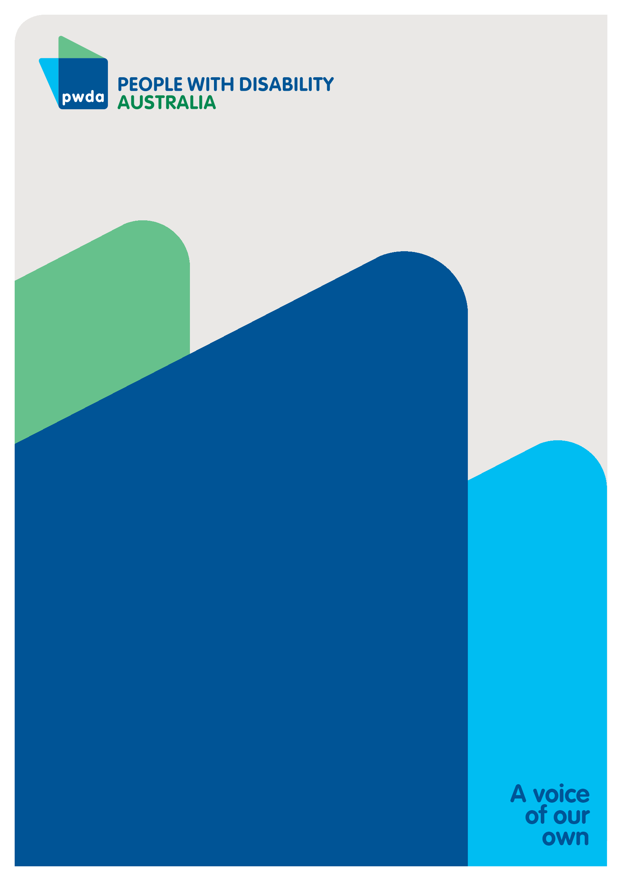

People with Disability Australia (PWDA) is a national disability rights and advocacy organisation made up of, and led by, people with disability.
For individual advocacy support contact PWDA between 9 am and 5 pm (AEST/AEDT) Monday to Friday via phone (toll free) on 1800 843 929 or via email at pwd@pwd.org.au
Submission contact
Clara Pirani
Senior Policy Officer
E: clarap@pwd.org.au

Victorian Council of Social Service. (2020). Social Services Issues Paper: NDIS access, eligibility and independent assessments. SUB_210222_VCOSS-issues-paper-on-NDIS-independent-assessments_FINAL.pdf
Women With Disabilities Australia. (2025). Rights-Based Needs Assessment Model. Final_WWDA-Statement-NeedsAssessments93.pdf
People with Disability Australia. Statement: NDIS Needs Assessment Tool I-CAN Version 6. https://pwd.org.au/pwda-statement-ndis-needs-assessment-tool-i-can-version-6/
Inclusion Australia. (2023) Background paper - Reasonable and necessary supports: NDIS Review Engagement Project. Reasonable and necessary supports
Ibid
People with Disability Australia. (2025). PWDA Response to Consultation on the NDIS Support Rule. https://pwd.org.au/pwda-response-to-consultation-on-the-ndis-support-rule/
Australian Human Rights Commission: United Convention on the Rights of Persons with Disabilities. United Nations Convention on the Rights of Persons with Disabilities (UNCRPD) | Australian Human Rights Commission
Justice and Equity Centre. (2026). NDIS Insights 2025-26. https://jec.org.au/publication/ndis-insights-2025-26/
The Guardian. (2025) NDIS changes may stop others getting help. https://www.theguardian.com/australia-news/2026/jan/15/ndis-support-plan-administrative-review-tribunal-appeal
People with Disability Australia. (2025). Statement calling for transparency regarding computer generated NDIS plans. https://pwd.org.au/disability-representative-organisations-call-for-transparency-on-computer-generated-ndis-plans/

