Submission on the Inquiry into the Integrity of the NDIS

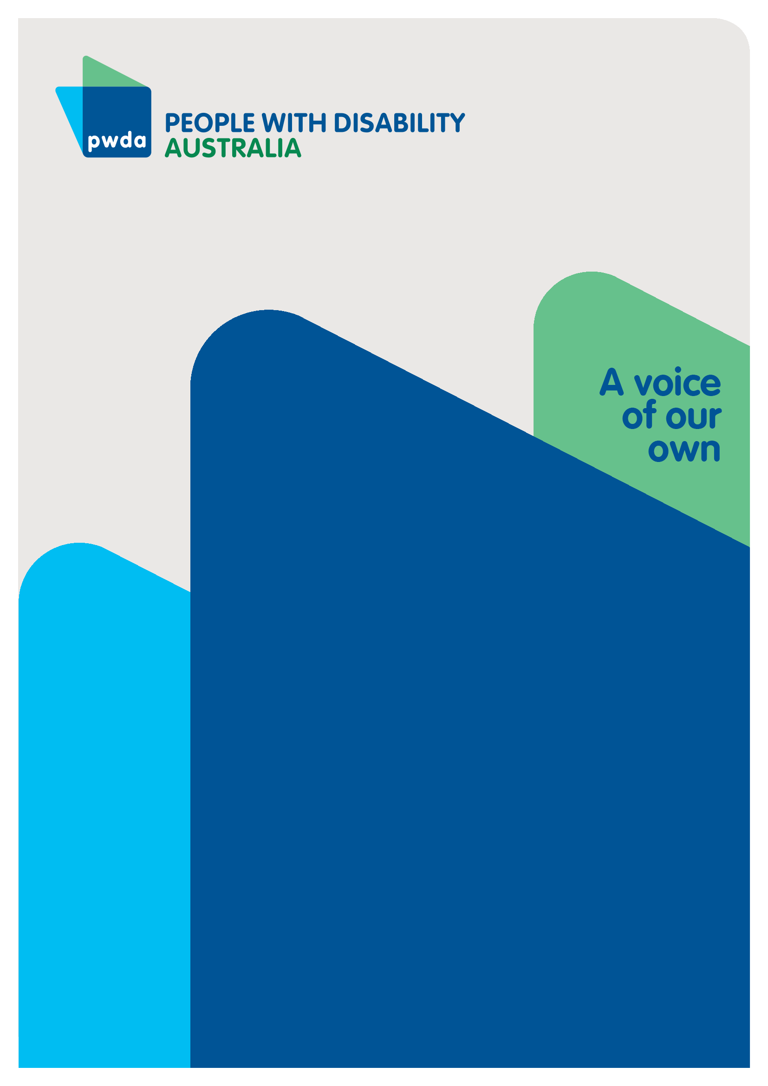
April
2026

Copyright information
Submission to the Inquiry into the Integrity of the NDIS.
First published in 2026 by People with Disability Australia Ltd.
Suite 10.01| Centennial Plaza | Level 10, 300 Elizabeth Street | Surry Hills NSW 2010
Email: pwd@pwd.org.au
Phone: 1800 422 015
URL: www.pwd.org.au
Typeset in Arial 12 and 14 pt and VAG Rounded 26 pt
© People with Disability Australia Ltd. 2026
The moral rights of the authors have been asserted
National Library of Australia Cataloguing-in-Publication data:
Creator(s): | People with Disability Australia
Title: | Submission to the Inquiry into the Integrity of the NDIS
All rights reserved. Except as permitted with the Australian Copyright Act 1968 (for example, a fair dealing for the purposes of study, research, criticism or review), no part of this book may be reproduced, stored in a retrieval system, communication or transmitted in any form or by any means without prior written permission. All inquiries should be made to the publisher at the address above.
Suggested citation:
People with Disability Australia; Submission to the Inquiry into the Integrity of the NDIS, April 2026.

About PWDA
People with Disability Australia (PWDA) is a national disability rights and advocacy organisation made up of, and led by, people with disability.
We have a vision of a socially just, accessible and inclusive community in which the contribution, potential and diversity of people with disability are not only recognised and respected but also celebrated.
PWDA was established in 1981, during the International Year of Disabled Persons.
We are a peak, non-profit, non-government organisation that represents the interests of people with all kinds of disability.
We also represent people with disability at the United Nations, particularly in relation to the United Nations Convention on the Rights of Persons with Disabilities (CRPD).
Our work is grounded in a human rights framework that recognises the CRPD and related mechanisms as fundamental tools for advancing the rights of people with disability.
PWDA is a member of Disabled People’s Organisations Australia (DPO Australia), along with the First People’s Disability Network, National Ethnic Disability Alliance and Women with Disabilities Australia.
DPOs collectively form a disability rights movement that places people with disability at the centre of decision-making in all aspects of our lives.
‘Nothing About Us, Without Us’ is the motto of Disabled Peoples’ International.

Introduction
People with Disability Australia (PWDA) welcomes the opportunity to contribute to the Joint Standing Committee on the Inquiry into the Integrity of the NDIS.
This submission responds to terms of reference (c) and (d), focusing on the effectiveness and adequacy of successive government policies to improve Scheme integrity and safeguard participants, and on legislative or other reforms required to strengthen NDIS integrity.
While PWDA supports strong integrity measures and robust safeguards, we are concerned that recent policy responses — including the NDIS Amendment (Integrity and Safeguarding) Bill 2025, passed by Parliament earlier this month — have focused heavily on compliance and enforcement without giving equal weight to participant rights, dignity, and supported decision-making.
Integrity reform cannot be achieved through legislation alone. There is significant work still required outside the scope of the Amendment Bill to address public narratives, implementation practices and systemic settings that risk undermining choice, control and safety for people with disability.

Summary of Recommendations
Recommendation 1 - Acknowledge that further integrity, safeguarding and trust-building work is required beyond the NDIS Amendment (Integrity and Safeguarding) Bill 2025 to ensure that participants feel safe exercising autonomy, making complaints or taking reasonable risks.
Recommendation 2 - Embed dignity of risk and supported decision-making as explicit legal duties within the NDIS Act and its implementation.

Recommendation 3 - Ensure integrity measures focus on unethical and unsafe provider practices, rather than framing people with disability as the source of risk.
Recommendation 4 - Address the damaging public narratives that conflate NDIS integrity with participant wrongdoing and safeguard participants from public vilification and harmful scrutiny of everyday, reasonable use of supports.
Recommendation 5 - Ensure compliance and integrity initiatives do not increase administrative burden in ways that reduce participant access to services and supports.
Recommendation 6 - Maintain strong safeguards against violence, abuse, neglect and exploitation, while ensuring expanded enforcement powers do not erode participant choice and control.
Recommendation 7 - Require that the Inquiry itself is co-designed with people with disability and structured around lived experience.
Recommendation 8 - Ensure the Inquiry strengthens, rather than undermines, trust in the NDIS and does not exacerbate fear or confusion arising from rapid and poorly communicated reforms.

Discussion

Effectiveness and adequacy of current integrity and safeguarding approaches (Terms of reference (c)
PWDA acknowledges that accountability, compliance and fraud prevention are essential to the long-term sustainability of the NDIS. Participants must be safe, public confidence must be maintained, and unethical conduct must be addressed decisively.
However, the effectiveness of successive integrity measures may be undermined by a narrow framing that prioritises provider compliance over safeguards for participants. This is reflected in the NDIS Amendment (Integrity and Safeguarding) Bill 2025, which introduced significant new regulatory and enforcement powers but failed to strengthen participant rights in parallel.
In our submission on the Bill and in evidence given to the Joint Standing Committee on the NDIS, PWDA specifically recommended that the Government:
“Insert explicit dignity of risk and supported decision-making principles and duties into the NDIS Act and co-design rules and guidance with people with disability.”
It is disappointing and concerning that these recommendations were not taken up.
The NDIS Review and the Disability Royal Commission emphasised supported decision‑making and dignity of risk as fundamental to safe, quality supports and ordinary lives.
In its Final Report, the Commission recommended embedding supported decision-making into guardianship and administration laws and practices, with the goal of progressively replacing substitute decision-making with supported approaches wherever possible.
The Commission also linked supported decision-making — including support to take risks — to Australia’s obligations under the UN Convention on the Rights of Persons with Disabilities (CRPD), particularly:
- Equal recognition before the law
- The right to exercise legal capacity with support
This necessarily includes the right to make decisions that involve risk, on an equal basis with others.
The significant new penalties introduced by the Amendment Bill are justified, however without any mechanism for lawful, participant-led risk-taking providers will increasingly refuse supports involving everyday risk (for example: beach access, sport, community living, innovative supports). This proportionately impacts participants with high and complex needs. Choice, control, flexibility, self-determination and dignity of risk will be reduced in practice.
The absence of explicit dignity of risk and supported decision-making provisions entrenches risk-averse practice and undermines the foundational NDIS principles of choice and control. Without these protections, integrity measures risk actively reducing participants’ ability to live ordinary lives and make decisions about their own supports and day to day lives.

The impact of damaging public narratives about NDIS fraud
PWDA is particularly concerned about the harmful public narrative that has developed around NDIS fraud and integrity. It is alarming that the public discourse increasingly positions people with disability as suspects rather than rights-holders.
While fraud certainly exists and must be addressed, the way integrity reform has been publicly framed has caused real harm. Media coverage and political commentary have too often implied that participants themselves are the problem, rather than acknowledging the significant damage caused by unethical, unsafe and exploitative provider practices.
PWDA is especially concerned about the risk that this Inquiry could further legitimise harmful scrutiny of participants’ everyday lives. Recent reporting, such as the Australian Financial Review story criticising NDIS participants for going to the movies or accessing haircuts, demonstrates exactly what must not happen as a result of integrity reform.
These examples reflect a profound misunderstanding of disability, support needs and inclusion. Everyday activities are not evidence of misuse — they are evidence of participation and ordinary life. Integrity reform that encourages surveillance of participants’ choices fundamentally contradicts the intent of the NDIS.
This framing is not only inaccurate; it undermines trust, fuels stigma and creates fear among participants about using their supports. Accountability systems that stigmatise the very people the NDIS exists to support cannot be considered equitable or effective.
Ensuring participants are not attacked, shamed or publicly judged must be a core consideration of this Inquiry.

Compliance, administration and access to supports
PWDA recognises the importance of compliance and oversight. However, compliance mechanisms must be proportionate and designed to avoid unintended consequences.
Participants are already navigating an increasingly complex and administratively burdensome system. Additional compliance requirements — particularly poorly communicated or rapidly implemented changes — risk reducing access to supports, delaying service delivery and driving providers out of the market, especially in thin or regional markets.
Integrity initiatives that reduce access to essential supports ultimately harm participants and undermine the Scheme’s intent. Effectiveness must be measured not only by enforcement activity, but by whether participants can continue to access safe, quality supports without fear or disruption.

Stronger safeguards - with participant rights at the centre
As outlined in PWDA’s submission on the NDIS Amendment (Integrity and Safeguarding) Bill 2025, we welcome stronger safeguards against violence, abuse, neglect and exploitation, and we strongly support a tougher penalty regime for providers who wilfully cause harm to participants’ physical, mental and financial wellbeing.
However, PWDA remains concerned that expanded administrative and enforcement powers, without corresponding participant safeguards and review rights, risk reducing choice and control in practice. Integrity measures must not create an environment where participants feel unsafe exercising autonomy, making complaints or taking reasonable risks.
The integrity of the NDIS cannot be measured solely by increased compliance activity. True integrity will be achieved when the Scheme consistently delivers safe, high-quality supports that uphold participants’ rights, dignity and control. Strengthening participant-centred safeguards is not peripheral to this Inquiry — it is fundamental to its success.

Legislative and other reforms required (Terms of reference (d))
To genuinely strengthen Scheme integrity, further reforms are required beyond the Amendment Bill. These include:
- Embedding dignity of risk and supported decision-making in the NDIS Act.
- Reframing integrity policy and communications to clearly distinguish between participant support needs and provider misconduct.
- Ensuring integrity measures are co-designed with people with disability and disability representative organisations.
- Improving transparency, communication and trust around reform implementation.
- Investing in rights-based education and guidance for regulators, providers and the community.
Critically, the Inquiry itself must be structured around the lived experience of people with disability. Co-design is not optional — it is essential to avoid unintended harm and ensure legitimacy.
This Inquiry occurs in a context of widespread uncertainty, fear and distrust driven by rapid and, in some cases, poorly communicated policy changes. PWDA has observed a growing climate of fear among participants, particularly about the New Framework Planning (NFP).
The Australian Government’s NDIS new framework planning: what we heard summary report , released in January 2026, revealed that people believed consultation processes were not transparent and felt tokenistic. They felt engagement with the disability community is limited and some decisions are made before consulting.
Last week the NDIS Reform Advisory Committee recommended delaying the rollout of the NFP by three months until October 1 to allow “sufficient time for development, testing and meaningful public consultation”. Their recommendations highlight the confusion and fear that occurs when changes are rushed and poorly communicated.
Without a co-designed, rights-based and inclusive approach, there is a real risk the Inquiry will exacerbate these concerns.

Conclusion
PWDA supports strong, effective integrity measures and decisive action against fraud, abuse and exploitation within the NDIS. However, integrity cannot be achieved by focusing on enforcement alone or by positioning people with disability as the source of risk.
There is still significant work to be done outside the NDIS Amendment (Integrity and Safeguarding) Bill 2025 to embed dignity, supported decision-making, trust and participant rights at the centre of the Scheme.
This Inquiry must strengthen — not undermine — confidence in the NDIS. It must challenge harmful narratives, centre lived experience and ensure that integrity reform delivers a safer, fairer and more inclusive Scheme for people with disability. It is critical that the Inquiry reframe integrity policy and communications to clearly distinguish between participants’ support needs and provider misconduct.
PWDA welcomes continued engagement with the Committee and urges that people with disability remain at the heart of all integrity reforms.

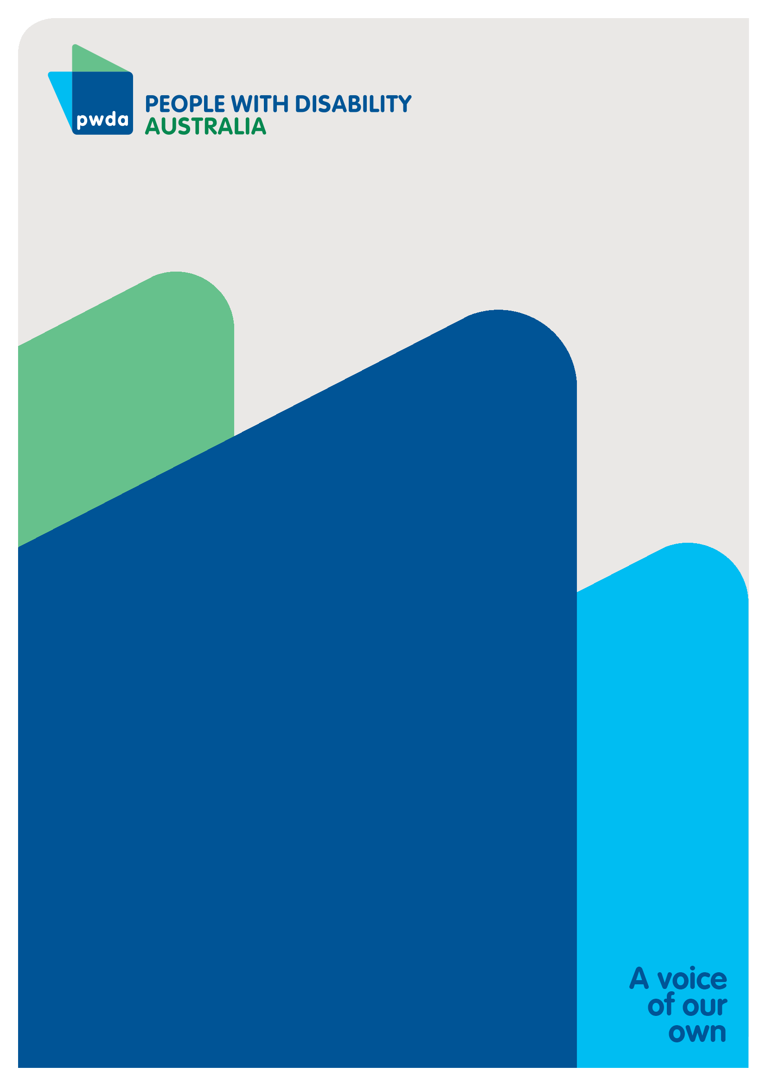

People with Disability Australia (PWDA) is a national disability rights and advocacy organisation made up of, and led by, people with disability.
For individual advocacy support contact PWDA between 9 am and 5 pm (AEST/AEDT) Monday to Friday via phone (toll free) on 1800 843 929 or via email at pwd@pwd.org.au
Submission contact
Clara Pirani
Senior Policy Officer
E: clarap@pwd.org.au

Royal Commission into Violence, Abuse, Neglect and Exploitation of People with Disability Final report (2023). https://www.nsw.gov.au/departments-and-agencies/trustee-guardian/news-stories/disability-royal-commissions-final-report
Australian Government. NDIS Review. (2023). https://www.ndisreview.gov.au/resources/reports/our-final-report-guide-people-disability-and-their-families-2023
Shih-Ning Then & Christine Bigby (2024). Supported decision-making and the Disability Royal Commission, Research and Practice in Intellectual and Developmental Disabilities, https://doi.org/10.1080/23297018.2024.233096
Royal Commission into Violence, Abuse, Neglect and Exploitation of People with Disability. (2023) Diversity, dignity, equity and best practice: a framework for supported decision-making | Royal Commission into Violence, Abuse, Neglect and Exploitation of People with Disability
Australian Financial Review.(2026). https://www.afr.com/policy/economy/ndis-spends-12b-on-support-for-walks-movies-haircuts-20260302-p5o6ls
PWDA. (2026) https://pwd.org.au/submission-to-the-ndis-amendment-integrity-and-safeguarding-bill-2025/
Department of Health, Disability and Ageing. (2026). https://www.health.gov.au/resources/publications/ndis-new-framework-planning-what-we-heard-summary-report
ABC News. (2026). Government advisory group recommends delaying NDIS 'robo-planning' changes

