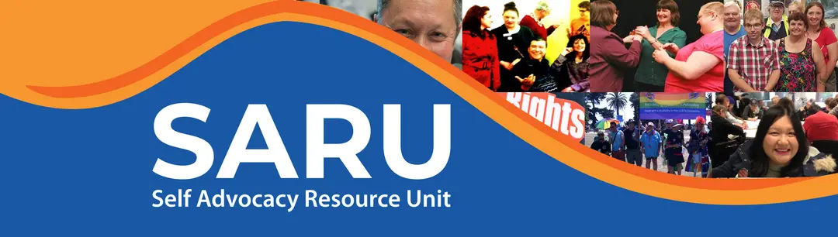

Easy Read submission template
  - About the new NDIS Bill
To | Senate Community Affairs Legislation Committee
From | [Name of self advocacy group]
Date | [Date]
Contact | [Name, email, phone]

Important message
This submission talks about concerns about the Bill.
It does not say we agree with the Bill.

Why we wrote this in Easy English:
These submissions are written in Easy English because they are for self advocates and people with disability.
Many people find government information hard to read. Some people need short sentences, clear words and simple layouts to understand what changes may mean for them.
Easy English helps more people take part, have their say and speak up about the NDIS Bill.
The NDIS is about our lives, our rights and our support.
We should be able to understand the information and be part of decisions that affect us.
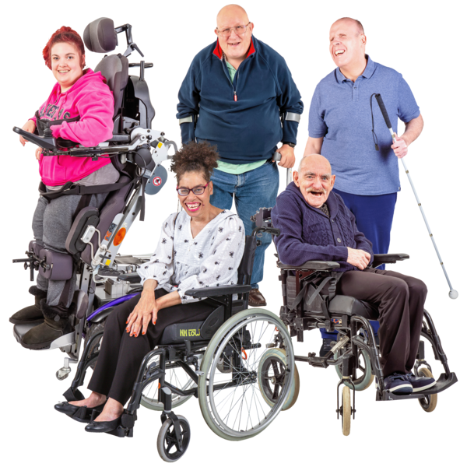 | About us  We are [name of group].  We are a self advocacy group.  (explain who you self advocacy group is)  Many of our members use the NDIS.  We know what good support looks like.  We know what happens when support is not there.
   | Our main message  We are worried the changes the government wants to make to NDIS laws will:  - Put people with disability in danger  - Hurt people's physical health and mental health  - Put people's safety and human rights at risk  - Stop people getting what they need to live their lives  We are worried the new Bill will mean people:  - lose support they need  - get less support to go out in the community  - have less choice and control  - are not listened to in assessments  - cannot get help when their life changes  People with disability must be part of all decisions about the NDIS.  Nothing about us without us.
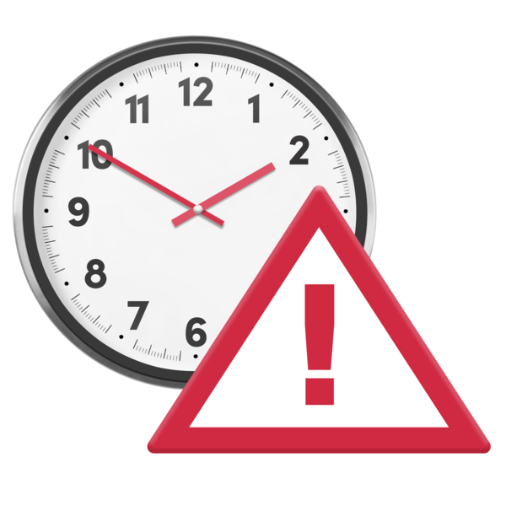  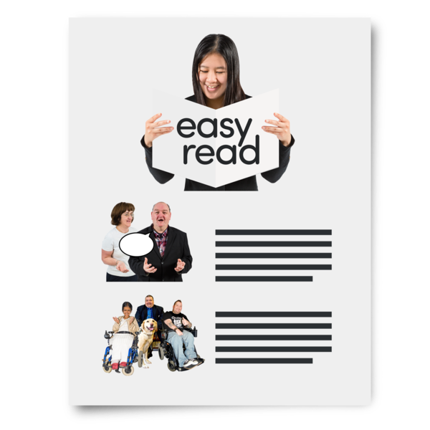 |  | Key facts about the Bill  - The Bill was introduced to Parliament in May 2026.  - The Senate Committee is looking at the Bill now.  - Submissions close on 29 May 2026.  This bill is rushed:  - This bill is rushed and we do not have time to properly understand how this will effect us and to speak up about this  - Self advocates NEED accessible information, like things in easy read and time to think and say how these changes will effect us.  - Because this bill is rushed, SARU helped us write lots of this submission.  But self advocates should be given time and support to lead this work instead.
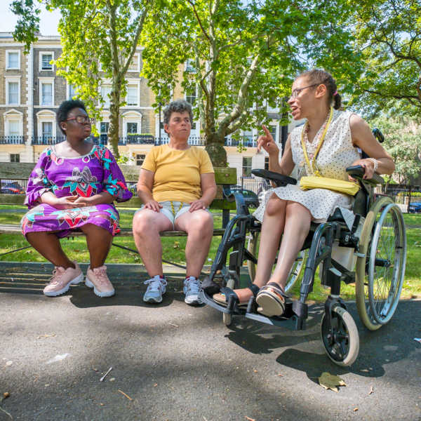  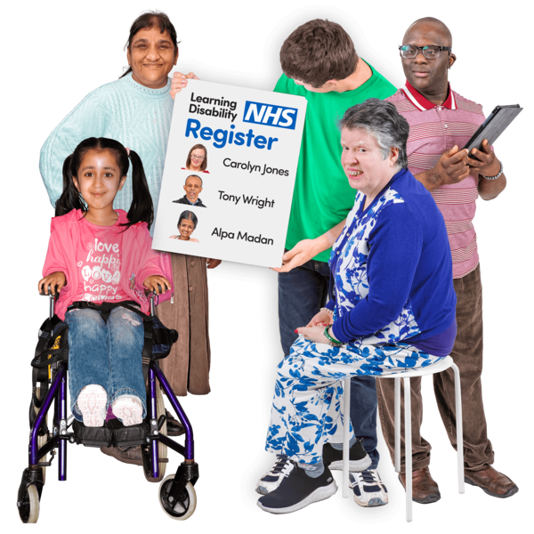   |  | Social and Community support must not be cut  Social and Community support is very important.  It helps people:  - do things outside of the home they need to do to  - make and see friends  - go to appointments and go shopping  - go to self advocacy groups  - learn skills  - use transport  - join the community  - speak up  This support is not extra.  It helps people have a real life.  Without it, people may be stuck at home.  They may become lonely or unsafe.  We ask: Do not cut community support for everyone. Look at what each person needs.
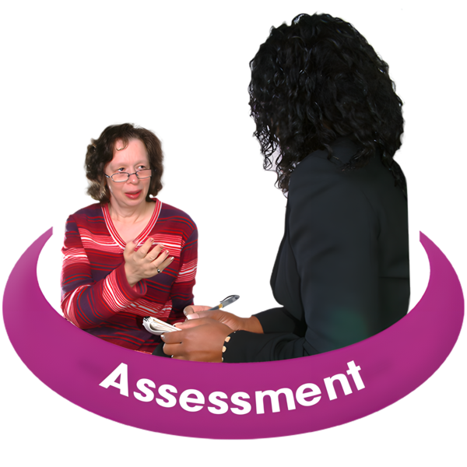   |  | Assessments must be fair  The Bill talks about new assessments.  Assessments must understand real life.  Some people:  - need help to explain their needs  - have good days and bad days  - use different ways to communicate  - feel scared in meetings  - say they are okay when they are not okay  - need someone they trust with them  Assessments must listen to the person.  Assessments must also listen to people the person trusts.  We ask: No one should lose NDIS support because of an unfair assessment.
 |  | Choice and control must stay  The NDIS should let people choose.  People should be able to choose:  - their workers  - their providers  - their support coordinator  - their plan manager  - how they use their support  Trust is very important.  Some people have worked hard to find workers they trust.  New rules must not take this away.  We ask: Keep real choice and control in the NDIS.
 |  | People need help when life changes  Life can change quickly.  A person may need more support if:  - their carer gets sick  - they leave hospital  - they move house  - they are unsafe at home  - their mental health gets worse  - their provider stops helping them  People should not have to wait too long for help.  We ask: Make sure people can get urgent plan changes when they need them.
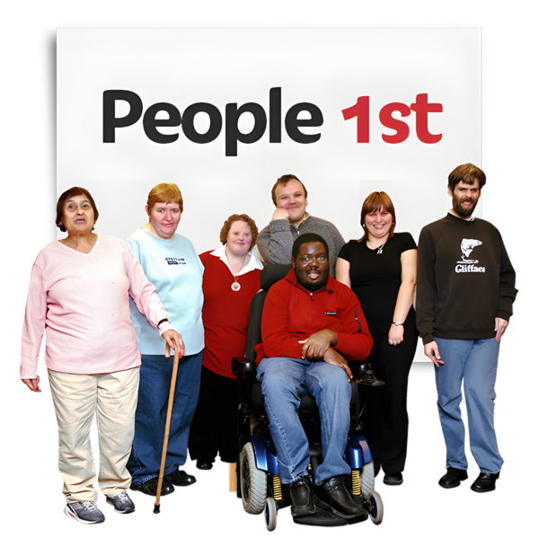 |  | Advocacy must be funded  Many people need support to speak up.  Self advocacy groups help people:  - understand changes  - know their rights  - speak up at meetings  - make complaints  - ask for reviews  - stay connected to other people  If the NDIS changes, people will need more advocacy support, not less.  We ask: Fund independent advocacy and self advocacy groups properly.
 |  | What we want the Senate Committee to do  We ask the Senate Committee to make sure the Bill:  - protects choice and control  - protects social and community support  - makes assessments fair  - lets people get plan changes when life changes  - funds advocacy and self advocacy  - listens to people with disability before changes happen
   |  | Final message  The NDIS helps people with disability live our lives.  It helps us be part of the community.  It helps us speak up.  It helps us be safe.  Do not change the NDIS without us.  Listen to self advocates.  Protect our rights.

Signed: [Name]
Role: [Role]
Group: [Group name]

