E-Micromobility Sharing Schemes Reform


Submission to Transport for NSW
April
2026

About PWDA
People with Disability Australia (PWDA) is a national disability rights and advocacy organisation made up of, and led by, people with disability.
We have a vision of a socially just, accessible and inclusive community in which the contribution, potential and diversity of people with disability are not only recognised and respected but also celebrated.
PWDA was established in 1981, during the International Year of Disabled Persons.
We are a peak, non-profit, non-government organisation that represents the interests of people with all kinds of disability.
We also represent people with disability at the United Nations, particularly in relation to the United Nations Convention on the Rights of Persons with Disabilities (CRPD).
Our work is grounded in a human rights framework that recognises the CRPD and related mechanisms as fundamental tools for advancing the rights of people with disability.
PWDA is a member of Disabled People’s Organisations Australia (DPO Australia), along with the First People’s Disability Network, National Ethnic Disability Alliance and Women with Disabilities Australia.
DPOs collectively form a disability rights movement that places people with disability at the centre of decision-making in all aspects of our lives.
‘Nothing About Us, Without Us’ is the motto of Disabled Peoples’ International.
Submission contact
Bastien Wallace - Senior Policy Officer E: bastienw@pwd.org.au
Table of Contents
1
E-Micromobility Sharing Schemes Reform 1
Submission to Transport for NSW 1
About PWDA 2
Recommendations 5
Recommendation 1 – prohibit ‘free floating parking zones’ for shared e-mobility 5
Recommendation 2 – prohibit footpath parking in most areas shared e-mobility 5
Recommendation 3 – set clear standards for where shared mobility devices can be parked including distance from curb ramps, intersections, bus stops, doorways, and require operators to prove compliance 5
Recommendation 4 – parking recommendations should always prioritise taking space away from car drivers rather than parking shared mobility devices on the footpath 5
Recommendation 5 – redesign parking bays to reduce the chance of shared mobility devices toppling and obstructing pedestrians 5
Recommendation 6 – build safe separated bicycle infrastructure urgently, and require micromobility users to use it instead of footpaths 5
Recommendation 7 – do not allow footpath riding for shared e-scooters 5
Introduction 6
Parking creating inaccessibility 7
Recommendation 1 prohibit ‘free floating parking zones’ for shared e-mobility 8
Recommendation 2 prohibit footpath parking in most areas shared e-mobility 8
Recommendation 3 set clear standards for where shared mobility devices can be parked including distance from curb ramps, intersections, bus stops, doorways, and require operators to prove compliance 9
Recommendation 4 parking recommendations should always prioritize taking space away from car drivers rather than parking shared mobility devices on the footpath 11
Recommendation 5 redesign parking bays to reduce the chance of shared mobility devices toppling and obstructing pedestrians 11
Footpath riding issues 11
Recommendation 6 build safe separated bicycle infrastructure urgently, and require micromobility users to use it instead of footpaths 12
Recommendation 7 do not allow footpath riding for shared e-scooters 13

Recommendations

Recommendation 1 – prohibit ‘free floating parking zones’ for shared e-mobility

Recommendation 2 – prohibit footpath parking in most areas for shared e-mobility

Recommendation 3 – set clear standards for where shared mobility devices can be parked including distance from curb ramps, intersections, bus stops, doorways, and require operators to prove compliance

Recommendation 4 – parking recommendations should always prioritise taking space away from car drivers rather than parking shared mobility devices on the footpath

Recommendation 5 – redesign parking bays to reduce the chance of shared mobility devices toppling and obstructing pedestrians

Recommendation 6 – build safe separated bicycle infrastructure urgently, and require micromobility users to use it instead of footpaths

Recommendation 7 – do not allow footpath riding for shared e-scooters

Introduction
Thank you for the opportunity to provide feedback on the NSW Government’s E-micromobility sharing schemes reform. Micromobility has the potential to improve transport amenity for its users and safety for everyone by reducing car trips. Car drivers colliding with pedestrians are the most common cause of injury and death, and NSW has the highest rates of fatality.0F0F We support measures that reduce the number of car journeys, provided they are enacted in ways that keep pedestrians and people with disability safe.
We are pleased to see that some of the elements people with disability have been calling for are mentioned in the New Approach to Sharing Scheme Reforms Summary Paper - including planning for safe parking and rider education, but more needs to be done.
It has been nearly 9 years since the first share bike schemes came to NSW in July 2017. Whilst the switch from ‘standard’ to electric share bikes reduced the numbers of dumped bicycles at the bottom of hills, many issues that have been raised consistently by people with disability since then have not been addressed.
This includes the obstruction of footpaths by parked or toppled devices, footpath riding and rider behavior that endangers people with disability.

Parking creating inaccessibility
People with Disability Australia (PWDA) agrees with finding 3 arising from The Parliamentary Inquiry into the use of e-scooters, e-bikes and related mobility options, namely:
“Shared e-bike operators claim to have the technology and adequate staffing to manage parking and pathway obstruction issues. However, the committee finds that these problems persist and are increasingly impacting public amenity and safety…”1F1F
The draft bike and micromobility parking guidance goes some way to addressing the many concerns people with disability have had over the obstruction of footpaths by dumped or poorly parked devices, tripping hazards and blocked access to essential pedestrian features such as crossings. Regrettably it is ‘guidance’ and like the rest of the Cycleway Design Toolbox, it is likely to be ignored by most LGAs based on historical levels of compliance.
We do not support “free floating zones” proposed in the Draft Bike and Micromobility Parking Guide for share bikes or other mobility devices. The difficulty is that where riders “can elect to park devices in any location” the claim they are “educated to park consistently without obstructing footpaths, access and egress points and street furniture”2F2F falls well short of the reality. It also ignores the needs of people who are blind or who have low vision and who depend on shorelines, curbs and tactiles to navigate. A short walk in any direction where share bikes operate yields examples of:
- footpaths and shared paths so narrowed by poorly parked bikes that wheelchair users cannot pass
- access blocked to pedestrian crossings and curb cuts by multiple parked bikes
- entrances and exits to homes and businesses blocked by parked bikes
- toppled bikes obstructing paths, and presenting a tripping hazard.
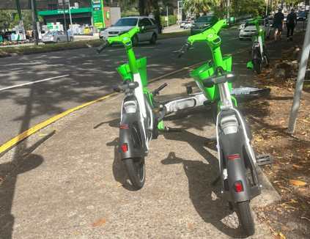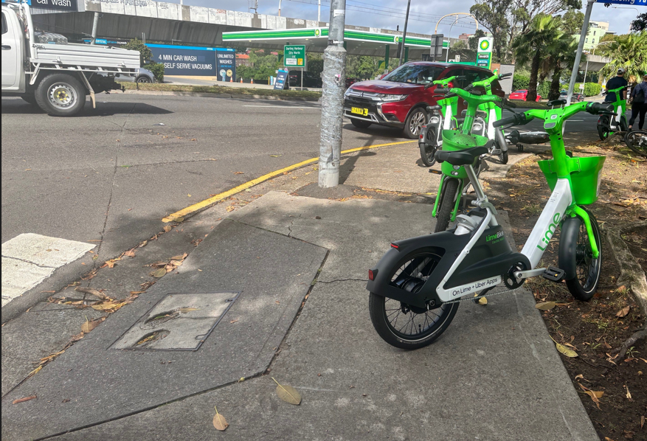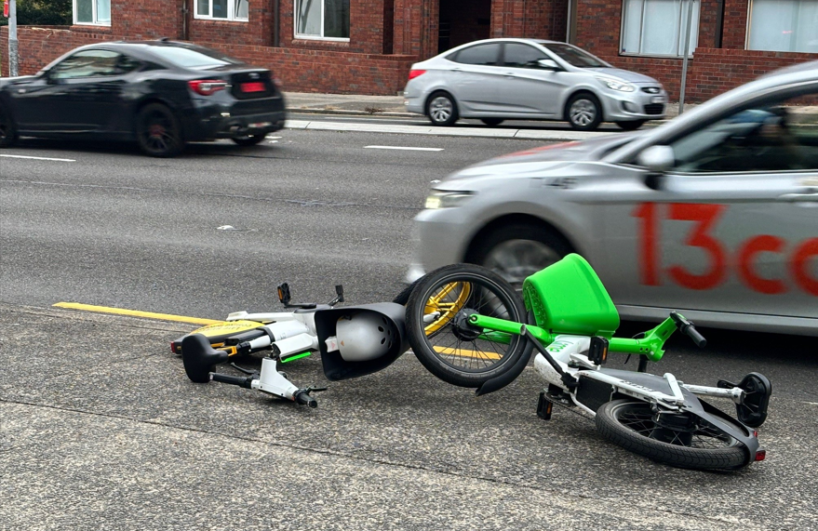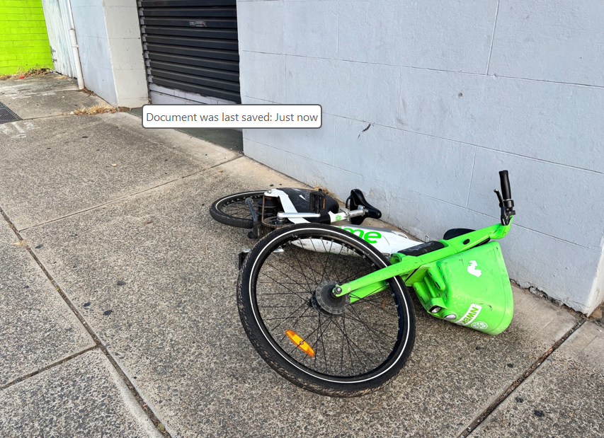

Recommendation 1 prohibit ‘free floating parking zones’ for shared e-mobility

Recommendation 2 prohibit footpath parking in most areas shared for e-mobility
At 35kg average weight, moving these bikes or righting them when they topple, is beyond the ability of many community members, and impossible for users of wheelchairs and mobility aids, many elders and children. It is unsafe and unreasonable to expect people who are blind or have low vision to have to avoid or relocate this commercial property in order to use a public thoroughfare.
We do not support the parking of share bikes or micromobility devices on the footpath. They obstruct path use by people using assistive mobility devices, and by those who need to navigate using building and curb lines. Clearly marked parking bays allocated in the roadway, away from pedestrian crossings, bus stops and taxi ranks, provide the most accessible solution for people with disability.

Recommendation 3 set clear standards for where shared mobility devices can be parked including distance from curb ramps, intersections, bus stops, doorways, and require operators to prove compliance
The guidance at page 12 (diagram extracted below) provides an example of bicycle parking that takes space away from parking car drivers, rather than the footpath, and the example circled in red is the best for people with disability. We also insist that disability parking allocation and location not be sacrificed to provide e-mobility spaces. The other two examples can work for privately owned bicycles which are locked to the parking arches.
However, when used by share bike customers, bicycles tend to be parked so they overflow/ spill/ topple to obstruct the pedestrian crossing. A solution could be to allow privately owned bicycles to be locked to the arches nearest the crossing (circled in blue in the below diagram), and share bikes to occupy the space further away. This creates a safety buffer for users of the crossing, with locked bikes and the arches preventing share bikes from toppling into the crossing.

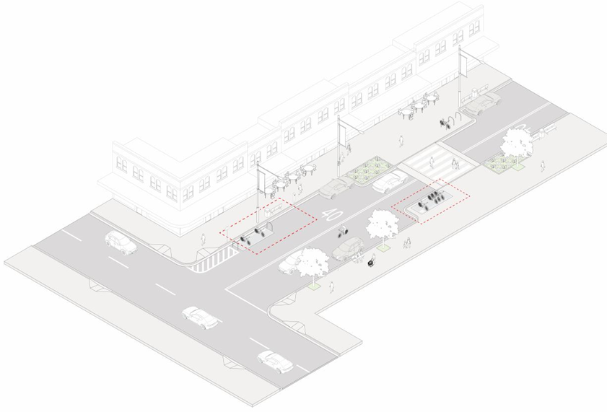
These guidelines proport to be for micromobility, however the focus is on shared bicycles. Shared e-scooters are far more likely to topple and cause obstruction, due to their design, and they can be more difficult for a person who has low vision to detect once they have fallen. This needs to be considered when designing parking places, and it may be necessary to install racks that are appropriate for their dimensions.
PWDA is aware that the successful Transport for NSW Newcastle Bykko docked share bike trial avoided footpath obstruction issues, whilst providing a last mile transport solution that reduced motor vehicle use.3F3F This lesson could be applied to shared micromobility, and we are aware that some share e-scooter schemes have solar-powered parking racks that act as charging docks - reducing operator costs.
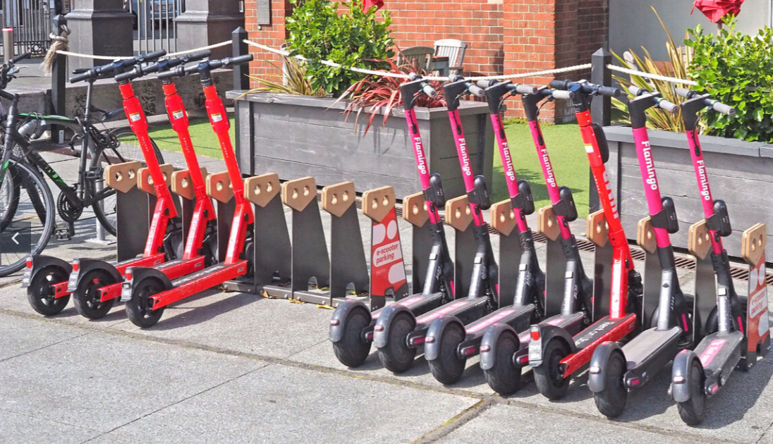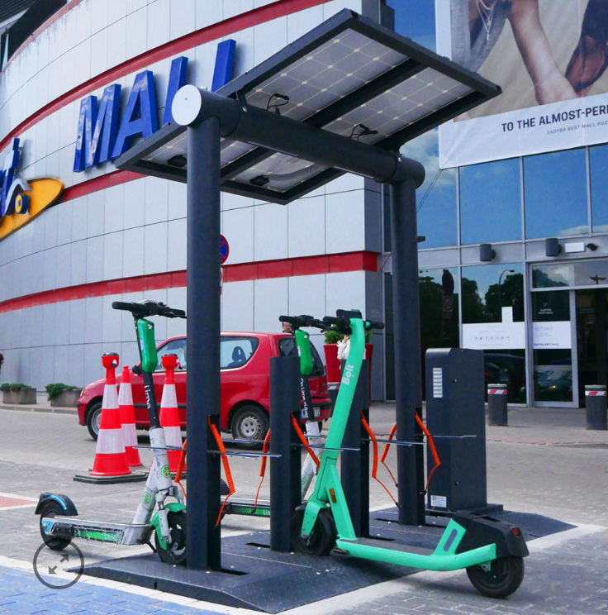
Example from Tilley & Park4F4F Example from Moodie Outdoor Products5F5F

Recommendation 4 parking recommendations should always prioritize taking space away from car drivers rather than parking shared mobility devices on the footpath

Recommendation 5 redesign parking bays to reduce the chance of shared mobility devices toppling and obstructing pedestrians

Footpath riding issues
The lack of safe cycling infrastructure in most of NSW forces bike riders onto the footpath. In the case of children under 16, and adults supervising children this is legal. Increasing rates of bike rider injury and death in collisions involving motor vehicles,6F6F has forced many adult riders to choose between breaking the law by riding on the footpath, or being hit by cars. This in turn can make footpaths less safe for pedestrians with disability.
Bicycles and micro-mobility vehicles cannot be heard approaching pedestrians, and people with low vision, or who are blind, cannot see bike riders to avoid them. We call on the NSW Government to urgently prioritize building safe, separated cycling infrastructure to protect pedestrians and riders, in line with recommendation 13 of its Parliamentary Inquiry Report into the use of e-scooters, e-bikes and related mobility options, and its own Active transport Strategy. 7F7F

Recommendation 6 build safe separated bicycle infrastructure urgently, and require micromobility users to use it instead of footpaths
PWDA is concerned that the NSW Government will follow Recommendation 8 from the Parliamentary Inquiry Report and amend the e-scooter rules to allow footpath riding.8F8F Like NSW, Victoria has footpath riding restrictions for most adult bike riders and the Victorian Transport Accident Commission decided that allowing e-scooters to be ridden on footpaths posed “…an unacceptable risk to vulnerable pedestrians, such as the elderly, children, and people with disabilities...” 9F9F
Retailers in New South Wales already sell e-scooters that travel well over 25km/h and many retail, and all shared e-scooters, are heavy and present a substantial injury risk if they hit a pedestrian. E-scooter riders are also more likely to hit pedestrians than bicycle riders,10F10F and we recommend restricting their use to clearly marked shared paths and bicycle infrastructure.
PWDA notes that the City of Melbourne terminated its e-scooter trial 6 months early due to safety concerns, including for pedestrians. During the 7-month trial period 860 collisions were recorded involving e-scooters, with a total of seven fatalities.11F11F On this basis it is clearly not safe enough for pedestrians and people with disability to allow shared e-scooters to be ridden on footpaths in NSW.

Recommendation 7 do not allow footpath riding for shared e-scooters

Australian Government, Department of Infrastructure, Transport, Regional Development Communication, Sport and the Arts, Pedestrians, accessed 31 March 2026 https://datahub.roadsafety.gov.au/safe-systems/safe-road-use/pedestrians
NSW Parliament, Parliamentary Inquiry Report into the use of e-scooters, e-bikes and related mobility options, Feb 2025 Inquiry Report into the use of e-scooters, e-bikes and related mobility options,
Draft bike and micromobility parking guidance page 8 https://hdp-au-prod-app-nsw-haveyoursay-files.s3.ap-southeast-2.amazonaws.com/7417/7154/6190/Attachment-C_Draft-Bike-and-Micromobility-Parking-Guidance.pdf
Newcastle eBike On Demand Service, last accessed 31 March 2026, https://transportnsw.info/travel-info/ways-to-get-around/on-demand/newcastle-ebike
Tilley & Patton Street and Park Furniture last accessed 31 March 2026 https://www.tilleystreetandparkfurniture.co.nz/products/ruru-scooter-rack/
Moodie Outdoor Products, last accessed 31 March 2026, Moodie scooter charging station
Transport for NSW, Fatality trends by gender, road user or region, as accessed 16 March 2026 https://www.transport.nsw.gov.au/roadsafety/statistics/interactive-crash-statistics/fatality-trends
Parliamentary Inquiry Report into the use of e-scooters, e-bikes and related mobility options, Feb 2025 last accessed 31 March, 2026 P. xiii Parliamentary Inquiry Report into the use of e-scooters, e-bikes and related mobility options, Feb 2025 last accessed 31 March, 2026 P. xii
Parliamentary Inquiry Report into the use of e-scooters, e-bikes and related mobility options, Feb 2025 last accessed 17 March, 2026 Parliamentary Inquiry Report into the use of e-scooters, e-bikes and related mobility options, Feb 2025 last accessed 17 March, 2026
Victorian Government, Transport Accident Commission, accessed 31 March 2026, https://www.tac.vic.gov.au/road-safety/road-users/e-scooters/e-scooter-safety
N. Haworth, A. Schramm, D. Twisk, Comparing the risky behaviours of shared and private e-scooter and bicycle riders in downtown Brisbane, Australia, Accident Analysis & Prevention, Volume 152, March 2021, 105981 https://doi.org/10.1016/j.aap.2021.105981
ABC News, Melbourne's snap decision to remove hire e-scooters from CBD could send 'shock waves' to other states, experts say, 15 August 2024, accessed 31 March 2026, https://www.abc.net.au/news/2024-08-15/share-hire-e-scooter-laws-australia-melbourne-ban/104224386

