Submission on the Inclusive Communities Fund

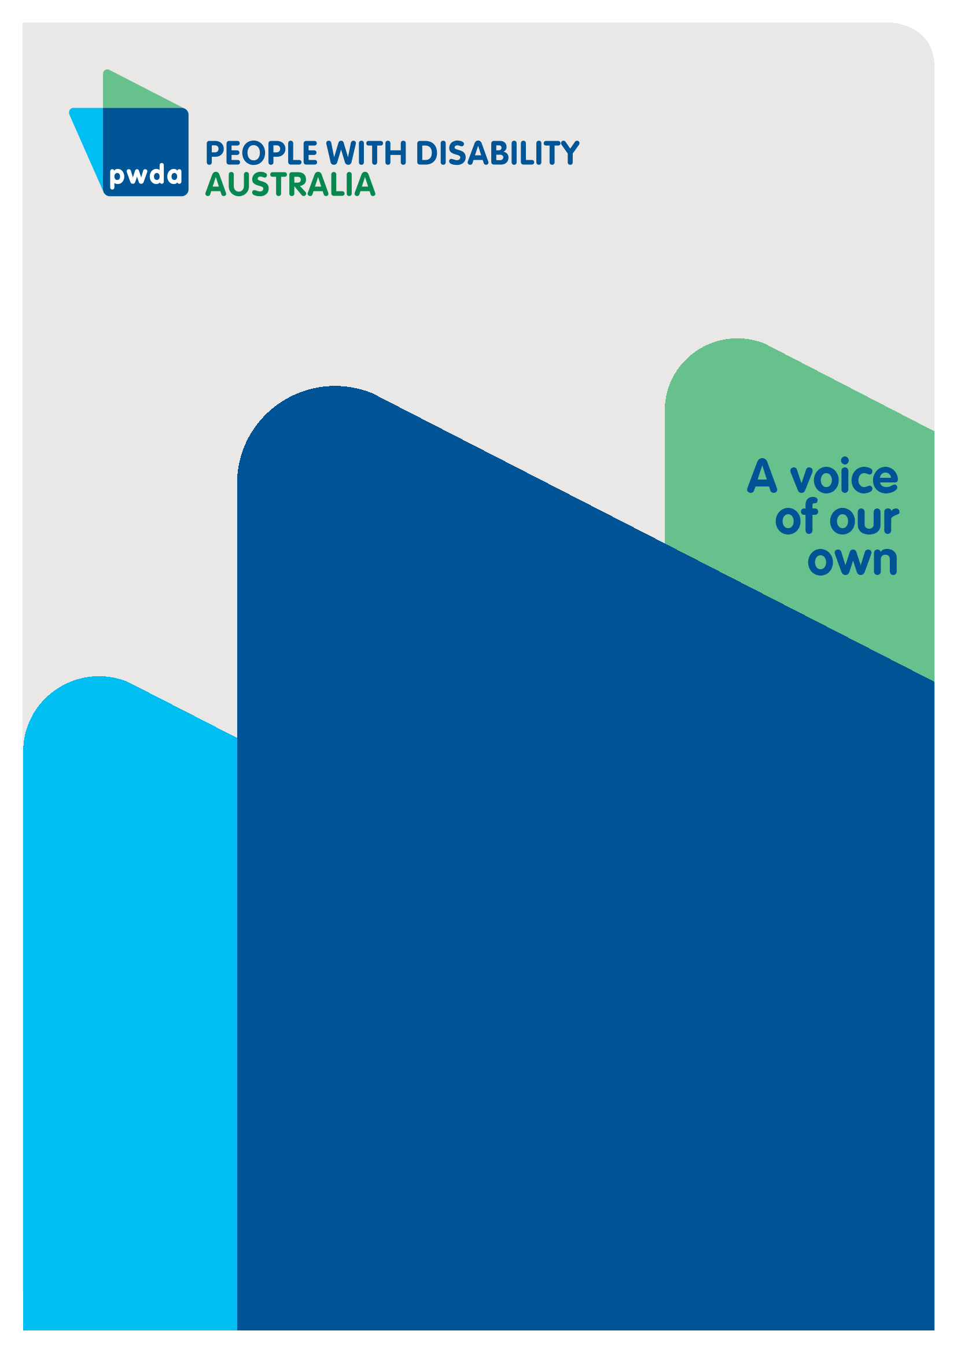
August
2026

Copyright information
Submission on the Inclusive Communities Fund.
First published in 2026 by People with Disability Australia Ltd.
Suite 10.01| Centennial Plaza | Level 10, 300 Elizabeth Street | Surry Hills NSW 2010
Email: pwd@pwd.org.au
Phone: 1800 422 015
URL: www.pwd.org.au
Typeset in Arial 12 and 14 pt and VAG Rounded 26 pt
© People with Disability Australia Ltd. 2026
The moral rights of the authors have been asserted
National Library of Australia Cataloguing-in-Publication data:
Creator(s): | People with Disability Australia
Title: | Submission on the Inclusive Communities Fund
All rights reserved. Except as permitted with the Australian Copyright Act 1968 (for example, a fair dealing for the purposes of study, research, criticism or review), no part of this book may be reproduced, stored in a retrieval system, communication or transmitted in any form or by any means without prior written permission. All inquiries should be made to the publisher at the address above.
Suggested citation:
People with Disability Australia; Submission on the Inclusive Communities Fund, August, 2026.

About PWDA
People with Disability Australia (PWDA) is a national disability rights and advocacy organisation made up of, and led by, people with disability.
We have a vision of a socially just, accessible and inclusive community in which the contribution, potential and diversity of people with disability are not only recognised and respected but also celebrated.
PWDA was established in 1981, during the International Year of Disabled Persons.
We are a peak, non-profit, non-government organisation that represents the interests of people with all kinds of disability.
We also represent people with disability at the United Nations, particularly in relation to the United Nations Convention on the Rights of Persons with Disabilities (CRPD).
Our work is grounded in a human rights framework that recognises the CRPD and related mechanisms as fundamental tools for advancing the rights of people with disability.
PWDA is a member of Disabled People’s Organisations Australia (DPO Australia), along with the First People’s Disability Network, National Ethnic Disability Alliance and Women with Disabilities Australia.
DPOs collectively form a disability rights movement that places people with disability at the centre of decision-making in all aspects of our lives.
‘Nothing About Us, Without Us’ is the motto of Disabled Peoples’ International.

Introduction
People with Disability Australia (PWDA) welcomes the opportunity to provide feedback on the Australian Government’s proposed Inclusive Communities Fund
PWDA strongly supports investment that improves social participation which is essential for Australians with disabilities as it provides a sense of belonging, increases safety, builds skills and social networks, and reduces isolation.
The Inclusive Communities Fund must prioritise overcoming the persistent barriers that prevent people with disability from having the same opportunities as people without disability to be part of our communities. To achieve this, funding must go beyond one-off projects and support sustainable organisational and cultural change.
To better understand community views about the Fund, PWDA released an Inclusive Communities Fund member and community consultation survey on August 11. We received a total of 197 responses.
87% of respondents said taking part in their community was essential or very important to their lives.
However respondents reported significant barriers to community participation, which this submission will outline.
The development of the Inclusive Communities Fund come as the same time the NDIS is undergoing the most far-reaching changes since its inception 13 years ago. The scale of changes and the extent of the cuts to supports under the NDIS Amendment (Securing the NDIS for Future Generations) Bill 2026 (NDIS Bill 2026) have caused widespread fear and uncertainty among the disability community.
Therefore, the Inclusive Communities Fund should not be considered in isolation. Rather, it must be assessed in the context of the upcoming 50% cuts to social, civic and community participation (SCCP) supports under the NDIS Bill 2026.
The Government’s own Impact Analysis shows the cuts will affect 393,000 participants (52% of participants who currently have SCCP funding).
Those most affected, on average, will be people with visual impairment. The modelling showed an average of about 34% of these plans was set aside for social participation, with an average six-month budget of $13,233.
For participants with psychosocial disability, about 30% of funding is typically reserved for social activities while for those with Down Syndrome, it is about 28%.
Even if some community activities became more accessible and inclusive under the Inclusive Communities Fund, 81% of 140 PWDA survey respondents said they would still need supports at least some of the time to participate.
Accessible venues, inclusive organisations and better community programs are important. But they do not replace the individual supports some people need to get out of the house, travel, communicate, make decisions or take part in an activity.
Accessible communities and individual disability supports do different jobs. We need both.
PWDA is also concerned that the Fund’s $200 million, three-year funding period is too short for organisations - in particular smaller organisations - to adequately develop, staff, implement and review community activities.
Many community organisations, sporting clubs, arts groups and volunteer-based organisations are operating under significant financial pressure. Community groups are being asked to do more with less, while facing rising costs, declining volunteer availability and increasing difficulty securing stable funding.
Organisations are struggling to maintain existing activities and are not in a position to take on additional responsibilities without ongoing support.
The Fund should recognise that inclusion activities require organisational capacity and resources. Short-term grants that create ongoing obligations risk placing unsustainable burdens on community organisations.

Summary of Recommendations
Recommendation 1 - Require community organisations applying for funding to partner with disability-led organisations
Recommendation 2 – Require genuine disability leadership in the design, governance, delivery and evaluation of all funded initiatives.

Recommendation 3 – Adopt a broad understanding of accessibility that includes cost, physical access, digital, information and cultural accessibility, and genuine inclusivity.

Recommendation 4 - Prioritise investment in regional, rural and remote communities to ensure equitable participation opportunities regardless of postcode.
Recommendation 5 – Prioritise projects that deliver long-term systemic change and demonstrate sustainability beyond the funding period.

Recommendation 6 – Ensure equitable access to funding for diverse disability communities and people with complex and high support needs.

Recommendation 7 – Embed robust accountability, evaluation and reporting requirements centred on the experiences of people with disability. This should include requirements to rectify identified deficiencies and, in cases of significant or ongoing non-compliance, the repayment of some or all funding received.

Recommendation 8 – The Inclusive Communities Fund should support both mainstream community inclusion and disability-specific opportunities, recognising that inclusion means having genuine choice about how and where people participate. Funding should enable people with disability to engage in community activities alongside people with and without disability, while also preserving disability-led spaces, peer support networks and disability-specific activities that many people value.
Recommendation 9 - The Australian Government should undertake ongoing evaluation of the interaction between the Fund and broader NDIS reforms to ensure people have the supports required to participate in community activities provided through the Inclusive Communities Fund.
Recommendation 10 - The Inclusive Communities Fund should be designed on the basis that many community organisations are already operating under significant financial and volunteer workforce pressures. Funding should support sustainable, long-term inclusion initiatives, avoid cost shifting from government-funded disability supports to community organisations, recognise the limits of volunteer capacity, and address financial barriers that prevent people with disability from participating in community life.

Discussion

Community inclusion and participation
People with disability continue to face significant barriers to participation in community life. While many people wish to participate in social, cultural, sporting and recreational activities, exclusion remains common.
Barriers frequently include:
- Physical inaccessibility.
- Attitudinal barriers
- Communication barriers.
- Lack of accessible information.
- Discrimination and negative attitudes.
- Transport limitations.
- Financial barriers.
- Safety concerns.
- Inaccessible program design.
- Insufficient supports to facilitate participation.
True inclusion is not simply the presence of people with disability within community settings. It requires meaningful participation, belonging, safety, influence and equal opportunity.
The Inclusive Communities Fund should focus on creating environments where people with disability can participate as valued and respected members of their communities on an equal basis with others.

Disability leadership and meaningful co-design
The success of the Fund will depend on whether people with disability are meaningfully involved in decision-making.
PWDA strongly believes disability-led partnerships should be a mandatory feature of funded projects.
Too often, consultation occurs after key decisions have already been made. Genuine co-design requires shared decision-making authority throughout project development, implementation and evaluation.
Funding guidelines should therefore require applicants to demonstrate:
- Meaningful involvement of people with disability.
- Partnerships with disability-led organisations.
- Shared governance arrangements.
- Clear evidence of co-design.
- Appropriate remuneration for lived experience expertise.
Disability leadership should also be embedded within the governance and ongoing oversight of the Fund itself.
Respondents to PWDA’s survey agree, identifying people with disability helping design activities (65%) and accessibility improvements (62%), alongside disability-led partnerships, inclusion expertise and training, accessible equipment and meeting disability-related participation costs.
92% said organisations should have to illustrate how they will work with people with disability to design activities before receiving funding.
Respondents also wanted people with disability involved in decision-making, clear accessibility and inclusion plans, demonstrated experience of inclusion and partnerships with disability-led organisations.
"A major concern for me is that people can technically be “included” in a mainstream activity but still not be able to participate safely or meaningfully because the organisation has not been funded or supported to make the necessary adjustments. The best community participation happens when inclusion is designed into the service from the beginning, rather than relying on the person with disability, their family or frontline staff to solve barriers after they arise.” PWDA survey respondent.

Recommendation 1 - Require community organisations applying for funding to partner with disability-led organisations
Recommendation 2 – Require genuine disability leadership in the design, governance, delivery and evaluation of all funded initiatives.

Preventing barriers to participation
The barriers to participation are in our communities, not with people with disability.
According to PWDA’s survey, the biggest barriers respondents identified were
- cost (58%)
- transport (61%)
- activities that were not welcoming, inclusive or accessible (56%)
- inaccessible buildings and venues (46%)
- not having the supports they needed (39%).
People also told us about inaccessible information, sensory barriers, inaccessible toilets, fatigue, communication barriers and activities simply not being available where they live.
People with disability want to participate. Too often, inaccessible places, unaffordable activities, poor transport and a lack of the right supports prevent us from doing so.
People with disability should have opportunities to participate wherever we live. The Fund must not create another postcode lottery. PWDA’s Inclusive Communities Fund survey found a significant regional difference in responses.
68% of respondents in regional, rural and remote respondents identified transport as a barrier, compared with 57% in major cities. 51% said activities were not available where they lived, compared with 20% in major cities.
Respondents strongly supported funding that responds to local needs, greater investment in regional, rural and remote communities and better transport.
When asked what would help create similar opportunities across Australia:
- 76% wanted funding responsive to local community needs
- 69% wanted more support in regional, rural and remote areas
- 68% wanted better transport
- 65% wanted funding available across Australia
- 59% wanted information to be easier to find
- 49% wanted local partnerships
- 45% wanted online activities
While accessibility modifications are important, inclusion cannot be achieved through infrastructure alone. Social attitudes, organisational culture and discriminatory practices are often equally significant barriers.
Funded initiatives should:
- Be financially accessible
- Improve physical access.
- Address discriminatory attitudes and practices.
- Create welcoming and inclusive environments.
- Support participation across diverse disability communities.

Recommendation 3 - Adopt a broad understanding of accessibility that includes cost, physical access, digital, information and cultural accessibility, and genuine inclusivity.

The Inclusive Communities Fund should include dedicated funding streams and assessment criteria that address the unique barriers faced by people with disability in regional, rural and remote areas. Funding should support locally designed solutions, improve transport and access to support, expand the availability of inclusive activities, and ensure people with disability can participate in community life regardless of where they live.

Recommendation 4 - Prioritise investment in regional, rural and remote communities to ensure equitable participation opportunities regardless of postcode.

Sustainability and lasting change
PWDA strongly supports investment that leaves a lasting legacy.
We encourage the Fund to focus on initiatives that demonstrate how inclusion outcomes will continue beyond the grant period. Applicants should be required to identify strategies for maintaining improvements, embedding inclusive practices and ensuring long-term organisational commitment.
According to the PWDA’s Inclusive Communities Fund survey, 57% of respondents wanted organisations to demonstrate their ability to keep the activity going after funding ends, before they received funding.
To make inclusion last after the Fund, respondents wanted organisations that receive funding to have:
- leaders to be committed to inclusion - 71%
- long-term partnerships with disability organisations - 62%
- ongoing accessibility improvements - 63%
- ongoing staff knowledge and training - 62%
- ongoing funding from other sources - 52%
Sustainability measures could include:
- Workforce capability development.
- Inclusive policy and governance reforms.
- Ongoing accessibility commitments.
- Long-term partnerships with disability-led organisations.
- Organisational inclusion strategies.
Without sustainability requirements, there is a risk that positive outcomes will disappear once funding concludes.

Recommendation 5 - Prioritise projects that deliver long-term systemic change and demonstrate sustainability beyond the funding period.

Equity and access to funding
PWDA is concerned that some communities may face barriers in accessing funding opportunities.
Targeted measures are required to ensure equitable outcomes for:
- First Nations people with disability.
- Culturally and linguistically diverse communities.
- LGBTQIA+ people with disability.
- People with high support needs.
- Older people with disability
- Smaller community organisations.
“Please fund what people with disability say they need, rather than deciding for us what our community participation should look like. Give us genuine choice, control and a real voice in the communities we are already part of. As a queer disabled person, I want fully accessible, fun and community wide (mainstream included) events and activities that are inclusive and welcome me for who I am.” PWDA survey respondent.
Government should provide accessible application processes, capacity-building supports and targeted outreach to ensure funding opportunities are broadly accessible.

Recommendation 6 - Ensure equitable access to funding opportunities for diverse disability communities and people with complex and high support needs

Accountability and evaluation
Strong accountability measures are essential to ensure public investment delivers meaningful outcomes.
Evaluation frameworks should focus on:
- Participation
- Genuine accessibility
- Belonging
- Social inclusion
- Wellbeing
- Organisational capability and sustainability
- Long-term cultural change.
Projects should be evaluated according to whether they improve participation outcomes for people with disability rather than solely whether activities were delivered.
“Often business will "tick boxes" saying they are doing or have done actions but there is nothing tangible to show. Lived experience reviews - applicants for funding should submit a report saying when/how they conducted a review, what recommendations were given and what recommendations were actioned.” PWDA survey respondent.
PWDA recommends that funding recipients be required to demonstrate genuine accessibility and inclusion outcomes, rather than simply meeting minimum compliance requirements. Accessibility should not be treated as a checklist exercise, nor assessed solely on the provision of individual features such as ramps or accessible toilets.
True accessibility requires consideration of the entire service experience, including whether people with disability can access, navigate, and meaningfully participate in funded activities. For example, an organisation may technically satisfy a requirement by installing a ramp, yet if there is no accessible path of travel to the building, limited accessible transport options, or barriers within the service environment, people with disability may still be effectively excluded.
The Inclusive Communities Fund should therefore require organisations to demonstrate that funded activities are accessible, inclusive, and delivering measurable benefits for people with disability. This should include evidence that services improve participation, inclusion, wellbeing, independence, and quality of life outcomes. People with disability should be directly involved in evaluation processes.
PWDA further recommends that robust monitoring and accountability mechanisms be incorporated into funding agreements. Where an organisation is found to have failed to provide accessible services, failed to remove significant barriers to participation, or failed to deliver demonstrable benefits for people with disability, funding should be subject to review and appropriate sanctions.
This should include requirements to rectify identified deficiencies and, in cases of significant or ongoing non-compliance, the repayment of some or all funding received.
Such measures would help ensure that public funds are invested in initiatives that deliver genuine inclusion and meaningful outcomes for people with disability, rather than merely meeting minimum compliance standards.
Recommendation 7 – Embed robust accountability, evaluation and reporting requirements centred on the experiences of people with disability. This should include requirements to rectify identified deficiencies and, in cases of significant or ongoing non-compliance, the repayment of some or all funding received.

Activities the Fund should support
Inclusion means choice, not segregation.
79% of PWDA survey respondents wanted opportunities to participate in community activities alongside people with and without disability. Respondents also valued disability-specific activities and spaces with other people with disability, depending on what they wanted to do.
People with disability should be able to choose how and where we participate. Making ordinary community activities accessible should not mean taking away disability-led spaces, peer groups or disability-specific activities people value.
Many community organisations want to become more inclusive but lack the knowledge, expertise and resources required to do so effectively. PWDA strongly supports funding that enables organisations to build sustainable disability inclusion capability. This should include:
- Disability inclusion and disability-affirming training and workforce development.
- Accessibility audits and implementation planning.
- Communication accessibility initiatives, including Easy Read, Auslan and alternative formats.
- Digital accessibility improvements.
- Development of inclusive governance structures.
- Initiatives that address ableism and discriminatory attitudes.
- Support for smaller organisations that may have limited resources.
Importantly, disability-led organisations should play a central role in supporting and advising funded organisations. People with disability are experts in the barriers they experience, and the solutions required to address them.
When asked what the Fund should pay for:
- 64% of PWDA survey respondents said people with disability helping decide what activities are offered and how they work
- 62% accessibility improvements
- 41% disability inclusion training
- 36% working with disability-led organisations
- 36% staff with disability inclusion expertise

Recommendation 8 – The Inclusive Communities Fund should support both mainstream community inclusion and disability-specific opportunities, recognising that inclusion means having genuine choice about how and where people participate. Funding should enable people with disability to engage in community activities alongside people with and without disability, while also preserving disability-led spaces, peer support networks and disability-specific activities that many people value.

Interaction with broader NDIS reforms
More inclusive communities do not remove the need for disability supports.
Even if community activities became more accessible and inclusive, 81% of PWDA survey respondents said they would still need supports at least some of the time to participate.
Accessible venues, inclusive organisations and stronger community programs are essential. However, they cannot replace the individual supports many people rely on to leave home, travel safely, communicate effectively, make decisions, or actively participate in community life.
The Fund should not be considered a substitute for individual disability supports. Community accessibility initiatives and individual supports serve distinct but complementary purposes. To achieve genuine inclusion, people with disability need both.
Among NDIS participants who responded to PWDA’s Inclusive Communities Survey, when asked what impacts a reduction in community participation supports would have on them:
- 88% said they would become more isolated
- 73% would stop doing some activities
- 47% would participate less often
- 31% would rely more on family or friends
- 32% would have to pay for more support themselves
- Only 1 respondent said they would keep participating just as much
When people lose the supports they need, they don't simply find another way to participate. They miss out. They see people less, stop doing things and become more isolated.
In its final report, the Australian Government’s NDIS Review placed strong emphasis on community participation and social inclusion as central outcomes for people with disability. Its recommendations reflect a shift from seeing the NDIS as a stand-alone scheme to embedding people with disability in inclusive communities, mainstream services, and everyday life.
The NDIS reform measures also run counter to the findings of the Disability Royal Commission, which identified that exclusion from community life significantly increases the risk of abuse, neglect, and exploitation for people with disability. The Commission agreed that segregation – in the sense of people with disability being compelled, directly or indirectly, to live, learn, work and socialise in isolation from their non-disabled peers and the community generally – is unacceptable and must cease.
“Community life is about much more than simply being able to attend an activity. It is about belonging, friendships, independence, purpose, confidence and having the same opportunities as everyone else. One of the biggest difficulties I see is that people with disability are often expected to justify why an activity is important to them in a way that people without disability are not.” PWDA survey respondent.
The Inclusive Communities Fund is intended to improve accessibility and inclusion in mainstream community settings. However, its effectiveness will depend on people with disability continuing to have access to the individual supports they need to engage with those opportunities. Reforms that reduce access to community participation supports risk undermining the objectives of both the Fund and broader disability policy reforms.
Government should therefore monitor not only the outcomes of the Fund itself, but also how concurrent NDIS reforms, in particular cuts to SCCP funding, affect people's capacity to access and benefit from inclusive community initiatives.
Evaluation should include measures of community participation, social connection, isolation, reliance on informal supports, and unmet support needs, with findings made publicly available and informing future policy development. This would help ensure that reforms collectively advance, rather than inadvertently undermine, the goal of full and equal participation in community life.
Recommendation 9 - The Australian Government should undertake ongoing evaluation of the interaction between the Fund and broader NDIS reforms to ensure people have the supports required to participate in community activities provided through the Inclusive Communities Fund.

Financial fragility of community organisations
PWDA is concerned that many community organisations are being expected to deliver more services and support with increasingly limited resources. Sporting clubs, arts organisations and other volunteer-based groups are experiencing rising operating costs, workforce shortages and declining access to secure funding, all of which are affecting their ability to remain viable.
Many organisations are struggling to sustain current activities and are not well positioned to absorb additional responsibilities without ongoing support.
A report by the Australian Sports Foundation found - because of the Covid 19 pandemic - around 25% of sports clubs are at risk of closing and 43% of sporting clubs project a decline in volunteering. Volunteering rates across all types of community organisations throughout Australia are declining, threatening the sector’s sustainability.
A report by Social Ventures Australia and the Centre for Social Impact revealed that since the pandemic, many charities also remain in vulnerable financial positions and require urgent funding.
The Inclusive Communities Fund should recognise that building and maintaining inclusive practices requires time, expertise and financial investment. Reliance on short-term grants may create obligations that organisations cannot realistically sustain once funding concludes.
The risk of cost shifting
PWDA is concerned that community inclusion reforms must not involve the transfer of responsibilities from government-funded disability supports to community organisations without corresponding, adequate resources.
Many community organisations already rely on membership fees, fundraising activities and volunteer labour to remain viable. Small community clubs and organisations frequently operate on narrow margins and have limited capacity to absorb additional costs associated with supporting participation by people with disability.
Sponsorship opportunities have also declined in many communities, with some organisations reporting a reduction in support from local businesses since the COVID-19 pandemic.
The success of the Inclusive Communities Fund will depend on ensuring that community organisations are supported to become more inclusive, rather than being expected to replace disability-specific supports without adequate funding.
Recommendation 10 - The Inclusive Communities Fund should be designed on the basis that many community organisations are already operating under significant financial and volunteer workforce pressures. Funding should support sustainable, long-term inclusion initiatives, avoid cost shifting from government-funded disability supports to community organisations, recognise the limits of volunteer capacity, and address financial barriers that prevent people with disability from participating in community life.

Conclusion
PWDA supports the establishment of the Inclusive Communities Fund and welcomes the Government’s commitment to improving participation and inclusion for people with disability.
To be successful, the Fund must be grounded in disability leadership, meaningful co-design, accessibility, accountability and sustainability. Investment should focus on creating lasting organisational and community change rather than temporary activities.
People with disability must remain at the centre of the Fund’s design, implementation, monitoring and evaluation.
By embedding these principles, the Inclusive Communities Fund can make a significant contribution to building communities where people with disability are welcomed, valued and able to participate on an equal basis with others.

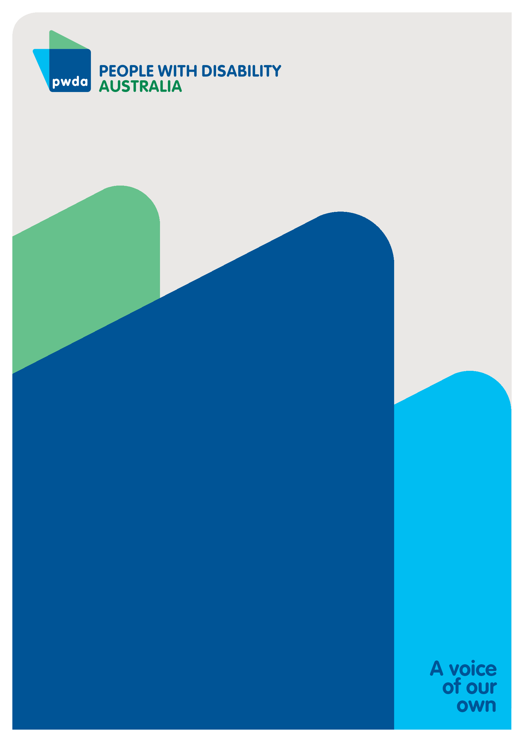

People with Disability Australia (PWDA) is a national disability rights and advocacy organisation made up of, and led by, people with disability.
For individual advocacy support contact PWDA between 9 am and 5 pm (AEST/AEDT) Monday to Friday via phone (toll free) on 1800 843 929 or via email at pwd@pwd.org.au
Submission contact
Clara Pirani
Senior Policy Officer
E: clarap@pwd.org.au

Department of Health, Disability and Aging, (May 2026). Office of Impact Analysis. National Disability Insurance Scheme Reforms, Impact Analysis. https://oia.pmc.gov.au/published-impact-analyses-and-reports/national-disability-insurance-scheme-reforms
Social Ventures Australia and The Centre for Social Impact. (2021) Vital support: Building resilient charities to support Australia’s wellbeing. Vital support: building resilient charities to support Australia's wellbeing
NDIS Review, Final Report (Dec 2023. https://www.ndisreview.gov.au/resources/reports/working-together-deliver-ndis/
Disability Royal Commission Final Report
Ibid
Australian Sports Foundation. (2020) The Impact of Covid 19 on Community Sport. The Impact of Covid-19 on Community Sport - (July 2020) | Australian Sports Foundation
ABC (2025). Volunteerism in Australia has been declining for decades. https://www.abc.net.au/religion/volunteerism-australia-decline-reimagining-social-infrastructure/105118866
Social Ventures Australia and The Centre for Social Impact. (2021) Vital support: Building resilient charities to support Australia’s wellbeing. Vital support: building resilient charities to support Australia's wellbeing

