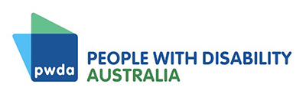
Annual Report
2025–26

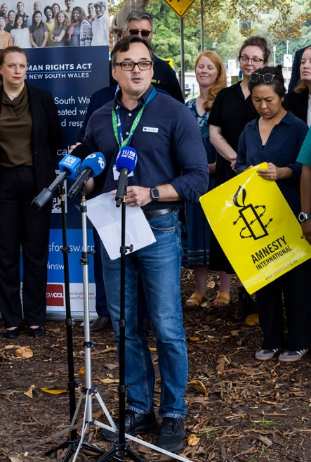

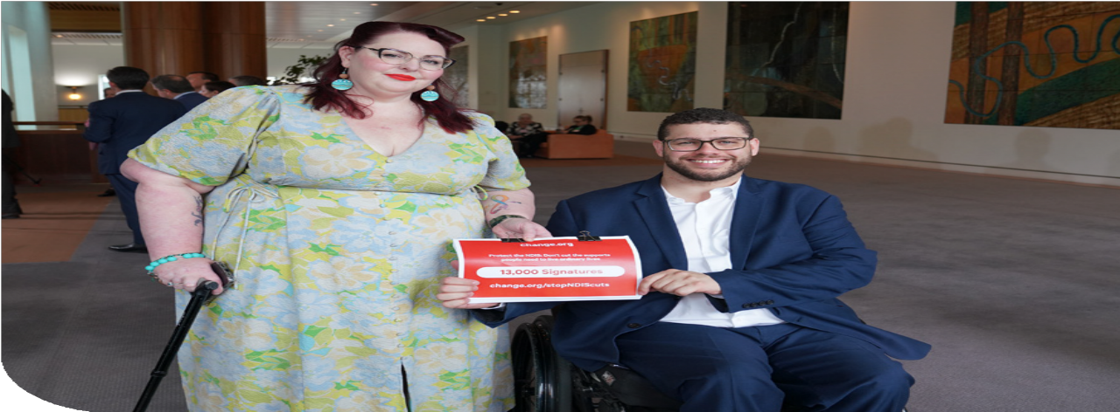
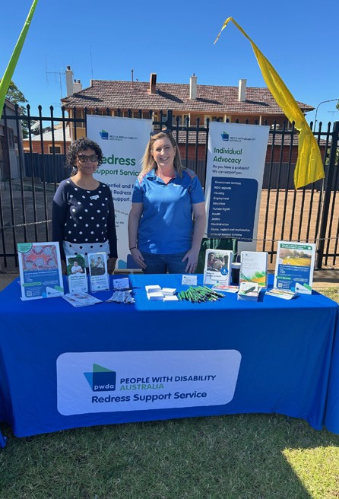

A voice of our own

Acknowledgment of Country
We acknowledge the Traditional Owners of the land where we work and live, and
their continuing connection to land, sea and community. We pay our respects to them, to their cultures and to their Elders both past and present. Always was, always will be Aboriginal land.

Image credits
We are grateful for the contributions of our staff, who have taken images featured in this report, along with photographers who feature their images on various photography websites. We recognise and thank all the members, supporters, staff and people
with disability featured in the photos in this report.

Thank you to our contributors
This report is shaped by the experiences, expertise and leadership of people with disability. PWDA thanks our members, supporters, volunteers and staff whose contributions are featured in this report and who strengthen our advocacy, services and the work we do every day.

Alternative formats
Copies of this document are available in alternative formats from:

People with Disability Australia Ltd. (PWDA)
Postal Address
PO Box 666, Strawberry Hills NSW 2012

Street Address
Suite 10.01, Level 10 Centennial Plaza, 300 Elizabeth Street, Surry Hills NSW 2010
Phone (toll free): 1800 422 015

Email: pwd@pwd.org.au
Translating and Interpreting Service:
13 14 50
National Relay Service: 1300 555 727
Give feedback or lodge a complaint Would you like to provide PWDA with feedback or lodge a complaint about our services or our work? We would be happy to hear from you. You can contact us at feedback@pwd.org.au or free call
1800 422 015. You can also lodge a complaint or provide feedback via our website at pwd.org.au/contact-us.

ACFID Code of Conduct complaints PWDA is a signatory to the Australian Council for International Development (ACFID) Code of Conduct. If you believe PWDA has breached the ACFID Code of Conduct, you may lodge a complaint with the ACFID Code of Conduct Committee at complaints@acfid.asn.au, telephone
+61 2 6285 1816 or contact PWDA.

2 | Annual Report 2025-26

Contents
A reflection from the Board of Directors 4
Message from the Acting CEO 8
About PWDA 10
Our impact and statistics 12
Membership and community engagement 15
Systemic advocacy 20
Individual advocacy 32
Strategic projects and training 39
Training and advisory services 45
Internal culture building and
business improvement 49
Financial report 54

A reflection from
the Board of Directors

People with Disability Australia was built by generations of people with disability who refused to accept exclusion, discrimination and low expectations.
For more than 45 years, PWDA members have challenged governments, changed laws, supported one another and demonstrated that people with disability must be in the room, at the table and leading the decisions that affect our
lives. As directors, we know we are only temporary custodians of that legacy.
Our responsibility is to protect it, strengthen it and leave PWDA in a stronger position for the members and generations of people with disability who come after us.
That responsibility carried particular weight during 2025–26.
People with disability faced a year of profound change to our rights, supports and futures. The biggest changes to the NDIS since its inception were pursued despite sustained opposition and deep concern from people with disability about what they would mean for the supports that keep hundreds of thousands of us safe, independent and able to live ordinary lives. At the same time, the response to the Disability Royal Commission continued to fall well short of the systemic change our community had fought for. For many of us, it was a bitter contrast to see the government find the urgency to pursue
4 | Annual Report 2025-26

sweeping changes to the NDIS while people with disability continued to wait for meaningful action on the discrimination, violence, abuse, neglect and exclusion exposed by the Royal Commission.
As directors, we heard the fear, frustration and anger this created through the work of our organisational teams and directly from our members. As people with disability ourselves, we shared it.
Throughout this period, PWDA continued to stand alongside people with disability and defend our rights. Clients defended their rights through our individual advocacy services. Members shaped submissions, campaigns and consultations. Our staff and volunteers represented Australians with disability at the United Nations, partnered with organisations to improve accessibility and inclusion, delivered training, strategic projects and advisory services, built the evidence needed to influence reform,
and created opportunities for people with disability to connect, participate and lead.

Behind every outcome in this report are the voices of our members, the dedication of our staff and volunteers,
the guidance of our Board and Advisory Groups, and the expertise of people with disability who continue to shape PWDA every day.

Our role as a Board is not to deliver this work. It is to ensure PWDA is governed in a way that keeps the organisation
strong, independent and accountable to its members. Strong governance protects the independence of our advocacy, the quality of our services and the trust our members place in us.
That is why this year we also reflected on how we govern. We identified and formally began significant pieces of reform at the board level to close historic gaps in PWDA's governance infrastructure. This includes dedicated work focused on improving understandings, standards and behavioural expectations in the boardroom and out,
re-centering the requirements of directors to upholding psychological safety, and respect for the expertise of the dedicated and hardworking staff that deliver for our community every day. Because we know, like those who established our amazing organisation, that they can support more people than any one of us can alone.
Members also told us they wanted to better understand how the Board works, what directors do and how they could become involved in strategically leading PWDA. They wanted governance to be more transparent, the Board role to feel more accessible and clearer pathways for members who may one day wish to serve as directors. We listened.
Your feedback shaped much of our work throughout the year. We hosted Board Information Sessions, committed to a Meet the Candidates Forum, improved
information about nominations and elections
and began exploring how we can better support future disability leaders to develop governance skills and confidence. Alongside this work, we commenced a governance review with Social Sector Consulting to strengthen collective decision-making, accessibility, accountability and the long-term effectiveness of the Board.
Whether change begins in the streets, through community campaigns or around the board table, it has always been driven by people with disability working together.
That is why remaining connected to our members was just as important this year as strengthening our governance.
Throughout the year, we joined our community at Midsumma Festival, Sydney Gay and Lesbian Mardi Gras Fair Day and Parade, and supported members
to come together for systemic change through the Reasonable. Necessary. Ordinary. campaign, community forums and consultations. At each of these moments, we were reminded that our Board is strongest when it listens, our advocacy
is strongest when it is shaped by the experiences and expertise of people with disability, and our organisation is strongest when members remain at the heart of everything we do and staff are empowered to deliver their work.
As with every member-led organisation, our Board continued to evolve throughout the year as directors completed their service and new directors brought fresh perspectives, skills and lived experience and expertise to the organisation. We extend our sincere thanks to every Director who served PWDA during 2025–26.

Every director has contributed to PWDA in different ways, and together we have remained united by a shared commitment to advancing the rights, leadership and representation of people with disability.
This year also marked an important period of executive leadership transition. We thank Sebastian Zagarella, who has now concluded his time as Chief Executive Officer (CEO) after leading PWDA since 2020. As CEO Sebastian worked alongside members, staff and the Board through a period of significant organisational growth, national advocacy and reform. We thank him for his contribution to PWDA and wish him every success for the future.
We also extend our sincere thanks to Megan Spindler-Smith, whose ongoing leadership as Acting Chief Executive Officer has provided continuity during a period of significant disability reform and organisational transition. Megan has led with integrity, compassion and an unwavering commitment to PWDA's mission, ensuring the organisation has
continued to deliver for members, clients and the broader disability community.
Good governance is never finished.
It requires us to keep listening, keep learning and remain accountable to the people we represent. The work we began this year is only the beginning, and we remain committed to strengthening the way we govern so PWDA continues to be a strong, independent and member-driven organisation.
On behalf of the Board, thank you to our members, staff, volunteers, Advisory Group members, partners and supporters.
Every campaign, submission, advocacy outcome, training session, consultation and conversation reflects the collective effort of people committed to advancing the rights of people with disability.
It is a privilege to serve this community. We know there is still much work ahead,
but we also know what people with disability can achieve when we come together.
Thank you for trusting us to play our part.

In solidarity,
The PWDA Board of Directors









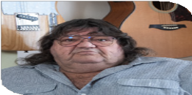
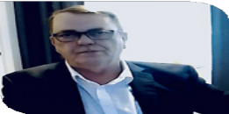


Directors who served during the year were:

Alexandra Bignell

Daniel Flynn

Stephanie Travers

Tahlia-Rose Vanissum

Wildaliz De Jesús Arocho

Jarrod Sandell-Hay
Jeramy Hope

Eva Sifis

Kevyn Morris

Stuart Mawbey

Priscilla Brice

Trinity Ford

Message from the Acting CEO

The 2025–26 year has been one of significant reform, organisational growth and resilience for our community. Across Australia, people with disability experienced considerable uncertainty as governments progressed major policy reforms with
far-reaching implications for rights, supports and inclusion. Throughout this period, PWDA remained steadfast in our commitment to ensuring that the voices, lived experience, expertise and leadership of people with disability were at the centre of these conversations.
As a disability-led organisation, we understand that change is constant.
Our responsibility is not only to respond to that change, but to provide stability for our members, our staff and broader disability community.
Throughout the year, we worked alongside Disability Representative Organisations and our members to influence national discussions on NDIS reform, contributing to parliamentary inquiries, government consultations and public debate through submissions, evidence, campaigns and direct engagement with decision-makers. Our Reasonable. Necessary. Ordinary.
campaign reinforced an important message: the NDIS exists to enable people with disability to participate in ordinary life, and reforms must strengthen, not diminish, our choice, control and inclusion.
At the same time, we continued advocating for stronger human rights protections at both state and national levels, supported people with disability to participate
directly in government consultations, and represented disability-led perspectives nationally and internationally.
In February we supported 50 people with disability to attend the Australian Disability Strategy National Forum in Adelaide, providing over $25,000 in direct funding to remove cost barriers.
While in June PWDA representatives joined other members of the Australian delegation including government and civil society representatives at the United Nations Headquarters in New York for the 19th session of the Conference of States Parties to the CRPD (COSP19).
Alongside our advocacy, we continued creating opportunities for connection, leadership and community participation. From A Voice of Our Own on International Day of People with Disability to our InFocus: Queer & Disabled storytelling campaign, community forums, workshops and consultation opportunities, we remained committed to amplifying diverse voices and creating spaces where people with disability could lead, connect and influence change.
One of the achievements I am particularly proud of this year has been the continued strengthening of our organisational culture.

The launch of our staff-led values reflects who we are as an organisation and how we choose to work together. This commitment was recognised through a significant increase in employee engagement
and wellbeing, culminating in PWDA receiving a Change Champions Award for organisational engagement. While awards are meaningful, the true achievement lies in creating a disability-affirming workplace
where our people feel connected, supported and empowered to deliver lasting impact for our members and community.
Like many organisations across the disability sector, PWDA continued to operate within an environment of increasing demand and limited resources. Throughout these challenges, our staff demonstrated remarkable resilience, innovation and commitment. By working collaboratively, strengthening partnerships and embracing shared leadership, we continued to deliver high-quality systemic and individual advocacy. It is important to recognise that, for most PWDA staff, myself included, the challenges and changes we worked so hard to respond to were not simply changes at
a policy level, they were realities we were living ourselves. While experiencing the same uncertainty, barriers and impacts as our community, we remained steadfast in supporting our members, clients and the broader disability community. This is,
and remains, one of the quietest and most demanding aspects of lived expertise.
I would like to sincerely thank our members, whose lived experience, leadership and willingness to share their stories continue to
shape every aspect of our work. Your voices give purpose to our advocacy and ensure
it remains authentic, community-led and focused on the issues that matter most.
My thanks also go to the PWDA Board for their guidance, governance and commitment throughout a period of significant change, and to our staff whose expertise, empathy and dedication to our
community, continue to strengthen both our organisation and Australia’s disability rights movement.
Finally, I acknowledge our government funders, Disability Representative Organisation colleagues, community organisations, researchers and sector partners. Your collaboration demonstrates what is possible when we work together to advance the rights, leadership and inclusion of all people with disability.
As we look to the year ahead, PWDA will continue advocating for reforms that
uphold human rights, strengthen disability leadership and ensure every person with disability can participate fully and equally in Australian society.

Megan Spindler-Smith
Acting Chief Executive Officer
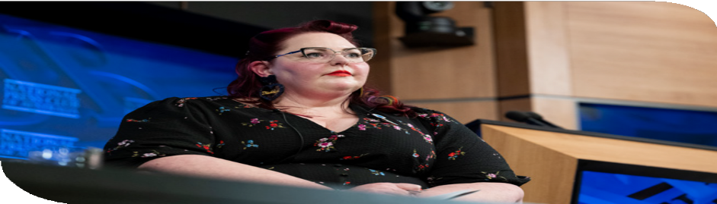

About PWDA

People with Disability Australia (PWDA) is a national peak organisation representing and advocating for the rights of people with disability. We are led by and for people with all kinds of disability.
Founded in 1981, PWDA is a not-for-profit, community-based and member-driven organisation. Our membership is made up of people with disability and
organisations mainly constituted by people with disability. In July 2024, PWDA received funding to serve as the national Disability Representative Organisation for LGBTQIA+ people with disability.
We work both nationally and internationally, and our work is grounded in a human rights framework that recognises the United Nations human rights conventions and related mechanisms as fundamental tools for advancing the rights of people with disability.
We deliver our programs, services and activities in partnership with our members and supporters as well as a variety of stakeholders across government, disability, education and research sectors.
We receive funding from various sources, including the Australian, New South Wales and Queensland Governments, and donations from our supporters.
We live our dream. We have a clear vision for the purpose and impact of our work and have a comprehensive set of values, beliefs and principles that guide and inspire our work.

Our vision
We have a vision of a socially just, accessible and inclusive community, in which the human rights, belonging, contribution, potential and diversity of
all people with disability are recognised, respected and celebrated with pride.

Our purpose
Our purpose is to be a leading disability rights, advocacy and representative organisation of and for all people with disability, which strives for the realisation of our vision of a socially just, accessible, and inclusive community.

Strategic plan summary (2022–2026)
- Represent Remain the leading national cross-disability member-driven organisation.
- Advocate Advocate for the human rights of people with disability at individual and systemic levels.
- Educate Drive positive change through education, training and advocacy.
- Sustain Maintain a financially viable, sustainable and inclusive organisation.

Represent
Remain the leading national cross-disability member driven
organisation. Reflect the diversity of our community and represent their voice nationally and internationally.
Advocate
Advocate for the human rights of all people with disability at individual and systemic levels.

Educate
Drive positive change for people with disability through education and advocacy.

Sustain
Maintain a financially viable and
sustainable organisation.

Our impact and statistics

Community and member engagement

19% increase in membership
433,000 website visitors
2.5 million people reached on social media

Amplifying disability voices
99 media releases, news articles and blogs published
3,440 media mentions

Systemic advocacy and engagement 44 reports, submissions and position statements 27 member focus groups, consultations and events 29 training sessions delivered to 1,031 participants

Our organisation
62 staff members employed nationally

Individual advocacy

1,859 advocacy clients supported
35,872 occasions of client service

12

I am better able to deal with issues that I sought help with
81% of respondents rated this as high or very high

The service listened to me and understood my issues
92% of respondents rated this as high or very high

Individual advocacy client outcomes

I am satisfied with the services I have received
93% of respondents rated this as high or very high

I would like to acknowledge the excellent support I received from my advocate. They were extremely
helpful in assisting me with my housing maintenance
issues…They communicated effectively, followed
up on the matter, and made sure my concerns
were taken seriously.
PWDA Individual Advocacy client

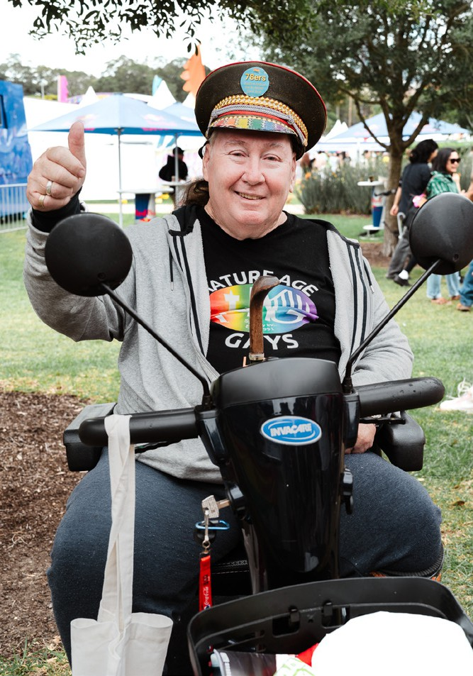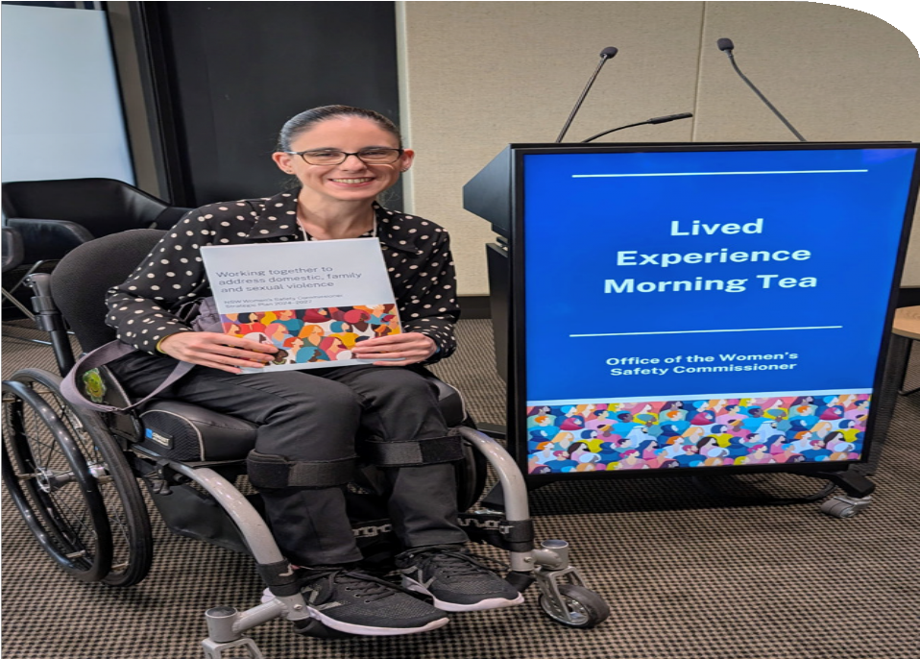
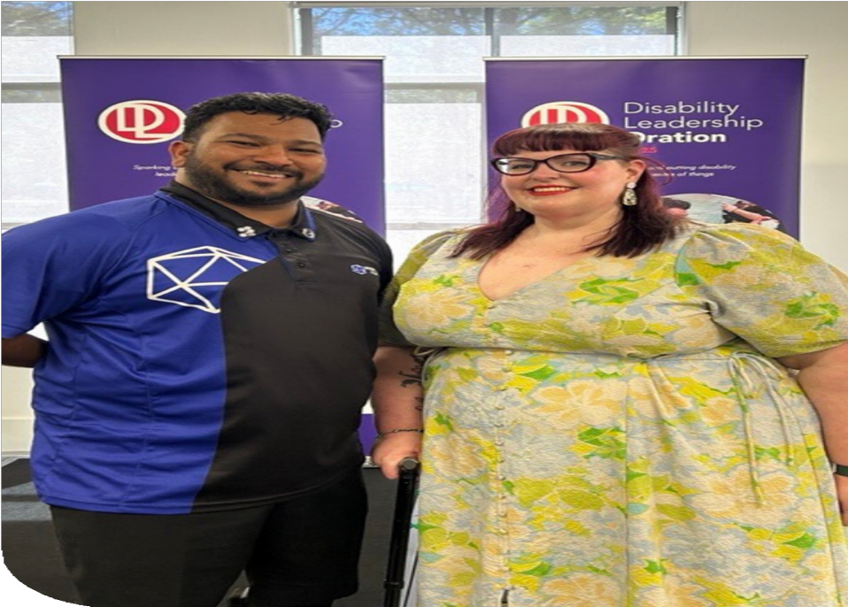


Membership and
community engagement
During 2025–26, PWDA membership grew by 19%. We also created more opportunities for members to have a say through consultations, events, webinars and campaigns. This helped
ensure our advocacy was shaped by the experiences, expertise and priorities of people with all kinds of disability across Australia.

Elevating disability voices

Members played a central role in shaping PWDA’s work throughout the year. Their lived experience and expertise informed government submissions and advocacy priorities, while member stories helped bring disability voices and experiences directly into our campaigns, media and public conversations.
We also brought members together through events and community forums, creating opportunities to connect with each other and hear from new voices, including members who joined us as speakers, presenters and performers.
PWDA member, Margie McCumstie hosted PWDA’s InFocus: Queer & Disabled online event, held on 18 February 2026.

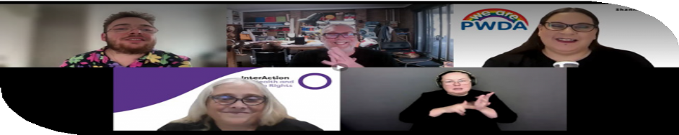

In sharing our experiences, our lived realities and our needs, we shine a light on our community.

Margie McCumstie

15

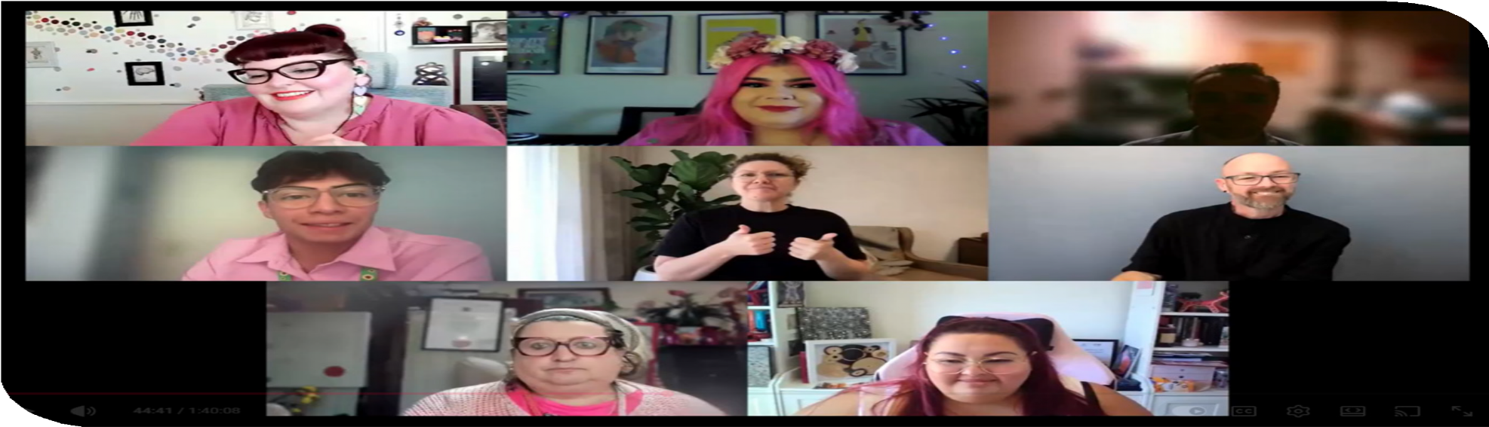
PWDA A Voice of Our Own national online conference.

Key activities

- A Voice of Our Own, PWDA’s national online conference for International Day of People with Disability
- National community forums and consultations on NDIS reforms
- Two Years on from the Disability Royal Commission community forum, reflecting on progress towards implementing the Royal Commission’s recommendations
- National Redress Scheme webinar
- InFocus: Queer & Disabled online event and storytelling campaign
- Participation in Sydney Gay and Lesbian Mardi Gras and Midsumma, celebrating the experiences of LGBTQIA+ people with disability
- PWDA Member Mingles and Board information sessions
- PWDA Annual General Meeting (AGM) was held for members on Thursday
13 November 2025.

Strengthening PWDA’s national voice

PWDA continued to bring the perspectives of people with disability into public debate and national media. Throughout the year, major news outlets regularly sought PWDA’s expert commentary on disability rights
and public policy, with coverage across ABC, SBS, Seven, Nine, Network 10, The Guardian, The Sydney Morning Herald, The Age, The West Australian, AAP and other national and international media.
Our media advocacy focused on issues
affecting people with disability, including:
- proposed NDIS reforms and participant safeguards
- accessible transport, public toilets and aviation
- inclusive education
- disability employment
- safeguarding and restrictive practices
- supported decision-making
- emergency management
- broader disability rights and human rights issues.

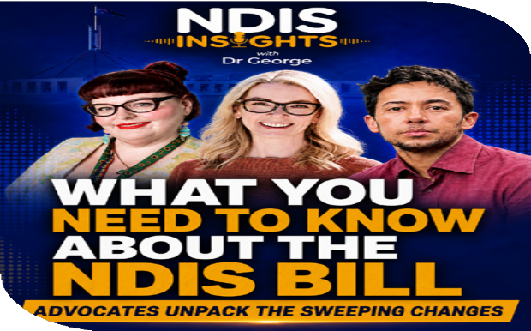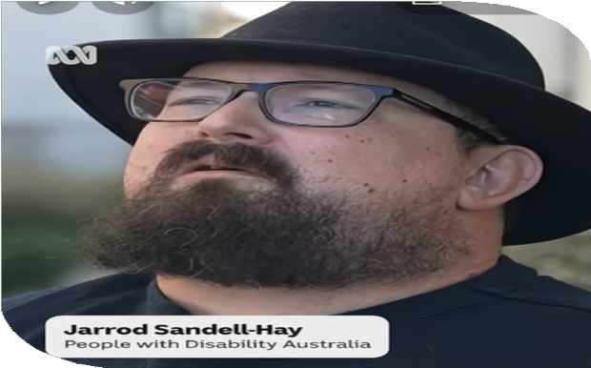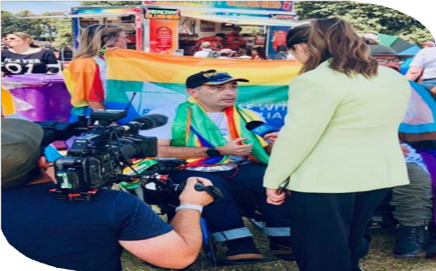

PWDA partnered with Dr George Taleporos’ NDIS Insights podcast on a limited three-episode series about the NDIS changes. Pictured are Megan Spindler-Smith, Skye Kakoschke-Moore and
Dr Stevie Lang Howson.
PWDA Vice President Jarrod Sandell-Hay.
Jeramy Hope, PWDA President at the time,
at Midsumma.

A significant focus of our public messaging during the year was PWDA’s Reasonable. Necessary. Ordinary. campaign. Informed by the stories, concerns and priorities of our members and the broader disability community, the campaign launched ahead of Minister Mark Butler’s National Press Club address announcing proposed
NDIS reforms. From there, PWDA led a sustained advocacy and media campaign opposing the cuts and working to keep the experiences and expertise of people with disability at the centre of public and policy debate.
This year PWDA achieved 3,440 media mentions. Our communications reached a further 2.5 million people through social
media while almost 80,000 people followed PWDA across our social media channels.
PWDA’s website continued to be a trusted source of disability information, attracting 433,000 users during the year. Strong interest in resources on disability rights, NDIS reform, the social model of disability and PWDA’s language guide reflected
our community’s ongoing demand for accessible, rights-based information.

Designing accessibility with people with disability
This year PWDA strengthened its commitment to ensuring accessibility is designed with people with disability, not simply for people with disability.
In March 2026, we launched the Accessibility Review Network, bringing together people with disability with diverse lived experience and accessibility expertise to undertake paid reviews of websites, digital products, publications and services.
Beyond strengthening PWDA’s own capability, the Network also enables PWDA to support government, community and private sector organisations to improve accessibility while recognising lived experience as professional expertise.
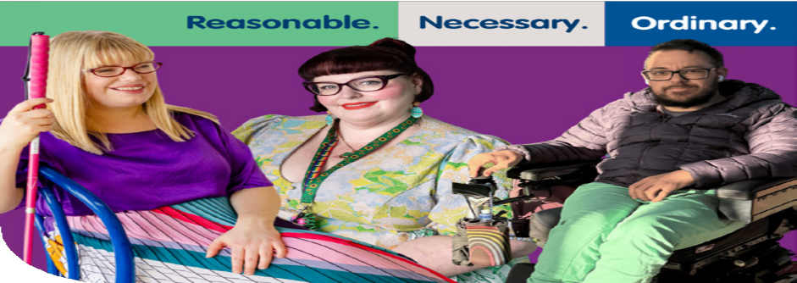
Throughout the year, PWDA improved the accessibility of our communications by redesigning our digital newsletter, introducing Easy Read survey capability, developing accessible communication templates, improving website content and governance, introducing post-
event evaluations and strengthening communications planning across the organisation.

Together, these initiatives made it easier for people with disability to access information, engage with PWDA and participate in our work.

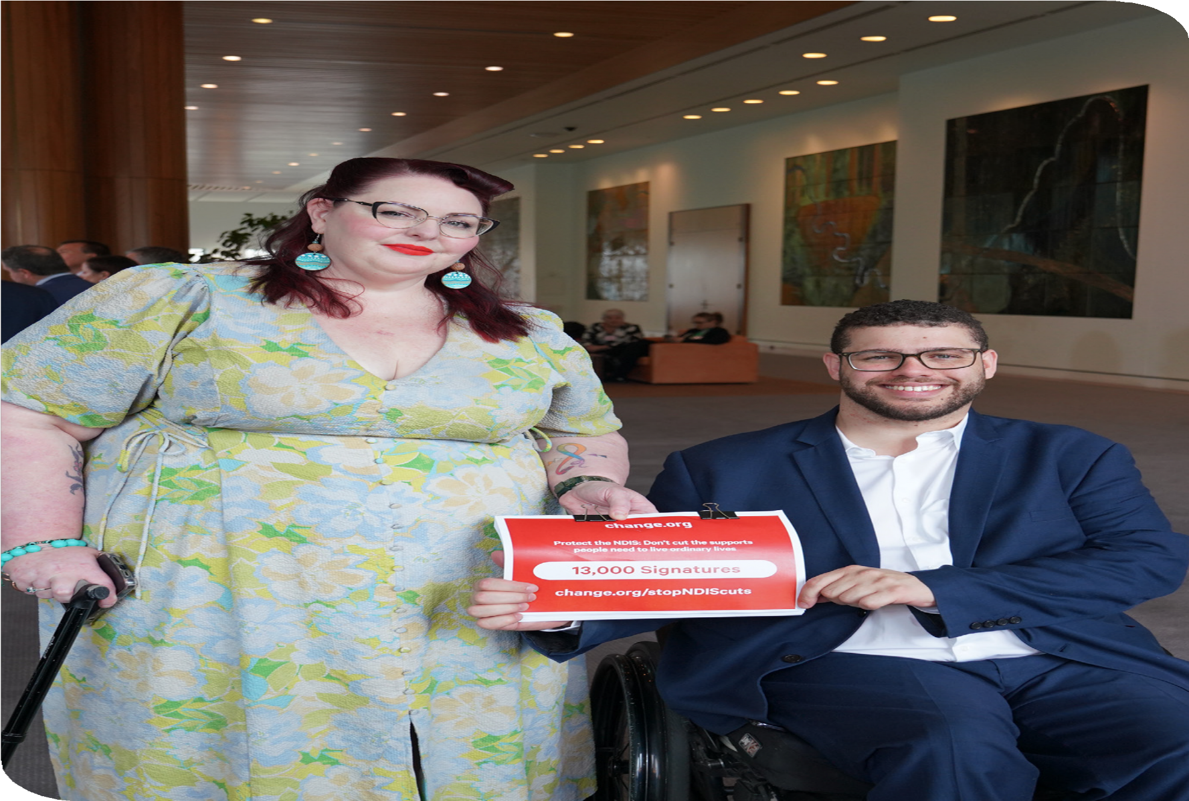
PWDA Acting CEO Megan Spindler-Smith hands over PWDA's petition regarding the NDIS cuts to Senator Jordon Steele-John.

Systemic advocacy
Informed by the lived experience of our members and community, throughout 2025–26 PWDA addressed some of the most significant disability rights issues at state, national and international levels.

Working alongside members, governments, Disability Representative Organisations and cross-sector partners, we provided expert policy advice, developed submissions, appeared before parliamentary inquiries, participated in advisory groups and led public campaigns to advance human rights and meaningful reform. Our advocacy focused on ensuring that people with disability are actively involved in shaping the decisions that affect our lives.

National advocacy priorities

Protecting the future of the NDIS
Protecting the rights of NDIS participants remained PWDA’s highest national advocacy priority. The proposed National Disability Insurance Scheme Amendment (Securing the NDIS for Future Generations) Bill 2026 represented one of the most significant reforms to the NDIS since its introduction.
PWDA developed a submission containing 44 recommendations, worked alongside other Disability Representative
Organisations on a joint submission, met directly with Ministers, Members of Parliament and Senators, and presented evidence to the Parliamentary Inquiry.
Alongside this work, thousands of people with disability and allies joined the Reasonable. Necessary. Ordinary. campaign.
The campaign helped people understand what the proposed reforms meant for their everyday lives while creating practical ways for people to have their voices heard by Parliament. It generated more than 21,400 petition signatures, 7,117 Parliamentary e-petition signatures, 543 emails to Members of Parliament, more than 1,000 downloads of PWDA’s Senate Inquiry submission template and over 140 lived experience stories. It also supported community participation in the Senate Inquiry, which received more than 4,000 submissions.
PWDA’s advocacy contributed to increased public and parliamentary scrutiny of the Bill. Parliamentary committees recommended amendments, and additional safeguards
for participants were secured during negotiations. While these changes represented important progress, they do not address PWDA’s fundamental concerns.

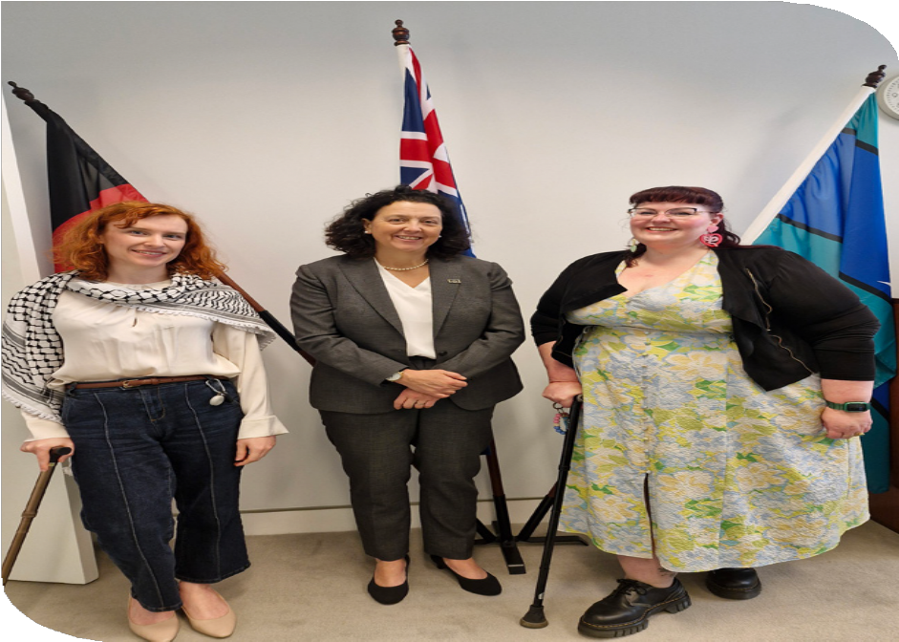
Trinity Ford, PWDA President at the time, Dr. Monique Ryan and PWDA Acting CEO
Megan Spindler-Smith.

PWDA continues to oppose the Bill and remains concerned it will result in people with disability losing access to essential supports. Our advocacy will continue until the NDIS delivers on its original promise: a rights-based scheme that provides people with disability the reasonable and necessary supports they need to live with choice, control and dignity.

2026–27 Federal Budget
The 2026-27 Federal Budget reduced projected NDIS funding by $37.8 billion over four years while introducing the first Commonwealth investment in Foundational
Supports. PWDA remained deeply concerned that the Budget reduced the supports people with disability rely on to live ordinary lives without ensuring equivalent supports were available to replace them.
Ahead of the Budget, PWDA developed a comprehensive Pre-Budget Submission informed by the experiences and priorities of our members and the broader disability community. Our recommendations called for stronger investment in disability supports, action on poverty and housing insecurity, stronger human rights protections and greater investment in disability-led research and genuine co-design.
Throughout the Budget debate, PWDA consistently advocated that no person with disability should lose essential supports until equivalent replacement supports are fully funded, available, accessible and proven
to meet people’s needs. We also called for greater transparency around proposed NDIS cuts, stronger safeguards for NDIS participants and sustained investment in
community supports that enable people with disability to participate equally in society.
PWDA’s advocacy helped keep the voices and priorities of people with disability at the centre of national debate on the Budget and NDIS reform. We will continue advocating for governments to honour the original promise of the NDIS and ensure any reforms strengthen the rights, choice and support available to people with disability.

Disability Royal Commission
Two years after the Disability Royal Commission’s Final Report, PWDA continued working to ensure its recommendations remained central to disability reform and that governments remained accountable for delivering the changes people with disability were promised.
Following the release of the Australian Government’s 2025 Progress Report, PWDA reviewed progress against the Royal Commission’s recommendations and our own advocacy priorities, identifying where meaningful change had occurred and where significant gaps remained. Through our
Two Years On from the Disability Royal Commission event, people with disability came together to reflect on progress, share their experiences and identify the reforms they believe governments should prioritise next. Their experiences continue to guide PWDA’s advocacy and reinforce that meaningful reform must be co-designed with people with disability and implemented.

Strengthening human rights protections
PWDA continued advocating for stronger legal protections for people with disability through the review of the Disability Discrimination Act 1992 (Cth) and ongoing calls for a national Human Rights Act.
More than 300 people with disability contributed to a national survey that informed PWDA’s submission to the Disability Discrimination Act review. Drawing directly on the experiences shared by people with disability, our submission recommended stronger legal protections,
a positive duty and better recognition of disability rights in Australian law. PWDA is co-leading with Women With Disabilities Australia a key working group that has been engaging with the Attorney General directly to ensure a disability community focused approach.

Improving emergency preparedness
People with disability continue to face disproportionately high risks during disasters and emergencies. The Disability Royal Commission found that people with disability are four times more likely to lose their lives during disasters, highlighting the urgent need for emergency responses that are accessible, inclusive and designed with people with disability.
Throughout the year, PWDA worked with the National Emergency Management Agency (NEMA) and governments to improve accessibility and inclusion in emergency planning. PWDA provided advice during
the development of the AusAlert system and called for improved testing for people with disability in rural and remote areas and who rely on older technology. PWDA also contributed to government responses to fuel security and highlighted the importance

of maintaining essential disability supports during emergencies.
Drawing on research and the experiences shared by people with disability, PWDA advocated for more accessible emergency alerts, better transport planning during evacuations and stronger coordination across health, energy and transport systems. This work has contributed to improvements in the development of AusAlert and greater recognition of disability needs in emergency and fuel security planning.
While progress has been made, PWDA continues to advocate for emergency systems that recognise the rights, expertise and needs of people with disability before, during and after disasters.

Making aviation more accessible
Accessible air travel remains a significant human rights issue for people with disability. Many people continue to experience discrimination, damaged assistive technology, unsafe travel conditions and barriers that limit participation in work, education, healthcare and community life.
Throughout the year, PWDA worked in partnership with the Federal Department of Infrastructure, Transport, Regional Development, Communications, Sport and the Arts (DITRDCSA), the Australian Federation of Disability Organisations, and the Justice and Equity Centre (JEC) to co-design Australia’s new Disability
Aviation Standards. We advocated for a process that recognised lived experience as expertise, brought together people with diverse disability experiences, including young people with disability, and ensured
participants were appropriately remunerated for their contribution.
The draft Standards represent an important opportunity to improve accessibility,
safety and dignity for people with disability travelling by air. The project also demonstrated how genuine partnership
with people with disability leads to stronger policy and better outcomes than designing systems without those most affected.
PWDA also completed submissions on Aviation Consumer Protection Principles, Regional Airfares.
This work builds on decades of advocacy by PWDA members and the broader disability community, whose experiences continue
to drive reform towards a fairer and more accessible aviation system.
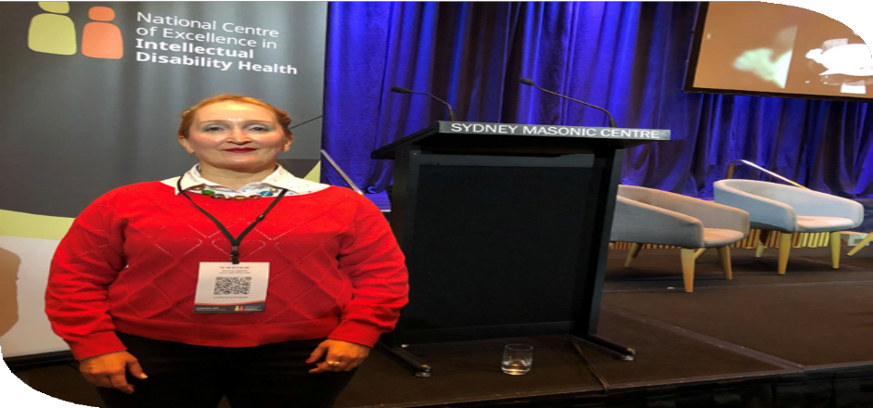
PWDA Senior Policy Officer Bastien Wallace.

Health equity
People with disability continue to experience poorer health outcomes than the broader community, often because healthcare is inaccessible, services are not designed to meet disability needs and barriers such as inaccessible transport prevent people from getting the care they need.
Throughout the year, PWDA influenced national health reforms by contributing to the Strengthening Medicare consultation, reviews of the National Safety and Quality Health Service Standards and the Optimal Cancer Care Pathway, while working with Cancer Australia to improve the accessibility of cancer screening, treatment and support services.
Our advocacy has helped ensure disability
perspectives are reflected in national health

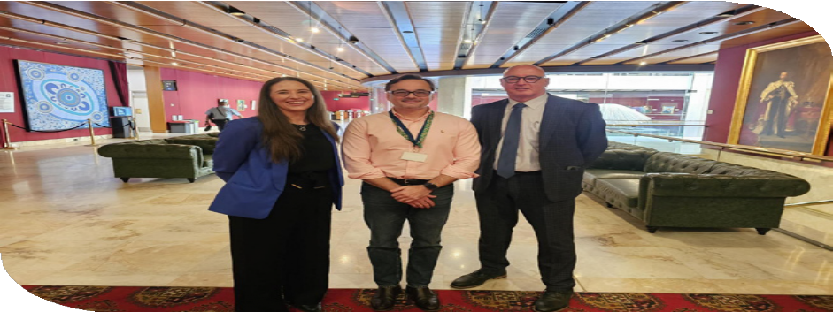
(left to right) Lowri Williams, State Manager NSW, National Disability Services, PWDA Senior Policy Officer Julian Laurens and Brett Thompson, CEO, Interaction Disability Service, at the NSW Parliamentary inquiry into supported decision-making for adults with disability and older people in NSW.
reforms and reinforced a simple principle: people with disability should receive
the same timely, safe and high-quality healthcare as everyone else.

Protecting human rights in automated decision-making
As governments increasingly use artificial intelligence and automated decision-making to deliver services, PWDA continued advocating to ensure technology strengthens, rather than undermines, the rights of people with disability.
Throughout the year, PWDA contributed to national reforms on artificial intelligence and automated decision-making, including Australia’s Artificial Intelligence Ethics Framework and guidance for government decision-making. Our advocacy called
for strong safeguards, transparency and meaningful human oversight wherever technology is used to make decisions that affect people’s rights, access to supports and participation in the community.
Drawing on lessons from previous harmful automated government decision-making in Australia, PWDA advocated for systems that people can understand, question and
challenge. We consistently called for human decision-makers to remain accountable
for decisions affecting access to essential supports and services, including the NDIS, aged care and healthcare.

As governments continue introducing new technologies, PWDA will continue
advocating for digital systems that are fair, transparent and accountable, ensuring people with disability remain at the centre of and are able to challenge decisions that affect their lives.

NSW advocacy priorities

Human Rights Act
Securing a national Human Rights Act remains a priority for PWDA. While this work continues, 2025–26 saw significant progress towards stronger human rights protections in NSW. After sustained advocacy, the NSW Government established a Parliamentary Inquiry into a Human Rights Act, delivering on its election commitment to consult on reform. The Inquiry was a significant win
for people with disability and the broader human rights community, and an important step towards stronger legal protections for everyone in NSW.
As a core member of the Human Rights Act for NSW Alliance, PWDA worked
alongside legal, community and human rights organisations to advocate for the Inquiry through sustained advocacy, public campaigning and engagement with Parliament. Following the Inquiry’s establishment, PWDA prepared a submission calling for a Human Rights Act that protects the rights of people with
disability and requires government agencies and other public authorities to consider human rights when making decisions and delivering services.
Our submission drew directly on the experiences shared by PWDA members, highlighting the need for stronger protections against discrimination, violence, abuse, neglect and exclusion. The Inquiry provides an important opportunity for people with disability to help shape future human rights laws in NSW and strengthen accountability across government and public services.
The Inquiry demonstrates that sustained, collective advocacy can lead to meaningful change. PWDA will continue working with members and Alliance partners to ensure any future Human Rights Act delivers stronger protections for people with disability.

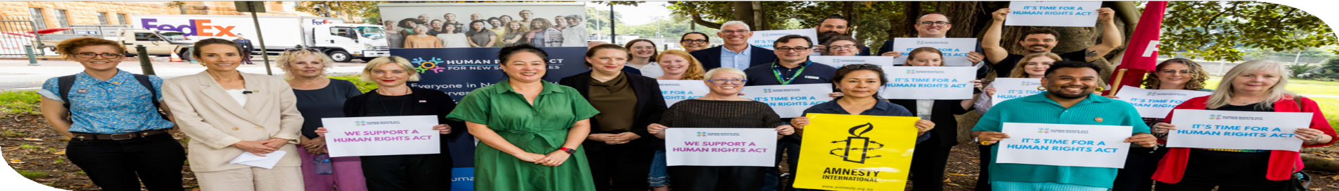
Representatives from the Human Rights Act for NSW Alliance.

Foundational supports
PWDA continued to advocate nationally for fully funded Foundational Supports that
people with disability can rely on, wherever they live. We do not want to see a postcode lottery where access to support depends on which state or territory a person lives in.
In NSW, we worked directly with government to help shape how Foundational Supports would be designed and rolled out. As a member of the NSW Department of Communities and Justice Foundational Supports Advisory Group,
PWDA pushed for people with disability to be involved in designing the new supports from the start and throughout implementation. We also advocated for
supports to be fair, culturally safe and able to meet people’s needs throughout their lives.
During the year, the NSW Government committed $631.9 million over five years to Thriving Kids, the first phase of Foundational Supports. Together with Australian Government funding, up to
$1.074 billion will be available for Thriving Kids services in NSW.
This was an important step, but there is much more to do. Thriving Kids is only the first phase of Foundational Supports, and significant questions remain about what will be available for other people with disability, who will be able to access it and whether supports will be available when and where people need them.
PWDA’s position is clear: no one should lose essential disability supports before
suitable alternatives are in place and meeting their needs. We will continue pushing governments to build a strong system of Foundational Supports for children, young people and adults with disability across Australia.

Accessible public toilets
Access to safe, accessible public toilets is fundamental to dignity, independence
and community participation. Yet for many people with disability, the lack of suitable public toilets continues to limit where they can go, how long they can stay and whether they can participate in everyday life.
This year, PWDA brought the experiences of people with disability directly to the NSW Parliamentary Inquiry into public toilets through a comprehensive submission and evidence calling for a coordinated, state-wide approach to planning, building and maintaining accessible public toilets. Our recommendations included stronger co-design, legislative protections and greater government oversight to ensure accessible public toilets meet the diverse needs of people with disability.
Following the Inquiry, PWDA continued advocating for reform after the NSW Government declined to support many of the Committee’s recommendations.
Through sustained media advocacy and ongoing engagement with parliamentarians, PWDA continued calling for a state-wide plan that recognises accessible public toilets as essential public infrastructure, not an optional amenity.

Our advocacy was driven by the experiences of PWDA members and the broader disability community, whose
stories continue to demonstrate that access to an accessible public toilet is often
the difference between participating in
community life and staying home.

International advocacy

Holding Australia accountable
International human rights advocacy remained a key priority throughout the year. By engaging with United Nations human rights processes, PWDA worked to hold Australia accountable to its obligations under the Convention on the Rights of Persons with Disabilities (UNCRPD) and other international human rights treaties.
PWDA contributed evidence to Australia’s reviews under the International Covenant on Economic, Social and Cultural Rights and the Universal Periodic Review, working alongside disability and human rights organisations, including National Ethnic Disability Alliance and Women With Disabilities Australia, to highlight the experiences of people with disability. Our advocacy reinforced the need for stronger
action on the Disability Royal Commission’s recommendations, NDIS reform, accessible housing, employment, education, health, social security and protection from violence and discrimination.

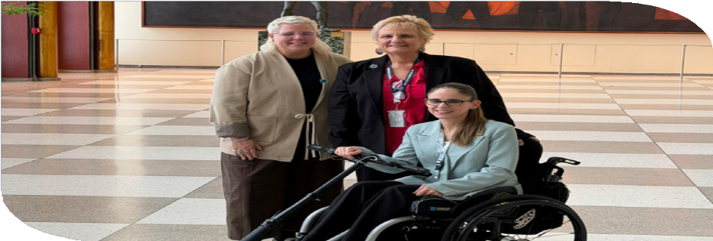
PWDA representatives Bobbie Trower and Lee-Anne Pringle with PWDA Board Director Stephanie Travers at COSP19.

The recommendations arising from these reviews reinforced many of PWDA’s longstanding advocacy priorities, providing an important platform to continue pushing for change in Australia.

Representing Australians with disability at the United Nations
PWDA representatives Bobbie Trower and Lee-Anne Pringle represented Australians with disability at the 19th Session of the Conference of States Parties (COSP19) to the United Nations Convention on the Rights of Persons with Disabilities in New York. As part of the Australian delegation,
they brought the experiences, expertise and priorities of people with disability in Australia to international discussions on disability rights.
Throughout the conference, Bobbie and Lee-Anne delivered interventions calling for genuine co-design, the right to supported decision-making and greater recognition

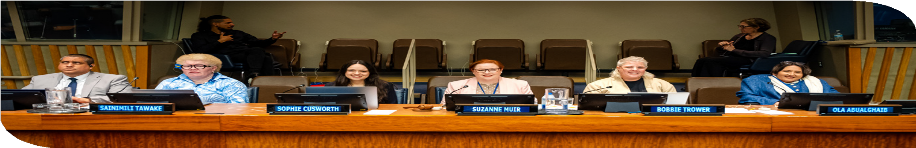
Nothing About Us Without Us All COSP19 side event panel.

of the experiences of people with disability who face multiple and intersecting forms of discrimination. Their message was clear: people with disability must be involved
in decisions that affect our lives, from identifying problems through to designing solutions, making decisions and reviewing outcomes.
Together with the Australian Government Department of Health, Disability and Ageing, Women With Disabilities Australia, the International Disability Alliance, the UN Global Disability Fund and the Pacific Disability Forum, PWDA co-hosted
Australia’s official side event, Nothing About Us Without Us All. The event demonstrated how genuine co-design leads to better policies, services and systems by sharing practical examples of governments working in partnership with people with disability.
By representing our members on the international stage, PWDA helped ensure the voices of people with disability in Australia informed international human rights discussions while strengthening our advocacy for change here at home.

Recognising the intersection of disability and modern slavery
PWDA’s sustained advocacy helped secure international recognition of the heightened risk of modern slavery faced by people
with disability, an issue that has historically received little attention in Australia or internationally.
Following disability-specific submissions by PWDA and a national roundtable bringing together people with disability and representative organisations, the United Nations Special Rapporteur on Contemporary Forms of Slavery dedicated part of his report on Australia to the experiences of people with disability. The report recognised the heightened risks
of exploitation experienced by people
with disability and reflected many of the issues consistently raised through PWDA’s advocacy.
The report has since informed national and international efforts to strengthen responses to modern slavery. Its findings have been

referenced by the Australian Institute of Criminology and reflected in the 2025 United States Trafficking in Persons Report, helping ensure disability is increasingly recognised as a critical human rights
issue in efforts to prevent exploitation and trafficking.
LGBTQIA+ advocacy priorities
PWDA is funded by the Australian Government to act as the national Disability Representative Organisation for LGBTQIA+ people with disability. This year we continued working to ensure the experiences and expertise of LGBTQIA+ people with disability are recognised
in policy, healthcare and human rights advocacy.
A major milestone this year was the release of findings from PWDA’s national survey of 974 LGBTQIA+ people with disability. Co-designed with people with lived experience, the survey provides one of Australia’s most comprehensive insights into the barriers, strengths and priorities of LGBTQIA+ people with disability. The findings are already informing government engagement, national advocacy, PWDA’s policy priorities, Australia’s first LGBTQIA+ and Disability Affirming Healthcare Guidelines, and international advocacy through the United Nations.
PWDA also continued improving access to inclusive healthcare by working with an LGBTQIA+ people with disability Advisory
Group, Inclusive Rainbow Voices, Centre for Family Research and Evaluation and healthcare partners to develop LGBTQIA+ and Disability Affirming Healthcare Guidelines. Co-designed with the community and supported by funding from nib Foundation, the national Guidelines will help healthcare professionals deliver safer, more inclusive care for LGBTQIA+ people with disability.
Throughout the year, PWDA increased the visibility of LGBTQIA+ people with disability through national and international advocacy, including representing LGBTQIA+ people with disability at the United Nations, creating opportunities for LGBTQIA+ people with
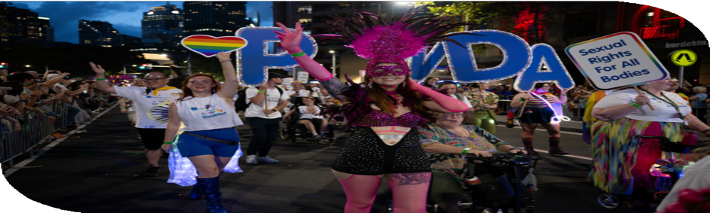
PWDA members participating in the 2026 Sydney Gay and Lesbian Mardi Gras Parade.
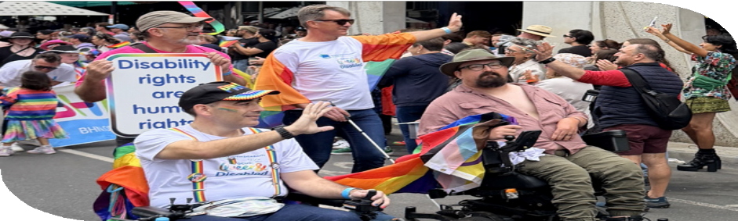
PWDA members participating in the 2026 Midsumma Pride March.

disability to participate in community activities such as Midsumma, Sydney Gay and Lesbian Mardi Gras and PWDA's own InFocus storytelling campaign and event. We also worked with governments and community organisations to ensure LGBTQIA+ disability perspectives were reflected in broader human rights and disability reform.
By combining lived experience, research and partnerships, PWDA continued to strengthen recognition of the rights of LGBTQIA+ people with disability and ensure their voices are reflected in the policies, services and decisions that affect their lives.

Acknowledgements
PWDA acknowledges the funding it receives from the Australian Government’s Department of Health, Disability and Ageing Disability Representative Organisations Program to undertake nationally focused systemic advocacy.
PWDA acknowledges the funding it receives from the National Disability Insurance Agency to support co-design activities.
PWDA acknowledges the funding it received from the Australian Government’s Department of Social Services to attend the 19th Session of the Conference of States Parties (COSP19).

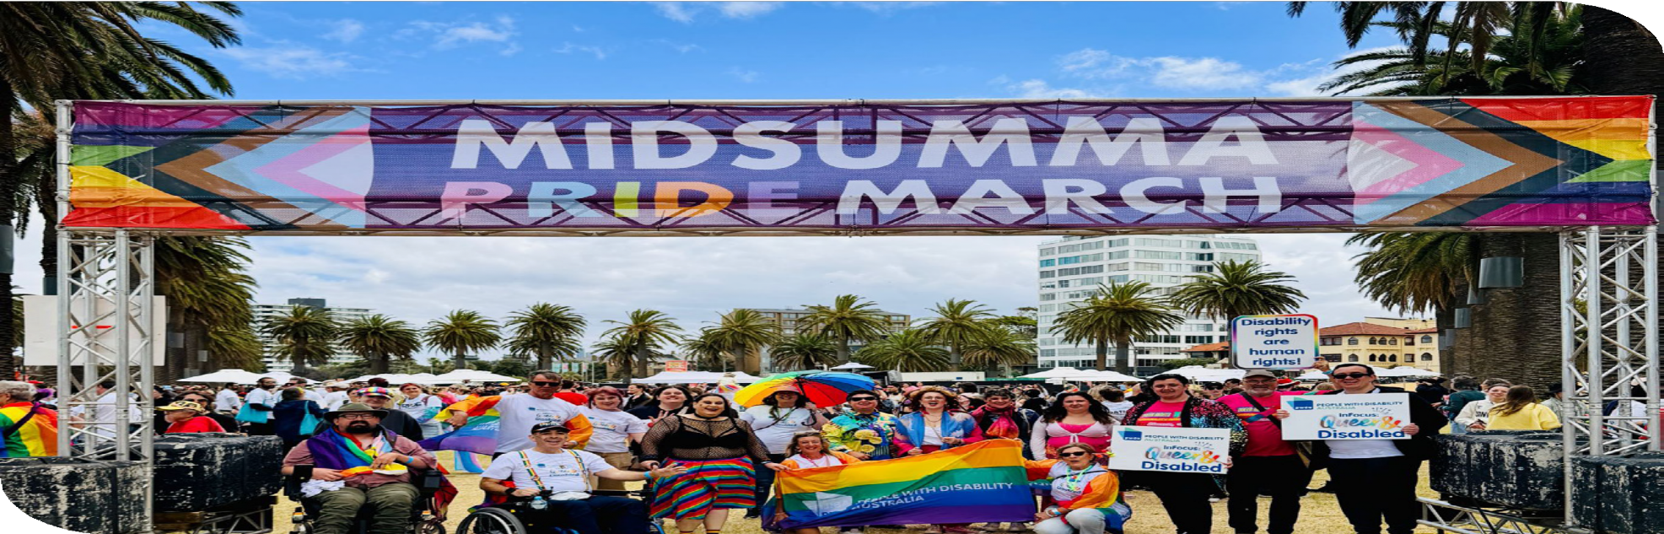
PWDA members participating in the 2026 Midsumma Pride March.


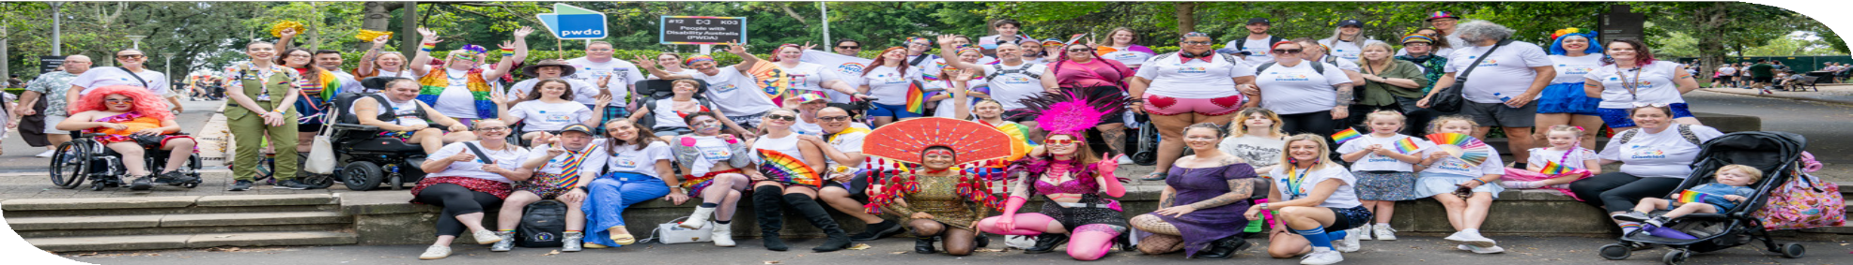
PWDA members participating in the 2026 Sydney Gay and Lesbian Mardi Gras Parade.

Individual advocacy

Working alongside people when systems don’t work
When people contact PWDA to request individual advocacy support, they are often navigating some of the most important decisions in their lives. Their housing may be at risk. They may have lost essential disability supports, be struggling to access education, or be trying to navigate complex legal, government or complaints processes.
These situations rarely involve just one system. People may need to deal with housing, health, education, justice, child protection and disability services at the same time, while navigating inaccessible processes, conflicting information and significant stress.
Throughout 2025–26, PWDA’s advocates worked alongside people with disability across parts of New South Wales and Queensland.
During the year we:

- Supported 1,859 people
- Delivered more than 35,800 occasions of service
- Responded to 5,253 community enquiries
- Reached more than 2,000 people through outreach and community engagement.

Our approach
Our advocacy is independent, rights-based and person-led. Our advocates work alongside each person to understand what matters to them, identify barriers, explain their rights and options, and support them to make their own decisions.
Good advocacy is about more than solving a problem. It is also about making sure people are heard and remain in control of decisions affecting their lives.
Where possible, we help people build the knowledge, confidence and connections to advocate for themselves in the future.
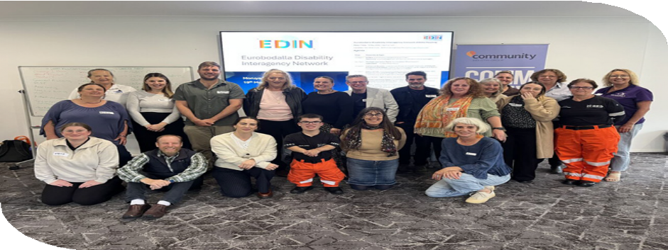
Eurobodalla Disability Interagency Network.

How PWDA’s individual advocacy service made a difference

This year, people sought advocacy across a broad range of issues including:
- NDIS reviews and Administrative Review Tribunal matters
- housing and home and living
- education
- guardianship and supported decision-making
- employment and discrimination
- the National Redress Scheme.
Our advocates helped people navigate these systems by explaining complex processes, coordinating communication across agencies, following up delayed decisions and helping people stay informed and involved.
This was particularly important when people encountered inaccessible communication, fragmented services or had limited support around them.

Outcomes
Our individual advocacy service delivered practical outcomes for people with disability throughout the year.
People with disability regained access to essential disability supports, resolved housing issues, secured reasonable adjustments at school, progressed National Redress Scheme applications
and connected with legal and community supports.
Advocacy also helped prevent problems from escalating, reducing risks such as homelessness, loss of supports, educational disengagement or people withdrawing from important processes because they had become overwhelming or inaccessible.
Client feedback showed that people valued both the outcomes achieved and how
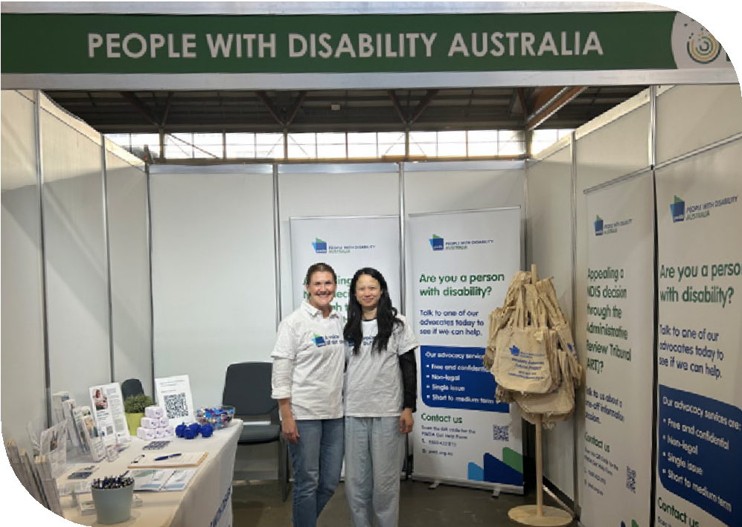
they were supported. Clients described advocates who listened, provided clear information and persisted when issues were complex.
- 93% were satisfied with the advocacy
they received.
- 92% said they felt listened to and understood.
- 81% said they felt better able to deal with the issue they sought help with.

Advocacy in action:

Removing barriers to education

The barrier
Lilly is a Year 11 student with disability who needed reasonable adjustments to participate in learning. After she and her family identified the support she needed, her school removed an approved assistive technology adjustment without proper
consultation, creating a significant barrier to
her education.

Advocacy in action
PWDA worked alongside Lilly and her family to understand their rights and communicate with the school. Her advocate explained
the school’s responsibilities under disability discrimination law, identified appropriate escalation pathways and supported the family to advocate for the reasonable adjustments Lilly needed to participate on an equal basis.

What changed
The school reinstated Lilly’s assistive technology adjustment, enabling her to return to learning with the support she required.
This case demonstrates how independent advocacy can help shift the focus from compliance to inclusion, ensuring disability-related support needs are recognised and students can fully participate in education.

34 | Annual Report 2025-26

Advocacy in action: Supporting choice, control and healing

The barrier
Charlene is an Aboriginal woman with disability who sought support with her National Redress Scheme application. The process required her to revisit traumatic experiences through complex written information, making it difficult to progress her application while maintaining her wellbeing and sense of control.

Advocacy in action
PWDA provided disability-affirming, trauma-informed advocacy that respected Charlene’s pace, choices and cultural safety. Her advocate obtained a copy of her application, reviewed the information
already provided, explained her options and supported her to decide whether she wished to add further information. PWDA also assisted Charlene to access counselling.

What changed
Charlene chose to continue her application without adding further information, reducing the risk of retraumatisation while allowing the process to continue. Throughout the advocacy, she remained in control of decisions affecting her application and was connected with the supports she needed.
This case highlights how our National Redress Scheme advocacy is not only about progressing an application. It is about ensuring people can participate in complex systems in ways that uphold their rights, dignity and wellbeing.

Community outreach and engagement
Throughout the year, PWDA strengthened referral pathways and community awareness through advocacy clinics, disability expos, regional outreach, information sessions and partnerships with legal, housing and community organisations across New South Wales and Queensland.
These activities helped more people understand their rights, increased awareness of advocacy services and improved access to support, particularly in regional, rural and remote communities.
More than 2,000 people participated in PWDA outreach activities during the year.

Individual advocacy driving systemic change
Every advocacy matter tells us something about how systems are working.
Across the year, advocates identified recurring barriers including inconsistent decision-making, inaccessible communication, delays in reviews and applications, fragmented complaint pathways, inadequate reasonable adjustments and limited access to appropriate housing and community supports.
These insights informed PWDA’s broader systemic advocacy across the NDIS, housing, inclusive education, supported decision-making, justice and Redress, helping ensure individual experiences contribute to improving systems for the wider disability community.

Programs delivered
Individual advocacy was delivered through:

- National Disability Advocacy Program (NDAP)
- NDIS Appeals Advocacy
- Disability Advocacy Futures Program (DAFP)
- Disability Advocacy Futures Education (DAFP-E)
- Queensland Disability Advocacy Program (QDAP)
- Disability Housing Advocacy Service (DHAS)
- Disability Housing Information Line (DHIL)
- National Redress Scheme Support Service.

Advocacy in action:

Finding Molly a safe home

Molly is a woman with disability living in Supported Independent Living. Her support network was concerned about inconsistent staffing, poor communication and support that did not reflect her needs. These issues affected Molly’s safety, daily routine and wellbeing.

How PWDA helped
PWDA worked alongside Molly and her support network to understand her goals, identify the barriers affecting her safety and ensure her concerns were heard. Our
advocate coordinated meetings with health, support coordination, behaviour support and accommodation providers to clarify
responsibilities, improve communication and explore accommodation options that better reflected Molly’s preferences and needs.

Outcomes achieved
Molly moved to a new Supported Independent Living provider.
Communication improved, support arrangements became clearer and her daily routine began to stabilise. This case shows how PWDA’s independent advocacy can help people exercise choice and control, address power imbalances and achieve safer, more appropriate support.

Acknowledgements
PWDA acknowledges the funding provided by the Australian Government Department of Social Services to deliver disability advocacy services, including the National Disability Advocacy Program, NDIS Appeals Advocacy and specialist Redress Support Services for people with disability accessing the National Redress Scheme.
We also acknowledge funding from the Queensland Government for the
Queensland Disability Advocacy Program and from the NSW Department of Communities and Justice for NSW-based advocacy services, including the Disability Advocacy Futures Program and related disability advocacy services.
We thank Legal Aid Queensland, Legal Aid NSW, Knowmore, other Redress Support Services, correctional centres, community organisations, disability services, housing providers, schools, health services, local councils and government agencies that worked alongside PWDA to improve access to individual advocacy and support for people with disability.

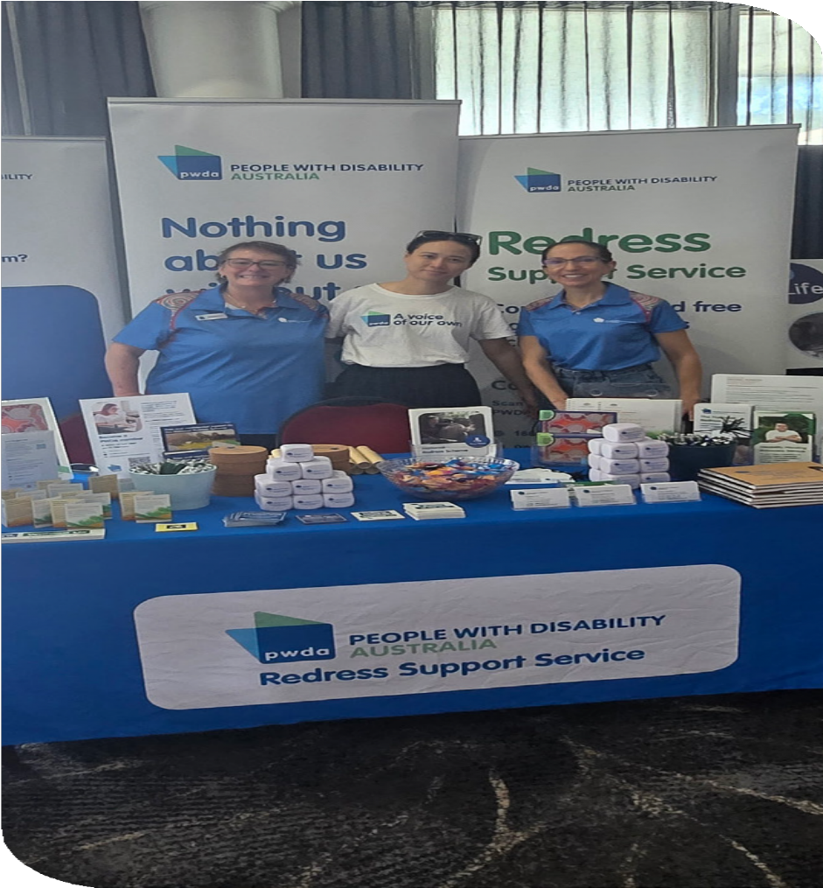
PWDA advocates and project officers
conducting community outreach.

Strategic projects and training

Throughout 2025–26, PWDA’s Strategic Projects and Training team worked alongside people with disability, governments, community organisations and industry to design practical solutions to barriers experienced by people with disability.
Every project was disability-led and grounded in co-design, recognising people with disability as leaders, experts and partners in creating more inclusive systems, workplaces and communities. Through leadership programs, workforce development, accessible education, strategic partnerships and organisational advisory services, the team strengthened disability confidence, expanded opportunities for participation and developed practical resources that will continue creating impact beyond the reporting period.
The year also marked an important investment in the future of disability-led learning. Across multiple projects,
PWDA developed accessible training and eLearning resources that will be brought together through a new online learning platform launching next financial year, expanding access to disability-led education and training resources across Australia.

Improving access to leadership opportunities and economic participation
People with disability continue to
face significant barriers to leadership, employment and economic participation. Throughout the year, PWDA delivered disability-led programs that strengthened leadership capability, professional networks and pathways into employment, business ownership and decision-making.

Advancing Women with Disability in the Workplace
After three and a half years, the Advancing Women with Disability in the Workplace project concluded this year, leaving a legacy of stronger leadership, confidence and professional networks for women, feminine-identifying and non-binary people with disability.
Through mentoring, workshops, peer learning and workplace engagement, participants built confidence, strengthened

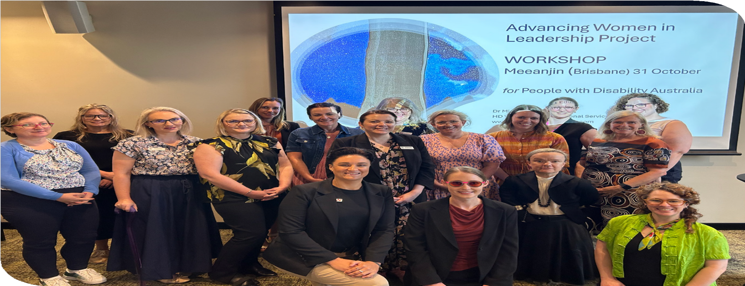
Advancing Women in Leadership Project workshop.

their leadership capability and expanded their professional networks. Many felt more ready to pursue leadership opportunities and advocate for their needs. Mentors also deepened their understanding of disability inclusion and inclusive leadership, while participating organisations showed early signs of more accessible and inclusive workplace practices.

I feel better equipped to create more inclusive opportunities and foster workplaces where diversity can thrive.

Mentor participant

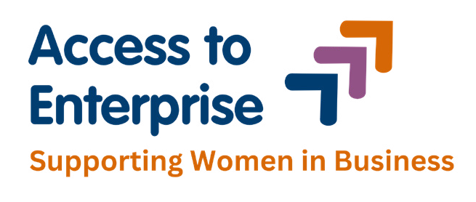

Access to Enterprise
PWDA also launched the Access to Enterprise program, supporting women, feminine-identifying and non-binary people with disability across New South Wales to build sustainable self-employment and small businesses.
The first cohort combined accessible eLearning, facilitated workshops, mentoring and peer networking to build business capability and confidence. Developed through lived experience leadership and
an Expert Advisory Panel, the program responds to barriers experienced
in mainstream entrepreneurship by recognising disability as a source of innovation, leadership and enterprise. While still in its first year, the program has already demonstrated strong demand
for disability-led business support and is laying the foundations for greater economic participation.

Strengthening responses to domestic, family and sexual violence
Throughout the year, PWDA continued to strengthen disability-inclusive approaches to preventing and responding to domestic, family and sexual violence through workforce development, community partnerships and accessible education.

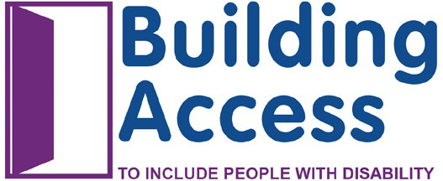

Building Access
Since 2017, the Building Access project has worked with domestic and family violence services across New South Wales to strengthen their ability to provide safe, accessible and inclusive support for people with disability. During 2025–26, the project entered a new phase, redesigning its training and resources in response
to evaluation findings and extensive
co-design with people with disability, frontline practitioners and subject matter experts. The updated model will provide more flexible learning opportunities and support organisations to embed disability inclusion into everyday practice, extending the project’s impact across the domestic and family violence sector.

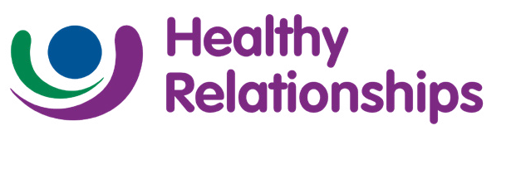

Healthy Relationships
PWDA commenced the Healthy Relationships project, a three-year initiative that will support people with intellectual disability to build the knowledge and
skills to recognise and develop safe, respectful relationships. Co-designed with people with disability, the project is developing accessible workshops, Easy Read resources and eLearning focused on consent, boundaries, respectful relationships and online safety. Together, these resources will form a sustainable primary prevention program that supports people with disability to make informed choices and build healthy relationships.

Remote Reach
Working in partnership with Maranguka and the Bourke community, Remote Reach strengthened disability-inclusive responses to domestic, family and sexual violence
for Aboriginal and Torres Strait Islander women and children. Through community consultation and co-design, the project established the foundations for a long-term partnership focused on accessibility, workforce capability, community leadership and sustainable systems change.

Maranguka and PWDA co-design sessions
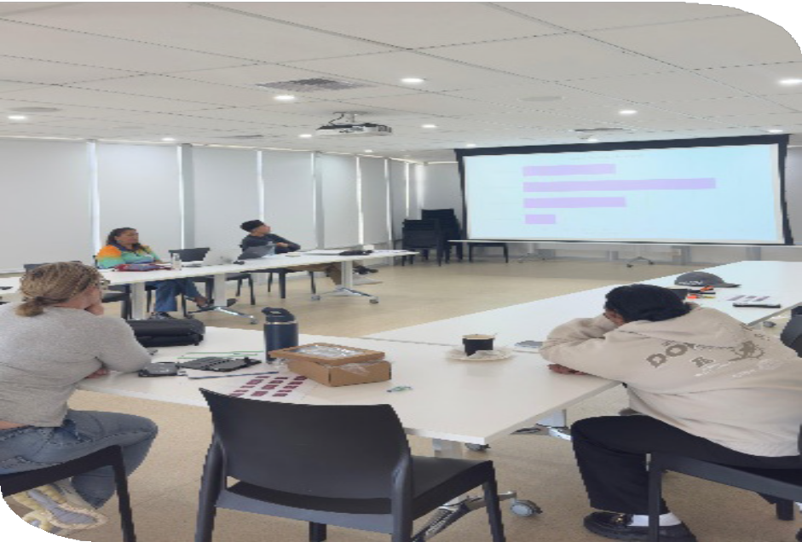
Bourke, NSW.

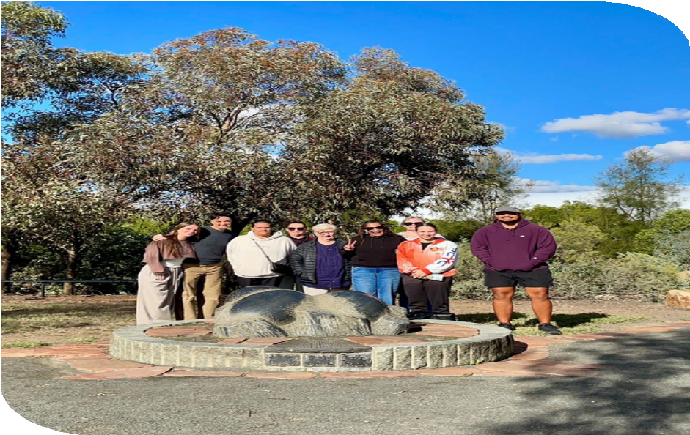
Maranguka and PWDA in Bourke, NSW.

Co-designing more inclusive systems
Throughout the year, PWDA partnered with governments and communities to ensure the lived experience and expertise of people with disability shaped future systems, services and community attitudes.

Australian Digital Health Agency Partnership
PWDA continued its partnership with the Australian Digital Health Agency to strengthen disability confidence and accessibility across the Agency.
Community consultation and staff capability development helped improve understanding of the barriers people with disability experience when accessing digital health services and informed more inclusive approaches to My Health Record and broader digital health initiatives.



Community Attitudes
PWDA also commenced the Community Attitudes: Connection and Safety in our Communities project. Through surveys, focus groups, a lived experience Advisory Group and co-designed eLearning, the project is developing accessible resources that challenge stigma, celebrate diversity and strengthen understanding of the intersection of disability and LGBTQIA+ identities.
To reflect the project’s commitment to lived experience and storytelling, PWDA commissioned an original artwork by artist Essa Chignell celebrating the diversity, strength and connection of LGBTQIA+ people with disability. The artist shared the following reflection on the work:

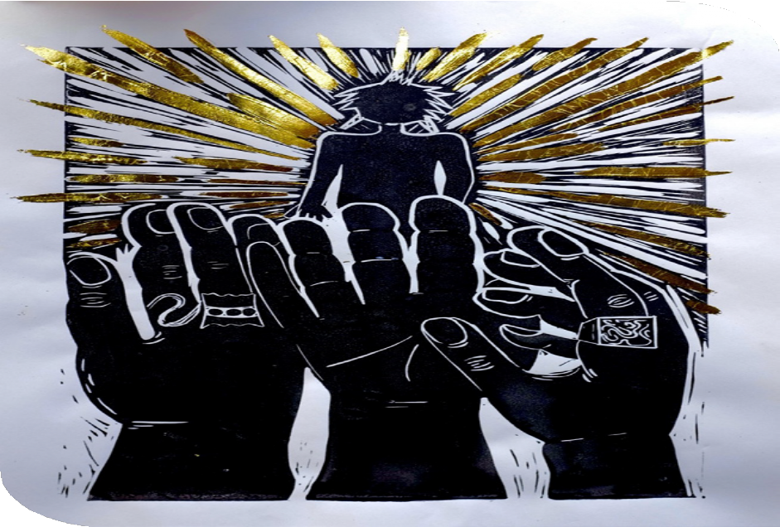

‘To be held’ is an ode to the symbiotic holding I’ve experienced in queer relationships that has been so essential to my
own relational healing and thriving. It’s a moment of gratitude for all the queer hands that have lifted me up and continue to do so. My experience of disability and queerness are inextricably linked
and finding community with similar experiences has been life changing. In whatever spaces we move it’s so so important to be with people who understand our lived
experience. This work aims to highlight the importance of authentic community
and how it creates space for us to thrive together.

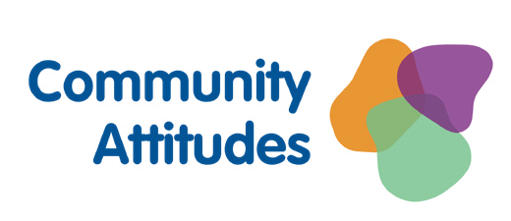
Left: PWDA commissioned artwork ‘To be held’ by Essa Chignell.

Training and advisory services

During 2025–26, PWDA partnered with organisations across Australia to help create more accessible, inclusive and disability-confident workplaces, services and communities. Through disability-led training, accessibility reviews, Disability Inclusion Action Plans and strategic advice, we helped organisations better understand the barriers experienced by people with disability and the practical steps they can take to remove them.
Working across government, health, legal, education, business and community sectors, PWDA delivered training to more than 1,000 participants and supported organisations to embed accessibility and
inclusion into the way they design services, engage with communities and make decisions.

Disability-led training
PWDA designs and delivers disability-led training that can be tailored to the needs of participating organisations.
During the year, we delivered disability confidence, disability inclusive leadership, accessible communication and workplace inclusion training to more than 1,000 participants across government, health, legal, business and community sectors.
Every program combined lived experience with practical strategies that participants could apply in their own workplaces and services.

Examples of our work included:

- Aged Care Quality and Safety Commission – Developed and delivered tailored training for Complaints Officers, alongside recorded learning resources to support ongoing capability development.
- Central and Eastern Sydney Primary Health Network – Delivered disability inclusion and disability inclusive leadership training, equipping managers with practical tools to create more inclusive workplaces.
- NSW Electoral Commission – Delivered disability awareness and inclusion training to support accessible electoral services.
- Ironman Group – Provided disability inclusion training to improve accessibility and inclusion across major sporting events.



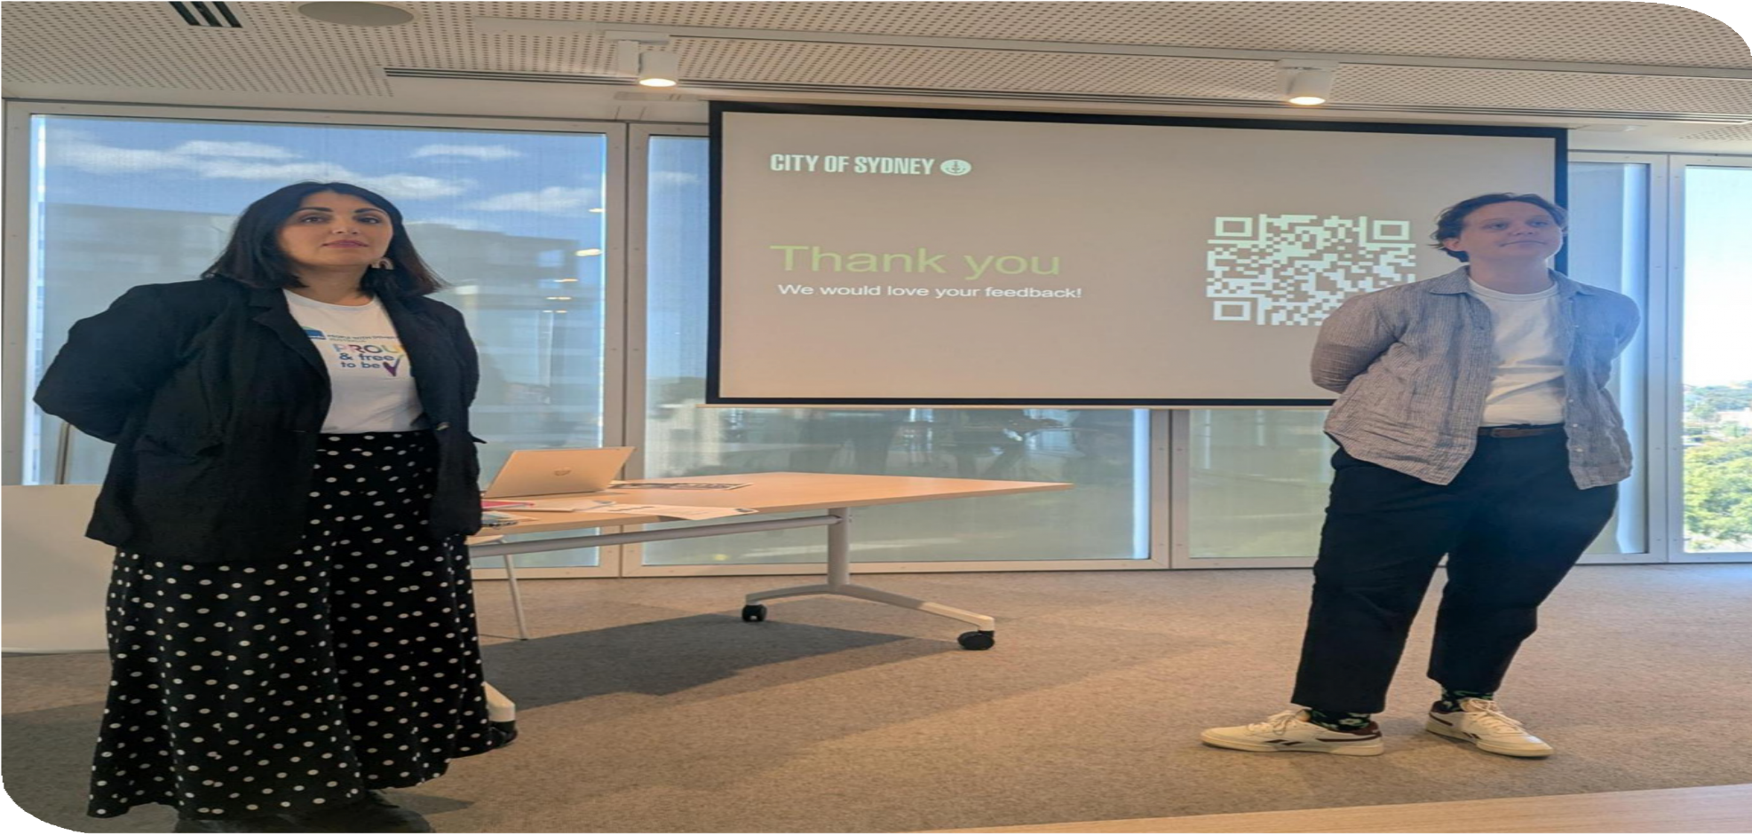
PWDA trainers delivering a workshop.

We have been delighted with the quality of the training and support provided by PWDA. Their approach is informative, engaging, and highly conversational, creating a safe and
interactive learning environment that encourages
meaningful discussion and reflection.

Advisory services

PWDA’s advisory services help organisations create more accessible and inclusive workplaces and services.
During the year, we partnered with organisations to deliver accessibility audits, Disability Inclusion Action Plans,
organisational reviews and consultation with people with disability.
Every project was shaped by the lived experience and expertise of people with disability and tailored to the organisation’s goals, challenges and communities. We helped organisations identify barriers, decide where to focus their efforts and develop practical plans for change.

Examples of our work included:

- Aboriginal Legal Service (NSW/ACT): PWDA completed the organisation’s first Disability Inclusion Audit and supported the development of its ACT Disability Inclusion Action Plan 2026–2030. The work combined organisational review with staff and community consultation. The resulting plan provides a practical framework for improving accessibility, inclusion and culturally safe services
for Aboriginal and Torres Strait Islander people with disability.
- Blue Mountains Women’s Health and Resource Centre: PWDA completed a physical accessibility audit to identify barriers affecting people with disability using the Centre’s facilities and services.
The report gave the Centre a clear evidence base to prioritise future work, plan improvements and discuss the resources needed to make its premises more accessible.
- City of Ryde, Blue Mountains City Council and Sutherland Shire Council: PWDA supported local government work to improve disability inclusion through planning, consultation and practical advice. This helped ensure the experiences and priorities of people with disability informed future organisational and service improvements.

Acknowledgements
PWDA acknowledges the support of the Department of the Prime Minister and Cabinet Office for Women, which
funded the project through the Women’s Leadership and Development Program – Lead and Succeed grants program.
PWDA also acknowledges project partners and contributors including HD Writing
and Educational Services, Empowering Pathways, Heidi La Paglia Consulting, the Expert Advisory Group, Co-design Panel members, participating organisations, mentors and mentees, whose expertise and lived experience contributed to the success of the project.
The Building Access Project is made possible through funding from the NSW Department of Communities and Justice (DCJ) under the Women NSW Domestic

and Family Violence (DFV) Program. PWDA gratefully acknowledges this support, which enables us to deliver this important work.
The Community Attitudes: Connection and Safety in our Communities – Disability and LGBTQIA+ Intersectionality project
is funded by the Australian Government Department of Health, Disability and Ageing. This investment supports our work to improve understanding, inclusion and safety for LGBTQIA+ people with disability.
PWDA also thanks the Department of Communities and Justice (DCJ) for its funding of the Remote Reach project. We further acknowledge the leadership,
partnership and collaboration of Maranguka, whose local knowledge, community leadership and commitment to community-led change have been central to the success of this work.

Qantas Carer Concession Card Program (QCCC)
The Qantas Carer Concession Card (QCCC) provides eligible cardholders and their carers with discounted travel on selected domestic and international
Qantas flights, helping make air travel more affordable for people with disability.
PWDA administers the program on behalf of Qantas. During the year, 838 cards were issued, including 670 new applications and 168 renewals.
This year PWDA also commenced work with Qantas to modernise the program, including exploring an online application process while recognising the importance of maintaining accessible application options, including paper-based forms.



Internal culture building and

business improvement

During 2025–26, PWDA continued strengthening the organisation behind our advocacy and services by investing in our people, culture and systems. These
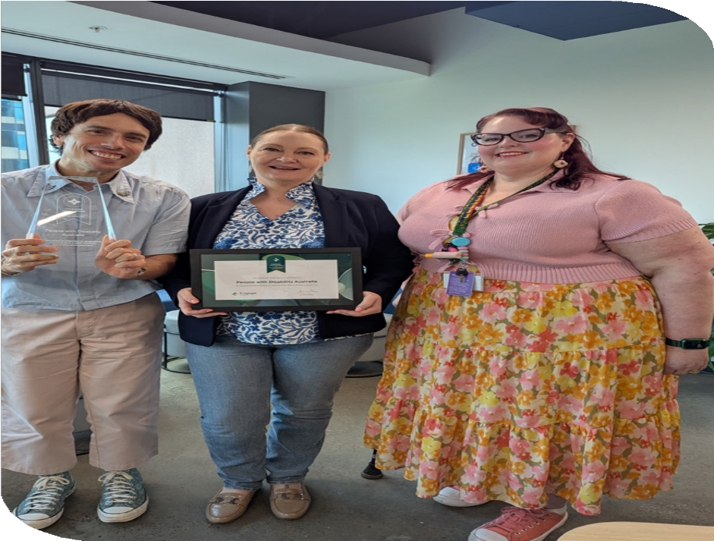
improvements ensure PWDA remains well placed to deliver high-quality, rights-based advocacy and representation for people with disability into the future.
We know that a strong organisation starts with its people.

As at 30 June 2026, PWDA employed 62 staff, with 44% identifying as having disability, a chronic health condition and/ or being neurodivergent. Our staff have a diverse range of genders, sexual identities and cultural backgrounds with
4% of staff identifying as being Aboriginal and/or Torres Strait Islander. We are committed to building a safe, inclusive and representative organisation where people with disability and diverse lived experience are recognised, valued and reflected across our workforce and leadership.

This year’s employee engagement survey showed significant improvements across the organisation, including a 26% increase in employee engagement and a 27% increase in employee wellbeing. These results were recognised externally through the Xref Engage Change Champion Award, acknowledging PWDA’s success in creating meaningful improvements in the employee experience.
PWDA staff (left to right) Marco Maclean, Karen Karakaya and Megan Spindler-Smith with Xref Engage Change Champion Award.


Community focused



Work as a team
Act with integrity
Champion inclusion

Employee values

During 2025–26, PWDA introduced its first employee values, developed by staff, for staff.
Rather than adopting a standard set of organisational values, we asked our people what matters most about working at PWDA and how we want to work together. Through a staff-led Employee Values Working Group, employees from across the organisation shaped four values that reflect our culture and our commitment to the disability community:
- Community focused
- Work as a team
- Act with integrity
- Champion inclusion.
The values are now embedded across the organisation through recognition programs, team workplans and everyday decision-making, helping create a workplace where lived experience is valued, collaboration is encouraged and everyone is empowered to contribute.

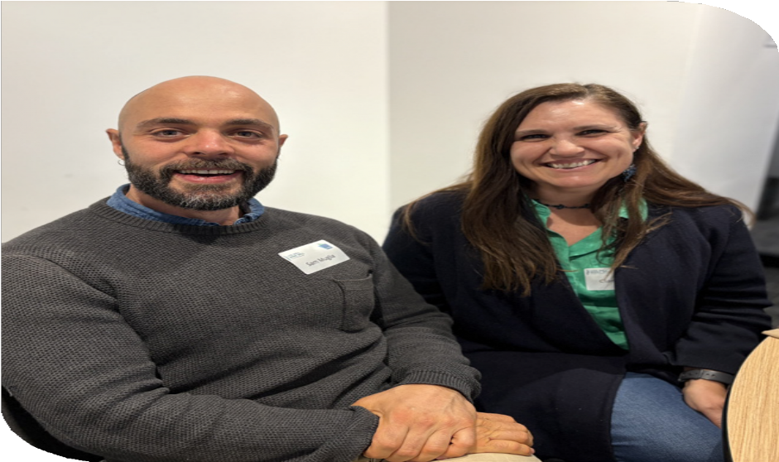
Learning and development
PWDA continued investing in the skills, leadership and wellbeing of our people to strengthen our ability to deliver high-quality, rights-based advocacy, services and work.
Throughout the year, we continued our Leadership Development Program in partnership with Axis People, providing our leaders with practical development in communication, building high-performing teams and leading organisational culture. Leadership coaching, DiSC profiling and the introduction of organisation-wide
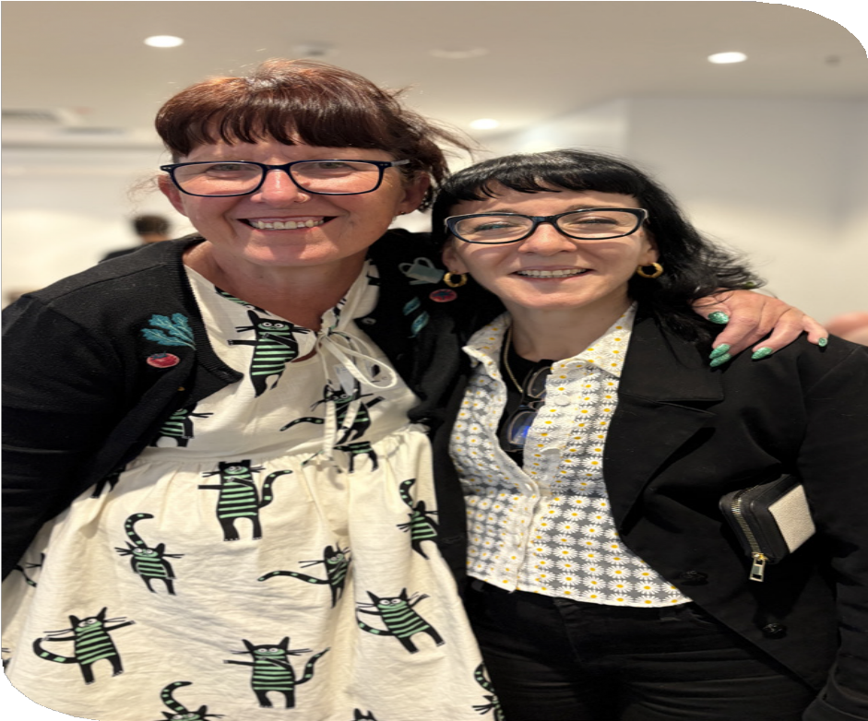
360-degree feedback supported leaders to better understand their strengths, build stronger working relationships and identify opportunities for ongoing development.
In October 2025, PWDA also brought staff together for our annual Live Well. Work Well. All Staff Conference. The conference focused on health, wellbeing, learning
and connection, creating opportunities for staff from across Australia to share ideas, strengthen relationships and invest in their professional development.
Together, these initiatives are helping build a culture of learning, accountability and continuous improvement.

Top and bottom: PWDA staff at the 2025 Live Well. Work Well. All Staff Conference.

I have always felt worried that workplaces would see my identities and limit me in my career because of them. This has felt very different at PWDA, I feel
supported to reach my potential and develop.

Employee Profile
Kit Walsh, Project Manager
Kit Walsh joined PWDA in 2024 and brings both professional expertise and lived experience to their work. Kit is a person with autism, ADHD, a learning disability and chronic health conditions. They are passionate about ensuring people with disability are involved in the decisions that affect their lives and applies the principle of
‘Nothing About Us, Without Us’ to all their work.
Since joining PWDA, Kit has led major strategic projects that have strengthened disability inclusion and community engagement, while also participating
in PWDA’s Leadership Development Program to continue building their own leadership capability.

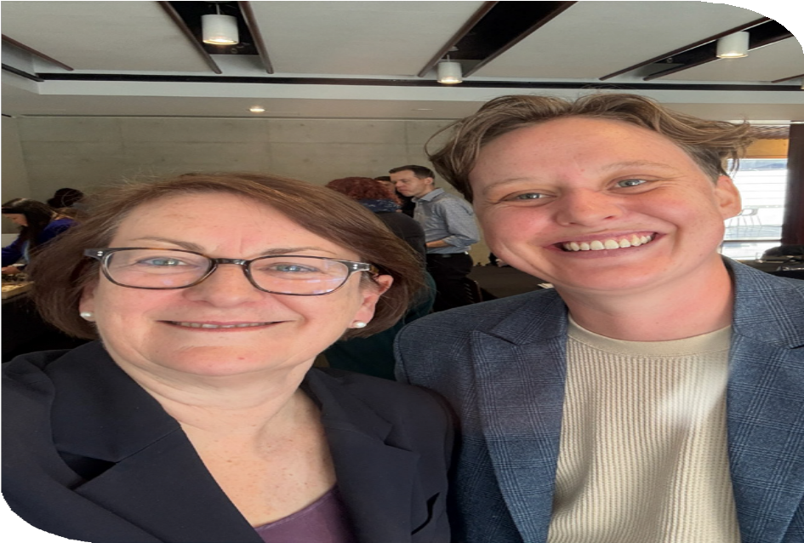
Kit Walsh (right) with Ms Susan Templeman MP (left).

Delivering quality advocacy services
PWDA is committed to delivering high-quality, rights-based advocacy and services that people with disability can trust.
During the year, PWDA achieved full conformity across every National Standard for Disability Services assessed during an independent audit. Auditors recognised our rights-based approach, person-centred advocacy and strong governance, with clients describing PWDA’s services as respectful, responsive and empowering.
The audit confirmed that people using our services felt safe, listened to and supported to make decisions about their own lives.
PWDA also completed and passed its three-year self-assessment against the Australian Council for International
Development (ACFID) Code of Conduct, demonstrating our ongoing commitment to strong governance, transparency and accountability.

Continuous improvement
Throughout the year, PWDA continued strengthening the systems that support our advocacy, services and work. A comprehensive review of policies and procedures simplified organisational documentation, strengthened governance and made policies easier for staff to understand and apply. This included consolidating several finance policies
into a single Financial Governance Policy
and streamlining Work Health and Safety documentation supported by practical procedures. Improvements to information security, payroll systems and self-service resources also reduced administrative effort and improved organisational efficiency.

Reconciliation
PWDA continued progressing our Reflect Reconciliation Action Plan, strengthening the foundations needed to support meaningful and ongoing action to support reconciliation. Throughout the year, we reviewed governance arrangements, accountability processes and the role of the RAP Working Group while continuing to embed Aboriginal and Torres Strait Islander voices, leadership, lived experience and cultural inclusion across our organisation and our work.

Sustainability
PWDA continued reducing our environmental impact through responsible procurement, greater use of technology to reduce travel, electronic document management and more efficient
office operations. Building efficiency improvements at our Surry Hills office have reduced utility costs by around 50% compared with our previous premises, allowing more resources to be directed towards our core disability advocacy work and services.

Financial report

30 June 2026
People With Disability Australia Ltd. ABN 98 879 981 198

Contents
Directors’ report 55
Auditor’s Independence Declaration to the
Directors of People With Disability Australia Ltd 58
Statement of profit or loss and
other comprehensive income 59
Statement of financial position 60
Statement of changes in equity 61
Statement of cash flows 62
Notes to the financial statements
for the year ended 30 June 2026 63

54 | Annual Report 2025-26

Directors’ report
The Directors present their report, together with the financial statements, on the Company for
the year ended 30 June 2026.

Directors
The following persons were Directors of the Company during the whole of the financial year
and up to the date of this report, unless otherwise stated:

Name | Position | Appointed/resigned
Alexandra Bignell | Board Director | Appointed 14 November 2024
Daniel Flynn | Interim President | Appointed 5 August 2024
Stephanie Travers | Board Director | Appointed 14 November 2024
Tahlia-Rose Vanissum | Board Director | Appointed 13 November 2025
Wildaliz De Jesús Arocho | Board Director | Appointed 13 November 2025
Jarrod Sandell-Hay (formerly known as Jarrod Marrinon) | Interim President | Appointed 13 November 2025
Jeramy Hope | President | Appointed 13 November 2025 and  resigned on 1 June 2026
Eva Sifis | Co-Vice President | Appointed on 15 November 2023 and term ended on 13 November 2025
Kevyn Morris | Co-Vice President | Appointed on 15 November 2023 and term ended on 13 November 2025
Stuart Mawbey | Treasurer | Appointed 5 August 2024 and term  ended on 13 November 2025
Priscilla Brice | Board Director | Appointed 14 November 2024  and resigned on 24 January 2026
Trinity Ford | President | Appointed 5 August 2024 and  resigned on 12 November 2025

Principal activities
The principal activity of People With Disability Australia Ltd during the financial year was to represent, support, educate and advocate for people with disability and undertake necessary activities and programs to achieve the organisation's objective.
No changes in the nature of the Company's activities during the financial year.

Long term objectives
The Company’s long term objectives are to:

- Empower people with disability as individuals, as specific population groups, and as a
sector;
- Advocate for the human rights of people with disability at the individual, specific population
group, and sector levels;
- Effective representation of people with disability as a sector to the government and to the
community generally; as well as focus on sector development; and
- Build our organisational capacity to empower, advocate for, and represent people with disability.

Review of operations
The surplus of the Company amounted to $318,240 (2025: $1,173,382).

With reference to the ACFID Code of Conduct, the Company confirms that there were no international aid and development revenue received during the year ended 30 June 2026 (30 June 2025: $nil).

Members’ Guarantee
If the Company is wound up, the constitution states that each member is required to contribute a maximum of $1 each towards meeting any outstanding obligations of the Company. At 30 June 2026 the number of members was 4,972 (30 June 2025: 4,182).

Auditor’s independence declaration
A copy of the auditor's independence declaration as required by Subdivision 60C of the Australian Charities and Not-for-profits Commission Act 2012 is set out immediately after this Directors' report.
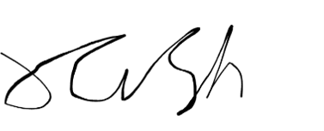
This report is made in accordance with a resolution of Directors. On behalf of the Directors
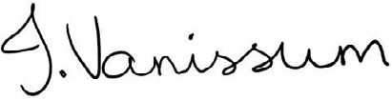

Jarrod Sandell-Hay Director
Dated: 29 September 2026.
Tahlia-Rose Vanissum Director
Dated: 29 September 2026.



Auditor’s Independence Declaration to the Directors of People With Disability Australia Ltd

For the Financial Year Ended 30 June 2026

In accordance with the requirements of section 60-40 of the Australian Charities and Not-for-profits Commission Act 2012, as lead auditor for the audit of People With Disability Australia Ltd for the year ended 30 June 2026, I declare that, to the best of my knowledge and belief, there have been:
- No contraventions of the auditor independence requirements as set out in the Australian Charities and Not-for-profits Commission Act 2012 in relation to the audit; and
- No contraventions of any applicable code of professional conduct in relation to the audit.
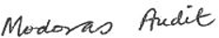
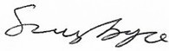

Modoras Audit Simon Joyce
Director
24 September 2026 Sydney, New South Wales

Statement of profit or loss and other comprehensive income

For the year ended 30 June 2026

Profit or loss | Note | 2026 $ | 2025 $
Revenue | 4 | 10,966,026 | 11,144,013
Interest revenue calculated using the effective interest method |  | 124,571 | 108,625
Expenses
Employee benefits expense |  | (7,633,603) | (7,527,892)
Depreciation and amortisation expense |  | (389,961) | (394,985)
Advertising and promotion |  | (65,448) | (55,341)
Meeting expenses |  | (153,943) | (82,394)
Consulting and professional fees |  | (652,404) | (343,425)
Telecommunications |  | (290,064) | (249,796)
Program costs |  | (178,868) | (322,402)
Travel |  | (413,764) | (347,876)
Rental and other property related costs |  | (125,252) | (121,996)
Other expenses |  | (753,579) | (494,659)
Finance costs | 5 | (115,471) | (138,490)
Total expenses |  | (10,772,357) | (10,079,256)
Surplus for the year attributable to the members of  People With Disability Australia Ltd |  | 318,240 | 1,173,382
Other comprehensive income for the year |  | - | -
Total comprehensive income for the year attributable to the members of People With Disability Australia Ltd |  | 318,240 | 1,173,382

The above statement of profit or loss and other comprehensive income should be read in conjunction with the
accompanying notes.

Statement of financial position
As at 30 June 2026

Assets

Current assets | Note | 2026 $ | 2025 $
Cash and cash equivalents | 6 | 6,365,688 | 5,216,732
Trade and other receivables | 7 | 182,069 | 136,213
Prepayments and other |  | 240,600 | 217,161
Total current assets |  | 6,788,357 | 5,570,106

Non-current assets
Trade and other receivables | 7 | 42,324 | -
Financial assets at fair value through profit or loss | 8 | 857,488 | 857,020
Property, plant and equipment | 9 | 583,753 | 783,287
Right-of-use assets | 10 | 592,149 | 784,198
Total non-current assets |  | 2,075,714 | 2,424,505
Total assets |  | 8,864,071 | 7,994,611
Liabilities

Current liabilities
Trade and other payables | 11 | 456,313 | 842,118
Lease liabilities | 12 | 367,584 | 324,718
Employee benefits | 13 | 687,687 | 549,411
Grants received in advance |  | 2,917,077 | 1,778,693
Total current liabilities |  | 4,428,661 | 3,494,940

Non-current liabilities
Lease liabilities | 12 | 920,906 | 1,288,491
Employee benefits | 13 | 48,106 | 68,464
Provisions | 14 | 73,740 | 68,298
Total non-current liabilities |  | 1,042,752 | 1,425,253
Total liabilities |  | 5,471,413 | 4,920,193
Net assets |  | 3,392,658 | 3,074,418
Equity

Retained surpluses | 3,392,658 | 3,074,418
Total equity | 3,392,658 | 3,074,418

The above statement of financial position should be read in conjunction with the accompanying notes.

Statement of changes in equity

For the year ended 30 June 2026

 | Retained  surpluses $ | Total  equity $
Balance at 1 July 2024 | 1,901,036 | 1,901,036
Surplus for the year | 1,173,382 | 1,173,382
Other comprehensive income | - | -
Total comprehensive income for the year | 1,173,382 | 1,173,382
Balance at 30 June 2025 | 3,074,418 | 3,074,418

 | Retained  surpluses $ | Total  equity $
Balance at 1 July 2025 | 3,074,418 | 3,074,418
Surplus for the year | 318,240 | 318,240
Other comprehensive income | - | -
Total comprehensive income for the year | 318,240 | 318,240
Balance at 30 June 2026 | 3,392,658 | 3,392,658

The above statement of changes in equity should be read in conjunction with the accompanying notes.

Statement of cash flows

For the year ended 30 June 2026

Cash flows from operating activities | Note | 2026 $ | 2025 $
Receipts from grants and customers (inclusive of GST) |  | 13,130,630 | 12,630,438
Payments to suppliers and employees (inclusive of GST) |  | (11,703,223) | (10,349,859)
Interest received |  | 112,065 | 100,746
Interest and other finance costs paid |  | (115,471) | (138,490)
Net cash from operating activities |  | 1,424,001 | 2,242,835

Cash flows from investing activities
Proceeds from disposal of property, plant and equipment | 20,527 | -
Receipts for term deposits | - | 1,470,000
Distributions received | 29,147 | 163,728
Net cash from investing activities | 49,674 | 1,633,728

Cash flows from financing activities
Repayment of lease liabilities | (324,719) | (252,884)
Net cash used in financing activities | (324,719) | (252,884)

Net increase in cash and cash equivalents |  | 1,148,956 | 3,623,679
Cash and cash equivalents at the beginning of the financial year |  | 5,216,732 | 1,593,053
Cash and cash equivalents at end of the financial year | 6 | 6,365,688 | 5,216,732

The above statement of cash flows should be read in conjunction with the accompanying notes.

Notes to the financial statements for the year ended 30 June 2026

Note 1 General information
The financial statements cover People With Disability Australia Ltd as an individual entity. The financial statements are presented in Australian dollars, which is People With Disability Australia Ltd’s functional and presentation currency.
People With Disability Australia Ltd is a not-for-profit unlisted public company limited by guarantee, incorporated and domiciled in Australia. Its registered office and principal place of business is:
People With Disability Australia Ltd Suite 10.1 Level 10 300 Elizabeth Street Surry Hills NSW 2010
A description of the nature of the Company’s operations and its principal activities are
included in the Directors’ report, which is not part of the financial statements.
The financial statements were authorised for issue, in accordance with a resolution of Directors, on 24 September 2026. The Directors have the power to amend and reissue the financial statements.

Note 2 Material accounting policy information
The accounting policies that are material to the Company are set out below. The accounting policies adopted are consistent with those of the previous financial year, unless otherwise stated.

New or amended Accounting Standards and Interpretations adopted
The Company has adopted all of the new or amended Accounting Standards and Interpretations issued by the Australian Accounting Standards Board (‘AASB’) that are mandatory for the current reporting period. The adoption of these Accounting Standards and Interpretations did not have any significant impact on the financial performance or position of the Company.
Any new or amended Accounting Standards or Interpretations that are not yet mandatory have not been early adopted.

Basis of preparation
These general purpose financial statements have been prepared in accordance with the Australian Accounting Standards - Simplified Disclosures issued by the Australian Accounting Standards Board (‘AASB’), the Australian Charities and Not-for-profits Commission Act 2012 and the New South Wales legislation the Charitable Fundraising Act 1991 and associated regulations as appropriate for not-for profit oriented entities.

Historical cost convention
The financial statements have been prepared under the historical cost convention, except for, the revaluation of financial assets at fair value through profit or loss.

Critical accounting estimates
The preparation of the financial statements requires the use of certain critical accounting estimates. It also requires management to exercise its judgement in the process of applying the Company’s accounting policies. The areas involving a higher degree of judgement
or complexity, or areas where assumptions and estimates are significant to the financial
statements, are disclosed in note 3.

Revenue recognition
The Company recognises revenue as follows:

Grant income
Grant income is recognised at the point in time when the monies are received, and obligations have been met in relation to the grant program. Funds received in advance of obligations are deferred and recognised over time as income as the related expenses are incurred and obligations are met.

Donations
Donations collected, including cash and goods for resale, are recognised as revenue when the Company gains control of the asset.

Interest
Interest revenue is recognised as interest accrues using the effective interest method. This is a method of calculating the amortised cost of a financial asset and allocating the interest
income over the relevant period using the effective interest rate, which is the rate that exactly discounts estimated future cash receipts through the expected life of the financial asset to the net carrying amount of the financial asset.

Other revenue
Other revenue is recognised when it is received or when the right to receive payment is established.

Income tax
As the Company is a charitable institution in terms of subsection 50-5 of the Income Tax Assessment Act 1997, as amended, it is exempt from paying income tax.

Current and non-current classification
Assets and liabilities are presented in the statement of financial position based on current and non-current classification.
An asset is classified as current when: it is either expected to be realised or intended to
be sold or consumed in the Company’s normal operating cycle; it is held primarily for the purpose of trading; it is expected to be realised within 12 months after the reporting period; or the asset is cash or cash equivalent unless restricted from being exchanged or used to settle a liability for at least 12 months after the reporting period. All other assets are classified as non-current.
A liability is classified as current when: it is either expected to be settled in the Company’s normal operating cycle; it is held primarily for the purpose of trading; it is due to be settled within 12 months after the reporting period; or there is no right at the end of the reporting period to defer the settlement of the liability for at least 12 months after the reporting period. All other liabilities are classified as non-current.

Cash and cash equivalents
Cash and cash equivalents includes cash on hand, deposits held at call with financial institutions, other short-term, highly liquid investments with original maturities of three months or less that are readily convertible to known amounts of cash and which are subject to an insignificant risk of changes in value.

Trade and other receivables
Trade receivables are initially recognised at fair value and subsequently measured at amortised cost using the effective interest method, less any allowance for expected credit losses. Trade receivables are generally due for settlement within 30 days.
The Company has applied the simplified approach to measuring expected credit losses, which uses a lifetime expected loss allowance. To measure the expected credit losses, trade receivables have been grouped based on days overdue.
Other receivables are recognised at amortised cost, less any allowance for expected credit losses.

Financial assets
Financial assets are initially measured at fair value. Transaction costs are included as part of
the initial measurement, except for financial assets at fair value through profit or loss. Such

assets are subsequently measured at either amortised cost or fair value depending on their classification. Classification is determined based on both the business model within which such assets are held and the contractual cash flow characteristics of the financial asset unless an accounting mismatch is being avoided. Financial assets are derecognised when the rights to receive cash flows have expired or have been transferred and the Company has transferred substantially all the risks and rewards of ownership. When there is no reasonable expectation of recovering part or all of a financial asset, its carrying value is written off.

Financial assets at amortised cost
A financial asset is measured at amortised cost only if both of the following conditions
are met: (i) it is held within a business model whose objective is to hold assets in order to collect contractual cash flows; and (ii) the contractual terms of the financial asset represent contractual cash flows that are solely payments of principal and interest.

Financial assets at fair value through profit or loss
Financial assets not measured at amortised cost or at fair value through other comprehensive income are classified as financial assets at fair value through profit or loss. Typically, such financial assets will be either: (i) held for trading, where they are acquired for the purpose of selling in the short-term with an intention of making a profit, or a derivative; or
(ii) designated as such upon initial recognition where permitted. Fair value movements are
recognised in profit or loss.

Impairment of financial assets
The Company recognises a loss allowance for expected credit losses on financial assets which are measured at amortised cost. The measurement of the loss allowance depends upon the Company’s assessment at the end of each reporting period as to whether the financial instrument’s credit risk has increased significantly since initial recognition, based on reasonable and supportable information that is available, without undue cost or effort to obtain.
Where there has not been a significant increase in exposure to credit risk since initial recognition, a 12-month expected credit loss allowance is estimated. This represents a portion of the asset’s lifetime expected credit losses that is attributable to a default event that is possible within the next 12 months. Where a financial asset has become credit impaired or where it is determined that credit risk has increased significantly, the loss allowance is based on the asset’s lifetime expected credit losses. The amount of expected credit loss recognised is measured on the basis of the probability weighted present value of anticipated cash shortfalls over the life of the instrument discounted at the original effective interest rate.
The loss allowance reduces the asset’s carrying value with a corresponding expense through
profit or loss.

Property, plant and equipment
Plant and equipment is stated at historical cost less accumulated depreciation and impairment. Historical cost includes expenditure that is directly attributable to the acquisition of the items.
Depreciation is calculated on a straight-line basis to write off the net cost of each item of
property, plant and equipment (excluding land) over their expected useful lives as follows: Leasehold improvements 5 years
Office equipment 3 years
Motor vehicles 5 years
The residual values, useful lives and depreciation methods are reviewed, and adjusted if appropriate, at each reporting date.
Leasehold improvements are depreciated over the unexpired period of the lease or the estimated useful life of the assets, whichever is shorter.
An item of property, plant and equipment is derecognised upon disposal or when there is no future economic benefit to the Company. Gains and losses between the carrying amount and the disposal proceeds are taken to profit or loss.

Right-of-use assets
A right-of-use asset is recognised at the commencement date of a lease. The right-of-use asset is measured at cost, which comprises the initial amount of the lease liability, adjusted for, as applicable, any lease payments made at or before the commencement date net of any lease incentives received, any initial direct costs incurred, and, except where included in the cost of inventories, an estimate of costs expected to be incurred for dismantling and removing the underlying asset, and restoring the site or asset.
Right-of-use assets are depreciated on a straight-line basis over the unexpired period of the lease or the estimated useful life of the asset, whichever is the shorter. Where the
Company expects to obtain ownership of the leased asset at the end of the lease term, the depreciation is over its estimated useful life. Right-of use assets are subject to impairment or adjusted for any remeasurement of lease liabilities.
The Company has elected not to recognise a right-of-use asset and corresponding lease liability for short-term leases with terms of 12 months or less and leases of low-value assets. Lease payments on these assets are expensed to profit or loss as incurred.

Impairment of non-financial assets
Non-financial assets are reviewed for impairment whenever events or changes in
circumstances indicate that the carrying amount may not be recoverable. An impairment loss

is recognised for the amount by which the asset’s carrying amount exceeds its recoverable amount.
Recoverable amount is the higher of an asset’s fair value less costs of disposal and value-in-use. The value-in-use is the present value of the estimated future cash flows relating to the asset using a pre-tax discount rate specific to the asset or cash-generating unit to which the asset belongs. Assets that do not have independent cash flows are grouped together to form a cash-generating unit.

Trade and other payables
Trade and other payables represent liabilities for goods and services provided to the Company prior to the end of the financial year and which are unpaid. Due to their short-term nature they are measured at amortised cost and are not discounted. The amounts are unsecured and are usually paid within 30 days of recognition.

Contract liabilities
A contract liability is recognised if a payment is received or a payment is due (whichever is earlier) from a customer before grant conditions are fulfilled. Contract liabilities include deferred income. Contract liabilities are recognised as revenue when the entity performs under the contract (i.e., fulfils conditions of the grant).

Lease liabilities
A lease liability is recognised at the commencement date of a lease. The lease liability is initially recognised at the present value of the lease payments to be made over the term of the lease, discounted using the interest rate implicit in the lease or, if that rate cannot be readily determined, the Company’s incremental borrowing rate. Lease payments comprise of fixed payments less any lease incentives receivable, variable lease payments that depend on an index or a rate, amounts expected to be paid under residual value guarantees, exercise price of a purchase option when the exercise of the option is reasonably certain to occur, and any anticipated termination penalties. The variable lease payments that do not depend on an index or a rate are expensed in the period in which they are incurred.
Lease liabilities are measured at amortised cost using the effective interest method. The carrying amounts are remeasured if there is a change in the following: future lease payments arising from a change in an index or a rate used; residual guarantee; lease term; certainty
of a purchase option and termination penalties. When a lease liability is remeasured, an adjustment is made to the corresponding right-of use asset, or to profit or loss if the carrying amount of the right-of-use asset is fully written down.

Provisions
Provisions are recognised when the Company has a present (legal or constructive) obligation as a result of a past event, it is probable the Company will be required to settle the obligation, and a reliable estimate can be made of the amount of the obligation. The amount recognised as a provision is the best estimate of the consideration required to settle the present obligation at the reporting date, taking into account the risks and uncertainties surrounding the obligation. If the time value of money is material, provisions are discounted using a current pre-tax rate specific to the liability. The increase in the provision resulting from the passage of time is recognised as a finance cost.

Employee benefits

Short-term employee benefits
Liabilities for wages and salaries, including non-monetary benefits, annual leave and long service leave expected to be settled wholly within 12 months of the reporting date are measured at the amounts expected to be paid when the liabilities are settled.

Other long-term employee benefits
The liability for annual leave and long service leave not expected to be settled within 12 months of the reporting date are measured at the present value of expected future
payments to be made in respect of services provided by employees up to the reporting date. Consideration is given to expected future wage and salary levels, experience of employee departures and periods of service. Expected future payments are discounted using market yields at the reporting date on national government bonds with terms to maturity and currency that match, as closely as possible, the estimated future cash outflows.

Defined contribution superannuation expense
Contributions to defined contribution superannuation plans are expensed in the period in
which they are incurred.

Goods and Services Tax (‘GST’) and other similar taxes
Revenues, expenses and assets are recognised net of the amount of associated GST, unless the GST incurred is not recoverable from the tax authority. In this case it is recognised as part of the cost of the acquisition of the asset or as part of the expense.
Receivables and payables are stated inclusive of the amount of GST receivable or payable. The net amount of GST recoverable from, or payable to, the tax authority is included in other receivables or other payables in the statement of financial position.
Cash flows are presented on a gross basis. The GST components of cash flows arising from investing or financing activities which are recoverable from, or payable to the tax authority, are presented as operating cash flows.

Commitments and contingencies are disclosed net of the amount of GST recoverable from, or payable to, the tax authority.

Comparative figures
Comparatives have been realigned where necessary, to be consistent with current year
presentation. There was no effect on deficit, net assets, or equity.

Note 3 Critical accounting judgements, estimates and assumptions
The preparation of the financial statements requires management to make judgements, estimates and assumptions that affect the reported amounts in the financial statements. Management continually evaluates its judgements and estimates in relation to assets, liabilities, contingent liabilities, revenue and expenses. Management bases its judgements, estimates and assumptions on historical experience and on other various factors, including expectations of future events, management believes to be reasonable under the circumstances. The resulting accounting judgements and estimates will seldom equal the related actual results. The judgements, estimates and assumptions that have a significant
risk of causing a material adjustment to the carrying amounts of assets and liabilities (refer to
the respective notes) within the next financial year are discussed below.

Receivables
The receivables at reporting date have been reviewed to determine whether there is any objective evidence that any of the receivables are impaired. An allowance for expected losses is included, where applicable, based on historical credit loss experience, adjusted for forward-looking factors specific to the debtors and the economic environment. The allowance for expected losses is based on the best information at the reporting date.

Useful lives of depreciable assets
Management reviews its estimate of the useful lives of depreciable assets at each reporting date, based on the expected utility of the assets. Uncertainties in these estimates relate to technical obsolescence that may change the utility of certain depreciable assets.

Employee benefits provision
As discussed in note 2, the liability for employee benefits expected to be settled more than 12 months from the reporting date are recognised and measured at the present value of the estimated future cash flows to be made in respect of all employees at the reporting date. In determining the present value of the liability, estimates of attrition rates and pay increases through promotion and inflation have been taken into account.

Note 4 Revenue

Revenue | 2026 $ | 2025 $
Operating grants | 10,506,182 | 9,740,232
Other revenue
Other revenue | 459,844 | 1,403,781
Revenue | 10,966,026 | 11,144,013

Disaggregation of revenue
The disaggregation of revenue from contracts with customers is as follows:

Major product lines | 2026 $ | 2025 $
Federal Government grants | 6,037,926 | 5,865,839
State Government grants | 4,169,711 | 3,811,987
Other Government grants | 298,545 | 62,406
 | 10,506,182 | 9,740,232

Geographical regions | 2026 $ | 2025 $
Australia | 10,506,182 | 9,740,232
 | 10,506,182 | 9,740,232

Timing of revenue recognition | 2026 $ | 2025 $
Revenue transferred over time | 10,207,637 | 9,677,826
Revenue transferred at a point in time | 298,545 | 62,406
 | 10,506,182 | 9,740,232

Top 10 sources of Government funding are as follows:

Government funding | 2026 $ | 2025 $
Federal Government
Department of Social Services | 3,403,342 | 3,202,090
Department of Health Disability and Ageing | 2,299,526 | 2,341,265
Department of the Prime Minister and Cabinet | 335,058 | 322,484
 | 6,037,926 | 5,865,839
State Government
New South Wales Government | 3,723,559 | 3,318,166
Queensland Government | 446,152 | 493,821
 | 4,169,711 | 3,811,987
Other funder
Other | 298,545 | 62,406
 | 10,506,182 | 9,740,232

Note 5 Expenses
Surplus includes the following specific expenses:

Expenses | 2026 $ | 2025 $
Finance costs  Interest and finance charges paid/payable on lease liabilities | 115,471 | 138,490
Rental and other property related costs  Short-term and low-value assets lease payments | 105,919 | 104,723
Employee benefits expense  Defined contribution superannuation expense | 776,991 | 740,343

Note 6 Cash and cash equivalents

Current assets | 2026 $ | 2025 $
Cash at bank | 3,124,792 | 2,816,732
Cash on deposit | 3,240,896 | 2,400,000
 | 6,365,688 | 5,216,732
Note 7 Trade and other receivables

Current assets | 2026 $ | 2025 $
Trade receivables | 118,070 | 133,210
Other receivables | 60,996 | -
Deposits | 3,003 | 3,003
Total current assets | 182,069 | 136,213

Non-Current assets | 2026 $ | 2025 $
Other receivables | 42,324 | -
 | 224,393 | 136,213
Note 8 Financial assets at fair value through profit or loss

Non-current assets | 2026 $ | 2025 $
Investments in managed funds | 857,488 | 857,020

Note 9 Property, plant and equipment

Non-current assets | 2026 $ | 2025 $
Leasehold improvements - at cost | 960,510 | 960,510
Less: Accumulated depreciation | (396,401) | (213,447)
 | 564,109 | 747,063
Office equipment - at cost | 39,279 | 304,963
Less: Accumulated depreciation | (28,163) | (282,811)
 | 11,116 | 22,152
Motor vehicles - at cost | 96,272 | 131,535
Less: Accumulated depreciation | (87,744) | (117,463)
Total motor vehicles | 8,528 | 14,072
 | 583,753 | 783,287

Reconciliations
Reconciliations of the written down values at the beginning and end of the current financial
year are set out below:

Leasehold Improvements $ |  | Office  Equipment $ | Motor Vehicles $ | Total $
Balance at 1 July 2025 | 747,063 | 22,152 | 14,072 | 783,287
Disposals | - | - | (1,622) | (1,622)
Depreciation expense | (182,954) | (11,036) | (3,922) | (197,912)
Balance at 30 June 2026 | 564,109 | 11,116 | 8,528 | 583,753

Note 10 Right-of-use assets

Non-current assets | 2026 $ | 2025 $
Buildings - right-of-use | 1,008,254 | 1,008,254
Less: Accumulated depreciation | (416,105) | (224,056)
 | 592,149 | 784,198
The Company leases land and buildings for its offices under agreements of 5 years with, in some cases, options to extend. The leases have various escalation clauses. On renewal, the terms of the leases are renegotiated. The Company also leases a vehicle under an agreement of 3 years.

Reconciliations
Reconciliations of the written down values at the beginning and end of the current financial
year are set out below:

 | Buildings $
Balance at 1 July 2025 | 784,198
Depreciation expense | (192,049)
Balance at 30 June 2026 | 592,149

Note 11 Trade and Other Payables

Current liabilities | 2026 $ | 2025 $
Trade payables | 82,635 | 22,078
GST and PAYG payable | 194,815 | 308,647
Sundry payables and accrued expenses | 178,863 | 511,393
Total trade and other payables | 456,313 | 842,118
Note 12 Lease liabilities

Lease liabilities | 2026 $ | 2025 $
Current liabilities  Lease liability | 367,584 | 324,718
Non-current liabilities  Lease liability | 920,906 | 1,288,491
Total non-current liabilities | 1,288,490 | 1,613,209
Future lease payments
Future lease payments are due as follows:
Within one year | 451,051 | 434,748
One to five years | 994,061 | 1,445,112
Total lease liabilities | 1,445,112 | 1,879,860
Note 13 Employee Benefits

 | 2026 $ | 2025 $
Current liabilities
Long service leave | 196,511 | 64,143
Employee benefits | 491,176 | 485,268
Total liabilities | 687,687 | 549,411
Non-current liabilities
Long service leave | 48,106 | 68,464
Total non-current liabilities | 735,793 | 617,875

Note 14 Provisions

Non-current liabilities | 2026 $ | 2025 $
Lease make good | 73,740 | 68,298

Lease make good
The provision represents the present value of the estimated costs to make good the premises leased by the Company at the end of the respective lease terms.

Movements in provisions
Movements in each class of provision during the current financial year, other than employee benefits, are set out below:
2026

Lease make good $
Carrying amount at the start of the year | 68,298
Additional provisions recognised | 5,442
Carrying amount at the end of the year | 73,740

Note 15 Key management personnel disclosures

Compensation
The aggregate compensation made to Directors and other members of key management personnel of the Company is set out below:

 | 2026 $ | 2025 $
Aggregate compensation | 633,578 | 704,096

Note 16 Remuneration of auditors
During the financial year the following fees were paid or payable for services provided by
Modoras Audit & Assurance (SYD) Pty Ltd, the auditor of the Company:

 | 2026 $ | 2025 $
Audit services - Modoras Audit & Assurance (SYD) Pty Ltd (2025: ESV Business Advice and Accounting)  Audit of the financial statements | 19,500 | 19,300
Other services - Modoras Audit & Assurance (SYD) Pty Ltd (2025: ESV Business Advice and Accounting)  Other services | 500 | 1,500
Total remuneration of auditors | 20,000 | 20,800

Note 17 Contingent liabilities
The Company did not have any contingent liabilities as at 30 June 2026 and 30 June 2025.

Note 18 Commitments
The Company did not have any material commitments as at 30 June 2026 and 30 June 2025.

Note 19 Related party transactions

Key management personnel
Disclosures relating to key management personnel are set out in note 15.

Transactions with related parties
There were no transactions with related parties during the current and previous financial
year.

Receivable from and payable to related parties
There were no trade receivables from or trade payables to related parties at the current and previous reporting date.

Loans to/from related parties
There were no loans to or from related parties at the current and previous reporting date.

Note 20 Economic dependency
The Company is reliant on the ongoing receipt of financial assistance from the Australian
government to continue delivering its programs.
During the year ended 30 June 2026, the Company received funding in excess of
$10,506,182 (2025: $9,740,232) from various government sources as disclosed in note 4.
As at 30 June 2026, the Directors have no reason to believe that the government grants will not continue.

Note 21 Events after the reporting period
No matter or circumstance has arisen since 30 June 2026 that has significantly affected, or may significantly affect the Company’s operations, the results of those operations, or the Company’s state of affairs in future financial years.

Directors' declaration
The Directors declare that in the directors' opinion:
- the financial statements and notes are in accordance with the Australian Charities and Not-for-profits Commission Act 2012, including;
  - giving a true and fair view of the registered entity’s financial position as at 30 June
2026 and of its performance for the year then ended; and
  - complying with Australian Accounting Standards – Simplified Disclosures and the Australian Charities and Not-for-profits Commission Regulations 2022; and
- there are reasonable grounds to believe that the registered entity is able to pay all of its debts, as and when they become due and payable.
Signed in accordance with subsection 60.15(2) of the Australian Charities and Not-for-profits Commission Regulations 2022.
On behalf of the Directors

Jarrod Sandell-Hay Director
29 September 2026
Tahlia-Rose Vanissum Director
29 September 2026


Independent Auditor’s Report to the Members of People With Disability Australia Ltd.
For the Financial Year Ended 30 June 2026

Opinion
We have audited the financial report of People With Disability Australia Ltd (the registered entity), which comprises the statement of financial position as at 30 June 2026, the statement of profit or loss and other comprehensive income, the statement of changes in equity and the statement of cash flows for the year then ended, and the notes to the financial statements, including a summary of material accounting policy information, and the directors’ declaration.
In our opinion, the financial report of People With Disability Australia Ltd has been prepared in accordance with Division 60 of the Australian Charities and Not-for-profits Commission Act 2012 (ACNC Act), including:
- giving a true and fair view of the registered entity’s financial position as at 30 June 2026 and of its financial performance for the year then ended; and
- complying with Australian Accounting Standards – Simplified Disclosures and Division
60 of the Australian Charities and Not-for-profits Commission Regulations 2022.

Basis for Opinion
We conducted our audit in accordance with Australian Auditing Standards. Our responsibilities under those standards are further described in the Auditor’s Responsibilities for the Audit of the Financial Report section of our report. We are independent of the registered entity in accordance with the ethical requirements of the Accounting Professional and Ethical Standards Board’s APES 110 Code of Ethics for Professional Accountants (the Code) that are relevant to our audit of the financial report in Australia. We have also fulfilled our other ethical responsibilities in accordance with the Code.
We believe that the audit evidence we have obtained is sufficient and appropriate to provide
a basis for our opinion.

Information Other than the Financial Report and Auditor’s Report Thereon
The directors are responsible for the other information. The other information is the directors’
report accompanying the financial report.
Our opinion on the financial report does not cover the other information and accordingly we
do not express any form of assurance conclusion thereon.
In connection with our audit of the financial report, our responsibility is to read the other
information and, in doing so, consider whether the other information is materially inconsistent

with the financial report or our knowledge obtained in the audit or otherwise appears to be
materially misstated.
If, based on the work we have performed, we conclude that there is a material misstatement of this other information, we are required to report that fact. We have nothing to report in this regard.

Responsibilities of Directors for the Financial Report
The directors of the registered entity are responsible for the preparation and fair presentation of the financial report in accordance with Australian Accounting Standards – Simplified Disclosures and the ACNC Act, and for such internal control as the directors determine
is necessary to enable the preparation of the financial report that is free from material
misstatement, whether due to fraud or error.
In preparing the financial report, the directors are responsible for assessing the registered entity’s ability to continue as a going concern, disclosing, as applicable, matters related to going concern and using the going concern basis of accounting unless the directors either intend to liquidate the registered entity or to cease operations or have no realistic alternative but to do so.
The directors are responsible for overseeing the registered entity’s financial reporting
process.

Auditor’s Responsibilities for the Audit of the Financial Report
Our objectives are to obtain reasonable assurance about whether the financial report as a whole is free from material misstatement, whether due to fraud or error, and to issue an auditor’s report that includes our opinion. Reasonable assurance is a high level of assurance, but is not a guarantee that an audit conducted in accordance with Australian
Auditing Standards will always detect a material misstatement when it exists. Misstatements can arise from fraud or error and are considered material if, individually or in the aggregate, they could reasonably be expected to influence the economic decisions of users taken on the basis of the financial report.
A further description of our responsibilities for audit of the financial report is located at the
Auditing and Assurance Standards Board website at: http://www.auasb.gov.au/. This description forms part of our auditor’s report.

Modoras Audit Simon Joyce
Director
29 September 2026, Sydney, New South Wales



pwd.org.au
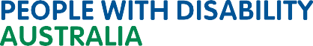
 pwd@pwd.org.au  1800 422 015

 PWDAustralia PWD.Australia

