Submission on NDIS Access Changes

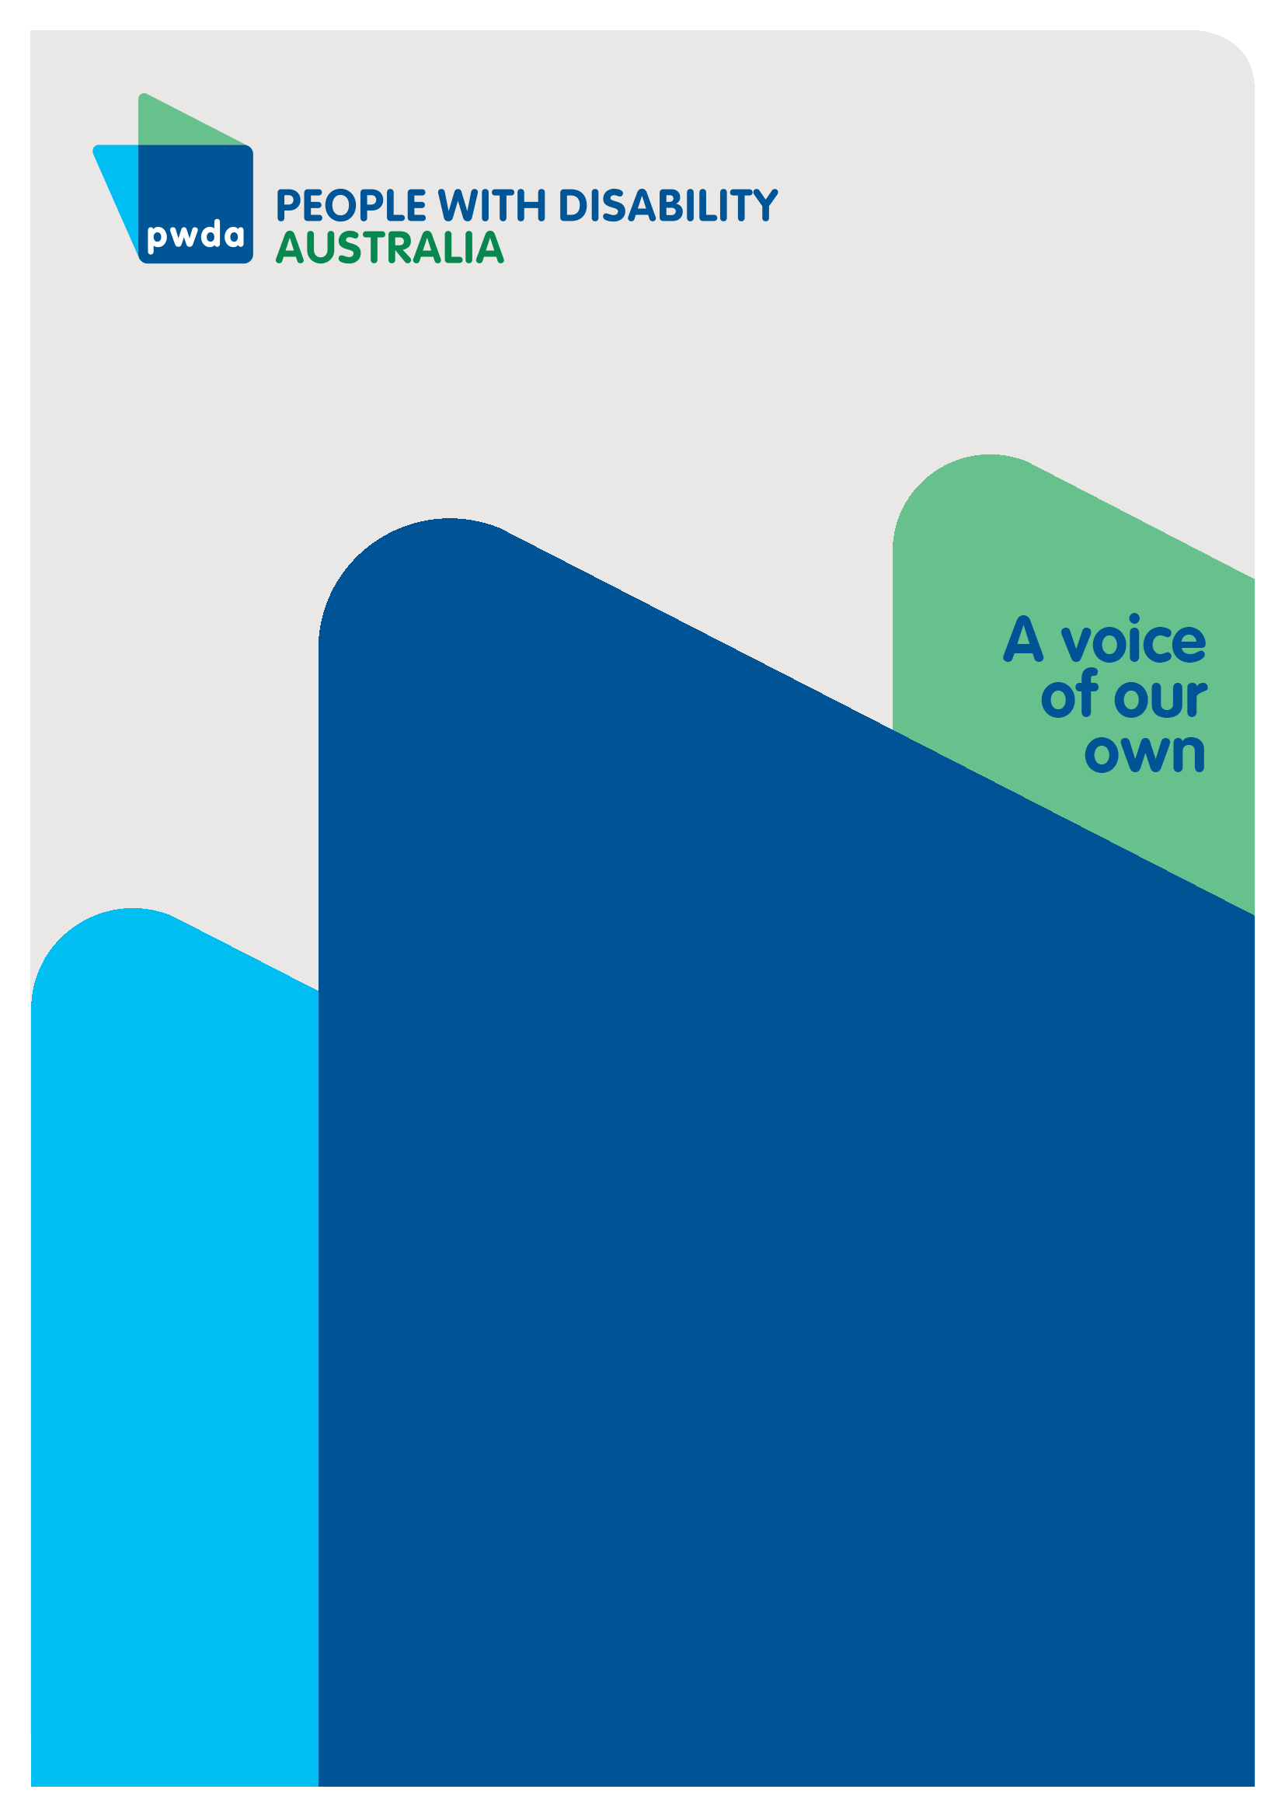
October
2026

Copyright information
Submission on the NDIS Access Changes
First published in 2026 by People with Disability Australia Ltd.
Suite 10.01| Centennial Plaza | Level 10, 300 Elizabeth Street | Surry Hills NSW 2010
Email: pwd@pwd.org.au
Phone: 1800 422 015
URL: www.pwd.org.au
Typeset in Arial 12 and 14 pt and VAG Rounded 26 pt
© People with Disability Australia Ltd. 2026
The moral rights of the authors have been asserted
National Library of Australia Cataloguing-in-Publication data:
Creator(s): | People with Disability Australia
Title: | Submission on NDIS Access Changes
All rights reserved. Except as permitted with the Australian Copyright Act 1968 (for example, a fair dealing for the purposes of study, research, criticism or review), no part of this book may be reproduced, stored in a retrieval system, communication or transmitted in any form or by any means without prior written permission. All inquiries should be made to the publisher at the address above.
Suggested citation:
People with Disability Australia; Submission on NDIS Access Changes, October, 2026.

About PWDA
People with Disability Australia (PWDA) is a national disability rights and advocacy organisation made up of, and led by, people with disability.
We have a vision of a socially just, accessible and inclusive community in which the contribution, potential and diversity of people with disability are not only recognised and respected but also celebrated.
PWDA was established in 1981, during the International Year of Disabled Persons.
We are a peak, non-profit, non-government organisation that represents the interests of people with all kinds of disability.
We also represent people with disability at the United Nations, particularly in relation to the United Nations Convention on the Rights of Persons with Disabilities (CRPD).
Our work is grounded in a human rights framework that recognises the CRPD and related mechanisms as fundamental tools for advancing the rights of people with disability.
PWDA is a member of Disabled People’s Organisations Australia (DPO Australia), along with the First People’s Disability Network, National Ethnic Disability Alliance and Women with Disabilities Australia.
DPOs collectively form a disability rights movement that places people with disability at the centre of decision-making in all aspects of our lives.
‘Nothing About Us, Without Us’ is the motto of Disabled Peoples’ International.

Introduction
People with Disability Australia (PWDA) welcomes the opportunity to provide feedback on the Australian Government’s changes to NDIS access.
PWDA strongly supports efforts to improve the consistency, transparency and fairness of NDIS access decisions, and recognises the importance of ensuring the Scheme remains sustainable for future generations of people with disability.
However, we are concerned that the pace and scale of the proposed reforms are not being matched by adequate safeguards, transparency measures and independent oversight to ensure people with disability are not left without the supports they need.
The NDIS Access consultation paper focuses heavily on sustainability and consistency while providing limited detail about how people will be protected from exclusion, inappropriate refusals, and unfair reassessments.
We are disappointed that the Australian Government has chosen to conduct four major NDIS reform consultations at the same time - Commissioning Supported Independent Living, New Framework Planning & NDIS Supports, NDIS Access Changes and Support Coordination and Connection. NDIS Reforms Consultation Hub.
This places an unreasonable burden on people with disability and disability representative organisations, many of whom are already stretched by ongoing reform processes.
Meaningful consultation requires adequate time and capacity to analyse proposals, engage with members, and develop considered responses. Concurrent consultations make this increasingly difficult and risk excluding important voices from the process.
This submission will respond to the questions outlined in the consultation paper in regard to the draft guiding principles, the design of access decision-making processes and evidence requirements.
However, PWDA urges the Australian Government to take into account the broader NDIS reform context when considering each of the public consultations and proposed changes to NDIS access.
On August 19, 2026, Parliament passed the NDIS Amendment (Securing the NDIS for Future Generations) Bill 2026 which represents the most significant changes to the NDIS since its inception 13 years ago.
The plan to remove hundreds of thousands of participants from the NDIS over the next four years, in the absence of established Foundational Supports, represents a profound systemic failure in the making.
Many of the changes outlined in the current public consultations will result in large-scale reductions in participant numbers with no timetable, roadmap and evidence of progress towards the development of Foundational Supports.
State and territory leaders have already signalled that they lack both the capacity and, in many cases, the willingness to absorb this responsibility. These changes will ultimately undermine the core purpose of the NDIS - supporting people with disability to live independently and participate fully in the community.
We encourage the Australian Government to work with state and territory leaders to develop and release a national roadmap for Foundational Supports to ensure that the proposed changes to NDIS access do not result in people with disability losing essential supports before appropriate alternative services are in place.

Summary of Recommendations
Recommendation 1 - Adopt a sufficiently broad interpretation of “reliable evidence” to prevent blanket decisions based on population-level evidence rather than consideration of individual outcomes.
Recommendation 2 - Evidence frameworks should not be developed solely through a narrow medical or clinical lens. They must adequately capture complex, episodic and fluctuating disabilities and be co-designed with people with disability to ensure they reflect the full diversity of disability experience.
Recommendation 3 - Publish all assessment frameworks, scoring methodologies, thresholds and evidence standards prior to implementation.
Recommendation 4 - The Government, in coordination with the NDIA, should design and implement alternative evidentiary pathways tailored specifically for individuals who face systemic barriers to accessing mainstream specialist assessments.
Recommendation 5 - Incorporate mechanisms to capture the peak impact of episodic, fluctuating, and degenerative conditions, rather than a single "snapshot" day where a person may be tracking better than usual.
Recommendation 6 - Introduce safeguards specifically addressing psychosocial, episodic, fluctuating, degenerative and rare disabilities.
Recommendation 7 - Ensure all assessment methodologies and tools undergo public validation and extensive disability-led testing before implementation.
Recommendation 8 - Apply a presumption of continuing eligibility for existing participants unless compelling evidence demonstrates otherwise.
Recommendation 9 - Ensure participants are not removed from the NDIS until equivalent alternative supports are demonstrably available.
Recommendation 10 - Develop and implement a formal, transparent review and appeals mechanism specifically tailored to functional capacity assessments. To ensure efficacy, equity, and procedural fairness, these safeguards must be co-designed in direct partnership with people with disability and their representative organisations.
Recommendation 11 - The Australian Government should adopt a communication and engagement strategy for NDIS access reforms that ensures participants, prospective participants and families receive clear, timely and accessible information about proposed changes, reassessment processes, review rights, safeguarding arrangements and available supports, with the objective of rebuilding trust and confidence in NDIS decision-making.
Recommendation 12 - Any treatment considered appropriate must be demonstrably accessible, affordable, clinically suitable, culturally safe, and available within a reasonable timeframe for the individual.
Recommendation 13 - Ensure information collected and verified by one agency or provider is automatically reusable across all assessment stages to drastically reduce administrative burdens on participants, carers, and families.
Recommendation 14 - Establish an independent, ongoing public evaluation framework to monitor the impact of access reforms across disaggregated disability cohorts, with findings published in a comprehensive annual report.

Discussion

Guiding Principles
PWDA supports the adoption of the following draft principles to help shape the future of access decision-making processes, as outlined in the consultation documents.
- Follow the NDIS Act and respect the human rights of people with disability.
- Be guided by the lived experiences of people with disability, families and carers.
- Focus on each person’s needs and strengths.
- Be fair, inclusive and safe
- Be clear, accessible and easy to use.
- Keep learning and improving.
We believe the draft principles listed above demonstrate a willingness to value the rights of people with disability and to ensure that changes to NDIS access are informed by their lived experience.
However, PWDA is concerned about the following principle:
- Use reliable evidence and make consistent decisions.
1. Medicalisation of evidence
PWDA questions the Government’s use of the term “reliable evidence” if it is not clearly defined and appropriately balanced with lived experience, participant choice and the social model of disability.
“Reliable evidence" could be interpreted as meaning only evidence from medical specialists, clinical assessments or standardised tools, which will reinforce a narrow medical model of disability if decision-makers discount a participant's own account of their support needs and daily experiences.
We are particularly concerned that:
- Clinical and medical expertise may dominate.
- Disability rights expertise may be underrepresented.
- Lived experience evidence could be given less weight.
- Recommendations may be based heavily on population-level evidence rather than individual circumstances.
Excessive reliance on technical or clinical advice may result in evidence standards that fail to recognise the diverse ways disability impacts people's lives, particularly where impacts are complex, cumulative or not easily measured through standardised assessment tools.
2. Complex and fluctuating disabilities may not fit standardised evidence models
Many disabilities, particularly psychosocial disability, chronic illness, neurodivergence, fatigue-related conditions and some neurological conditions, do not present consistently from day to day.
Evidence that appears consistent in a clinical setting may fail to accurately reflect the episodic, fluctuating or cumulative impacts of disability experienced in everyday life
Participants should not have to demonstrate their disability at its worst moment to access support. A rigid interpretation of "reliable evidence" could disadvantage people whose support needs fluctuate or are difficult to capture through a one-off assessment.
3. "Reliable evidence" may be used to exclude supports with emerging or limited research evidence
Some disability supports are highly individualised. Participants often benefit from supports that may not have a large clinical evidence base but are effective for that specific person.
A narrow interpretation of reliability could lead to blanket decisions based on population-level evidence rather than consideration of individual outcomes.
For example:
- peer support,
- capacity building supports,
- innovative technologies,
- culturally specific supports, and
- supports tailored to intersectional experiences of disability.
4. Risk of hidden bias in what counts as "reliable"
Evidence frameworks are not neutral. Historically, disability systems have often privileged forms of evidence developed around physical impairments and medical diagnosis.
This can disadvantage:
- people with psychosocial disability,
- people with intellectual disability,
- First Nations participants,
- CALD participants,
- women with disability, and
- people with multiple or intersecting disabilities.
Therefore, the definition of "reliable evidence" may inadvertently exclude forms of evidence that are critical for understanding the support needs of people whose disabilities do not fit traditional clinical models.
Any definition of "reliable evidence" must recognise the legitimacy of lived experience, functional impact evidence, disability-specific expertise and participant self-reporting.
The draft principles largely focus on process quality rather than outcomes. A process can be accessible, consistent and evidence-based while still producing exclusionary outcomes if eligibility thresholds are too restrictive.
PWDA believes the guiding principles should place greater emphasis on:
- Equity of outcomes.
- Disability self-determination.
- Independent oversight.
- Accountability.
- Co-design.
- Protection from unintended exclusion.
Recommendation 1 - Adopt a sufficiently broad interpretation of “reliable evidence” to prevent blanket decisions based on population-level evidence rather than consideration of individual outcomes.
Recommendation 2 - Evidence frameworks should not be developed solely through a narrow medical or clinical lens. They must adequately capture complex, episodic and fluctuating disabilities and be co-designed with people with disability to ensure they reflect the full diversity of disability experience.

Design of access decision-making process
1. Fairness, Consistency and Transparency
PWDA agrees that reform is needed to address the complexity and significant inconsistencies that characterise the current NDIS access process.
Many people report receiving different decisions despite presenting similar evidence. Others struggle to access costly specialist reports necessary to demonstrate eligibility. The proposed move towards functional capacity assessments may improve consistency.
However, consistency alone is not sufficient. An assessment system can consistently produce poor decisions if the underlying methodology is flawed.
The consultation paper provides very little information regarding:
- Assessment tools.
- Weighting of evidence.
- Decision thresholds.
- Quality assurance mechanisms.
- Reviewer qualifications.
- Internal review safeguards.
Without this information, stakeholders cannot effectively assess whether reforms will improve fairness.
Recommendation 3 - Publish all assessment frameworks, scoring methodologies, thresholds and evidence standards prior to implementation.
2. Reducing Administrative Burden
Currently many participants spend thousands of dollars obtaining specialist reports. Others wait months or years navigating complex evidence requirements. The introduction of functional assessments must not simply replace one layer of bureaucracy with another.
People with disability should not be required to repeatedly prove their disability or repeatedly participate in intrusive assessments.
Under the new framework starting in April 2027, the primary tool for deciding standard plan budgets will transition to an interview-based Support Needs Assessment (using the I-CAN tool) conducted by an NDIA assessor. Private reports from participants’ treating specialists or allied health team will transition into a supportive role:
The Government should establish streamlined pathways where eligibility is clear and there is clarity regarding:
- exactly what clinical evidence will be required for access;
- how existing reports from treating professionals will be weighted;
- whether participants can submit additional evidence where they disagree with an assessment outcome;
Recommendation 4 - The Government, in coordination with the NDIA, should design and implement alternative evidentiary pathways tailored specifically for individuals who face systemic barriers to accessing mainstream specialist assessments.
3. Functional Capacity Assessments
PWDA agrees that diagnosis alone is not always an appropriate indicator of support requirements. People with the same diagnosis often experience vastly different levels of functional impact. A greater focus on function may therefore improve equity.
However, functional capacity assessments risk excluding or misrepresenting vulnerable cohorts. Functional assessments can fail to capture:
- Fluctuating support needs.
- Fatigue.
- Sensory impacts.
- Psychosocial disability.
- Communication differences.
- Environmental barriers.
- Cumulative disadvantage.
Many people have developed strategies that mask disability impacts during brief assessments. Consequently, assessments conducted on a single day may not accurately reflect lived experience.
Psychosocial disability, in particular, fluctuates over time. People may experience periods of relative stability alongside significant functional impacts. Assessments focused on a snapshot of functioning may underestimate support needs.
People with conditions such as multiple sclerosis, chronic fatigue syndrome, autoimmune disorders and many neurological conditions also may experience substantial variation in functioning from day to day.
People who communicate differently require accessible processes and multiple opportunities to demonstrate functional impact.
Recommendation 5 - Incorporate mechanisms to capture the peak impact of episodic, fluctuating, and degenerative conditions, rather than a single "snapshot" day where a person may be tracking better than usual.
Recommendation 6 - Introduce safeguards specifically addressing psychosocial, episodic, fluctuating, degenerative and rare disabilities.
Recommendation 7 - Ensure all assessment methodologies and tools undergo public validation and extensive disability-led testing before implementation.
From 1 January 2028, all new applicants will be assessed using standardised tests, while existing participants will undergo reassessment over a two-year period.
There is a real and immediate danger that people who currently qualify for support will lose access during reassessment, undermining continuity of care and exposing them to serious negative consequences for their safety, health and wellbeing.
Recommendation 8 - Apply a presumption of continuing eligibility for existing participants unless compelling evidence demonstrates otherwise.
Recommendation 9 - Ensure participants are not removed from the NDIS until equivalent alternative supports are demonstrably available.
4. Review, Appeals and Procedural Fairness
The consultation paper contains no discussion regarding review rights and the role of automation during the assessment process.
This omission is concerning.
A PWDA member survey on NDIS Support Needs Assessments conducted in November 2025 revealed deep apprehension and mistrust of the proposed I-CAN based assessments:
- 85% of the 340 respondents said they have concerns about the introduction of a support needs tool based on the I-CAN assessment tool
- 91% of respondents expressed concerns about the new assessment process
The relationship between the proposed access assessments, the Technical Advisory Group's (TAG) work and influence and the I-CAN assessment framework remains unclear.
Access to the NDIS should never be determined solely through automated scoring systems. Functional capacity assessments must support, rather than replace, professional judgement, lived experience evidence and individualised consideration of a person's circumstances, particularly for people with psychosocial, fluctuating, episodic and complex disabilities.
As reforms place greater emphasis on assessment processes and functional capacity judgments, robust safeguards become even more important.
Participants must understand:
- Why decisions were made.
- How evidence was weighted.
- What thresholds were applied.
- How to seek review.
PWDA supports recommendations of the Joint Standing Committee on the National Disability Insurance Scheme Annual Report 1 of the 48th Parliament that in the development of the rules for the new support needs assessment framework, the NDIA ensures:

- that participants are provided with an opportunity to review a draft of their plan, including details on the rationale for decision-making, with the ability to make suggested amendments before the finalisation of their budget; and
- assurance that the Administrative Review Tribunal retains its ability to make changes to a participant's budget or support allocation, rather than limit the ART to return a decision to the NDIA for development of a new I-CAN report.

Recommendation 10 - Develop and implement a formal, transparent review and appeals mechanism specifically tailored to functional capacity assessments. To ensure efficacy, equity, and procedural fairness, these safeguards must be co-designed in direct partnership with people with disability and their representative organisations.

5. Consistent Transparency to Rebuild Trust

Consistency and transparency are essential to rebuilding participants’ trust in the NDIS.
People need accessible information about what is changing and when. If the NDIA contacts a participant about their eligibility, plan or funding, they need to know why, what information is being sought and what could happen next.
They also need to know they can have a supporter or advocate with them. Supported decision-making means giving people the information, time and support they need to understand what is happening, express their will and preferences and participate in decisions about their lives.
The same approach must apply to safeguarding.
When someone reports abuse, neglect, exploitation or unsafe supports to the NDIS Quality and Safeguards Commission, they need to know what is happening, what action is being taken and when they will hear from the Commission again.
Confusion and uncertainty arising from poor communication from the NDIA and the Commission have undermined trust and made it more difficult for participants to understand how changes will affect them.

The development of new access decision-making arrangements must avoid repeating these shortcomings and instead prioritise clear, consistent and accessible communication at every stage of the process.

PWDA considers it critical that the TAG operates in a transparent and accountable manner as it develops advice on NDIS access and eligibility processes. This includes clearly communicating the evidence base underpinning recommendations, meaningfully engaging with people with disability and their representative organisations, and publicly explaining how stakeholder feedback has informed decision-making.
Recommendation 11 - The Australian Government should adopt a communication and engagement strategy for NDIS access reforms that ensures participants, prospective participants and families receive clear, timely and accessible information about proposed changes, reassessment processes, review rights, safeguarding arrangements and available supports, with the objective of rebuilding trust and confidence in NDIS decision-making.

Evidence requirements
1. Permanence of Disability and “treatments”
One of the most concerning changes under the NDIS Amendment (Securing the NDIS for Future Generations) Bill is the plan to restrict access to the NDIS to individuals whose impairment is assessed as “permanent,” requiring that appropriate treatments that could remedy or alleviate the impairment have already been undertaken.
PWDA welcomes the amendment to the NDIS Bill which clarifies that ‘appropriate treatment’ is considered treatment that is widely accepted and regularly undertaken in Australia if public funding is available through Medicare, the Pharmaceutical Benefits Scheme (PBS) or public hospitals.

We also welcome the assertion that restrictive practices do not count as ‘appropriate treatment’. However, we remain concerned that permanence requirements could be interpreted too narrowly.
The inclusion of the term “alleviate” may result in minor or temporary improvements in function being used to argue that an impairment is not permanent, regardless of whether those improvements significantly change a person’s overall level of need.
The Government did not rule out the possibility that short term improvements would have an impact on the definition of permanent, rather it stated, “small or short-term improvements would not usually be enough.”
The requirement to consider treatments places ongoing pressure on individuals to pursue medical interventions to qualify for the NDIS, and to possibly undergo treatments that are inappropriate, that they would not ordinarily consent to or unlikely to deliver meaningful benefit.
People with variable, episodic, or fluctuating conditions are especially vulnerable under this approach. Conditions that do not present as consistently stable, even where they are lifelong and substantially disabling, could fail to meet the strict criteria for permanence, resulting in exclusion from necessary supports.
This risk is also highly gendered. Women with disability are disproportionately represented among people with conditions that are episodic, fluctuating, poorly understood, or historically under-recognised by medical systems, including autoimmune conditions, chronic pain conditions, ME/CFS, endometriosis, and some psychosocial disabilities.
Extensive evidence demonstrates that women frequently experience diagnostic delays, dismissal of symptoms, and reduced access to specialist care compared with men. Where access to the NDIS is contingent upon demonstrating permanence through formal diagnosis, treatment history, or specialist evidence, these systemic inequities may create additional barriers for women seeking access to disability supports.
It is also unclear how permanence and functionality will be considered for genetic or congenital - related disabilities.
The requirement also fails to account for inequities in access to healthcare. Individuals who cannot access recommended treatment, particularly those in rural and regional areas will be unfairly excluded from the NDIS on the basis that they have not undertaken all widely accepted treatments.
Assessment of treatment suitability should consider:
- Clinical advice
- Individual preferences
- Psycho-social impacts
- Cultural considerations
- Risks and side effects
- Accessibility
- Geographic availability
- Cost
Recommendation 12 - Any treatment considered appropriate must be demonstrably accessible, affordable, clinically suitable, culturally safe, and available within a reasonable timeframe for the individual.
2. Minimising duplication
People with disabilities that are permanent, significant and clearly meet eligibility requirements should have access to simplified assessment and decision-making processes. Assessment arrangements should focus on determining appropriate supports rather than repeatedly requiring individuals to demonstrate the existence or permanence of their disability.
The TAG should place substantial weight on existing medical, clinical and allied health evidence where this evidence remains current and relevant. People with disability should not be required to repeatedly obtain costly reports or undergo additional assessments where sufficient evidence has already been provided through previous NDIS processes or other government systems.
Assessment processes should also minimise duplication across agencies, providers and assessment stages. Information that has already been collected and verified should be reusable wherever possible, reducing administrative burden on participants, carers and families while improving efficiency across the system.
Adopting these measures would better align assessment processes with the principles of fairness, proportionality and administrative efficiency, while reducing unnecessary barriers to access.
It would also help ensure that people with profound and permanent disabilities can devote their time and energy to participating in everyday life, rather than repeatedly navigating assessment and evidentiary requirements.
Recommendation 13 - Ensure information collected and verified by one agency or provider is automatically reusable across all assessment stages to drastically reduce administrative burdens on participants, carers, and families.
3. Monitoring and Continuous Improvement
While PWDA supports continuous quality improvement within the NDIS, sustainable systemic improvement is contingent upon robust, meaningful public accountability. To ensure transparency and safeguard participant rights, the Government must mandate comprehensive, public reporting on the following performance metric:
- Access approval rates to track entry thresholds and identify potential barriers.
- Appeals outcomes to evaluate the fairness and accuracy of initial agency decisions.
- Cohort impacts to monitor systemic effects across diverse demographics.
- Assessment consistency to guarantee equitable decision-making processes.
- Participant experiences to capture qualitative data on service delivery and dignity of risk.

Recommendation 14 - Establish an independent, ongoing public evaluation framework to monitor the impact of access reforms across disaggregated disability cohorts, with findings published in a comprehensive annual report.

Conclusion
PWDA supports efforts to improve fairness, consistency and transparency in NDIS access arrangements.
However, access reforms must not become primarily a mechanism for limiting NDIS growth or reducing participant numbers.
The NDIS exists to support people with people with disability to live ordinary lives and participate in the community on an equal basis with others. Access reforms should strengthen, rather than weaken, that objective.
The proposed shift toward functional capacity assessment represents a fundamental redesign of the Scheme. If implemented appropriately, it could improve consistency and equity. If implemented poorly, it risks excluding many people with disability who genuinely require lifelong disability support.
The success of the reforms will ultimately be judged not by whether costs are constrained, but by whether people with disability experience greater fairness, dignity and access to the supports they need.
PWDA would welcome the opportunity to work with Government to ensure access to the NDIS remains rights-based, evidence-informed and genuinely responsive to the needs of people with disability, with the design and implementation of any new assessment processes being transparent, co-designed with people with disability, and subject to ongoing independent monitoring and evaluation.

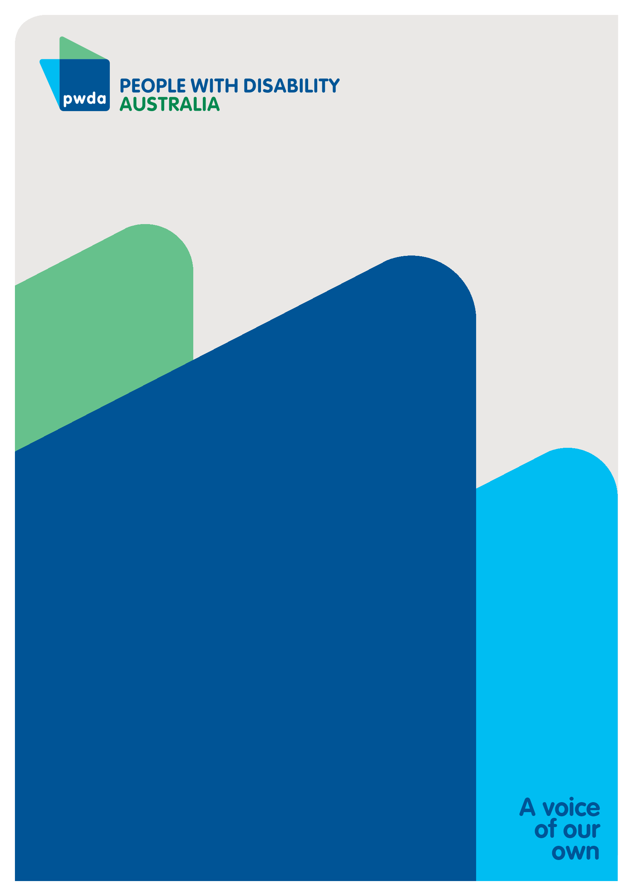

People with Disability Australia (PWDA) is a national disability rights and advocacy organisation made up of, and led by, people with disability.
For individual advocacy support contact PWDA between 9 am and 5 pm (AEST/AEDT) Monday to Friday via phone (toll free) on 1800 843 929 or via email at pwd@pwd.org.au
Submission contact
Clara Pirani
Senior Policy Officer
E: clarap@pwd.org.au and policy@pwd.org.au

ABC News (April 2026). State and territory ministers react to the Albanese government’s NDIS changes. State and territory ministers react to the Albanese government's NDIS changes - ABC News
Joint Standing Committee on the NDIS. https://www.aph.gov.au/Parliamentary_Business/Committees/Joint/National_Disability_Insurance_Scheme/AnnualReport_1_48th
University Health. (2024) Why women are at higher risk of Autoimmune Disorders. https://www.universityhealth.com/blog/women-autoimmune-disease
National Center for Biotechnology Information. (2025). Gender Bias and Diagnostic Delays in Young Women. https://pmc.ncbi.nlm.nih.gov/articles/PMC12829432/

