Submission on New Framework Planning and NDIS Supports
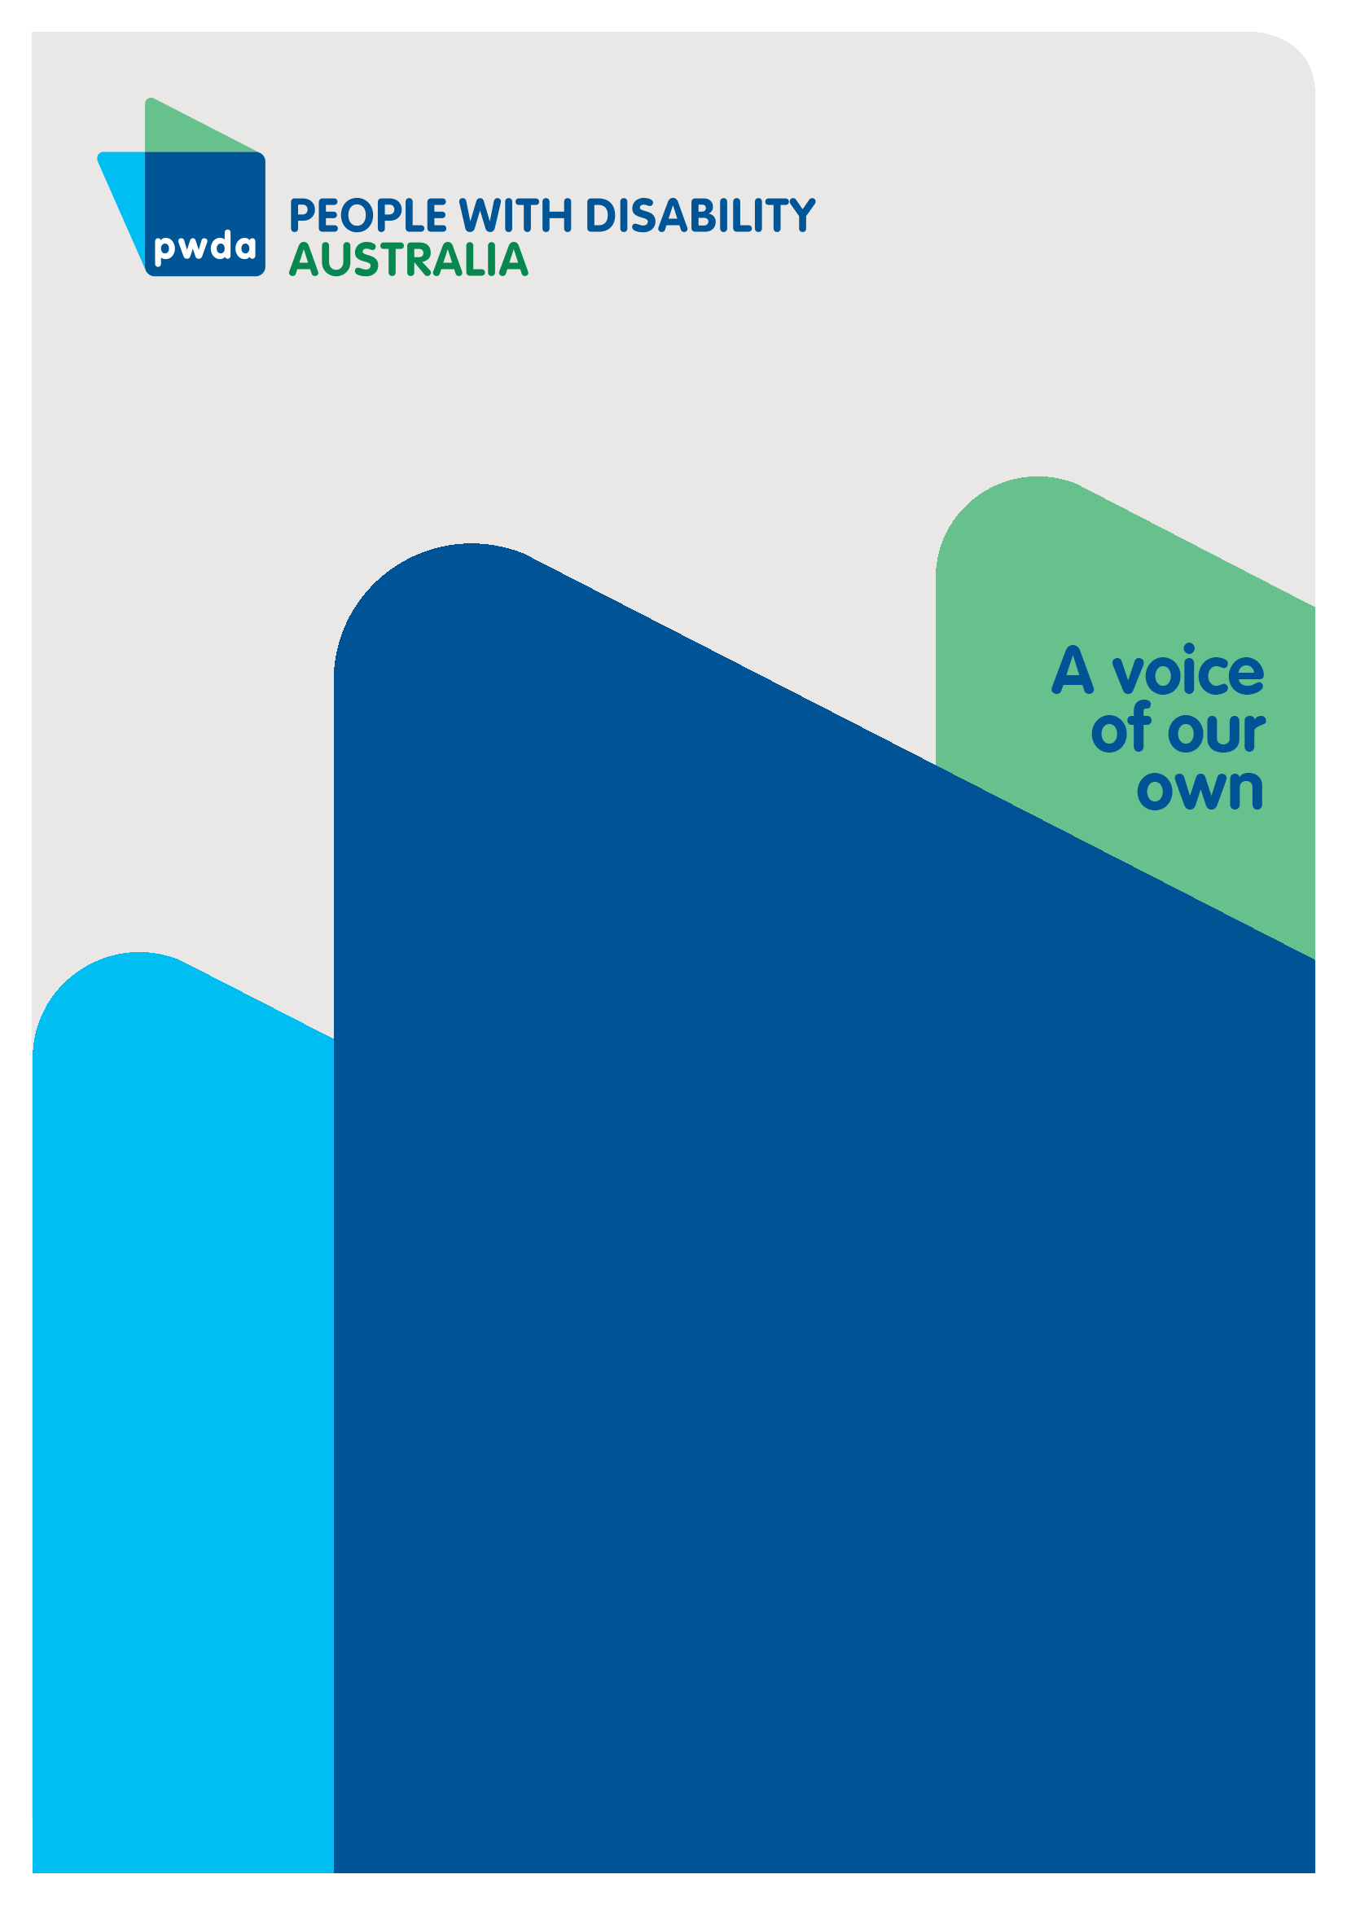
October
2026

Copyright information
Submission on New Framework Planning and NDIS Supports
First published in 2026 by People with Disability Australia Ltd.
Suite 10.01| Centennial Plaza | Level 10, 300 Elizabeth Street | Surry Hills NSW 2010
Email: pwd@pwd.org.au
Phone: 1800 422 015
URL: www.pwd.org.au
Typeset in Arial 12 and 14 pt and VAG Rounded 26 pt
© People with Disability Australia Ltd. 2026
The moral rights of the authors have been asserted
National Library of Australia Cataloguing-in-Publication data:
Creator(s): | People with Disability Australia
Title: | Submission on New Framework Planning and NDIS Supports
All rights reserved. Except as permitted with the Australian Copyright Act 1968 (for example, a fair dealing for the purposes of study, research, criticism or review), no part of this book may be reproduced, stored in a retrieval system, communication or transmitted in any form or by any means without prior written permission. All inquiries should be made to the publisher at the address above.
Suggested citation: People with Disability Australia; Submission on New Framework Planning and NDIS Supports, October 2026

About PWDA
People with Disability Australia (PWDA) is a national disability rights and advocacy organisation made up of, and led by, people with disability.
We have a vision of a socially just, accessible and inclusive community in which the contribution, potential and diversity of people with disability are not only recognised and respected but also celebrated.
PWDA was established in 1981, during the International Year of Disabled Persons.
We are a peak, non-profit, non-government organisation that represents the interests of people with all kinds of disability.
We also represent people with disability at the United Nations, particularly in relation to the United Nations Convention on the Rights of Persons with Disabilities (CRPD).
Our work is grounded in a human rights framework that recognises the CRPD and related mechanisms as fundamental tools for advancing the rights of people with disability.
PWDA is a member of Disabled People’s Organisations Australia (DPO Australia), along with the First People’s Disability Network, National Ethnic Disability Alliance and Women with Disabilities Australia.
DPOs collectively form a disability rights movement that places people with disability at the centre of decision-making in all aspects of our lives.
‘Nothing About Us, Without Us’ is the motto of Disabled Peoples’ International.

Table of Contents
Submission on New Framework Planning and NDIS Supports 1
Copyright Information 2
About PWDA 3
Introduction 5
Summary of Recommendations 7
Discussion 11
1.New Framework Planning Rules 11
1.1 Support Needs Assessments Rules 11
1.2 Budget Method Rules 16
1.3 Plan Variations and Reassessment Rules 18
2. NDIS Supports Transitional Rules 21 2.1 New Support Categories 21
2.2 Flexible and Stated Supports 23
2.3 What is not an NDIS support 24
2.4 Replacement Supports 25

Conclusion 26

Introduction

PWDA welcomes the opportunity to respond to the August 2026 consultation on the remaining New Framework Planning Rules and the proposed amendments to the NDIS Supports Transitional Rules. These consultations are critically important because they will shape how participants are assessed, how funding is determined, how plans are varied, and how supports are accessed under the National Disability Insurance Scheme.

In March 2026, PWDA made 32 recommendations aimed at strengthening transparency, procedural fairness, participant rights, independent oversight and meaningful co-design within New Framework Planning.

Those recommendations reflected concerns raised by PWDA members and the broader disability community that major reforms were proceeding without sufficient information, safeguards or accountability mechanisms.

PWDA acknowledges that the Government has responded to a number of these concerns. In particular, the August consultation papers provide more information about support needs assessments, the Personal and Environmental Circumstances Questionnaire (PECQ), targeted assessments, categories of NDIS supports, plan variations and the broad architecture of the new budget method.

The Government has also committed to releasing exposure drafts of all eight New Framework Planning Rules later in 2026, confirmed that most supports will be flexible rather than stated, and indicated that participants can expect longer plans of up to five years.

PWDA welcomes these improvements.

However, many of the concerns raised in our March 2026 New Framework Planning submission remain unresolved. Despite increased transparency in some areas, participants still do not know how assessment outcomes will translate into funding, what safeguards will apply to replacement assessments, how CEO and NDIA discretionary powers will operate, how automated decision-making will be used, or how many decisions under New Framework Planning will be meaningfully reviewable.

The consultation papers also acknowledge that significant aspects of the budget method remain under development and testing.

PWDA therefore considers that substantial improvement is still required before the proposed Rules can be considered fully transparent, rights-based and consistent with the principles of choice and control that underpin the NDIS.
In recent weeks PWDA conducted a member and community survey to collate views of the New Framework Planning Rules and NDIS Supports Transitional Rules. The strongest survey finding is a crisis of confidence in the proposed support needs assessment.
Of 55 respondents, 90% disagreed or strongly disagreed that the proposed support needs assessments would fairly assess support needs, and 98% were somewhat or very concerned that people with similar assessment outcomes may have significantly different support needs.
Respondents repeatedly questioned whether a standardised assessment could capture fluctuating, psychosocial, neurodivergent, cognitive, communication, invisible, progressive and complex disability, particularly where needs vary by environment, informal support, geography or the interaction of multiple impairments. 95% were concerned that budgets may not reflect individual circumstances and 78% disagreed or strongly disagreed that the proposed budget method would improve consistency.
The survey also revealed significant concerns not only about whether an assessment is accurate first time, but about whether participants can see what has been recorded, correct mistakes, provide additional evidence, obtain human reconsideration and challenge an outcome before an error flows through to their budget.
PWDA supports respondents repeated calls for professional evidence and disability expertise to complement, rather than be displaced by a standardised assessment. This is especially prominent in responses about psychosocial disability, complex disability, assistive technology and fluctuating conditions.
Respondents want a system that is structured enough to be predictable, but flexible and accountable enough to recognise an individual whose needs do not fit the standard case, and to correct the decision quickly when the system gets it wrong.

Therefore, PWDA argues that the Government should not finalise the NDIS rules until it can demonstrate that the assessment process and budget methods are fair and effective for people with a diversity of disability, circumstances and locations, and has openly shared the evidence.

Summary of Recommendations

Support Needs Assessment Rules
Recommendation 1 - The rules should not be finalised until the assessment, and budget pathway has been tested across a demonstrably diverse range of disability, communication, support and geographic circumstances, with results made transparent enough for the community to evaluate.
Recommendation 2 - Exposure-draft consultation should allow the community to examine the rules as an interacting system, including the complete assessment-to-budget pathway, rather than requiring feedback on key components before the operative detail is available.
Recommendation 3 - Assessment processes must be accessible by design. Reasonable adjustments must protect the accuracy of the assessment, not merely the participant's ability to attend it. The rules must guarantee reasonable adjustments to the assessment process and make clear that a participant must not receive a lower assessment outcome because the assessment method itself prevented them from communicating their needs.
Recommendation 4 - Develop a public explanation of the I-CAN 6 scoring-to-funding logic, so participants can understand how their assessment leads to specific budget decisions.
Recommendation 5 - Provide validation evidence to demonstrate that the combined core assessment, PECQ and targeted assessment pathway is reliable across different disability types, communication methods and fluctuating or complex support needs.
Recommendation 6 - Relevant existing medical, allied health and other professional evidence must be genuinely considered, with a clear process for resolving conflicts between that evidence and the standardised assessment.
Recommendation 7 - People must be able to review the draft of the support needs assessment before it is finalised and submitted and have access to supported decision making and/or individual advocacy. This ensures there is the opportunity to correct any misunderstandings that could result in delayed access to critical supports.

Budget Method Rules
Recommendation 8 - The budget method rules should require the NDIA to provide participants with a plain language budget explanation statement outlining how each component of their funding was calculated, including assumptions, adjustments, and supporting evidence and options to challenge an error.
Recommendation 9 - The NDIA should publish regular, accessible public reporting on budget method outcomes, including funding trends, review outcomes, participant satisfaction measures, and impacts across different disability cohorts.

Plan Variations and Reassessment Rules
Recommendation 10 - Participants should have an explicit right to request a plan reassessment where they believe a variation would not adequately address their circumstances.

Recommendation 11 - The NDIA should be required to provide written reasons explaining why a variation, rather than a reassessment, has been undertaken.

Recommendation 12 - Plan variation decisions should include transparent information about how the budget methodology was applied and how funding amounts were calculated.

Recommendation 13 - Plan variations should not be used to reduce participant funding or significantly alter support categories unless the participant has been afforded procedural fairness and an opportunity to provide additional evidence.

Recommendation 14 - In instances where the NDIA refuses a request for a variation or reassessment, that decision should remain fully reviewable.

Recommendation 15 - The NDIA should develop and publish clear definitions of the “significant changes” to support needs that will justify a reassessment.
Recommendation 16 - Clarify what decision timeframes will apply to urgent plan variations and reassessments, and what funding or support continues while a decision is pending.

New Support Categories
Recommendation 17 - Maintain flexibility for supports that span multiple categories.
Recommendation 18 - Ensure broader support categories adopt rules for overlapping and atypical needs and should not become de facto caps or barriers to otherwise appropriate supports.
Recommendation 19 - Adopt a person-centred approach to support determinations.
Recommendation 20 - Monitor and publicly report on the impact of category reforms.
Recommendation 21 - Co-design category boundaries with people with disability.

Flexible and Stated Supports
Recommendation 22 - Strengthen transparency, participation, and review rights in decisions to apply stated supports.

Recommendation 23 - The NDIS Rules should establish clear criteria limiting the use of stated supports and require regular review mechanisms that enable participants to seek greater funding flexibility without unnecessary administrative burden.

What is not an NDIS Support
Recommendation 24 - Retain a disability-related exception for otherwise ordinary items.

Recommendation 25 - Introduce individualised assessment criteria for proposed excluded supports.

Replacement Supports

Recommendation 26 - Provide evidence identifying which of those supports would remain available under the proposed rules and explain the pathway for beneficial disability-related supports that are not anticipated on a prescribed list.
Recommendation 27- The removal of replacement supports should not proceed without a transparent account of which currently available supports would cease to be available and how beneficial unlisted alternatives will be considered.

Discussion

1. New Framework Planning Rules

1.1 Support Needs Assessment Rules
Respondents to PWDA’s New Framework Planning and Support Rules survey identified the support needs assessment as the greatest area of concern.

90% of 53 respondents disagreed or strongly disagreed that the proposed process would result in a fair assessment and 98% were somewhat or very concerned that similar assessment outcomes may conceal materially different support needs.

The issue is not just standardisation itself. Rather, it is the risk that a standardised assessment tool becomes determinative of support decisions without adequate safeguards to identify and account for needs, circumstances and impacts that the tool does not measure well.

Respondents identify fluctuating function, psychosocial disability, neurodivergence, communication differences, invisible disability, complex and multiple impairments, fatigue, environmental variation and changing informal supports as circumstances in which a single structured assessment may produce an incomplete account.

The Department's consultation paper says the core needs assessment is based on a modified I-CAN, supplemented by a personal and environmental circumstances questionnaire and targeted assessments.

PWDA remains concerned that standardised tools can fail to capture fluctuating disability, intersectional disadvantage, complex communication requirements and lived experience. Previous concerns raised by PWDA, WWDA and other disability organisations remain relevant.

PWDA asserts the Department needs to demonstrate, before finalisation, how the combined process has been validated across the diversity of disability and communication profiles represented in the NDIS, how discordant evidence will be resolved, and what happens when a participant's needs are not adequately represented by the standard pathway.

Survey respondents describe the assessment encounter as potentially inaccessible for people who experience fatigue, post-exertional effects, cognitive overload, anxiety, trauma responses, memory or processing difficulties, sensory sensitivity, communication barriers or fluctuating capacity.

If the mode or duration of assessment affects what a person can communicate, accessibility can affect the substantive accuracy of the assessment.
“I have significant PTSD … and find trusting new people challenging, making it particularly difficult to openly discuss things I find really hard. Additionally engaging with anyone for 3 hours is beyond my capacity - most likely I’ll get overwhelmed and shut down, becoming unable to answer the questions… then how do they assess me?”
“My baseline day does not reflect the full amount of support I need…The i-can assessment does not adequately capture good, baseline and bad days which can vary significantly between participants.”

Recurring safeguards requested by respondents include:
- information, questions and response options available in advance and in accessible formats
- the ability to provide information in writing or through alternative and augmentative communication
- breaks, shorter sessions and the option to complete the assessment across more than one session
- face-to-face and other alternatives where telephone or video is inaccessible
- appropriate involvement of advocates, nominees, family, carers and communication partners
- assessors having sufficient time to review relevant existing evidence before the assessment
- assessor capability matched to the participant's disability and communication needs.
“The process is not taking into account the interaction of multiple impairments, that individually might not have high support needs but in combination are very disabling and require a lot of support.”
“Allow people with disability to have the questions in writing and be allowed to answer in writing. I then have time to digest the information and respond when my brain is clear. Otherwise, I can’t give an accurate answer.”
Recommendation 1 - The rules should not be finalised until the assessment, and budget pathway has been tested across a demonstrably diverse range of disability, communication, support and geographic circumstances, with results made transparent enough for the community to evaluate.
Recommendation 2 - Exposure-draft consultation should allow the community to examine the rules as an interacting system, including the complete assessment-to-budget pathway, rather than requiring feedback on key components before the operative detail is available.
Recommendation 3 - Assessment processes must be accessible by design. Reasonable adjustments must protect the accuracy of the assessment, not merely the participant's ability to attend it. The rules must guarantee reasonable adjustments to the assessment process and make clear that a participant must not receive a lower assessment outcome because the assessment method itself prevented them from communicating their needs.
Recommendation 4 - Develop a public explanation of the I-CAN 6 scoring-to-funding logic, so participants can understand how their assessment leads to specific budget decisions.
Recommendation 5 - Provide validation evidence to demonstrate that the combined core assessment, PECQ and targeted assessment pathway is reliable across different disability types, communication methods and fluctuating or complex support needs.

Existing evidence and specialist expertise remain critical

Across multiple questions in PWDA’s survey, respondents placed high value on evidence from professionals who know the participant and on disability-specific expertise. Functional capacity assessments, occupational therapy evidence, medical and allied health reports and other specialist material are described as providing longitudinal or disability-specific information that may not be reproducible in a single conversation.

This does not establish that every participant wants a clinician-led planning model. Rather, the evidence supports a narrower proposition: respondents do not want relevant professional evidence to be displaced by a generalised assessment, particularly where the two sources of evidence conflict.

The consultation paper states that medical or allied health reports will be relevant to many targeted assessments. However, PWDA seeks clearer rules on when existing evidence must be considered, how much weight it receives, how conflicting evidence is resolved and whether participants can require reconsideration where material evidence has been overlooked.
Recommendation 6 - Relevant existing medical, allied health and other professional evidence must be genuinely considered, with a clear process for resolving conflicts between that evidence and the standardised assessment.

Error correction, human oversight and reasons are cross-cutting safeguards
PWDA’s survey identified a strong fear that an error could become embedded in later decisions across all the assessment, budget and reassessment processes. Respondents wanted to know what information will be recorded, how it will be interpreted and how to correct it before it determines funding.

“Without human interaction, right of review and discussion there will always be things missed.”
“Every Rule MUST allow for individuality.”

Concerns about automated or algorithm-supported decision-making are part of this theme, but the underlying issue is broader: whether there is an accountable human decision-maker capable of recognising when a standard process has produced an implausible, incomplete or unsafe result.

The Department proposes that an NDIA delegate review the support needs assessment report for completeness. Respondents' concerns highlight the need for substantive review: whether the report accurately reflects the participant, whether relevant evidence has been considered and whether the resulting outcome makes sense in the participant's circumstances.

PWDA advocates for explicit safeguards for participant verification of the assessment record, correction of factual errors, reasons for material decisions, human review of anomalous outcomes and a review pathway capable of changing the substantive outcome rather than simply repeating the same process.

Recommendation 7 - People must be able to review the draft of the support needs assessment before it is finalised and submitted and have access to supported decision making and/or individual advocacy. This ensures there is the opportunity to correct any misunderstandings that could result in delayed access to critical supports.

1.2 Budget Method Rules
PWDA welcomes the Government's commitment to improving transparency in NDIS planning and funding decisions. Greater clarity regarding how funding decisions are made has the potential to improve trust, fairness, and accountability within the NDIS.
The NDIS Review Final report repeatedly identified a lack of transparency in NDIA decision-making as a major contributor to loss of trust and recommended clearer decision-making processes, accessible information, and improved digital systems that allow participants to understand decisions affecting them.
While the proposed budgeting methodologies may support consistency, they should not create ceilings, caps, or default funding allocations that constrain individualised decision-making. Participants with complex, fluctuating, episodic, psychosocial, intellectual, cognitive, or multiple disabilities may require funding that deviates from standard assumptions.
78% of PWDA survey respondents disagreed or strongly disagreed that the proposed budget method would improve consistency and 96% were somewhat or very concerned that budgets may not adequately reflect individual circumstances. Respondents frequently use the language of 'block funding', 'blanket amounts' and loss of individualisation.

“We’re going back towards the block funding model that NDIS was designed to move away from.”

PWDA is aware that further detail on budget calculations will be provided later in 2026 after additional testing and therefore we acknowledge that our survey measures respondent confidence in the proposed direction and safeguards, not the performance of a final budget algorithm that respondents have been able to inspect.

The qualitative evidence nevertheless identifies the circumstances respondents believe the budget method must address:
- multiple impairments
- atypical support combinations
- fluctuating needs
- geography
- informal supports
- service availability and
- supports that reduce reliance on more intensive assistance.

PWDA asks that exposure drafts and subsequent consultations provide enough information for participants to test the actual relationship between assessment inputs and budget outputs. At minimum, participants need to understand what information affects each category, the calculation approach, adjustments, assumptions, discretion available to delegates and the mechanism for correcting an inadequate result.

“The budgets for supports will be based on a standardised assessment which may not capture all support needs for all participants and may be incorrect.”
Recommendation 8 - The budget method rules should require the NDIA to provide participants with a plain language budget explanation statement outlining how each component of their funding was calculated, including assumptions, adjustments, and supporting evidence and options to challenge an error.
Recommendation 9 - The NDIA should publish regular, accessible public reporting on budget method outcomes, including funding trends, review outcomes, participant satisfaction measures, and impacts across different disability cohorts.

1.3 Plan Variations and Reassessment Rules
PWDA acknowledges that the proposed plan variation mechanism is intended to simplify and accelerate updates to participant plans. Allowing participants to obtain urgent funding for crisis situations, equipment repairs, assistance animal costs, or minor changes in support needs without requiring a full reassessment may reduce delays and administrative complexity.
Many NDIS participants currently experience lengthy waits when seeking relatively minor amendments to their plans. A streamlined variation process may improve responsiveness and reduce the burden on participants who would otherwise need to undergo a full reassessment for issues that could be resolved through a targeted adjustment.
However, the proposed framework also raises concerns regarding participant rights, procedural fairness, transparency, and the potential for reduced access to comprehensive reassessment processes.
The success of these reforms will depend on ensuring that participants retain genuine choice and control, are protected from funding reductions through administrative processes, and have accessible avenues to seek review of decisions.
Plan variations and replacement assessments need clear triggers, urgent pathways and continuity safeguards so participants are not left without adequate support while the system determines which process applies.
PWDA is concerned that participants may experience a gradual accumulation of unmet need if multiple variations are used instead of undertaking a holistic review of the person's circumstances.
Disability support needs are often interconnected, and changes in one area of a participant's life may have broader implications for their overall support requirements, health, participation, housing, employment, or informal support arrangements.
Plan variations could potentially be used to reduce funding without the robust procedural protections that accompany a full reassessment process.
While the current NDIS legislation outlines specific escalation pathways — such as the 90-day reviewable timeframe for rejected requests and the NDIA's discretion to substitute a requested reassessment with a partial variation — these mechanisms do not go far enough.
A key safeguard must be the participant's ability to request a reassessment where they believe a plan variation will not adequately address their circumstances. Participants are best placed to identify when changes to their disability-related support needs are substantial and require a comprehensive review.
Responses to PWDA’s survey identified four recurring risks:
- uncertainty about the threshold between a plan variation and a full reassessment
- delay while needs are urgent
- fear that requesting a limited change may expose unrelated parts of a plan to reconsideration
- difficulty correcting an inaccurate assessment or budget.
Respondents suggested triggers for a replacement assessment should include
- material error in the original assessment
- failure to consider relevant evidence
- significant change in disability or function
- loss or change of informal supports, hospital discharge
- major changes in living circumstances
- circumstances creating immediate safety risk.
“Please: there needs to be an option for corrections of errors, before a complete replacement assessment is required. People could end up with 10 assessments due to simple errors in each assessment, e.g. typing errors, missed items, misunderstanding of participant's words.”

Recommendation 10 - Participants should have an explicit right to request a plan reassessment where they believe a variation would not adequately address their circumstances.

Recommendation 11 - The NDIA should be required to provide written reasons explaining why a variation, rather than a reassessment, has been undertaken.

Recommendation 12 - Plan variation decisions should include transparent information about how the budget methodology was applied and how funding amounts were calculated.

Recommendation 13 - Plan variations should not be used to reduce participant funding or significantly alter support categories unless the participant has been afforded procedural fairness and an opportunity to provide additional evidence.

Recommendation 14 - In instances where the NDIA refuses a request for a variation or reassessment, that decision should remain fully reviewable.

Recommendation 15 - The NDIA should develop and publish clear definitions of the “significant changes” to support needs that will justify a reassessment.
Recommendation 16 - Clarify what decision timeframes will apply to urgent plan variations and reassessments, and what funding or support continues while a decision is pending.

2. NDIS Supports Transitional Rules

2.1 New Support Categories
PWDA’s member and community survey revealed mixed views about the use of broader support categories, with 43% indicating that they opposed or strongly opposed reducing the number of support categories, while 29% supported or strongly supported the proposal and a further 29% expressed a neutral position.
The qualitative feedback provides a more significant insight than the quantitative results alone. Respondents consistently raised concerns that broader category structures may fail to adequately capture the complexity and diversity of disability support needs.
These findings suggest that, while there is not a unified position on reducing the number of support categories, there is strong concern that any reform must retain sufficient flexibility to recognise the complexity of participants' lives, support needs that cut across multiple domains, and the diverse ways in which people achieve their goals and exercise choice and control.
PWDA encourages the Government to focus less on the number of categories and more on whether categories constrain entitlement or flexibility. The NDIS should retain mechanisms that enable participants to access supports that do not fit neatly within a single support category.
Support needs are often interconnected and may arise from the interaction of multiple impairments, health conditions, environmental factors and life circumstances. Category structures should therefore be sufficiently flexible to ensure participants are not disadvantaged where an effective support delivers outcomes across more than one category or support domain.
The NDIA should also establish clear guidance, quality assurance processes and review mechanisms to identify and address circumstances where category boundaries may result in unmet support needs.
Particular attention should be given to supports delivered across home, community, health, therapeutic and coordination contexts, where respondents identified the greatest risk of supports being overlooked or excluded due to categorisation issues.
Support decisions should be based primarily on an individual's functional needs, goals and circumstances rather than on rigid interpretations of support categories. Assessors and decision-makers should be empowered to consider the whole person and the cumulative impact of multiple impairments, ensuring that support determinations reflect the realities of participants' lives and uphold the principles of choice, control and individualised support.
PWDA recommends the Australian Government and the NDIA undertake ongoing monitoring of the implementation of broader support categories, including collecting data on plan outcomes, participant experiences, internal reviews, appeals and complaints.
Findings should be publicly reported and developed in partnership with people with disability and their representative organisations to ensure any unintended consequences are identified and addressed promptly.
Any future changes to support categories should be co-designed with people with disability, families, carers, advocates and representative organisations. Co-design processes should specifically test whether proposed category structures adequately capture complex, intersecting and evolving support needs, and whether they preserve participants' ability to access the most appropriate and effective supports.
“If a support does not easily fit into one of these categories, this flaw in the current wording could lead to a person's support need being completely ignored.”

Recommendation 17 - Maintain flexibility for supports that span multiple categories.
Recommendation 18 - Ensure broader support categories adopt rules for overlapping and atypical needs and should not become de facto caps or barriers to otherwise appropriate supports.
Recommendation 19 - Adopt a person-centred approach to support determinations.
Recommendation 20 - Monitor and publicly report on the impact of category reforms.
Recommendation 21 - Co-design category boundaries with people with disability.

2.2 Flexible and Stated Supports
PWDA welcomes confirmation that most categories of support will remain flexible and that only a limited number of support categories will be stated.

This approach has the potential to strengthen participant choice and control by allowing individuals to determine how funding is used to meet their support needs. This change also represents a positive response to PWDA’s earlier concerns regarding participant choice and control outlined in our New Framework Planning submission in March.
Stated supports should be limited to situations where there is a clear and documented safeguard rationale, the restriction is necessary to address a specific risk, less restrictive alternatives have been considered and ruled out, and the participant has been meaningfully involved in the decision.
However, further information is needed regarding how decisions will be made to apply stated supports and how those decisions may be challenged.

There is a risk that over-reliance on stated supports could recreate some of the rigidities that participants currently experience through highly prescriptive funding arrangements. Participants should have straightforward mechanisms to request variations where their circumstances change during the life of their plan.

This issue becomes increasingly important under the proposed longer plan durations of up to five years. Circumstances, support needs, housing arrangements, employment participation, and informal support networks can change significantly over such periods.

Recommendation 22 - Strengthen transparency, participation, and review rights in decisions to apply stated supports.

Recommendation 23 - The NDIS Rules should establish clear criteria limiting the use of stated supports and require regular review mechanisms that enable participants to seek greater funding flexibility without unnecessary administrative burden.

2.3 What Is Not An NDIS support
Respondents to PWDA’s member and community survey did not express uniform views to the proposed exclusions to NDIS supports. Plans to exclude electronic noise-cancelling headphones produced the strongest views with 78% of respondents opposed or strongly opposed to their exclusion.

They described headphones as a sensory access support for some autistic people and people with ME/CFS, sound sensitivity or other sensory disability. Fencing and gates also attracted more opposition than support, with respondents describing disability-related safety and access functions.

Views on hair styling tools were evenly divided across opposition, support and neutral responses. A majority supported or strongly supported excluding hydrogen fuel and EV charging costs.

The Australian Government should amend the proposed exclusions to ensure that items ordinarily available to the general community are not automatically excluded where they perform a demonstrable disability-specific function and are necessary to address the functional impacts of a participant's impairment. Eligibility should be determined based on the purpose the item serves for the participant, rather than whether the item is also used by the broader community.

PWDA also recommends the Government establish a clear and transparent assessment framework for proposed excluded items that allows participants to demonstrate disability-related necessity on a case-by-case basis.

“Energy saving devices are essential for people with energy limiting disabilities.”
Recommendation 24 - Retain a disability-related exception for otherwise ordinary items

Recommendation 25 - Introduce individualised assessment criteria for proposed excluded supports

2.4 Replacement Supports
PWDA tentatively supports the proposal to remove the current replacement supports process and instead include these types of supports in a participant’s plan where they have been determined reasonable and necessary under old framework planning, or where a participant has an assessed need in new framework planning.
PWDA previously recommended that the Replacement Supports Process be abolished and replaced by a more accessible and flexible system that allows for consideration of non-listed but reasonable and necessary supports within participants’ plans.
Respondents to PWDA’s member and consultation survey who opposed the removal of replacement supports emphasised the capacity of replacement supports to provide lower-cost, individualised or innovative alternatives to paid assistance.
Others stressed that technology cannot replace human support in circumstances where physical assistance or skilled support is required.
Recommendation 26 - Provide evidence identifying which of those supports would remain available under the proposed rules and explain the pathway for beneficial disability-related supports that are not anticipated on a prescribed list.
Recommendation 27 - The removal of replacement supports should not proceed without a transparent account of which currently available supports would cease to be available and how beneficial unlisted alternatives will be considered.

Conclusion
PWDA recognises that the implementation of the New Framework Planning Rules and the NDIS Supports Transitional Rules represents a foundational shift in how funding and supports are delivered across Australia.

While the Government’s increased transparency, commitment to longer plan durations, and emphasis on flexible rather than stated supports are welcome steps forward, a severe crisis of confidence remains across the disability sector. 89% of PWDA member and survey respondents believe the New Framework Planning and new NDIS Rules will somewhat or significantly worsen the NDIS experience for participants.

Our members and the broader community remain deeply concerned that standardised assessment tools and rigid budget methods risk erasing the nuances of individual lives, fluctuating conditions, and complex intersectional needs.
For these major legislative reforms to be genuinely successful, they must move beyond administrative efficiency and remain anchored to the fundamental principles of the United Nations Convention on the Rights of Persons with Disabilities (CRPD).
The NDIA must ensure that structural predictability does not come at the expense of individual choice and control. Robust human oversight, individualised exceptions for excluded items, clear error-correction loops, and full preservation of review rights are non-negotiable safeguards required to protect participants from systemic errors and unmet need.
PWDA strongly urges the Government and the NDIA to thoroughly test the full assessment-to-budget pathway before finalisation and to actively co-design these boundaries alongside people with disability.

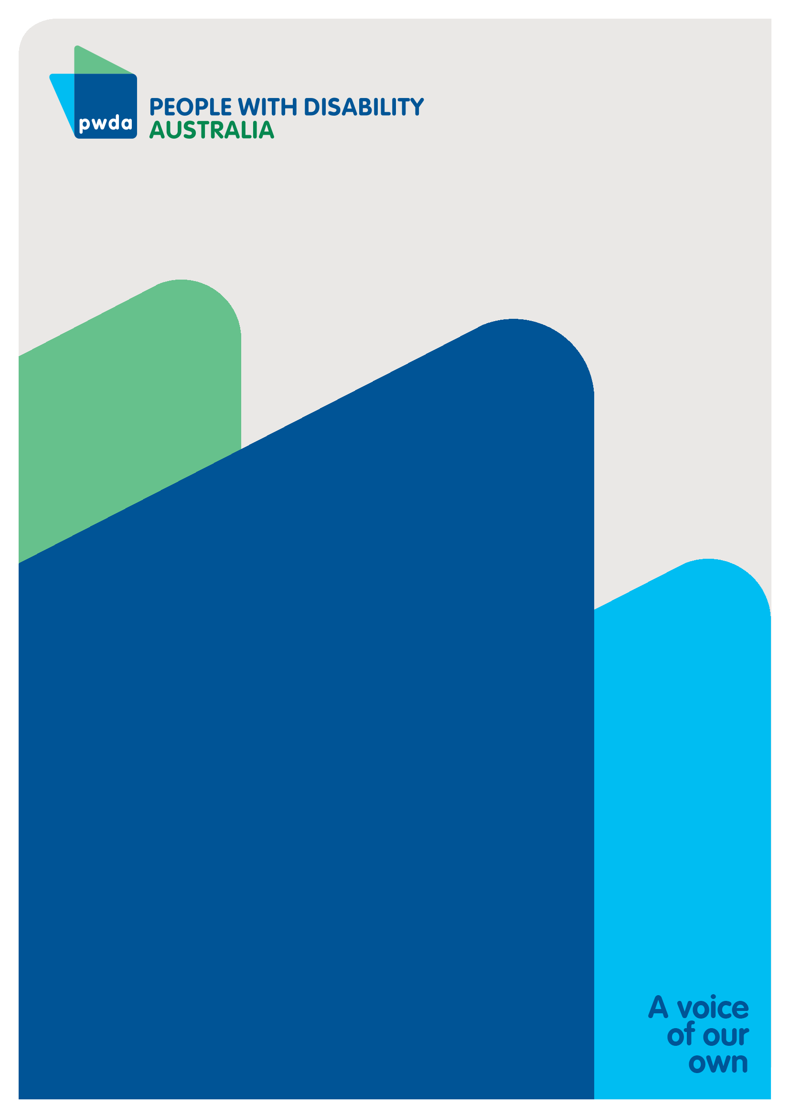

People with Disability Australia (PWDA) is a national disability rights and advocacy organisation made up of, and led by, people with disability.
For individual advocacy support contact PWDA between 9 am and 5 pm (AEST/AEDT) Monday to Friday via phone (toll free) on 1800 843 929 or via email at pwd@pwd.org.au
Submission contact
Clara Pirani
Senior Policy Officer
E: clarap@pwd.org.au and pwd@pwd.org.au

PWDA (2026) Submission on NDIS Rules: New Framework Planning. https://pwd.org.au/pwda-submission-on-the-ndis-rules-new-framework-planning/
Ibid.
PWDA (March 2026). NDIS Rules: New Framework Planning Submission. https://pwd.org.au/pwda-submission-on-the-ndis-rules-new-framework-planning/
The Australian Government (October 2023) NDIS Review Final Report. Working together to deliver the NDIS. https://www.ndisreview.gov.au/resources/reports/working-together-deliver-ndis/
Ibid
PWDA (August 2025) PWDA Response to the Consultation on the NDIS Support Rule. https://pwd.org.au/pwda-response-to-consultation-on-the-ndis-support-rule/

